

Student name:Misjona Kovaci
Student ID:2226356
Module name: Changemakers Building your Personal Brand for Sustainable Employment.
Module code : BMHP5015
Lecture Name : Brian Mashumba

Introduction

The module Changemakers: Building Your Brand for Sustainable Employment has been very valuable in helping me understand personal and professional development. Through the four units, I have explored important topics including personal growth, global connections, opportunity awareness, and wellbeing. Each unit offered practical lessons and reflective activities that encouraged me to think about my own abilities, goals, and mindset.
Unit 1 focused on self-awareness, personal branding, motivation, and emotional intelligence, helping me understand how knowing myself and showing my values can improve my career prospects. Unit 2 highlighted the importance of global connections, networking, and cultural awareness, showing me that building relationships and understanding diversity are essential in health and social care. Unit 3 taught me how to recognise and use opportunities, plan goals, and present myself professionally. Finally, Unit 4 emphasized wellbeing, resilience, and work–life balance, encouraging me to manage stress, stay motivated, and maintain a positive mindset.
Overall, this module has given me tools to develop my personal brand, build professional networks, identify opportunities, and maintain wellbeing, all of which are essential for a successful career in health and social care. In this assignment, I will reflect on what I learned from each unit and explain how these lessons will support my future work in the field.

Unit 1:

Reflection on Personal Growth, Self-Awareness, and Career Skills

This module was eye-opening for me because it made me think deeply about who I am, what drives me, and how I want to grow in my career. Learning about self-awareness, personal branding, motivation, emotional intelligence, and flexible career paths made me realise that building a successful career in health and social care is about more than just qualifications it’s about knowing yourself, connecting with others, and staying motivated.
I discovered that self-awareness is the foundation of personal and professional growth. Understanding my strengths, weaknesses, and values helps me make better decisions and communicate more effectively. The Johari Window model (Luft & Ingham, 1955) showed me that being aware of what others see and being open to feedback can improve teamwork and relationships. Thinking about my skills, such as empathy, patience, and resilience, made me excited about how I can contribute positively to a care setting. Maddux (2016) explains that believing in our abilities, or self-efficacy, is crucial for taking on challenges and I really felt that as I reflected on my own potential.
Personal branding was another concept that inspired me. I realised that it’s about showing who I am and what I value, not just appearing professional. Roy (2008) explains that having ambition and purpose helps create a strong personal image. Through the “Brand You” activities, I reflected on qualities like compassion, responsibility, and professionalism. I felt motivated to start building a brand that genuinely reflects my values and strengths, which I think is exciting because it shows who I truly am to future employers.
Motivation and goal setting also captured my interest. I learned that ambition is about purpose and determination, not just money or status (Roy, 2008). Writing down my goals and planning small steps made me feel focused and confident. Houston (2019) explains that goal setting keeps people going even when challenges appear. Pink’s (2011) ideas of autonomy, mastery, and purpose made me realise that having control, improving skills, and doing meaningful work makes me more driven and satisfied.
I felt even more excited when I learned about emotional intelligence and flexible careers. Emotional intelligence (Salovey, Caruso & Mayer, 2004) is essential for understanding emotions and building trust, while Johnson (2015) explains its importance in patient care. Learning about boundaryless careers (Arthur, Khapova & Wilderom, 2005) inspired me to be adaptable, embrace learning, and explore opportunities across different workplaces and cultures.
Overall, this m made me feel motivated, curious, and confident. I now understand that self-awareness, personal branding, motivation, emotional intelligence, and adaptability are all key to success, and I am excited to apply these ideas to create a meaningful career in health and social care.
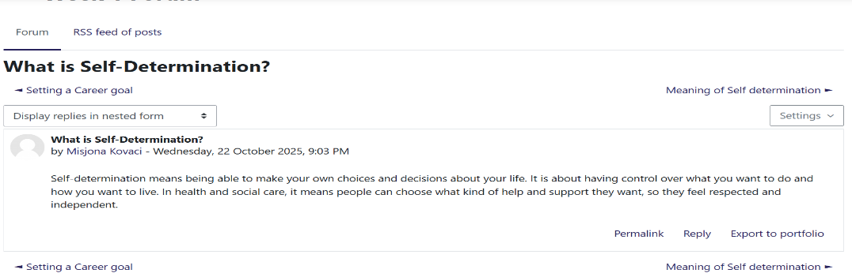
Screenshot No 1 (week 1): Understanding Self-Determination

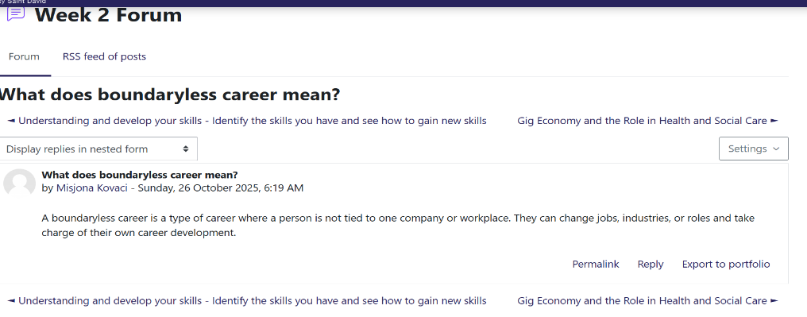
Screenshot No 2(week 2): Understanding boundaryless career

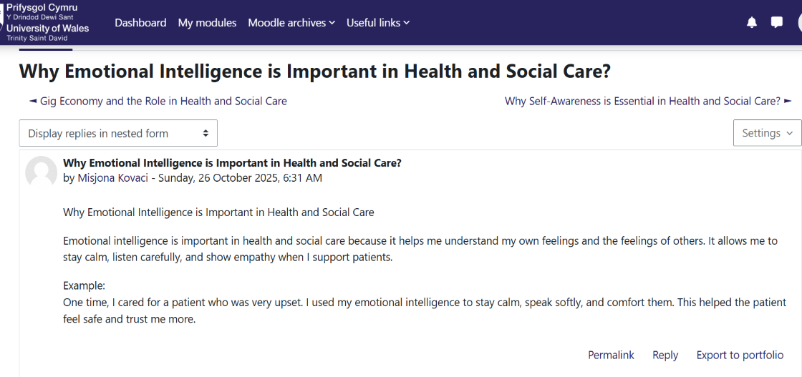
Screenshot No 3 (week 2): The importance of emotional intelligence in Health and Social Care.

Reflection on Unit 2: It’s a Small World
In Unit 2, I learned about global connections, cultural awareness, diversity, and the importance of networking in health and social care. The unit helped me to understand how the world is becoming more connected and how professionals need to build networks that support effective care. These lessons have changed how I view global health and professional development.
One key idea I learned was that networking means creating relationships to share information and support (Gibson, Hardy and Buckley, 2014). In health and social care, networking helps professionals work together to improve the quality of care and share best practices. I realised that collaboration between different professionals, such as doctors, nurses, and social workers, is important for achieving better patient outcomes. The Health and Care Act 2022 also support this idea by promoting partnership working across the NHS and local authorities (Legislation.gov.uk, 2022).
Another important topic was diversity and cultural competence. I learned that understanding different cultural values can improve how care is delivered. Hofstede’s Cultural Dimensions Theory (1984) helped me to see how people’s beliefs and communication styles can vary across cultures. For example, some cultures value teamwork, while others prefer independence. Being aware of these differences helps health professionals provide person-centred care and show respect to all service users (Papadopoulos, 2006). I also learned that diverse teams bring more creativity and better problem-solving in healthcare settings (CIPD, 2020).
The unit also discussed the “network society,” which shows how technology connects people globally (Castells, 2010). I understood that digital communication, such as online forums and social media, helps professionals share ideas and support each other. This can improve professional learning and community engagement. The idea of social prescribing, where link workers connect people to local activities, showed how networking supports mental health and reduces loneliness (NHS England, 2022).
Overall, Unit 2 helped me see that health and social care rely on strong connections between people and communities. Building networks, respecting cultural diversity, and using technology effectively are all key to improving global health. I plan to apply these lessons by developing my professional network and showing cultural sensitivity in my future work.
Screenshot Hofstede’s Cultural Dimensions Theory task.
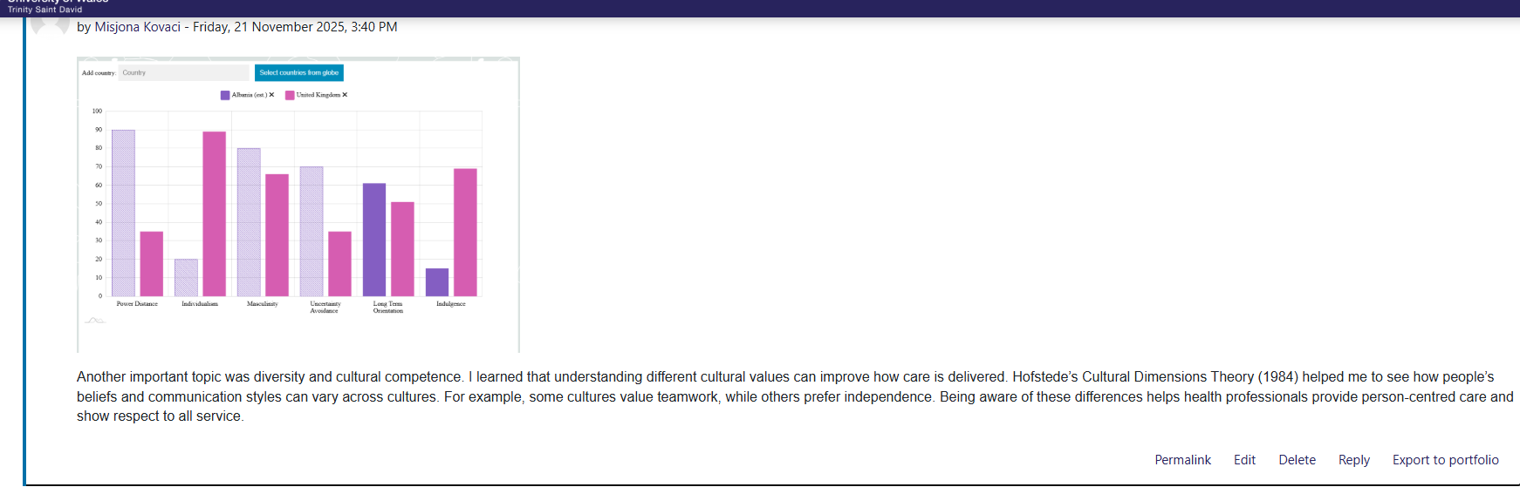

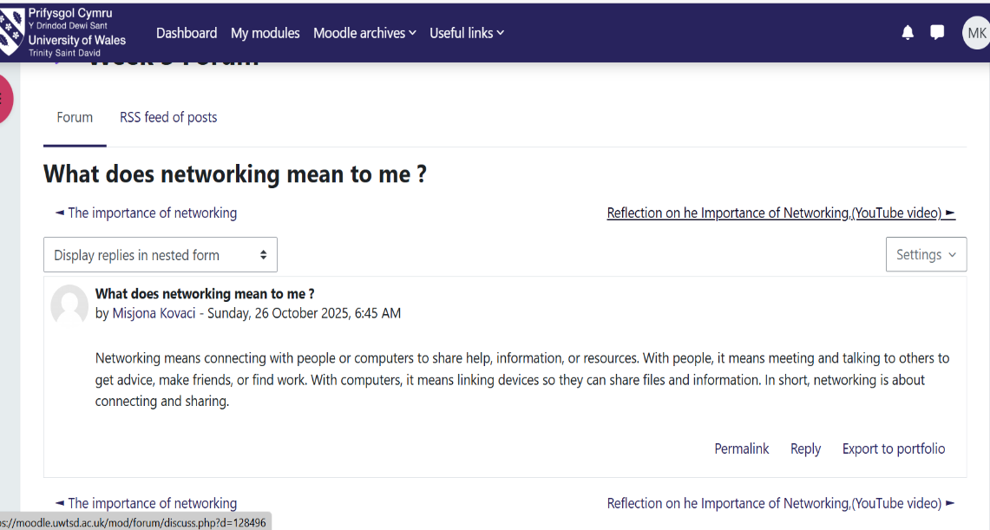
Screenshot No 4(week 3): What does networking mean to me?

Screenshot No 5(week 3): Connections with different people
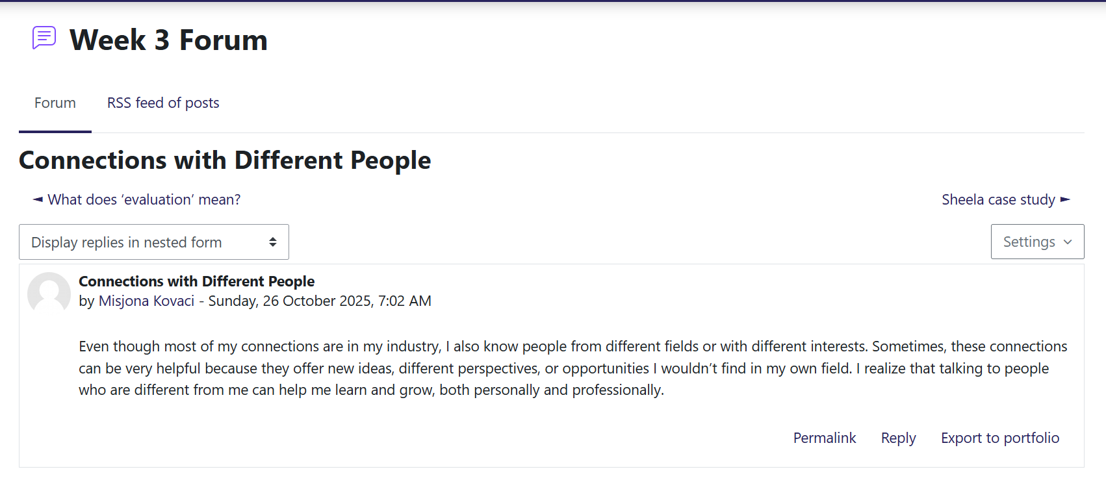

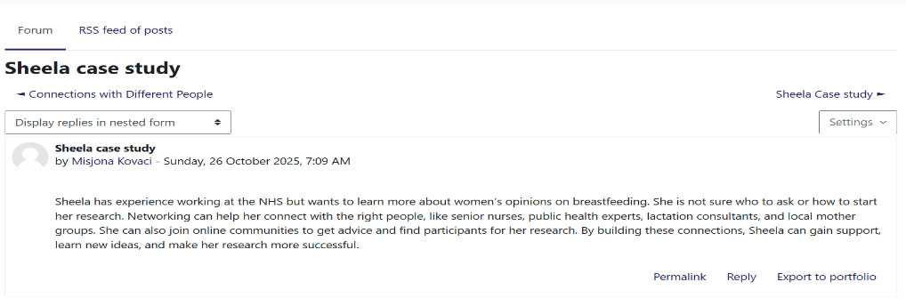

Screenshot No 6(week 3): Sheela case study

Screenshot No 7(week 4): Network influence

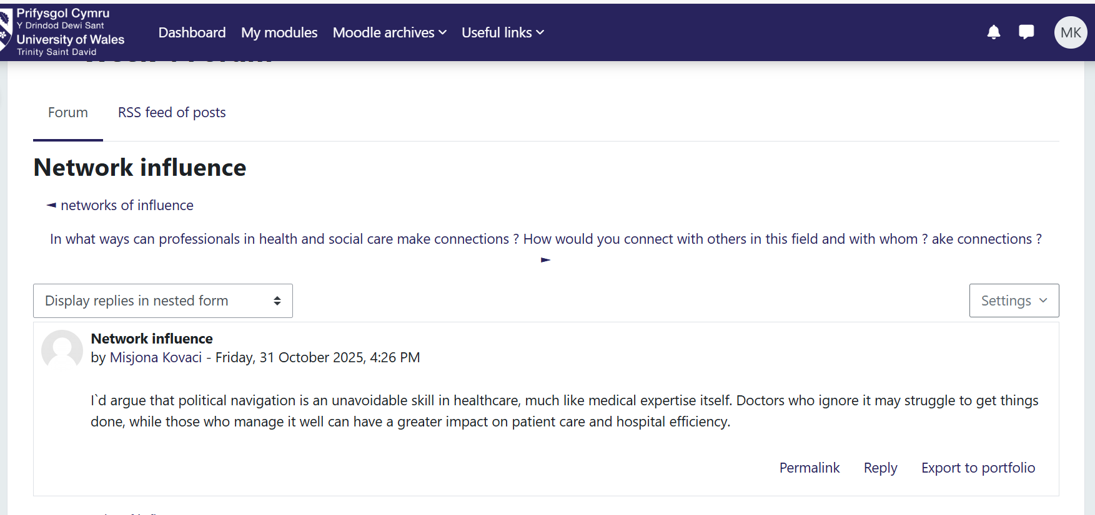

Reflection on Unit 3: Opportunity Knocks Learning to Find and Use Opportunities in Health and Social Care

In Unit 3, I learned how to see and use opportunities to grow in my personal and professional life, especially in health and social care. The lessons in this unit helped me to think in new ways, plan, and understand how to present myself as a professional.
In Week 5, I learned that success is not only about luck but also about working hard and being ready when opportunities come. The idea of the serendipity mindset (Heinstrom & Sormunen, 2020) means being open to new chances and learning from unexpected situations. For example, in health and social care, noticing small positive changes in patients can help improve care. I also learned that changing the way I look at things helps me find new solutions to problems.
Another topic was stretch goals. I learned that these are big goals that are hard to reach but help people grow and learn new things (Pina e Cunha et al., 2017). This taught me not to be afraid to challenge myself. For example, I set a goal to speak more confidently in class and during group work. This helped me build confidence and improve my communication skills, which are important in health and social care jobs. In Week 6, I learned about opening doors to job opportunities. This means updating my CV, networking, and using social media like LinkedIn to connect with professionals (Stansky, 1996). I now understand that building a professional online presence (Aveyard & Sharp, 2017) is very important because employers often check profiles online. I also learned how to write short blogs to share ideas and knowledge, which can help me show my interest in the field.

Screenshot No 7(week 5):
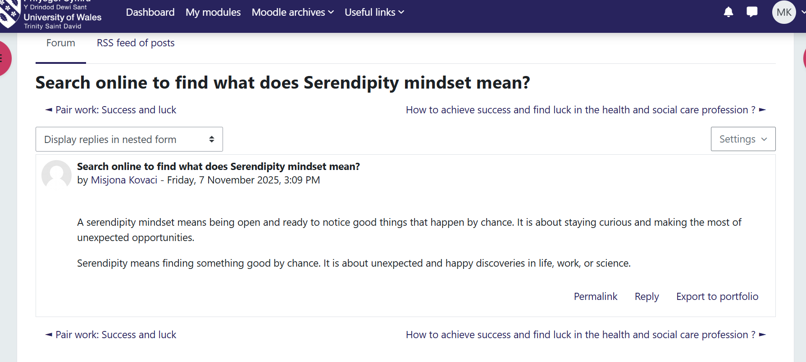

Screenshot No 8(week 5):
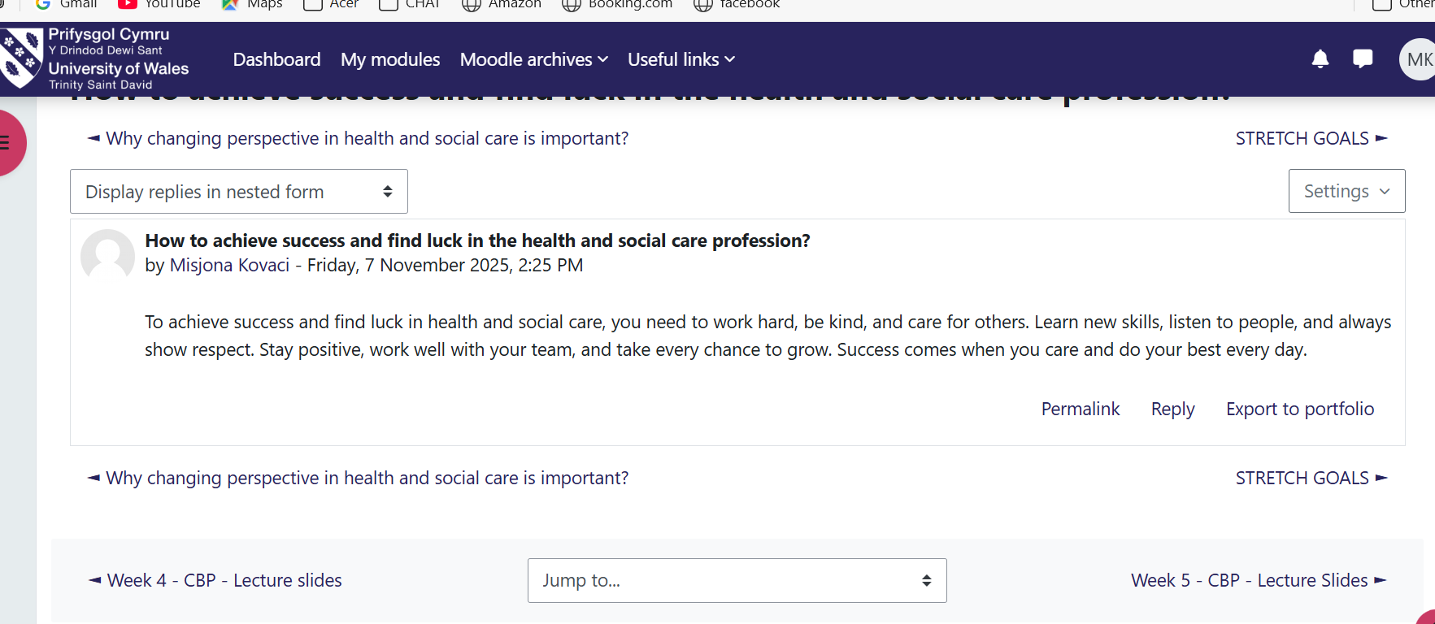
Screenshot No 9(week 6): Open doors for job opportunities
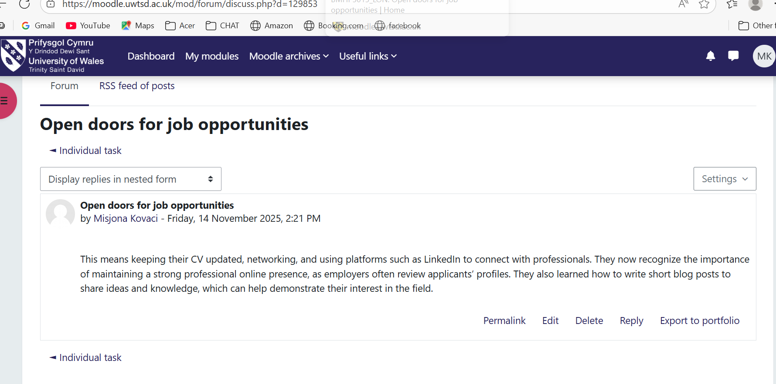

Screenshot No 10(week 6): Individual task

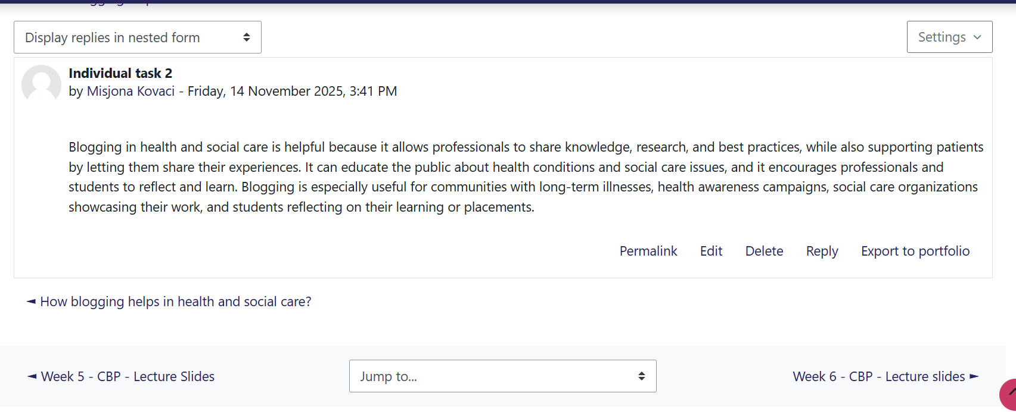
Screenshot No 12(week 6): Writing a short blog

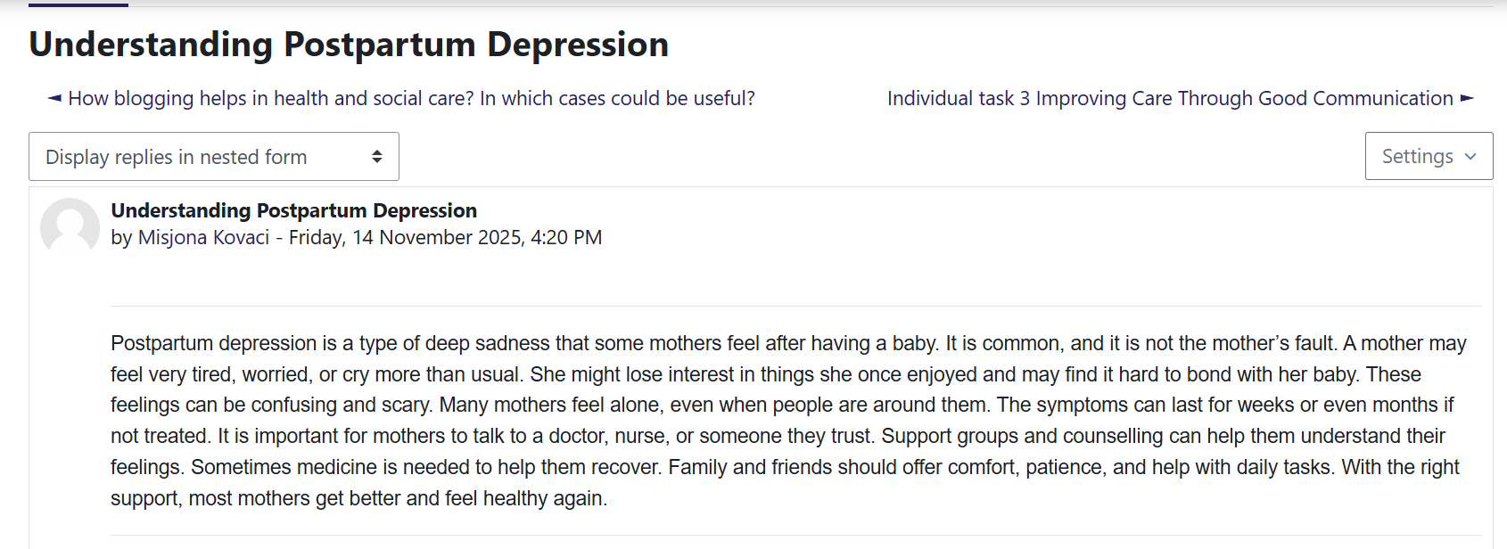

Reflection on Unit 4 : The Pursuit of Happiness
Unit 4, The Pursuit of Happiness, helped me think deeply about wellbeing, resilience, and balance in my life and future career. Before this unit, I often focused only on tasks and goals without noticing how my thoughts and feelings affected me. This unit made me realise that happiness and mental health are important for both personal life and professional work, especially in health and social care.
One thing I learned is about wellbeing. Wellbeing is not just feeling happy but also having purpose, good relationships, and balance in life. I learned about the PERMA model, which shows that positive emotions, engagement, meaningful work, relationships, and achievements all contribute to wellbeing (Seligman, 2011). Thinking about this made me reflect on my habits. I now understand that small daily actions, like connecting with friends, setting realistic goals, and taking time to rest, can improve my overall wellbeing.
I also learned about resilience. I used to think resilience only meant being strong during hard times. Now I see it as learning from difficulties, adapting to change, and keeping a positive mindset (Duckworth et al., 2007). In health and social care, staff face stress and challenges every day. This unit showed me that developing resilience will help me stay calm, keep learning from experiences, and not give up when situations are difficult.
Another important lesson was about self-awareness and emotions. I learned to notice my limiting beliefs, pause and reflect on my thoughts, and accept my feelings without letting them take over. This skill will help me work with colleagues and support clients without being overwhelmed by stress. I also learned not to worry too much about what others think, which helps me focus on my own growth and wellbeing.
Finally, I understood the importance of work–life balance. Spending time only on work or study can lead to stress and burnout. Balancing work, rest, and hobbies is essential for long-term health and for providing good care to others.
Overall, Unit 4 helped me see how happiness, wellbeing, and resilience are connected to professional success. The ideas and skills I learned will help me stay positive, manage stress, build good relationships, and provide care with compassion in my future career in health and social care.

Screenshot No 13(week 7): Self Limiting Beliefs

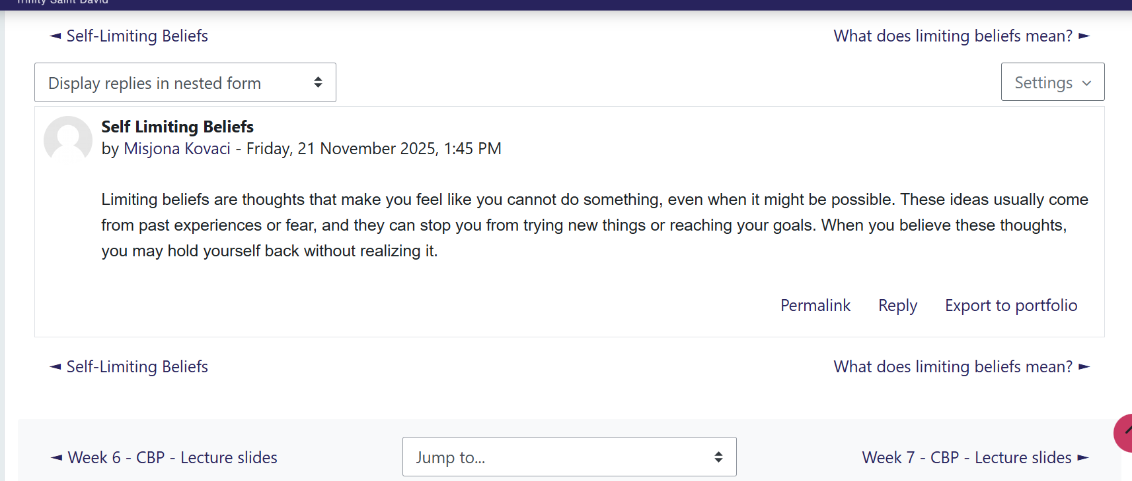

Screenshot No 14(week 7): Quiz Reflection

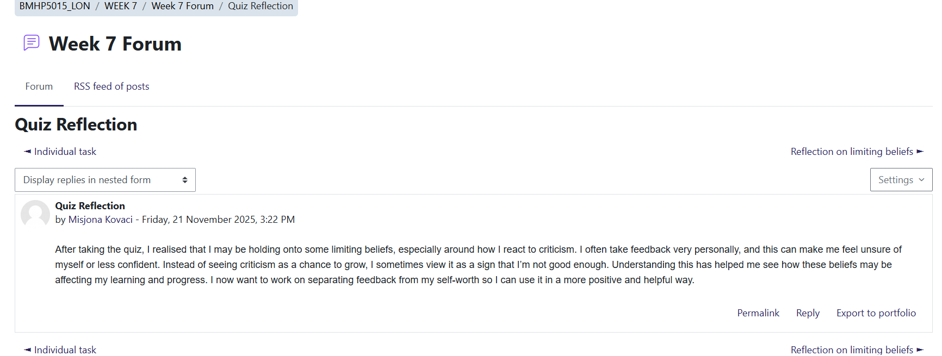

Conclusion

Reflecting on the four units of this module has helped me understand the importance of self-awareness, personal branding, global connections, opportunity awareness, and wellbeing in building a successful career in health and social care. Unit 1 taught me to recognise my strengths, values, and emotions, and showed how personal branding and motivation can help me communicate effectively and stay focused on my goals. Unit 2 emphasised the value of networking, cultural awareness, and diversity, helping me see how collaboration and understanding different perspectives improve the quality of care. Unit 3 focused on identifying and using opportunities, setting goals, and presenting myself professionally, which highlighted the importance of being proactive and adaptable. Unit 4 reinforced the significance of wellbeing, resilience, and work–life balance, reminding me that managing stress and maintaining a positive mindset are essential for long-term personal and professional success. Overall, the knowledge and skills I gained from this module will help me develop professionally in health and social care. I feel better prepared to work effectively with colleagues, support patients with compassion, manage challenges with resilience, and continue learning throughout my career. This module has strengthened my confidence, self-awareness, and understanding of what it takes to thrive in a caring and dynamic work environment.

References
Houston, (2019) What is Goal Setting and How to Do it Well. Available at: https://positivepsychology.com/goal-setting/
Maddux, J.E. (2016) ‘Self-efficacy’, in Interpersonal and Intrapersonal Expectancies. Routledge, pp. 41–46.
Pink, D.H. (2011) Drive: The Surprising Truth About What Motivates Us. Riverhead Books.
Roy, S.K. (2008) ‘Identifying the dimensions of attractiveness of an employer brand in the Indian context’, South Asian Journal of Management, 15(4), pp. 110–130.
Arthur, M.B., Khapova, S.N. and Wilderom, C.P. (2005) ‘Career success in a boundaryless career world’, Journal of Organizational Behavior, 26(2), pp.177–202.
Johnson, D.R. (2015) ‘Emotional intelligence as a crucial component to medical education’, International Journal of Medical Education, 6, pp.179–185.
Luft, J. and Ingham, H. (1955) The Johari Window: A Graphic Model of Interpersonal Awareness. University of California.
Salovey, P., Caruso, D. and Mayer, J.D. (2004) ‘Emotional intelligence in practice’, in Positive Psychology in Practice, pp.447–463.

Castells, M. (2010) The Rise of the Network Society. 2nd ed. Oxford: Wiley-Blackwell.

Duckworth, A.L., Peterson, C., Matthews, M.D., & Kelly, D.R. (2007). Grit: perseverance and passion for long-term goals. Journal of Personality and Social Psychology, 92(6), 1087.
Seligman, M.E.P. (2011). Flourish: A Visionary New Understanding of Happiness and Wellbeing. Free Press.

