Task 1 - Manifesto

8 Statements

- Achieve both maximalism and modernism.
- Serendipity: Take advantage of mistakes.
- Create interesting multiple-purpose patterns.
- Take notice of everything around you e.g., textures, shapes, imperfections -
there are patterns in everything.
- Be industry aware (of costs, environmental impact, time of production,
trends) but do not let it hold you back.
- Be led by what you are producing, go with the flow, enjoy it. Don’t stick too
much
to a structure; it may hold back your creative development.
- Challenge tradition and trends.
- Start small – build.

2. Serendipity: Take advantage of mistakes

I intend to begin all my projects very experimentally, creating an archive of marks that were not necessarily what I was trying to do; it has become evident that the best marks are created on accident and without expectation. These marks will provide me a starting point in which I will create a series of patterns based on mistakes I have made. This is an idea that many other artists explore such as Erik Kessels who said, “society teaches us to avoid mistakes, but for creative people and innovators they are essential” when talking in a workshop about an exhibition Fabulous Failures (Kessels, 2017) or Renee Phillips who has “replace[d] the word ‘mistake’ with ‘opportunity’” (Phillips, 2017). In the book High Art Lite: The Rise and Fall of Young British Art, (Stallabrass, 2006, P.18) Julian Stallabrass suggests modern artists face a paradox: “the means by which that art is pursued are steadily less expressive of the artist’s personality”. Expression is a natural reaction, not a performance, so it is only logical that expressive art is achieved through freedom and mistakes. Artists are constrained by expectation to always create something “good” even when we are learning new processes or exploring new ways to depict something. Going back to the basics, allowing failure and exploring marks are a sure way of expressing personality at the most basic level. In the same book (p.73), Stallabrass suggests modern artists “believe in Art and the idea of the avant-garde”- the use of new and experimental ideas and methods. This resonates heavily with me, as something I am interested in is learning the “correct” ways to do things and avoiding that. Not only does this detach you from your expectations, but it leaves you with something unexpected and therefore exciting and often new. Printing processes and short, timed sketches will help me to play with these ideas.

- Maximalism and Modernism

In recent years – or since the Bauhaus movement - minimalism has become a very popular approach to design and their functions. It is of popular opinion that “less is more” but I would like to deconstruct this. An article called What is Bauhaus Style in Graphic Design? (Iakovlev, 2021) lists Bauhaus design principles including “form follows function”, “use of minimalism”, and “simplicity and effectiveness”, all which encouraged artists to create something much more refined and with reduced detail. The very existence of minimalism is dangerous to the surface pattern industry, rendering designs useless as everyone’s homes and clothes lack in colour, dimension and variety. These are all qualities I like to have in my designs, which due to these standards and trends, might not be desirable. However, some artists like Piet Mondrian and Wassily Kandinsky who worked during the time of the Bauhaus and used blocks of colour, simple shapes and reduced colour palettes provide me with a lot of my own inspiration. I would like to find a balance between maximalism and modernism, to create exciting designs that have a wide audience and can be used to elevate minimalist interiors/ fashion ensembles as features. Another article on the website Architectural Digest about maximalist interior design defines maximalism as an “eclectic mix of patterns, colours, textures and objects” (Katherine McLaughlin February 27, 2023). Some examples of maximalism can appear dated and lack a certain aesthetic when too random or “eclectic”. Combining this with the fundamentals of modernism (minimalistic, muted colours, rigid shapes etc.) will allow me to create designs that cater to a wide range of people.

- There are patterns everywhere.

Inspiration can strike at any moment, because there is so much beauty around us at all times, in both nature and the man-made. I have previously briefly explored the Japanese Edo Period (1603-1867), where wealth and peace increasing in the country due to new leadership created a demand for art based on the mundane. New groups of people moving into the country gave artists a “new audience in prosperous city-dwellers who had an appetite for images of daily life”, according to an article on the Princeton university art museum website (The Art of Observation in the Edo Period (1600–1868) [part two], n.d.). This encouraged artists to employ a “keen observation of the world around them” and notice beauty in the things they saw every day. Pieces like ‘Inn with Serving Maids’ and ‘Watching Fireworks on the River’ depict people carrying out their “mundane” tasks that wouldn’t have before been recorded, but now carried a desired aesthetic of simplicity. More relevant to myself, there are many landscapes from this era (commonly named ‘view of…’) as I would argue that a person carrying out a task is nowhere near as mundane – or beautiful – as things that are naturally occurring. This exploration led me to the belief that art and design do not require some big, meaningful idea to be successful, and that it is possible to make the everyday exciting. I will be taking notice of my surroundings, looking at objects in both the micro and macro; I will be sketching the finer details and repetitive textures as well as negative space between objects and their basic forms.

Task 2 – Observational Writing

Ferdinand De Saussure defined semiotics as a study of “the life of signs within society” (Duignan, Britannica, last updated: 17th November 2023) Signs are vital to our lives but are useless without meaning. In this piece I will deconstruct a perfect example of how integral signs are and how effective they are by influencing the subconscious.

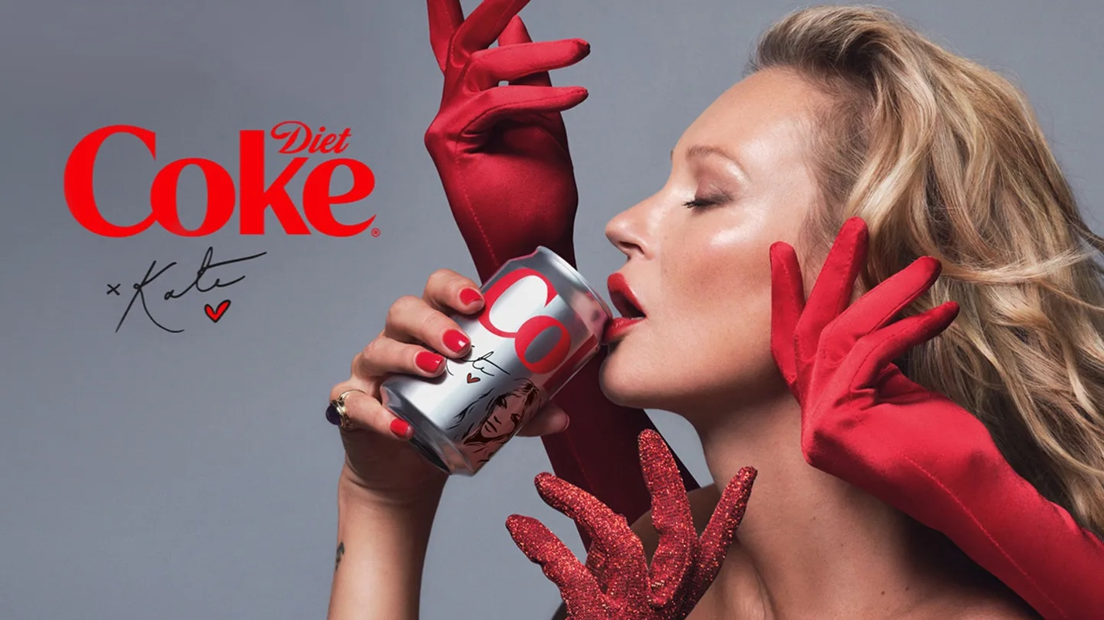
Figure 1: Kate Moss – Love What You Love (July 2022)

The Kate Moss campaign for Diet Coke is one I find very interesting, because while on the surface it suggests to customers “drink this drink because this famous model does!”, it actually carries a lot of underlying messages.
The feature of Kate Moss is the first signifier that stands out to me, as her whole career encouraged an unhealthy desire for that “heroin chic” aesthetic. In her prime she promoted unrealistic beauty standards and contributed to a detrimental diet culture that suggested being underweight was a goal. Despite all these negatives, most simply, the model was known for her thin figure, and so it only makes sense for her to lead a campaign for a diet drink. Her associations with a slim body were taken advantage of by the creators in a way to utilise the power of diet culture in a way to make more money.
This is something, though, that may not be the intended first impression, and not as simple of a signifier as usual. It has been said “a text bears no meaning unless the receiver of the text knows the code” (Sebeok, 1994, p.20). Something that has more than likely been realised by many viewers is the connotations of the colour red and its repeated use as the only colour present (red lips, nails, font, gloves etc.). However, perhaps this was purposeful as it leaves you questioning which is the true meaning of red here. One thing red can mean is love (supported by the little red heart beneath her signature) suggesting you will love this drink. Other interpretations could be passion, anger and danger, all of which are powerful concepts so no matter how different people perceive the colour, it is always followed with feelings of dominance, importance and boldness. This is an ad that you will remember.
The gloves are yet another interesting symbol in this ad, as there are at least two extra hands, reinforcing the idea of desire and suggesting a high demand and popularity. This ad plays on the idea of trends, and the way people tend to be followers. This, combined with the use of Kate Moss, leads the viewers to believe that they should want this product because so many other people – including a celebrity – also do. The fact the hands are wearing gloves creates a feeling of high class; something that is so important that you can’t touch it with your bare hands. Something that fortifies this is the elegant poses of the hands that suggest a graceful motion of reaching for something that they were unable to attain. All these symbols provided by the hands create the belief that it is an honour to drink this drink and helps consumers to feel proud when they do.
The change of packaging and the use of Kate Moss’s signature re-introduce this product as a collectible item. Existing customers will be intrigued by the change and new customers will be invited in by a fresh new look. The can itself carries value due to its impermanence as it is known that the packaging will at some point revert.
After analysing this ad, it becomes so much more interesting as it evidently caters to so many audiences; there is not one targeted group. It speaks to Coke fans, Kate Moss fans, people who diet and, because of its clever colour use, stands out to everyone. At first, I believed the ad to be nonsensical as it contradicts the idea of health, but now I see it to be a very smart campaign that builds on the public’s pre-existing opinions rather than trying to create new ones.

Bibliography

Books

Sebeok, T.A. (1994). Signs: An Introduction to Semiotics. 2nd edn. Toronto, Buffalo, London: University of Toronto Press

Stallabrass, J. (2006). Hight Art Lite : the rise and fall of young British art. London: Verso

Websites

Duignan, B. (2023). Semiotics. In: Britannica Encyclopaedia. Available at: https://www.britannica.com/science/semiotics
(Accessed 29th November 2023)

Kessels, E. (n.d.). Lectures & Workshops. [online] Available at: https://www.erikkessels.com/lectures-workshops
(Accessed 21st November 2023)

Iakovlev, Y. (2021). Best Online Tools for Graphic Designers. [online] Zeka Design. Available at: https://www.zekagraphic.com/what-is-bauhaus-design-history/
(Accessed 21st November 2023)

Nast, C. (2023). Maximalist Interior Design: Everything You Need to Know About This Bold and Playful Style. [online] Architectural Digest. Available at: https://www.architecturaldigest.com/story/maximalist-interior-design-101
(Accessed 24th October 2023)

Phillips, R. (n.d.). Release Perfectionism and Celebrate Mistakes In Your Art Career. [online] Available at: https://renee-phillips.com/release-perfectionism-and-celebrate-mistakes-in-your-art-career/
(Accessed 21st November 2023)

Images

Coca-Cola. (2022) Kate Moss. Available at: https://www.coca-cola.com/gb/en/media-center/diet-coke-appoints-fashion-icon-kate-moss-as-creative-director
(Accessed 21st November 2023)

