ECAD6001 Individual video presentation and supporting file.

The importance of successful transition

The research underpinning the need for this change in the schools current transition plan is the research of Crafter and Maunder within Macblain’s book How To Learn where they were cited having said “Each child’s transition to new formal learning situations will be different and the process they go through in making these transitions will be as important as the outcomes they experience.” (Crafter & Maunder, 2012 cited in Macblain, 2014, t.121) The importance of this is the idea of transitions being a process, not an event If it were an event it would be quick. However, as we have come to find out it takes a long period to transition correctly.

Professor Grayham Donaldson the educator conducting the current curriculum reformation in Wales stated in his 2015 report Aiming For Excellence that “transition points can hinder progression and there was evidence that this could contribute to disengagement as young people progress through school” (Professor Donaldson Graham, Successful futures, (2015,52) http://dera.ioe.ac.uk/22165/4/150225-evidence-base_Redacted.pdf). Due to this being found as an area of importance within our current curriculum reformation. This importance of successful transitions will become even more apparent when the new curriculum is rollout due to the new outcome format for assessment.

The National Foundation for educational research, published a report into Evaluation Of Excellence In Cities Primary extension, A report of the transition strand study. Caroline sharp the Principal research officer found was that “pupils were looking forward to the transition, however there were some concern the pupils had one such concern was regarding the workload expected of them” (Evaluation Of Excellence In Cities Primary extension, A report of the transition strand study, Ekua Brown, Lesley Kendali, David Teeman and Kate Ridley, NFER, https://www.nfer.ac.uk/evaluation-of-excellence-in-cities-primary-extension-a-report-of-the-transition-strand-study/ , 2004 ) One main recommendation was to involve the pupils, parents, and staff. The main recommendation regarding pupils transitioning from KS2 to KS3 was for “A greater level of cross-phase communication between primary and secondary schools. This includes in-depth pupil profiles and information for pupils to pass onto students and parents.”

This belief that secondary schools and primary schools should work in partnership is a belief by ESTYN where they ere quoted saying “secondary schools and their partner primary schools formalise their arrangements to work together more closely on curriculum, learning and assessment in order to improve transition for learners” (ESTYN, Excellence for all, Transition plans and grant, An evaluation of the impact of transition plans and grant on primary and secondary school partnerships at key stage 2 and key stage 3, March 2010)

The New Proposed transition plan ensures pupils have plenty of access and time within the school to be aware of their surroundings before they transition into KS3. The plan is designed to be a three-year process that gradually gets more intense the older the pupils get. The transition plan is broken down into what will take place each month so that its clear nothing is missing. While planning I have worked with the theory of mallows hierarchy of needs in the back of my mind this was due to the knowledge of there being the need for basic needs to be met before we could assess and support the phycological needs of the pupils. This theory is also what lead me to decide on the need for an Individual Transition plan as some pupils are lacking the simple physiological and safety needs for pupils to progress.

The use of Maslow's hierarchy of needs can be seen in use in addition to, the pupils IDP during the planning process for the Individual transition plan.

Year five do not take part in activities that are academically challenging due to the provision to come in year 6. The aim for year 5 is to get the pupils comfortable with the areas surrounding the comprehensive school.
While conducting further reading for this assignment the work of James A. Beane lead me to the realisation that the Transition plan must adhere to all areas of the curriculum including the cross-curricular responsibilities He is quota saying “curriculum integration allows children to seek and use knowledge in an organic way” (James A. Beane, Curriculum integration and The Disciplines of Knowledge, 1995). This was an important aspect of my planning as the pupils needed to be able to use their knowledge organically to ensure their phycological needs were meet in resigning with new information about the transition they are undergoing.

Included with the new transition plan. I would also propose independent transition plans that will run alongside the current transition plan for transitions into KS3. The independent transition plan put in place will be there to allow a pupil to smoothly transition into the new school environment. This is in order to provide a learning experience that does not isolate the learner.

The theory underpinning my decision is first and foremost developed through the theory of Maria Montessori’s idea of Spontaneous self-discipline within her writing it is said: “Children respond best to educational opportunities in an environment which is prepared to meet their special sensitivities for learning.”Maria Montessori’s cited in Linda Pound How children learn practical pre-school books publishing 8/7/2014” This confirms the need for special changes to be made to allow the best possible learning. Due to the fact we have already discussed transitions being full of learning opportunities and experiences it makes sense to develop individual transition plans to provide the best possible transition.

In addition, the individual transition plan will be planned and created by several people this group includes the pupil, parents or guardians, ALNCO, class teacher and any additional support needed such as a team around the family. This is due to the findings of Kate Ridely within the article cited earlier in this document.

The plan will include a vast array of activities the pupil will be expected to complete while attending the school these include learning new spaces and navigating a larger environment, to learning the new route to school and how to be independent in other areas of school life e.g. school cafeteria and play areas.

The pupil in this example will be given additional opportunity to get used to their surroundings and take time to investigate the classroom. In addition to this, the pupil will meet their new teachers and all staff. This will also provide additional opportunity for the teacher to learn how to plant and provide support for the individual. The aim of the pupil's experience in school if for it to not isolate the learner at any given time and provide them with the same experiences and opportunities as other students.

The pupil is lucky to be staying with their current one to one as they need assistance with a learning assistant who is fluent in Braille.

This extended transition period will also allow the school to learn how to best support this individual and discover any problem areas within the day to day running of school life. Our school and the comprehensive are in discussion and have already shared some of the suggestions on how to ease certain aspects of school life such as navigating busy halls and loud areas.

As well as the pupil making regular visits to the comprehensive school for intervention the headteacher of the comprehensive school has also shown interest in taking additional time to meet this student during visits to the primary school as part of the current transition plan.

Script

Prynhawn da, thank you for allowing me to come and present my intervention suggestion to aid the transition from KS2 to KS3. As you are aware our ethos is of an all-inclusive school that takes great pride in providing the best possible care and opportunities for our pupils.

It has come to my attention that pupils and indeed parents within the school are concerned with the change their children will undertake when transitioning from KS2 up to KS3.

There is a large amount of research to suggest that transitions are a process, not an event. Furthermore, these processes experienced are important to learners. This finding can be found by theorists such as Crafter & Maunder.

Upon reflecting on our current transition plan I believe we are treating transition as an event not as a process through time. There is also scope to believe we are then neglecting the potential experiences within this process.

I have noticed there is a large gap within our own transition plan. As you can see there is a vast period of time where we do not provide any form of interaction with the comprehensive school where our pupils will be attending.

With no interaction until the Winter term is over, and pupils return after Christmas break. This does not provide enough time for our pupils to settle and prepare for the big changes ahead of them.

But why is this necessary as you are aware wellbeing is one of the top priorities of the Welsh government, therefore it is our responsibility to ensure that the wellbeing of our pupils is met during this period.

There is also much research to suggest that Transition points, if not treated correctly, can have a negative impact on pupil's learning. This will also become more apparent with the new curriculum documentation headed up by Professor Graham Donaldson, who was quotes in his 2015 report successful futures saying that “transition points can hinder progression and there was evidence that this could contribute to disengagement as young people progress through school” Do we want this for our pupils I think not.

I would propose a new transition plan created in conjunction with three other large primary schools in our area who all feed into the local comprehensive school. The plan’s aim is to ensure a smooth transition into KS3 allowing pupils to both get used to their surroundings, break down the mental barriers imposed upon them and meet other pupils they will share this experience with.

I would also propose individual transition plans for key individuals in order for them to best transition between the key stages. For example pupils with additional learning needs, disabilities, and special circumstances.

Headteachers from the three other schools have already agreed upon the need for an inclusive transition plan. With your support today I hope to begin the process of rolling a new plan to each school. I have created the first draft of a transition plan created in conjunction with our local comprehensive.

If you would look at the plan in your handout you can see that the plan begins from as early as October. The Comprehensive school is proposing a large number of different activities throughout the year to provide the best possible transition.

The transition for year six pupils begins on the 3rd of October with an open evening within the local comprehensive schools. This event is open to all parents/guardians and pupils. In order to provide a smooth transition.

Year 6 teachers are also to attend the evening to provide a source of helpful questions and a familiar face to students. Later on, in the month pupils will experience a range of lessons within the focus of the curriculum. Within the comprehensive school to show them what their new environment will be like to learn in.
I am very happy to announce the possibility of a stem day within the comprehensive. This is the first time groups of pupils from the four schools within the plan will mix learning groups. This should, in turn, provide the students with opportunities to develop social skills with students from other schools in a learning environment.

There is not much provision within the month of December for year 6 pupils this is due to activities within the run-up to Christmas and also this provides an excellent chance for each school's more able and talented pupils to have further time to get to know each other. With addition to teachers being given the opportunity to best learn how to challenge these learners.

The transition period/plan for year six is rather similar for the remainder of the year allowing teachers and pupils time to get to know each other and begin to form relationships with the pupils. There are also various sporting events within school time to make visiting the comprehensive less formal

You may notice from your hand out that transition begins within year 4 with basic sports events this is due to the knowledge that transition is a process and the established through that it takes time to break down the barriers.

Year five will receive constant exposure to the comprehensive school. through monthly sporting activities, these activities will be run by the school's sixth form who are completing their A level in Pe. The year five pupils will also receive an open evening within the month of June, before starting the year six transition program the following academic year.

There are no physical costs to this program due to all resources are available on-site at the comprehensive school. In addition, there is no travel cost as the comprehensive school is within walking distance at only 5 minutes away.

In conjunction with this transition plan, I believe it is our role to make adjustments for individual pupils who will benefit from this greatly. I would suggest that these Individual transition plans are created with the individual present and their ideas must be listened to this is due to article 12 of the UNCRC (UN convention on the rights of the child) which states children have the right to say what they think should happen and be listened to.

An example an individual transition plan can be seen on the second page of your handout where a pupil of ours who is legally blind has had amendments made to their daily and weekly activities to best suit them to getting to know their surroundings and make their transition period as smooth as possible

These individual transition plans would be available to all and any children who needed or required one of these plans. These individual transition plans would be to follow their IDP (Individual development Profile). The plans are to be created to aid not only their IDP but also their transition. Again to best design the transition period. These plans would be developed with the pupil, parents/guardians, ALNCO and their class teacher. This is in order to make the process as easy and as less stressful as possible.

I would like to say thank you to the whole governing body for listening to me today I hope you will consider my Plan to help create this highly important moment for our pupils the best it can.

Diolch un fawr.
Self Evaluation

Within this assessment I have chosen I believe a rather obstruct intervention. Despite the intervention being in place in most if not all schools. However, I believe my intervention differs is in the details I have done my best to show the need for my intervention academically and used supporting material from other authors to form my work.

I have created a school contest which is both challenging and quite realistic the issues proposed are some I’ve seen in recent years and therefore shows that the issues or problems I have chosen to support are very realistic. It is also very adaptable despite there not being a model created for all there is significant knowledge of the intervention and what it takes to create such a plan.

I do believe my file is well put together with several different sources and appendixes it shows a clear model for what should be taking place within schools. Perhaps, more importantly, bringing forward why we should ensure the intervention in this scenario is conducted correctly.

Within the video segment of this assignment I believe I have shown many professional values. The way in which I have spoken to the governing body and used technical vocabulary when appropriate shows knowledge of my audience. In addition the use of a handout sheet instead of a powerpoint for members within the meeting to be able to follow themselves exactly what is happening and what I propose.

I believe that not only in my knowledge of the audience but in other aspects of professional values I have shown maturity and the ability to converse suitably in this profession.

Overall I am happy with my assignment I am happy I did not refer to too much theory as I when placing theory within the assignment otherwise it may become distorted when simply searching for supporting material. Some of which do not always improve the current point.

Appendices

Individual development profile
Pupils name: | Pupils year group: 6 | ALN: Pupil is completely blind in one eyes and has less than 10% vision in the other eye. | ALNCO: Mr Davies
Areas of development | Current ability | Next steps | Desired outcome by next transition | Further comments
Independent learning | Pupil currently relies on 1 to 1 support to aid in the acquisition of resources and books within the classroom | Pupil must be encouraged to be more independent with their learning. | Pupil must independently set up Brailer Machine and locate her books within the classroom in addition to being aware where their additional resources are e.g. Brail ruler. | Pupil currently does not like the encouragement to be more independent as there are further challenges to discover.
Braille writing | Grade 1 | Pupil is currently learning Braile level 2 shorthand/letter clusters | To be developing skills in typing using grade 2 Braille when appropriate | Pupil has developed knowledge of basic letters and simple punctuation
Braille reading | Grade 1 | Pupil is beginning to read at level 2 braise with some difficulties with shorthand Braille and some punctuation. | To have developed reading skills in a grade 2 of Braille allowing the pupil to independantly read material with technical knowledge. | Pupil shows the ability to read independently however the pupil is reluctant to proceed and try book at a harder difficulty.
Begin to show independence in development of skills for everyday life e.g. getting dressed | Pupils can effectively get dressed and tie shoes however lacks the confidence to independently prepare simple food and drink. |  | Pupil must be able to transverse through new environments independently

Individual Transition plan
Pupils name: | Pupils year group: 6 | ALN: Pupil is completely blind in one eyes and has less than 10% vision in the other eye. | ALNCO: Mr Davies
Transition intervention | What is currently being done | What needs to be done to develop | What the result will be | Further comments
1 to 1 support | Pupil receives one to one within school times for support. | 1 to 1 will follow pupil due to special skills in Braille. However suggestion that 1 to 1 is present whenever pupil attends the school will aid the transition process. | Pupil should transition quicker and develop the needed skills feeling safe in their environment. | The pupil asked whether their 1 to 1 will come with them to visit the school.
Reading dogs | Pupils currently travels to council building in the next town, to take part in a reading intervention. | This intervention task will change place and be situated on site at the comprehensive school to allow more time within the environment. | Pupil should feel calm and begin to associate that they are within and area of learning
Physical literacy skills | Pupil currently works with additional agency within the council to support, the pupil with Braille and movement skills i.e Cane walking. | This intervention task will change place and be situated on site at the comprehensive school to allow more time within the environment | Pupil should being to learn how to navigate the stools corridors at a faster rate and come to terms with climbing the stairs within the comprehensive schools. | Still working on scheduling of council support staff.
Extended exposure to the comprehensive school | Currently there is no opportunity outside of the existing transition plan for the pupil to get used to her surrounding. | Included with other interventions taking place the pupil is also to be allowed the opportunity to visit the school once a week during term time, between 4pm-6pm to walk around the school aid the transition.  Pupil will also experience their new route to school with their taxi driver in order for them to better understand, how to cope with their daily comings and goings. | Pupil should have no problems navigating the school between classes.
Extended exposure to key individuals | Other than meeting teachers during lesson time there is no additional opportunity for teacher and the pupil to meet. | We would propose additional time during visits to the school to get to know teachers and, encourage them to get to know the individual while they are in the class and around the school. | Pupil should become more confident within the school period and teachers will be able to better provide for this pupil. | Head teacher is also keen to come and visit students within the primary school and take time with the individual pupil in order to get two know them better.

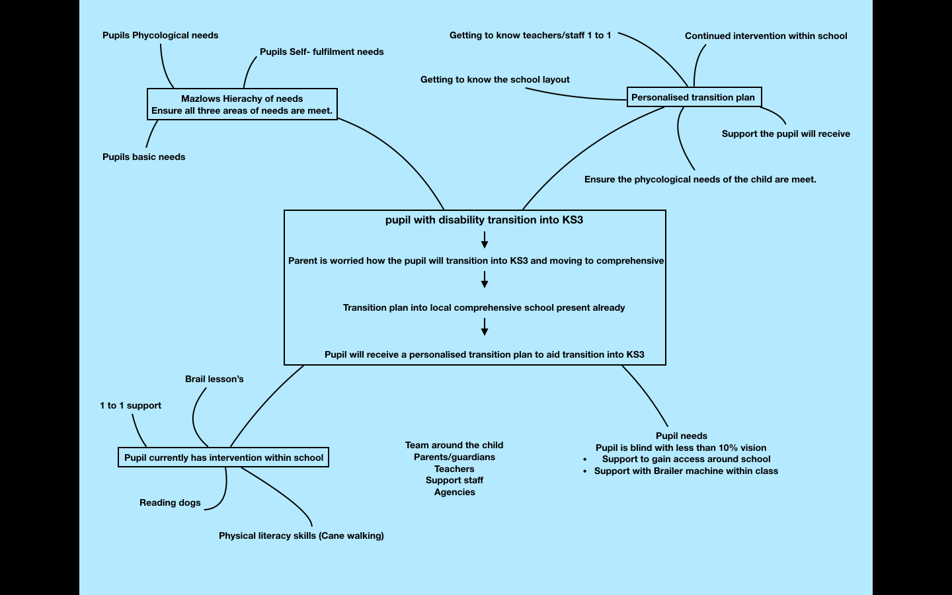

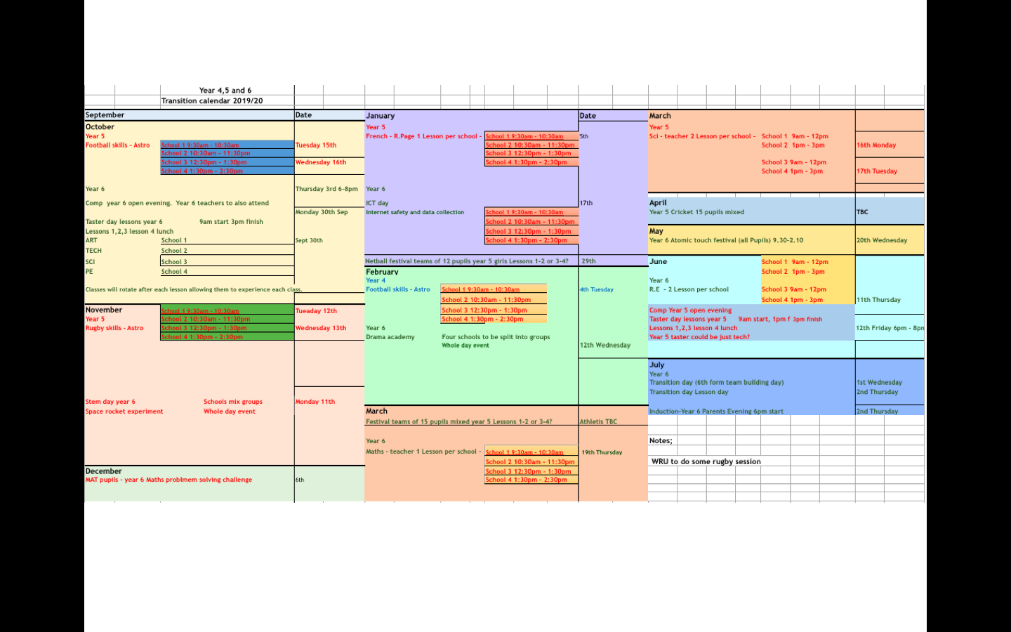

School context/Development plan

The Primary school located in the county of Pembrokeshire the school is a medium-sized school with a number of 250 pupils and a large amount of staff. The school is a community school with low literacy and reading scores. The school is currently waiting upon another visit from ESTYN following the amber rating in the last academic year. The school has a strong school development plan and an inclusive ethos. The school's ethos is of a constructivist approach who believes the provision of all pupils is paramount. The school takes pride in it’s many after school clubs activities and, are proud to be an eco-school. The school is also working towards being recognised as a right's respecting school and, takes pride in their inclusiveness to all walks of life. The areas surrounding the school include the neighbouring village which is large in size. Many children within the school are from broken homes and many parents do not work. Due to this, the school is used to visits from community officers and many pupils (40% average) fall within the FSM bracket. The school is situated within a rural area with many cultural landmarks within the surrounding areas including a local castle and beach. The school makes trips whenever possible to visit such areas and conducts a large amount of learning in the school's outdoor areas i.e. fields and woodland. The school is at maximum capacity with an average of 31 pupils within each class and is waiting for a new school building to be built in the neighbouring fields.

The school is proud to have a full-time intervention class for pupils within the KS2 years with a mix of pupils with additional learning needs and independent development profiles. The class was created prior to the last Estyn inspection where it was found that there were pockets of pupils within KS2 who were struggling and needed additional support.

The school has three main areas of development

Increasing Reading scores. The school has experienced low reading scores due to this reason they have adopted a number of interventions thought the school to aid the pupils in their reading. There is a new library with books suggested by the children. There are visitors every Tuesday and Thursday to the foundation phase classes to aid in reading. The school has also launched a book scheme where pupils can read books and claim points for completing the book. The pupils must show some level of understanding of the book then the teacher awards a point to that individual on the class point system. Rewards are given at various intervals of points. Beginning at 25 point intervals and moving to 50 point intervals after 100 points are claimed.

Use of Welsh within the school. The school’s Welsh coordinator has put in place a new clwb Cymraeg system to encourage pupils in the class to speak welsh. Teachers are asked to give the names of pupils who have spoken welsh in class that week. Then one Pupil within each year is given a welsh dragon puppet. The pupil is then asked to write a diary entry over the weekend about what they have got up to with the dragon.

Use of ICT and following the digital competency framework. The ICT coordinator in the school has started a new after school computer club to encourage pupils to develop their skills. In addition to this, each class is asked to complete one piece of work online each week. This may vary from maths to drawing a picture through hwb.

Reference list

(Crafter & Maunder, 2012 cited in Macblain, 2014, t.121)

(Professor Donaldson Graham, Successful futures, (2015,52) http://dera.ioe.ac.uk/22165/4/150225-evidence-base_Redacted.pdf)

(Evaluation Of Excellence In Cities Primary extension, A report of the transition strand study, Ekua Brown, Lesley Kendali, David Teeman and Kate Ridley, NFER, https://www.nfer.ac.uk/evaluation-of-excellence-in-cities-primary-extension-a-report-of-the-transition-strand-study/ , 2004 )

(ESTYN, Excellence for all, Transition plans and grant, An evaluation of the impact of transition plans and grant on primary and secondary school partnerships at key stage 2 and key stage 3, March 2010)

James A. Beane, Curriculum integration and The Disciplines of Knowledge (1995)

”Maria Montessori’s cited in, Linda Pound How children learn practical pre-school books publishing 8/7/2014”

(ESTYN, Excellence for all, Transition plans and grant, An evaluation of the impact of transition plans and grant on primary and secondary school partnerships at key stage 2 and key stage 3, March 2010)

Bibliography

Arshad,R. , Wrigley, T., Pratt, L. (Ed by) (2012) Social Justice re-examined: dilemmas and solutions for the classroom teacher,London:IOE Press

Symonds, J. (2015) Understanding School Transition: What happens to children and how to help them. Oxon: Routledge

WAG (2016) Well-being of Future Generations (Wales) Act.Cardiff:WAG

Welsh Assembly Government. (2006) Guidance on the preparation of Key Stage 2 to Key Stage 3 Transition Plans. Cardiff: Welsh Assembly Government.

Welsh Assembly Government. (2004) Aiming for Excellence in Key Stage3: Bridging the Gap. Developing and using bridging units to support effective transition from Key Stage 2 to Key Stage 3. Cardiff: Welsh Assembly Government

(Crafter & Maunder, 2012 cited in Macblain, 2014, t.121)

(Professor Donaldson Graham, Successful futures, (2015,52) http://dera.ioe.ac.uk/22165/4/150225-evidence-base_Redacted.pdf)

(National training federation of wales: Education for sustainable development and global citizenship, in work based training report, author unknown, 2010-2011)

(Evaluation Of Excellence In Cities Primary extension, A report of the transition strand study, Ekua Brown, Lesley Kendali, David Teeman and Kate Ridley, NFER, https://www.nfer.ac.uk/evaluation-of-excellence-in-cities-primary-extension-a-report-of-the-transition-strand-study/ , 2004 )

James A. Beane, Curriculum integration and The Disciplines of Knowledge (1995)

”Maria Montessori’s cited in, Linda Pound How children learn practical pre-school books publishing 8/7/2014”

(ESTYN, Excellence for all, Transition plans and grant, An evaluation of the impact of transition plans and grant on primary and secondary school partnerships at key stage 2 and key stage 3, March 2010)

(Russell Grigg ‘Becoming an outstanding primary school teacher second edition’ pages 30 table 1.4 (24th Aug 2014) published by Routledge Taylor & Francis group, Printing house in London or NewYork)

Youtube link to video presentation

https://www.youtube.com/watch?v=FQRkwgf54Tg&feature=youtu.be

