Ryan Morris (1550957)
1550957@student.uwtsd.ac.uk
Final Year Project
Project proposal
Enhancing Financial Literacy Through a Web-Based Compound Interest and Investment Calculator for Young Investors
Table of Contents
Introduction 1
Background (Literature Review) 2
Summary 3
Similar Tools 4
Monevator Compound Interest Calculator 4
Investor.gov Compound Interest Calculator 5
Nutmug Calculator 5
The Calculator Site 6
Problem Statement 7
Aims and Objectives 8
Aim 8
Objectives 8
Project Design (Product Development) 8
Requirements Specification 8
Basic Wireframe Design 9
Development Methodologies 12
Development Technologies 12
Frontend Development 12
Backend Development 12
Database 12
Application Programming Interface (API) 12
Version Control 12
Timeline 13
Bibliography 13

Introduction
The power of compound interest is no new discovery, the younger people are when they begin to invest, the longer their money has to compound. If we take the S&P 500 for instance, over the last 30 years (1993-2023) the average return was 9.90%. 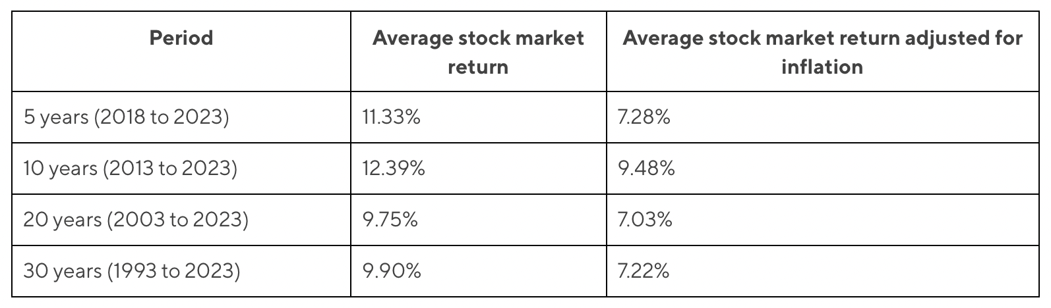[1]
If someone invested £100 per month for 30 years at 9.90% interest, their investment would be worth £218,397.71, with a total contribution of just £36,000.

There are plenty of compound interest calculators on the internet, but I believe there is a gap, and need, for an interactive compound interest calculating tool specifically for high yield stock indices with proven and trackable histories. Stocks I would endeavour to provide historical data on include; S&P 500, Dow Jones, NASDAQ, FTSE100/FTSE250.
I feel current calculators don’t go far enough in educating users & are not interactive enough.

The primary objective of the online tool is to visualise data to encourage young people to use their youth to their advantage and invest early to capitalise on the power of compound interest. To achieve this, initial key features include an investment calculator which will allow users to modify variables such as investment duration, interest rates, initial investment amount. Reverse calculations such as “how much would I need to invest monthly at $x$% interest rate to have $x$ amount invested by $x$ date” would also be a key feature.

Background (Literature Review)
“A Study of Financial Literacy and Financial Behaviour Among Millennials and Generation Z” by Dr. Anita Riwari, Akash Yadav [2, No. 21] is a journal published study which explores different aspects of financial literacy, including investing behaviours. The study shows that of the 109 participants, a low 35.8% of respondents invest in mutual funds, with a larger percentage (87.2%) opting for savings accounts. The study also shows that just 11% of respondents allege to have excellent knowledge on financial literacy.
Dr. Anita Riwari, Akash Yadav [2, No. 21] also analysed sources of awareness for gaining financial literacy. The use of the internet was prevalent as the most effective source of gaining financial knowledge, this supports my web-based application to encourage financial literacy surrounding investing and compound interest.

Hubbard, Matthews, and Samek [3, No. 2] “Using online compound interest tools to improve financial literacy” notes that people who understand compound interest are typically more likely to effectively financially plan, including investing for retirement and managing credit card debt Lusardi et al [4]. Hubbard et al. [3, No. 2] designed, tested and analysed three tools to establish which data display method was most effective at improving understanding of compound interest (text, linear graphs and volumetric graphs), measured by tests before and after using the tools. The results surprisingly showed that the text-based tool improved understanding more than the two graph-based methods. Interestingly, the tools use “what if” scenarios to prompt and calculate the compound interest, which I agree is a good way to ensure the user is invested and interested in the results. I will explore multiple options of viewing data on my web-application to ensure the results of any calculations are easily understood.

Hastings and Mitchell [5, p. 1] paper looks at how retirement wealth and investing behaviours are shaped by financial literacy and impatience by analysing experimental data from the Chilean EPS/Social Protection Survey, which is akin to the US Health and Retirement Study. Their results found that impatience, the subjects need for instant gratification rather than long term results, heavily influenced their self-reported retirement savings. I feel that having an easy to access/use and self-explanatory compound interest calculator which demonstrates a big potential upside to long term investment could encourage impatient users to invest for the future. Hastings and Mitchell also found that financial literacy directly correlates to more retirement savings, again highlighting the need for online tools which directly improve users’ financial literacy through education on investing and compound interest.

Summary
The literature review has shown that there is a need for online resources to help educate young people on compound interest and investing. According to Dr. Anita Riwari, Akash Yadav [2, No. 21], more young people are opting for lower yield savings accounts over investing in indices, which could greatly enhance their financial potential, further highlighting the need for educational tools in this area. Hubbard et al. [3, No. 2] research supports my project idea that online tools which present data in text and graph format are effective at improving users knowledge on compound interest. Finally Hastings and Mitchell [5, p. 1] shows us that financial literacy (and impatience) effects long-term investing behaviour. By creating an accessible and engaging web-application I hope to show users of the potential which could be realised through investing.

Similar Tools

Monevator Compound Interest Calculator
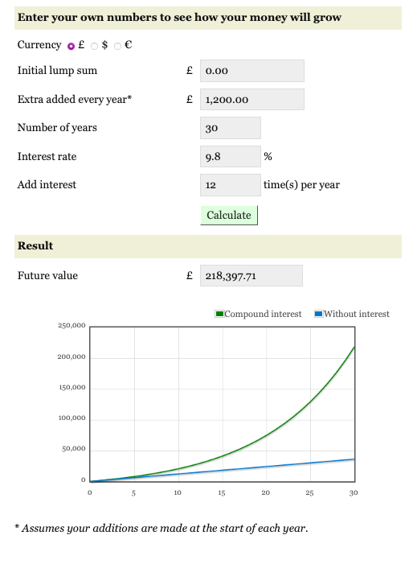[6]
This compound interest calculator by Monevator is simple but effective. It allows multiple currencies, which is a useful and easy addition I could implement on my own web-app. The graph is clear but based on Hubbard et al. [3, No. 2] a text based graphic could be more beneficial for user information. There is no option for historical interest rates.

Investor.gov Compound Interest Calculator
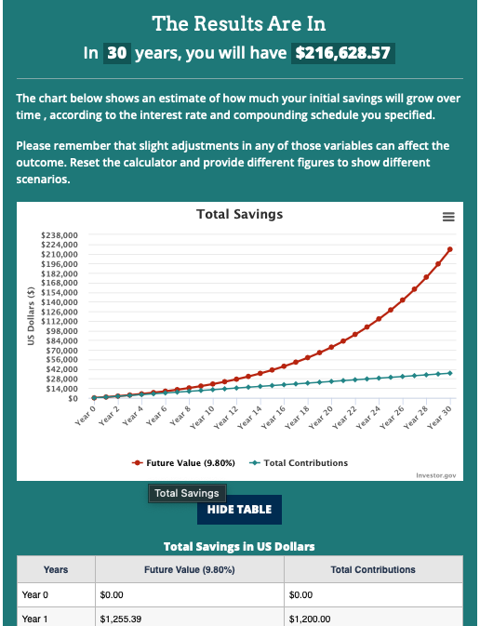
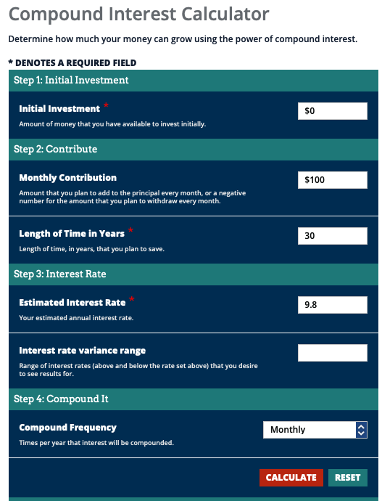

Investor.gov [7] have a simple compound interest calculator which is very matter of fact. Beside showing a clear graph and optional, hidable table the website is typical of a US government website and does little to engage the user. We can’t use any currency except USD and cannot select an interest from a list of historical indices, only entering a manual interest rate.

Nutmug Calculator
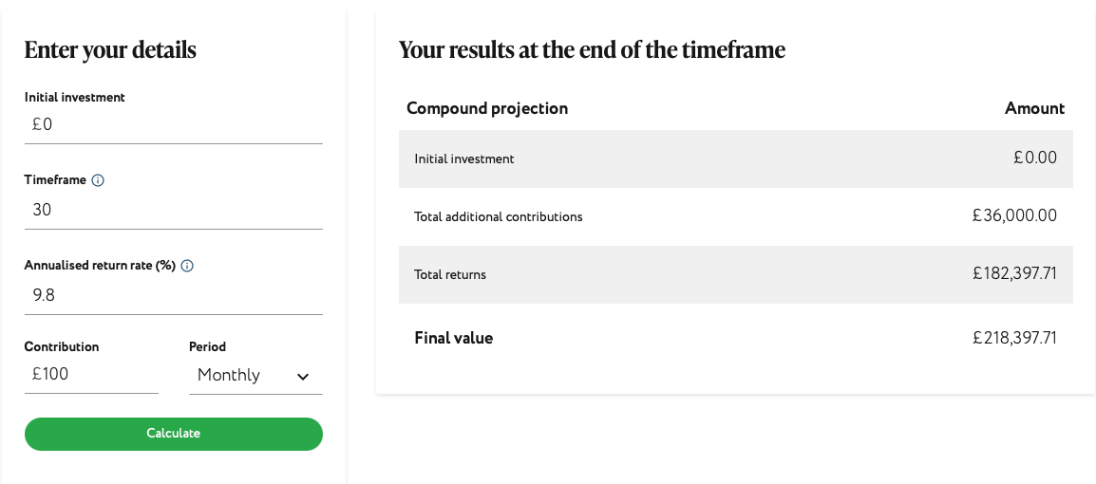[8]

Nutmeg provides a very simplistic compound interest calculator, without any text-based or graph-based graphics. The simplistic nature of the calculator could be utilised for an initial summary to accompany other visualisation methods on my web-app, providing a concise overview.

The Calculator Site
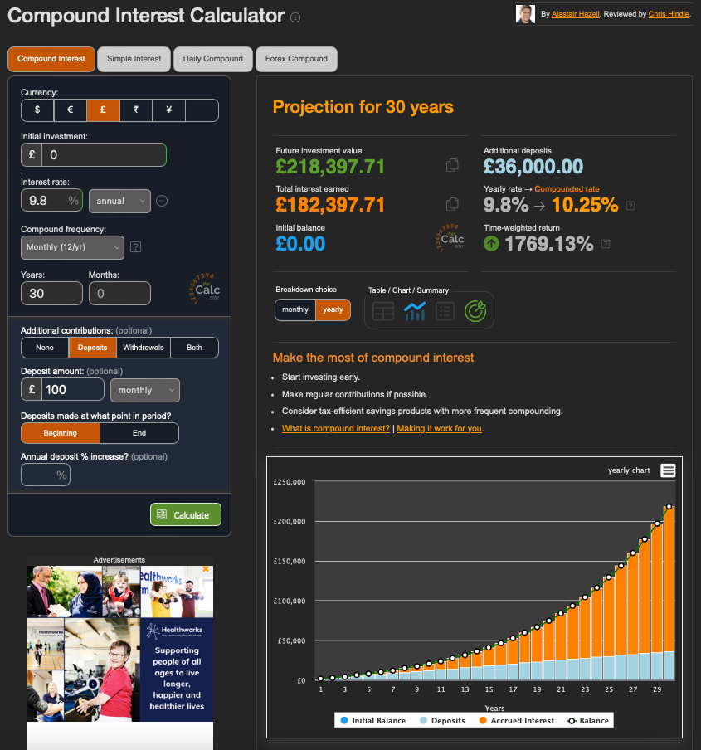
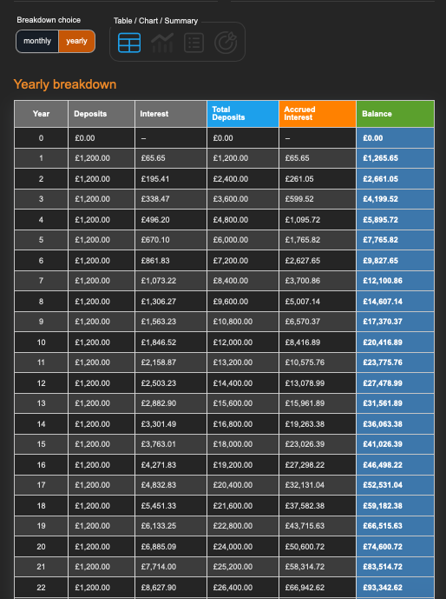[9]
The Calculator Site has the most comprehensive compound interest calculator of those reviewed. Their tool utilises graphs and text-based graphics to display investment returns and has multiple currencies to pick from and variables to edit. I especially like the option to increase the monthly deposit by a percentage annually, as many employers give cost of living pay increases annually, this could be an option that many find useful.

Problem Statement
Given the review on similar products on the market, there is certainly a lack of tools currently on the market which allow the user to select from a predefined list of historical indices, allow users to do reverse or ‘what if’ calculations, and save their calculations for future reference. There is an overall lack of focus on educating the user in the reviewed tools.
My project idea will build on the similar basic compound interest calculators we have looked at, amalgamating the best features from each into a web-application. By allowing users to input custom variables, visualise the results in multiple engaging formats as researched by Hubbard et al. [3, No. 2], and allowing users to save calculations, I hope to create a web-application which will keep users engaged and in turn encourage users to invest early to maximise the potential of compound interest, as well as educate users on the benefits of compound interest through clear and concise descriptions and explanations throughout the app.

Aims and Objectives

Aim
To design and develop an interactive, web-based compound interest calculator which educates users by demonstrating the potential growth of investments based on historical data, or user defined interest rates.

Objectives
- Design and develop a compound interest calculator web-application which will allow users to modify inputs such as interest rate, initial investment, length of investment and monthly contributions, if applicable. APIs will be used to obtain historical interest rates for popular index funds such as S&P 500, NASDAQ, Dow Jones, and the FTSE 100. Users can also opt to enter their own custom interest rates if preferred to test out hypothetical interest rates etc.
- Implement different data visualisation methods (for example text based and linear graphs) within the web-app to clearly communicate the effects of compound interest and the growth of investments over time.
- Implement a reverse calculation feature which will enable the user to input a target investment amount and reverse calculate the required monthly contributions required to reach said figure in a given timeframe, either based on historical interest rates (obtained via API) or custom interest rates.
- Enable a register/log in system which will allow users to create accounts to save select calculations for future reference.
- Ensure an engaging user experience by providing clear navigation, simplicity, accessibility and responsiveness. Tooltips will be used where necessary to ensure the user has a thorough understanding.

Project Design (Product Development)

Requirements Specification

Basic Wireframe Design
I have created a basic wireframe of my potential web-app, focusing on the three main features/calculators. I have created this using MockFlow (https://www.mockflow.com).
1. Landing page incl. compound interest calculator
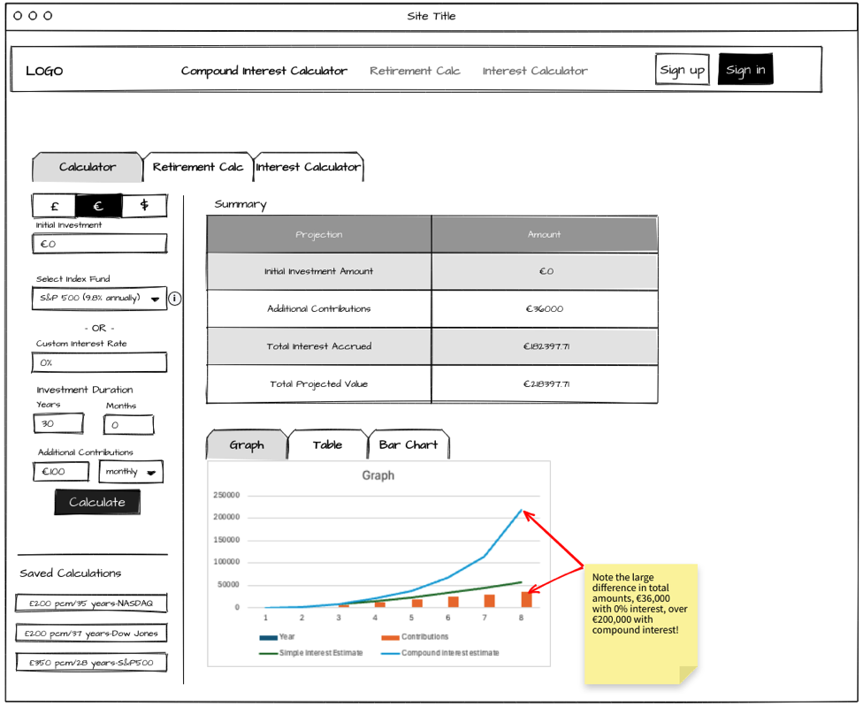

2. Retirement/Long-Term Calculator
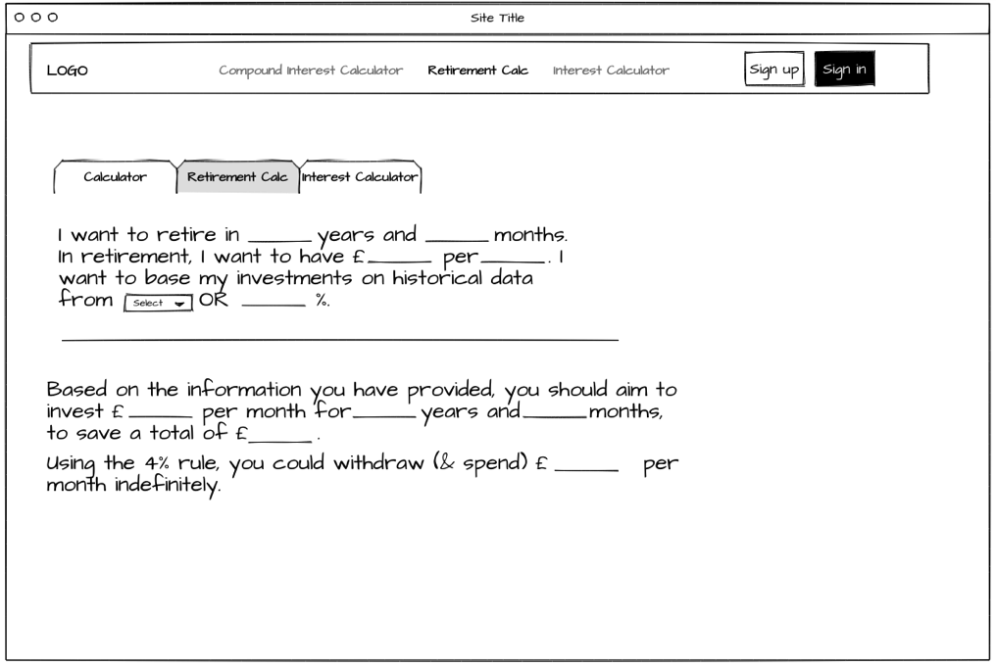

3. Interest Calculator
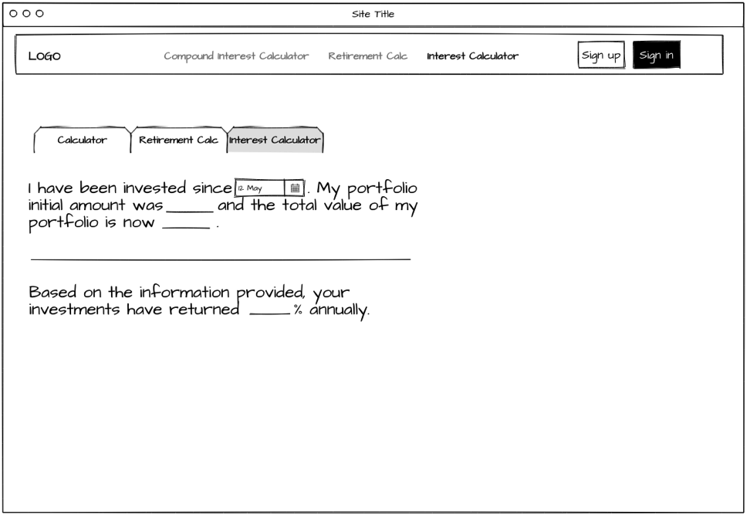

Development Methodologies
I am going to use a personal Kanban for solo development methodology to manage my development project. Some steps I will take include:
- Maintain Kanban Board. Will have columns “To-do”, “WIP”, and “Done” for ease of visualising task tracking/workflow [11].
- WIP limits to ensure I do not have too many tasks running concurrently, this will stop me from becoming overwhelmed.
- By regularly monitoring the Kanban board, I will have a good overview of the project and timelines, ensuring timely completion of the project.

Development Technologies
I am planning on using the following technologies to develop the web-app.

Frontend Development
HTML, CSS & JavaScript will be used for the main UI of the website. React.js will enable me to create dynamic and responsive content. I may use Bootstrap to ensure the app is responsive across various devices.

Backend Development
To ensure efficient handling of requests, I will use Node.js to execute JavaScript on the server while Express.js will manage routing, retrieving data from APIs and managing dataflow between the frontend and backend.

Database
I will use PostgreSQL database for my project as it is reliable and scalable. PostgreSQL also offers robust data encryption which is necessary for storing user data. If the project were to scale, a NoSQL approach using MongoDB may be more suitable.

Application Programming Interface (API)
In 2017, Yahoo! shut down it’s official API [10], fortunately there are third party APIs which continuously scrape Yahoo! Finance to maintain an up to date, unofficial Yahoo! Finance API. Another option I will investigate is the Alpha Vantage API which provides similar functionality in gathering historic stock prices.

Version Control
I will use Git and GitHub to manage the code and track version, as well as performing roll backs if necessary.

Timeline
I have used Tom’s Planner to create a gantt chart for a timeline for my project.
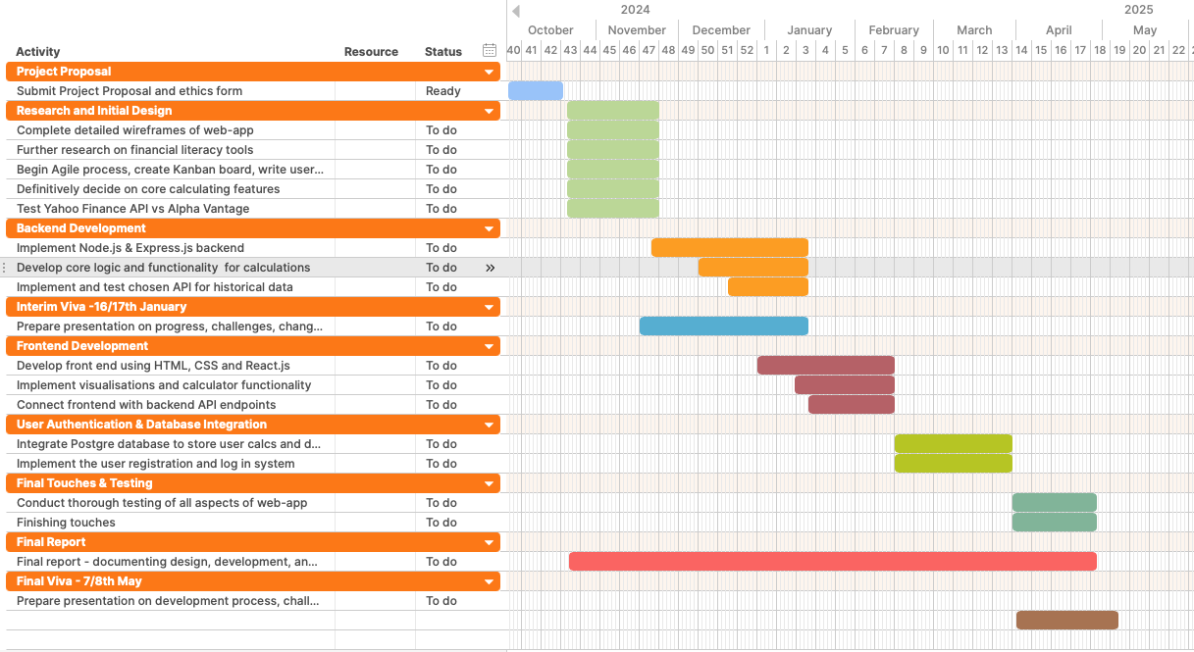

Bibliography

[1]
R. Lake, “What Is the Average Stock Market Return?,” Sep. 10, 2024. https://www.sofi.com/learn/content/average-stock-market-return/#:~:text=Average%20S%26P%20500%20Return%20for%20the%20Last%2030%20Years,%25%20when%20adjusted%20for%20inflation). (accessed 2024).
[2]
A. Y. Dr. Anita Tiwari, “A STUDY OF FINANCIAL LITERACY AND FINANCIAL BEHAVIOUR AMONG MILLENNIALS AND GENERATION Z,” no. 21, 2022.
[3]
E. Hubbard, P. Matthews, and A. S. Samek, “Using online compound interest tools to improve financial literacy,” vol. 47, no. 2, Apr. 2016, doi: 10.1080/00220485.2016.1146097.
[4]
“Compound Interest Calculator .” https://www.investor.gov/financial-tools-calculators/calculators/compound-interest-calculator.
[5]
A. Hazell, “Compound Interest Calculator.” https://www.thecalculatorsite.com/finance/calculators/compoundinterestcalculator.php (accessed 2024).
[6]
A. Lusardi et al., “NBER WORKING PAPER SERIES FINANCIAL LITERACY AND PLANNING: IMPLICATIONS FOR RETIREMENT WELLBEING,” May 2011.
[7]
“Compound interest calculator UK .” https://monevator.com/compound-interest-calculator/ (accessed 2024).
[8]
“Nutmeg Compound interest calculator .” https://www.nutmeg.com/compound-interest-calculator (accessed 2024).
[9]
L. Watts, “Benefits of Kanban Boards.” https://vertocloud.co.uk/blog/benefits-of-kanban-boards/ (accessed 2024).
[10]
G. Bland, “Yahoo Finance API – A Complete Guide .” https://algotrading101.com/learn/yahoo-finance-api-guide/ (accessed 2024).
[11]
J. Hastings and O. S. Mitchell, “How financial literacy and impatience shape retirement wealth and investment behaviors,” vol. 19, no. 1, p. 1, Sep. 2018, doi: 10.1017/s1474747218000227.

