DS 1 Template

My Screenshots/Photos
- Please add 4–6 screenshots or photos of your digital life.
- You can use your phone or laptop.
- For each screenshot, write one or two sentences explaining what it shows.

Screenshot/Photo 1
This is a Social Communication app called what’sapp
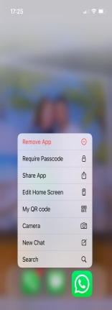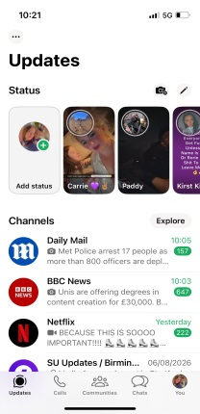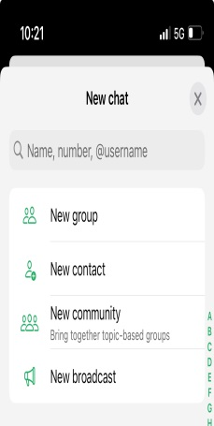
This app can be downloaded from any app store though a smartphone, iPad, or PC. It is used through a registered telephone number to be able to be used as a form of communication this can involve family, friends, and work. You can make group chats through the app which save you time if you have to send messages to numerous people at once. However you can also use video calls through the app to one or more people at a time.

I use this app on a daily basis to be able to keep in contact with my family and also my work friends. I also use it for public community updates such as the news and worldwide updates. This app is very quick and easy to use, the only thing which could be seen as a negative about this app is the fact it does have to be used through either mobile data or Wi-Fi connection, If you don’t have these then no messages can be sent out or received.

Screenshot/Photo 2
This is a free social app called Instagram
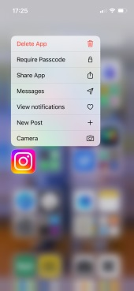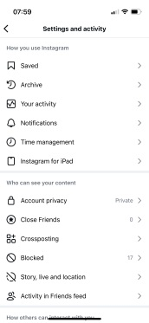
Instagram is a form of social media that lets people share photos, short videos and direct messages. The app can be used to add or follow family, friends and popular online creators that you might be interested in. The app can be used for your own personal life or an online account where you can promote items such as brands, popular tourist attractions etc. When making an Instagram account you can choose to have a public account which can be seen by anyone worldwide or you can choose a private account which can only be seen by people you accept to be able to see your posts or story’s you upload.

I use this as a personal account so only people I allow on to my account can see my posts. I mainly use this to keep close friends and family up to date with my son, I share photos off days out and achievements he has made, I also share popular quotes that I agree with to my story which can be seen for 24 hours after posting. This form off communication is important to me as I don’t see my family or friends regularly so having this app is useful for us all to be able to stay up to date with what we have all been up to without having to message each other every day.

Screenshot/Photo 3
This app is called Arbor.
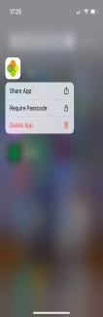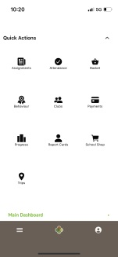
Arbor is a private App that can only be used by the parents and careers that attend my sons school, its not open to the public.
I personally use this app to be able to:
- See my sons daily timetable
- Keep on top off his attendance
- Check if any money is owed for trips or clubs he attends

I find this app really useful for parents as it is confidential so you can only see your child no one elses, but also because as a parent daily life can sometimes get on top off us and we can forget about payment deadlines, however with this app you are reminded off your balance and can keep track off payments due, or payment late.

Screenshot/Photo 4
This is a secure digital app called Natwest.
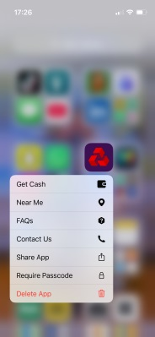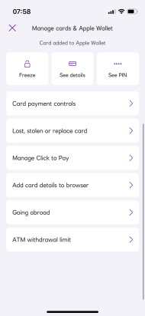

This app is a digital platform which lets you manage your personal or business bank account 24/7, this can be done through your mobile phone or a computer. It allows you access to be able to view your balances, pending transactions on your accounts and bank statements to show all your transactions either coming in to your ban or leaving your account. Using this app is very useful as if you was to lose your bank card instead of going in to a ban directly you can report your card lost or stolen through the app straight away and have your card frozen incase anyone was to find it.

The app is kept secure directly for only your access through your own private customer number and pin, but also your own private password to be able to gain access on your phone in to the app.

I love this app due to the easy access daily to be able to move money between accounts but also to be able to see what I have available straight away when needed. I find it easier to keep on top off my bills as I can see my direct debit’s and dates they are taken. If needed it is also very hand to be able to set up a payee to be able to send money.

Screenshot/Photo 5
This is a digital app called Outlook.
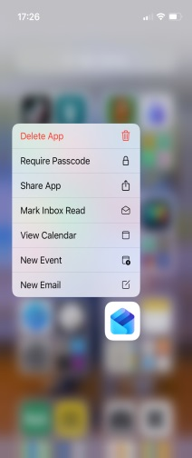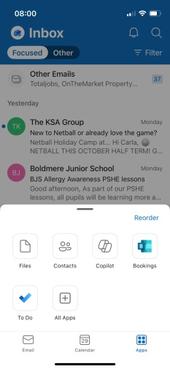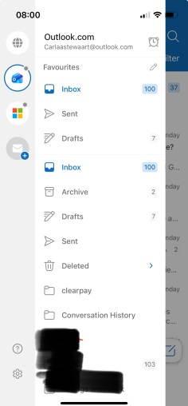

This app is called Outlook which was developed through Microsoft. This app can be used to send and receive emails, manage your calendars and plan ahead.

I use this app to be able to keep in touch with professionals such as companies I have accounts with, my household bills, University and my son’s school for newsletters and important information. I use the app to be able to keep everything organised in folders so I can refer back to any information I need at any time, but also to be able to plan ahead by using the calendar’s available to set deadlines, appointments, or due dates for bills. The app also allows people to contact me directly and gives me the chance to be able to reply directly from the message that has been sent to me. By allowing this is give you a conversation thread so I don’t have to search through all my emails to be able to find previous messages to anyone.

Screenshot/Photo 6
This is an online selling or buying app called Vinted.
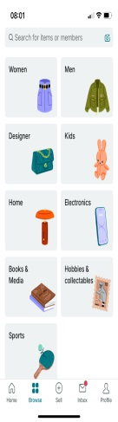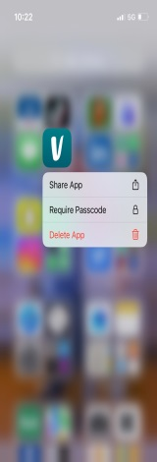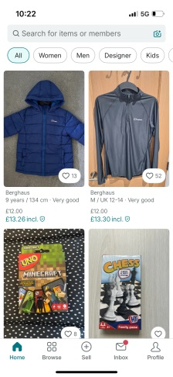
Vinted is an online app where people with an account can buy, sell and browse for items. The app is very useful is you have purchased items that don’t fit or you don’t like so you can upload them on to your profile with an asking price, however people can send you direct messages if they want more information and can send you messages asking if you would lower the price. The postage off the items is covered by the person selling, and is all done through a secure payment process where no private or confidential information is given.

I love using this app as it is so easy to browse for items I need for myself or my son, but also it is so much cheaper then going directly in to shops. Postage is very cheap which again means a lot to me as if I was to order from an online store such as JD Sports there delivery can vary rising to around £5.99 which in some cases is unaffordable. Delivery is aimed for 3-5 working days which is so helpful if I need something quick. I have previously sold items on here which is such an easy process and the posting parcels is so simple and straight forward with direct instructions how to do it. Since using this app I rarely use any online shops I always come to this app first to have a browse to save myself money.

My Short Reflection
- Write 5–8 simple sentences about your digital life.
- You can use the sentence starters below if helpful.
Overall I use these Digital tools on a daily basis as my way off communication, purchasing items or to gather information I need. I sometimes feel nervous about using Digital tools, as they can require updates which can make changes to the way things work, but I do find it an easy process once I have went over the changes a few times.

Digital tools are really important to be because I need a way to access documents for my study, but also for my personal life such as family connections, work rota’s and my son’s appointments and school. Furthermore I think without digital skills my day to day needs would be very hard to keep track off. I feel confident using the Digital tools above because I have used them for so long as part of my daily life. I feel I know everything I need to know about the app’s individually and the importance of each off them to me. I do feel that if Digital skill wasn’t a form of communication I would really struggle to maintain relationships and my work life, aswell as keeping on top off deadlines and appointments.

I hope this module will help me understand the importance of Digital Skills in a business environment, but also help me learn the risk’s off using them aswell.

Sentence starters
- I use digital tools to …
- I feel confident when I …
- I want to improve …
- I often use these tools: …
- I sometimes feel nervous about …
- I hope this module will help me …
- Digital skills are important for me because …
You can write more if you want.

Submission Checklist
Before you submit, please check:
​​​ ☐ I added 4–6 screenshots
☐ I wrote short sentences for each screenshot
☐ I wrote my short reflection
☐ My work is my own
☐ My file opens correctly
​​☐ My file opens correctly

