Callum Jones
2306025@student.uwtsd.ac.uk

fundamentals of construction technology
Assignment 1

Site investigation case study

Contents
History of Swansea docklands 2
Research of other surrounding local areas 2
Sit details. 3
Site archaeological risk 4
Things to consider when doing a survey of the Swansea docklands area. 5
Borehole testing 5
Soil contamination assessment 5
Ground water assessment 6
Topographical survey 6
Modern considerations due to the history of the docklands 6
Environmental contamination 6
Ground stabilities issues 7
Flood risks 7
Suggestions for the construction of the foundation of the building 8
Pile foundation 8
Why the pile foundation is the most suitable for the dockland area. 10
Ground conditions 10
Load bearing capacity 10
Environmental impact 11
Minimising the risk to settlement 11
Water table variability 11
Construction efficiency 11
Future implications 12
Flexibility in design 12
Conclusion 12
Bibliography 13

History of Swansea docklands

Swansea docklands had early industrial roots being used as a vital part of the worlds coal and copper trade in the 19th century. Due to its amazing coast location, it made it easy to dock ships for the transportation of this coal and copper. At one point the docklands dominated the copper industry so much that it earned the nickname “Copperopolis”. Swansea docklands was one of the largest transporters of coal all around the world and at the time this contributed significantly to the city’s economic prosperity.
The great western railway line ran straight away the sea front allowing easy transportation of coal and copper to the docklands for exportation. This railway was initially constructed for the purposes on transporting coal from the nearby coalmines, however later evolved to become one of the first passenger railways.
Due to the many job opportunities within and around the thriving docklands many people come to work leading to a large influx in population in the local area.
Swansea docklands outstanding ability to provide the copper and coal led to it becoming a global in leader in metallurgical processing according to (Rogerson, n.d.)
Information found at (Swansea museum, n.d.) (Discovering Britain, 2018) (M.Powel, 2021)

Research of other surrounding local areas

I believe that research in the surrounding areas will provide us with more information on problems that may occur on the Docklands construction site due to the history of the area and the relatively close proximity of some of the sites.
This site is in SA6 8QL which isn’t that close, but I believe some similar outcomes to a site investigation due to what the whole Swansea area was used for in the 19th century. (Davies , 2019)
This site is from SA1 7DB where an applicant wanted to build 45 domestic houses and this was a response from the planning committee which could have a similar result when applying for permission to create the university building (Planning Committee, 2018)

Sit details.

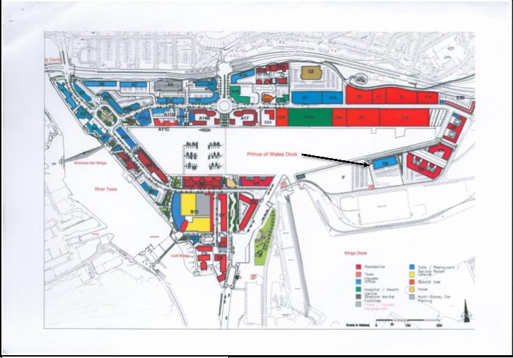
(Nantel, site plan photo informtion, 2023)

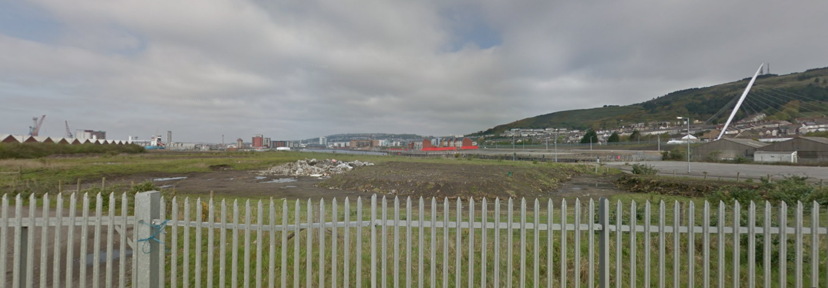
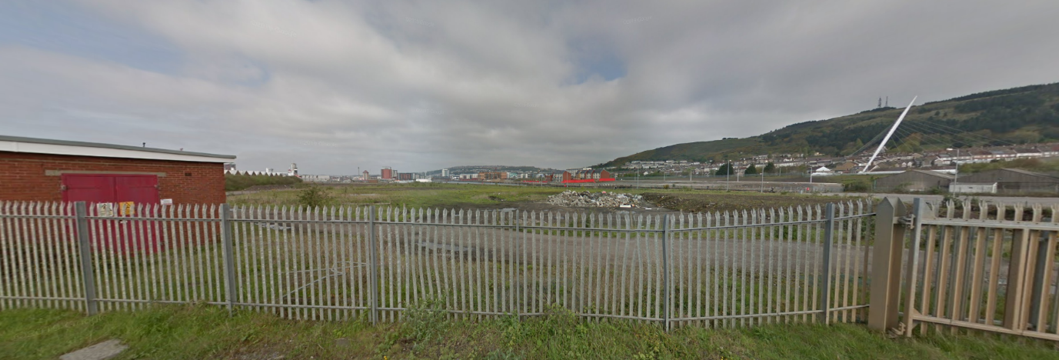
These pictures were taken from google maps to provide me with a better understanding of the site location and size. (Google, 2012)
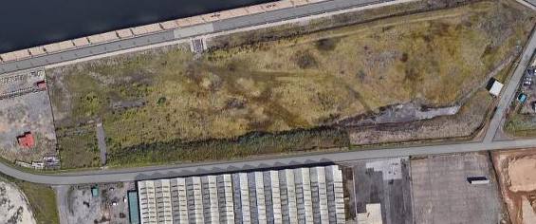
(Google, n.d.)

The site is a brown field site showing a lot of signs of having previous structures having been in this location. The site is completely fenced off showing low risks to vandalism. Access to the site seems reasonable decent with two accessible roads connecting to either side of the site.

Site archaeological risk

Within the local area black mountain archaeology say “ The laboratory was used to test the metal mixtures during smelting and alloying and dozens of small ceramic assaying cupels were found in demolition rubble” ( Black mountain archaeology, 2020) This is a risk due to historical artifacts being found in the area this could end up making construction come to a holt.

Things to consider when doing a survey of the Swansea docklands area.

Borehole testing

Borehole testing should be carried out by professionals so that a variety of different soil sampling techniques can be used to provide us with a better understanding of the ground composition which would help us get a more accurate understanding of what considerations need to be taken into account when selected our foundation choice. Here are the regulations on borehole testing (HSE, 2008)
Here is a document showing some results that could be similar to the ground under the site (Nantel, Bore Hole Log, 2023)
Bore hole findings of a nearby site suggests that to be made ground consisting of layers that have ashes, soft sandy clay, sandy gravel, gravelly boulder clay, and mudstone this suggests that you would likely have to have deep structurally supportive foundations have would provide you with enough stability to keep a structurally sound building on top. Given that the building is proposed at three stories high it is likely that the building would be at risk of settlement at due to these layers unless the foundations depth goes beyond the unstable ground into the more solid layers bellow. I think that due to this these are various foundation choices to consider ensuring that the load of the building is to be evenly distributed throughout the area bellow the surface.
It is also important to consider the possibility of remnants of the old dock work being under the site and if it is deemed necessary construction will be halted to extract these remains potentially causing major time delays in the project.

Soil contamination assessment

a soil contamination assessment would provide us with a better understanding of the contaminants this would be especially important considering the industrial history of the area, it would be very important for us to test for the more common contaminants associated with the history due to it being likely of things such as heavy metals hydrocarbons or other common pollutants. Here is the information about soil contamination testing (GOV, 2012)

Ground water assessment

Do any groundwater assessment would be important so that we know the depth and the fluctuations of the water table to better understand the implications of doing construction in the area. Having done a groundwater assessment would also give us a better understanding of the groundwater quality and help us identify any risks associated with contamination giving us an even better understanding. Here is information on ground water protection. (The Environment Agency, 2018)

Topographical survey

A topographical survey after being conducted would provide us with a understanding of the surface features and contours of the site. This would then allow us to identify any existing infrastructure utilities or other features that may take a part in impacting the construction of the university building. Here is information on the ordinance survey act (Gov, 2005)

Modern considerations due to the history of the docklands

Due to the history of Swansea docklands when considering the construction of new builds it is important to have a good understanding of what the potential risks to ensure the safety and stability of the new university building.

Environmental contamination

Due to the heavy industrial history of the docklands more specifically with coal and copper exportation. It is important to consider the potential for ground contamination that may have been left behind from this period as it is really likely, and this could be an environmental risk during construction.
To minimise this risk, I suggest that ground investigations need to be done in the proposed area to find the extent of the contamination. After that to address this issue may involve soil remediation or ground water treatment. This would ensure the health of the future students and lectures that would be in this building for extended period of time.

Ground stabilities issues

Due to the excessive mining and shipping in the area this may have affected the overall stability of the ground. This could lead to ground subsidence or instability which would pose as a massive threat to the structural integrity of any new build that were to be implemented.
To ensure that this risk is not a problem later down the line I would suggest that the conduction of geotechnical investigations be taken place to assess the ground bellow the site this would include things like borehole tests and analysing the water context of the soil.

Flood risks

Due to the location of the site is it important to consider the possibility of the site being at risk of flooding this could be impacted due to multiple factors such as rising sea levels; excessive rain fall and soil permeability.
To ensure that this risk is at a minimum I would ensure that a sufficient drainage system be put into place. This would significantly lower the risk of flooding ensuring the safety of the site. This would be important due to the local planning committee stating that no occupants are permitted to stay in the buildings until a sufficient drainage system has been put into place. (Planning Committee, 2018) This would give the idea that because there is a high risk of flooding in this area it is likely to receive a similar outcome.

Suggestions for the construction of the foundation of the building

There are many considerations that need to be taken into account when considering what foundation should be used for this building. I am going to be discussing what foundation I believe to fit the criteria for the area the best along with suitable reasoning for my choice. This is important due to the plethora of problems that are likely to occur with the ground underneath the construction site.

Pile foundation

The foundation I think best fits this area is a pile foundation so here is a bit about the pile foundation. A pile foundation is one of the deeper foundations used to ensure the stability of a structure. Pile foundations are typically made from reinforced concrete and are either smashed into the ground (displacement) or dug out and placed into the hole (replacement). Pile foundations are used most commonly is larger high-rise buildings, bridges and waterfront structures where the soil stability in the area is insufficient. Making this the initial thought when it comes to the idea of foundations in the area.
An expert says that low bearing capacity soils give the right conditions for pile foundations (Doherty, 2018)
Here is a cross sectional drawing of a pile foundation to get a better understanding of what kind of stability it could provide for the heavier load of the building proposed.
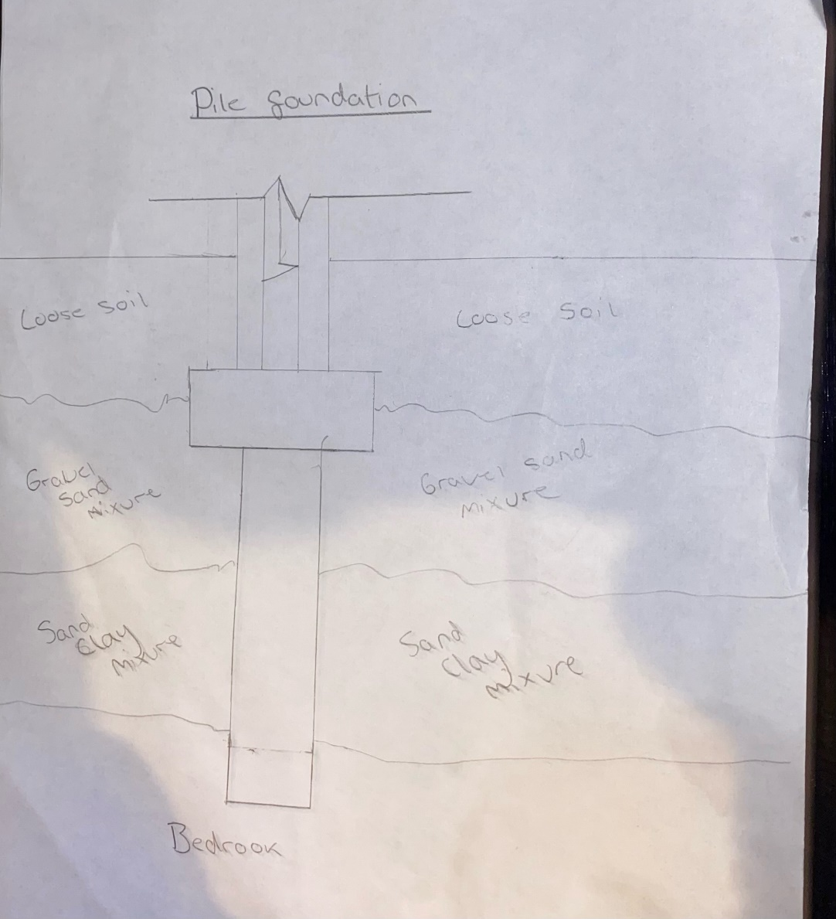
(This picture was hand drawn by me)
This drawing shows how the piles themselves go beyond the unstable layer and use the added friction in addition to remain solidly stuck into place.
Here is another picture of a foundation to get a better understanding on a bit larger scale.
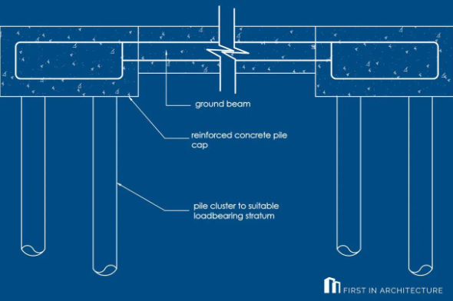
(First in Architecure, 2023)

Why the pile foundation is the most suitable for the dockland area.

Ground conditions

The soil conditions of the area may be unstable due to the history of the area. However, the pile foundations would be effective as they would go deep down through the poor soil conditions and reach the more stable rock bellow giving the building greater stability in the potentially soft/looser soils that are likely to be found bellow the site.

Load bearing capacity

It is almost a given that the university building would have a lot of weight placed on the soil. The reason I believe pile foundations to be the best solution to this is because it would evenly distribute this weight deeper into the ground over a much larger area. This would be beneficial in this area due to the site likely having a low load bearing capacity due to the industrial history of the site.

Environmental impact

Having pile foundations being used can be to a huge benefit due to it minimising the environmental impact that would be placed upon the site when compared to the more traditional shallow foundations. The construction process would involve a lot less excavation reducing the disturbance to the soil that has a very high chance of being potentially contaminated. This would also save on money due to heavy soil remediation being a lot less within the site.

Minimising the risk to settlement

Pile foundations would be good in this regard do to be in amazing at preventing settlement issues. And due to the history of the site it is very likely that settlement would have occurred due to the variations of soil composition. The piles would be driven deep enough into the soil so that it reaches the most stable rock below it this would be highly beneficial to the structural integrity of the building reducing the risk of differential settlement.

Water table variability

Due to the location of the site, it is very likely that Swansea Docklands may have a fluctuating water table as a result of this pile foundations would be to a great advantage as they can be designed to extend through the water table providing the building with a lot more stability, I'm making it less likely to be affected by the changes in the groundwater levels.
Here is some information on the effects and implications that may occur due to the water table (Green cap, 2021)

Construction efficiency

Pile foundations can be a lot more time efficient than traditional shallower foundations such as strip foundations especially when dealing with the challenging soil conditions that are likely to be a large problem due to the area. The construction process would involve a lot less excavation and can proceed concurrently with other construction activities. This would then have a high likelihood of potentially reducing the overall project timelines which has a benefit of saving not only time but money as well.

Future implications

There are many things I could talk about when talking about the future implications that could come about I primarily focusing on how the pile foundation would save money over time the first way it would do this is do too pile foundations needing less maintenance then some of the more shallow foundation alternatives which may result in a cost of savings over the lifetime of the building which do to the location of the building I believe this is important as with other foundation options there is risk that they would not be appropriate leading to constant foundation repairs. Ever because of the deep anchoring into the stable rock this reduces the likelihood of the foundation having issues that could potentially cost money.

Flexibility in design

pile foundations in general typically offer a greater flexibility of design. This would allow the engineers to essentially tailor make the foundations to accommodate the specific grown conditions of the site. This would in turn be beneficial because the adaptability of pile foundations would be advantageous because of the many different problems that are likely to occur due to the history and geological contacts of the Swansea Docklands site.
Research on pile foundations was done at (Groundsun, 2021) (Science Direct, 2020) (EL-Reedy, 2014) (Kumar, 2021)

Conclusion

after careful consideration of various foundation options for the proposed building in the dockland area, the pile foundation emerges as the most suitable choice. The unique characteristics of pile foundations align seamlessly with the specific needs of this location, providing a robust and efficient solution. making it the optimal choice for the unique challenges presented by the Swansea Docklands site.

Bibliography
Black mountain archaeology. (2020, 24 1). Excavations. Retrieved from Black mountain archaeology: https://blackmountainsarchaeology.com/2020/01/24/excavations-at-the-hafod-morfa-copperworks/
Davies . (2019, january). Geo-environmental and Geo-technical report. Retrieved from IRM Planning: https://lrmplanning.com/app/uploads/2022/09/Geo-environmental-and-Geotechnical-Report-Part-1.pdf
Discovering Britain. (2018). Content. Retrieved from Discovering Britain: https://www.discoveringbritain.org/content/discoveringbritain/viewpoint%20pdfs/Swansea%20viewpoint2.pdf
Doherty, T. (2018, december 30). self build renovation. Retrieved from built it : https://www.self-build.co.uk/piled-foundations-explained/
EL-Reedy, M. a. (2014). Marine structural design calculations. In M. a. EL-Reedy, Marine structural design calculations (pp. 217-280). Elsevier Science & Technology.
First in Architecure. (2023). detail-post-foundation-details. Retrieved from First in Architecure: https://www.firstinarchitecture.co.uk/detail-post-foundation-details/
Google. (2012, may). Google Maps. Retrieved from Google: https://www.google.com/maps/@51.6183831,-3.9163962,3a,20.6y,266.55h,88.71t/data=!3m6!1e1!3m4!1sMuR2nsMtRMn04_had0q-Bg!2e0!7i13312!8i6656?entry=ttu
Google. (n.d.). Maps. Retrieved from Google maps: https://www.google.com/maps/d/edit?mid=1E_2JVV4UDvk1Eaj1xIetABeL1WiRdgE&ll=51.61886224725576%2C-3.918990275910801&z=17
Gov. (2005, april 1). Legislation. Retrieved from Gov: https://www.legislation.gov.uk/ukpga/Vict/4-5/30/section/2/2005-04-01
GOV. (2012, April). Contamination land guidance. Retrieved from GOV: https://assets.publishing.service.gov.uk/media/5a757dfa40f0b6360e47489d/pb13735cont-land-guidance.pdf
Green cap. (2021, may 27). risk review. Retrieved from green cap: https://www.greencap.com.au/news/2021-05-confined-aquifers-risk-review
Groundsun. (2021). pile foundations. Retrieved from Ground sun: https://groundsun.co.uk/pile-foundations-and-their-suitability-within-construction/
HSE. (2008). Boreholes. Retrieved from HSE: https://www.hse.gov.uk/pubns/priced/l72.pdf
Kumar, S. (2021). pile foundations. Retrieved from constrofacilitator: https://constrofacilitator.com/know-how-about-the-pile-foundation-advantages-and-types/
M.Powel, B. (2021). site. Retrieved from Coflein: https://coflein.gov.uk/en/site/300028/
Nantel. (2023). Bore Hole Log. Retrieved from UWSTD: https://uowtsd.sharepoint.com/:w:/r/teams/ACBA400120232024FUNDAMENTALSofCONSTRUCTIONTECHNOLOGY_GRP/_layouts/15/Doc.aspx?sourcedoc=%7BE2D94C6E-55F4-451C-9502-B57BC38F457C%7D&file=Borehole%20that%20can%20be%20associated%20with%20Assignment.docx&action=defau
Nantel. (2023). site plan photo informtion.
Planning Committee. (2018, April 3). documments. Retrieved from democracy swansea: https://democracy.swansea.gov.uk/documents/s43481/SCHEDULE%20-%203RD%20APRIL%202018.pdf
Rogerson, I. (n.d.). Docklands history. Retrieved from Swansea docks: http://www.swanseadocks.co.uk/docksnewsite/history.html
Science Direct. (2020). pile foundations. Retrieved from Science Direct: https://www.sciencedirect.com/topics/engineering/pile-foundations
Swansea museum. (n.d.). Docks and transport. Retrieved from Swansea museum: http://www.swanseamuseum.co.uk/swansea-a-brief-history/the-sea/docks-and-transport
The Environment Agency. (2018, February). Ground water. Retrieved from Gov: https://assets.publishing.service.gov.uk/media/5ab38864e5274a3dc898e29b/Envirnment-Agency-approach-to-groundwater-protection.pdf

