
University of Wales Trinity Saint David
Birmingham Campus

Raport

Writing Module: Academic and Employability Skills

Assigment Title: Evaluation of blended learning and classroom learning on student attainment

Student Name : Natalia Rupet
Lecturer Name : Buddhi Pathak
Student ID : 2109475
Module Code : BMSW 4001

Birmingham, 07.12.2021

Task 1

TABLE OF CONTENT
1.INTRODUCTION...............................................................................................................................  2. PROS AND CONS OF BLENDED LEARNING IN THE UNIVERSITY EDUCATION…….…..  2.1 Advantages of blended learning in the university education…...…………………….  2.2 Disadvantages of blended learning in the university education……………………..  3. PROS AND CONS OF TRADITION CLASS ROOM LEARNING IN THE HE SECTOR……..  3.1 Advantages of traditional class room learning in the HE sector……………………..  3.2 Disadvantages of traditional class room learning in the HE sector………………....  4. EVALUATION OF BOTH FORMS OF TEACHING AND LEARNING IN THE PAST AND PRESENT…………………………………………………………………………….……...….  5. RECOMMENDATIONS BASED ON EVALUATION…………………………………..……………..  6. CONCLUSION.................................................................................................................................  REFERENCES…………………………………………………………………………………….………...... | 2  3  3  4  5  5  6  7  7  8  9

- INTRODUCTION
The aim of this report is to compare blended learning with traditional classroom.
Whether in the past or present, students learn in their own ways, they have always been diverse. These days, teachers are likely to serve more students with special educational needs, and to teach either younger or older from diverse language backgrownds. Even there are to many students who are hesitant to try out unfamiliar learning methods, in this report we will try to find out the best method of learning between the two. Barindra De (2018) Traditional Learning Vs. Online Learning
What is blended learning and traditional classroom learning?
Traditional classroom means the formal process when students and instructors are physically present in the same classroom (Law insider,2013-2021).
Method of study where teachers and students do not meet in a classroom but use the Internet, email, mail, etc., to have classes, is called distance learning (Merriam-Webster, 2021).
According to Garrison and Kanuka (2004, p. 96). blended learning is "the thoughtful integration of classroom face-to-face learning experiences with online learning experiences".
Students studying in the University Education may ask themselves: “Which method of learning is more useful and beneficial for the educational development of our future?”. To find the answer to this question, it is necessary to study the advantages and disadvantages of both methods of education, then based on these pros and cons, one can draw final conclusions about this confusion, facing all students.

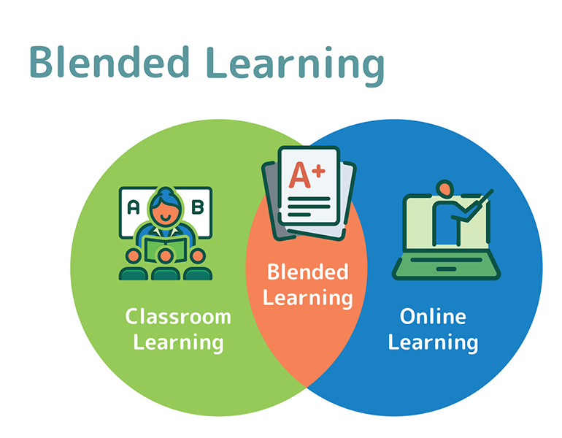
(NewAge, 2021)

2. PROS AND CONS OF BLENDED LEARNING IN THE UNIVERSITY EDUCATION
The last ten years have brought an explosion of online education around the world. Thousands of universities offer online courses. In online courses, students are given skills that allow them to understand each other after graduation in a knowledge-based dynamic. These capabilities refer to solving concrete problems, communication, teamwork, continuous improvement, as well as social responsibility.
Some people believe that distance learning is the ideal form of education where there are no disadvantages, but research studies in this field show that there are pros and cons in both cases.

2.1 Advantages of blended learning in the university education
It gives the possibility to study at any university in the world. Regardless of your geographical location and time zone, students can get all the knowledge they need from the comfort of their home. This is especially important for people with disabilities, as well as for those living in regions where education is not possible due to lack of institutions (Student Portal, 2020).
The cost of distance learning is much lower, student do not need to travel to another city or country to study at a university and thus save travel and accommodation costs. This learning method allows students to study at any time and in any place convenient, whether it is a cafe, work, park or even at home without interrupting their main activity. All the materials are sent by email or posted on the site, which is quite convenient. Students can listen to lectures or complete assignments while sitting at home on a comfortable couch or while on vacation in distant lands and they can receive real-time feedback on their performance.
It happens that some universities do not have enough and various textbooks, so students must buy them. With distance education, all necessary educational materials are in electronic form so students will never have problems with lack of materials, like reference books and textbooks. They can get everything they need to fully acquire knowledge. All students decide how much time they should spend studying the given subject, and based on it, calculate the duration of their studies. In some universities it is possible to postpone training for a long time and later it is possible to return to it without having to pay again.

2.2 Disadvantages of blended learning in the university education
Distance learning is a very popular form of education, which is increasingly used in the modern education system. Most sources talk about the benefits of distance learning, while everyone prefers to remain silent about the disadvantages. If any student decides to choose such a training path as distance learning, then they need to know what disadvantages have to face:
To fully acquire all the necessary knowledge, students must be technically proficient and understand the use of online computer programs, to participate in online lectures equally with everyone and to use everything necessary for learning. Not everyone who wants to receive distance education can have constant access to the internet, and some do not even have a computer. Often, during online classes, communication is disconnected, or its speed is so unstable that leads to frustration and to not a successful learning. Which is not desirable for both the teacher and the student (Lawrence Haywood, 2021).
It is difficult for teachers to track whether a student performs all tasks independently, passes the tests or not. Students usually are distracted by things at home, kids or calls etc… As an example, are our lessons, students from home are not egaiging all the time with the work that we must do in the class. Our tutor must ask them two or three times until someone is answering something like “I am not sure if I understood what we had to do” or sometime there is no answer at all.
Personal contact between students and teachers is very minimal or even completely absent. Therefore, this form of education may not be suitable for the development of communication skills, confidence and of course teamwork skills. Usually when we have a team task during class, it takes a long time until the teams are formed, students who use the online class method, always have errors with the final result. Certainly distance learning students need to put more effort into learning the material.

3. PROS AND CONS OF TRADITION CLASSROOM LEARNING IN THE HE SECTOR
Traditional classroom continues to be one of the most common in educational institutions. It must be acknowledged that it has some positive and valuable aspects for educational development, as well as its weaknesses or disadvantages (WarbletonCouncil, 2021).

3.1 Advantages of traditional classroom learning in the HE sector
Collaborating with colleagues and teachers is an added benefit as well as educational support. Students, seeing each other at every educational class, have the opportunity to make friends with each other and even to remain friends for life. During their educational studies, students have the opportunity to physically participate in a lecture or discussion in class. If a question or ambiguity arises, students have the opportunity to ask questions directly to the teacher, or to exchange views with each other. Spencer Hendricks (2021)
Contributes to the development of personal effort, will and self-discipline among students. It is most efficient for transmitting pure data. Provides students with the knowledge and experience to be able to answer questions immediately. Ability to work in a group, as we always do in the class. It is easy to separate students in groups and there is no confusion between students who is in which team. It allows students to learn more easily under the presure of time, for example assigning in class activities that need to be finished in couple of minutes or hours. Presentations are more efficient and time is not wasted. When students are interacting with a live audience, they gain lots of confidence and ability to speak in public. Anthea Papadopoulou (2020)
Students have the opportunity to study structured in the classroom by using paper textbooks, written lectures and self-directed activities. For some students, the classroom environment is the only style of education they know or practice, and changing the type of education can be difficult for them to adapt. Sudden deviation from past learning experience can add unexpected academic stress, for example by making classroom materials much more difficult (Spencer Hendricks, 2021).

  - Disadvantages of traditional class room learning in the HE sector
Large amounts of information are assimilated without considering effectiveness.Usually, there is no coexistence between theory and practice. It has been shown that much of the knowledge gained and stored is forgotten over time.
Through traditional education in the classroom, it is necessary for students to be present at courses in order to obtain participation credit (Spencer Hendricks,2021). In the case of students living far from the university, it is necessary to provide more time so that they can arrive on time in class. Especially in periods of rain or snow. There are additional costs that could become a problem for students with lower financial status and is no flexibility. (Classgap, 2021)
Studying in class is an organized program that cannot be changed. Students are required to comply with the program and not deviate from it. In case the student missed one of the classes, they have to recover the lost material individually, because the material is not offered to be taught repeatedly. If unexpected changes or even an emergency occur in the student's plans, the student does not have the power to adjust the class schedule to another time. If there is a scheduling conflict between work and school, students are put in an awkward situation, they are forced to choose between studies that help them evolve or or work that provides them with the income to survive.Spencer Hendricks (2021)
This days the state of the pandemic alert of Coronavirus COVID-19 is the bigest disadvantage of traditional class.

4. EVALUATION OF BOTH FORMS OF TEACHING AND LEARNING IN THE PAST AND PRESENT
According to information sources regarding traditional and blended education, in present, we are at a revolutionary stage in which educational institutions around the world practice both methods of teaching education.
It is well known that traditional education, over time, has led to a remarkable development, as at present, we can enjoy a lot of inventions in various fields of science, especially technical inventions, such as the computer and the global network of Internet. This invention led to the distance education process, which over time, has developed more and more as it is used today in the entire education system globally.
In recent years, this mixed educational system was used only at university-level institutions. But at present, due to the alert state of the global pandemic of Coronavirus COVID-19 since January 2020 until now. The blended education system has been playing a vital role globally. Students practice blended education system, which consists of teaching lessons at a distance through the computer and Internet.
With the partial remediation of the COVID-19 alert, now most education institutions have begun to move back to the traditional system. The pandemic alert state gave rise to the new hybrid educational system because university students attend the educational system depending on the state of the pandemic alert, COVID-19.

5. RECOMMENDATIONS BASED ON EVALUATION
According to the information provided in this report, during the current period, in which we are facing the pandemic situation of COVID-19, for the safety of our teachers and students who are studying the Certificate in Higher Education, the hybrid educational system is the most recommended. Through this educational sistem they can study and at the same time keep the distance, so that they are not infected with COVID-19. Students carrying out studies in the traditional classroom, as well as online, throughout this period will accumulate not only the educational information in the university but will obtain great information and development in remote communications as well.

6. CONCLUSION

According to the information studied in this report, we conclude that the educational system offers playback of studies through traditional and blenede learning. These types have its advantages and disadvantages depending on the situations. It is known that COVID-19 has influenced the teaching methods of education in the education system around the world but according to this pandemic period, university administrations have opted for online courses as an alternative way of resuming education. Although co-education is useful in protecting the health of students and teachers during this pandemic of COVID-19. This educational teaching method maybe is not as effective as traditional learning but, in this way, we will be able to stay at a distance to protect ourselves from this virus, but at the same time to keep up with the process of the educational system, to develop and prepare our skills for a happier future and a rich career in everyday life.
Education is a great condition for a successful career.

REFERENCES

- Barindra, D. (2018) ‘Traditional Learning Vs. Online Learning’, eLearning Industry [blog]. 4 February. Available at: https://elearningindustry.com/traditional-learning-vs-online-learning (Accessed: 25 November 2021)

- Classgap (2021) Online education vs Traditional Education: Which one is better for you? Avalable at: https://www.classgap.com/en/blog/online-education-traditional-education-which-one-better-for (Accessed: 4 November 2021)

- Garrison DK. and Kanuka H. (2004) Blended learning: Uncovering its transformative potential in higher education. Internet and Higher Education.

- Haywood, L. (2021) ‘Guide to the Pros and Cons of E-Learning’, AhaSlides [blog]. 20 Octomber. Available at: https://ahaslides.com/ro/blog/pros-and-cons-e-learning-virtual-classroom/ (Accessed: 4 November 2021)

- Hendricks, S. (2021) ‘Advantages & disavantages of classroom learning’, science and education [blog]. nd. Available at: https://www.ehow.co.uk/info_7922444_advantages-disadvantages-classroom-learning.html (Accessed: 30 November 2021)

- Law insider, (2013-2021) ‘Traditional education definition’ Available at: https://www.lawinsider.com/dictionary/traditional-education (Accessed: 2 November 2021)

- Merriam-Webster (2021) Distance learning. Available at: https://www.merriam-webster.com/dictionary/distance%20learning (Accessed: 28 November 2021).

- Mesbahuddin M (2021) Avalable at: https://www.newagebd.net/article/136071/phygital-platform-and-blended-learning (Accessed: 4 November 2021)

- Papadopoulou, A. (2020) ‘Online Classes vs Traditional Classes – Find the Best for You’, LearnWorlds [blog]. 15 July. Available at: https://www.learnworlds.com/online-classes-vs-traditional-classes/ (Accessed: 2 November 2021)

- Student Portal, (2020) ‘Distance learning: pros and cons, reviews’ Available at: https://ik-ptz.ru/ro/testy-ege---2014-po-fizike/distancionnoe-obuchenie-plyusy-i-minusy-esse-distancionnoe-obuchenie-plyusy.html (Accessed: 3 November 2021)

- WarbletonCouncil, (2021) ‘Traditional school: characteristics, methodology, advantages, disadvantages’ Available at: https://ro.warbletoncouncil.org/escuela-tradicional-3928 (Accessed: 4 November 2021)

