University of Wales Trinity Saint Davids
Wales Institute of Science & Art

Application of Computer
Aided Engineering Processes
ACHA6010

Ashley Lane
1903102
18th December 2022
Contents
1 Introduction 2
2 Literature review 3
3 Validation Methodology 4
3.1 Analytical solution 4
3.1.1 Cantilever with axial force 4
3.1.2 Cantilever with uniform load 5
3.1.3 Thermal loading 5
3.2 Simulation analysis 7
3.2.1 Axial Force 7
3.2.2 Uniform load 9
3.2.3 Thermal load 11
4 Piston methodology 12
4.1 Piston constraints 12
4.2 Piston mesh study 13
4.3 Piston temperature analysis 15
4.4 Piston material analysis 16
5 Piston simulation discussion 17
6 Discussion 21
7 Conclusion 22
8 References 23
9 Appendix 24

Introduction
To know the capabilities of materials in the past was a very timely process. It involved trial and error, stress testing on different components. This came at a great cost (Shahzad, 2017). With the advancements of technology comes the advancements of Computational Aided engineering (CAE) tools. These simulate the materials investigated with set stresses. This process saves a great deal of time and money, however it is only a simulation (Dawson, 2012). This report will investigate how accurate the software is.
Simple case studies will be used with beams that analytical solutions can be calculated, as a form of validation of the software. If and when the software provides a good correlation of results with a low percentage error, then further studies can then be calculated.
Once a validation has been conducted, a more complicated study will be investigated. A piston assembly from an engine will be investigated. Although the engine has eight cylinders one cylinder will be isolated and investigated to save on computational power.

Literature review
The main advantages of using Computational aided design software are the time and financial savings (Siemens, 2020). Risks are reduced majorly both physical and financial. To choose the most suitable material for an application takes a great level of development and trials. Each material has different properties which either makes it better or worse suited to the application, (MechaniCalcEng, 2022).
When sourcing a new material for the internals of an engine in particular the piston, a consideration of the true application must be done. Is the goal extra power per stroke? Or is it fuel consumption for the same amount of power? (Vaczkó, 2016). For these applications or for a general analysis of the working of an existing engine CAE can certainly be a useful tool. (M.Viswanath, 2021).
The stresses experienced by the piston must be calculated accurately. With thermal and mechanical failure considered and prevented. (Singh, 2015). The material of the piston will also have a major influence on the design to have the most desirable characteristics for the required application (rao, 2021).

Validation Methodology
To begin with analytical solutions will be completed on a basic case study which can be replicated in Ansys. A study on percentage error between theses case will be analysed to assess the feasibility. A decision on the accuracy of the study, from their analysis into more complex designs can be conducted.

Analytical solution

Cantilever with axial force
To calculate a Cantilever beam requires a simple analytical solution. The weight of the beam is assumed to be ignored. The equation and method are shown below in equation 1.
$$U_{xmax}=\frac{F_{x}L^{3}}{EA}$$
Equation 1 Cantilever beam axial equation
With the input of numbers,
$$u_{max}=\frac{(1600)×(10000)}{(210000)×(80^{2})}$$
$$=0.0119mm$$

The results of this test case are calculated to 0.0119mm, further on in the report this figure will be analysed against the outcome of the Ansys simulation.
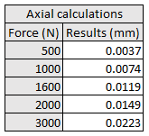
This equation was used on multiple occasions with other forces. The results are published below in table 1.
Table 1 Axial calculations

Cantilever with uniform load
To calculate a beam with a uniform distributed load (UDI) requires the equation and method below. Again, it is to be assumed that the weight of the beam is ignored
$$u_{zmax}=\frac{qL^{4}}{8EIy}$$
Equation 2 Cantilever beam UDL equation
With the values inputted,
$$\frac{3PL^{4}}{2Ew^{2}t}=\frac{3(2750)×({1)}^{4}}{2(210000)×{\left(0.05\right)}^{2}×(0.05)}$$
$$=157.144mm$$
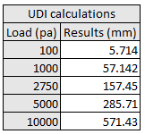
The outcome of this calculation is 157.144mm, as before this will be investigated for feasibility further in the report. Other calculations were completed changing the loads as below in table 2. These results will be further analysed.
Table 2 UDL calculations

Thermal loading
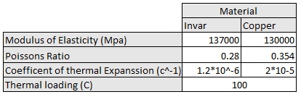
A beam was created and developed from two different materials. It is to to have the following material characteristics.
The beam is to have the following dimensional properties in mm. 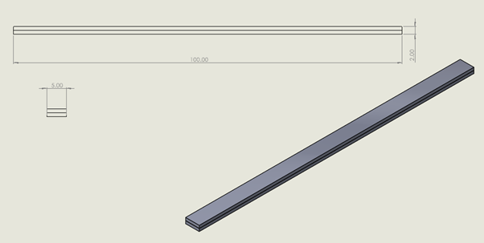
To analytically solve the thermal properties of the beam the equation 3 below was used.
$$k_{1}=4+6\frac{t_{c}}{t_{i}}+4{(C\frac{t_{c}}{t_{i}})}^{2}+\frac{E_{c}}{E_{i}}{(\frac{t_{c}}{t_{i}})}^{3}+\frac{E_{i}t_{i}}{E_{c}t_{c}}$$
Equation 3 Thermal equation for k1
With the figures applied,
$$k_{1}=4+6\frac{1}{1}+4{(\frac{1}{1})}^{2}+\frac{130000}{137000}{(\frac{1}{1})}^{3}+\frac{137000×1}{130000×1}$$
$$k_{1=16.003}$$
Once $K_{1}$ is calculated the equation 4 below can then be used
$$u_{zmax}=\frac{6(θ_{i}-θ_{c})(t_{i}+t_{c})T_{c}}{t_{s}^{2}k_{1}}×\frac{L^{2}}{2}$$
Equation 4 Thermal equation for displacement
With the figures applied,
$$u_{zmax}=\frac{6(1.2×10^{-6}-2×10^{-5})(1+1)(100)}{(1)^{2}(16.003)}×\frac{{100}^{2}}{2}$$
$$u_{zmax}=-7.049$$

The solution is shown above and is calculated as -7.049mm. The answer will be analysed later in the report. Other temperatures were explored and calculated below in table 4.
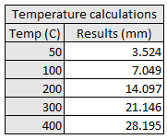
Table 3 Temperature calculations

Simulation analysis

Axial Force
Firstly, an investigate into the Axial force simulation method was completed. To assess the most accurate method, other studies were completed parrel to the investigation. These involve mesh studies and force locations, among others.
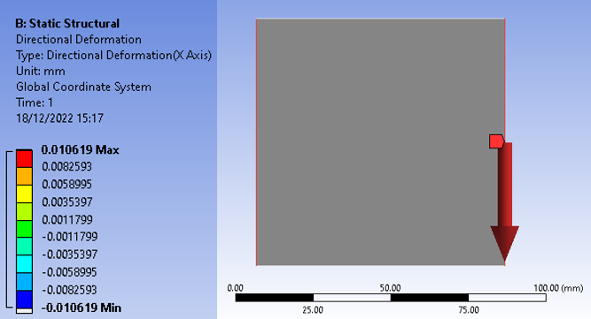
The side edges were first investigated as the figure 1 below shows, a result is calculated at 0.0106mm.
Figure 1 Axial force side force

The figure 2 below shows the force being simulated on the end face, this also produces a result of 0.0106mm.
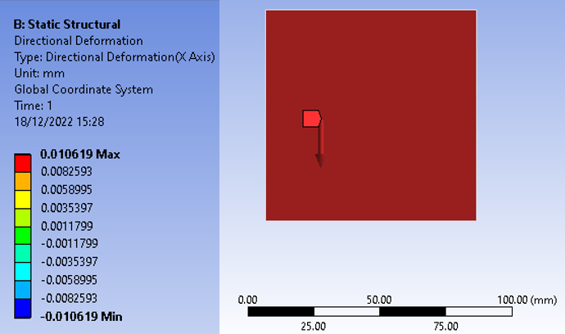
Figure 2 Axial Frontal study
When changing the location of this force to the top edge as figure 3 show, produces a deformation of 0.0106mm.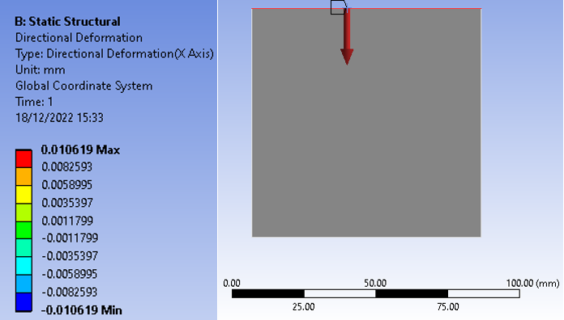
Figure 3 Axial force, Top edge
It was found that changing the mesh and the location of the forces for this simple beam case did not influence the results. Different force loads were calculated to ensure there is a strong level of accuracy.
Table 4 Axial Validation
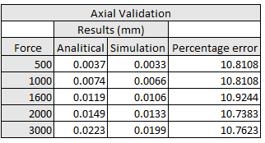
Table 4 above shows the results with the maximum deflection. This correlation between the analytical solution and the simulation is as high as 10.9% however, this result is consistent throughout the force range.

Uniform load
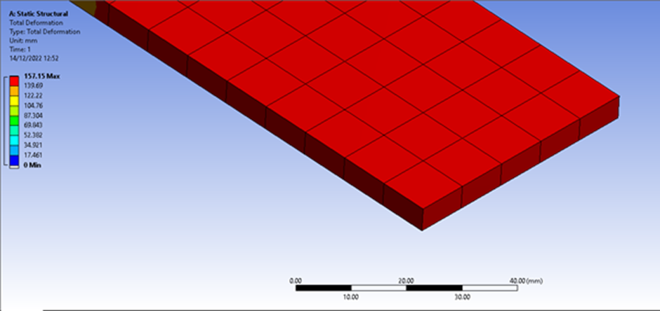
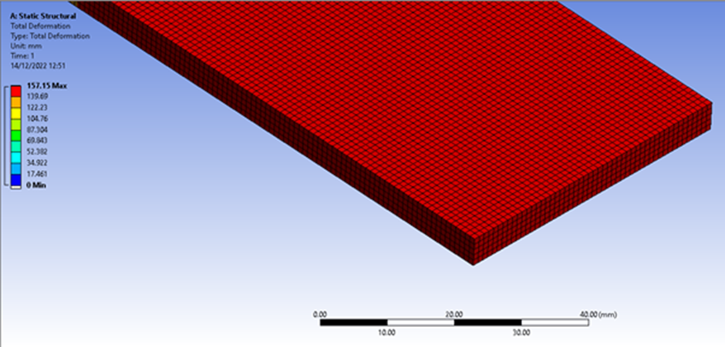
A similar process was conducted on the uniform load cantilever beam. Again, different mesh sizes were investigated with no effect. Although having no change with mesh shows confidence in the software, it will mean a full mesh study will have to be completed on a piston later in the project.
Figure 4 Uniform beam mesh 1mm
Figure 5 Uniform Beam mesh 10mm
Above the two figures, figure 4 and figure 5 show the diffrence between some of the meshes investigated. Figure 4 shows a mesh at a size of 1mm, as can be seen it seems to be a very fine mesh. The figure 5 , shows the mesh at 10mm. It is visually much more coarse, however there isnt a diffrence in the results that the meshes produce. For a simple construction such as this beam, the time to calculate didn’t come in to effect. However with a more complicated study such as a piston having a mesh which is too fine can slow the simulation down vastley. The opposite happens if the mesh is too large. The soloution calculates too quickly and not accurate enough.
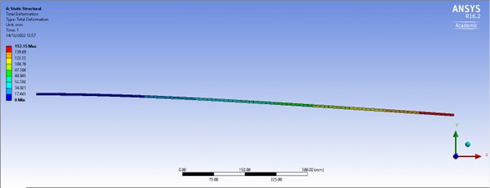
The mesh was reverted to a coarser figure of 10mm as it is proven that a finer mesh will not have an effect. The results of the study with the same dimensions as the analytical calculation are published below in figure 6 and figure 7.
Figure 6 Uniform beam deflection side view
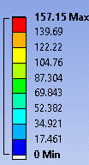
Table 5 UDI validation
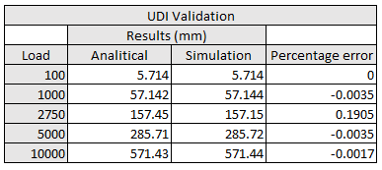
Figure 7 Uniform Beam results
Further tests were completed at different force loads, the results of these are published above in table 5, along with the analytical solution to compare. The correlation between them is particularly good yet again, with an exceptionally low percentage error as listed in table 5. One figure that stands out from the others is a load of 2750N which has the highest percentage error of 0.19% it is still very minimal and not a concern.

Thermal load
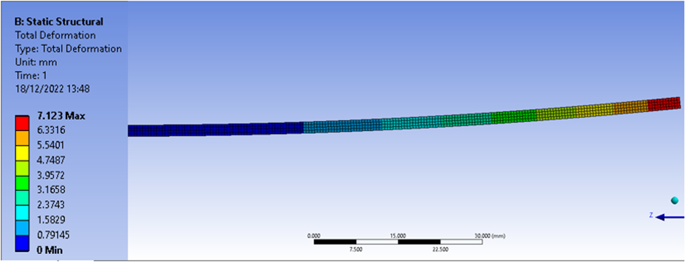
The results from the thermal load simulation are shown below in figure 8. Comparing these results with the analytical solutions of 7.049mm a slight variant can be seen.
Figure 8 Thermal load
Several different temperature values were simulated as the table shows. The feedback from the different temperature variants is that the simulation is consistent even if the percentage error is 1%.
Table 6 temperature validation
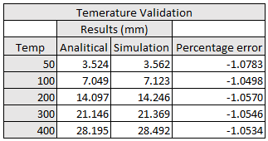

Piston methodology

Piston constraints
To complete a simulation on an assembly there are several steps to take beforehand in order to ensure the assembly interacts with the other components as expected. The constraints are shown below in figure 9.
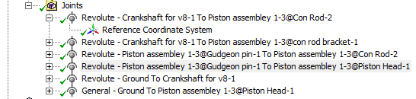
Figure 9 Piston constraints
Comparing the engine assembly in Solidworks against Ansys confirms the pistons restraints are operating correctly, figure 10 shows this.
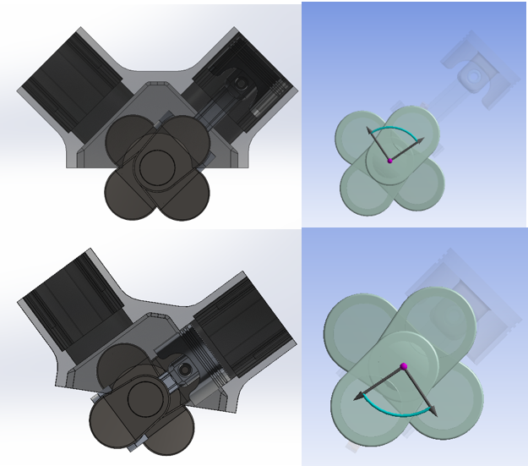
Figure 10 Piston constraints comparisons
The rotational velocity of the piston is set at 4000RPM in the clockwise direction figure 11 shows this.
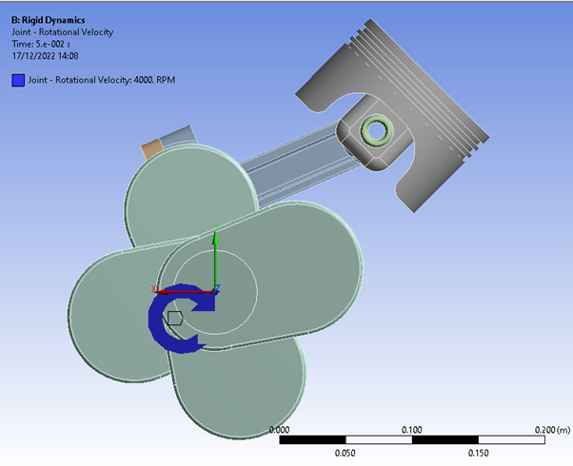
Figure 11 Piston Revolution direction

Piston mesh study
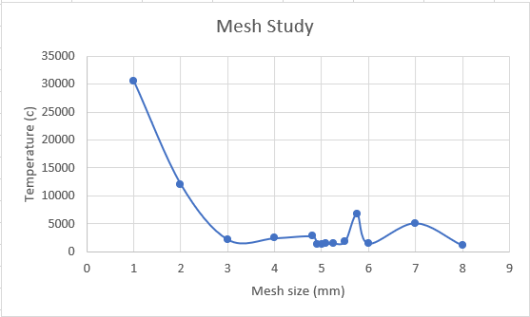
As mentioned earlier in the report the outcome of the mesh study on the beam did not produce a variation between a coarse mesh and fine. The piston being a more complex shape has a wider scope to change the mesh sizing. A visual analysis of the sizing around complex shape variations will be conducted. Larger areas such as the skirt of the piston will not need as fine of a mesh.
Figure 12 Mesh study 1mm to 8mm
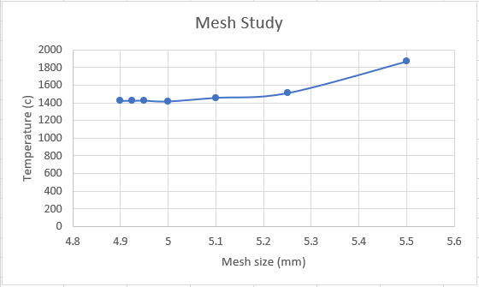
The different mesh sizes used were originally from 8mm up to 1mm. A mesh size larger then 8mm would poorly represent the geometry of the piston. On the other hand, a mesh size smaller than the 1mm evaluated would take a significant longer time to calculate. By analysing the graph in figure 12, it is clear to see a steep climb in results from 3mm up to the 1mm mark. As mentioned before a finer mesh does not always equate to a more accurate result. Other stresses would start to form which ordinarily would not exist.
Figure 13 Mesh study 4.8mm to 5.6mm
From figure 13 above, the flattest area of the curve was further refined to study where the results stay the most similar between measurements. For this piston, it was found that a mesh size of 4.925mm will be used for the simulations.
The difference between 8mm and 4.925mm for the piston mesh is shown below in figure 14. It is clear to see how much finer the mesh is for the 4.925mm mesh compared to the 8mm. The extra computational power to produces the finer mesh is negligible especially if the results will be more accurate. 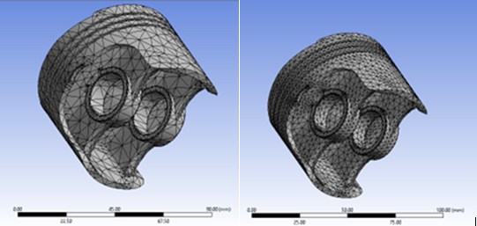
Figure 14 8mm and 4.925mm comparison

Piston temperature analysis
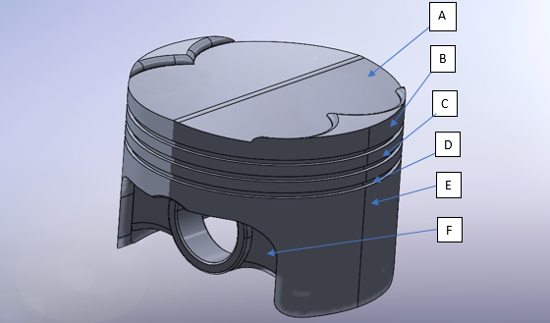
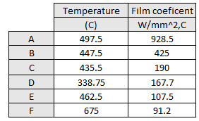
The average temperature that the piston will experience under normal operation was supplied data. The figures and associated locations used are listed below in table 7 and figure 15.
Figure 15 Piston temperature refinement
Table 7 Piston temperature range
These figures are taken from the engine running at 4000RPM. Logically theses figures seem plausible with the hottest part being the crown. The coolest being the skirt which oil will have a cooling effect on (Tong, 2021). The figures produced here are material dependant.
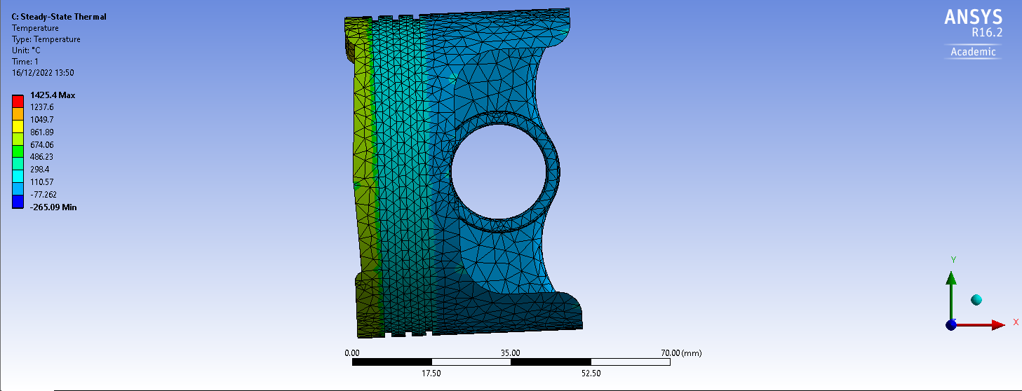
There is an area on the piston crown which shows a large temperature concentrated, as figure 16 and 17 shows. A refinement of the mesh did not improve the problematic area. Analysing the geometry of the piston of where this is, could be the answer to the inconsistency. The location is on the corner edge of the piston at the point where there is an elevation on the crown. 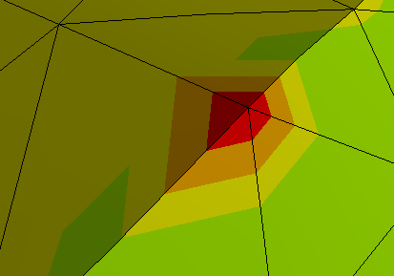
Figure 16 Piston temperature distribution
Figure 17 Stress concentration
From the results provided above the concentration of a high-level temperature, up to 1425.4C is not a true gauge of the temperature distribution across the piston. If this high peak was non-existent, then the distribution would be expected to show as a more even spread across the crown.

Piston material analysis
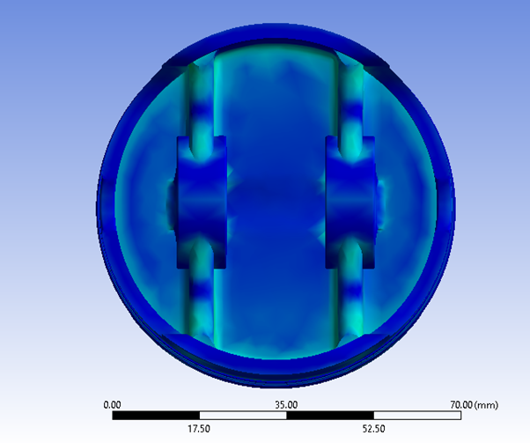
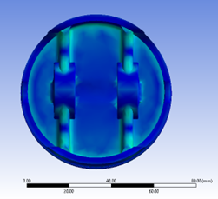
Analysing alternative materials for use on a piston has interesting results. Visually when looking at the stress areas there is not a change, after all the pistons have the same geometry. However, the amount of force in the stress areas does change. The below images in figure 18, use steel on the right and aluminium on the left.
Figure 18 Aluminium and steel piston stress
The steel piston has a maximum stress of 3573MPa. The Aluminium has a maximum stress of 2491.1MPa, This would imply that the steel piston would be able to cope with higher forces then the alternative aluminium piston.
The addition of steel would add a larger weight to the moving components of the engine, this would reduce the efficiency. Using forged aluminium would provide the lower desired weight of aluminium without compromising on efficiency.

Piston simulation discussion
The results from the piston simulation are collaborated in the same simulation, including the thermal and stress study. The results are published below in figure 19 from screenshots of Ansys. The maximum stress experienced from this piston is shown to be 2491.1MPA. it would appear the highest stress experienced by the piston is around the third piston ring. This conclusion logically would appear unusual. 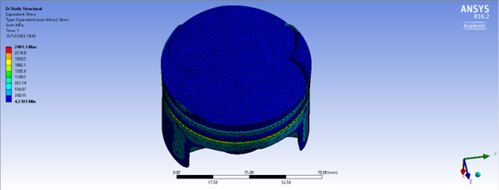
Figure 19 Equivalent stress
A stress area under the piston skirt is also present in figure 20. A more expected result is around this area is where the piston is attached to the conrod via the Gudgeon pin.
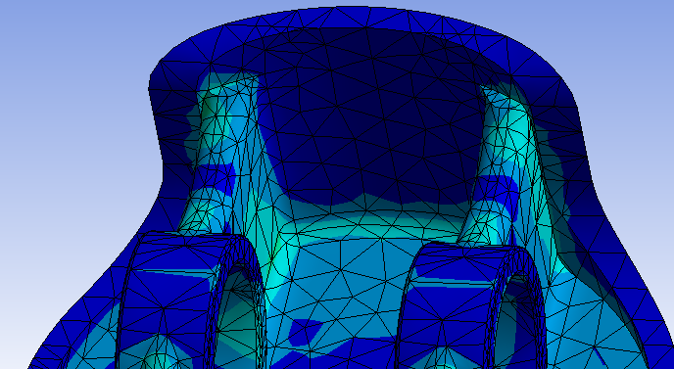
Figure 20 Piston stress skirt

The maximum deformation experienced from this piston is shown to be 0. 784mm. Unsurprising these highest deformations are at the highest point on the piston crown as figure 21 shows. 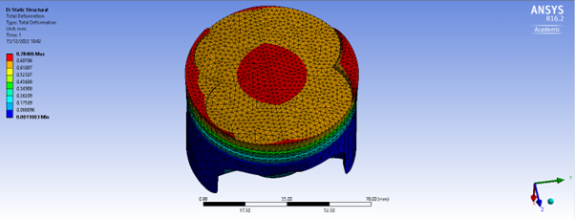
Figure 21 Piston deformation
When further analysed the stress concentrations extend around the piston edge, with a slight increase towards the centre, figure 22 shows this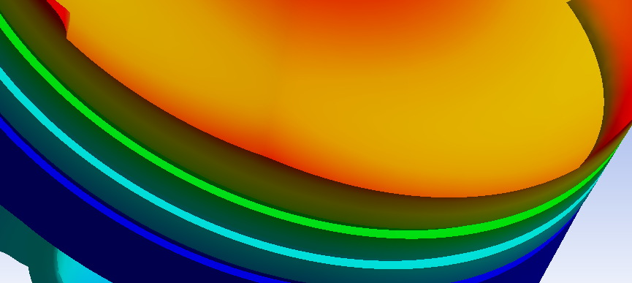
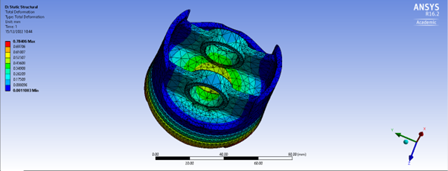
Figure 22 Piston deformation, edge concentration
Figure 23 piston skirt deformation
The underside of the piston shows the skits deformation. A high concentration can be seen in the centre in figure 23.

Figure 24 Gudgeon pin locator
The concentrations of stress which would bear down on the gudgon pin can be seen above in figure 24. A concern in this area would be if this area was red. This would show an elevated level of stress through the gudgeon pin. Which in turn, would eventually cause the gugeon pin to fail due to fatigue. A further analysis of the gudgeon pin would be interesting to see what stress it is experiencing.

Discussion
Once a study has been completed on a piston, with an investigation into optimisation of weight reduction which includes the piston material properties. The applications into production can then be discussed. If aftermarket parts are to be fitted onto the engine such as a turbocharger, then the engine internals will need to be re-stimulated to analyse whether the engine holds the correct characteristics or whether further modification will need to be made.
Commonly using forged materials within the piston assembly increases the stress resistance as well as the resistance to higher temperature. The main negative with using forged metals is the sharp increases in costs (direct, 2012).
The simulation software Ansys seems to give an accurate representation of the forces experienced within an engine assembly. However, it does have its limitations. The full engine simulation was not able to be computed in one simulation. So, the potential of modelling a crankshaft’s forces can be almost forgotten. A full simulation involving a V8 engine was attempted as figure 25 shows, however this was unsuccessful due to the computing power required.
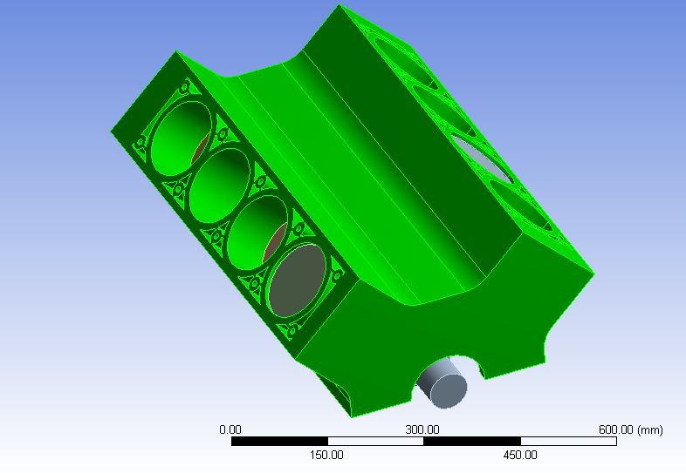
Figure 25 V8 engine simulation

Conclusion
When modelling simple beam cases, including thermal, axial and UDL forces, Ansys is a reliable software. If there are errors within the software these can generally calculated as a percentage error throughout different force ranges. The further applications such as modelling assemblies we can assume to be accurate. Validation could come in the form of measuring an engines forces. However, this can become costly for measurement equipment.
The concept of accurate simulations is almost there with Ansys, however not providing 100% accuracy on a calculation which can be calculated simply and quickly analytical does provide some doubt over the accuracy of more complex equations.

References
Dawson, L. (2012, June 19). Failure Mode and Effects Analysis (FMEA). Retrieved from Quality One: https://quality-one.com/FMEA/
direct, C. (2012, Febuary 22). The Benefits of Forged Pistons. Retrieved from Cas direct: https://www.carsdirect.com/aftermarket-parts/why-install-forged-pistons
M.Viswanath. (2021). Design and Analysis of Piston on Different . Coimbatore: International Journal of Engineering Research & Technology.
MechaniCalcEng. (2022). Engineering Materials. Retrieved from MechanicalC: https://mechanicalc.com/reference/engineering-materials
rao, B. J. (2021). DESIGN AND ANALYSIS OF PISTON WITH VARIOUS . Andhra Pradesh: BULLETIN MONUMENTAL.
Shahzad, H. (2017). Examination of Stress and Stress Types in Engineering: Everything You Need to Know. Michigan: Sunglass.
Siemens. (2020). Computer aided engineering. Retrieved from plm automation: https://www.plm.automation.siemens.com/global/en/our-story/glossary/computer-aided-engineering-cae/13112
Singh, L. (2015). FINITE ELEMENT ANALYSIS OF PISTON IN ANSYS. Noida: IJMTER.
Tong, D. (2021). Thermal Analysis of a Novel Oil Cooled Piston Using a Fluid-Solid Interaction Method. Weifang: Tech Science Press.
Vaczkó, D. (2016). Piston development of a microconsumption race car. Kecskemét : Procedia Engineering.

Appendix
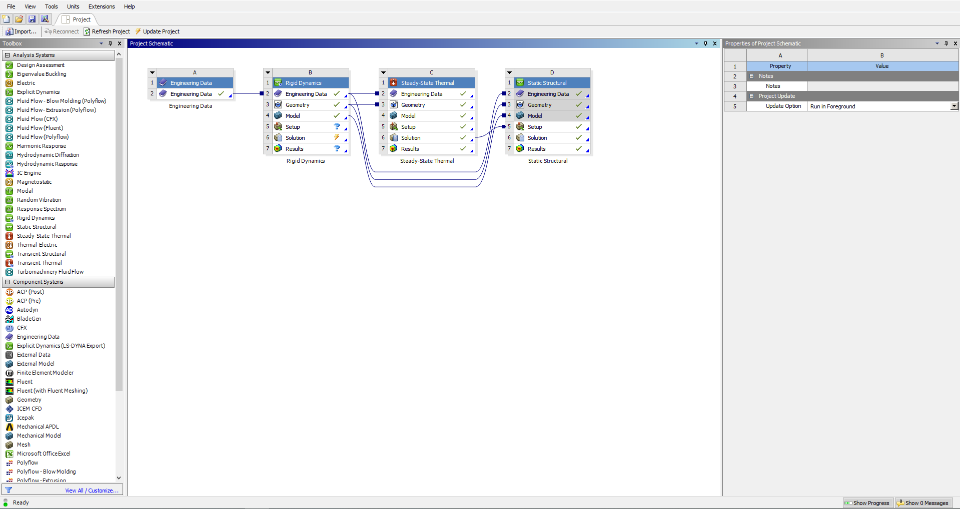
Ansys main page

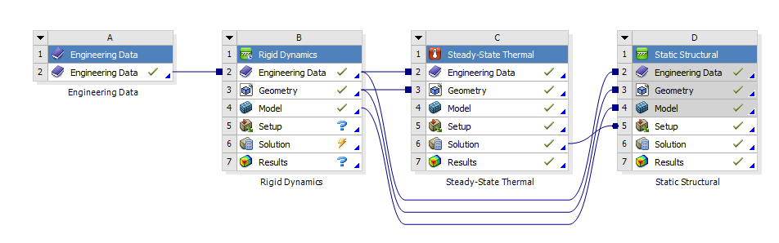
Ansys workbook layout

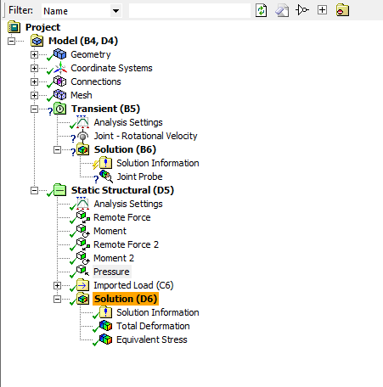
Rigid dynamics study

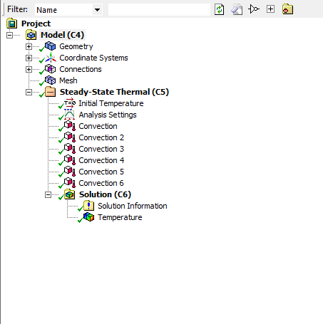
Steady state thermal study

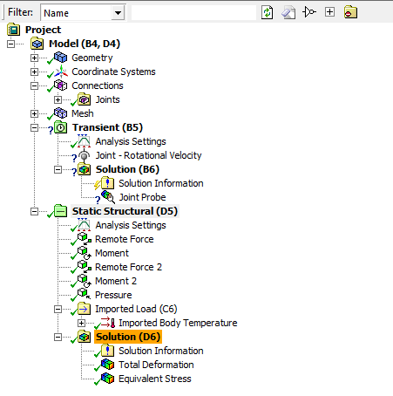
Static structural study

