Rachel Pickersgill (2004655)
[Company Name] | [Company Address]
Globally responsible business
(BMSP6001)

Table of Contents
Introduction 2
Challenges 5
Conclusion 7
References: 7

Introduction

The report presents the main principles of the circular and linear economy and demonstrates how circularity can solve the issues of a linear economy. An analysis of how Patagonia reflects the circular economy is undertaken with the issues of becoming circular outlined. Long, medium- and short-term goals are given as a solution to these challenges to enable the business to be fit for the future and to continue working towards circularity.

The linear and circular business models are very different; the linear model focuses on the profitability of a product irrespective of the consequences of its lifecycle, whereas the circular model targets sustainability. The linear economy is based on a “take-make-waste” business model where raw materials are taken to create a product and are then disposed of once they reach the end of their useful life (Taylor, 2020a). On the other hand, the circular economy tackles global challenges like climate change, pollution etc, using a solution framework. It aims to close loops of resource flow, preventing waste by recovering as many materials as possible (Ellen MacArthur Foundation, n.d). There are three main principles these are:
- Eliminate waste and pollution.
- Circulate products.
- Regenerate nature.

Figure 1 below depicts what the circular economy looks like compared to linear.

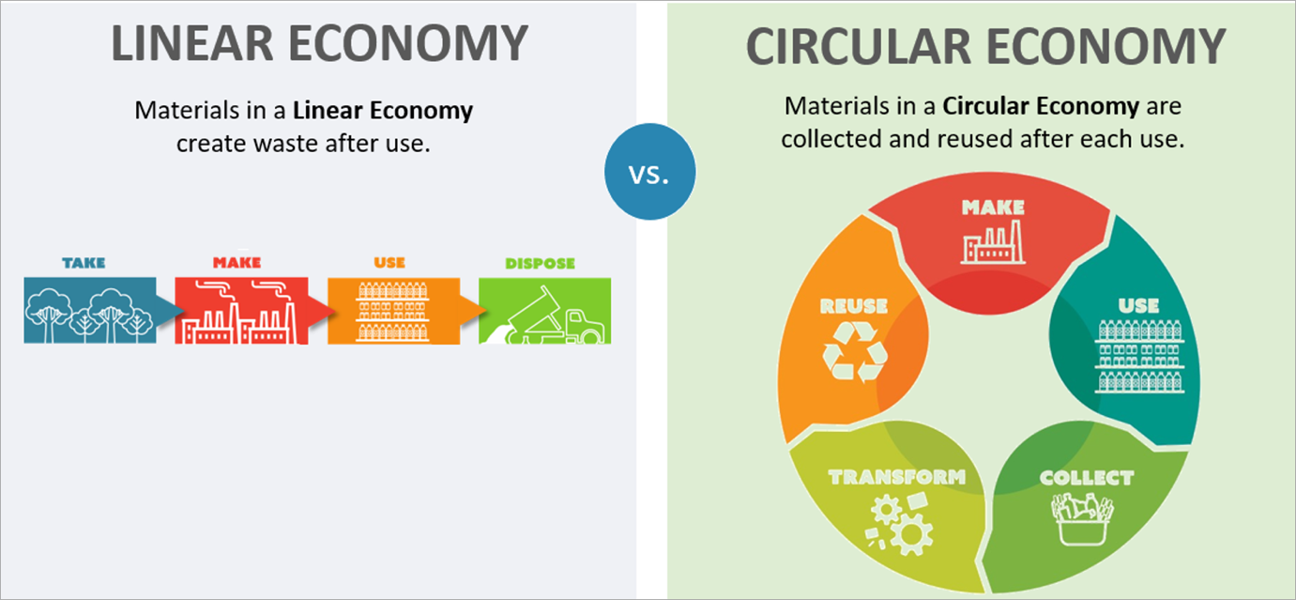

Figure 1: Linear vs circular economy (Hi-cone, 2020).

Linear thinking has directed production since the beginning of the third industrial revolution and led to growth in many different parts of the world (Jørgensen & Pedersen, 2018). However, the linear economy has many issues; one of its most significant issues is its predisposition to waste materials by dumping them in landfills on a planet with a finite number of resources. The issue with these materials being put in landfill is that it means that valuable materials that could have been used again are being buried, resulting in more raw materials being extracted (Taylor, 2020b). In the circular economy, resource consumption and waste prevention are considered throughout a product's lifecycle; the focus is on reducing environmental harm in all the stages a product goes through, from the gathering of raw materials through to when the product becomes waste. This helps to control waste management and reduces the amount of waste which goes into landfill (Cohen, 2022).

The circular economy refers to materials being included in a cycle so that products can be divided into components and become resources again. The sharing economy is part of the consumption segment of the circular economy; it means that a customer chooses not to own a product but to share it with others (i.e., by renting). This means that the same product is used more often and by more people optimising its use. The circular economy looks at optimising raw materials, and the sharing economy aims to keep the final product in circulation for as long as possible before being divided into its valuable components again (Aldieri et al, 2021a). Moving towards a sharing economy transforms the traditional market into a collaborative market to ensure the efficient use of resources through access rather than ownership concept. This concept is an important pillar which contributes to the circular economy. The contribution is clear as by making the shift to access rather than ownership; manufacturers are then responsible for making products which are longer lasting with repair and reuse as a primary consideration which links to the underpinnings of the circular economy. It also means that goods consumption and production will decrease as products are being shared, meaning there is less demand for new ones (Aldieri et al, 2021b).

Patagonia’s circular economy credentials

The chosen organisation is Patagonia, a clothing company which markets and sells outdoor clothing; the company was founded in 1973 by Yvon Chouinard. Patagonia has achieved a B-label meaning that it is one of the more sustainable clothing brands (Highsnobiety, n.d.). According to a new survey, Patagonia is the world’s most circular clothing brand with its commitment to recycling its materials within its supply chain and the rollout of its new rental and second-hand offerings service (Consultancy, 2022). Patagonia’s quest for circularity was based on the idea to create a clothing line which would never end up in a landfill; their aim was to return, recycle and reuse all their polyester fibres. In 2011 the company evolved a “Common threads” recycling program through eBay, which then developed into “Worn wear”. In 2017 they launched “Worn wear”, which allows customers to shop for used items. Since this launched, the company has repaired approximately 130,000 items.

The company is currently working on a new product called “Tee-cycle”, which is a t-shirt made from old ones which Patagonia and other retailers have sold. The t-shirt will be made from pre-consumer and post-consumer mechanically recycled cotton; this blend creates a like-new fibre which may never see a landfill (Ram, 2021). Furthermore, to support their “Worn wear” initiative, Patagonia launched an advertisement called “Don’t buy this jacket” to encourage the repair and reuse of their clothing, promoting the reduction in resource consumption and sustainable living (Bocken et al., 2016). Patagonia has also invested in wind and solar energy, with its solar energy covering 100% of its US footprint; this is not only sustainable but is also ethical, and by integrating this into its business model, it has boosted its brand name (Dezi et al., 2022).
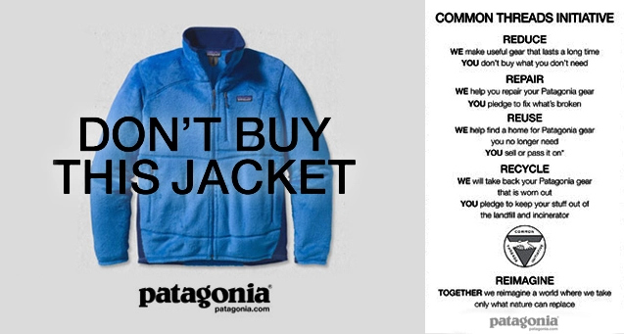

Figure 2: Patagonia’s “Don’t buy this jacket” advertisement (Williams, 2013).

Patagonia’s key aspects are that they use environmentally friendly raw materials to manufacture their products and that they are durable and repairable. To ensure that products are repairable, the company have founded one of the largest repair centres in the US. In addition, they have a mobile repair service which attends outdoor sporting events and repairs their apparel for free. The company has also released incentives for customers to return their products after using them so that they can reuse them within their production process. However, their efforts are not constrained to just their design but have been extended to their entire supply chain; their production is being progressively run-on renewable energy (Stucki et al., 2023).

Another clothing line that is working towards a more circular economy is The North Face. The North Face has released a circular collection of clothing which is made using sustainable single-fibre fabrics which can be easily recycled. This is the company’s first circularly designed line of clothing that aims to minimise waste. The company is also planning to relaunch a program called “Renewed” this will allow customers to take their North Face clothing to the company’s take-back bins; the clothing will then be washed, restored and sold through Renewed (Sharma, 2022). The North Face is one of Patagonia’s many competitors, which is working towards circularity; however, they are still behind Patagonia. The North Face’s materials page only gives an overview of four categories of recycled materials; however, Patagonia’s page presents 28 materials used within their production. Patagonia also dedicates individual pages on recycling, dyeing etc, whereas North Face does not have any pages on their website on how they process their materials. In addition to this, Patagonia is also ahead of the game as they mention on their website the harmful materials which they use; however, North Face does not meaning there is a lack of transparency to their customers, and it can be deceiving (Melchionne, 2023). Figure 3 below shows that Patagonia has 7% more products which are made from recycled fabrics than its competitor, The North Face. Not only this but both Patagonia and The North Face have produced a jacket made from 100% recycled fabrics; however, Patagonia’s jacket is not only sustainable but has been Fairtrade certified and P.U.R.E.TM certified, meaning it has been produced using reduced levels of emissions giving Patagonia the upper hand again (Advertorial, 2022).

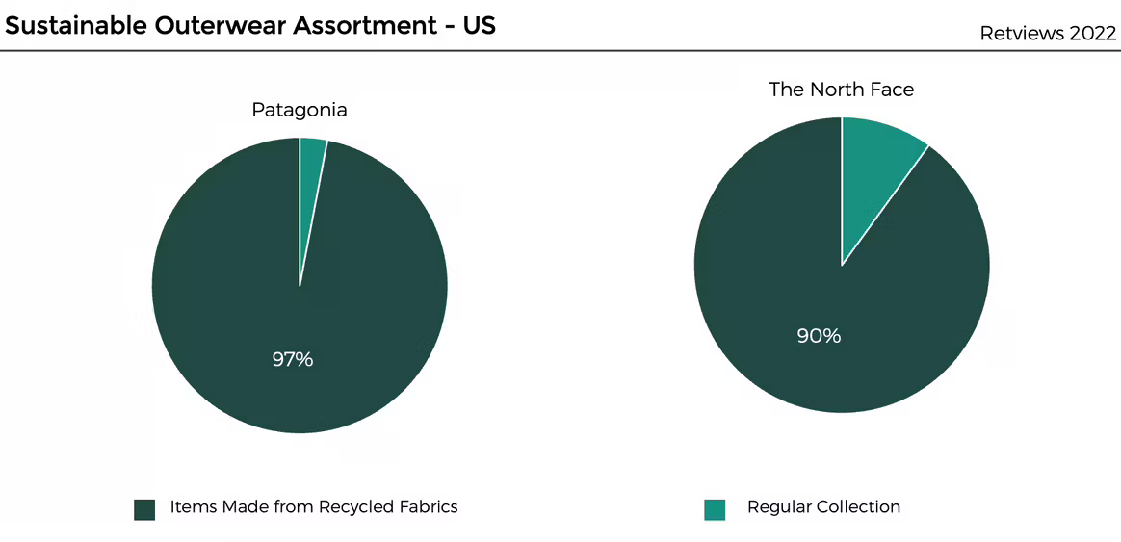

Figure 3: Sustainable outerwear assortment (Advertorial, 2022).

Challenges

Patagonia has many strengths, one being its eco-friendly operations. Currently, Patagonia is one of the most eco-friendly and circular clothing brands. As a retailer, it commits 1% of its profits to environmental groups using One percent for the planet (Parker, 2023). Another strength of Patagonia’s is that its focus on brand purpose and drive to become sustainable and circular has boosted its brand reputation as consumers find this more appealing. A study has shown that 62% of consumers want companies to stand up for global issues (Sonsev, 2019). Some of Patagonia’s opportunities include extending its product line; currently, the brand only offers outdoor clothing and sports gear. With the brand reputation growing, the company could consider branching out into casual wear and other types of clothing. This could potentially attract more customers and enable the brand to grow (Momin, 2022). Another opportunity for Patagonia is to utilise its e-commerce platform; most customers seeking their outdoor apparel prefer to shop online. By effectively exploiting its platforms, the company would gain a broader reach of customers and improve the shopping experience of existing customers (Shastri, 2022).

Some of their weaknesses and challenges to becoming more circular and sustainable are that the company still uses synthetic fibres in their swimwear line predominantly, and they also use DWR on their products, which is harmful to the environment. In addition, one of Patagonia’s most significant threats is that its integrity is being diluted by its growth; another threat is that people will shop less due to the focus of circularity. These challenges and threats will be discussed in the section below, with long, medium- and short-term goals suggested as solutions to these factors.

A threat Patagonia faces is that due to the company's growth, it is becoming challenging to suppress its environmental impact. Patagonia faces the threat of becoming an advertisement for consumerism. Patagonia’s sales are up due to their ethical and slow-fashion initiatives, which poses a risk of the integrity of Patagonia being diluted (Erdmane, 2019). To battle this issue, Patagonia has launched campaigns and advertisements in aid of anti-consumerism; however, it could be doing more. One way Patagonia could tackle consumerism is by changing its return policy, so customers are charged for returning items rather than being free. This would encourage consumers to shop mindfully, especially when 2.3 million tonnes of returned goods end up in landfill. It would also reduce their emissions as fewer delivery vans would be required to return unwanted parcels reducing their environmental impact (Goodwin, 2022). This short-term goal to solve the issue aligns with Patagonia’s strive to become more circular as it discourages customers from returning parcels, reducing the number of items ending up in landfill and reducing pollution, which is one of the main principles of becoming circular.

Another long-term threat that Patagonia may encounter is that customers will be shopping less due to the focus of circular fashion being on recycling and reusing products, meaning that people will keep hold of their products for longer than usual (Sarkar, 2019). There is no easy solution to this issue of becoming a circular clothing brand; however, to make up for the loss of revenue from sales, the company should look at other areas of the business where cuts can be made. For example, by implementing new strategies to reduce waste through their production line and use more circular inputs, the company could make its supply chain more efficient, reducing the cost spent throughout. Moving towards a circular business model does mean there is a potential loss of revenue from new purchases; however, it presents companies with new revenue streams and reduced costs of production to counteract these losses (Reil, 2018). If circularity is appropriately implemented within Patagonia, this risk should be outweighed by the benefits of becoming part of the circular economy and will help them work towards the principle within the circular economy to help reduce waste.

One of Patagonia’s challenges is that it still uses synthetic fibres in some of its apparel. Patagonia’s textiles still use 4-5% synthetic fibres in its main collection; this figure increased when it launched its swimwear collection (Barrett, 2023). An alternative material Patagonia could use in their swimwear collection to help the company move towards the circular economy is Repreve, a fibre made from recycled plastic. This material also helps to preserve natural resources with natural capital in mind; it requires less petroleum, energy and water to produce. In addition, the material has a natural UV protection of factor 50, odour control, and water resistance, and there is no compromise on quality (Assoune, 2022). The use of this fibre in Patagonia’s swimwear line could be one of their medium-term goals towards circularity as it is a material which has already been adopted by many other companies proving it to be an excellent circular alternative to synthetic fibres, which would mean products can be circulated and showing that Patagonia could easily implement it.

One product that could benefit from an examination of biomimicry is Patagonia’s durable water repellent (DWR). Patagonia uses conventional DWR treatments, which involves the application to the surface of a product to make it waterproof. The DWR treatment applies fluorocarbons to the surface of a product; this method is durable and practical; however, it produces a by-product that is toxic and harmful to the environment. Since the use of this, the company have been testing fluorocarbon-free alternatives, including waxes and silicones; however, these alternatives are easily contaminated, meaning that they functionally degraded well before the product itself had worn out (O’Rourke & Strand, 2017). Biomimicry could offer a natural solution to Patagonia’s issue, and research has been undertaken to find a natural resource which can be mimicked to produce new products. In this instance, mimicking the lotus leaf could replace the need for DWR on raincoats. The lotus leaf has a hierarchical structure which discourages saturating, and its tubules are made of a non-polar wax which has a hydrophobic effect (Patagonia, 2020). However, it is not easy turning to nature due to its complex innovations, which have evolved over the years to produce helpful tools. In addition, it takes time and development, meaning it is challenging to implement. However, more research and testing could be a good alternative for DWR which Patagonia could adopt as one of their long-term goals of becoming more circular and sustainable.

Conclusion

This report has looked at the fundamental principles of the circular economy, including the following goals to eliminate waste and pollution, circulate products and regenerate nature. Patagonia is already taking the appropriate steps towards becoming circular; however, as highlighted in this report, it is still facing some challenges in some regions of the organisation, preventing it from becoming circular. Some possible solutions have been suggested within this report, one of which is adopting biomimicry to solve the issues with DWR. Which is a product used by the organisation for waterproofing; this solution would be beneficial to the environment as it would eliminate any unnecessary toxins being released into the environment. The move from free returns to chargeable returns could help the company to eliminate waste and help reduce pollution, in turn being beneficial to the environment. Changing to Repreve fibres could help achieve the principle of making their clothing eligible for recirculation and helps to achieve the reduced waste principle, as the fibre is made from recycled plastics, helping to serve the environment. Finally, the organisation will open new revenue streams by moving towards circularity. It will be able to implement more circular inputs into its production line, making its supply chain more efficient and cost-effective. This would benefit both the environment and the organisation as fewer raw materials will be required meaning the world's natural capital will benefit, and organisations can save by reusing rather than buying more raw materials.

References:

Advertorial. (2022). Patagonia: Pioneering a New Form of Environmental Corporate Leadership. Retrieved March 4, 2023, from: https://fashionunited.uk/news/business/patagonia-pioneering-a-new-form-of-environmental-corporate-leadership/2022101265642.

Aldieri, L., Brahmi, M., Bruno, B., & Vinci, C. P. (2021a). Circular Economy Business Models: The Complementarities with Sharing Economy and Eco-Innovations Investments. Sustainability, 13(22), 12438. Retrieved March 1, 2023, from: https://doi.org/10.3390/su132212438.

Aldieri, L., Brahmi, M., Bruno, B., & Vinci, C. P. (2021b). Circular Economy Business Models: The Complementarities with Sharing Economy and Eco-Innovations Investments. Sustainability, 13(22), 12438. Retrieved March 1, 2023, from: https://doi.org/10.3390/su132212438.

Assoune. A. (2022). The Truth About Repreve Polyester by Unifi. Panaprium. Retrieved March 4, 2023, from: https://www.panaprium.com/blogs/i/repreve-polyester-unifi.

Barrett. A. (2023). Trashion: The stealth export of waste plastic clothes to Kenya. Retrieved March 4, 2023, from: http://changingmarkets.org/wp-content/uploads/2023/02/Trashion-Report-Web-Final.pdf.

Bocken. N. M. P., De Pauw. I., Bakker. C., & Van Der Grinten. B. (2016). Product design and business model strategies for a circular economy. Journal of Industrial and Production Engineering, 33(5), 308–320. Retrieved March 2, 2023, from: https://doi.org/10.1080/21681015.2016.1172124.

Cohen. N. (2022). Making the Linear Circular: a short guide to the circular economy. Retrieved March 1, 2023, from: https://www.greenelement.co.uk/blog/a-short-guide-to-the-circular-economy/.

Consultancy. (2022). Kearney: Patagonia the world's most circular fashion retail brand. Retrieved March 2, 2023, from: https://www.consultancy.uk/news/31228/kearney-finds-patagonia-to-be-worlds-most-circular-brand.

Dezi. L., Hysa. X., Calabrese. M., & Mercuri. F. (2022). Open Total Quality Management in the Circular Economy age: a social enterprise perspective through the case of Patagonia. Total Quality Management &Amp; Business Excellence, 1–15. Retrieved March 2, 2023, from: https://doi.org/10.1080/14783363.2022.2051698.

Ellen MacArthur foundation. (n.d). Circular economy introduction. Retrieved March 1, 2023, from: https://ellenmacarthurfoundation.org/topics/circular-economy-introduction/overview.

Erdmane. A. (2019). Patagonia’s conflicting green consumerism. Retrieved March 4, 2023, from: https://commercialwaste.trade/patagonias-conflicting-green-consumerism/.

Goodwin. J. (2022). How to Stop Mindless Consumption in E-Commerce with Anders Ankarlid, CEO of A Good Company. Grow Ensemble. Retrieved March 4, 2023, from: https://growensemble.com/a-good-company-anders-ankarlid/.

Highsnobiety (n.d.). Patagonia: What to Know About the Outdoor Brand. Retrieved March 1, 2023, from: https://www.highsnobiety.com/tag/patagonia/.

Jørgensen, S., & Pedersen, L. J. T. (2018). The Circular Rather than the Linear Economy. SpringerLink. Retrieved March 1, 2023, from: https://link.springer.com/chapter/10.1007/978-3-319-91971-3_8?error=cookies_not_supported&code=eecab966-87ea-4c3b-aed4-ad11367094e7.

Melchionne. L. (2023). Sustainability battle of the brands: Patagonia vs The North Face. Retrieved March 4, 2023, from: https://impakter.com/sustainability-battle-of-brands-patagonia-vs-the-north-face/.

Momin. A. (2022). Patagonia SWOT Analysis 2022. PESTLE Analysis. Retrieved March 4, 2023, from: https://pestleanalysis.com/patagonia-swot-analysis/.

O’Rourke. D., & Strand. R. (2017). Patagonia: Driving Sustainable Innovation by Embracing Tensions. California Management Review, 60(1), 102–125. Retrieved March 4, 2023, from: https://doi.org/10.1177/0008125617727748.

Parker. B. (2023). Patagonia SWOT Analysis (2023). Business Strategy Hub. Retrieved March 4, 2023, from: https://bstrategyhub.com/patagonia-swot-analysis/.

Patagonia. (2020). “Biomimetics: Design by Nature” in National Geographic. Retrieved March 4, 2023, from: https://www.patagonia.com/stories/learning-from-1/story-20441.html.

Ram. A. (2021). Our Quest for Circularity. Patagonia. Retrieved March 2, 2023, from: https://eu.patagonia.com/gb/en/stories/our-quest-for-circularity/story-96496.html.

Reil. A. (2019). How the circular economy unlocks new revenue streams. Retrieved March 4, 2023, from: https://www.greenbiz.com/article/how-circular-economy-unlocks-new-revenue-streams.

Sarkar. P. (2019). What is Circular Fashion | Challenges in Circular Fashion Movement. Retrieved March 4, 2023, from: https://www.onlineclothingstudy.com/2019/11/what-is-circular-fashion-challenges-in.html.

Sharma. J. (2022). How The North Face created its latest circular-design product. Retrieved March 4, 2023, from: https://www.retailbrew.com/stories/2022/10/20/how-the-north-face-created-its-latest-circular-design-product.

Shastri. A. (2022). Complete SWOT Analysis of Patagonia - 2023 Edition. IIDE. Retrieved March 4, 2023, from: https://iide.co/case-studies/swot-analysis-of-patagonia/.

Sonsev. V. (2019). Patagonia’s Focus On Its Brand Purpose Is Great For Business. Forbes. Retrieved March 4, 2023, from: https://www.forbes.com/sites/veronikasonsev/2019/11/27/patagonias-focus-on-its-brand-purpose-is-great-for-business/?sh=19efbbe154cb.

Stucki. T., Woerter,.M., & Loumeau. N. (2023). Clearing the fog: How circular economy transition can be measured at the company level. Journal of Environmental Management, 326, 116749. Retrieved March 2, 2023, from: https://doi.org/10.1016/j.jenvman.2022.116749.

Taylor. L. (2020a). What is the linear economy and why do we need to go circular? Retrieved March 1, 2023, from: https://acehub.org.au/news/what-is-the-linear-economy-and-why-do-we-need-to-go-circular.

Taylor. L. (2020b). What is the linear economy and why do we need to go circular? Retrieved March 1, 2023, from: https://acehub.org.au/news/what-is-the-linear-economy-and-why-do-we-need-to-go-circular.

Figure 1: Hi-cone. (2021). The total cost of consumption. Retrieved March 1, 2023, from: https://hi-cone.com/2020/08/the-total-cost-of-consumption/.

Figure 2: Williams. J. (2013). Sustainable business – a spotlight on Patagonia. Retrieved March 4, 2023, from: https://earthbound.report/2013/02/06/sustainable-business-a-spotlight-on-patagonia https://earthbound.report/2013/02/06/sustainable-business-a-spotlight-on-patagonia/.

