Module: Food & Beverage Operations
Module code: BMIH4002
Assignment Title: Assignment 1 Student Journal

Student Name: MD Shamim Kabir Chowdhury
Student ID: 2234243
Word Count: 750

Contents
Introduction 3
Understanding of the Topic 4
First Restaurant: Fine Dining Restaurant 5
Title of the Job: Server or Waiter 5
Second Restaurant: Casual Dining Restaurant 6
Title of the Job: Server or Waiter 6
Conclusion 8
Reference 9

Introduction
There is a specialized set of skills necessary to provide excellent service to consumers in the food and beverage business. However, the unique business model and service being provided may call for a different set of abilities and skills (Montilla Alonso, 2019). In this introspective paper, I'll look at two distinct kinds of restaurants as well as study how the requirements for a certain employment description vary depending on the cuisine served. I will discuss the effects these variations have on the food and beverage worker's abilities and the business as a whole by drawing on my own experiences, findings, and insights.

Understanding of the Topic
To begin, it's not hard to see that the hospitality sector is highly fragmented into subsectors such as fine dining, informal dining, quick service, etc. These dining establishments serve a wide variety of clientele, each in their own distinctive way (Ma, 2023). Therefore, each position in the food and drink industry calls for a unique set of skills that mesh with the eatery's customer service philosophy and the needs of its clientele. Take, as an example, the difference between a nice dining establishment and a quick food chain. Both restaurants have "Server" or "Waiter" jobs. The server positions at these two restaurants require very different skills. We'll examine these two types of restaurants and the skills needed for each:

First Restaurant: Fine Dining Restaurant

Title of the Job: Server or Waiter
A fine dining establishment is one that caters to those looking for a more refined eating experience (Shin, 2023). To meet the needs of such affluent customers, waiters and waitresses must have specialized abilities.
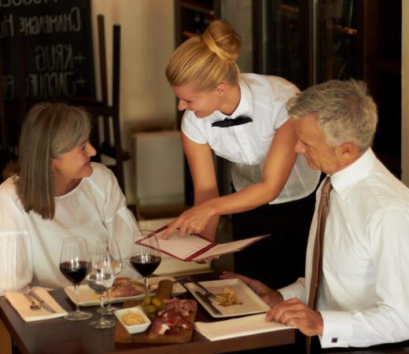
Figure 1: Etiquette of server at a Fine-Dining Restaurant (Shin, 2023)
Some of the most important abilities for this position are:
- Navigating elaborate brochures at fine dining locations require familiarity with gourmet food. Understanding the menu's components, cooking techniques, and taste profiles is essential for a server's job.
- Knowledge of wines and other beverages is essential in fine dining. A bartender or server in this kind of establishment must be well-versed in a wide range of alcoholic beverages in order to advise patrons on their selections.
- Formal dining establishments have stringent rules on table manners and service. A bartender or waiter should always look presentable, have impeccable manners, & be well-versed in professional service practices, for instance, tableside planning, wine serving, and cutlery handling (Filimonau, 2017).
- Fine dining places place a premium on meticulous monitoring of detail. Waiters and waitresses need to pay careful consideration to their clients, checking their orders for accuracy and trying to guess what else they may want.

Second Restaurant: Casual Dining Restaurant

Title of the Job: Server or Waiter
Casual eating establishments also known as fast-food chain servers is bit different from fine-dining restaurant as it provides a less formal dining environment, appealing to groups of neighbours, friends, relatives, and single diners who want to take it easy (Nguyen, 2018). Waiters and waitresses at casual dining establishments need a distinct set of abilities than those required in upscale eateries.
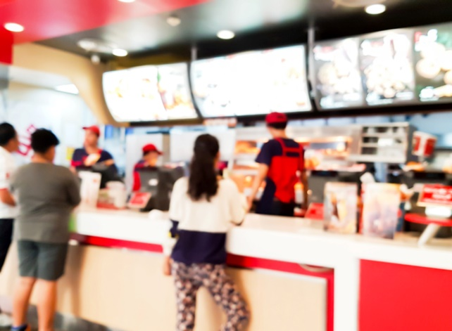
Figure 1: Etiquette of server at a Casual-Dining Restaurant (Nguyen, 2018)
Some of the most critical abilities for this position are:
- Waiters and waitresses in fast food eateries still require knowing about the meals, components, and specials, even if the menu isn't as vast as it would be at a restaurant that offers fine dining. They need to have the self-assurance to provide suggestions and respond to inquiries from clients.
- Patron participation: In casual dining establishments, the emphasis is often placed on providing a warm and inviting ambience. Waiters and waitresses need excellent people skills to successfully interact with clients, learn their preferences, and tailor their service accordingly.
- Effective multitasking and a quicker pace are possible in a more relaxed eating environment. Servers/waitpersons need to be able to take orders quickly, provide food to customers fast, and keep track of many tables at once.
- Customers often have questions or requests that need to be addressed in a casual eating setting (Filimonau, 2023). In today's fast-paced restaurants, servers and servers must be adept at problem-solving, improvising, and keeping customers happy.
There's no denying that different dining establishments need other skills from their food and beverage workers. In fine-dining establishments, the server's primary responsibilities are to make each guest feel special and to ensure that their meal is one they will never forget (Verma, 2018). At the same time, a fast food server places a premium on efficiency and customer satisfaction.

Conclusion
In conclusion, a Food & Beverage worker's necessary abilities vary from one establishment to the next and from one job to the next. The clientele and service philosophy of a particular restaurant will determine the specific duties associated with this position. As an analytical professional, you must know these variations to better cater to your customers' needs.



