
University of Wales Trinity Saint David
School of Engineering
Bridging Craftsmanship and Automation: The Role of Cobots in Surface Finish
Callum Thomas
Supervisor: Jordan Jenkins
2004500
Bachelor of Engineering, Mechanical & Manufacturing Engineering
12/12/2023
Independent Project
ACMA6013
Contents
Abstract 4
1. Introduction 5
1.2 Broad Project Aim 5
1.3 Project Time Plan. 6
1.4 Case Study Overview 6
2. Objectives 7
2.1 Primary Focus 7
2.2 Comprehensive Review 7
3. Literature Review 8
3.1 preliminary Literature Review 8
3.2 Collaborative Robot Arms 9
3.3 Components and Their Impact on Surface Finishing 9
3.4 Current Technological Limitations 9
3.5 Tooling Attachment Compatibility: 10
3.5.1 10
3.6 Materials for Polishing Pads 10
4. Polishing Processes 11
4.1 Integration of Multitool Dremel 11
4.2 Capabilities of the UR3 Cobot in Manufacturing Operations 12
4.3 Precision Control System 13
4.4 Examples and Applications 14
5. Design Criteria 15
5.1 Integration of Polishing Tool 17
5.2 XEBEC Brush A32-CB06M for Industrial Application Testing 18
5.3 Implications for Testing 19
6. Experimental Procedure 20
6.1 Testing Parameters and Objectives 20
6.2 Methodology 20
6.4 Efficiency of Iterations 23
6.5 Pre-and post-polishing surface data: 23
6.6 Significance of Findings 25
7. Analysis of Steel and Aluminium Post-Polishing Iterations 25
7.1. Steel Surface Finish Gradients and Polishing Efficacy 25
7.2 Diverse Initial Conditions and Their Transformations 25
7.3 Observations on Incremental Polishing and Surface Interaction Dynamics 26
7.3.1 Incremental Polishing Effects 26
7.3.2 Initial Passes 27
7.3.3 Mid-Range Iterations 27
7.4 Approach to Optimal Finish 27
7.4.1 Plateau of Refinement 27
7.4.2 Implications for Manufacturing Processes 27
7.5 Polishing Effects on Aluminium Surfaces with Varied Initial Finishes 28
7.5.1 Impact of Polishing on Different Initial Finishes 28
7.5.2 Initial Polishing 28
7.6 Evolution of Surface Texture 29
7.6.1 Surface Finish Response: 29
7.7 Comparative of the Surface Finish Evolution of Steel and Aluminum 29
7.7.1 Initial Roughness Assessment 30
7.8 Iterative Refinement Patterns 30
7.9 Comparative Observations 31
8. Challenges Faced 31
9. Further Work 32
9.1 Operation in Dusty Environments 32
9.2 Advanced Filtration Systems 33
9.2.1 Regular Maintenance and Cleaning 33
9.3 Environmental Impact and Sustainability 33
9.4 Compliance with Standards and Best Practices 33
9.6 Advanced Sensing Techniques for Cobots 34
9.7 Expanding Material Compatibility 34
9.8.1 Limitations of Current Polishing Tools 34
9.8.2 Need for Material-Specific Tooling 34
10. Conclusion 34
11. Reference 35

List of Tables

Table 1: Precision Control Features for Cobot-Assisted Polishing. 14
Table 2: Mitutoyo Surface Finish Inspection Certificate for Polishing Test Sample. 19
Table 3: Tool Selection and Issue Resolution in Cobot Polishing Experiment 29
List of Figures
Figure 1: Time Plan Table & Gantt Chart 6
Figure 2 : Automated Surface Polishing by Cobot 9
Figure 3: Dremel 3000 Multitool Kit with Flex Shaft Attachment. 11
Figure 4 : Cobot Axis Orientation and Movement Diagram. 11
Figure 5: Cobot Control Panel with Cartesian and Rotational Movement Interface. 12
Figure 6: Cobot-Enabled Precision Drilling with Dremel Tool. 13
Figure 7Automated Tool Holder for Dremel in Robotic Polishing Operation. 14
Figure 8: Weight Assessment of Dremel and Tool Holder for Cobot Payload Calibration. 15
Figure 9: XEBEC Brush A32-CB06M Polishing Tool. 17
Figure 10: Mitutoyo sj-210. 19
Figure 11: Profilometer Measurement of Surface Roughness. 20
Figure 12: Cobot Conducting Polishing Test with Tooling Setup. 21
Figure 13:Block of Steel. 24
Figure 14: Progression of Steel Surface Finish RA and RQ Over Polishing Iterations for 1.7 µm Initial Roughness. 24
Figure 15: Comparison of Steel Surface RA and RQ Across Polishing Iterations for 0.7 µm Initial Roughness. 25
Figure 16: Evolution of Steel Surface Finish Parameters RA, RQ, and RZ for 0.3 µm Initial Roughness. 25
Figure 17:Block of Aluminium. 26
Figure 18: Aluminum Surface Finish Variation for 2.3 µm Initial Roughness Over Polishing Iterations. 26
Figure 19: Aluminum Surface Finish Trend for 0.5 µm Initial Roughness Across Polishing Iterations. 27
Figure 20: Changes in Aluminum Surface Finish for 0.2 µm Initial Roughness Through Polishing Iterations. 27
Figure 21: RA Roughness Comparison Between Steel and Aluminum Across Iterations. 28
Figure 22:RZ Roughness Trends in Steel vs. Aluminum Polishing Performance. 29
Figure 23: Iterative RQ Roughness Analysis of Steel and Aluminum Surfaces. 29
List of Equations
Equation 1: RA: Arithmetic Average Roughness 19
Equation 2: RQ: Root Mean Square Roughness 20
Equation 3: RZ: Average Maximum Height of the Profile 20

Abstract
This report investigates the integration of the UR3 collaborative robot (cobot) into metal polishing processes in industrial manufacturing, particularly in the aerospace, automotive, and consumer electronics sectors. The study collaborates with leading manufacturing companies to evaluate the cobot's potential to enhance productivity, improve safety, and reduce manual labour dependency. The research focuses on designing and testing an advanced robotic system, exploring optimal configurations for robotic arms, and addressing barriers to technological adoption. Key findings indicate that cobots can significantly streamline operations, boost efficiency, and increase profitability. The report highlights the technical specifications, implementation strategies, and potential industry-wide benefits of adopting robotic solutions to enhance competitive advantage in manufacturing.

Introduction
The industrial manufacturing sector has undergone a significant transformation with the advent of advanced robotics, leading to the emergence of Industry 4.0, a new era of modern manufacturing. Among the most transformative forces in this sector are collaborative robots, known as cobots, such as the UR10, “which have revolutionised the metal polishing process, a critical aspect of the aerospace, automotive, and consumer electronics industries.
The integration of cobots in the manufacturing process has enabled the optimisation of productivity (Smith, 2023).” and introduced a new level of safety and adaptability in the workspace by mitigating potential risks and challenges. Cobots can work seamlessly with human workers, making manufacturing more efficient and effective.

Despite their promising potential, cobots' adoption rate varies widely across regions and industries. While some sectors have embraced cobots rapidly, others remain cautious due to initial investment costs and perceived complexities in integrating new technologies into existing systems. In many countries, for instance, the manufacturing sector faces the challenge of more skilled labour to operate and maintain these robots and the need for significant reconfiguration of existing production lines to accommodate cobots.

As the global manufacturing landscape continues to evolve, the strategic implementation of technologies like the UR10 robot in metal polishing will play a crucial role in enabling industries to stay competitive, enhance productivity, and drive innovation. This report primarily focuses on the UR3 robot, a variant of the UR10, and its potential to revolutionise metal polishing processes. It offers detailed insights into robotic automation's practical benefits, challenges, and future directions in the manufacturing sector (Silva, Correia Simões, and Blanc (2024)). The report provides an in-depth analysis of how cobots can improve manufacturing, making it more efficient and safer. Cobots can work alongside human workers, helping to streamline the production process and reduce workplace hazards, ultimately leading to increased productivity and profitability.

1.2 Broad Project Aim
The primary objective of this research, undertaken in partnership with leading manufacturing entities, is to explore, design, and implement an advanced robotic system leveraging the UR10 for automated metal polishing operations., which are pivotal in aerospace, automotive, and consumer electronics manufacturing.
The feasibility and effectiveness of this robotic system will be meticulously evaluated through a series of experimental analyses, focusing on critical performance indicators such as surface finish quality, operational efficiency, and the reduction of manual labour dependency.
1. Optimal configurations and programming of robotic arms for intricate surface finishing tasks.
2. Strategies for overcoming barriers to adopting robotic technologies in traditional manufacturing environments.
The goal is to facilitate the widespread acceptance and implementation of robotic solutions, thereby driving innovation, productivity, and quality improvements across the manufacturing sector

1.3 Project Time Plan.
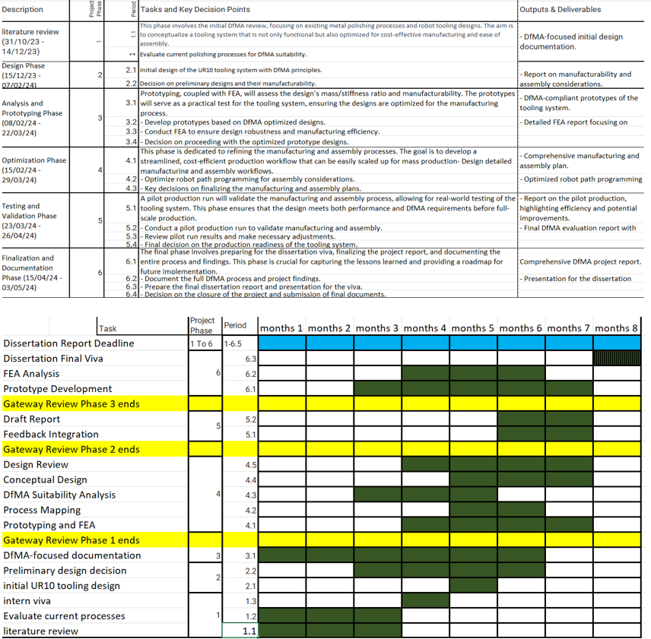
Figure 1: Time Plan Table & Gantt Chart

1.4 Case Study Overview
The company prides itself on the exceptional quality of its moulds; however, with the impending retirement of this key individual, the company is at a crossroads.
The challenge lies in transferring the craftsman's invaluable knowledge and skill set to the next generation. The traditional approach would involve hiring a new employee and dedicating substantial time to training under the guidance of an experienced craftsman.
In response to this challenge, the company is exploring an innovative approach: integrating Human-Robot Collaboration (HRC) in the metal polishing process. The goal is to achieve a similar standard level in the moulds' surface finish without the extensive training period traditionally required for a new hire.
Objectives of the HRC Integration:
1. Evaluate the Technical Feasibility: Assess whether HRC can meet the exacting standards of mould surface finish required for pie manufacturing.
2. Knowledge Transfer Efficiency: Determine if integrating HRC can effectively encapsulate and replicate the retiring artisan's expertise.
3. Productivity and Quality Compare the productivity and quality outcomes between a novice worker trained by the veteran and the results achieved through HRC.
The success of this project has the potential to secure the company's future in delivering high-quality moulds and other products like this company and set a precedent in the manufacturing industry or blending traditional craftsmanship with advanced robotic technology.

2. Objectives

2.1 Primary Focus
The primary focus of the study is to identify and delineate a specific metal polishing process. The UR3 robot's application will be critically analysed for efficiency, quality improvement, and operational safety enhancements.

2.2 Comprehensive Review
Conduct a comprehensive literature review on the application of UR10 robots in industrial settings, with a particular emphasis on their use in metal polishing. This review will cover technological advancements, process optimisations, collaborative robotics safety standards, and the impact of automation on manufacturing quality and throughput.
This paper details the technical specifications and operational framework of the UR3 robotic system used in the metal polishing process (Yang et al., 2023), including the selection criteria for polishing tools and end-effectors. It also covers the software and programming environments utilised for the robot control unit and task programming.
Develop a systematic approach for integrating the UR3 robot into the metal polishing process, encompassing the selection of appropriate polishing compounds and programming the robot for various surface finishes.
Evaluate the performance of the UR3 robotic polishing system through experimental analysis, focusing on key performance indicators such as surface finish quality (measured by parameters like Ra), process efficiency (time reduction), and the reduction of manual labour. This evaluation will also consider the robot's adaptability to different metal types and shapes.
Conclude the research by assessing the feasibility of widespread adoption of robotics in metal polishing operations across different industries, identifying potential barriers to implementation, and proposing recommendations for future research and development in robotic automation for manufacturing excellence.

3. Literature Review

3.1 preliminary Literature Review
It aims to provide a thorough understanding of the technological progress, operational methodologies, and the various approaches developed in this niche area of study.
The literature review is structured to achieve several objectives:
1. Clarify and define key concepts pertinent to robotic automation applied to metal polishing, focusing on the operational functionality (Berx et al., 2024), capabilities, and quality parameters associated with using the UR10 robot.
2. Highlight the current trends, research, and development efforts directed towards employing cobots for metal polishing tasks. This encompasses a review of progress in designing end-effectors tailored for polishing applications without integrating sensors for quality monitoring purposes.
3. Discuss the relationships among critical factors such as the accuracy of the robotic arm and the choice of end-effectors and their impact on the quality of surface finishes achieved on different metals.
4. Point out possible research gaps in the deployment of cobots for metal polishing tasks, especially concerning the robot's adaptability to intricate shapes, its long-term reliability, and the cost versus benefit analysis.
5. Provide essential insights into system design and development decision-making processes, including selecting hardware components(Javaid et al., 2022) like robotic arms and tooling attachments and software solutions for programming the robot's tasks.
This comprehensive review will include contemporary and foundational literature to offer an all-encompassing view.
The scope of this literature survey encompasses:
1. This paper examines cutting-edge robotic automation for metal polishing, focusing on the technological capabilities of robots like cobots and their effectiveness in achieving high-quality surface finishes.
2. A review of the models and methodologies devised for automating the polishing process. This includes analysing the physical interactions between the robot and the material and the adjustments required for different types of metals and desired finishes.
3. A discussion on the role of computational advancements in augmenting the effectiveness of the UR10 robot in metal polishing tasks, thereby making sophisticated automation systems more accessible to a broader manufacturing audience.
4. An investigation into the significance of system design choices and the development of tooling attachments, such as multitool Dremel, for enhancing the UR10's functionality in metal polishing, sidestepping the focus on sensor integration and AI-based enhancements.
By systematically reviewing these areas, the chapter aims to construct a detailed understanding of the current capabilities, challenges, and future directions for robotic automation in metal polishing, setting the stage for informed experimentation and innovation in the subsequent phases of this research project.

3.2 Collaborative Robot Arms
Also known as Cobots, have emerged as a game-changer in the field of automation technology. Recent studies have focused on several critical areas of cobot technology, including advancements in human-robot collaboration, reconfigurable platforms, abrasive finishing technology, FluidJet Polishing, quality assessment techniques, safety architecture, and augmented reality for quality assessment. Researchers have explored the neural basis of trust in human-robot collaboration (HRC) and the integration of additive manufacturing, providing valuable insights into the future of manufacturing and human-robot interaction.
Developing reconfigurable platforms and abrasive finishing technology has enabled robots to perform various tasks, including deburring, polishing, and grinding. Meanwhile, advanced quality assessment techniques have enhanced the accuracy and efficiency of product inspections, reducing the risk of (Javaid et al., 2022) errors and defects. In addition, researchers have explored the use of augmented reality for quality assessment, allowing operators to inspect products in real time and make necessary adjustments on the fly.
Furthermore, safety architecture has been a critical area of focus in cobot development. By integrating advanced safety features (Akella et al., 1999), cobots can operate safely and efficiently near humans. This has opened new possibilities for human-robot collaboration in industries such as healthcare and education.
Overall, cobot technology's continued growth and development promise to revolutionise how look at automations and human-robot collaboration. As researchers continue to explore new avenues for innovation, it be possible to expect to see more cutting-edge applications of cobot technology in various sectors of the economy.
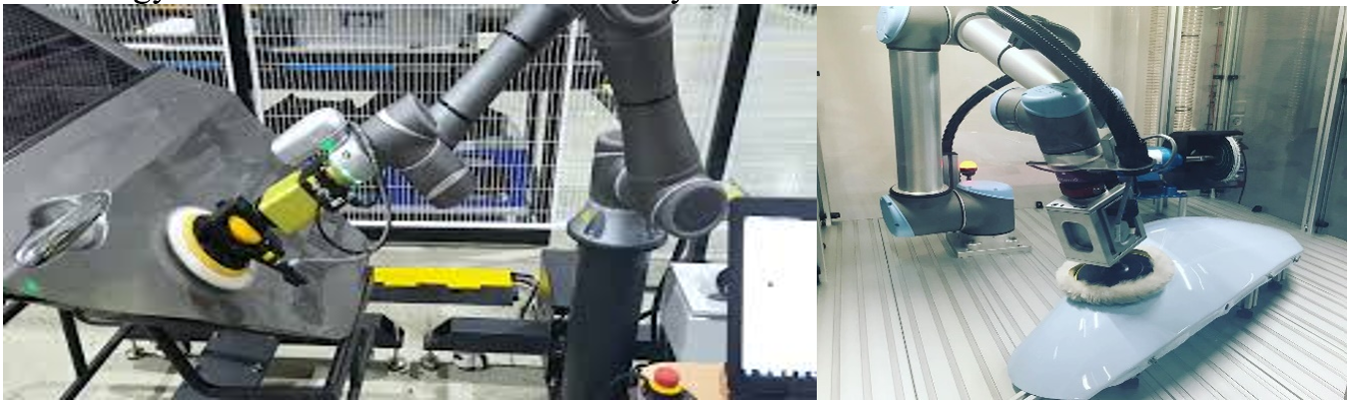
Figure 2 : Automated Surface Polishing by Cobot

3.3 Components and Their Impact on Surface Finishing
Integrating collaborative robots in surface finishing and additive manufacturing signifies a paradigm shift towards more efficient, safe, and high-quality manufacturing processes. The insights from these studies underscore the necessity for ongoing research to optimise further cobot technology and its applications in various manufacturing domains. Enhancing robot reliability, optimising assistance levels, and advancing (Smith, J. (2023)) safety architectures are pivotal for fostering human-robot collaboration that complements human skills and meets industrial demands.

3.4 Current Technological Limitations
One of the key challenges when using the UR3 robot for surface finishing tasks, particularly polishing, is integrating specialised tooling attachments. This is especially relevant when using holders for multitool Dremel's, which can offer a versatile solution to the issue of material compatibility. The advantage of using Dremel tools is that they can be equipped with various attachments, each suited for different (Hopko et al., 2023) materials. This makes switching between different materials during a task easier without switching tools entirely. However, despite its versatility, this approach has several limitations that must be considered. For example, using Dremel tools can result in increased maintenance costs due to the wear and tear of the attachments. Additionally, certain materials may still require specialised tools to achieve the desired finish, so using Dremel tools may only sometimes be a feasible option.:

3.5 Tooling Attachment Compatibility:
The effectiveness of the UR3 in polishing applications heavily relies on the compatibility and performance of the tooling attachment used. While a multitool Dremel provides flexibility, ensuring that the cobot can accurately (Berx et al., 2024) control and manipulate these tools across different materials poses a significant challenge. Precise control is crucial to achieving the desired surface finish, especially when dealing with materials with varying hardness levels and requiring different polishing techniques.

3.5.1 Adaptation to Material Properties:
The Dremel tool is a highly versatile handheld device with various attachments, making it a popular choice among hobbyists and professionals. While it can be used for various tasks, including grinding, sanding, and cutting, polishing is one of its most popular applications. However, optimising the polishing process for each material can be complex and challenging. This is because different materials may require different polishing speeds, pressures, and movements, which can be difficult to achieve manually.
To address this issue, many manufacturers are turning to collaborative robots (cobots) that can be programmed to perform polishing tasks automatically. However, even with cobots, calibrating the device for each material can be complex. Current systems may require sophisticated programming to automatically adjust the parameters in real-time, which can be challenging. As a result, the finishes on materials that fall outside of the pre-programmed settings' effectiveness may need to be more optimal. Therefore, more advanced technology is needed to optimise each material's polishing process, resulting in a high-quality finish every time.

3.5.2 Wear and Maintenance of Polishing Tools:
The frequent use of various materials can lead to rapid wear of the polishing tools, affecting the consistency and quality of the finish over time. Ensuring these tools are maintained and replaced as needed adds complexity to the cobot's operation.
These advancements could enable the cobot to automatically adjust its polishing technique based on real-time assessments of the material being worked on and the condition of the tooling attachment. Additionally, exploring more durable materials for the polishing attachments themselves could extend their lifespan and reduce the need for frequent replacements, thereby maintaining a consistent quality of finish.

3.6 Materials for Polishing Pads
Recently, significant advancements in the manufacturing and maintenance industry have occurred in developing innovative materials for polishing pads. These materials are not just minor improvements over their predecessors but represent a massive leap forward, providing unparalleled adaptability and efficiency. The growing need for precision and versatility in the industry has made it crucial to develop such materials. These innovative materials now address the critical need for polishing pads that conform to various textures and hardness levels without compromising performance.

One of the cornerstones of these novel materials is their remarkable engineered adaptability that can accommodate (Parmar et al., 2022) an extensive spectrum of surface textures. The adaptability of these materials ensures that a single polishing pad can be effectively used across different materials, from the softest plastics to the hardest metals, without requiring frequent replacements. This versatility reduces operational costs and enhances the precision with which these surfaces are polished, resulting in a superior finish that meets stringent quality standards.

These cutting-edge polishing pad materials offer a multitude of benefits to manufacturers and maintenance professionals. They can boost efficiency by minimizing downtime, thanks to their high durability and reduced need for replacements. Moreover, they deliver superior quality finishes with unmatched accuracy and precision, making them an invaluable asset to the industry. The unparalleled adaptability and versatility of these materials make them a top choice for anyone seeking to enhance their polishing processes.

Another significant characteristic of these materials is their ability to adjust hardness in response to the polishing surface. This is achieved through innovative chemical compositions and manufacturing processes that allow the pad's hardness to match the surface it is working on dynamically. This feature is particularly beneficial for complex manufacturing tasks that require working with materials of varying hardness within the same processing line, ensuring optimal contact and efficiency throughout the polishing process.

4. Polishing Processes

4.1 Integration of Multitool Dremel
When you need to achieve precision polishing, mounting the multitool Dremel on the cobot via a holder attachment is a robust solution that can save you a lot of time and effort. This setup allows you to quickly swap Dremel bits that are tailored to the specific requirements of the surface being polished, ranging from coarse abrasion to fine finishing.

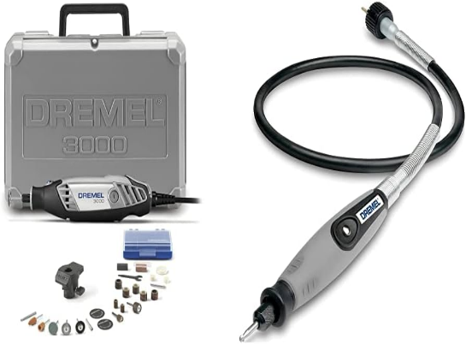
One of the key advantages of using the cobot for polishing is its precision control system. This system is instrumental in regulating the Dremel tool's speed, pressure, and angle during the polishing process. With a Cobot it could be possible to be precise this is particularly important when working with novel materials that react differently to variations in pressure and temperature. (Dremel. (2021))
Figure 3: Dremel 3000 Multitool Kit with Flex Shaft Attachment.
The bot can adjust these parameters in real-time based on the feedback from the material being polished. This ensures that the adaptive polymers and engineered nanomaterials are used to their fullest potential, minimizing waste, and maximizing the quality of the polish.

Moreover, a control system allows for consistent and uniform polishing results, regardless of the complexity of the surface being polished. This means that even the most intricate designs and patterns can be polished to perfection, without compromising on the quality of the final product.
With use of a these applications will not only improves the quality of the polishing process but also enhance the durability and efficiency of the operation. Engineered nanomaterials, known for their durability, combination of this setup it is possible to reduce the wear and tear on the Dremel bits and extending the life of the polishing brush/pads. This synergy between the cobot, the multitool, and the novel materials leads to a more sustainable polishing process, with less downtime for tool or pad changes and reduced operational costs.
Overall, the combination of the cobot and the Dremel offers a reliable and efficient solution for precision polishing that can save you time, effort, and resources while delivering high-quality results.

4.2 Capabilities of the UR3 Cobot in Manufacturing Operations
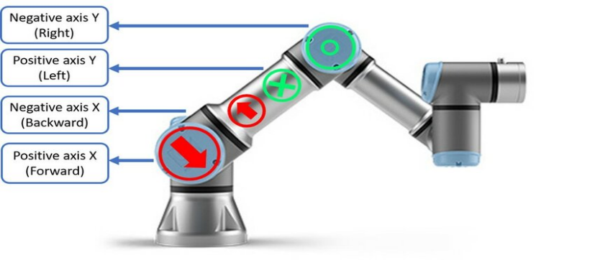
The UR3 cobot, developed by Universal Robots, is renowned for its flexibility, ease of programming, and capacity to work alongside human operators safely. With a reach of 360° and a payload of up to 3 kg, the UR3 is adept at performing various tasks, including assembly, pick-and-place, and, notably, polishing operations. Its intuitive programming (Universal Robots. (n.d.)) interface and versatile arm movement allow for precise control over the polishing process, making it an invaluable asset in manufacturing environments focused on quality and efficiency.
Figure 4 : Cobot Axis Orientation and Movement Diagram.
The Dremel multitool is equipped with various attachments suitable for different polishing tasks. These include:
Felt polishing wheels and cones: Ideal for polishing metals and plastics, providing a high-gloss finish.
Abrasive brushes: help remove exterior surface imperfections without affecting the base material.
Polishing compound: Applied with felt or cloth accessories for a mirror-like finish on metals.

4.3 Precision Control System
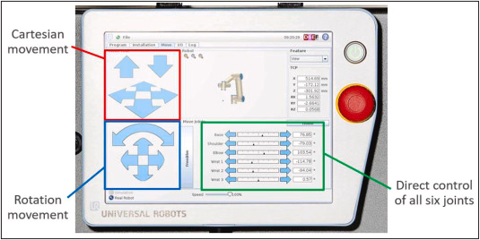
The cobot's precision control system is a fundamental component of its operational capabilities, especially evident in how it manages the Dremel tool during detailed polishing tasks. (Universal Robots. (n.d.)) This system is intricately designed to fine-tune various parameters such as speed, pressure, and angle of the tool. This feature ensures consistency across each pass of the polishing process. Such precision is crucial for achieving the desired finish and maintaining the integrity of the workpiece.
Figure 5: Cobot Control Panel with Cartesian and Rotational Movement Interface.

Feature | Description
Speed Adjustment | The control system adjusts the Dremel tool's speed to match the hardness of the material, optimising the polishing process while preventing damage to softer materials.
Pressure Regulation | Modulates the pressure applied by the tool to ensure optimal force is used for each material, enhancing the finish quality and preventing surface degradation.
Angle Precision | Maintains precise angle alignment to avoid uneven polishing and ensure uniform application across all areas of the material.
Material Sensitivity | Automatically adjusts operational parameters to the specific hardness and texture of the material, ensuring each is handled with the necessary care and precision.
Consistency and Reproducibility | Replicates exact settings across multiple cycles with minimal variation, crucial for maintaining uniform product quality in industrial applications.
Damage Prevention | By finely tuning the tool's operation parameters, the system minimizes risks of material damage, ensuring surface integrity and extending the lifespan of the material.
Table 1: Precision Control Features for Cobot-Assisted Polishing.
Integrating a multitool Dremel with the UR3 cobot offers significant durability and efficiency benefits. This setup minimises the need for manual tool changes, reducing downtime and increasing the throughput of polishing operations (Pires et al., 2022). Additionally, using advanced materials in the polishing pads, combined with the precise control offered by the cobot, extends the life of the Dremel attachments, further enhancing the system's overall efficiency.

4.4 Examples and Applications
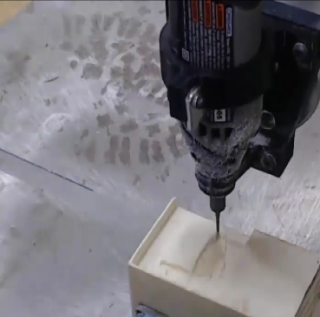
An example of this integration in action can be found in the engineering industry, where the UR10 and Dremel combination is used to ingrain a carving a component. The precision and adaptability of this setup ensure that each part meets the high-quality standards required, demonstrating the system's effectiveness in high-value manufacturing contexts.
Figure 6: Cobot-Enabled Precision Drilling with Dremel Tool.
Here are examples of how collaborative robots are applied in industrial settings:
5: Cobot-Enabled Precision Drilling with Dremel Tool
- Glass Polishing at Saint-Gobain:
At its Sully-sur-Loire plant in France, Saint-Gobain has implemented the cobot to automate the glass polishing process. This initiative replaced a manual process that caused musculoskeletal disorders among workers. Equipped with a Robotiq FT 300 force torque sensor, the cobot enhances safety and efficiency, boosts production by 30%, and delivers a return on investment in less than a year.
- Finishing Tasks with Universal Robots
Universal Robots showcases the versatility of the UR10 cobot in delicate finishing operations, such as polishing, buffing, and sanding. The cobot's force control technology adjusts its position to apply consistent force on uneven and curved surfaces, improving product quality and enhancing workplace safety by taking over ergonomically challenging tasks.
- FerRobotics' Easy Finishing Kit:
Designed for Universal Robots, the Easy Finishing Kit facilitates the automation of manual sanding, grinding, and finishing tasks. This kit, which includes the ACF-K and RoboDK Software, is compatible with UR models UR10, UR10e, and UR16e. It is praised for its simplicity, flexibility, and versatility in improving quality and efficiency in surface treatment processes.
- Surface Finishing Solutions by Tulip Technologies:
Tulip Technologies offers a cobot-based solution for automating surface finishing processes. This system uses various sanding and polishing tools and allows for easy programming of tool trajectories with precise control over the pressure, ensuring high-quality finishes on different surfaces.
The advent of bots, such as those produced by Universal Robots, has revolutionised automation by providing flexible and user-friendly robotic arms. To capitalise on this innovation, the university is harbouring both UR3 and UR10 models, which utilise standardised M screws for attachment, thus ensuring a high degree of interchangeability between tooling systems. The objective is to design a mounting system that can universally fit the cobot model without necessitating re-engineering efforts when switching between them.

5. Design Criteria
One critical design challenge was creating a mount that was easily manufactured using 3D printing technology. The mount also had to provide a secure and stable interface for the Dremel 3000 multitool and its flexible shaft attachment. This was crucial to ensure the cobot could perform its tasks without issues. Another important consideration was the robustness of the design, which needed to be strong enough to withstand the dynamic movements of the cobot during operation without the need to purchase a CNC machine. This was particularly important as acquiring and setting up such a machine would have been costly and time-consuming.
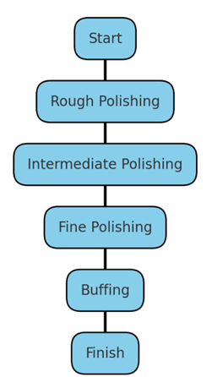
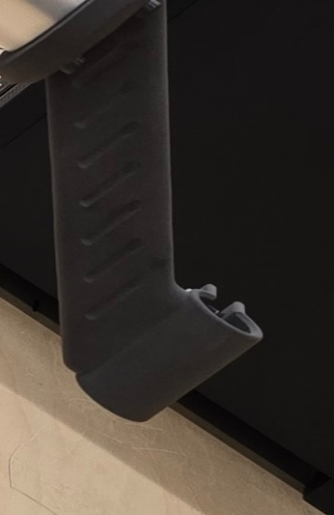
Finally, the mount had to be versatile enough to accommodate UR3/10 models. This was essential to ensure the mount could be used with different cobot models, increasing its usefulness and flexibility. Achieving these goals required careful planning and attention to detail throughout the design process.
Figure 7Automated Tool Holder for Dremel in Robotic Polishing Operation.
It was intended to develop a mounting system that could seamlessly interface with the predefined screw locations on the arms, utilising SolidWorks, a sophisticated 3D computer-aided design (CAD) program. To conceptualise a sleeve-like structure that houses an integrated clamping mechanism to hold the multitool in place firmly. The mounting system was designed with great attention to detail, ensuring easy assembly and disassembly and facilitating rapid tool changes and maintenance. The design process considered various factors, such as the size, weight, and shape of the multitool and the requirements of the cobots' arms, without being complex. The final design incorporated a sleek and durable structure that provided a secure and reliable platform for the multitool while also being aesthetically pleasing.

After the design was finalised, it was time to bring it into the physical realm. A 3D printing process was used to create a swift prototyping phase. The process was chosen because it enabled tests and refined the design in real-world situations, providing valuable feedback and insights that helped to improve the mount's functionality and performance. The mount designed and created for the collaborative robot demonstrated remarkable flexibility regarding its usage. This mount allowed for the attachment of the Dremel 3000 multitool, greatly expanding the capabilities to perform a wide range of detailed and intricate tasks. The mount's design was universal, which means that it facilitated the adaptability of the role in various scenarios without the need for tool-specific customisation. This feature made the cobot highly versatile and efficient in performing its tasks, regardless of the nature of the project at hand.
The designed mounting system exemplifies the potential for additive manufacturing to contribute to the field of robotics, particularly in enhancing the utility of cobots. Adopting a universal design approach establishes a precedent for creating tooling compatible with multiple models, thereby increasing efficiency, and reducing the time and costs associated with customisation. Ensuring that the payload does not exceed the designated limit is imperative. The addition of the universal mounting system and the Dremel 3000 multitool constitutes an extra mass that must be accurately measured and accounted for to maintain the cobots' maximum efficiency.

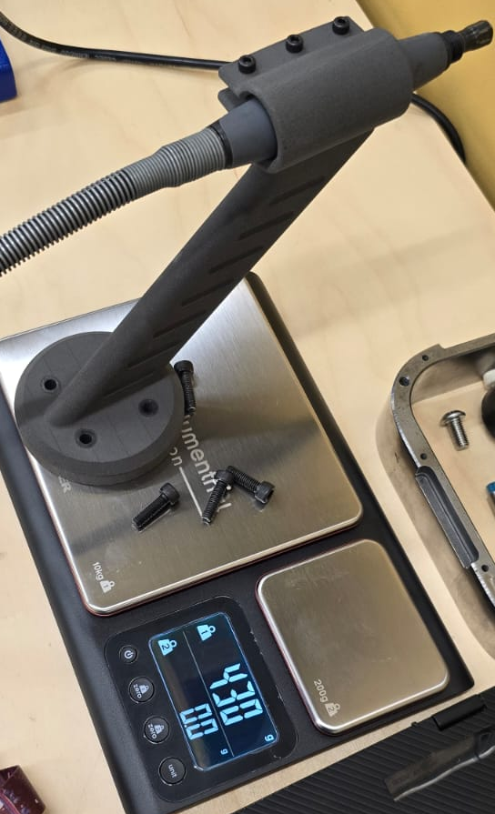
For this purpose, a weighing scale has been employed to determine the mass of the entire assembly – the mounting system and the mass of the Dremel attachment as this will impact the overall mass when placed into the tooling, the multitool, and its flexible shaft. Once ascertained, this value will be meticulously entered into the cobots' control system. Modern cobots are equipped with sophisticated software for inputting tooling mass; this data is critical as it informs the internal dynamics calculations. The accurate input of the mass ensures that the movements remain precise, efficient, and within the safety parameters set by the payload restrictions.
Figure 8: Weight Assessment of Dremel and Tool Holder for Cobot Payload Calibration.
The control system utilises the input mass to adjust the arm's motor torques, ensuring stable and safe operations. This is particularly crucial when the cobots are tasked with detailed and delicate operations such as polishing, where consistent force application is vital. By maintaining the payload within the capabilities, the system can achieve optimal performance and extend the longevity of the mechanical components. Upon verification, the total weight of the universal mounting system, including the Dremel 3000 multitool and the flexible shaft attachment, has been determined to be 0.445 kilograms. This measurement falls well within the payload capacity of the UR3 and UR10 collaborative robots, designed to handle significantly more weight. Specifically, the UR3 has a payload capacity of up to 3 kilograms, and the UR10 can payload up to 10 kilograms.

This weight assessment confirms that the mounting system can be safely and efficiently used on either cobot model without the risk of overloading. The weight of the tooling is a critical factor in maintaining the cobots' balance and ensuring precise movement control, particularly when the cobot arm is fully extended or operating at high speeds.

The modest mass of the tooling also implies considerable leeway for the cobots to operate at their full range of motion and speed, thus ensuring maximum output efficiency during polishing tasks. Moreover, the lightweight nature of the tooling minimises the wear on the cobots' joints and motors over time, promoting longevity and reducing maintenance requirements. The precise weight measurement of the tooling not only substantiates its compatibility with both models but also underscores the effectiveness of the design process.

5.1 Integration of Polishing Tool
Choosing suitable polishing pads for surface finishing tasks with collaborative robots (cobots) is crucial. These pads should match the multitool's specifications and the material of the workpiece. Available in various materials like foam, microfiber, or wool, each pad type provides unique benefits such as different levels of abrasiveness, finish quality, and heat management.
It is essential to consider the durability and flexibility of the pad material, as these affect the precision and efficiency of the polishing. For instance, foam pads have different firmness levels to handle everything from aggressive cutting to fine finishing. In cobot applications, these pads typically feature a hook-and-loop backing, allowing quick changes and secure attachment during the robot's operation.
Integrating suitable polishing pads and brushes into a cobots toolkit is critical for efficient automated polishing tasks. Specific requirements like the workpiece's desired surface finish and material properties must guide tool selection. With the right tools, cobots can become highly effective, versatile polishing systems, demonstrating the potential of advanced manufacturing techniques to create tailored tooling solutions for specific applications.
Polishing Wheels: These are made from compressed lambswool and are used for polishing metals and plastics. They are great for getting into tight spaces and are effective for final polishing.
Felt Pads: These flat, circular pads apply polishing compounds to flat surfaces. They can also be used for the final polishing of metals and for achieving a high-gloss finish on plastics.
Abrasive Buffs: These are used for slight removal of burrs and for smoothing out rough surfaces before applying finer polishing techniques.
Rubber Polishing Points: These are impregnated with abrasive and used to smooth and polish hard materials like steel, aluminium, and ceramics.
Micro Abrasive Discs: These are small, circular abrasive discs that can be used for light sanding and preparation before polishing.
Polishing Compounds: These are used with other polishing accessories to provide the abrasive action needed to bring a high shine to metal or plastic. They typically come in the form of solid bars or paste.
On the other hand, alternatives like polishing brushes are suited for a range of materials. Options include natural bristles for delicate surfaces and synthetic filaments for more arduous tasks. The choice of brush must consider the flexibility and density of the bristles to ensure they adapt well to various surface contours and maintain adequate pressure.
These brushes need a robust mounting interface compatible with the multitool to handle the rotational forces during use while still allowing precise control. It is also important that the brushes are designed to minimise shedding and maximise longevity to uphold quality and reduce downtime.

5.2 XEBEC Brush A32-CB06M for Industrial Application Testing (Xebec Technology)
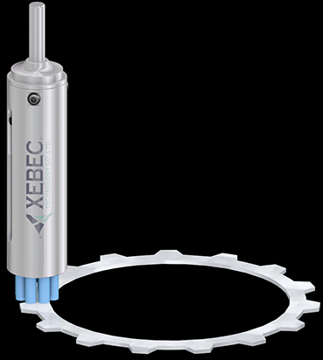
The choice of the XEBEC Brush Surface A32-CB06M is particularly relevant to automated polishing applications. This decision is informed by several factors that mirror industrial requirements and standards.
Figure 9: XEBEC Brush A32-CB06M Polishing Tool.
Industry Standard: The XEBEC Brush Surface A32-CB06M is recognised as a standard tool in industrial polishing. Its widespread adoption in manufacturing sectors provides a benchmark for performance and expected outcomes.
Material Consistency: This brush is made with unique ceramic fibres that are consistent in quality. This ensures uniform abrasion and finish on the workpiece, which is essential for maintaining industry-level quality.
Durability: XEBEC brushes are known for their longevity and wear resistance, which is crucial in a factory setting where tools are used extensively and must withstand repetitive tasks.
Adaptability: The A32-CB06M model is versatile and can adapt to various surface geometries, making it an ideal candidate for testing a cobot's polishing capabilities across various applications.

Predictable Results: The repeatability of results when using an XEBEC brush ensures that testing can accurately predict how the cobot system will perform in real-world factory conditions.
Efficiency: XEBEC brushes' efficiency in removing material and producing a high-quality finish reduces processing time, aligning with industrial settings' productivity goals.
Adaptability to the Dremel 3000: The Dremel 3000's flexibility allows for the attachment of various tools, including the XEBEC Brush. This adaptability simulates the performance of more specialised and less accessible CNC machines, offering near-close results with a more widely available and versatile instrument.

5.3 Implications for Testing
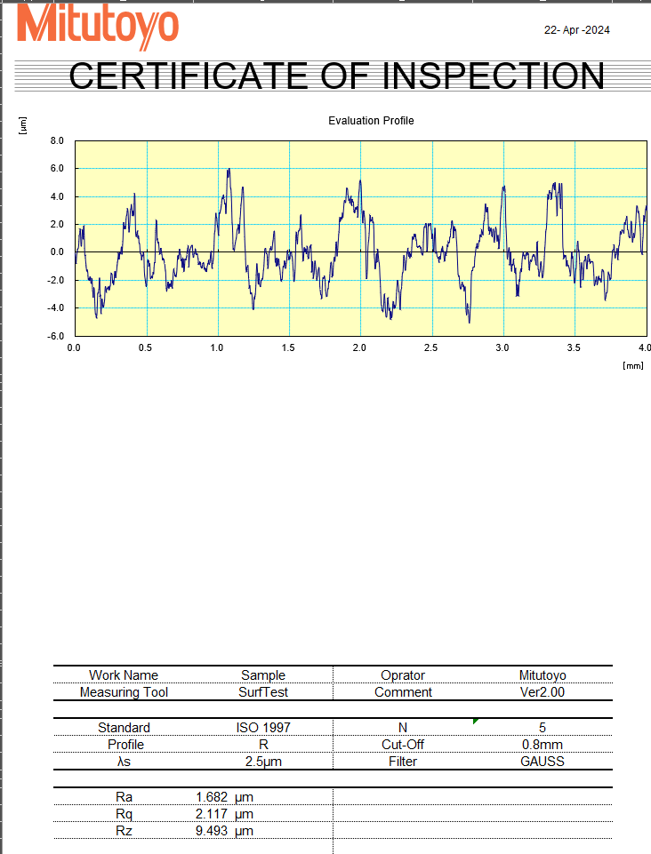
The study mimics a real-world manufacturing environment by integrating the XEBEC Brush Surface A32-CB06M into the testing phase of the cobot's polishing process. This choice ensures that the testing is representative of the conditions found in industrial applications and that the results are directly translatable to such settings. It verifies the cobot's capabilities regarding consistent performance, endurance, and output quality. (Taylor Hobson July 2017)
Table 2: Mitutoyo Surface Finish Inspection Certificate for Polishing Test Sample.

6. Experimental Procedure

6.1 Testing Parameters and Objectives
The experimental phase of this project was designed to optimise the number of passes that must be executed to achieve an industrially acceptable surface finish on metal workpieces. This was investigated through a series of systematic iterations on two types of metals: aluminium and steel. Each metal workpiece was prepared with four distinct surface finishes on rectangular faces. The initial face was left as-is, reflecting the raw, unprocessed condition of the metal. The subsequent three faces were milled using a CNC machine to create a gradient of finishes, ranging from a rough to a smooth surface.

6.2 Methodology
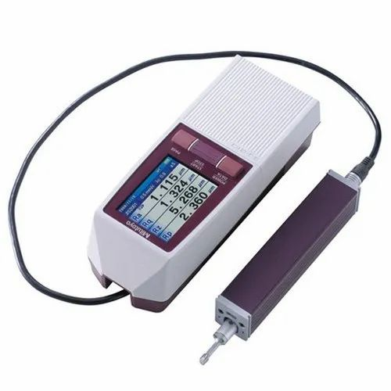
Figure 10: Mitutoyo sj-210.
- Before commencing the polishing process, a meticulous initial evaluation was performed to guarantee precise and reliable outcomes. Employing a sophisticated Mitutoyo surface measurement tester, baseline surface finish measurements were established for each face of the metal workpieces. This crucial step was undertaken to thoroughly comprehend the initial surface conditions, (Mitutoyo Corporation. (2013)). thereby enabling effective planning and adjustment of the polishing procedure. By establishing a baseline, any changes in surface finish post-polishing could be accurately measured and documented. This careful and detailed approach assured consistent, high-quality results in the final polished product. (Taylor Hobson July 2017)

Understanding Surface Finish Measurements: RA, RQ, and RZ
Surface finish, or surface roughness, refers to the texture of a surface and is critical in determining how a material will interact with its environment. Three common parameters to quantify surface finish in engineering are RA, RQ, and RZ. These measurements are essential for assessing the quality of machined and polished surfaces, as they directly affect the performance and longevity of mechanical components. ( A.W. Stahli (n.d))

RA: Arithmetic Average Roughness
Equation 1: RA: Arithmetic Average Roughness
RA, or Arithmetic Average Roughness, measures the average deviation from the centerline of a surface's profile over a specified length. It is calculated by taking the average of the absolute values of the vertical deviations from the mean line, typically expressed in micrometers or microinches. The equation for RA is:
$$RA=\frac{1}{n}​∑_{i=1}^{n}∣yi​∣$$

where $yi$ are the vertical deviations from the mean line and 𝑛n is the number of measurements. RA is particularly useful for general purposes, providing a quick snapshot of surface texture.

RQ: Root Mean Square Roughness
RQ, or Root Mean Square Roughness, offers a more sensitive measure of surface texture by considering the square of the vertical deviations before averaging, which emphasizes larger deviations more heavily than smaller ones. It is defined by the equation:
Equation 2: RQ: Root Mean Square Roughness
$$RQ=\sqrt{\frac{1}{n} {​∑}_{i=1}^{n}y_{i}^{2}}​$$

This parameter is especially valuable in applications where high precision is critical, such as in the aerospace or automotive industries, where surface irregularities can significantly impact performance.

RZ: Average Maximum Height of the Profile
RZ represents the average maximum height of the profile. It is determined by averaging the vertical distance between the highest peak and the lowest valley within five sample lengths along the surface. RZ is particularly important in contexts where extreme deviations in surface texture might interfere with the function of a component, such as sealing surfaces in engines or pumps. ( A.W. Stahli (n.d))
RZ calculates the average of the maximum peak-to-valley heights within multiple sampling lengths along the surface. Here, $Z_{pi}$ and $Z_{vi}$ represent the peak and valley heights in each of the 𝑘 sampling lengths. RZ is useful for identifying significant surface features that might impact component functionality, particularly in high-precision engineering contexts. It is defined by the equation:
$$RZ=\frac{1}{k}\sum_{i=1}^{k}{(Z_{pi}-Z_{vi}​)}$$

Equation 3: RZ: Average Maximum Height of the Profile

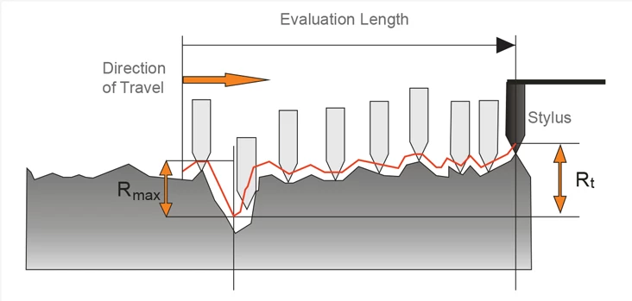
RZ can be more indicative of surface faults than RA or RQ and is often used in quality control to ensure compliance with more stringent specifications. Each of these parameters, RA, RQ, and RZ, provides a different perspective on surface texture, offering valuable insights into the material's (Mitutoyo Corporation. (2013)). characteristics and suitability for specific applications. By utilizing these measures, engineers can better tailor the polishing process to meet the desired specifications, ensuring optimal performance and durability of the final product. This comprehensive understanding of surface finish parameters enhances the precision of manufacturing practices and contributes significantly to advancements in material engineering and processing technology.
Figure 11: Profilometer Measurement of Surface Roughness.
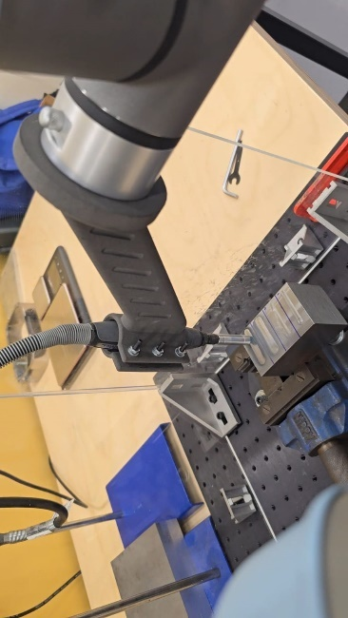
2. During the polishing process, the cobot was fitted with a suitable tool designed explicitly for this task. The cobot was then programmed to perform multiple passes, which included 1, 10, 20, and 30 iterations. This wide range of iterations was chosen to thoroughly test the cobot's polishing capabilities in efficiency and effectiveness across a broad spectrum of repetitive actions. The cobot's performance was evaluated based on precision, speed, and consistency. The results of this evaluation were then used to fine-tune the cobot's programming and optimise its performance for future polishing tasks.
Figure 12: Cobot Conducting Polishing Test with Tooling Setup.
3. When it comes to achieving a desired surface finish, the materials used play a crucial role. In the case of aluminium and steel, for instance, the contrast in their hardness and abrasiveness makes a significant difference in the number of iterations needed. This means that achieving the same surface finish for both materials would require different processes and techniques. Therefore, considering the material specifics is essential in determining the optimal method to achieve the desired surface finish. (Fletcher & Webb, 2017)
4. The workpieces under study had three distinct CNC-milled faces, each displaying varying degrees of initial surface roughness. The study's primary objective was to evaluate the cobot's adaptability to different starting textures. The cobot was subjected to an identical number of polishing iterations on each of the three faces to achieve this. The study aimed to (Dilibal et al., 2021)investigate the cobot's ability to respond to surface irregularities and adjust its polishing technique accordingly, thereby achieving a consistent and uniform surface finish across all three faces.

6.3 Post-Polishing Analysis
After the completion of polishing tasks by the collaborative robot (cobot) on the metal workpieces, utilising the Mitutoyo SJ-210 surface measurement tester was imperative for quantifying the post-polishing surface finishes. The instrument's precision provided a detailed comparative analysis between pre- and post-polishing surface data, revealing critical insights into the polishing process's efficacy.

6.4 Efficiency of Iterations
The analysis underscored the concept of Efficiency of Iterations, pivotal in evaluating the production process. This metric signifies the number of polishing passes needed to attain an industrial-grade surface finish, emphasising the necessity for balancing effort with effectiveness. The Mitutoyo SJ-210's detailed measurements identified the minimum iteration threshold at which the surface finish meets the required standards. Optimising this element yields a triad of benefits: diminished production times, enhanced product quality, and lowered operational costs. Such efficiency is paramount in any manufacturing endeavour to swiftly deliver premium products, bolstering the competitive edge in a dynamic market.

6.4.1 Optimal Pass Counts
Furthermore, the data collected facilitated the determination of Optimal Pass Counts, a decisive element in surface finishing protocols. By examining the data for various iteration counts, the study distinguished whether fewer iterations, such as ten passes, produced a finish comparable to that of more extensive iterations, like thirty passes. This comparison provided insights into the point at which additional iterations cease to improve the surface quality significantly — the point of diminishing returns. Understanding the optimal pass count is indispensable as it underpins a cost-efficient and resource-effective manufacturing strategy. Implementing the findings from the Mitutoyo SJ-210 ensures that surface finishing processes are precisely calibrated and economically and practically aligned with industry requirements.
The Mitutoyo SJ-210 surface measurement tester is an invaluable tool for advancing the understanding of the polishing process's dynamics. Its ability to deliver precise and reliable surface finish measurements informs strategic decisions regarding iteration efficiency and optimal pass counts. (Zhao, L., & Lee, J. (2023)) This level of detail and accuracy is essential for advancing manufacturing methodologies prioritising quality, efficiency, and sustainability in surface treatment operations.

6.5 Pre-and post-polishing surface data:
Optimal Pass Counts are a critical factor in surface finishing. It entails evaluating whether a lower number of iterations, such as ten passes, can achieve a comparable finish to that of a higher count, like 30 passes. By determining the optimal pass counts, we can better understand the point of diminishing returns in terms of the iteration count versus surface finish improvement. This analysis helps us identify the most efficient and cost-effective way to achieve the desired finish outcome. Therefore, it is an essential aspect of surface finishing that should be considered while designing the process.

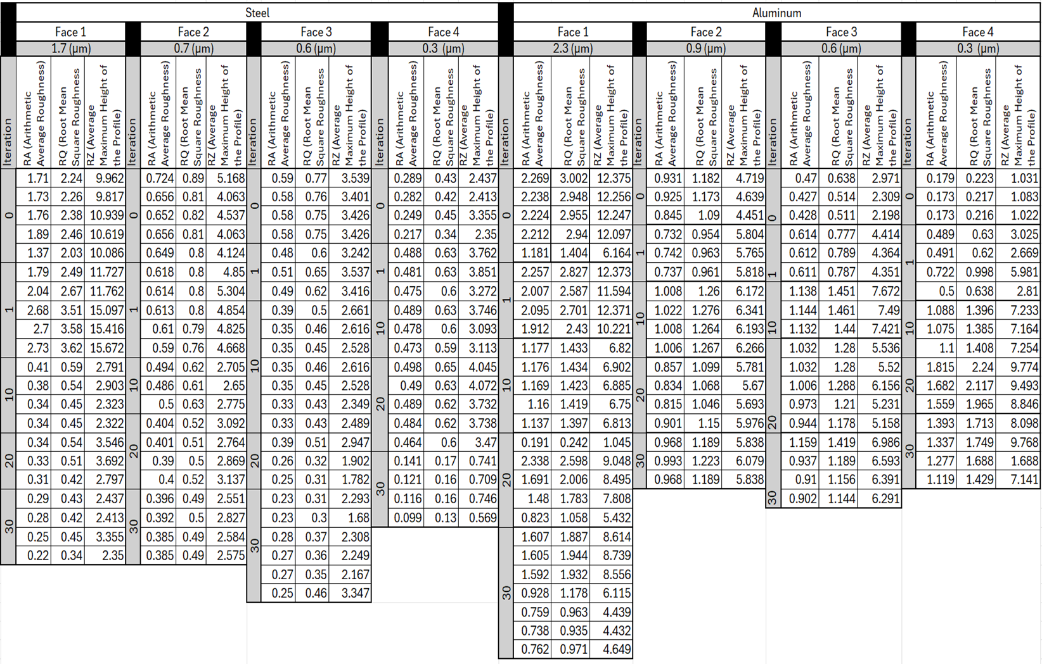
Table 3: Surface Finish Data for Steel and Aluminum Polishing Iterations.

6.6 Significance of Findings
The results and analysis obtained from this experiment hold immense potential to offer a comprehensive and strategic framework for industries that leverage collaborative robots (cobots) for polishing tasks. By determining the optimal iteration count for different types of metal surfaces and finishes, considering factors such as time and resource efficiency, this research aims to enhance operational efficiency and optimise the use of cobots in manufacturing processes. This, in turn, can significantly improve productivity, quality, and cost-effectiveness for businesses that rely on cobots for polishing tasks. The insights gained from this study can also help businesses make informed decisions on using and deploying cobots in their specific manufacturing contexts.

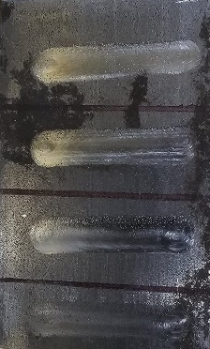
7. Analysis of Steel and Aluminium Post-Polishing Iterations
Figure 13:Block of Steel.

7.1. Steel Surface Finish Gradients and Polishing Efficacy
The experimental framework was meticulously designed to explore the effects of cobot polishing on steel surfaces with four distinct initial roughness gradients: 1.7 µm, 0.7 µm, 0.6 µm, and 0.3 µm. Each side of the steel was polished several times to ascertain the progressive changes in surface finish.

7.2 Diverse Initial Conditions and Their Transformations
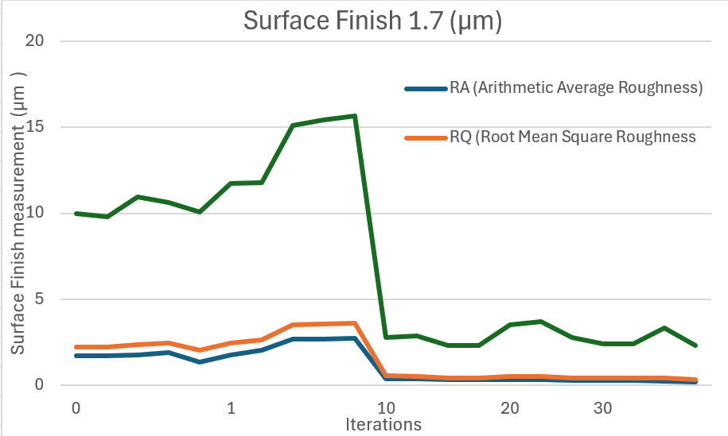
The polishing process began with a surface roughness of 1.7 µm. Initially, the cobot applied a coarse polishing technique to the surface, significantly reducing roughness after the first pass. The cobot continued to polish the surface for ten iterations, with each pass resulting in further improvements in smoothness. However, beyond the 10th iteration, the enhancements in smoothness became less pronounced, suggesting an optimal polishing limit for coarser textures. The cobot's polishing process demonstrated its ability to improve the overall smoothness of the surface efficiently and effectively, making it ideal for applications where a high degree of surface finish is required.
Figure 14: Progression of Steel Surface Finish RA and RQ Over Polishing Iterations for 1.7 µm Initial Roughness.
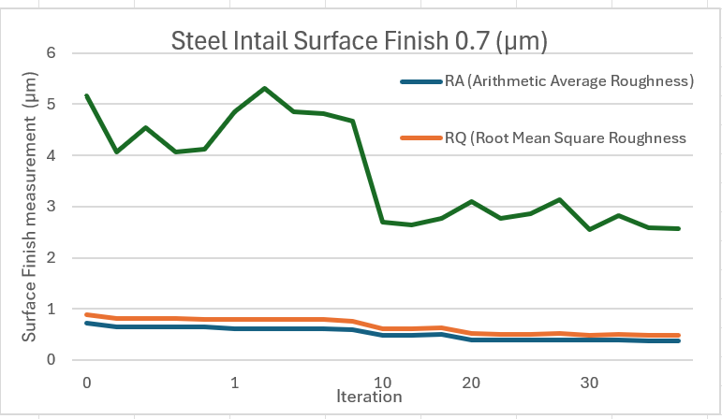

0.7 µm and 0.6 µm Initial Finishes: During the intermediate stages of the finishing process, the surfaces achieved moderate smoothness. However, as soon as the polishing step started, slight increases in roughness parameters were occasionally observed, which could be attributed to the initial abrasive interactions. Nevertheless, the iterations of polishing progressed, and a clear trajectory towards a finer finish was evident. It was particularly noticed after 20 passes that the surface quality had significantly improved. The polishing action eliminated most surface imperfections and irregularities, resulting in a smoother, more polished surface. The polishing step significantly impacted the final surface quality, and the results were impressive.
Figure 15: Comparison of Steel Surface RA and RQ Across Polishing Iterations for 0.7 µm Initial Roughness.

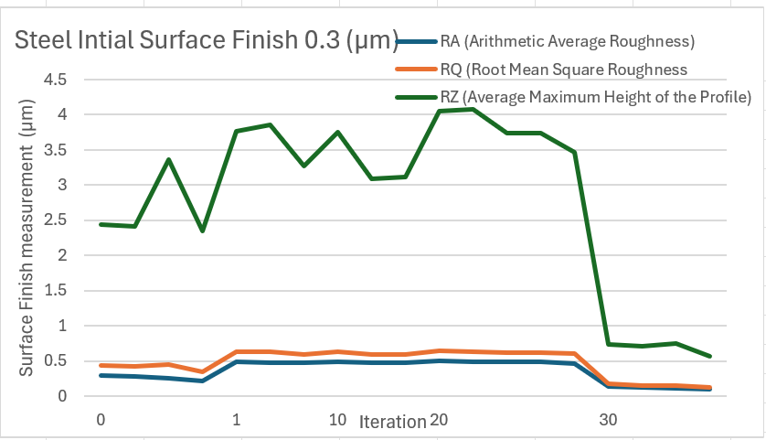
Figure 16: Evolution of Steel Surface Finish Parameters RA, RQ, and RZ for 0.3 µm Initial Roughness.
0.3 µm Initial Finish: The most refined initial finish presented a unique challenge, where even minor alterations were pronounced. Initial polishing iterations at times showed an unexpected rise in roughness measurements, indicating the introduction of fine abrasions. Nevertheless, consistent polishing beyond these early stages ultimately yielded the smoothest finish, with the 30th iteration significantly enhancing the surface quality.

7.3 Observations on Incremental Polishing and Surface Interaction Dynamics

7.3.1 Incremental Polishing Effects
Incremental polishing refers to the progressive steps taken to enhance the surface finish of a material by repeating the polishing process. This iterative approach allows for gradual improvements and the ability to monitor the surface texture's evolution closely. The cobot's role in this methodology is pivotal, ensuring consistency and precision across each iteration.

7.3.2 Initial Passes
Substantial reductions in roughness parameters were observed in the initial stages of cobot polishing, particularly evident on the coarsest surface with a 1.7 µm initial finish. This indicates that the most significant deviations from the mean surface level were effectively smoothened. The first few passes are crucial for quickly levelling out the peaks and valleys of the rough surface, resulting in a markedly smoother texture.

7.3.3 Mid-Range Iterations
As the number of iterations increases, especially in the transition from 1 to 10 passes, the rate of surface improvement begins to stabilise. This polishing phase may introduce minute scratches or micro-abrasions on surfaces with initial finishes of 0.7 µm and 0.6 µm. These micro-abrasions are a natural consequence of the abrasive materials interacting with the surface, occasionally increasing the surface roughness temporarily until subsequent iterations polish out these minor imperfections.

7.4 Approach to Optimal Finish
Surfaces that start smoother (0.3 µm finish) may exhibit increases in roughness after initial iterations, a counterintuitive phenomenon likely due to the delicate balance between removing existing imperfections and not introducing new ones. The cobot's repeated action gradually refines the surface, homing in on the optimal finish. Here, the precision and consistency of cobot polishing demonstrate their worth, methodically enhancing the surface until a desired level of smoothness is achieved.

7.4.1 Plateau of Refinement
Across all initial surface finishes, there is a common point where further iterations no longer yield significant improvements. This plateau of refinement suggests the steel surface has reached a state where the existing tooling and parameters can no longer make appreciable changes without the risk of over-polishing, which could damage the surface integrity.

7.4.2 Implications for Manufacturing Processes
These observations underline the importance of identifying an ideal iteration count for polishing, contingent on the initial surface finish and the desired result. Understanding the incremental effects of cobot polishing is essential for optimising industrial applications, ensuring that each tool pass contributes positively to the surface finish and that resources are not expended on ineffective additional iterations.
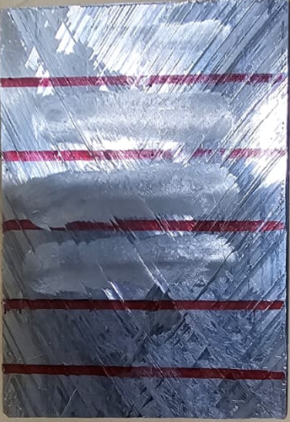
By recognising the characteristics of cobot polishing dynamics, manufacturers can adjust their processes to maximise quality and efficiency, catering the number of iterations to the specific conditions and constraints of their surface finishing tasks.
Figure 17:Block of Aluminium.

7.5 Polishing Effects on Aluminium Surfaces with Varied Initial Finishes

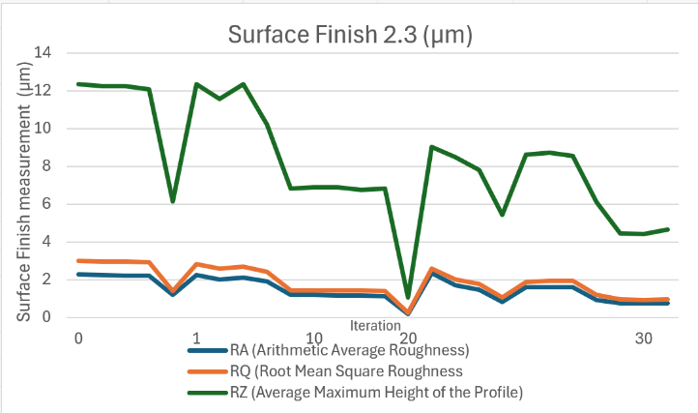
7.5.1 Impact of Polishing on Different Initial Finishes
Figure 18: Aluminum Surface Finish Variation for 2.3 µm Initial Roughness Over Polishing Iterations.
The experiment's approach aimed to assess the cobot's efficiency in polishing different surfaces. The surfaces chosen had initial finishes of 2.3 µm, 0.9 µm, 0.5 µm, and 0.2 µm, allowing for a comprehensive evaluation of the cobot's capabilities. The impact of polishing on each surface was measured systematically at different stages, precisely at 0 to 30 iterations. This approach allowed for a detailed assessment of the progressive modifications that occurred to each surface, providing valuable insights into the cobot's polishing performance.

7.5.2 Initial Polishing
Coarser Initial Finish (2.3 µm): After conducting experiments on surface refinement, with the observation that the surface's initial finish was notably rough. However, upon applying the initial polishing technique, One should notice that a significant reduction in the surface roughness. This observation strongly indicates the effectiveness of the process in smoothing out the macro-surface imperfections. The experiment's results demonstrate the substantial impact of refining surfaces that require significant texture refinement.
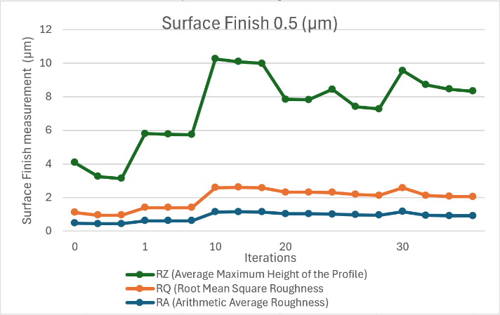
Figure 19: Aluminum Surface Finish Trend for 0.5 µm Initial Roughness Across Polishing Iterations.
Medium Initial Finishes (0.9 µm and 0.5 µm): The surfaces with moderate initial roughness in the experiments showed an exciting pattern of change during the polishing process. After the first polishing iteration, with the increase in roughness parameters. To attribute this effect to the abrasive action of the polishing compound, which likely introduced micro-level surface disruptions. These disruptions can be considered minor scratches or grooves on the surface, contributing to a rougher appearance. However, as the tests continued to polish the surface with subsequent iterations, the observation shows a gradual smoothing of these effects. Over time, the surface finish improved and approached the pre-polished state. This suggests that the polishing process is iterative, where the surface undergoes multiple changes before reaching its final state.

Finest Initial Finish (0.2 µm): The most polished initial surface showed a substantial roughness increase after the initial pass, suggesting that the aggressive initial interaction overshadows the fine pre-existing texture. Further iterations revealed the capacity for progressive refinement, although not to the initial pre-polished levels.

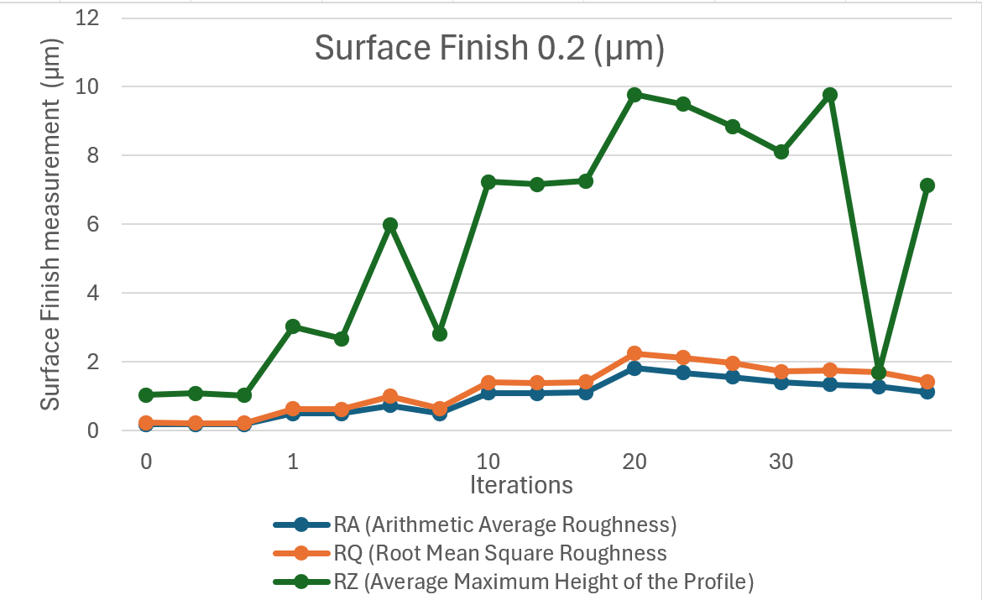
7.6 Evolution of Surface Texture
Figure 20: Changes in Aluminum Surface Finish for 0.2 µm Initial Roughness Through Polishing Iterations.
Across all initial finishes, demonstrated a nonlinear response to the polishing process. The first iteration typically increased roughness, possibly unmasking sub-surface irregularities or creating new ones. From the 10th iteration onwards, a general trend of improvement in smoothness was observed, although the degree of change and the rate of improvement varied based on the initial surface condition.
Understanding the Optimal Iteration Range through Surface Response Analysis

The optimal iteration range for polishing is the specific number of iterations after which the surface shows minimal improvement or reaches a plateau in surface finish quality. This concept is pivotal to maximising efficiency and preventing material wastage or damage in industrial applications.

7.6.1 Surface Finish Response:
The response of surfaces to cobot polishing varied depending on the initial finish quality. Coarser surfaces showed rapid improvement at lower iteration counts as the more prominent surface irregularities were smoothed out. Conversely, finer surfaces required careful attention to avoid surpassing the optimal iteration threshold, beyond which the process could induce new micro-scratches or sub-surface stresses, potentially degrading the surface. The surface's sensitivity to polishing increased for finer initial finishes, underscoring the need for precise control over the polishing process. The optimal iteration range in these scenarios often occurred earlier in the sequence, as the fine pre-polished textures could be quickly affected by over-polishing.

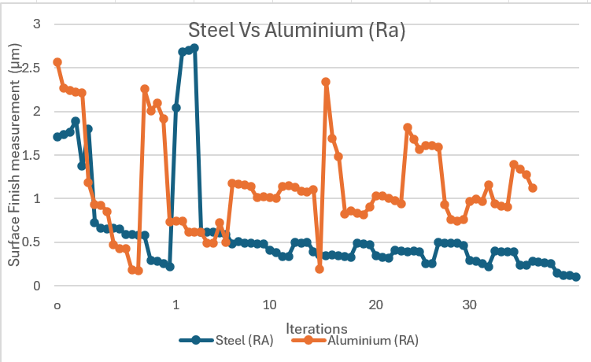
7.7 Comparative of the Surface Finish Evolution of Steel and Aluminum
Figure 21: RA Roughness Comparison Between Steel and Aluminum Across Iterations.
To achieve superior industrial performance, it is essential to have a thorough understanding of how various metals respond to different surface finishing processes. Conducting a comparative analysis of diverse metals, such as steel and aluminium, under identical polishing conditions is essential for several reasons. Firstly, it helps select the appropriate materials based on their post-treatment performance, which is crucial for applications where the surface's integrity affects the product's functionality, durability, and aesthetic appeal. Secondly, such comparisons enable the optimisation of the finishing processes, ensuring that each metal's treatment is aligned with its unique physical properties and intended use. Lastly, by comprehending the behaviour of different metals, manufacturers can predict wear patterns, maintenance requirements, and longevity, thereby enhancing product quality and consumer satisfaction. This knowledge can also aid in developing new and improved finishing techniques that can further improve the performance of various metals, leading to better products.

7.7.1 Initial Roughness Assessment
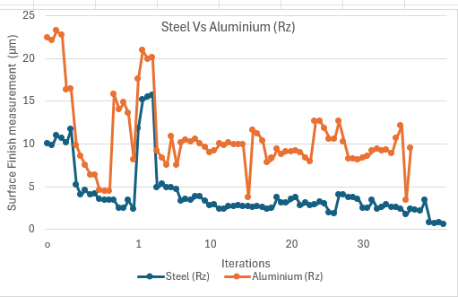
Upon the first round of polishing, roughness significantly reduced across all steel parameters, indicating a significant initial improvement. On the other hand, aluminium exhibited higher sensitivity, with visible fluctuations in roughness that did not always follow a clear downward trend. This could be attributed to the metal's inherent nature, which made it more susceptible to changes in surface conditions. These findings suggest that the polishing and surface treatment process should be tailored to each material's properties for optimal results.
Figure 22:RZ Roughness Trends in Steel vs. Aluminum Polishing Performance.

7.8 Iterative Refinement Patterns
Subsequent iterations often resulted in a continued improvement or stabilisation of steel's surface quality, especially regarding RA and RQ, which measure the average roughness and the root mean square values, respectively. Steel's RZ values indicated a general decrease in the height variations of the profile peaks and valleys, punctuated by occasional rises that could indicate the need for process optimisation.
Graph 8: RZ Roughness Trends in Steel vs. Aluminum Polishing Performance
The response was less predictable in aluminium, with each parameter showing more pronounced swings throughout the iterations. While there were intervals of surface improvement, particularly in the transition between the initial iterations and mid-range counts, the latter iterations displayed a trend reversal in some instances, emphasising aluminium's propensity for irregular surface modifications.

7.9 Comparative Observations
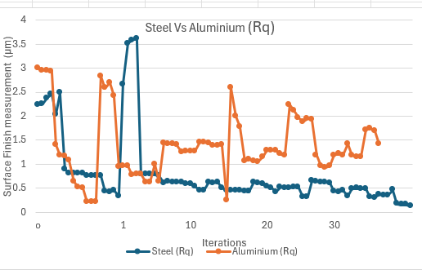
The comparison reveals that steel's inherent hardness and resilience may exhibit a more consistent pattern toward achieving a refined surface finish through polishing. Conversely, aluminium's responses to the same polishing conditions were markedly different, characterised by more significant variability and an apparent need for tailored polishing strategies to mitigate potential surface deterioration.
Figure 23: Iterative RQ Roughness Analysis of Steel and Aluminum Surfaces.
The findings highlight the imperative for material-specific optimisation in polishing processes. Steel's trajectory suggests a potential for aggressive polishing without significant detriment to the surface finish, provided the process parameters are carefully controlled. On the other hand, aluminium's fluctuating roughness metrics call for a more nuanced approach, where optimising iteration counts and polishing intensity is essential to ensure a consistent and high-quality finish.

8. Challenges Faced
During this project, selecting and optimising a suitable multitool for polishing operations presented several challenges. Initially, the tool selected was incompatible with the required operational specifications, particularly regarding speed compatibility with the XEBEC brush. This table outlines the sequence of issues encountered, from the initial choice of the tool to the complications arising from its use, the selection of a better-suited alternative, and the mitigation strategies implemented to ensure consistent performance. The detailed breakdown helps illustrate how each problem was addressed, ensuring the project remained on track while maintaining high quality and operational efficiency standards.
Table 3: Tool Selection and Issue Resolution in Cobot Polishing Experiment
Aspect | Details
Initial Tool Selection | Choose Dremel 9100-21 Fortiflex with a fixed speed of 21,000 RPM.
Issue Identification | The selected multitool's speed was incompatible with the XEBEC Brush Surface A32-CB06M's maximum recommended speed.
Complications | Rapid Wear of Brush Fibers: High RPM caused excessive friction and heat, shortening brush lifespan.  Uncontrolled Polishing Process: The inability to adjust the tool's speed to the brush specifications risked damaging the workpiece and creating uneven finishes.
Resolution | Switch to the Dremel 3000 for its variable speed feature, aligning the tool's speed with the brush's specifications.
Benefits of New Tool | Preservation of Brush Integrity: Reduced speed to 10,000 RPM to decrease wear on brushes.  Enhanced Control: Improved precision in the polishing process.  Operational Flexibility: Speed adjustments enhanced versatility across different materials.
Spindle Speed Dynamics | Maintaining consistent spindle speed during extended operations proved challenging, affecting surface finish uniformity and material sensitivity.
Mitigative Measures | Equipment Calibration: Recalibration of the multitool’s motor controller for stable RPM.  Process Monitoring: Real-time monitoring and adjustments of spindle speed to ensure consistency.
Integration into Methodology | Adaptations were made to ensure tool capabilities aligned with operational parameters, maintaining experimental integrity and enabling accurate evaluation of polishing performance.

9. Further Work

9.1 Operation in Dusty Environments
Dust can pose a significant challenge to cobots, especially in environments where it is frequently generated, such as in woodworking, metalworking, and mining. The composition of dust particles can cause mechanical parts to wear out faster, clog cooling systems, and interfere with sensor functions. This can result in decreased efficiency and reliability, increased maintenance costs, and reduced lifespan of the cobot.
To mitigate these risks, it is crucial to adopt measures that protect cobots from dust-related damage. One effective strategy is to apply protective coatings and use enclosures. Protective coatings are applied to the cobot's surface to repel dust particles and reduce debris buildup. These coatings can be made from various materials, including polyurethane and silicone, which offer durability and resistance to abrasive particles.
Conversely, enclosures are designed to shield the cobot's sensitive components from direct exposure to dust. These enclosures are compliant with industry standards, such as IP (Ingress Protection) ratings, and can effectively prevent dust penetration, preserving the integrity of mechanical and electronic systems.
By implementing protective measures like these, cobots can be safeguarded from the effects of dust accumulation, ensuring that they continue to function efficiently and reliably in even the most challenging environments.

9.2 Advanced Filtration Systems
Another critical approach to implementing advanced filtration systems is cooling and ventilation mechanisms. These systems use high-efficiency particulate air (HEPA) filters or electrostatic precipitators to trap dust particles before they can enter the machine. By maintaining a clean airflow within the cobot, these filtration systems prevent dust accumulation in critical areas, such as motors and electrical components, thereby enhancing operational reliability and reducing the need for frequent maintenance.

9.2.1 Regular Maintenance and Cleaning
Regular maintenance and cleaning schedules are crucial when operating in dusty environments. Your role as operators is vital in ensuring that the cobot operates efficiently and safely. Dust accumulation and wear-and-tear on protective measures can lead to malfunctions and even pose a threat to your health and safety. Therefore, routine inspections should be conducted by you to identify any signs of dust accumulation or damage to the protective measures.
Cleaning procedures should be integrated into the cobot's operational protocols to efficiently remove dust and debris. Automating or semi-automating cleaning procedures can ensure the cleaning process is completed thoroughly without disrupting production. Depending on the specific needs and constraints of the operating environment, compressed air, vacuum systems, or specialised cleaning solutions can be used for cleaning.
It is important to tailor the cleaning procedures to the specific needs of the operating environment. This involves considering factors such as the type of dust present, the size of the particles, and the accessibility of the areas that need to be cleaned. Your ability to adapt the cleaning procedures to the specific operating environment can lead to efficient and effective cleaning, ensuring the longevity of the cobot and the safety of the environment.

9.3 Environmental Impact and Sustainability
A contemporary design philosophy must incorporate an analysis of the environmental impact of materials used in producing tooling holders. Integrating sustainable practices, such as using recycled polymers or biodegradable alternatives, is crucial. Further work should investigate the holder's life cycle analysis, considering end-of-life recyclability and the environmental implications of the manufacturing process itself. The goal is to minimise ecological footprints, driving innovation towards eco-friendly materials and production methods.

9.4 Compliance with Standards and Best Practices
Ensuring compliance with industry standards is not just a requirement but a crucial aspect for the broader adoption of any tooling holder design. Future iterations should include a comprehensive review of relevant safety and operational regulations to ensure the design meets or exceeds all mandated criteria. This adherence establishes trust and reliability, positioning the design as a viable option for widespread industrial use and reassuring the audience about its safety and quality.
Additional Advanced Research Directions in Cobotic Polishing, a process that involves the use of collaborative robots (cobots) for surface finishing tasks.

9.6 Advanced Sensing Techniques for Cobots
Integrating advanced sensing techniques is crucial for cobots to perceive their environment accurately, make informed decisions, and interact safely and effectively with human operators. Vision systems, utilising cameras and sophisticated processing algorithms, are particularly transformative, enabling cobots to recognise objects, assess their size and shape, detect their position and orientation, and monitor environmental changes. (Ihlenfeldt, S. (2024))

9.7 Expanding Material Compatibility
Research should also explore new polishing attachments, tools, and techniques to broaden the range of materials that cobots can polish. This includes developing universal tooling that can adjust to different material properties and investigating novel materials for polishing pads that adapt to various textures and hardness.
“As collaborative robots continue to expand their roles in industrial surface finishing, selecting appropriate polishing tools becomes critical to maintaining quality and efficiency (UR cobots)”. The XEBEC Brush A32-CB06M, known for its robust performance in general polishing tasks, exemplifies the advances in tooling that have facilitated these applications. However, its suitability varies depending on the material being polished, highlighting the need for a nuanced approach to tool selection.

9.8.1 Limitations of Current Polishing Tools
While effective for many applications, the XEBEC Brush A32-CB06 M may be better for polishing softer metal surfaces. Its abrasive nature, designed for more resilient materials, can lead to surface scratches or excessive material removal when used on softer metals. This mismatch can compromise the aesthetic and functional integrity of the workpiece, underscoring the necessity for a more adaptable tooling strategy in robotic systems. (Xebec Technology)

9.8.2 Need for Material-Specific Tooling
It is imperative to integrate various polishing tools tailored to specific material characteristics to address these challenges. For softer metals, incorporating a softer brush, potentially made from finer, less abrasive materials, would mitigate the risk of damage and ensure a high-quality finish. This approach enhances the versatility of cobots and ensures that they can perform at their best across a broader range of materials.

10. Conclusion
This study has elucidated the profound impact of collaborative robots (cobots), specifically the UR3 model, on automating metal polishing processes within the industrial manufacturing sector. The findings from this research underscore the capability of cobots to significantly enhance operational efficiency, safety, and productivity across pivotal industries such as aerospace, automotive, and consumer electronics. Through a series of experimental analyses focusing on critical performance indicators like surface finish quality and operational efficiency, it has been demonstrated that the strategic implementation of cobots can reduce dependency on manual labour while maintaining high-quality production standards.
The integration of cobots into traditional manufacturing environments, although met with initial resistance due to perceived complexities and initial investment costs, offers considerable advantages in terms of cost efficiency and adaptability to dynamic manufacturing needs. The UR3 robot, with its precision and flexibility, has proven especially effective in tasks requiring intricate surface finishes, showcasing the tangible benefits of robotic automation in enhancing workplace safety and operational throughput.
However, adopting such technology also brings challenges, including requiring skilled labour to manage and maintain robotic (EVS Robot. (n.d.)). systems and significant modifications to existing production lines. To address these challenges, this report strongly advocates for ongoing training programs to boost workforce proficiency with robotic technologies. It also suggests that manufacturers adopt a phased integration approach to facilitate the gradual assimilation of cobotic systems into existing infrastructures.
In summary, the potential for cobots to transform metal polishing processes and broader manufacturing operations is evident. With ongoing technological advancements and strategic implementation, cobots are set to become integral parts of the manufacturing industry, driving innovation and efficiency. As this technology progresses, it will undoubtedly create new opportunities for quality improvement and cost reduction, further cementing the role of automation in manufacturing excellence. Therefore, industry stakeholders must embrace these innovations, ensuring they stay competitive in a rapidly evolving technological landscape.

11. Reference
How Robotic Welding is Revolutionizing the Manufacturing Industry. https://www.bhlmetalind.com/post/how-robotic-welding-is-revolutionizing-the-manufacturing-industry
. http://pubs.sciepub.com/ajcea/2/6/2/index.html
Robots Pave the Way for Reshoring Manufacturing - Robotics 24/7. https://www.robotics247.com/article/robots_pave_way_reshoring_manufacturing
Collaborative robotic automation | Universal Robots Cobots. https://www.universal-robots.com/?gclid=CjwKEAjw3Nq9BRCw8OD6s4eI5HASJABsfCIarpUeUfmi8f7593fIf0RMTojkzjaYW8VBhmkXjQI0SRoCODnw_wcB
EVS Robot. (n.d.). Next-Gen Robotics: Advancements in Polishing and Assembly Technologies. Retrieved from https://www.evsint.com/advancements-in-polishing-and-assembly-technologies/

Zhao, L., & Lee, J. (2023). Movement Modeling and Control for Robotic Bonnet Polishing. Chinese Journal of Mechanical Engineering. https://doi.org/10.1186/s10033-023-0075-x

Lorenzini, M., Lagomarsino, M., Fortini, L., Gholami, S., & Ajoudani, A. (2023). Ergonomic human-robot collaboration in industry: A review. Frontiers in Robotics and AI, 9. https://doi.org/10.3389/frobt.2022.813907

Agostini, L., Chen, Y., Palazzi, E., & Vertechy, R. (2024). Physical ergonomics monitoring in human-robot collaboration: A standard-based approach for hand-guiding applications. Machines, 12(4), 231. https://doi.org/10.3390/machines12040231
Mitutoyo Corporation. (2013). Surftest SJ-210 series: Portable surface roughness tester [User manual]. Mitutoyo America Corporation. https://www.mitutoyo.com/webfoo/wp-content/uploads/Surftest_SJ210.pdf

Dremel. (2021). Dremel 3000 User Manual [User manual]. Bosch Power Tools B.V. (https://www.dremel.com/storage/de-de/dremel-3000-1190-original-pdf-25069-de-de.pdf)

Abicht, J., Hellmich, A., Wiese, T., Harst, S., & Ihlenfeldt, S. (2024). New automation solution for brownfield production – Cognitive robots for the emulation of operator capabilities. CIRP Journal of Manufacturing Science and Technology, 50, 104–112. https://doi.org/10.1016/J.CIRPJ.2024.02.007
Akella, P., Peshkin, M., Colgate, E., Wannasuphoprasit, W., Nagesh, N., Wells, J., Holland, S., Pearson, T., & Peacock, B. (1999). Cobots for the automobile assembly line. Proceedings - IEEE International Conference on Robotics and Automation, 1, 728–733. https://doi.org/10.1109/ROBOT.1999.770061
Berx, N., Decré, W., & Pintelon, L. (2024). A tool to evaluate industrial cobot safety readiness from a system-wide perspective: An empirical validation. Safety Science, 170, 106380. https://doi.org/10.1016/J.SSCI.2023.106380
Chen, M., Nikolaidis, S., Soh, H., Hsu, D., & Srinivasa, S. (2018). Planning with Trust for Human-Robot Collaboration. ACM/IEEE International Conference on Human-Robot Interaction, 307–315. https://doi.org/10.1145/3171221.3171264
Dilibal, S., Sahin, H., Danquah, J. O., Emon, M. O. F., & Choi, J. W. (2021). Additively Manufactured Custom Soft Gripper with Embedded Soft Force Sensors for an Industrial Robot. International Journal of Precision Engineering and Manufacturing, 22(4). https://doi.org/10.1007/s12541-021-00479-0
Fletcher, S. R., & Webb, P. (2017). Industrial robot ethics: The challenges of closer human collaboration in future manufacturing systems. Intelligent Systems, Control and Automation: Science and Engineering, 84, 159–169. https://doi.org/10.1007/978-3-319-46667-5_12
Hopko, S. K., Mehta, R. K., & Pagilla, P. R. (2023). Physiological and perceptual consequences of trust in collaborative robots: An empirical investigation of human and robot factors. Applied Ergonomics, 106, 103863. https://doi.org/10.1016/J.APERGO.2022.103863
Javaid, M., Haleem, A., Singh, R. P., Rab, S., & Suman, R. (2022). Significant applications of Cobots in the field of manufacturing. Cognitive Robotics, 2, 222–233. https://doi.org/10.1016/J.COGR.2022.10.001
Parmar, H., Khan, T., Tucci, F., Umer, R., & Carlone, P. (2022). Advanced robotics and additive manufacturing of composites: towards a new era in Industry 4.0. In Materials and Manufacturing Processes (Vol. 37, Issue 5). https://doi.org/10.1080/10426914.2020.1866195
Pires, J. N., Azar, A. S., Nogueira, F., Zhu, C. Y., Branco, R., & Tankova, T. (2022). The role of robotics in additive manufacturing: review of the AM processes and introduction of an intelligent system. Industrial Robot, 49(2). https://doi.org/10.1108/IR-06-2021-0110
Yang, X., Zhou, Z., Sørensen, J. H., Christensen, C. B., Ünalan, M., & Zhang, X. (2023). Automation of SME production with a Cobot system powered by learning-based vision. Robotics and Computer-Integrated Manufacturing, 83, 102564. https://doi.org/10.1016/J.RCIM.2023.102564

(Abicht et al., 2024; Akella et al., 1999; Berx et al., 2024; Chen et al., 2018; Fletcher & Webb, 2017; Hopko et al., 2023; Javaid et al., 2022; Yang et al., 2023)

