Omar Qassem | 2316700 | Computing (Data & Information Systems)

Introduction to Web and Database Concepts
  - Developing an MS Access Database for Coastal Tourism Management

Contents

Section A
Users, roles & responsibilities................................................................3
Departments & responsibilities...............................................................3
Entity Relationship Diagram...................................................................5
Database Schema Design......................................................................6
Database Management System.............................................................8
Reports Designs & Creation.................................................................13
Customer Reservation & Event Owner update forms...........................17
User Friendly Menus.............................................................................20

Section B
Database efficiency & effectiveness for coastal tourism.......................28
Challenges & benefits of transitioning...................................................30

Bibliography..........................................................................................31

Coastal Tourism Management System

Section A

Users, roles & responsibilities and their needs of the system.

User | Roles & Responsibilities
Tourist | Register, reserve, explore packages, leave feedback
Businesses | Register, upload/amend details & photos, leave feedback
Admin Staff | Register, reserve, explore packages, view/amend users, view/amend packages
Manager/Owner | Register, reserve, explore packages, view/amend users, view/amend packages, view/amend pricings, view financial information, view reports
Database Admin | explore packages, view/amend users, view/amend packages, view/amend pricings, create/view/amend database schemas/tables
IT Technician | Maintain IT equipment, databases, websites, cyber security
Legal Adviser | Ensure company exists and works within the law

Department | Roles & Responsibilities
HR | Staff, complaints
Bookings | Assisting customers
Tourism | Vetting places, creating itineraries
Advertising | Uploading holidays/photos
IT | Maintaining website/IT systems
Legal | Ensure compliance with law

Database Design and Implementation

Tables required:
- Reservation – bring together all tables to make a reservation, so package, price, date from/to.
  - Package ID, Customer IDs, dates
- Packages – destination with itineraries
  - Package ID, Destination ID, itinerary, price,
- Destinations – photos, details & availability
  - Destination ID, Address, photos, details, reviews, rating, availability
- Customer - customer details
  - Customer ID, Name, address, date of birth, email address, contact number
- Reviews – package reviews/feedback & rating
  - Review ID, Destination ID, details/comment
- Staff – details
  - Staff ID, Name, address, department ID, salary, Staff role ID
- Staff roles
  - Role ID, role
- Department table – hold details about departments to assign to staff
  - Department ID, department detail/name

Entity-Relationship diagram(s)

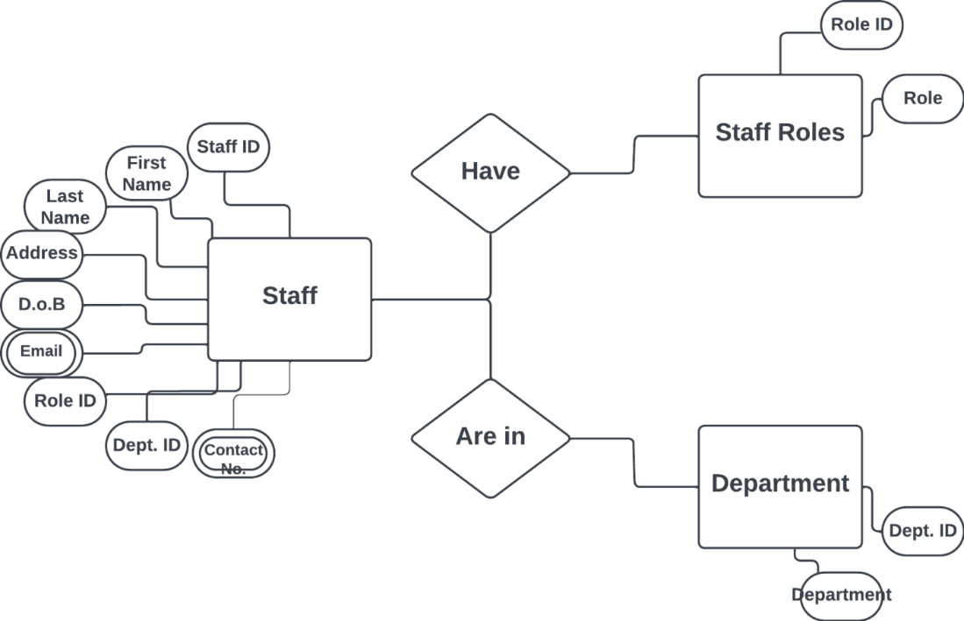

Explanation:
Staff & staff roles etc. are not related to the booking system in any way, unless there is a need to audit who does what, which could be useful but not implemented in this design as the customers and the event owners themselves would often be inputting into the system manually. Hence this ER diagram is separate from the other, below.

- Staff have staff roles. Staff can have many staff roles and staff roles can have many staff.
- Staff belong/are in departments. Staff can belong to one department, while departments can have many staff.

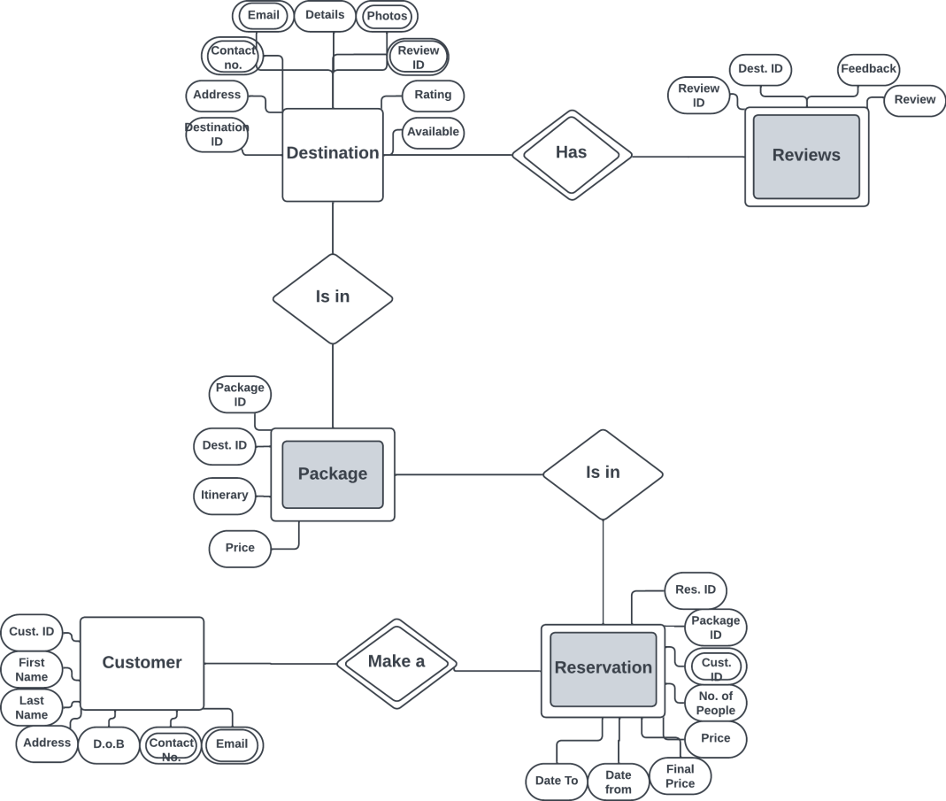

- Each destination has reviews given to them. A destination can have many reviews, while each review is associated with one destination.
- Each destination is in a package. A package contains one destination and a destination can be in many packages.
- Each package is in a reservation. Each reservation contains one package and each package can be in many reservations.
- Customers make a reservation. A customer is in one reservation, and many reservations can be made by one customer.

Note: All cardinality mentioned here is shown below in the schema diagram.
All diagrams completed in Lucid Chart software. Available at: Intelligent Diagramming | Lucidchart

Database schema based on entity-relationship diagram
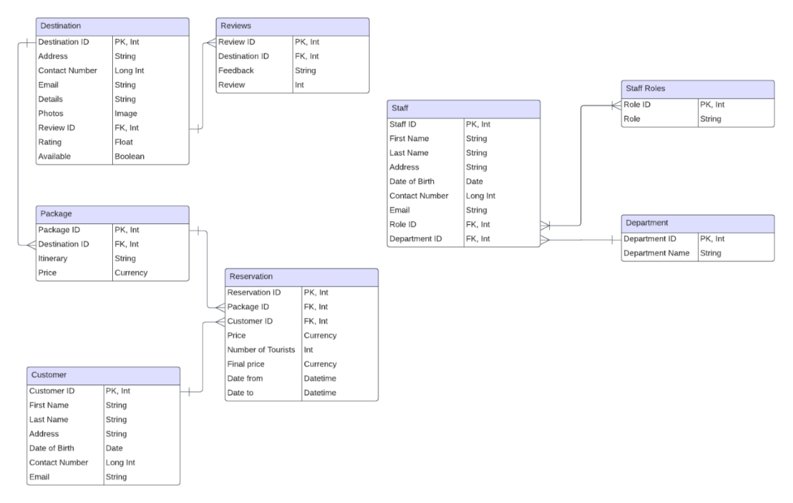

Cardinality explained above with ER diagrams.

Database created in Microsoft Access. Relationships created as per the schema diagram.

Note: Address has been split in to “Address 1, Address 2, City, Country and Postcode in the database. Only “Address” in the schema to save space.

Customer table
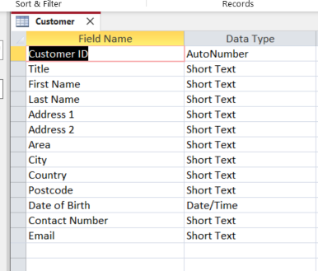
All data non-null apart from Address 2 and email. Contact number must be in mobile format.

Department table
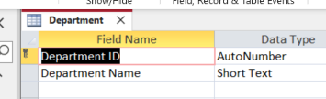
All fields non-null.

Destination table
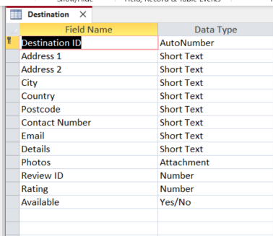
All data non-null apart from Address 2, email and photos. Contact number must be in mobile format.

Package table
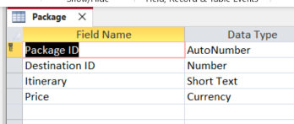
All fields non-null apart from Itinerary.

Reservation
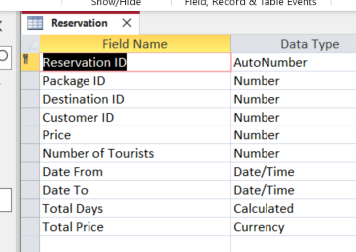
All data non-null. Date From field must be before Date To. Total Price calculated from Total Days * Price. Total Days calculation is the days between Date From & Date To.

Reviews
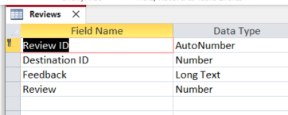
Review Id & Destination non-null.

Roles
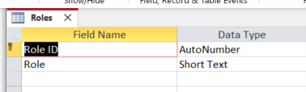
All fields non-null.

Staff
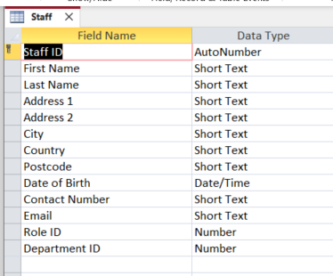
All fields non-null apart from Address 2, Email, Role Id and Department ID, as they may have none assigned to them when first starting.

Relationships within MS Access database

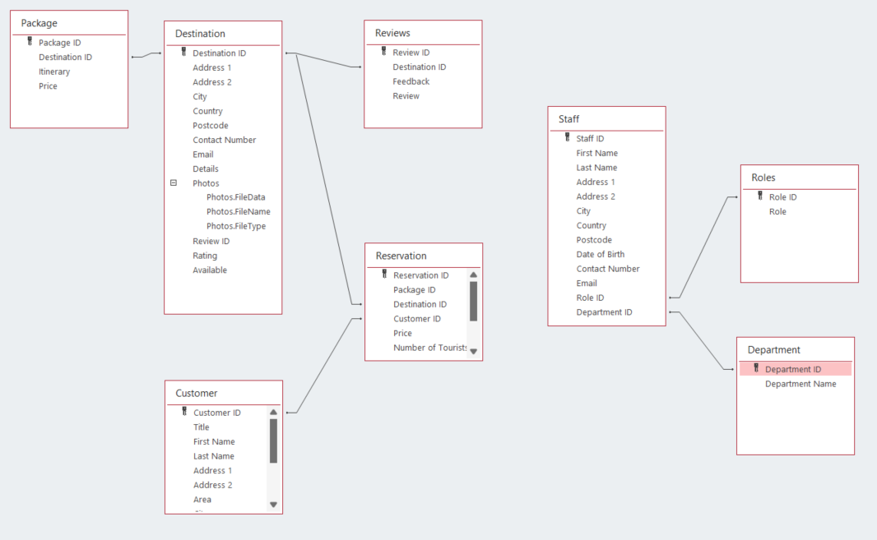

As seen in the schema design.

Report Designs

Design for report that will calculate total revenue generated by Coastal Getaways for a specific period.

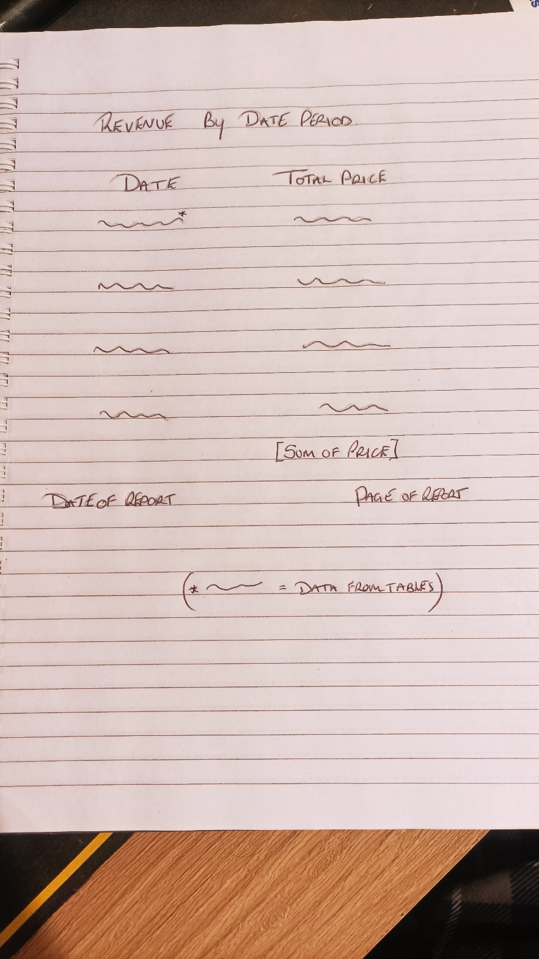

Report within MS Access database:

On open, presented with the following input box.
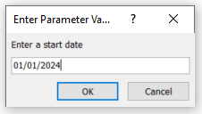

And then
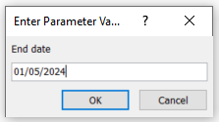

Which then produces the following
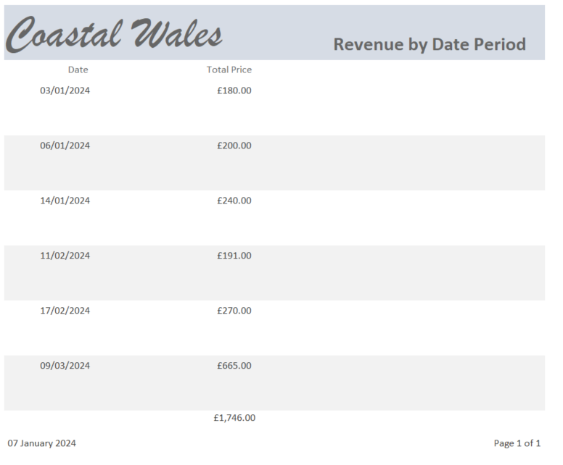

Design for report that compiles guest feedback and reviews for Coastal Getaways.

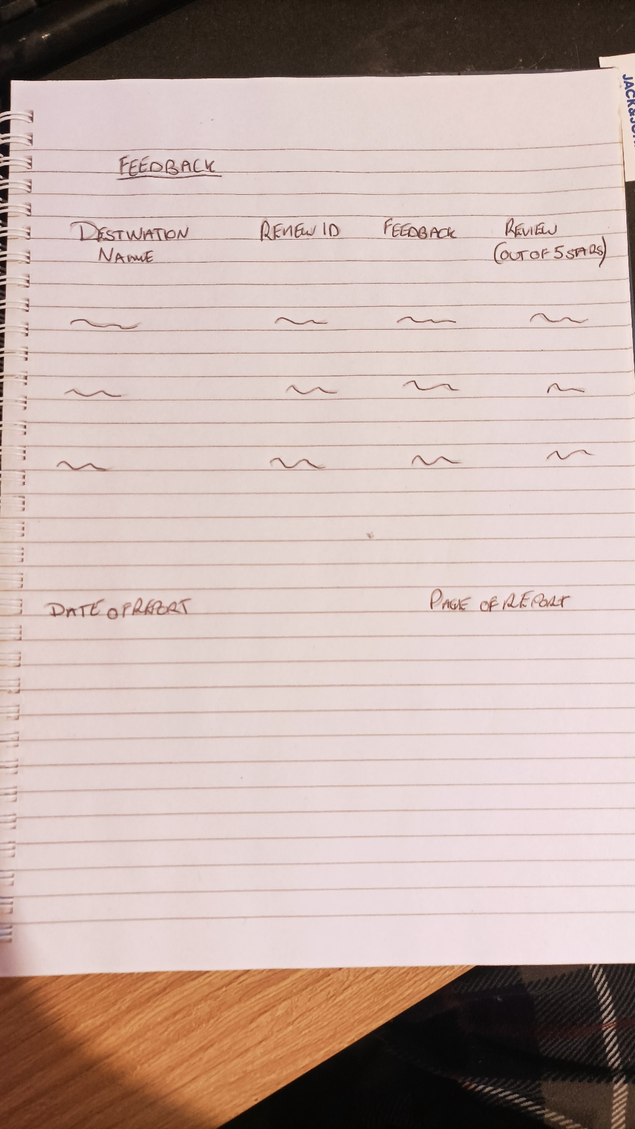

Report in MS Access database:
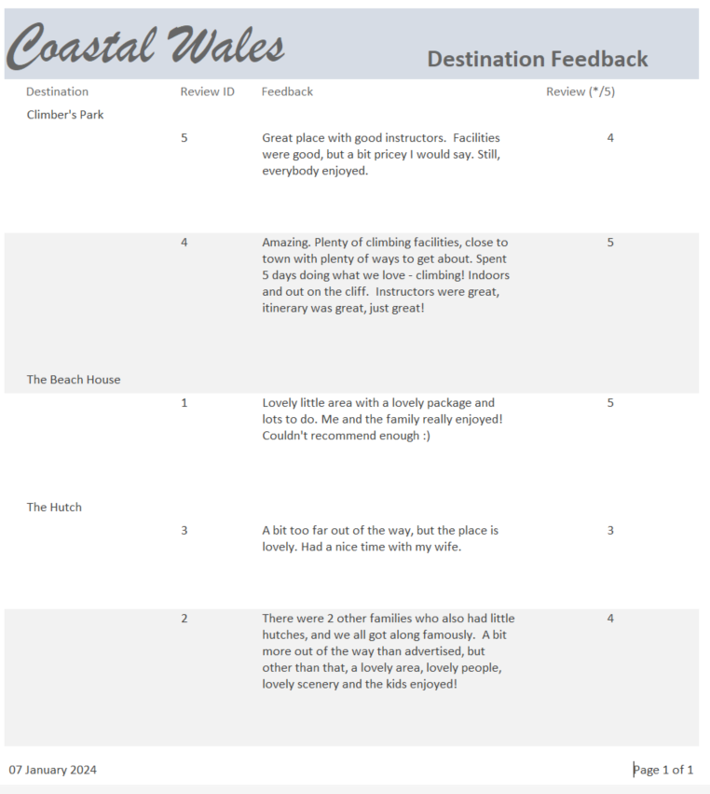

Reservation form for tourists to book a vacation
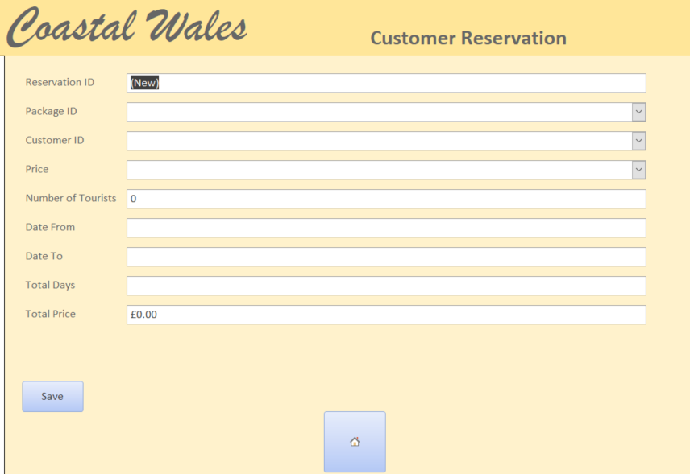
Controls & validation rules present in the form above:
- Reservation Id cannot be written in as this is autogenerated in the table/form when the customer inputs data.
- Package ID can only be of type ‘number’ so as to not cause an error. If the ID is not present in the “Package” table, then an error message occurs stating no ID can be found and to enter a new one.
- Customer ID can only be of type ‘number’ to not cause an error as only numbers can be written in the Customer ID field in the table.
- Price is not available to enter details into. It will be pulled from the relevant tables. The customer does not set the price.
- Number of Tourists can only be of type ‘number’ as only numbers can be written in the corresponding field in the table.
- Date From & Date To fields can only be in the short date format and have a calendar icon to help choose the correct date. The fields within the table will only accept dates in short format.
- ‘Total days’ is not available to be typed into as it is calculated within the table.
- ‘Total Price’ is not available to be typed into as it is calculated by multiplying the total days by the price.

Form to allow event owners to update information about their events
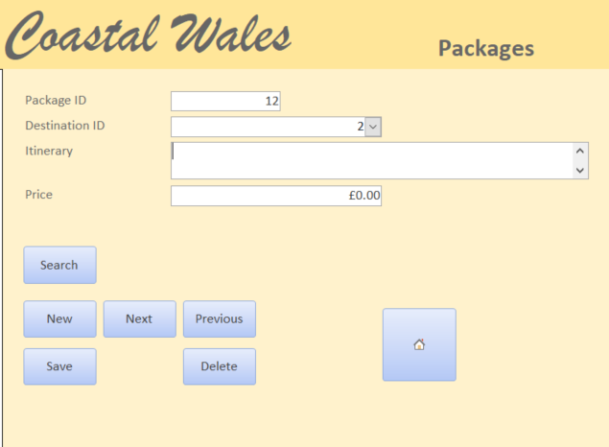
- The ‘Package ID’ and the ‘Destination ID’ are not available to be typed in as they are primary keys within the table. Therefore, it must not be allowed to be changed as the relationships throughout different tables would be broken.
- Itinerary is of type ‘Text’ as many sentences need to be written in there
- Price is of type ‘Currency’ as that is the format money is expressed in.

User-friendly menu for Coastal Tourism Management system has been designed and implemented within the database.

Please see database. Home screen opens immediately once database is opened.

Screenshots below.

On opening the system:

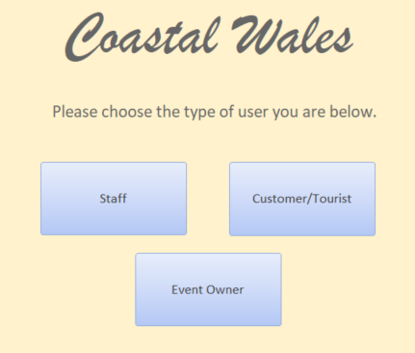

All users are presented with this screen and need to choose what their user type is, and can then proceed to the relevant menus.

Options available to staff:

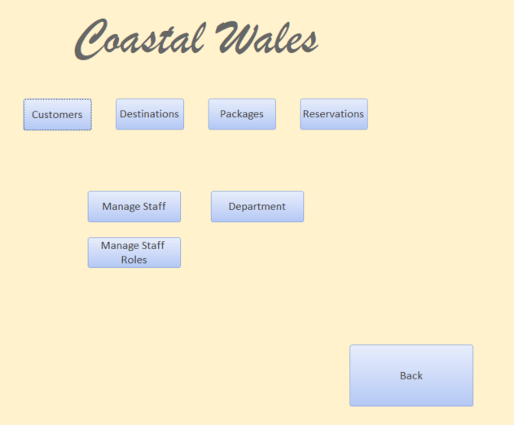
Staff can do essentially everything a customer and event owner can do. Managers can also manage staff and departments.

The following is what staff can do within the system

View/amend/create customers:

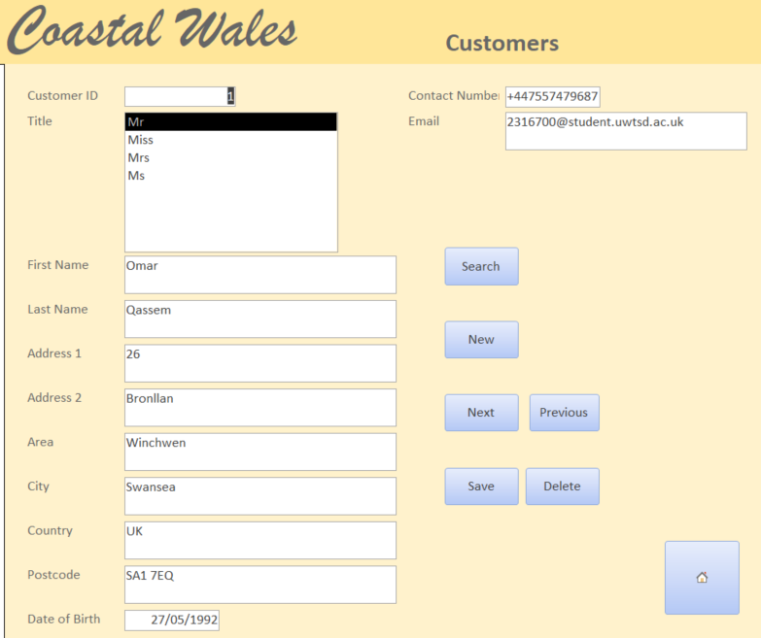

View/amend/create destinations:

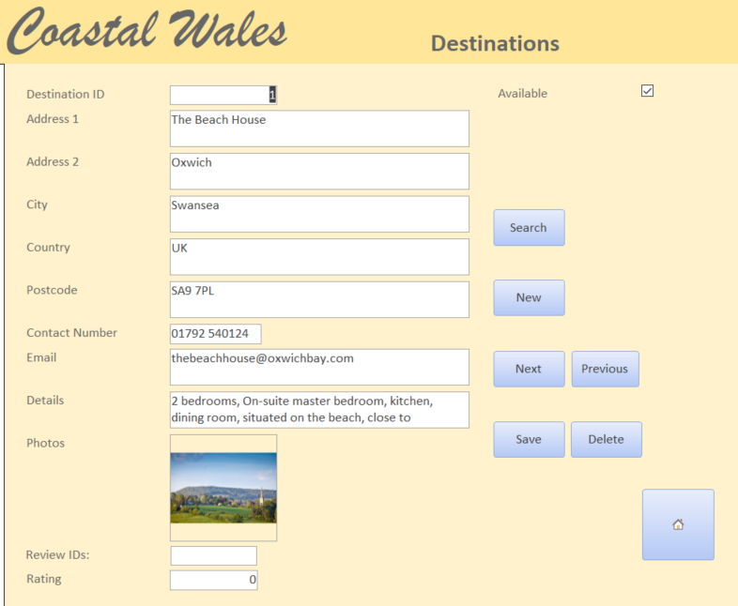

View/amend/create packages:

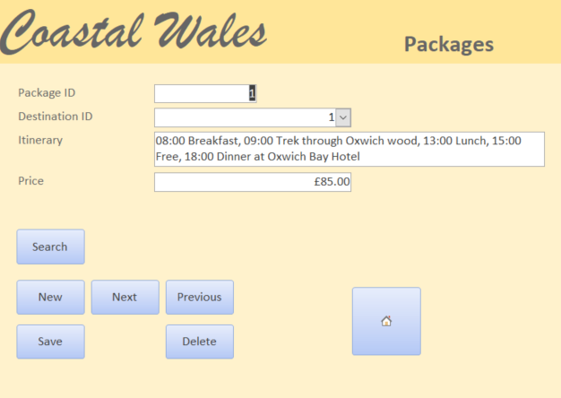

View/amend/create reservations:

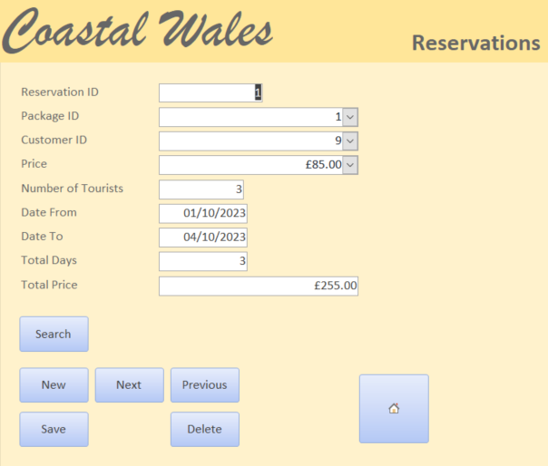

View/amend/create staff:

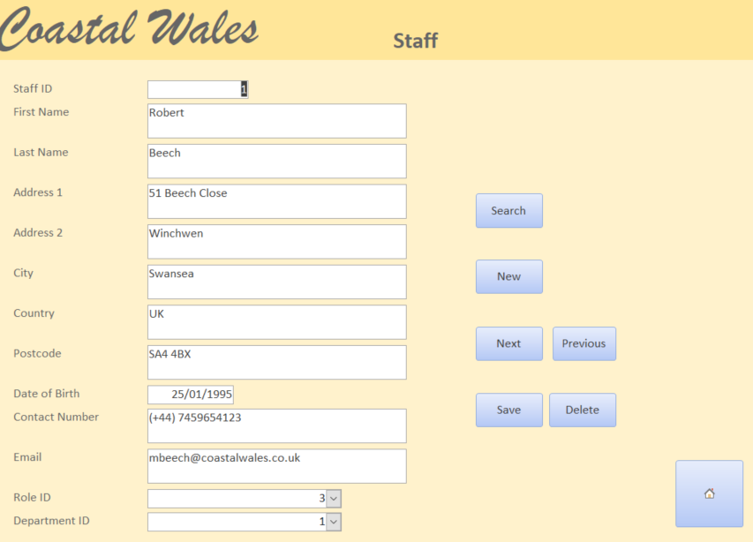

View/amend/create departments:

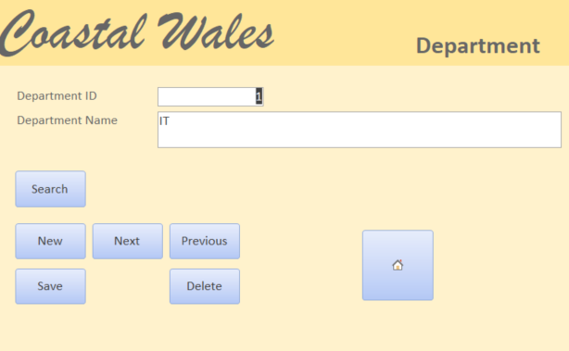

What a customer can see within the system

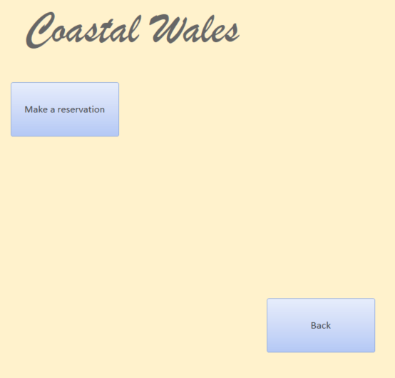

Making a reservation:

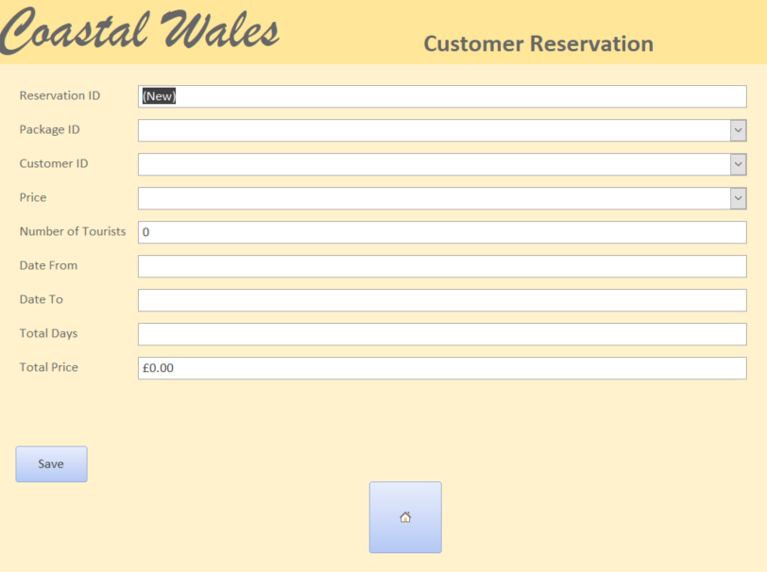
What event owners can see within the system

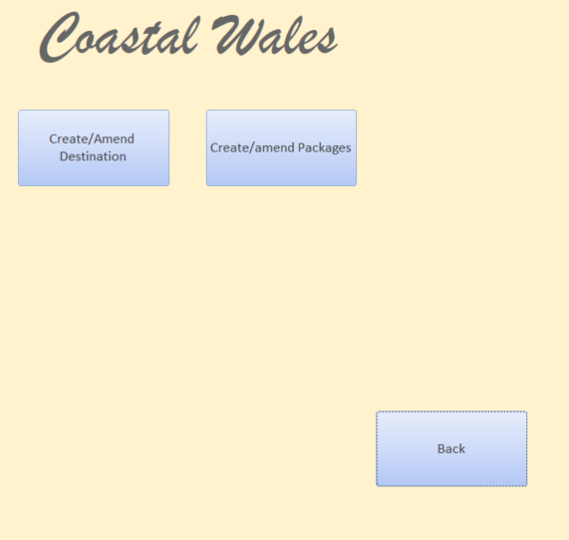

View/amend/create destinations:

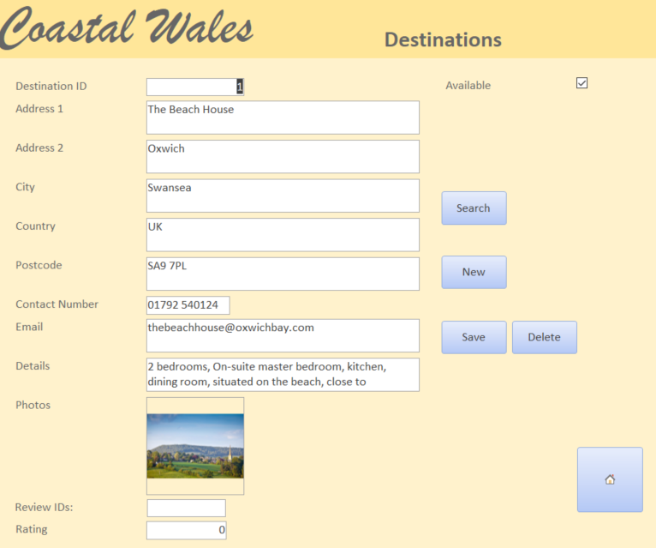
View/create/amend packages:

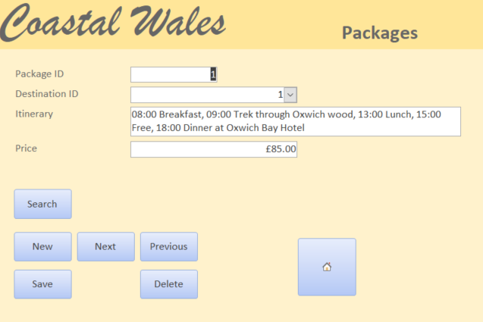

Section B

The importance of developing a database for Coastal Tourism & how it will improve efficiency and effectiveness

The are many advantages of using an MS Access database (or any database for that matter, preferably written solely in SQL) to assist in the managing of Coastal Getaways and coastal tourism in general:
- Centralised administration of data
  - All the data for the company is held in one easy-to-access place. If, for example, all data was held manually and individually on paper/in filing cabinets, even if it is well organised, it will become very cumbersome and time consuming to pull together everything that is needed and then file it away as necessary. A database allows the business to access files very efficiently and quickly.
  - As data is stored in the same place, reports and analysis can be run effectively on the data and business intelligence can be garnered far more easily and with far less time than would be necessary if paper storage was used.
  - Data can be easily backed up & stored and restored if disaster occurs.
  - Everything can be audited – all data that is input or changed can be tracked (what changes were made, who made those changes etc.)
- Easy and effective organisation and structuring of data
  - Assists in querying the data – speed and the type of queries and reports that can be run
  - Legal guidelines can be followed; GDPR, for example. All data can be secured properly and data can be managed effectively to fit those legal rules.
- Understanding your audience/users/customers
  - As data can be analysed & reports can be run & business intelligence can be found, it is possible to tailor the business to meet the demands of the customer (tourist) base, ultimately ever-increasing demand and becoming a more profitable business.
  - Using analysis, predictions can be made surrounding the business such as busier times in the year.
- Online administration
  - Customers/tourists/event owners can update and/or add reservations or details about events to the business without the need for calling the business and speaking to staff. Not only does this reduce the number of necessary staff within the business but allows for ease-of-use for clients and customers.
- Financial management
  - A database allows the business to “keep track and forecast financial information” [1] by keeping an easily accessible full record of transactions, bookings and invoicing.

Having a database of places and destinations, with itineraries consisting of activities, and having people dedicated to going out and finding these places or having the availability for owners to advertise these places, is very important for coastal tourism as a whole. It expands the availability and knowledge of different places, meaning more people will find out about potential spots/activities which will inevitably bring more tourism to the area. This will also benefit the area as more investment will be put into it, but nature may be affected by the increase in traffic and/or people.

In summary, having a robust, well-managed database will assist our coastal tourism business by enhancing customer experience and allowing the business to improve efficiency and make better-informed decisions, ultimately making the business more competitive and successful.

Benefits & challenges of transitioning from manual data management to a computerised system & how the challenges are eventually overcome

Transitioning from manual data management to a computerised system for the business comes with a list of challenges that must be overcome if it is to add value to the company:
- Data migration
  - There is a need to input all the data that has been accumulated via manual, paper means into the database. This initial hump is necessary and will take a large amount of time and human resources. There are different ways to do this but the most common is manual data entry, however scanning and text recognition software can be used, however that still requires alot of time.
  - There is a possibility errors can occur due to human error
- Compatibility issues
  - Alot of planning must be done before even making the database so that the data held in the paper files can be transitioned over correctly.
  - There will inevitably be some ‘teething issues’ when first introduced, which include data compatibility issues, and changes to the database in the first few weeks and months will most likely be necessary.
- Training
  - Users must be trained to use the new database, which takes time, effort and resources (human and financial).
- Resistance to change
  - Users of the system (mainly staff) do not like change and prefer to keep to the ways they know already. For this reason, it is important to highlight the benefits and ensure users are well supported so the transition is as smooth as possible.
- Expensive
  - Databases and computerised systems take expertise to produce, so external contractors will most likely need to be employed for this endeavour. This will incur a high cost and any unforeseen challenges will add to that further.
- Disruption to business
  - While contractors are auditing the business to determine the needs of the system-to-be, they will need to gather as much information as possible, which involves speaking to staff, observing how the system currently runs and asking questions. This will cause frustration for the staff who will need to explain and increase their workload and the time it takes to complete tasks.
In summary, while there is a lot of financial and resource burden when it comes to defining, designing and creating a database system, and it will take a lot of time and effort, the solution provided will only incur these challenges during the initial staged and will pay for itself over time, ultimately creating a more effective and successful business.

Bibliography
[1] everconnect, “7 ways a good database can improve your business,” Everconnect, https://everconnectds.com/blog/7-ways-a-good-database-can-improve-your-business/ (accessed Jan. 5, 2024).
[2] E. Thompson, “Overcoming four key data transformation challenges,” Database Trends and Applications, https://www.dbta.com/Editorial/News-Flashes/Overcoming-Four-Key-Data-Transformation-Challenges-144573.aspx (accessed Jan. 5, 2024).

