Individual Presentation
Module Code: BMIH6007
Module Title: International Meetings Management
Assignment Title: Planning and Delivering “Hwyl and Heritage: A Welsh Welcome through Dogs & Horses”
Lecturer’s Name: Kathryn Roberts
Student Name: Klaudia Modrzejewska
Student Number: 2243846

AI guidance acknowledgement
I confirm that I have not presented any AI-generated text as my own work. I confirm I have copies of my drafts, notes, and other resources I used before, and after the use of AI tools which I may be asked to provide in evidence
Slide 1
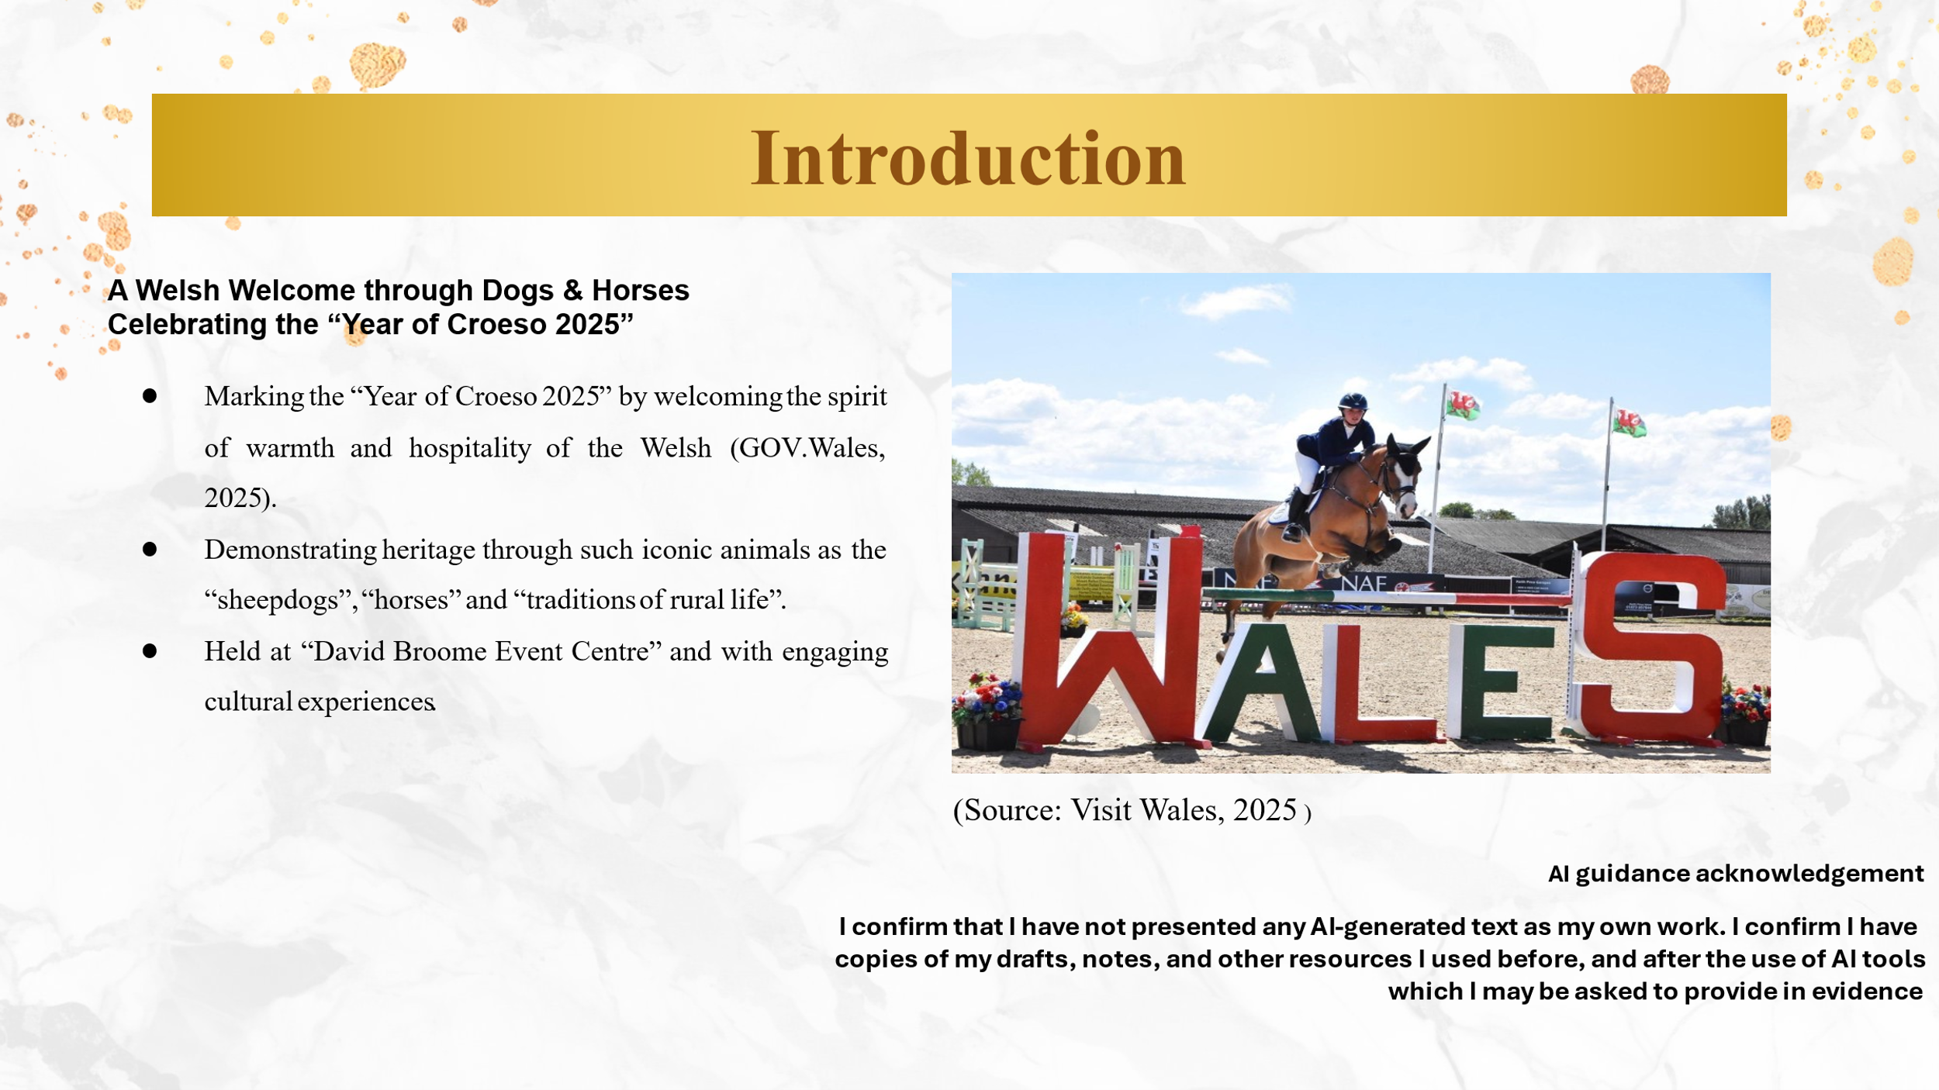
Wales pungently celebrates the “Year of Croeso in 2025”, showcasing its legendary hospitality and colourful culture. At the heart of this carnival is the concept of “Hwyl”, which is uniquely Welsh feeling of joy and passion. The proposed event, “Hwyl and Heritage: A Welsh Welcome Through Dogs & Horses,” reflects this essence of being, as it subtly displays its national traditions, especially its famous “sheepdogs and horses”. Surrounded by the picturesque “David Broome Event Centre”, participants will indulge in the most authentic Welsh experiences such as listening to “traditional music” and tasting “local cuisine”, participating in “workshops and demonstrations”.

Slide 2: Event Content and Context
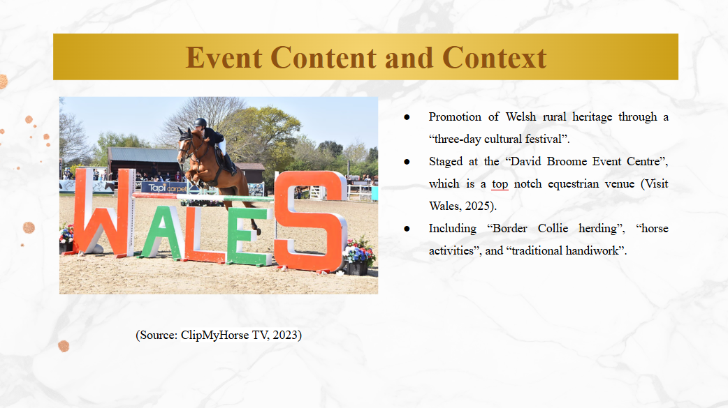
The “Hwyl and Heritage: A Welsh Welcome Through Dogs & Horses” festival is going to be an epitome of Wales' “Year of Croeso 2025” and symbolises the famous hospitality and rich culture of the country. This three-day event will submerge the attendees in the “rich tapestry” of Welsh rural life, where there will be demonstration from skilled sheepdogs and majestic horses that symbolises the deeply rooted agricultural traditions of the country. Apart from the scenic landscape that comes with being set at the “David Broome Event Centre”, Wales' biggest equestrian ground of more than 100 acres, the festival also provides a true experience of the Welsh countryside.

Slide 3: Event Content and Context
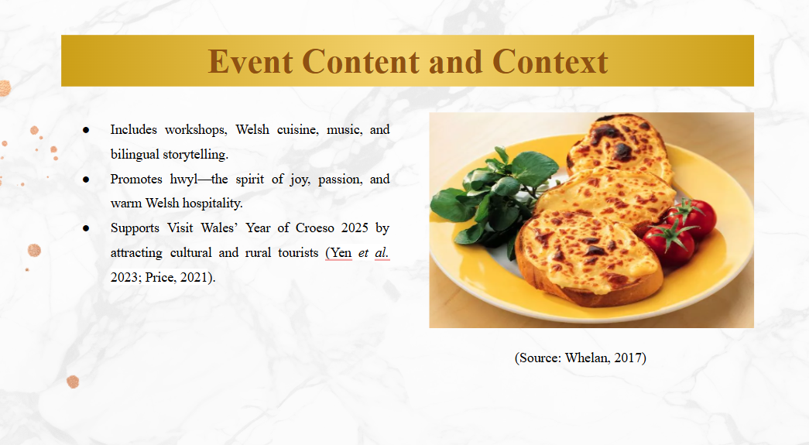
It is stated that many people will participate in interactive workshops, taste “Welsh traditional cuisine," attend performances of the “local music and dance," and thus create a strong affinity with the legacy of the nation. Following the “Visit Wales initiative” to popularise the unique concept of hwyl – a strong feeling of joy and passion, the event will create opportunities for genuine connections and celebrations. Additionally, the festival aims to attract both domestic and international visitors to Wales by presenting iconic representations of "Welsh culture" and offering immersive experiences, allowing them to learn about and engage with the authentic spirit of the region country.

Slide 4: Market Factors
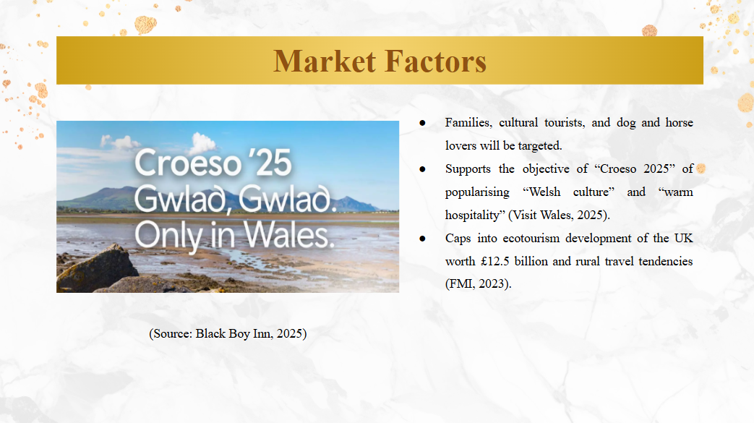
The target audience for the proposed event is represented by domestic families, international cultural tourists, rural experience seekers, and pet lovers, specifically “dog and equestrian enthusiasts”. It is posited that the Visit Wales’ “Year of Croeso 2025” will ensure Wales becomes a culture-rich, language-rich, landscape-rich welcoming nation, where people looking for experiences that are meaningful and people-led are attracted to visit. Moreover, authentic and nature-based tourism is demanded and measurable. For evidence, the “UK ecotourism market” is projected to surpass £ 12.5B in the year 2025, with the increased desires for countryside holidays, outdoor festivals and pet-friendly travel.

Slide 5: Market Factors
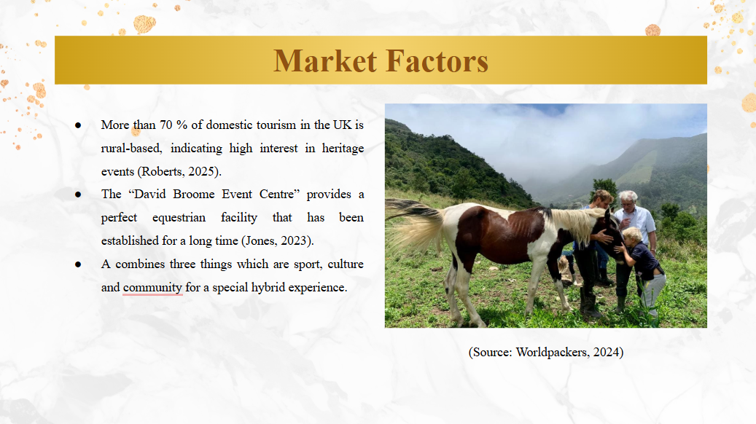
Nearly 70% of the UK domestic tourism is rural based; this points the strength in the market interest in agricultural and cultural heritage events. The “David Broome Event Centre”, hosting international events in equestrianism, offers an effective location. In contrast to already-existing horse shows taken as sport, “Hwyl and Heritage” provides a hybrid experience that is through “Welsh culture”, “local crafts”, and “heritage dogs” and “involvement of the community”.

Slide 6: Market Factors
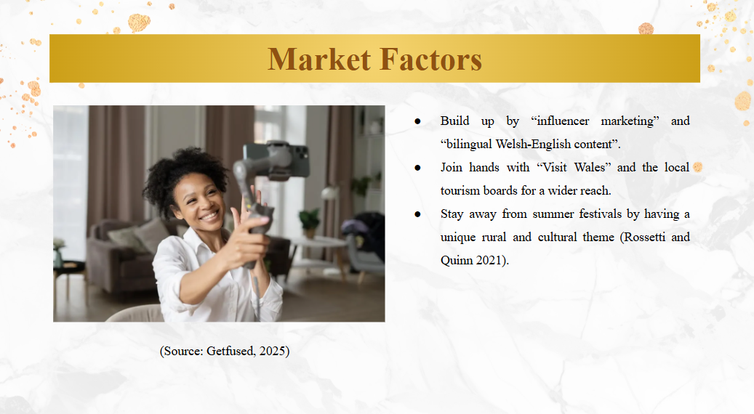
The “unpaid partnerships” with influencers, “Welsh-language content”, and co-promoting with “Visit Wales” and local tourism organisations will be some of the marketing activities. The idea of hwyl, “joyful spirit”, and “community pride” will be a focus of the campaign, which conforms to the “Croeso 2025” message. However, commercial risk can result in case summers interfered with each other’s festivals; yet, the rural concreteness and cultural specificity of this event guarantees precise distinction.

Slide 7: Operational Factors
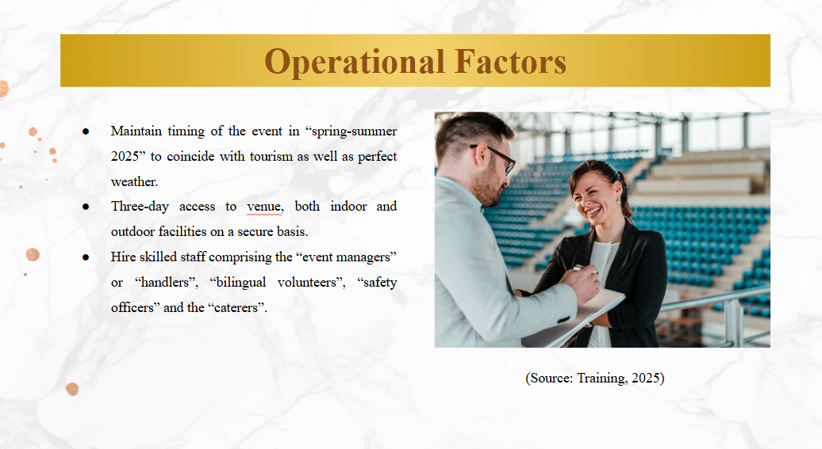
The event will need proper planning and coordination in various operational domains. Availability of the venue will be booked to correspond with the spring-summer of 2025 period to maximise weather conditions and tourism trends in Wales. A booking of a “3-day stay” in the facility with access to the indoor and outdoor areas will help cater for the wide range of activities, such as “dog trials”, “horse displays” and “cultural workshops”. Staffing needs will be event managers, workshop facilitators, animal handlers, safety officers, bilingual volunteers, and catering groups.

Slide 8: Operational Factors
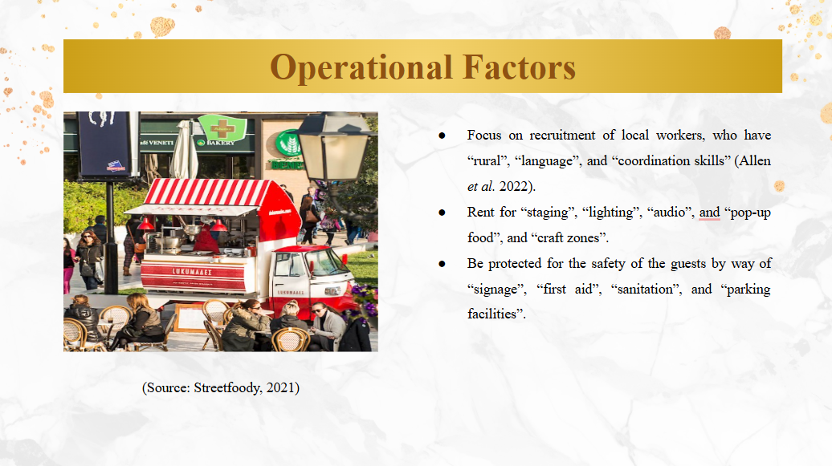
Essential skills will include “mastery of language,” “crowd management,” and the “rural experience.” Moreover, local talent will be given preference in recruitment to drive economic development and help establish the community-based nature of the Croeso 2025. On the flip side, provisions for staging, day and night event lighting rigs, audio requirements for live music, and temporary solutions for “food stalls” and “craft areas” will be catered for by resource allocations. “Sanitation units,” “medical first-aid tents,” “directional signs,” and “marked-out parking zones” will ensure comfort and safety for guests.

Slide 9: Operational Factors
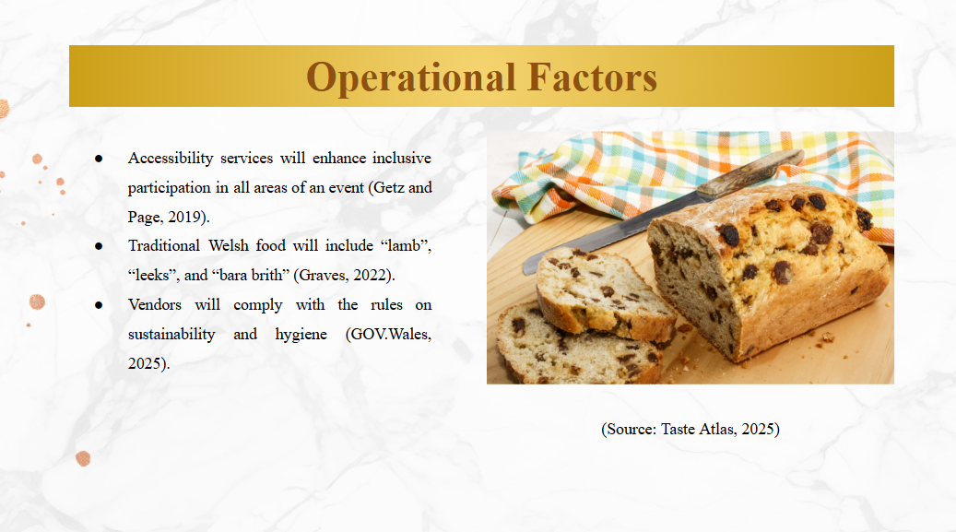
It will have accessibility services for disabled persons. Catering will also promote Welsh produce; “lamb”, “leeks”, and “bara brith” among others – to extend the cultural theme. The onsite vendors will be controlled to guarantee sustainable packaging and compliance with hygiene. This operational framework is consistent with the intentions of the Welsh Government for the “Year of Croeso 2025” that prioritise authenticity, rural identity, and inclusive tourism experiences. Further, good logistics will guarantee a smooth visitor journey thus reaffirming Wales as a warm, organised and hospitable place to visit.

Slide 10: Financial Factors
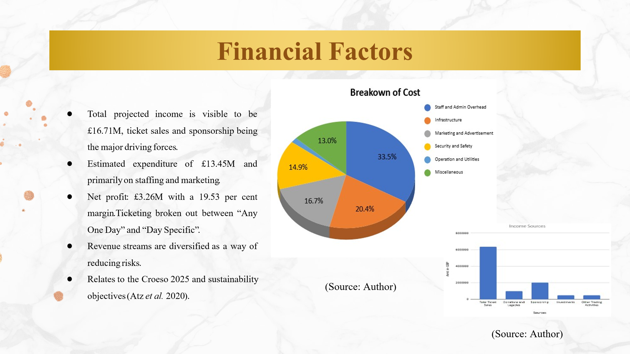
The anticipated revenue for “Hwyl and Heritage” stands at £16,714,400, where the most contributions are from “ticket sales” (£6,357,200), “sponsorship” (£2,000,000), and “donations or legacies” (£1,000,000). Other funding sources are seems to be for the “investments” and “trading activities”; both are around £500,000 together. The total estimated cost of expense is £13,450,000, and the greatest proportion is allocated £4,500,000 for the “staff and administration”, £2,750,000 for the “infrastructure”, and £2,250,000 for the “marketing”. Other outlays are £2,000,000 for the purpose of security, £200,000 for the “utilities” and also £1,750,000 for the “miscellaneous”. The event is to realise a net profit of £3,264,400 with a healthy profit margin of 19.53 per cent to gain financial stability.
Ticketing will be the main source of revenue whereby the adult and children tickets will be segmented under “Any One Day” and “Day Specific” passes. Financial and budgeting practices on sustainable events adhere to sustainable event guidelines and have a good return on investment (Atz et al. 2020).

Slide 11: Conclusion
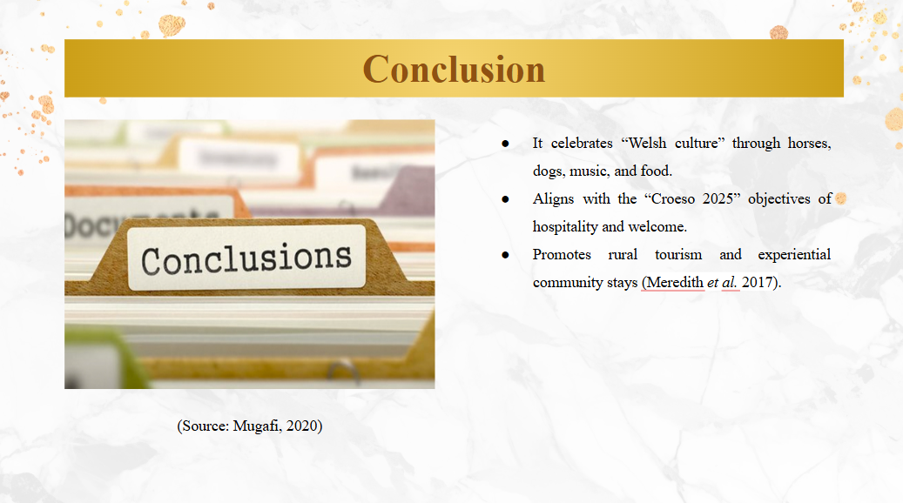
It can be concluded that “Hwyl and Heritage: A Welsh Welcome Through Dogs & Horses” perfectly captures what Croeso 2025 is about by strengthening Welsh rural existence, culture, and hospitality. It offers a warm and authentic celebration through adequate planning, community involvement, and efficient money management. Such cultural experiences help in setting up long-term tourism and strengthening national identity (Meredith et al. 2017).

Slide 12: References
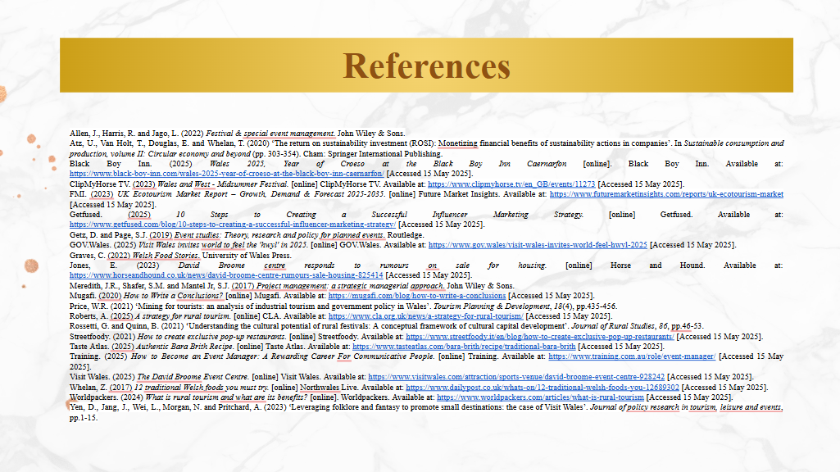
Thank You

