Career Development Portfolio: Child Protection Social Worker

Student Name: Renata Balogh
Student ID: 2407673

Module Code: BMHP5015
Module Title: Changemakers: Building Your Personal Brand for Sustainable Employment

Introduction

This report is about the role of a Child Protection Social Worker in the UK. It explains the skills, knowledge and qualities needed for this job and why they are important. Child Protection Social Workers help protect children from abuse, neglect and other risks. They also work closely with families, schools, health professionals and other services to make sure children are safe. I chose this career because I want to help vulnerable children and make a positive difference in their lives. In this report, I will look at my own skills, identify areas where I need to improve, and explain my plan to achieve my future career goal.
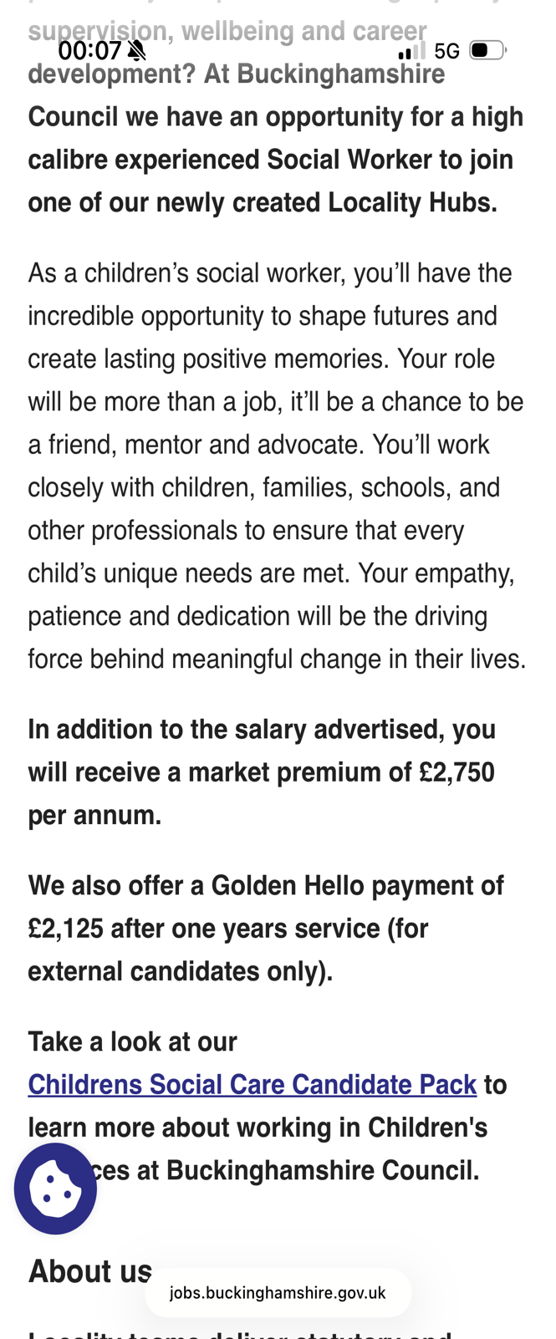
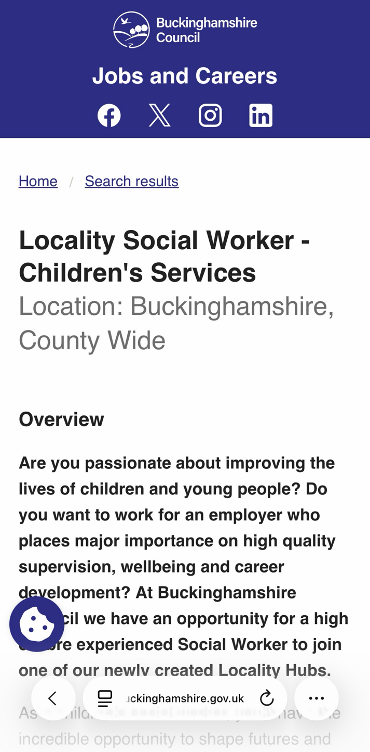

Job Advertisement

For this report, I chose a Locality Social Worker – Children’s Services job advertised by Buckinghamshire Council. I chose this job because my goal is to become a Child Protection Social Worker in the future. The role involves working with children and families to make sure children are safe and supported. Social workers also work with schools, health professionals and other agencies to protect children and improve their wellbeing. The job requires good communication, teamwork, empathy, safeguarding knowledge and the ability to make professional decisions. I believe this role matches my future career goals and will allow me to make a positive difference in children’s lives.
(Buckinghamshire Council, 2026).

Job Role Employability Skills
A Child Protection Social Worker needs many different skills to do the job well. I think one of the most important skills is communication. Social workers talk to children, parents, teachers, doctors and many other professionals every day. Good communication helps people understand each other and makes it easier to support children and families.
Another important skill is teamwork. Social workers do not work alone. They work with schools, hospitals, the police and other services to make sure children are safe. Working well with others helps everyone make better decisions for the child.
Empathy is also very important. Children and families may be going through difficult situations, so it is important to listen to them, understand how they feel and treat them with kindness and respect. This helps build trust and good relationships.
A social worker also needs problem-solving and decision-making skills. Sometimes they have to make difficult decisions to keep children safe. They need to stay calm, think carefully and always do what is best for the child.
Finally, organisation and time management are very important. Social workers have many cases, meetings and reports to complete, so they need to manage their time well. They also need to understand safeguarding, confidentiality and professional boundaries. I believe these skills are essential because they help social workers protect children and give the best possible support to families.

Evaluate Your Own Skills
At the moment, I am studying BSc Health and Social Care at the University of Wales Trinity Saint David. During my course, I have learned about safeguarding, communication, equality and diversity, professional values and working with different people. These subjects have helped me understand the responsibilities of health and social care professionals.
I also have experience from running my own beauty business. Although this is different from social work, it has helped me improve my communication skills, patience and professionalism. Every day I work with different people, listen to their needs and make them feel comfortable. I believe these skills will also be useful when working with children and families.
One of my biggest strengths is that I care about people and I enjoy helping others. I am a good listener and I always try to stay calm when solving problems. I am also organised because I manage appointments, clients and my own business. As a mother of three children, I have learned to be patient, responsible and understand children’s different needs.
However, I know there are still areas where I need to improve. I do not have practical experience in children’s social work yet, so I would like to gain experience through placements and future employment. I also want to improve my confidence when making professional decisions in difficult situations. Another area I would like to develop is my knowledge of child protection law and UK safeguarding procedures.
To improve these skills, I will continue working hard during my university course, learn from my tutors and placement supervisors, and complete additional safeguarding training whenever possible. I also hope to learn from experienced social workers who can guide me and help me become a confident professional in the future.

Create an Action Plan and Timeline
To become a Child Protection Social Worker, I know that I need to keep learning and developing my skills. I already study Health and Social Care, but I understand that this is only the first step. I want to continue improving my knowledge and gain practical experience before starting my career.
Short-term goals (1 year):
My first goal is to successfully complete my BSc Health and Social Care degree. I also want to achieve good grades and make the most of my university placements. During this time, I plan to improve my communication skills, confidence and knowledge of safeguarding and child protection. I would also like to attend extra training courses if they are available.
Medium-term goals (2–3 years):
After finishing my degree, I plan to complete a Master’s degree in Social Work. This will give me the qualifications I need to register as a social worker in the UK. During my studies, I hope to gain more experience by working with children and families during placements and learning from experienced social workers.
Long-term goals (4–5 years):
My long-term goal is to work as a Child Protection Social Worker. I would like to build good relationships with children and families and help protect children who are at risk. I also want to continue attending training courses and developing my professional skills throughout my career because social work is always changing and there is always something new to learn.
I understand that becoming a good social worker takes time, patience and experience. I know there will be challenges, but I am motivated to work hard and keep improving. My goal is to become a professional who is trusted, caring and able to make a positive difference in the lives of vulnerable children and their families.

🟦 2026–2027
Complete BSc Health and Social Care
⬇️
🟩 2027–2029
Complete a Master’s in Social Work
⬇️
🟨 2029
Register with Social Work England
⬇️
🟧 2029–2031
Gain experience as a Newly Qualified Social Worker
⬇️
🟥 Future
Become an Experienced Child Protection Social Worker

Building Your Personal Brand
Building a professional personal brand is important because it helps employers learn more about me and my skills. In the future, I would like to build a positive reputation as a Child Protection Social Worker. I want people to see me as someone who is caring, professional and trustworthy.
One way I will do this is by creating a professional LinkedIn profile. I will keep it updated with my education, qualifications, placements and work experience. I also want to attend training courses and workshops to continue improving my knowledge and skills.
I understand that social media is important, but I will use it professionally. I will make sure that anything I post reflects my values and does not affect my future career. I also hope to build good relationships with my tutors, placement supervisors and future colleagues because networking can help create new opportunities.
I believe that being honest, respectful and willing to learn will help me build a strong personal brand. My goal is to become a social worker who is trusted by children, families and other professionals.

Promoting Your Professional Identity
Promoting my professional identity is important because it helps employers understand my skills, experience and motivation. I want to present myself as someone who is reliable, caring and willing to learn. I know that first impressions are important, so I always want to behave professionally and respectfully.
I will keep my CV updated with my education, qualifications, placements and any relevant work experience. I will also write a clear cover letter for each job I apply for, explaining why I am interested in the role and why I would be a good candidate. I believe a well-written CV and cover letter can help employers understand my strengths and my commitment to social work.
I also plan to keep my LinkedIn profile up to date. I will include my qualifications, achievements and professional development. This will help me connect with other professionals, learn about job opportunities and stay informed about changes in social work practice.
During interviews, I will communicate confidently and professionally. I will explain my strengths, my willingness to learn and my passion for helping children and families. I will also give examples from my university course, placements and previous work experience where possible.
I understand that learning does not stop after university. I will continue attending training courses and developing my knowledge throughout my career. My goal is to show employers that I am committed to becoming a Child Protection Social Worker and that I am ready to continue learning, improving my skills and making a positive difference in the lives of children and families.

Building a Network for Successful Employment
Building a professional network is very important because it can help me learn from experienced people and create new career opportunities. As a future Child Protection Social Worker, I know that working with other professionals is an important part of the job. Building strong professional relationships can also help me improve my knowledge and confidence.
During my university course, I want to build good relationships with my tutors, classmates and placement supervisors. They can support me, give me advice and help me develop the skills I need for my future career. I also hope to learn from experienced social workers during my placements by asking questions and observing how they work with children and families.
I plan to attend training courses, workshops and professional events whenever I have the opportunity. These events will allow me to meet new people, learn about current issues in social work and develop my professional knowledge. I will also use LinkedIn to connect with professionals, follow social work organisations and keep up to date with job opportunities and new developments in the field.
I believe that having a strong professional network will help me grow both personally and professionally. It will give me the chance to learn from others, share experiences and continue improving my skills. My goal is to build positive relationships with colleagues and other professionals so that I can provide the best possible support for children and families throughout my career.

Conclusion
This report has helped me understand the skills, knowledge and personal qualities needed to become a Child Protection Social Worker. After researching this career, I am even more confident that this is the profession I would like to follow in the future. I understand that the role involves a great deal of responsibility and requires good communication, teamwork, empathy and professional decision-making skills. These skills are important because they help social workers protect children and support families during difficult situations.
While completing this report, I also had the opportunity to evaluate my own strengths and identify the areas where I need to improve. I know that I still need to gain practical experience and continue developing my confidence, communication skills and professional knowledge. However, I am willing to work hard, learn from experienced professionals and continue improving throughout my studies and future career.
Creating my action plan helped me think about the steps I need to take to achieve my career goal. I also understand the importance of building a professional network, creating a positive personal brand and presenting myself professionally to future employers. These are all important for finding employment and developing a successful career.
Overall, this report has increased my understanding of the social work profession and confirmed that this is the career I want to follow. I am motivated to continue learning, developing my skills and making a positive difference in the lives of vulnerable children and their families.

- Buckinghamshire Council (n.d.) Locality Social Worker – Children’s Services. Available at: https://jobs.buckinghamshire.gov.uk/job_detail/330048/ (Accessed: 19 July 2026).
- Buckinghamshire Council (n.d.) Children’s Services. Available at: https://jobs.buckinghamshire.gov.uk/working-buckinghamshire-council/childrens-services/ (Accessed: 19 July 2026).
- Social Work England (n.d.) Become a social worker. Available at: https://www.socialworkengland.org.uk/ (Accessed: 19 July 2026).
- NHS Health Careers (n.d.) Social worker. Available at: https://www.healthcareers.nhs.uk/explore-roles/social-work/social-worker (Accessed: 19 July 2026).
- Skills for Care (n.d.) Careers in social work. Available at: https://www.skillsforcare.org.uk/ (Accessed: 19 July 2026).
- British Association of Social Workers (2021) Code of Ethics. Available at: https://basw.co.uk/policy-practice/standards/code-ethics (Accessed: 19 July 2026).
- Department for Education (2023) Working Together to Safeguard Children. Available at: https://www.gov.uk/government/publications/working-together-to-safeguard-children (Accessed: 19 July 2026).
- Department for Education (2024) Keeping Children Safe in Education. Available at: https://www.gov.uk/government/publications/keeping-children-safe-in-education–2 (Accessed: 19 July 2026).
- UK Parliament (1989) Children Act 1989. Available at: https://www.legislation.gov.uk/ukpga/1989/41/contents (Accessed: 19 July 2026).
- UK Parliament (2004) Children Act 2004. Available at: https://www.legislation.gov.uk/ukpga/2004/31/contents (Accessed: 19 July 2026).

