University of Wales Trinity Saint David
School of Engineering

Control Technology
ACMA6001
Factory Control 1

By
Gareth Gimblett
1910095

BEng Manufacturing Systems Engineering
July 2021



Contents
Summary 3
Task 1 - Literature review of PLCs in industry 4
SIEMENS S7-1200 4
Allen Bradley Micro820 PLC CPU 5
Schneider Electric Zelio Logic Logic Module 6
Flow chart process operation 7
Alarm and warning strategy 8
Task 2 – Factory IO scene and drivers 9
Task 3 – ladder logic networks 10
Task 4 – HMI devices & Task 5 – Multiscreen design and operation 22
References 29

Figure 1 - Simatic specifications 4
Figure 2 - Simatic plc 4
Figure 3 - AB PLC 5
Figure 4 - AB specifications 5
Figure 5 - Schneider PLC 6
Figure 6 - Schneider specifications 6
Figure 7 - Overall process flowchart 7
Figure 8 - Alarm and warning strategy flowchart 8
Figure 9 - Factory IO scene screenshot 9
Figure 10 - Factory IO PLC sensors actuators and drivers 9
Figure 11 - Network 2 ladder program 10
Figure 12 - Network 3 ladder program 11
Figure 13 - Networks 4-11 ladder program 11
Figure 14 - Network 12 ladder program 12
Figure 15 - Network 13 ladder program 12
Figure 16 - Network 14 ladder program 13
Figure 17 - Network 15 ladder program 13
Figure 18 - Network 16 ladder program 14
Figure 19 - Network 17 ladder program 15
Figure 20 - Network 18 ladder program 15
Figure 21 - Network 21 ladder program 16
Figure 22 - Networks 19 & 20 ladder program 16
Figure 23 - Network 21 ladder program cont. 17
Figure 24 - Network 22 ladder program 18
Figure 25 - Network 23 ladder program 18
Figure 26 - Network 23 ladder program inc DS10 sensor 19
Figure 27 - factory IO scene showing BOX (M) at sensor DS10 19
Figure 28 - Network 23 DS10 running 20
Figure 29 - Factory IO scene showing BOX (S) not triggering DS10 and ladder program screenshot 20
Figure 30 - Networks 25 - 27 ladder program 21
Figure 31 - Network 28 ladder program 21
Figure 32 - Network 29 ladder program 22
Figure 33 - root screen screenshot 23
Figure 34 - user logon dialog popup 23
Figure 35 - Engineering control screen logon and counter adjustment popups 24
Figure 36 - Engineering screen Function button animations 24
Figure 37 - Alarm and wanring animation sequence 25
Figure 38 - Alarm and warning screen 25
Figure 39 - Factory IO lost box warning lights 26
Figure 40 - Unattended counter experiment screenshot 26
Figure 41 - Network 26 showing ESTOP functional input for MASTER_ERROR 27
Figure 42 - Network 2 running showing ESTOP function 27
Figure 43 - Warning and Alarms screen in quiescent mode 27
Figure 44 - Network 2 showing ESTOP tripped 28
Figure 45 - Network 26 showing MASTER_ERROR triggered 28
Figure 46 - ESTOP & MASTER_ERROR animations 28

Summary
This report details the programming and design steps taken to satisfy the brief of designing a factory system which sorts 4 different packages based on their sizes and weights. In addition to this the design of the HMI screen – this is achieved utilising the animation setting within the TIA software.

Task 1 - Literature review of PLCs in industry
Several PLCs currently used in industry are as follows:

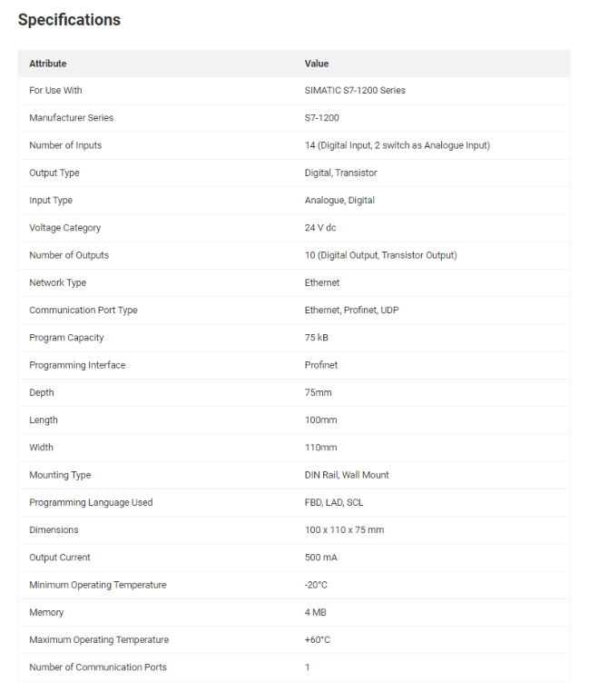
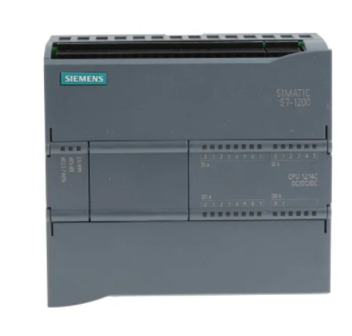
SIEMENS S7-1200
Figure 1 - Simatic specifications
Figure 2 - Simatic plc

Table 1 - Simatic pros and cons
Pros | Cons
Has both analogue and digital inputs / outputs | Propriety software portal
Both DIN and wall mountable | Limited analogue inputs
Built in ethernet comms
Good min and max operating temp resilience
On board memory size for multiple CPU modules

Allen Bradley Micro820 PLC CPU
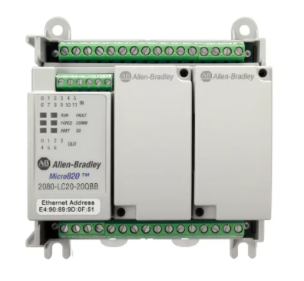
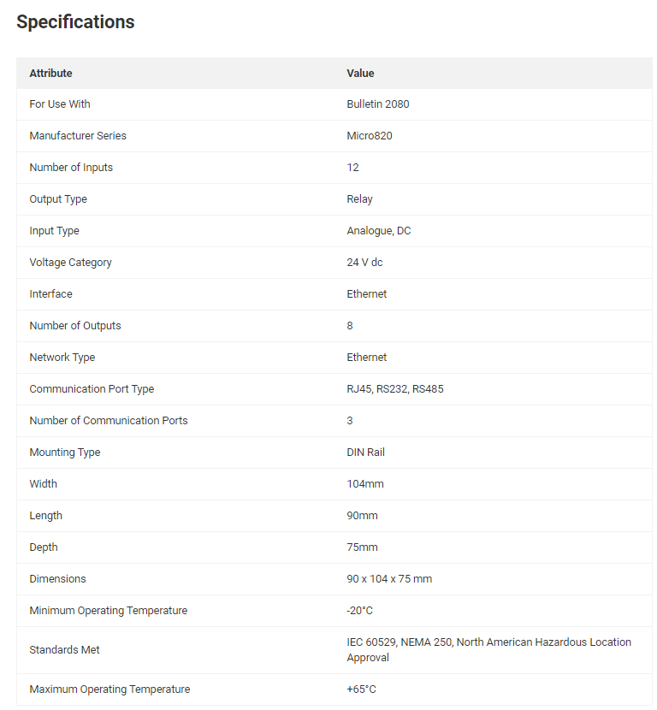
Figure 3 - AB PLC
Figure 4 - AB specifications

Table 2- AB pros and cons
Pros | Cons
Compact size | Only analogue input
Good min and max operating temp resilience | Only DIN rail mounting
Serial and digital comms ports

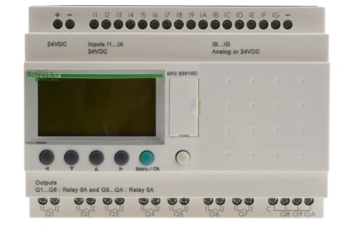
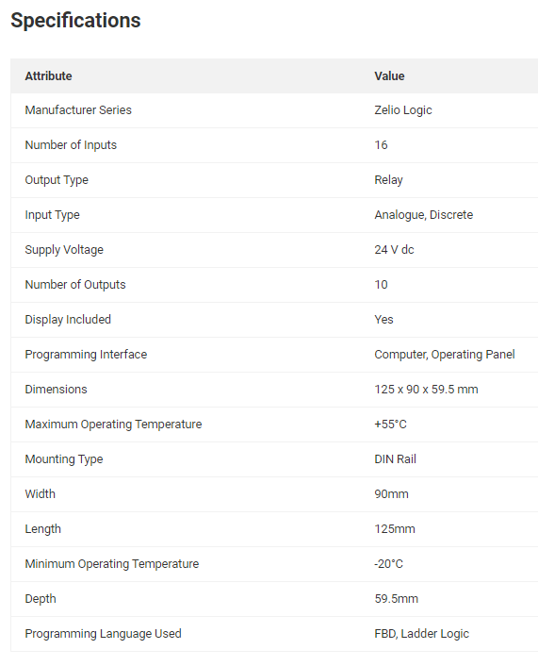
Schneider Electric Zelio Logic Logic Module
Figure 5 - Schneider PLC
Figure 6 - Schneider specifications

Table 3- Schneider pros and cons
Pros | Cons
Onboard panel screen for easy navigation | Only DIN rail mountable
16 inputs | Lower maximum operating temperature
Compact size | Only 2 programming language options

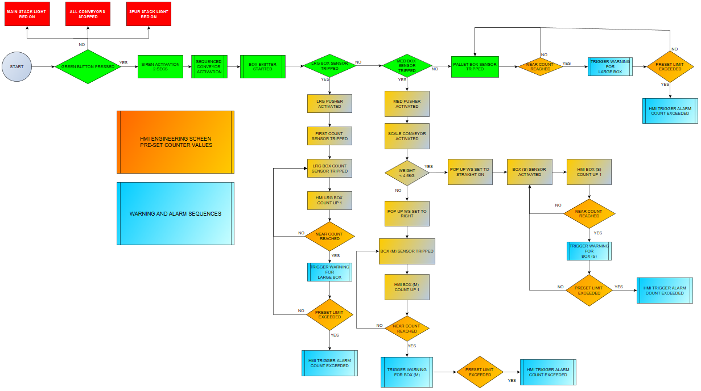
Flow chart process operation
Figure 7 - Overall process flowchart

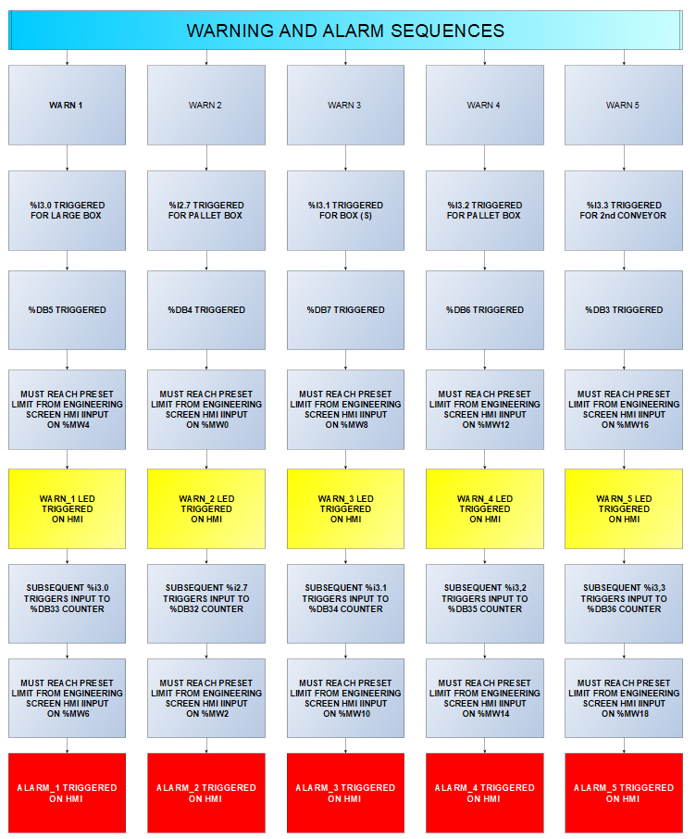
Alarm and warning strategy
Figure 8 - Alarm and warning strategy flowchart

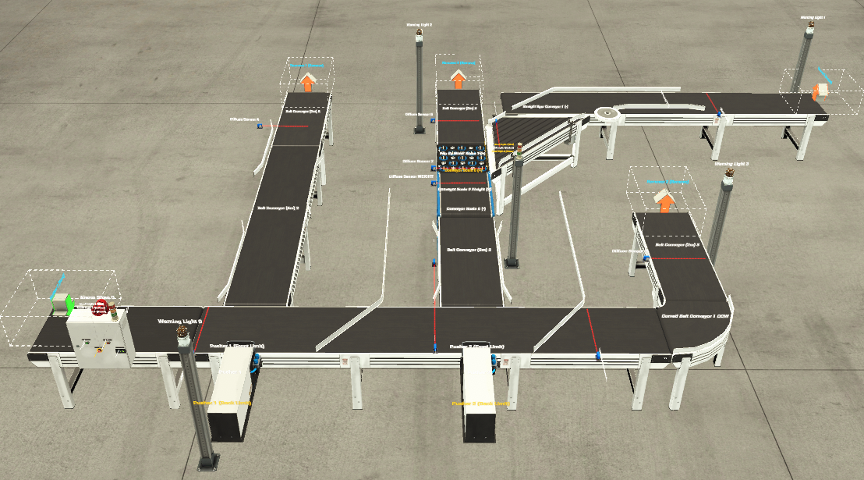
Task 2 – Factory IO scene and drivers
Figure 9 - Factory IO scene screenshot

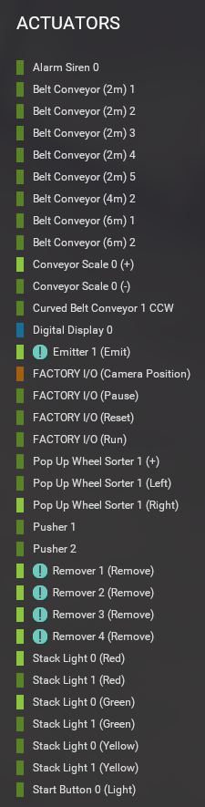
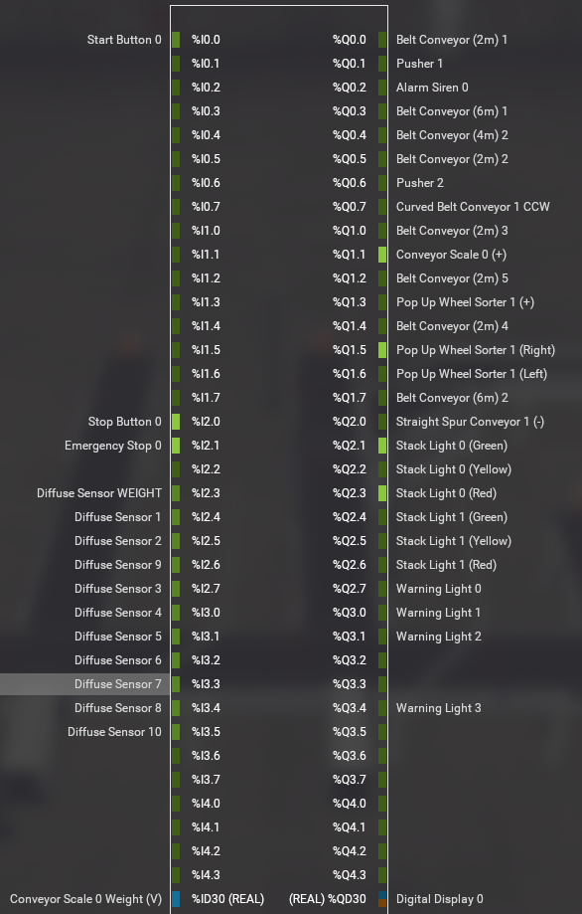
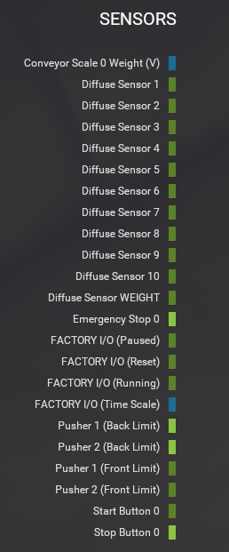
Figure 10 - Factory IO PLC sensors actuators and drivers

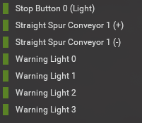

Task 3 – ladder logic networks
The first section of the ladder was to create the stop / start circuit this also utilised the “operate” output to latch on the system until such time the stop button, Estop or Master error triggered.
Using the same output to manage the stack light settings for the conveyor scale stopped position. Then using the not operate input for the system stopped stack lights.
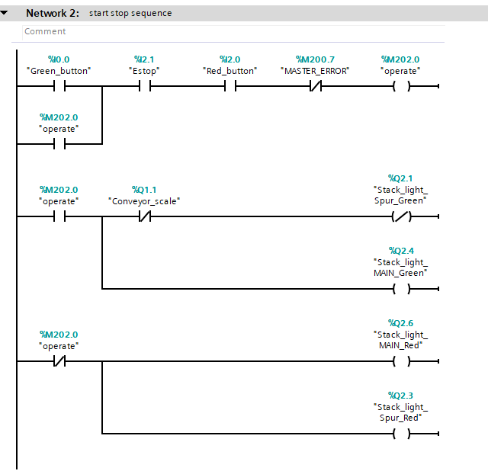
Figure 11 - Network 2 ladder program

The next network (see Figure 12) used the memory location of the operate output as an input which when combined with a pulse timer allowed an audible warning in the form of a siren to sound for 2 seconds warning of the impending conveyor sequence start-up.
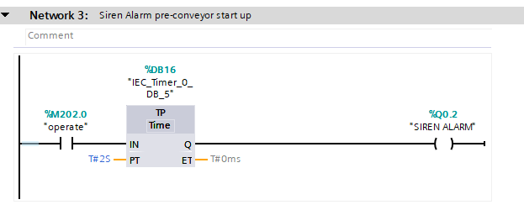
Figure 12 - Network 3 ladder program
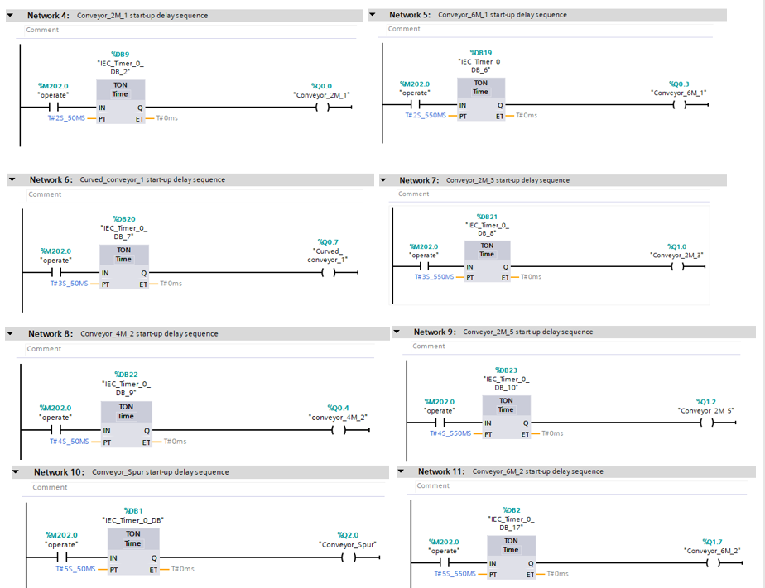
The brief specified that in order to limit the current draw at start up each conveyor needed to be started in sequence. Networks 4 -11 show how this was achieved by having incremental time delays triggered off the “operate” output condition being set.
Figure 13 - Networks 4-11 ladder program
The final conveyor is triggered in parallel with a 2nd operate output “operate_2” this is used in the next network for the setting of the scale conveyor power output.
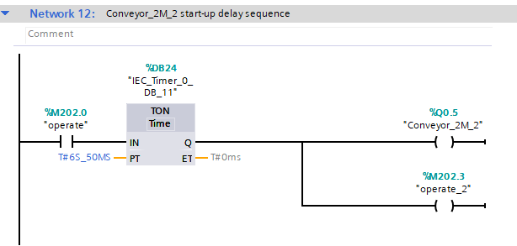
Figure 14 - Network 12 ladder program

The following network shows how the input conditions to set the conveyor scale, and simultaneously illuminate the yellow spur stack light, upon the scale conveyor power being interrupted to enable an accurate measurement to take place.
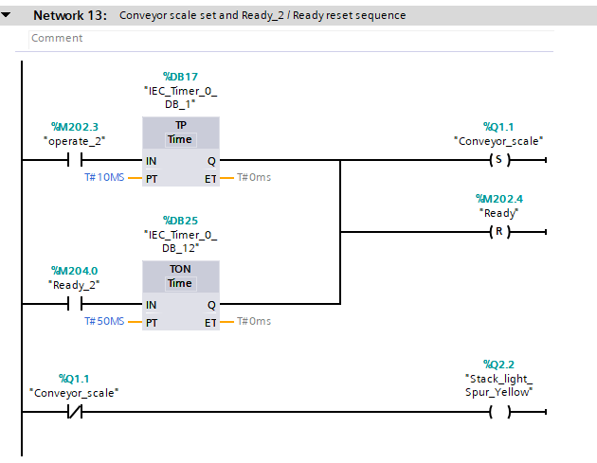
Figure 15 - Network 13 ladder program

The scale conveyor sequence starts with a positive edge trigger on the “WEIGHT_SCALE_SENSOR” this pulses a reset of the conveyor output for 500ms with a further 400ms delay on the ready output being set.
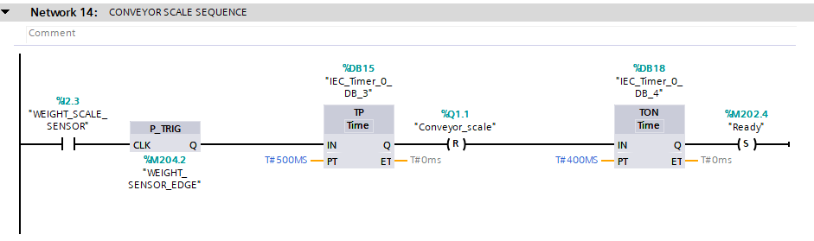
Once the “Ready” output is set the input for Network 15 triggers a move function which converts the real live “Weight” measurement into a stored weight memory “weight_store” to be recalled for use in sorting the boxes based on weight.
Figure 16 - Network 14 ladder program
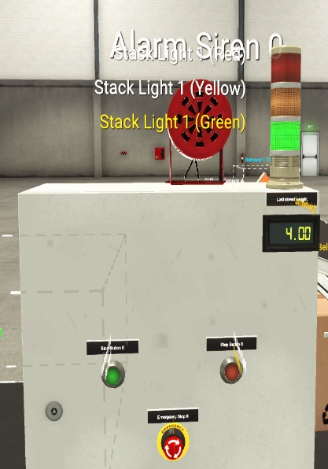
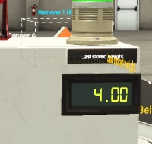
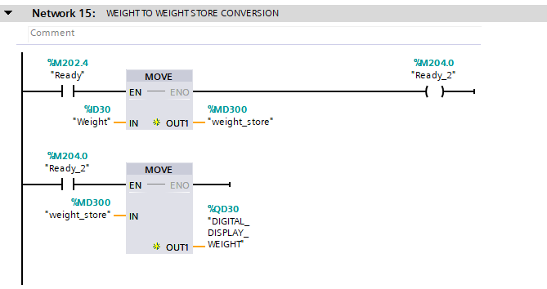
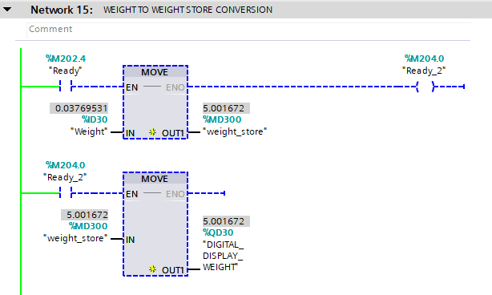
Figure 17 - Network 15 ladder program
There is an additional MOVE function which sends the stored weight in the PLC memory to the digital display on the factory panel.
The “Ready” input reference triggers the next sequence which takes the value stored under “weight_store” and uses several comparator operations to determine which pop-up wheel directions are set. If the item weighs greater than 3.5kg and less than 4.5kg this is a small box, and the pop-up wheels are set so the box will continue straight on – this is achieved by resetting both the Left and right pop-up wheel outputs. The other condition looks if the item weighs more than 4.6kg but less than 7.0kg, this is a medium box, and the pop-up wheels are set to send the box right to the spur conveyor. A further fail safe is that the is the weight is greater than 8.0kg then the pop-up sorters are set to expel the box to the left of the conveyor. (This condition is true when multiple boxes are on the conveyor scale due to an error in the sequence)
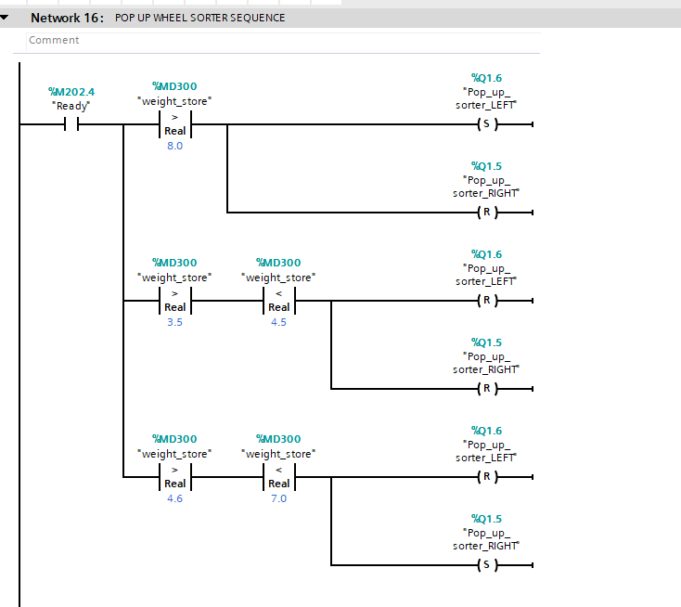
Figure 18 - Network 16 ladder program

Network 17 shows the 500ms delay before the power to the “pop_up_sorter” is triggered this delay this from the memory input from “operate_2” which is powered in parallel to the “Conveyor_2M_2” in Network 12 as shown previously. “Conveyor_2M_2” being the last conveyor before the scale conveyor in sequence.
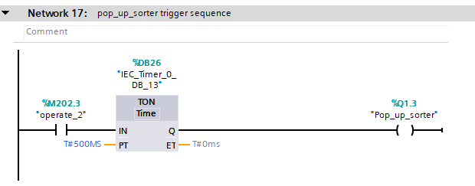
Figure 19 - Network 17 ladder program
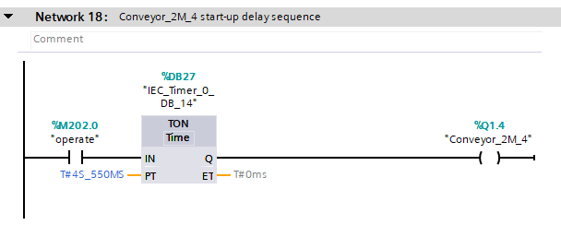
Network 18 follows on with the sequenced power up of the conveyors, again with a time delay from the initial “operate” output. The “conveyor_2M_4” is the last conveyor in the BOX (S) path.
Figure 20 - Network 18 ladder program

Networks 19 & 20 control the large and medium pushers. Once the diffuse sensor beam is broken by a box passing through it the TOF timer holds the signal on for a set period of 800ms in this case. This allows the box to continue traveling on the conveyor so when the pusher is actuated it is pushing into the middle of the box. The timings have been adjusted to enable the best transition to the respective conveyors.
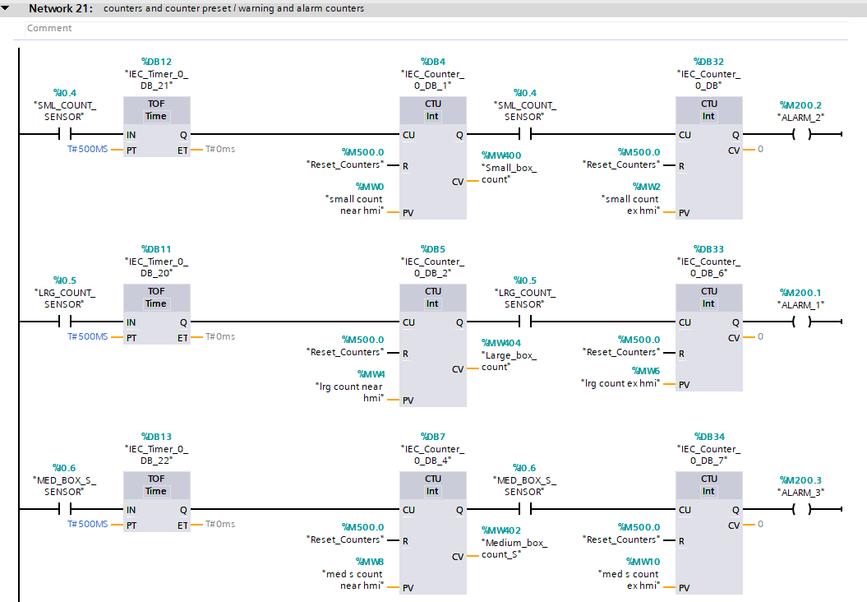
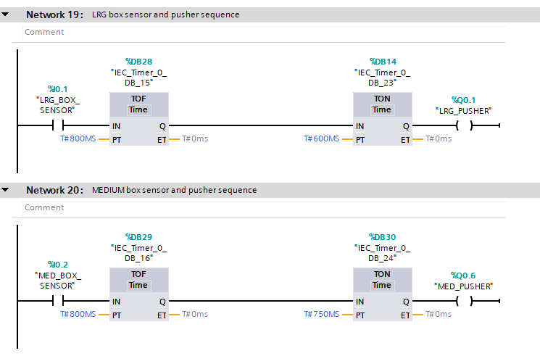
Network 21 uses a combination of timers and counters to enable the cumulative count of the various box sizes and allow a pre-setting of the counter limit for both warning and alarm level. This also links to the HMI Engineering screen where the pre-set values can be entered in a live simulation. The input reference for the first counter is the diffuse sensor for the box size, each trip of this laser allows a count up of 1 to be inputted to the CTU – CU. The pre-setting is linked to the PV tag. Each CU input will pass to the CV tag. Only when this CV tag matches the PV value will the output tag Q be set and allow the next pulse to the diffuse sensor to start the input on the CU of the next CTU which is used for the alarm level output. The PV of each counter is changeable during the running of the simulation. Initially this was static and could only be updated in the main (OB1) and re-uploaded to the PLC before it took effect.
Figure 21 - Network 21 ladder program
Figure 22 - Networks 19 & 20 ladder program
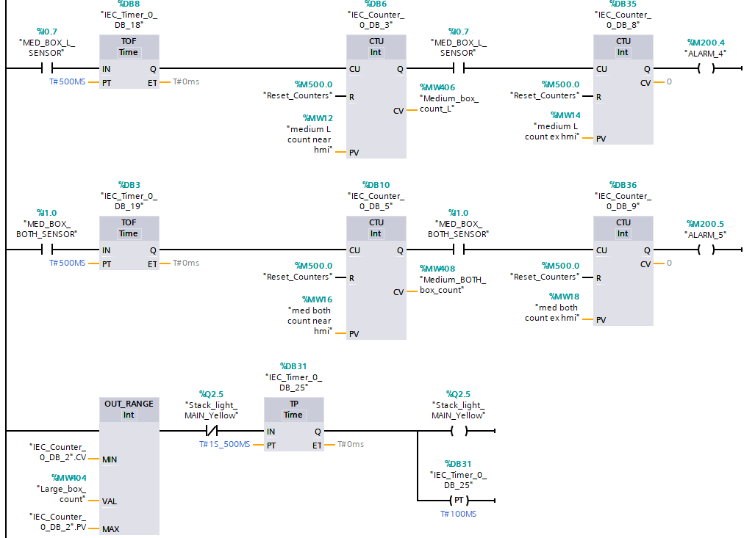
Figure 23 - Network 21 ladder program cont.
Each of the alarm outputs are linked to the HMI and the LED on the warnings and alarms screens.
Network 22 covers the tracking on the large box from the large pusher to the exit of the conveyor this uses the diffuse sensor for the entry command the input is tagged to a CTU. An additional diffuse sensor links to another CTU to count the exit of the box. There is a not equals comparator which checks with a 10s delay on the output which, if true triggers a warning light and a red light on the main stack light. The 10s delay is set to allow the large box to traverse fully circa 8s from beam-to-beam break. Therefore, if a package was to fall from the conveyor the counters would not be equal after 10s and an alarm condition would be set. This is depicted on the root screen with a top-down view of the factory and pilot lights in specific locations. If a warning light illuminates in the factory, then the HMI will display the corresponding warning to the operator.

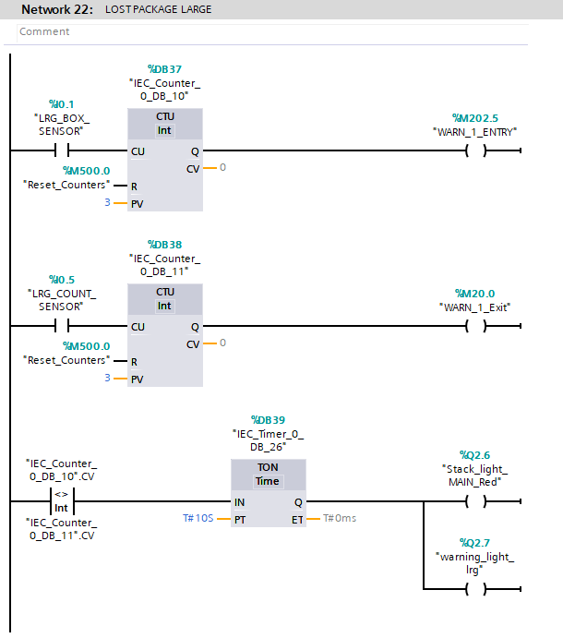
Figure 24 - Network 22 ladder program

This sequence is then repeated for the other box sizes with appropriate time delays for the respective traverse timings.
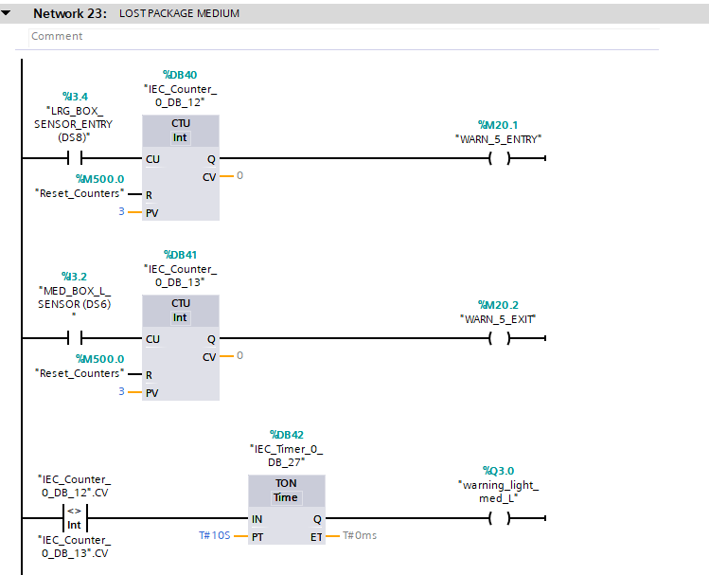
Figure 25 - Network 23 ladder program
Network 23
Initially encountered difficulties with the entry trigger for the boxes as both the BOX (S) & BOX (M) trigger from the same entry point but with 2 possible exit points. This meant that if a box triggered the shared entry diffuse sensor it couldn’t trigger both (S) and (M) exit sensors so a lost package alarm would be erroneously triggered. To resolve this the box (M) entry sensor was moved to the start of the spur conveyor with the timings adjusted accordingly.
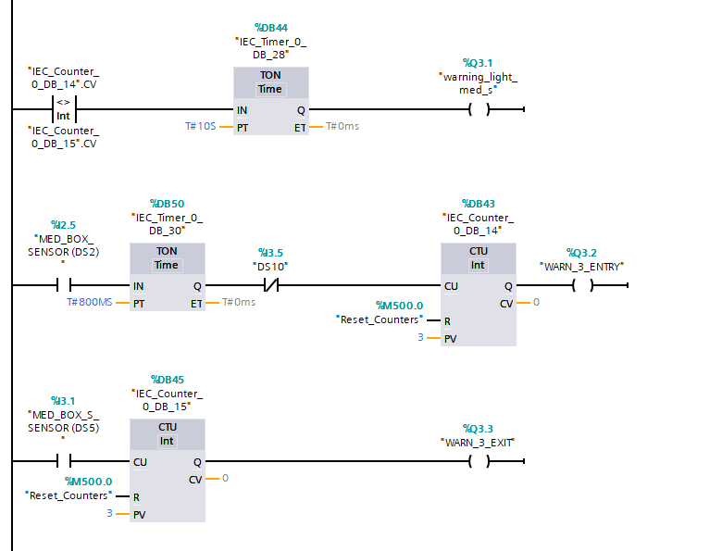
However, a further issue was created when the Box (M) would trigger a BOX (S) counter. This was resolved using a NEW sensor (DS10) placed on the opposite side of the conveyor before the medium pusher which would only be triggered by a Box (M) by using this within Network 23 as a normally closed sensor and having it in series with a TON delay. So, the sensor would only input to the counter if there was no trigger of the other sensor (DS10)
Figure 26 - Network 23 ladder program inc DS10 sensor
There is scope to change the PT time values should the output intervals of the boxes need to be increased / decreased.
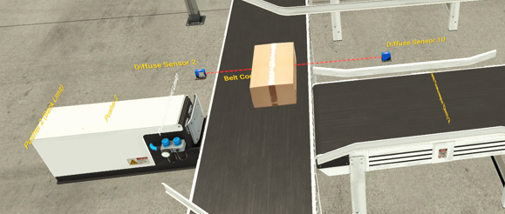
As (DS10) has been triggered the signal is not allowed to pass through to the counter for the BOX (S)
Figure 27 - factory IO scene showing BOX (M) at sensor DS10

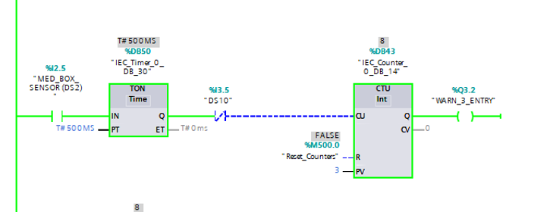
Figure 28 - Network 23 DS10 running
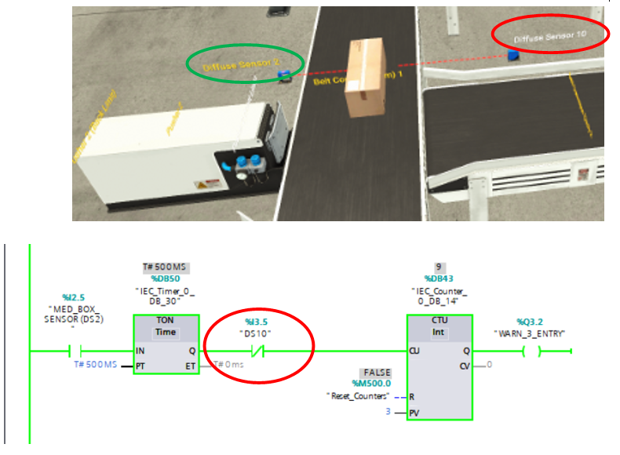
As (DS10) has not been triggered the signal is allowed to pass through to the counter or the BOX (S)
Figure 29 - Factory IO scene showing BOX (S) not triggering DS10 and ladder program screenshot

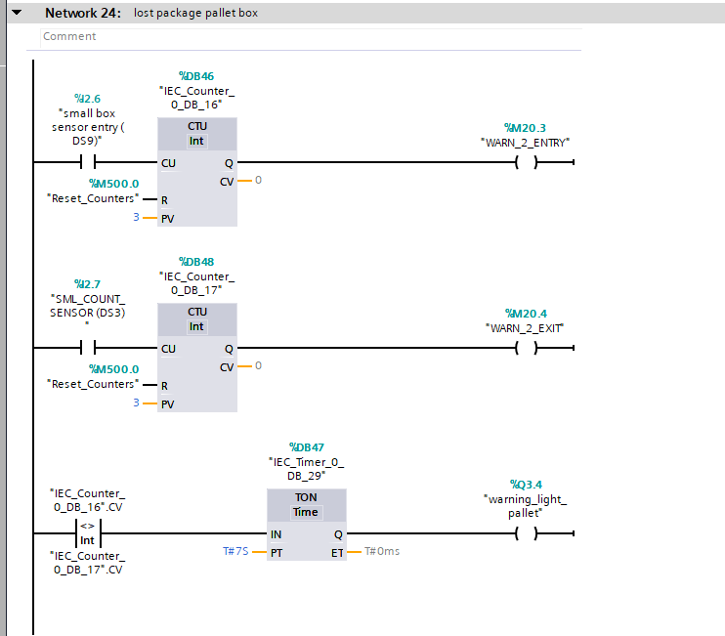
Network 24 shows the pallet box sequence.

Networks 25, 26 & 27 all relate to the setting of the master warning and alarm error flags
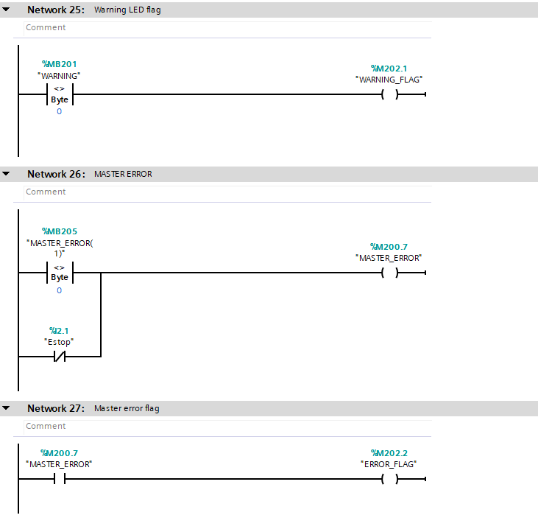
Figure 30 - Networks 25 - 27 ladder program
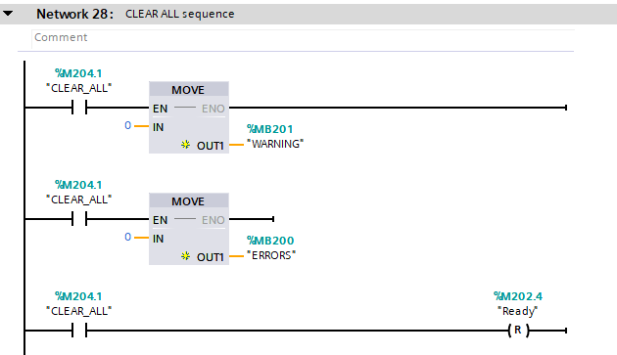
Network 28 is a trigger for the master reset of all errors.
Figure 31 - Network 28 ladder program
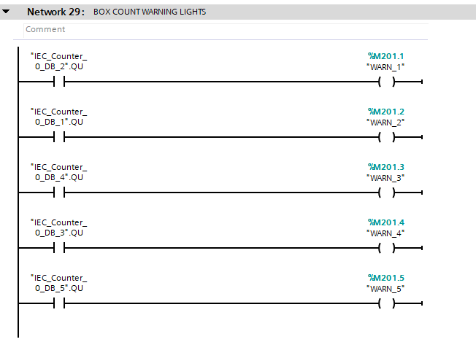
Network 29 is the trigger for all the separate counter warnings from Network 21
Figure 32 - Network 29 ladder program

Task 4 – HMI devices & Task 5 – Multiscreen design and operation

The HMI device consists of 3 separate screens which can all be navigated through using function buttons.
The root screen contains the main process function buttons. START, STOP and emergency stop.
There is a replication of both the main stack lights and the spur stack lights. There is also a section which lights up if a box is being weighed on the scale and this is shown as a “Current Weight” and then remains visible in the “Previous Weight” until the next box is weighed.
The lower portion of the HMI displays the current live count for that session. There is also a top-down view of the factory with lost box indicators. Which illuminate.
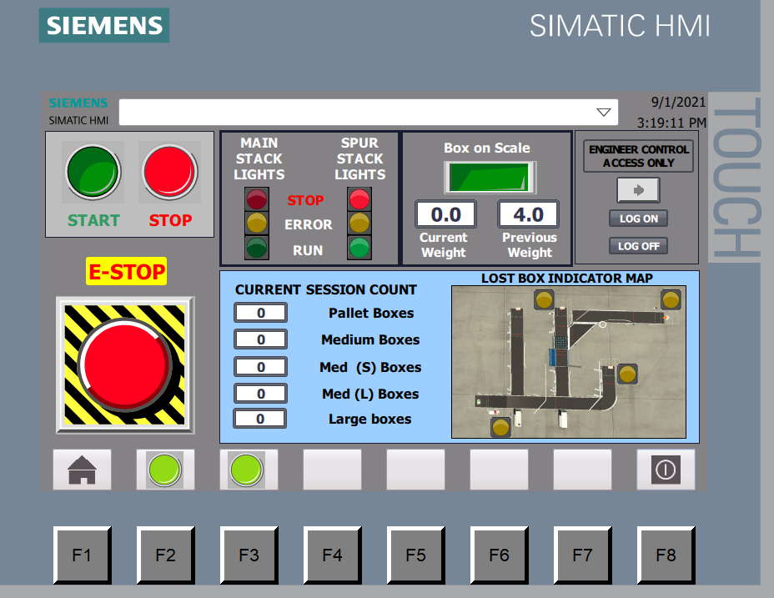
Figure 33 - root screen screenshot
There are 2 green button which navigate to the warnings and alarms screen. These buttons illuminate red when a warning or an alarm is triggered.
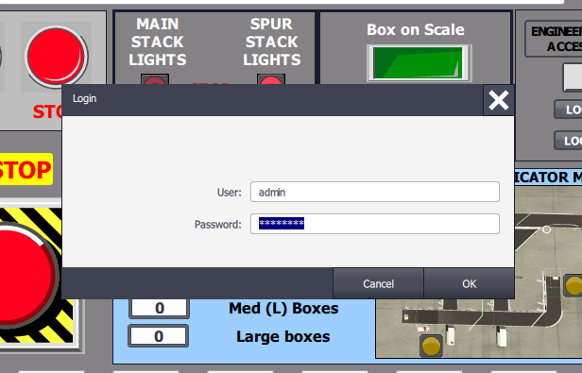
There are special inputs and functions which are only accessible from the Engineering Control screen, this is setup through user administration groups and the user is required to log in – this is set as username “admin” and Password “password” this then allows further access to the pre-setting of the counter warning and alarm values. The Engineering access control allows the user to “reset all counters” and to “clear all” faults and “reset master errors” there is also a replication of the current live count so the user can see that the counters have been reset from this screen.

Figure 34 - user logon dialog popup

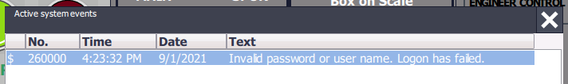
if the user enters the incorrect password, then the system will show a pop-up dialog box informing them that the logon has failed.
The system is also set to log out automatically on a timeout – set to 5 mins auto log off.
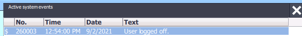
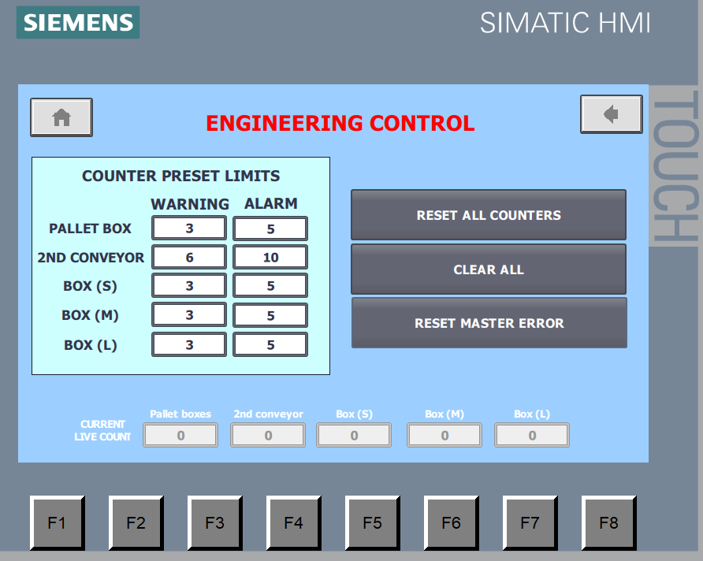
Figure 35 - Engineering control screen logon and counter adjustment popups
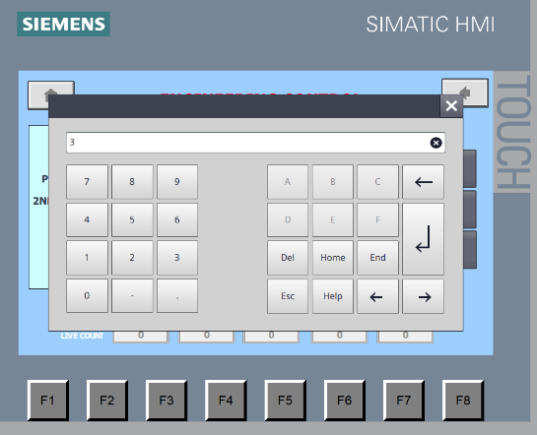
Utilising the animations settings each button has been setup for the text to change colour when the button is pressed to indicate to the user that button was selected successfully.
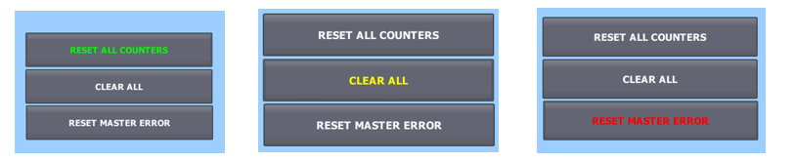
Figure 36 - Engineering screen Function button animations
Still taking advantage of the animations the appearance of the warning and Alarms screen changes as the various warning / alarm stages change.
When the system is in a quiescent condition the warning and alarm messages are greyed out and the pilot lights are not illuminated.
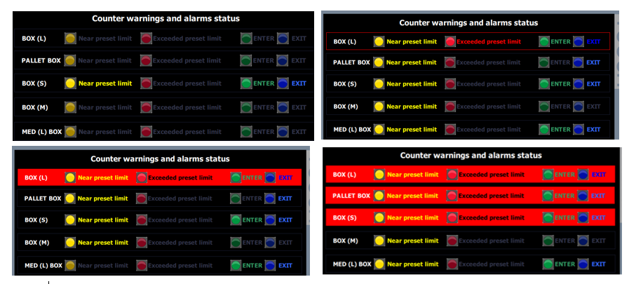
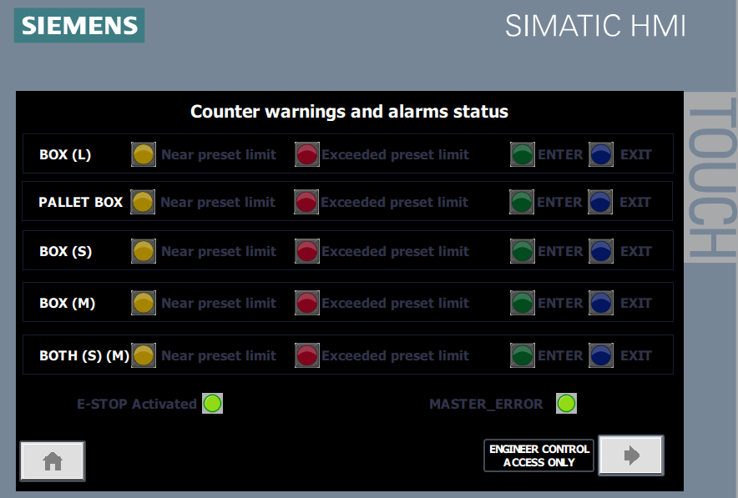
However, if a box counter surpasses the warning qty then the yellow pilot light illuminates for that row and the “near pre-set limit” text changes to yellow. If the qty reaches the pre-set limit for the upper values, the red pilot light illuminates.
Figure 37 - Alarm and wanring animation sequence
Figure 38 - Alarm and warning screen

Lost box warning triggers on HMI controlled by CTU and Comparator functions in Networks 22 -24
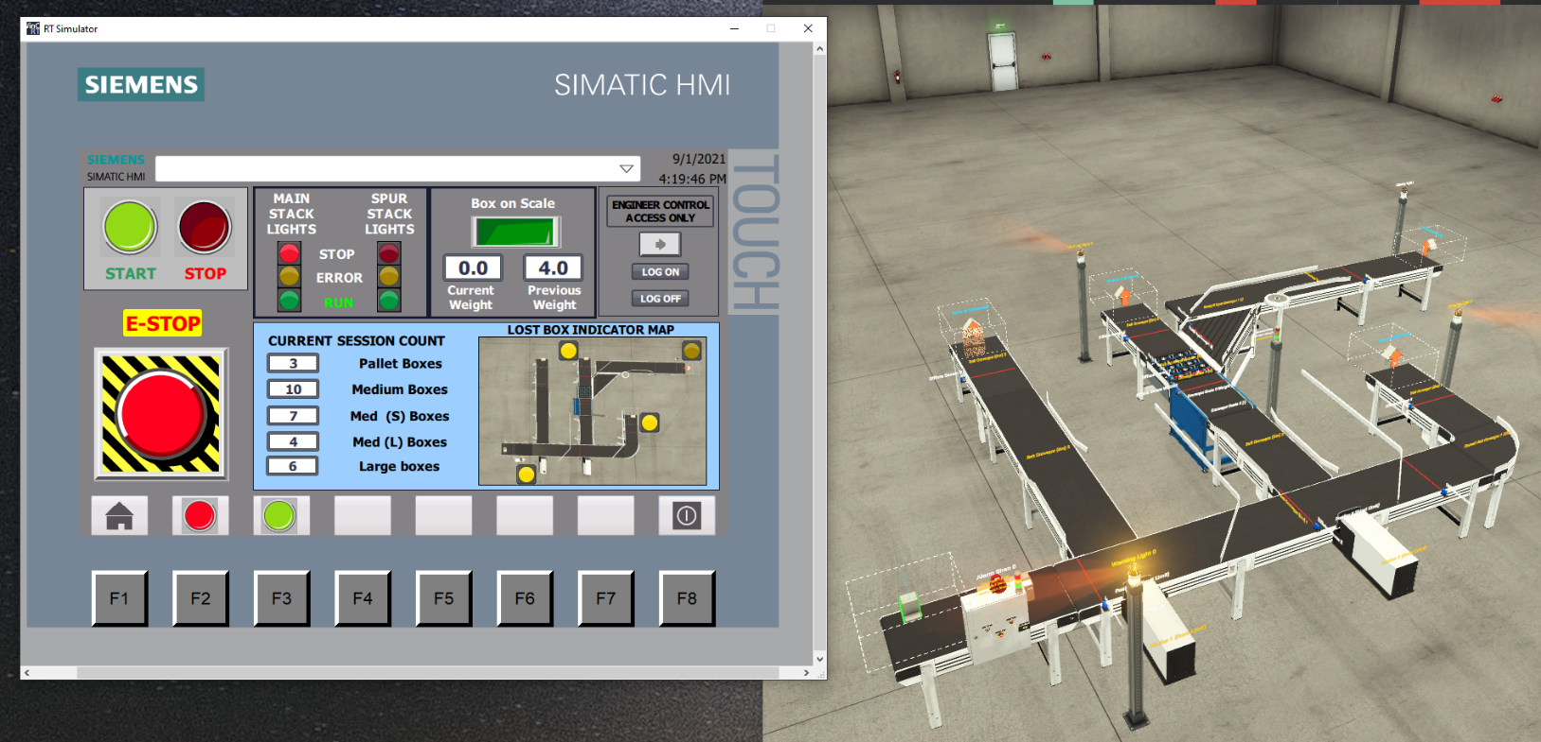
Figure 39 - Factory IO lost box warning lights

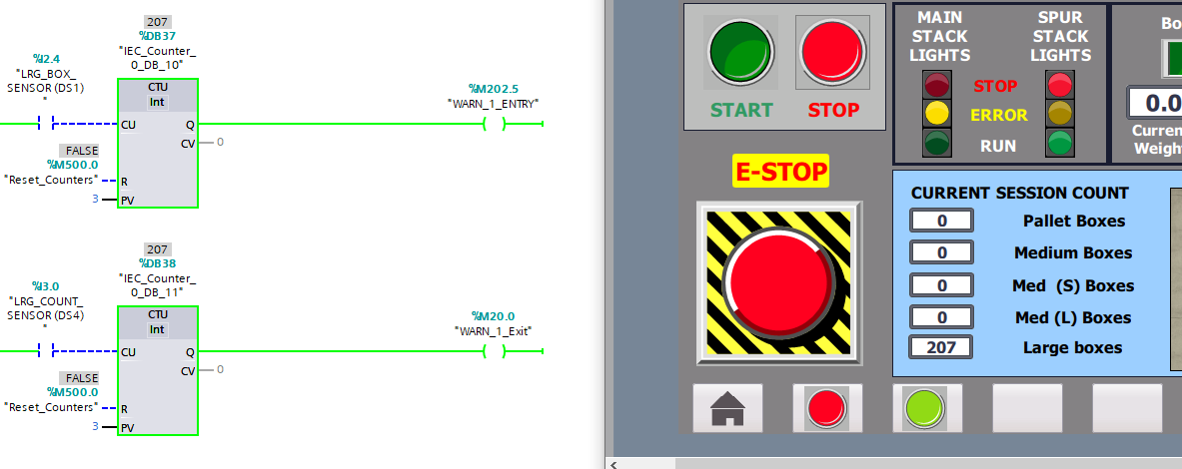
Left the system running to ensure the counters were counting correctly as there was some issues with double counts on large box.
Figure 40 - Unattended counter experiment screenshot

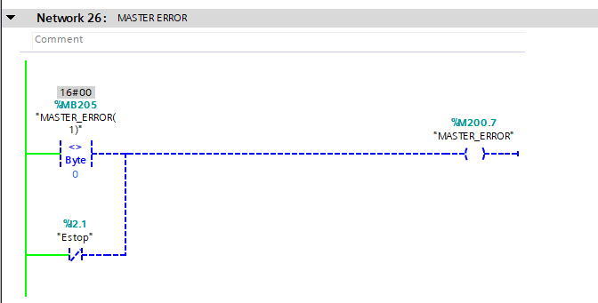
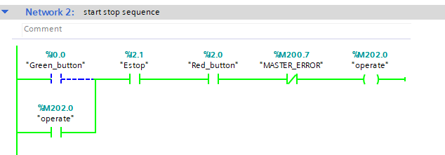
This sequence shows the ESTOP not activated, signal is passing through the Network.
Figure 41 - Network 26 showing ESTOP functional input for MASTER_ERROR
Figure 42 - Network 2 running showing ESTOP function
The warning indicators are not set and remain normal (green)
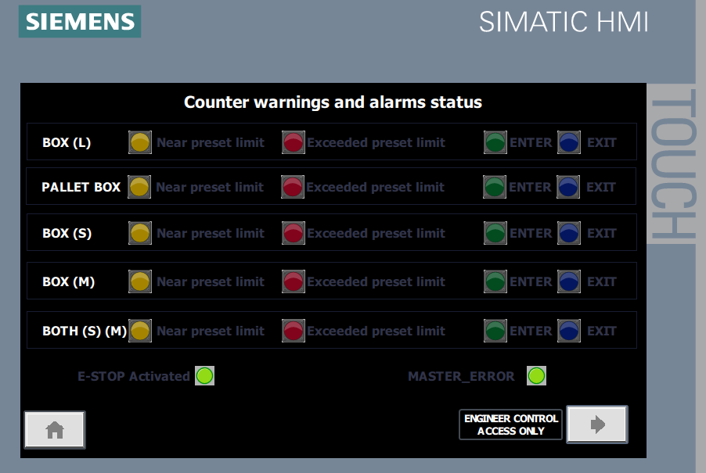
Figure 43 - Warning and Alarms screen in quiescent mode

When the physical ESTOP is triggered from the factory IO simulation the following condition is TRUE
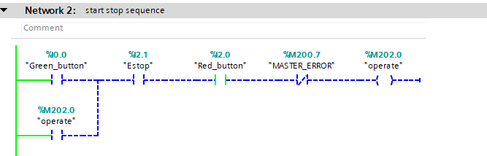
Figure 44 - Network 2 showing ESTOP tripped
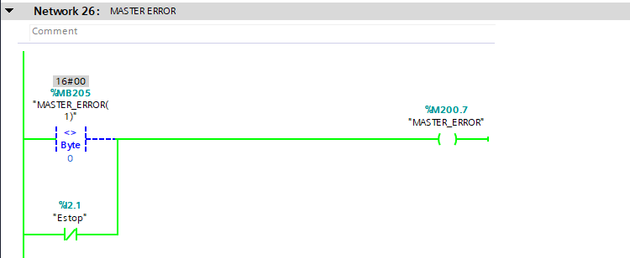
The Normally open contact on the main stop start sequence is broken and the operate output is turned off.
Figure 45 - Network 26 showing MASTER_ERROR triggered


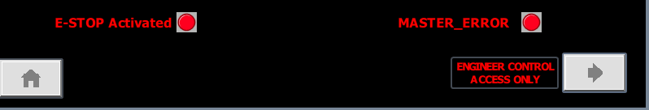
The “MASTER_ERROR” output memory location is activated, and the HMI warning and alarms screen triggers the” E-STOP” and “MASTER_ERROR LED” animation the text also flashed red to prompt an engineering log on and once logged into the engineering screen the user will see the reset master error button text is also red.
Figure 46 - ESTOP & MASTER_ERROR animations

References
“Allen Bradley Micro820 Plc CPU - 12 Inputs, 8 Outputs, relay, for use with bulletin 2080, ethernet networking,” 2080-LC20-20QWB | Allen Bradley Micro820 PLC CPU - 12 Inputs, 8 Outputs, Relay, For Use With Bulletin 2080, Ethernet Networking | RS Components. [Online]. Available: https://uk.rs-online.com/web/p/plcs-programmable-logic-controllers/8937761. [Accessed: 02-Sep-2021].
“Schneider electric Zelio logic LOGIC module - 16 INPUTS, 10 Outputs, Relay, computer, Operating panel interface,” SR3B261BD | Schneider Electric Zelio Logic Logic Module - 16 Inputs, 10 Outputs, Relay, Computer, Operating Panel Interface | RS Components. [Online]. Available: https://uk.rs-online.com/web/p/plcs-programmable-logic-controllers/4684242. [Accessed: 02-Sep-2021].
“Siemens S7-1200 Plc CPU - 14 (Digital Input, 2 switch as Analogue input) INPUTS, 10 (Digital OUTPUT, Transistor output),” 6ES7214-1AG40-0XB0 | Siemens S7-1200 PLC CPU - 14 (Digital Input, 2 switch as Analogue Input) Inputs, 10 (Digital Output, Transistor Output) | RS Components. [Online]. Available: https://uk.rs-online.com/web/p/plcs-programmable-logic-controllers/8624471. [Accessed: 02-Sep-2021].

