Marketing Essentials - Marketing plan

Student name: Aneliya Sergeeva Karamanova
Student ID: 2235641
Lecturer’s Name: Huw Thomas
Word Count: 1591

1. Introduction
As per the view of Morganet al., (2019, p. 4), a marketing plan is the advertising techniques that a business would implement in order to sell its products or services in a systematic way. Best Western is one of the popular hotels in the US the plan is for identifying a problem or marketing opportunity as well as making communications techniques for this hotel in the present situation, 4ps are important for any type of business and helpful to increase the business in a systematic way. In the below part it is discussed both micro as well as macro analysis of this company.
2. Situation Analysis
2.1 SWOT analysis
Strengths  - Best Western is situated in a good location.  - One of the largest Hotel Chain in the world | Weakness  - Limited accountability  - Competition from international hotel chain
Opportunities  - Online presence and digitalisation  - Penetration in emerging economies | Threats  - Threats of the pandemic  - Changing market condition

2.2 Segmentation and targeting
Segmentation
Best Western Hotel follows behavioural segmentation in its business and that’s why more customers are attracted to the hotel. As per the study it has been found that in the last three months this brand’s global ranking has increased from 11,744 to 10,520. Marketing is important for the business (Campbell, et al., 2020, p. 227).
Targeting
Age | 25 years to 65 years
Location | United States of America
Income Group | Socio-Economic group means middle income group to higher income group

2.3 Perceptual position map, Bowman’s Strategy clock
This brand is offering high quality services to their customers at affordable prices that means this brand is implementing a competitive pricing strategy in order to compete with its competitors in the market. Marketing is helping to grow the business in systematic way (D’Souza, et al., 2019, p. 317).
As per the view of Goldman et al., (2021, p. 350), Bowman’s strategy clock is comprehensive as well as easy in order to apply tools which offers options for positioning in a market based around prices as well as perceived.
2.4 Demonstrate an awareness of the brand’s B2B relationship, partnerships, Franchise.
Here it has been observed that this brand is maintaining relationships with tour and activity providers as well as other businesses because it helps the brand to attract more customers in a systematic way.
2.5 PESTLE analysis

Factors | Analysis | Impact
Political | Government regulation | Government regulation of the US are impacting the business of hotel industry (Lahtinen et al., 2020, p. 350)
Economical | Economic stability | Economic stability is not in good condition in the US after the pandemic situation that is threats for this brand
Social | Changes in lifestyle | Changes in lifestyle of the US people are affecting the business because most of the people visit this hotel to spend their leisure time. Marketing is affecting by social changes (Liu, et al., 2019, p. 265)
Technological | Upgraded technology | Best Western upgraded technology in order to offer high quality services to their customers (Clow and Baack, 2013)
Legal | Customer protection law | Customer protection law is applied by the US government in order to offer security to the customers
Environmental | Sustainability programme | Best Western is maintaining sustainability in its premises that also attract customers.

Marketing mix

Product | Best Western offers high quality services to their customers
Price | Best Western implements a competitive pricing strategy in its business
Place | This hotel is situated in the US
Promotion | Both offline as well as online promotional strategy is applied by this brand

1. Objectives
Objective | Specific | Measurable | Attainable | Relevant | Time Bound
To identify marketing opportunity | The objective is achieved through consumer segmentation | Measurability is generally checked by staff members survey | The attainability depends upon the feedback offered | Marketing opportunity is vital for a company in order to increase the profitability rate in a systematic way | 3 months
To make a communication strategy | The objective is achieved through upgraded technology | Measurability is decided by the satisfaction level of staff members | It is attainable through conducting some programs | It is relevant as it helps to enhance productivity as well as efficiency of Best Western hotel in a systematic way | 6 months

2. Strategy
As stated by Chaffey and Ellis (2019), new value proposition is one type of statement that defines the advantages an organisation’s items as well as services would deliver to their target customers in a systematic way. Best Western thinks to improve their customer’s services as it helps them to increase their brand image in the hotel industry in a systematic way. It has been identified that they also want to expand their business in a systematic way.
Ansoff’s matrix
As viewed by Ghauri, (2014), Ansoff’s matrix is one type of strategic planning tool which offers a framework in order to help grow the business in a systematic way. It can be said that Best Western could follow product development strategy because they try to implement new services for customers in the US market that will help them to increase the customer satisfaction rate in a systematic way. It has been found that product development strategy would also help them to attract more customers.
3. Tactics
Best Western would follow a communication mix strategy that helps them to improve in a systematic way. As postulated by Housden (2008), the communication mix associates all the tools a business person applies in order to communicate with their customers in a systematic way. It has been identified that limited accountability is present in the business of this hotel. On the other hand, it is also observed that competition from international hotel chains is also regarded as one of the threats of the business.
Application of communication mix strategy
Through communication mix strategy this company needs to always know why incidents happen. It has been analysed that this can be anything from defining roles as well as responsibilities in order to checking in on the progress of the project. As per the researchers it has been found that the communication mix also associates with advertising, social media as well as websites (Kotler and Kartajaya, 2017). In this aspect it is also required to offer advertising because it can be said that advertising is helpful to a brand to compete with the main competitors. The major unique as well as impactful advertising may be helpful to this brand to be popular among the customers (Ryan, 2012).
On the other hand, personal selling is also helpful because through this method the people try to connect with their customers in a systematic way. Through a personal selling method this brand could compete with international hotel chains in the US market as well as attract customers in a systematic way. Nowadays public relations are an important technique in order to expand the business in a systematic way. Researchers have stated that most successful businesses try to increase their business through public relation techniques. It can be said that by implementing the public relation strategy this brand could expand its business properly in the US market as well as increase its brand image properly.
It is found that this brand is applying Facebook as well as Twitter in order to connect with customers as well as attract their customers in a systematic way. Its’ bounce rate is almost 47.38% and it could be improved through applying the advertising strategy that is under the communication mix, it is known that this brand has faced immense competition with international hotel chains and that is why these techniques help the organisation to compete with rivals.
4. Action

 | W1 | W2 | W3 | W4 | W5 | W6 | W7 | W8 | W9
Marketing aim and objectives
Promotion
Content marketing
Advertising
Searching the marketing channels
Communication channels
Budget
Distribution strategy
Selling

It has been found that marketing aims and objectives would be complete within 3 weeks because it is required to make some plans for the marketing strategy. On the other hand, it is also important to do promotion as it is one of the most important aspects of marketing activities. Week 3 and week 4 would be allocated to complete the promotion. It is also observed that content marketing as well as advertising are taking 3 weeks and 5 weeks to complete these in a systematic way.
5. Control
As pet the view of it has been found that a KPI matrix is important in order to display as well as visualise the unlimited number of business matrices in a single table.

Revenue growth | It can be said that revenue of this brand would be increased properly after implementing the communication mix strategy in its business in a systematic way.
Profit margins | Profit margin would be also increased properly after 1 months of implementing
Client retentions rates | Client retention rates would be positive because all strategies are scientifically applied to the business.
Satisfaction rate of the customers | Customer satisfaction rate would be in a good condition as well as it would be increased in a systematic way.

6. Conclusion
Most of the researchers have stated that a marketing plan is not only helpful to increase the business growth as well as increase the customer satisfaction rate in a systematic way. Best Western is one of the most popular hotels in the US. It has been analysed that this is situated in a good location that is one of the opportunities of this brand. It has been analysed that this brand is following behavioural segmentation in its business. In the above part it is also discussed PESTLE analysis of this company. This brand would follow product development strategy in order to attract customers.

References
Task 1
Journals
Benzaghta, M.A., Elwalda, A., Mousa, M.M., Erkan, I. and Rahman, M., 2021. SWOT analysis applications: An integrative literature review. Journal of Global Business Insights, 6(1), pp.55-73.https://digitalcommons.usf.edu/globe/vol6/iss1/5/
Capobianco, N., Basile, V., Loia, F. and Vona, R., 2021. Toward a sustainable decommissioning of offshore platforms in the oil and gas industry: a PESTLE analysis. Sustainability, 13(11), p.6266.https://www.mdpi.com/1134592
Lahtinen, V., Dietrich, T. and Rundle-Thiele, S., 2020. Long live the marketing mix. Testing the effectiveness of the commercial marketing mix in a social marketing context. Journal of Social Marketing, 10(3), pp.357-375.https://www.emerald.com/insight/content/doi/10.1108/JSOCM-10-2018-0122/full/html
Paurova, V. and Gregova, E., 2020, December. Importance and Process of Marketing Environment Analysis as Strategic Analysis Tool of Business. In Fifth International Conference on Economic and Business Management (FEBM 2020) (pp. 720-723). Atlantis Press.https://www.atlantis-press.com/proceedings/febm-20/125948486
Rosenbloom, D., Markard, J., Geels, F.W. and Fuenfschilling, L., 2020. Why carbon pricing is not sufficient to mitigate climate change—and how “sustainability transition policy” can help. Proceedings of the National Academy of Sciences, 117(16), pp.8664-8668.https://www.pnas.org/doi/abs/10.1073/pnas.2004093117
Tanrıvermiş, H., 2020. Possible impacts of COVID-19 outbreak on real estate sector and possible changes to adopt: A situation analysis and general assessment on Turkish perspective. Journal of Urban Management, 9(3), pp.263-269.https://www.sciencedirect.com/science/article/pii/S2226585620302168
Book
Bowie,D. Buttle,F. Brookes,M & Mariussen,A 2017, Hospitality Marketing. 3 rd ed, Routledge, London
Jobber, D. and Ellis-Chadwick, F 2020, Principles and practice of marketing. 9th ed. London:
Kotler, P., Armstrong, G., Harris, L. and He, H., 2020. Principles of marketing. 8 th European ed, London: Pearson Education Limited.
Smith PR and Zook ZE 2020 Marketing Communications. 7 th ed, Kogan Page, London
Website
ihg.com.2023 Holiday Inn United Kingdom Family Hotels - Book a Great Hotel Deal - Kids Stay and Eat Free. Available at: https://www.ihg.com/holidayinn/destinations/gb/en/united-kingdom-hotels (Accessed: 24 May 2023).
similarweb.com.2023 Holidayinn.com market share, revenue and Traffic Analytics - Similarweb. Available at: https://www.similarweb.com/website/holidayinn.com/ (Accessed: 24 May 2023).
similarweb.com.2023 Sixsenses.com Traffic Analytics & Market Share | similarweb. Available at: https://www.similarweb.com/website/sixsenses.com/ (Accessed: 24 May 2023).
sixsenses.com.2023 Luxury Resorts, Spa Escapes - Six Senses About Us. Available at: https://www.sixsenses.com/en/about-us (Accessed: 24 May 2023).
statista.com.2023 Holiday inn hotels gross revenue worldwide 2022, Statista. Available at: https://www.statista.com/statistics/223345/holiday-inn-hotels-revenue/ (Accessed: 24 May 2023).
Task 2
Journals
Campbell, C., Sands, S., Ferraro, C., Tsao, H.Y.J. and Mavrommatis, A., 2020. From data to action: How marketers can leverage AI. Business Horizons, 63(2), pp.227-243.https://www.sciencedirect.com/science/article/pii/S0007681319301624
D’Souza, C. Marjoribanks, T., Young, S., Sullivan Mort, G., Nanere, M. and John, J.J., 2019. Environmental management systems: an alternative marketing strategy forsustainability. Journal of Strategic Marketing, 27(5), pp.417-434.https://www.tandfonline.com/doi/abs/10.1080/0965254X.2018.1430054
Goldman, S.P., van Herk, H., Verhagen, T. and Weltevreden, J.W., 2021. Strategic orientations and digital marketing tactics in cross-border e-commerce: Comparing developed and emerging markets. International small business journal, 39(4), pp.350-371.https://journals.sagepub.com/doi/pdf/10.1177/0266242620962658
Granato, D., Barba, F.J., Bursać Kovačević, D., Lorenzo, J.M., Cruz, A.G. and Putnik, P., 2020. Functional foods: Product development, technological trends, efficacy testing, and safety. Annual review of food science and technology, 11, pp.93-118.https://www.annualreviews.org/doi/abs/10.1146/annurev-food-032519-051708
Lahtinen, V., Dietrich, T. and Rundle-Thiele, S., 2020. Long live the marketing mix. Testing the effectiveness of the commercial marketing mix in a social marketing context. Journal of Social Marketing, 10(3), pp.357-375.https://www.emerald.com/insight/content/doi/10.1108/JSOCM-10-2018-0122/full/html
Liu, Y., Ma, W., Renwick, A. and Fu, X., 2019. The role of agricultural cooperatives in serving as a marketing channel: evidence from low-income regions of Sichuan province in China. International Food and Agribusiness Management Review, 22(2), pp.265-282.https://www.wageningenacademic.com/doi/abs/10.22434/IFAMR2018.0058
Marzuki, A.P., 2021. Low Cost Social Media Based Marketing Communication Mix Analysis On Medium Small Micro Enterprises In Parepare. MEDIALOG: Jurnal Ilmu Komunikasi, 4(1), pp.10-24.http://www.jurnal-umbuton.ac.id/index.php/Medialog/article/view/832
Morgan, N.A., Whitler, K.A., Feng, H. and Chari, S., 2019. Research in marketing strategy. Journal of the Academy of Marketing Science, 47, pp.4-29.https://link.springer.com/article/10.1007/s11747-018-0598-1
Book

Chaffey, D and Ellis- Chadwick, F. 2019 Digital Marketing. 7 th ed, Pearsons, London.
Clow, K and Baack, D 2013, Integrated Advertising, Promotion and Marketing Communications. 6 th ed, Pearson, Londonhttps://books.google.com/books?hl=en&lr=&id=z3dd7hFCA3cC&oi=fnd&pg=PA25&dq=Clow,+K+%26amp%3B+Baack,+D+(2013),+Integrated+Advertising,+Promotion+and+Marketing+Communications.+6+th+ed,+Pearson,+London&ots=KrQzBbCNbf&sig=x1-t3J2_-_PvqrABbizMGDnsq9o
Ghauri, P N 2014, International Marketing, 4 th Ed, McGraw Hill, Londonhttps://books.google.com/books?hl=en&lr=&id=23PhCgAAQBAJ&oi=fnd&pg=PR1&dq=Ghauri,+P+N+(2014)+International+Marketing,+4+th+Ed,+McGraw+Hill,+London&ots=KQ237vQ-0i&sig=Qd0H2d9fdu4C68UhKiSqtcn1dVE
Housden M 2008, Marketing Research &amp; Information, Butterworth Heinemann, Oxford.
Kotler,P and Kartajaya, H. Marketing 4.0 Moving from Traditional to Digital (2017) Wiley. New York.
Ryan, D. 2012, Understanding Digital marketing: Marketing Strategies for Engaging The Digital Generation. Kogan Page, London.https://books.google.com/books?hl=en&lr=&id=4pZlDQAAQBAJ&oi=fnd&pg=PR5&dq=Ryan,+D.+(2012)+Understanding+Digital+marketing:+Marketing+Strategies+for+Engaging+The+Digital+Generation.+Kogan+Page,+London.&ots=Pb7YmBXMcq&sig=RInEUavjQV-OMe6ZloDuWAbqcF8

Website
bestwestern.com.2023, About - best western. Available at: https://www.bestwestern.com/en_US/about.html (Accessed: 24 May 2023).

Appendix (For Essay part)
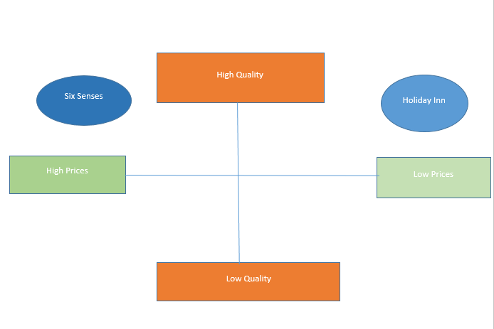

Task 2 PowerPoint Presentation
Appendices 1

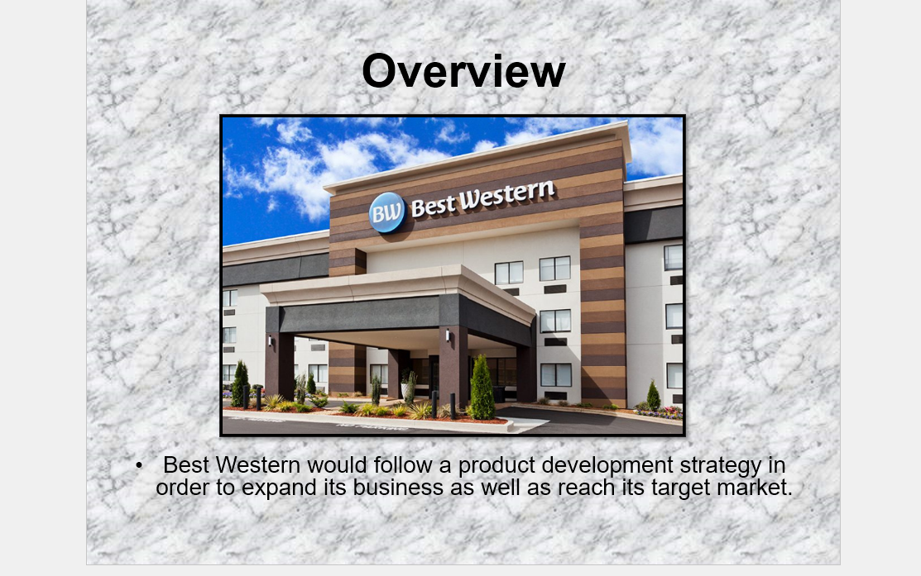
Appendices 2

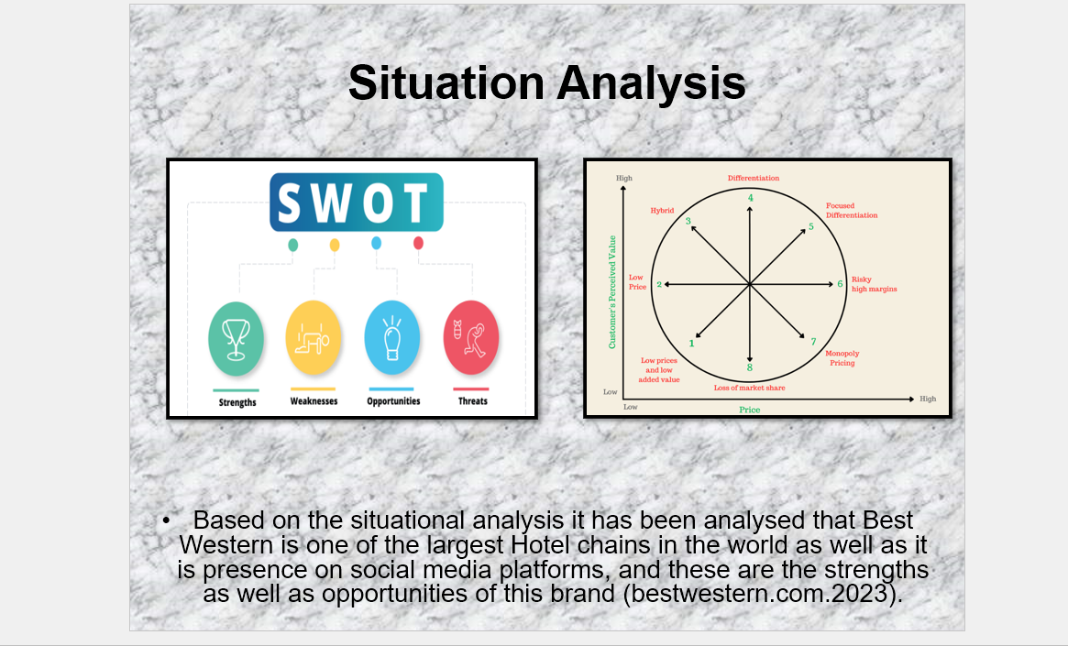

Appendices 3
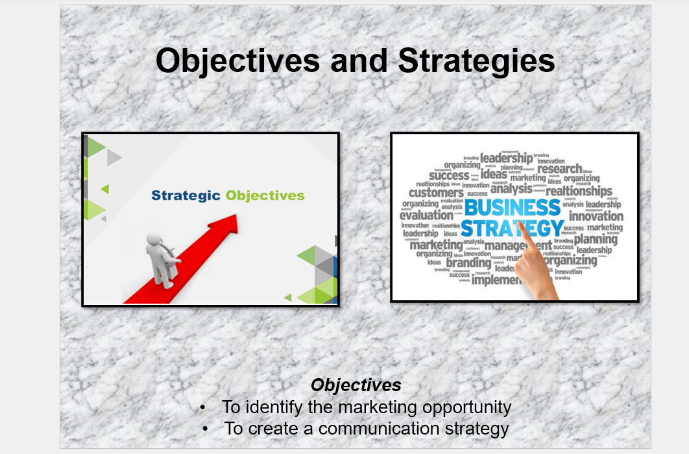

Appendices 4
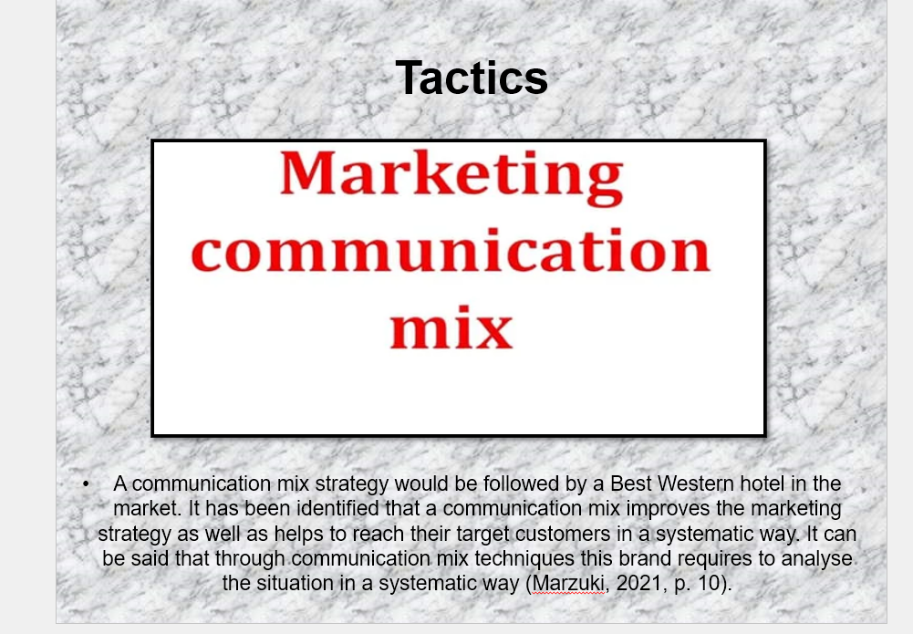

Appendices 5
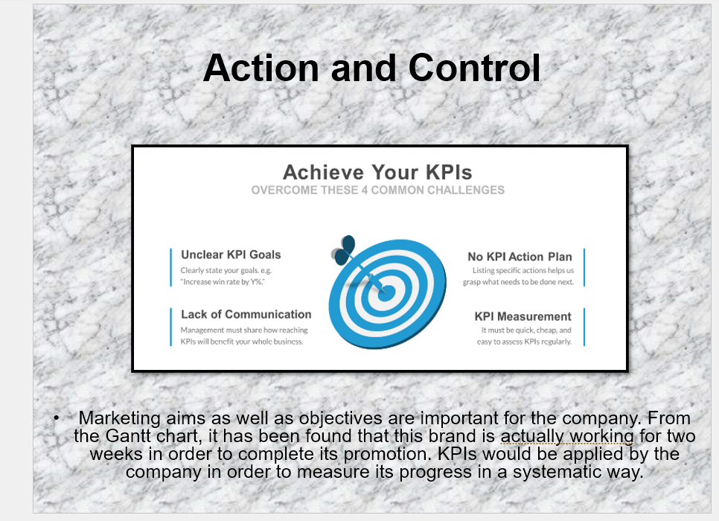
Appendices 6

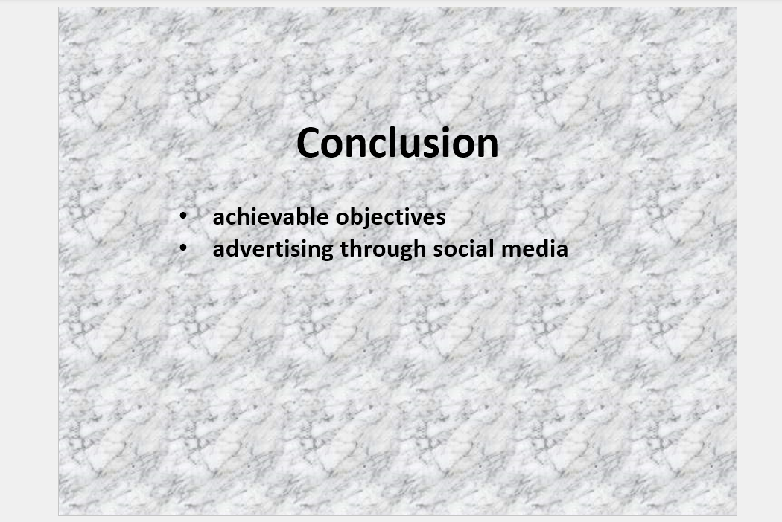

Appendices 7


