An analysis of the utilisation of dogs within the police service: Evaluating the efficiency and ethical implications of working police dogs in modern day policing.

Chapter: Analysis of results

Word Count: 1061
Cerys Morgan
2134358

Introduction:

This chapter of this dissertation focuses on analysing the data collated from within primary research which was undertaken as part of this study. This methodological approach permitted research to be conducted through the creation and utilisation of an online survey, where participants were invited to provide their personal views on using dogs within the police service, by answering a series of questions which centred on this topic. This method of study was chosen, as it produces qualitative data which focuses on the subjective opinions of an individual (Weng, 2024, p.1). Qualitative data which collects public opinion on police dogs (PDs) is important to this academic dissertation, as it relates and provides emphasis to the research found in the previous literature review chapter, where it was identified that there are both positive and negative views of utilising dogs in policing. However, this chapter does not only feature a qualitative research method, as numerical data collected from the survey responses will be presented via charts and graphs in this chapters appendix. Therefore, this chapter features an overall mixed method research approach.

Research method:

This academic study featured an online survey where sixty-three respondents each over the age of eighteen participated and provided their views and opinions on the utilisation of dogs within policing. This survey was accessed by its participants following being shared on social media platforms, via email, and internally within a policing organisation. All participants remained anonymous, and the study included forty females and twenty-three males. The survey identified which category the respondents belonged to, including active serving police officers, police staff, retired police officers or staff, and non-police. Most participants who took part in the study were not part of a policing organisation, with thirty-nine of these persons being non-police. However, eighteen individuals were serving officers, four were police staff and two were retired officers. It was important to include diversity with participants to compare the different opinions and viewpoints.

Public opinion on utilising dogs in policing:

Whilst analysing the results of the survey, it was evident from the responses that public opinion is in favour of using dogs for policing purposes, with 98.4% of participants believing that using dogs is an appropriate tactic in law enforcement, with 1.6% of individuals unsure on the matter. See appendix A for this data. When participants were asked to provide their reasoning as to whether they supported the use of dogs for policing purposes, most responses included the opinion that dogs have better capabilities than humans in certain aspects of policing. This often featured the personal views that dogs have an enhanced sense of smell allowing them to competently locate missing persons, narcotics, and firearms, or that dogs are more efficient in apprehending offenders than officers, due to their quick speed. Additionally, dogs are seen to be a deterrent to criminals. When synthesising, the previous literature review chapter provides the view of the National Police Chiefs’ Council (NPCC) (2023) who believe that dogs provide ultimate protection to the public and are an integral asset to police organisations. Crispino et al. (2023, p.1) also concurs, stating that dogs possess an exceptional sense of smell which is why they are used within policing.

Is it ethical?

When reviewing the responses provided in survey, it is acknowledged that 91.9% of participants deem that using dogs in policing is ethical, compared to 8.1% of individuals who were unsure. See appendix B for data. Furthermore, many respondents provided their reasoning for why they believed it was ethical, with several stating that the dogs are well cared for by officers and enjoy the role that they play within policing. However, from previous research conducted within the literature review chapter of this dissertation, Sachkova (2024) affirms that according to the People for The Ethical Treatment of Animals (PETA), dogs should be withdrawn from policing duties due to the injuries they have acquired from rioting events within the United Kingdom (U.K), and that police should find alternative methods to carry out their duties. On the other hand, respondents within the primary research survey provided a mixed reaction to the utilisation of police dogs PDs for rioting events. The survey revealed that 61.9% of participants believed that it is suitable to use PDs for rioting events, 28.6% supposing it as not fitting, and 9.5% were unsure. See appendix B and C for data. Whilst providing their thoughts on the matter, some participants felt that rioting was too dangerous for PDs, however others believed that dogs were a deterrent to offending parties.

Withdraw or employ more?

Hoyt (2024, p.2) expresses that there is insufficient evidence available which governs whether PDs should be removed from policing duties. However, the online research survey has revealed that 98.4% of individuals do not wish for dogs to be withdrawn from active police duties, with 1.6% having an unclear opinion. When asked why they had such opinion, most respondents shared the same views, which were that dogs are too valuable to the police service and are an excellent support for officers; police should continue to utilise dogs both safely and effectively. Regarding acquiring further PD resources, 38.1% of respondents strongly agreed, 25.4% of participants agreed, and 30.2% had a neutral response. However, 1.6% of participants disagreed, and the additional 4.8% of individuals were either unsure or felt that they did not have enough information to make comment. See appendix D and E for data.

Conclusion:

To conclude, this chapter has identified and analysed the results of a primary research survey, whilst ensuring to compare such responses with research discovered within the previous literature chapter. From the data provided within the survey, there is clear evidence that the public mostly support the use of dogs within the police, with many respondents providing a positive opinion compared to a small number of participants who were unsure on the subject. However, there appears to be a mixed response to utilising PDs for rioting purposes, where some individuals felt that such events were dangerous and unsuitable for the dogs. Most participants appeared to wish for PDs to remain within their active duties, although there were varied answers regarding acquiring more dogs to carry out policing purposes. The majority of individuals who took part in the survey believed that dogs are too significant to remove from the police service. Overall, the primary research has concluded that the public are favourable of PDs.

Appendices:

Appendix A

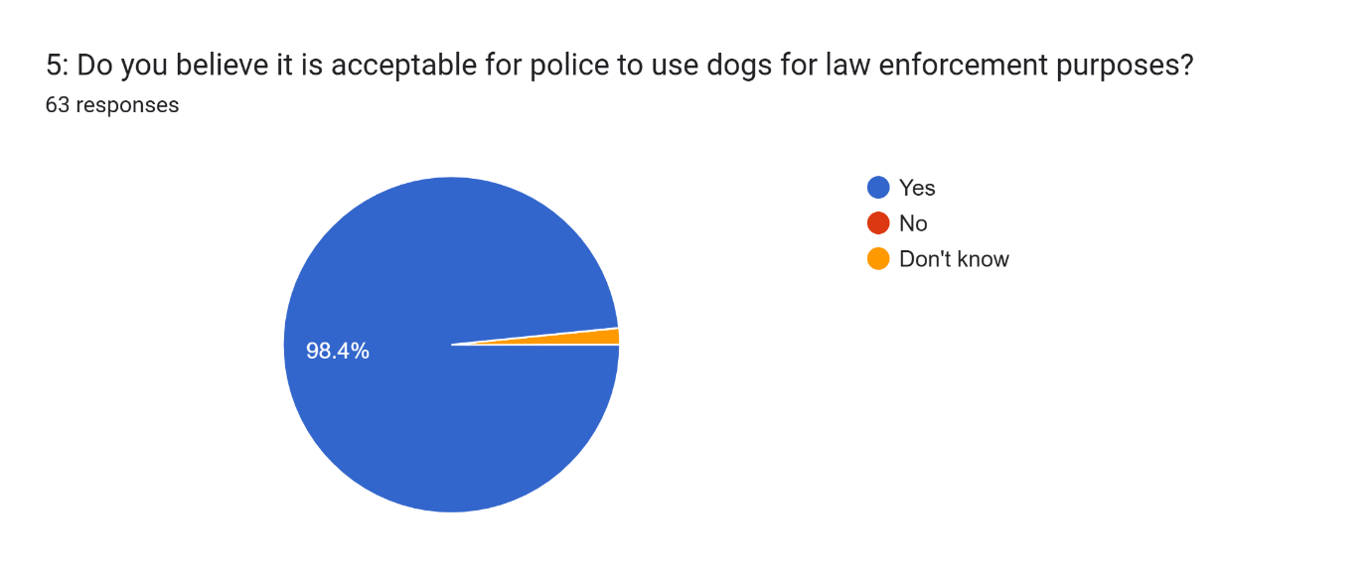

Appendix B

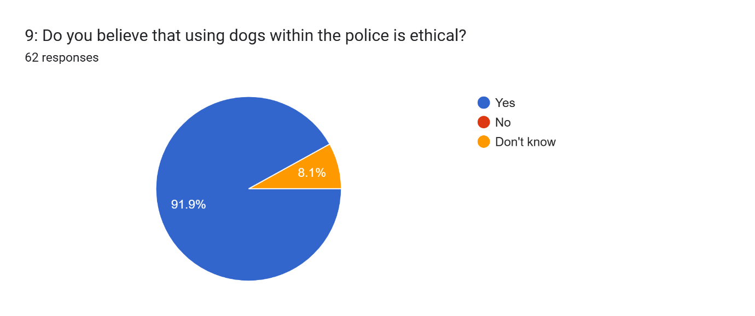

Appendix C

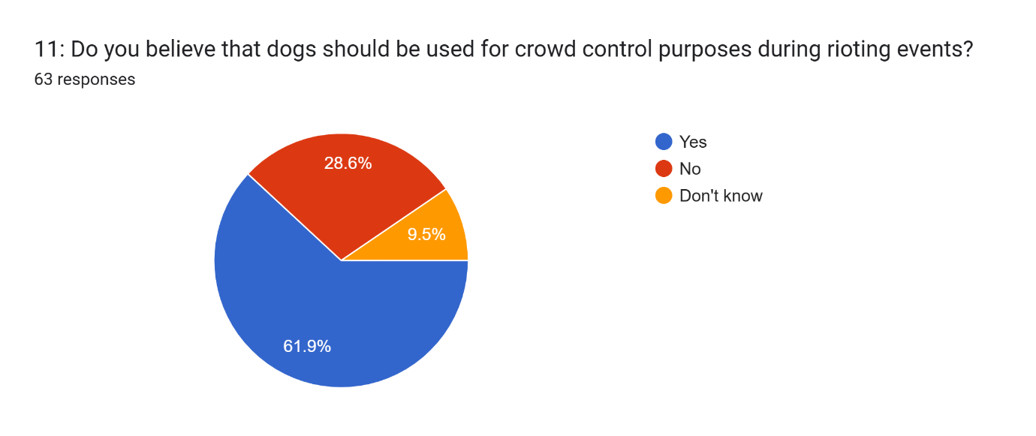

Appendix D

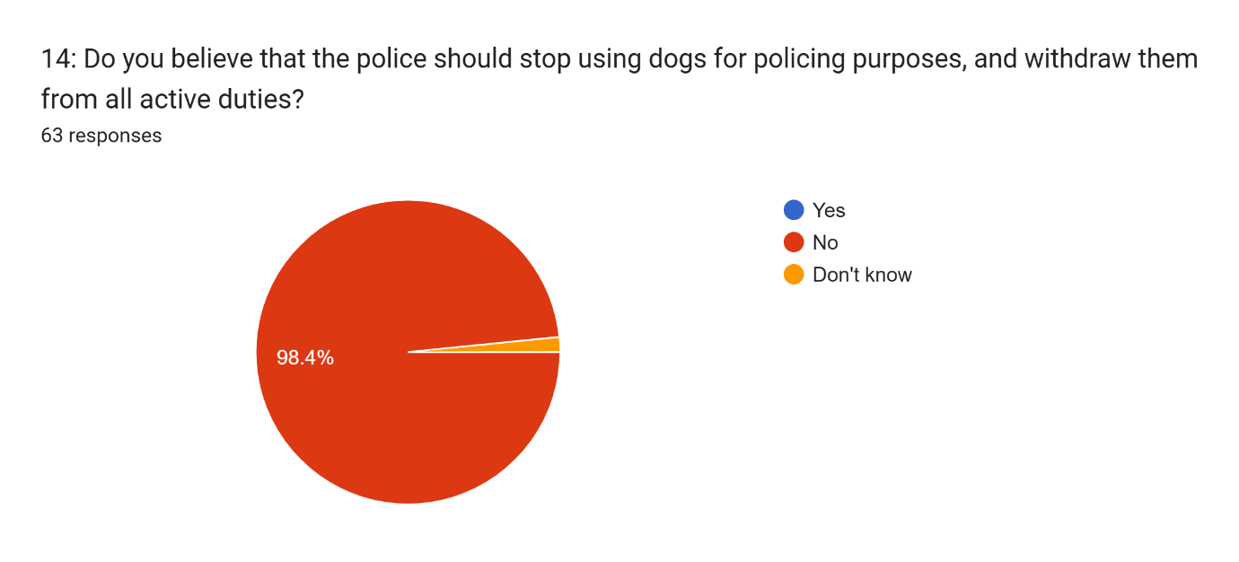

Appendix E

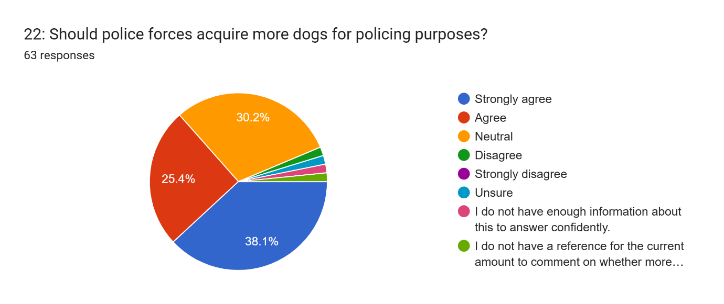

Bibliography:

Crispino, F., Ferry, B., Gansloßer, U., Hohlfeld, N.M., Osterkamp, T., and Woidtke, L. (2023) ‘The use of mantrailing dogs in police and judicial context, future directions, limits and possibilities – A law review’, Forensic Science International: Synergy, 7, pp.1-17. Available at: https://doi.org/10.1016/j.fsisyn.2023.100439 (Accessed: 13 October 2024).
Hoyt, M. (2024) ‘Police Dogs: A Useful Tool or Expensive legal nightmare’, Themis: Research Journal of Justice Studies and Forensic Science, 12(1), pp. 1-22. Available at: https://scholarworks.sjsu.edu/cgi/viewcontent.cgi?article=1130&context=themis (Accessed: 4 October 2024).
National Police Chiefs Council (NPCC) (2023) Public consultation on NPCC Police Dog Standard. Available at: https://news.npcc.police.uk/releases/public-consultation-on-npcc-police-dog-standard#:~:text=Police%20dogs%20play%20a%20vital%20role%20in%20keeping,best%20care%20to%20every%20single%20one%20of%20them. (Accessed: 12 October 2024).
Sachkova, M. (2024) Injuries and Deaths: It’s Time to End the Use of Dogs in policing. Available at: https://www.peta.org.uk/blog/dogs-policing/ (Accessed: 20 October 2024).
Weng, M.L. (2024) ‘What is Qualitative Research? An Overview and Guidelines’, Australasian Marketing Journal 0(0), pp.1-31. Available at: https://journals.sagepub.com/doi/epdf/10.1177/14413582241264619 (Accessed: 8th December 2024).

References:

Crispino, F., Ferry, B., Gansloßer, U., Hohlfeld, N.M., Osterkamp, T., and Woidtke, L. (2023) ‘The use of mantrailing dogs in police and judicial context, future directions, limits and possibilities – A law review’, Forensic Science International: Synergy, 7, pp.1-17. Available at: https://doi.org/10.1016/j.fsisyn.2023.100439 (Accessed: 13 October 2024).
Hoyt, M. (2024) ‘Police Dogs: A Useful Tool or Expensive legal nightmare’, Themis: Research Journal of Justice Studies and Forensic Science, 12(1), pp. 1-22. Available at: https://scholarworks.sjsu.edu/cgi/viewcontent.cgi?article=1130&context=themis (Accessed: 4 October 2024).
National Police Chiefs Council (NPCC) (2023) Public consultation on NPCC Police Dog Standard. Available at: https://news.npcc.police.uk/releases/public-consultation-on-npcc-police-dog-standard#:~:text=Police%20dogs%20play%20a%20vital%20role%20in%20keeping,best%20care%20to%20every%20single%20one%20of%20them. (Accessed: 12 October 2024).
Sachkova, M. (2024) Injuries and Deaths: It’s Time to End the Use of Dogs in policing. Available at: https://www.peta.org.uk/blog/dogs-policing/ (Accessed: 20 October 2024).
Weng, M.L. (2024) ‘What is Qualitative Research? An Overview and Guidelines’, Australasian Marketing Journal 0(0), pp.1-31. Available at: https://journals.sagepub.com/doi/epdf/10.1177/14413582241264619 (Accessed: 8th December 2024).

