Jolene Mann
Student no: 2011697
OPERATIONAL LEADERSHIP IN MODERN POLICING

OPERATIONAL LEADERSHIP

(BMPO 7001)

Contents

1. Introduction 1
2. Reflective journal 2
2.1 Description 3
2.2 Feelings 26
2.3 Evaluation 28
2.4 Analysis 29
2.5 Conclusion 33
2.6 Action plan 34
References 35

Introduction

Despite there being decades of research into leadership, the literature is still ‘vast and bewildering’ (Yukl, 2010 pg. 30), yet, what is consistent is that Leadership is multifaceted and requires constant reflection, adaption and action (Roe, 2017). This paper will reflect on a leadership challenge I have experienced as a Police Chief Inspector.
The landscape of policing has become increasingly complex with new strategic threats and challenges that are fast-moving, knotty and difficult to address, such as increasing migration, rapid technological advances and international organised crime (FOE, 2020). In this context, policing is critically dependent on the development and welfare of its people and changes to culture and leadership are vital if policing is to transform at the pace required to meet the future challenges (NPCC, 2016).

Reflective journal

Hereafter, I apply the Gibbs (1988) Reflective Model to a leadership challenge I have experienced (Figure 1).
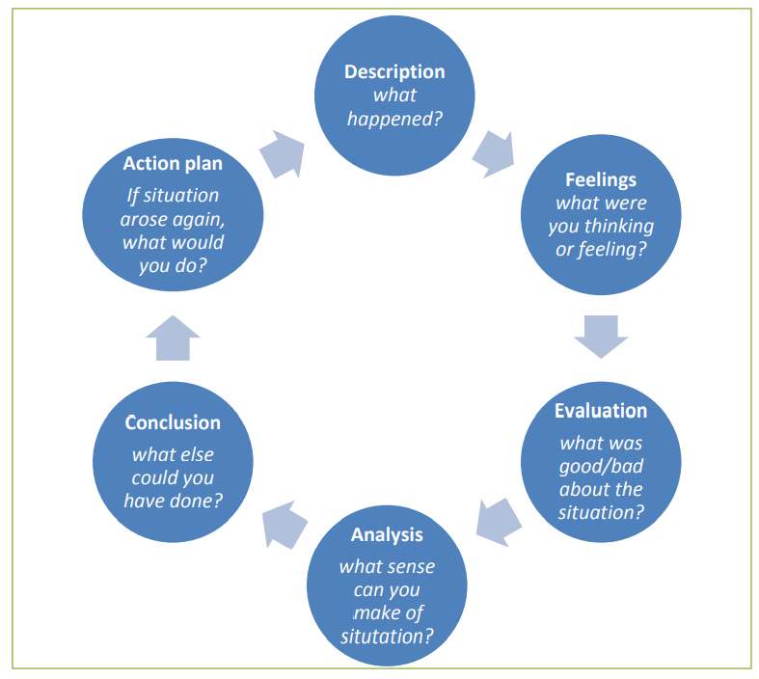
Figure 1 GIBBS Model (Dye, 2011 pg. 230)

Description

Dyfed-Powys Police were providing an unacceptable level of service to Victims of crime, the force were graded 32nd of 43 forces across England and Wales in a Victim Survey (ORS, 2016). This meant, Victims were being let down and were not being adequately safeguarded. I was tasked by Chief Officers to lead a four-month change programme to improve performance and compliance with legislative requirements of the Victims Code of Practice (VCOP).
The success of the programme and my effectiveness as a leader relied heavily on my ability to attend to three separate, but crucially interconnected areas of need, namely achieving the task, building and maintaining the team and motivating and developing individuals (Adair, 2006) (Figure 2).
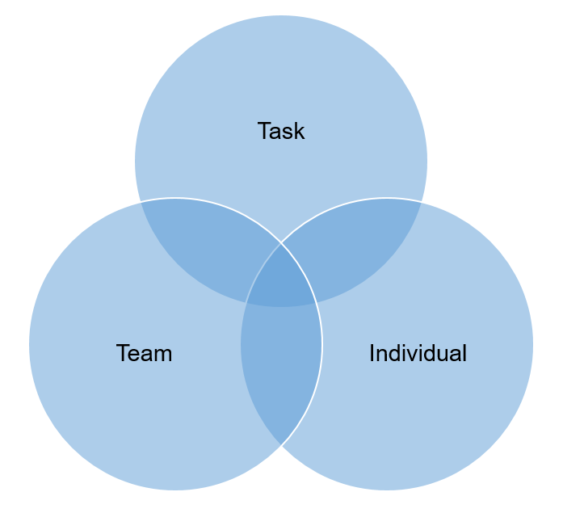
Figure 2 Action-centred leadership (Adair, 1973).

To achieve the task, I drew on a change model outlined by (Kotter, 1995), (Figure 3). This was a task-and-finish programme of work, promptly I ‘formed a guiding coalition’ by selecting individuals for the implementation team that had expertise and influence to make change happen. The personnel comprised individuals from different business areas including, Continuous Improvement, Information Technology and externally, Victim Support Services and the Crown Prosecution Service (CPS).
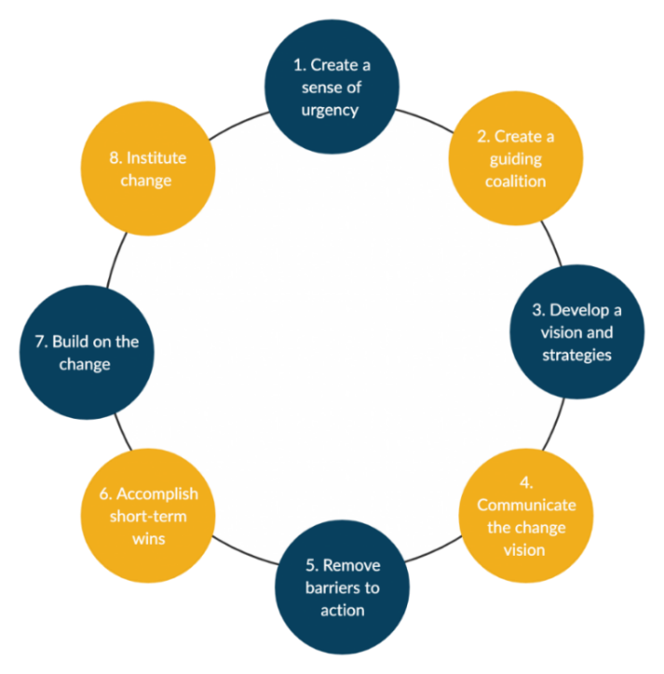
Figure 3 Change Model (Kotter, 1995).

The team were newly formed and individuals felt anxious as they lacked purpose and direction. An important and non-urgent priority (Covey, 2017) was for me to focus on developing the team and the individuals, more so than on the task itself, as this would enable me to build trust and mutual respect.
Clutterbucks research (1999) supports this concept, it is fundamental to team development to have a range of different characteristics and it is pivotal for all to get to know one another and to understand how they can best work together (Figure 4).
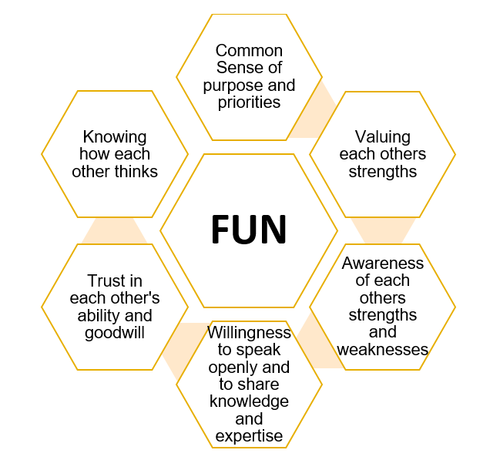
Figure 4 Team Model (Clutterbuck, 1999)

Supporting evidence appears in Adair (1973), successful leaders understand their team as individuals, they get to know their personalities, skills, strengths and expectations. In this context, Belbin (1993) says a successful team includes individuals with a full compliment of roles and success does not depend on a team of the most talented individuals, but on a mix of people with different skills and experiences. For ‘no individual can possess all the qualities needed of a good leader, but a team of individuals can’ (Belbin, 2010 pg. 9).

With this in mind, I organised speed-dating engagement activities, the team were allocated 30-minutes on a one-to-one basis to find out about each others interests, career-experiences, strengths and areas of development. This enabled working relationships to form and encouraged group transparency and trust.
To strengthen this approach, I drew on Bass and Avolio’s (1990) concept of ‘Individualised considerations’ and I met the team on a one-to-one basis.
This assisted me to get to know them individually and I identified character traits, motivators, strengths and weaknesses. Furthermore, I gave praise and I showed genuine recognition for individual contributions, commitment and goodwork and I followed this up, with written feedback in their Development and Assessment Profiles. The one-to-ones also aided me to satisfy individuals expectations in line with Maslows hierarchy of needs (Mullins, 2019).
For instance, as below-mentioned. I identified a physiological need for an indivdiual who had hearing difficulties and this was having detrimental impact on her being able to deliver some tasks, including Victim Satisfaction Surveys. The individual felt anxious and unhappy. I put measures in place and I arranged for her to have an adapted telephone. This helped the individual feel safe and it encouraged self-worth and belonging. During our one-to-one meetings I gave recognition and praise for her good work and I empowered her to have autonomy over tasks, thus encouraged her to seek new learning opportunities and to grow.
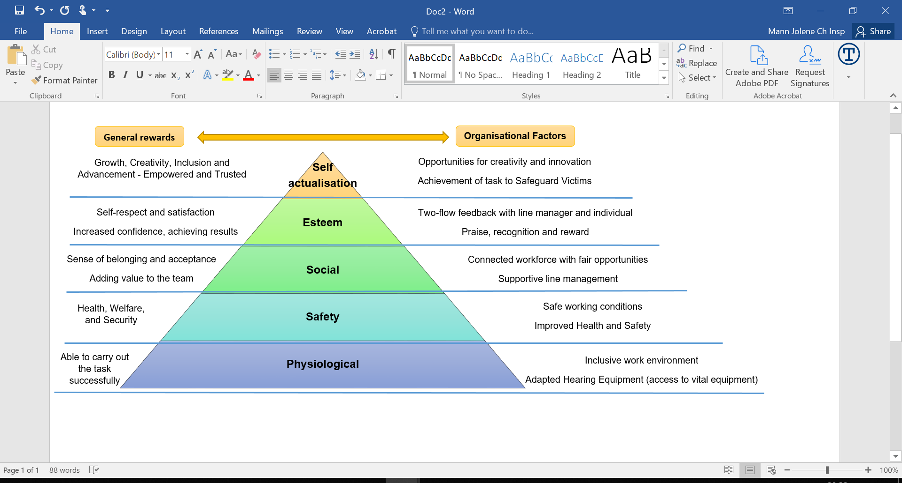
Futhermore, I saw the team one-to-ones as an opportunity to uncover my unknowns and to seek honest feedback on my performance. According to Mullins (2019) we all have behaviour traits that are known to ourselves and not others.
Johari’s window explores this concept further, we all have hidden behaviours we conceal from others and we all have a blind area, where a behaviour is known to others but remains unknown to oneself, for example mannerisms (Mullins, 2019).
In this context, I am cognisant of the impact I have on others and drawing on the Betari Box (2020) Model, I considered how my attitude and behaviours, affected the attitude and behaviours of others. An individual gave me feedback, my daily team progress meetings, were intrusive, my tone was condescending and I was micro-managing their progress. This was unknown to me, my intentions were well intended, yet my behaviour was affecting morale.
Acting on feedback, I moved to holding twice-weekly high-level progress update meetings and I made a concious effort not to delve into the detail.
I was cognisant of the perceptions and underlying predispositions I had towards individuals in the team and the impact on my decision-making. For instance, one individual appeared to lack commitment, I formed this assumption because they were quiet and non-engaging.
This assumption was based on my unconscious personality traits, highlighted in an insights survey (HDS, 2019). According to Hogan (2018), dark-side personalities emerge in times of increased pressure. The findings demonstrate when I am not monitoring my behaviour, I am at high-risk of being sceptical, scoring 90%, signifying I am on high alert for duplicity and it takes me time to trust others motives. Likewise I am highly diligent, scoring 98% but this can result in me micromanaging others.
Likewise, I have undertaken a Myers-Briggs (1962) assessment, the results demonstrate I have a preference for Extraversion, Sensing, Thinking and Judgement. My strengths include being organised, I am detail orientated and I expect very high standards, yet this can result in me setting unrealistic goals for those I lead and I have a tendency to prioritise everything as equally important. My weaknesses show I favour overtly motivated individuals and people who appear to over procrastinate decisions make me feel frustrated (MBTI, 2016).

Drawning on McGregors (1960) theory X concept, I had taken a pessimistic view and had made assumptions towards the individual, believeing they were unmotivated and lazy, without any evidence to base my assumptions on. I believed I needed to closely supervise this indiviual and to micro-manage their activities and I was authoritarian over their tasks.
Consequently, I established the individual was neither lazy or disinterested, to the contary, they were competent but lacked organisational knowledge to complete the task of mapping out the Victims journey from start-to-finish. The indivdiual was new to the organisation and had a limited knowledge of force procedures. To provide support, I arranged for the individual to have a mentor. Consequently the individual gained confidence and successfully completed the task. On reflection I acknowledge by adopting a theory X approach, my style had a detrimental impact on the individual, that had subsequently hindered their morale and performance.
These reflections have enabled me to be very honest, in terms of recognising and addressing my motivations and areas of development. Consequently, I apply the Covey (2017) prioritisation matrix (Figure 5), to plan and prioritise my objectives and I relate to this model in my reflections.
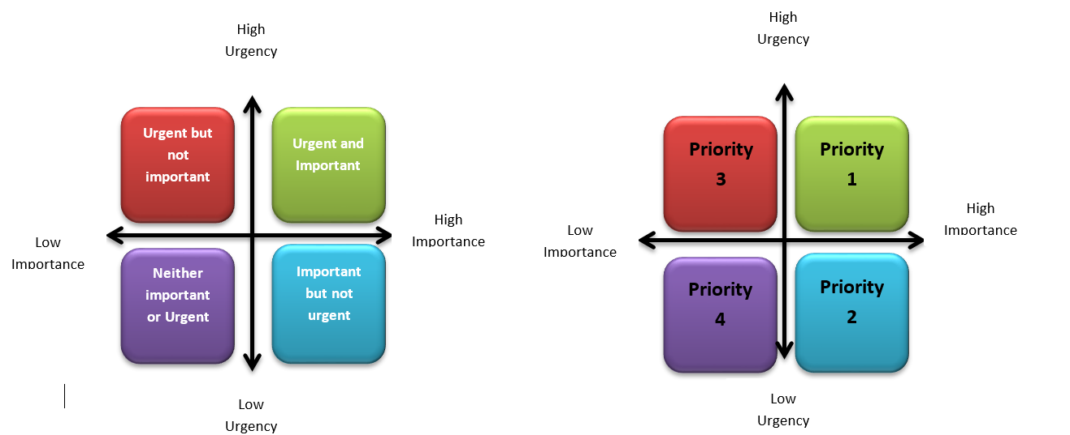
Figure 5 Prioritisation Matrix (Covey, 2017)

Furthermore, the one-to-one discussions assisted me to unleash potential and identify team roles. In this context, Belbin (1993) says, the strongest teams have diversity of skills and character.
Drawing on Belbin’s (1993) model (Figure 6), I identified an individual was a ‘resource investigator’, they had fantastic networking skills, I tasked this individual to coordinate consultation workshops with key stakeholders, including the Independent Advisory Group (IAG), Criminal Justice Department (CJD), CPS and front-line Officers and Detectives. I was cognisant this indivdiual had tendencies to become pre-occupied, so it was key for me to ensure they remained interested in their tasks.
Another individual was a ‘monitor evaluator’, they had fantastic analytical skills, but quickly got lost in detail and failed to meet deadlines. Cognisant of the individuals strengths, I tasked him to plot overall progress.
To support the individual I encouraged the use of a project management chart (Gantt, 2021) to align tasks against a delivery timeline.
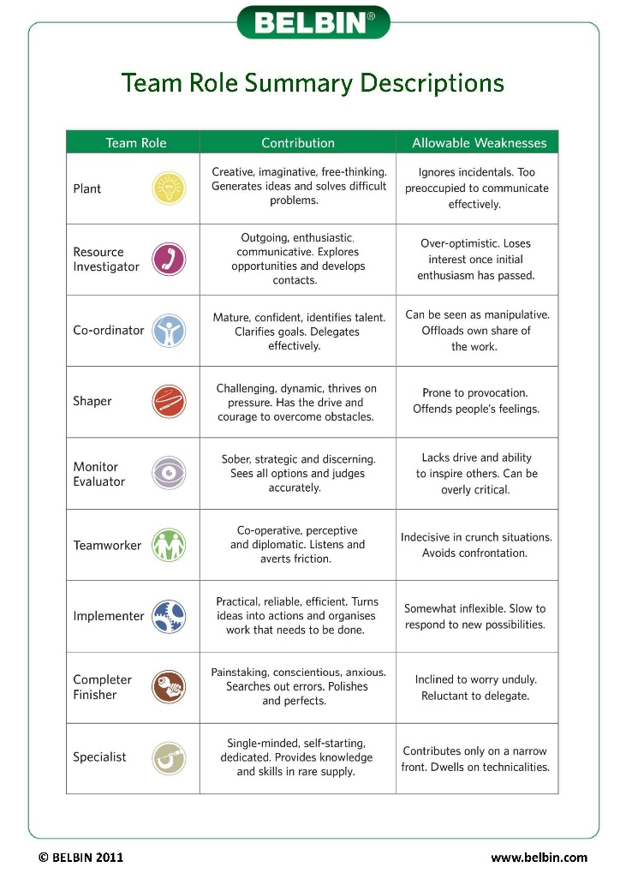
Figure 6 Team Roles (Belbin, 2021)

To guide and develop the team I applied a phase-based change model (Tuckman and Jensen, 1977) (Figure 7). I ‘created a sense of urgency’ (Kotter, 1995) to inspire and win over the hearts-and-minds of the team and stakeholders and to ensure they fully understood the need for change. I defined the task through honest communications, outlining that victims were being let down and we all had a duty to safeguard the vulnerable. I cited raw feedback from Victims and factual evidence identified in crimes where Victims had received a poor level of service, including a high-risk victim of domestic abuse.
I drew on the concept of ‘Inspirational motivation’ (Bass and Avolio, 1990) and asked individuals to consider how they would like their loved ones to be treated, this drove commitment and intrinsically encouraged individuals to deliver the best possible service.
To support team development and to achieve the task, an important and urgent priority (Covey, 2017) was for me to ‘develop the vision and strategies’ (Kotter, 1995). I created a project delivery plan and I established individual responsiblities, I defined tasks, I set realistic aims and targets, I outlined the standards expected and I defined the monitoring and evaluation arrangements. Futhermore, I specified the governance arrangements and reporting parameters. I set up a task-and-finish group that met monthly to monitor progress. To ensure strategic buy-in, the group was chaired by the Assistant Chief Constable, this enabled me to hold Heads of Department and external partners including the CPS to account for delivery.
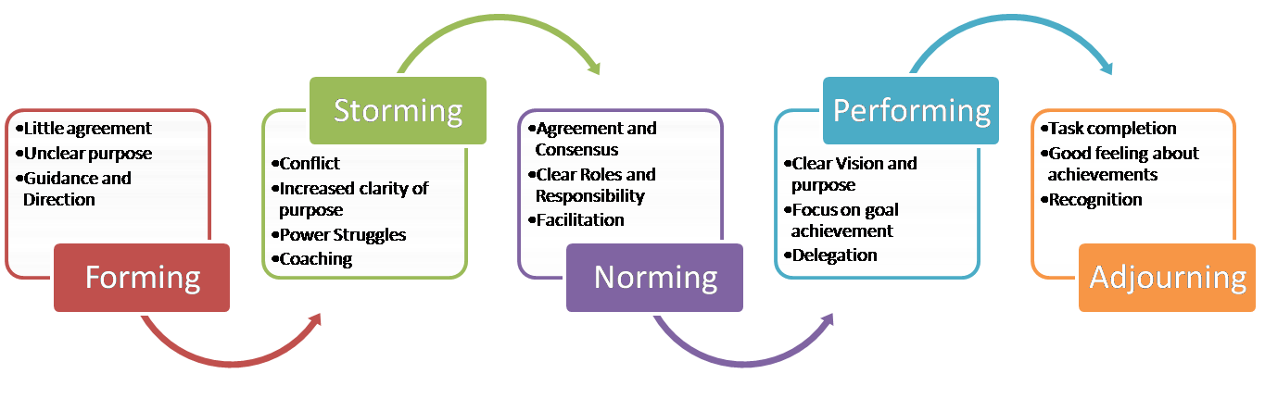
Figure 7 Phase-based Model (Tuckman and Jensen, 1977)

To support with the ‘forming’ of the team, I ‘communicated the change vision’ (Kotter, 1995) and I ensured every team member had clarity of the need for change - put simply, we could not continue letting Victims down.
The team were highly experienced, yet there were varying degrees of commitment and many had competing ideas and suggestions and power-struggles started to emerge during the ‘storming’ phase, with individuals challenging one-another’s ideas and perspectives, likewise I received challenge as the leader, over decisions I had made.
For instance, I decided on the wording for the revised Victims of Crime Leaflet and drawing on Tannenbaum and Schmidt’s (1958) model, I ‘consulted’ with stakeholders before making a final decision.

In doing so, I received challenge from an Officer that I had not considered the views of under-represented groups and the terminology was not inclusive. I respected the Officers observations and I sought the views of the IAG and in doing so, I gained wider perspectives and I revised my initial decision.
In this context, Heffernan (2012) says, when people have the moral courage to break silence and challenge thinking, conflict is created and this enables leaders and others to do their very best thinking.
Supporting evidence appears in research by Police Professional (2020), which prompts policing to adopt the principles of ‘Servant Leadership’, a model introduced in the 1970s (Greenleaf, 1977), where the leader is more service-orientated rather than power-driven and places greater focus on respecting the views of subordinates and bringing out the best in others.
The Servant leadership Model is transformational, leaders focus on the people and the task (Harvard Business School, 2006) and its closely aligned to the Police Code of Ethics (COP , 2014), which promotes self-awareness, to empower everyone in policing to do the right thing and to confidently challenge colleagues irrespective of rank or position.

Martin et al. (2017) and (Spears, 2009) agree with this notion, ‘Servant Leadership’ offers a dramatic change to traditional models of police leadership as it creates an inclusive culture where teams thrive in decision-making and says police leaders need to be open-minded to the fact, that despite their wealth of experience, there will be occassions where they do not have all the answers and in a complex policing landscape, the views of others below them in rank or position are critical in making decisions.
To understand Victim needs I met with a selection of Victims’ and I encouraged them to be honest about their experiences. Largely, Victims’ were disappointed at the lack of updates and that their individual needs had not been considered. For instance, a vulnerable Victim had been exploited by an organised crime group. The Victim was living in fear of repercussions and police had failed to refer him to Victim Support Services. Consequently, he lacked trust and confidence in the police and withdrew support for a prosecution.
The team analysed findings from stakeholder consultation workshops and identified a number of barriers inhibiting performance. For instance, the Crime Management System (CMS), used by Officers to record their Victim and crime investigation updates was out-dated, clunky and bureaucratic. Officers were failing to comply with the most basic principles of Victim care – Victims were not being consistently referred to support services and Officers were failing to give Victim of Crime Leaflets, both of which are legislated requirements.
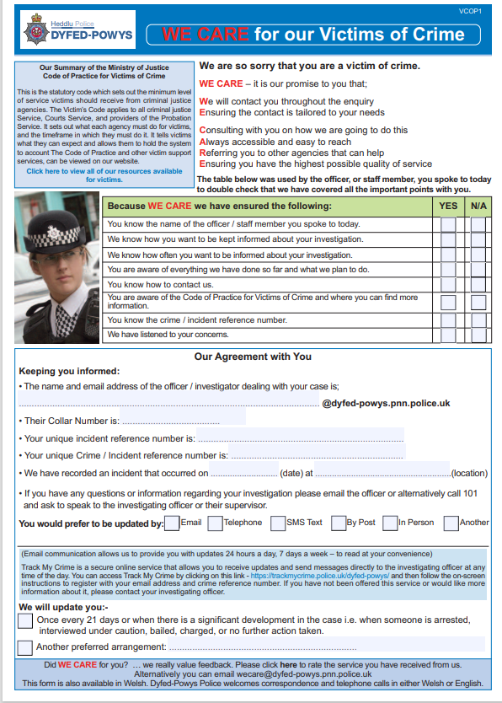
An individual in the team put forward a suggestion of creating an electronic Victim of Crime Leaflet for Officers to complete on their Mobile Data Terminals.
On Officers inputting the Victims email address and/or mobile number onto the crime report, the leaflet would be automatically sent to the Victim and stamped onto the CMS, to verify receipt and to evidence VCOP compliance.

Conversely, criticism was received from stakeholders that this it would offer a preferential level of service to Victims that have an email address and/or mobile number and it would discriminate against those that don’t have the same level of access. I was open to views and suggestions and after discussions a mutually beneficial solution was agreed. This saw the introduction of electronic ‘We Care’ leaflets being introduced, which automatically prompted the sending of a postal card when an email or mobile number were not detailed.
Successfully, ‘barriers were removed’ (Kotter, 1995) and VCOP compliance improved, rising from 62% to 94%, thus accomplishing a ‘short-term win’ (Kotter, 1995) for the team and the improvements were recognised by Chief Officers.
It was my role as the leader, to be directive and to coach and guide the team through this unsettled phase and to facilitate harmony and compromise to ensure the team remained focused on the task and to prevent the team becoming distracted by conflict. I assumed Hersey, Blanchard and Johnson (2008) situational leadership model (Figure 8), where initially I adopted a ‘directing’ approach.
I held daily progress meetings with the team and I gave descriptive guidance over the tasks and I maintained close supervision to ensure progress. I had presumed the team were unable to perform the task and I made decisions and I told the team what to do. In this context, Tannenbaum and Schmidt, (1958) say, by ‘telling’ people what to do, the leader does not maximise the knowledge and talents of people in the team.
As I got to know the team, my attitude changed and trust was built. I then adopted a ‘coaching’ approach, the team were willing, but occasionally they were unsure of the task and my expectations. I took time to provide clarity and when required I arranged training and I provided team developmental opportunities, for instance I recognised an individual lacked confidence using a performance data system, rather than single this person out, I arranged for the team to receive an input to strengthen everyone’s knowledge. In this context, I drew on the concept of ‘Idealised Influence’ (Bass and Avolio, 1990) where I ensured all individuals felt a sense of belonging and had a fair and equal opportunity to be involved in discussions and training inputs.
The team started to become more energised and motivated, as they had a clear understanding of the task and an acceptance of their roles.
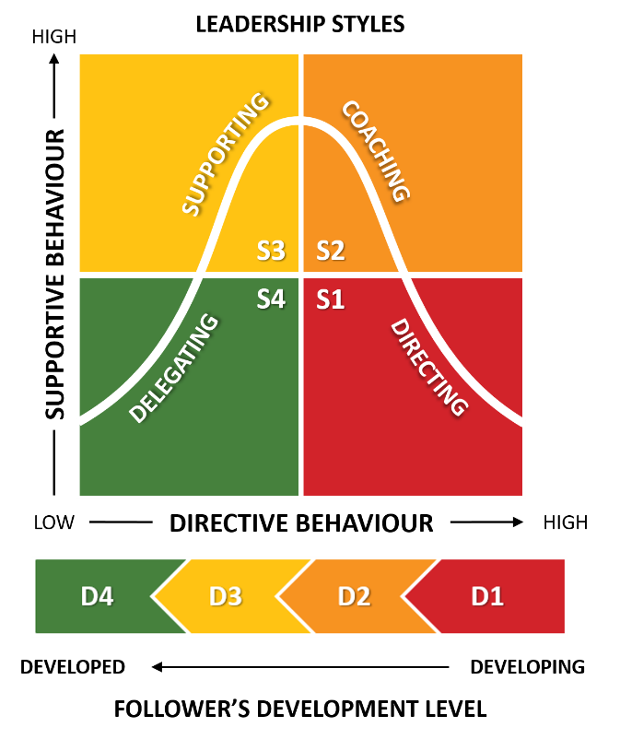
Figure 8. Leadership Styles (Hersey et al., 2008; B2U, 2020)

According to Blake and Mouton (1964) there are two drivers for leadership behaviour, one is task-focused, with more concern shown for getting the job done and the second, is people focused, with more concern shown for building relationships. They argue, if the leader has more concern for the task, it can lead to conflict and adversely effect performance, yet if the pendulum swings and the leader, is more relationship focused, they avoid conflict, which is equally detrimental to the achievement of objectives.

With this in mind, it was key for me to adopt a balanced team management approach in line with Blake and Mouton’s (1964) framework (Figure 9), where I showed equally high concern to my team and the task. This approach helped me embolden teamwork and relied heavily on my ability to make individuals feel valued and to recognise the contributions they made to the achievement of objectives (Roe, 2017).
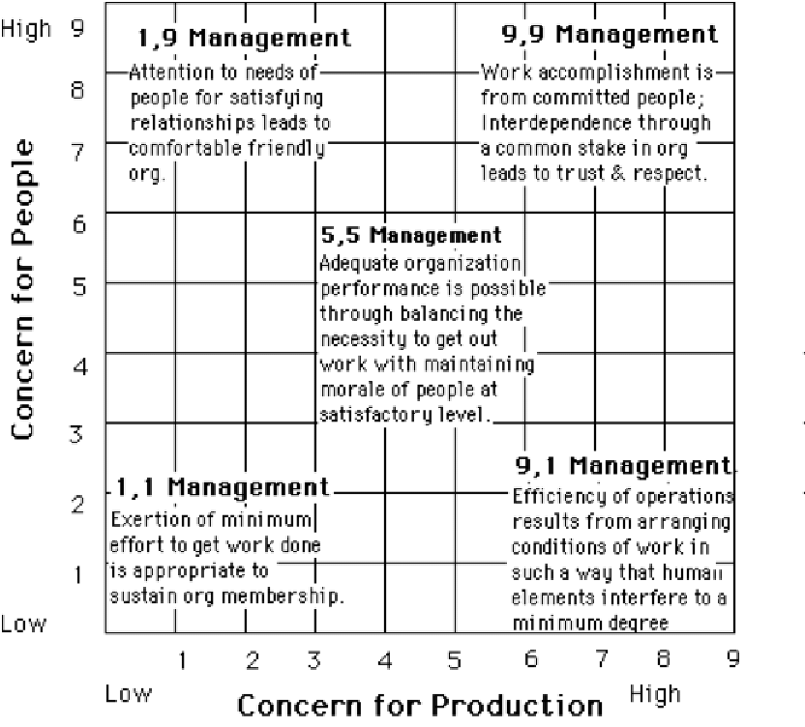
Figure 9. Leadership grid (Blake and Mouton, 1964; ResearchGate, 2021a)

During the ‘norming’ phase (Tuckman and Jensen, 1977), I adopted a ‘supporting’ approach (Hersey et al. (2008), in line with theory Y assumptions (McGregor, 1960). I was optimistic and I trusted the team to have greater responsibility over tasks.

As a result, I inspired self-generated action and exciting innovative ideas started to emerge. For instance, to capture force-wide ideas, a team member developed an electronic idea-drop system, thus enabled every single person to express their views.
The team started forming relationships with external stakeholders and began to use autonomy to resolve problems, this saw a team identity emerge, which later became the force branding of ‘We Care’. Drawing on the concept of ‘Intellectual stimulation’ (Bass and Avolio, 1990), I proudly created a diverse and open environment which encouraged individuals to innovate and form new ideas. For example, an individual of their own volition developed a quick response code to scope live-time Victim feedback.
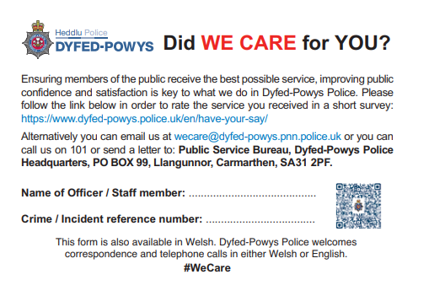

The team used their success, to make group decisions which included the development of a new all-encompassing Victim Support Service and an improved Force-wide training programme.
As the team grew in confidence, I gave them power and freedom to become more autonomous in their decision-making and I adopted a ‘delegating’ style (Hersey et al., 2008), yet I continued to observe and monitor progress from afar to offer support. This approach, enabled me to draw on theory Y (McGregor, 1960) assumptions, where I empowered individuals to have self-belief, responsibility and self-direction over tasks and decision-making.
Consequently, the team were ‘performing’ (Tuckman and Jensen, 1977) with a shared vision, they understood the improvements that needed to be made and when uncertainty arose, I reinforced the purpose of the task – to ‘Improve services for Victims and to safeguard the Vulnerable’, this helped give the team direction and to make the right decisions. I agreed the scope of the team’s decision-making responsibilities and I provided them with space to think for themselves and achieve goals and objectives.
According to Marquet (2017), successful leaders create an environment where teams have ability to think independently and they act without being told what to do. In this context, an indivdiual asked me to specify what questions needed to be incorporated in the Victim Support Services telephone risk-assessment for Victims of domestic abuse. I reframed from providing the answer and encouraged the individual to think for themselves.
I signposted the individual to identify national best practice and to engage with partner agencies and key-stakeholders, such as Independent Domesic Abuse Advisors for their views. Consequently, with minimal input from myself, the individual developed an improved risk-assessment that fully incorporated safeguarding.
When adopting this approch, I was cognisant of the continuum leadership styles, specified by Tannenbaum and Schmidt (1958). The model demonstrates the relationship between the level of authority the leader uses and the freedom given to the team. At one end of the continuum are leaders who make all the decisions. At the other end are leaders who are hands off and individuals make the decisions.
My leadership style moved along the continuum dependent on the decisions being made, in the main, I had a tendency to ‘consult, join and delegate’ (Figure 10).
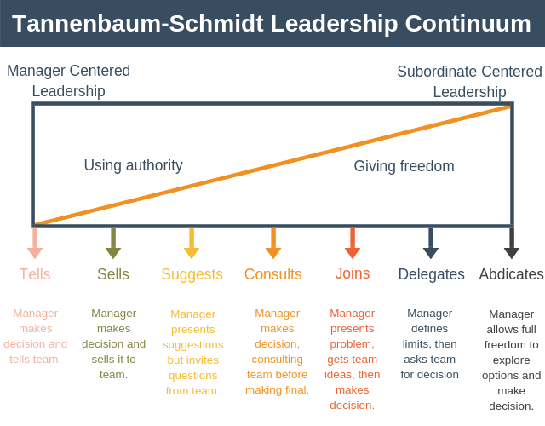
Figure 10 Leadership Continuum (EPM, 2021)

When deciding on the most appropriate style to adopt, I considered Tannenbaum and Schmidt’s corresponding forces (1958) (Figure 11), which enabled me to consider my traits as a leader, the situation and the team.
When considering individual forces, I was cognisant of the findings of my personality survey (HDS, 2019), I lack trust in others and could result in me making unfair judgements on an individuals skills and competence and I was observant that this could have a bearing on the degree of freedom I gave to individuals.
When considering situational forces, I was cognisant to the fact I was working to time constraints and I was cautious to ensure this did not have a detrimental impact on me delegating tasks, as the time pressures began to mount.
Furthermore, when considering Individuals, I was cognisant of their development and the importance of enabling them to have independence and responsiblities, yet I remained alert whilst some members of the team relished with freedom, others prefered to work to firm guidance and boundaries.
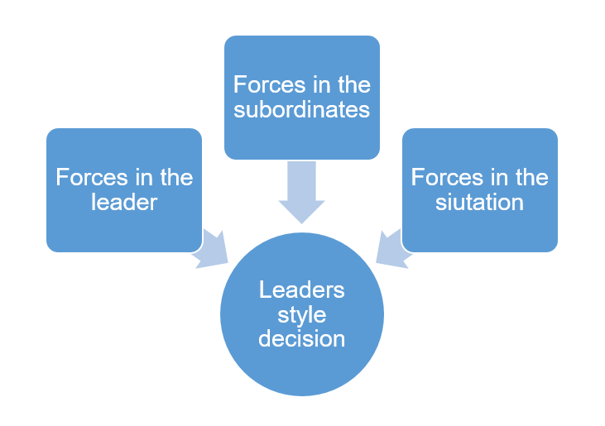
Figure 11 Tannenbaum and Schmidt’s (1958) Forces.

2.2 Feelings

As a senior Officer leading on a force-wide change programme, I felt exposed as others were looking at me to make decisions. As a perfectionist, I felt frustrated and constrained by the timeframe and I was anxious I could not be as meticulous as I preferred.
I was met with resistance from key stakeholders including the Head of CJD and front-line response Officers and Detectives, this made me feel hypersensitive, as I took the criticism personally. However, when reflecting I acknowledge during programmes of change, individuals need time to adjust and it’s only natural for individuals to experience different emotions. To manage the situation, I considered Kübler-Ross’ (1969) (Figure 12) transition curve. This enabled me to understand the different stages individuals experience when they encounter change.
It became evident to me, the Head of CJD, felt threatened I was reviewing and re-designing an aspect of her business area, namely, Victim Support Services and she became frustrated and destructive, putting up unnecessary barriers that prevented the team having access to systems and data. I established she felt the review was a personal slur on her team’s performance. This tested my resolve and through persistence and open dialogue, I sought to ‘remove the barriers to action’ (Kotter, 1995).

Initially during the heated discussions, I felt flustered because the Head of CJD is a powerful individual with an intimidating persona. I remained calm and focused on the achievement of the task and through honest interactions we explored the new proposals in greater detail and I provided an evidence-based rationale for the changes being introduced.
Consequently there was an acceptance of the changes proposed and positive agreements were made for a resource to join the project team from CJD to offer additional expertise. Once all had been resolved, I felt relieved and if I was faced with a similar situation in the future, I would ensure early engagement and consultation with key Heads of Department, to sight them on the task and to seek their early-buy in.
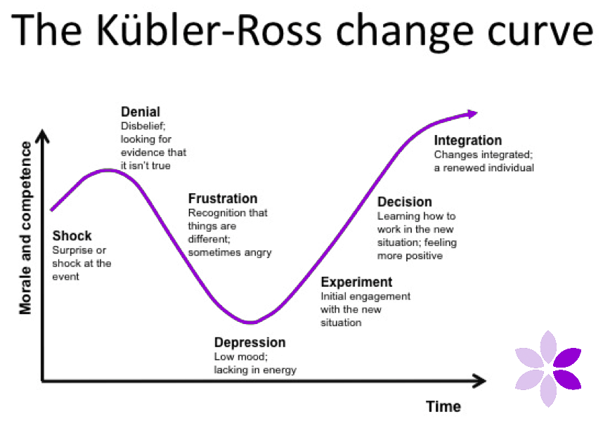
Figure 12. Transition Curve (Kübler-Ross,1969; Crocus, 2021)

2.3 Evaluation

Overall I feel the experience went well. At the conclusion I submitted a report to Chief Officers, outlining fifty-seven recommendations and changes to improve services for Victims and to provide wider safeguarding, all of which were implemented in short succession.
Upon implementation of the task, the team were disassembled under the ‘adjourning’ phase (Tuckman and Jensen, 1977) and I along with the team felt frustrated that time had not been allowed to embed the changes and there were feelings of detachment, as individuals returned to their previous roles, some described it to feel like an anti-climax, as their day jobs were less challenging and more repetitive.
I made contact with each individual’s line-manager to formally recognise their good work and to ensure they were fully integrated and supported back into their roles. I felt proud that as a team we had made a positive difference to services being provided to Victims. Consequently, the force moved from 32nd to 17th for overall experience and overall complaints were reduced.

2.4 Analysis

In analysing the negatives, Kotter (1995) argues, the key to embedding change, is to ‘institutionalise the change’, to make it stick and to then monitor its effectiveness. However, in this instance the programmes sustainability failed, because Chief Officers had made a decision to disband the team as soon as the recommendations had been implemented, this resulted in there being no central oversight or ownership and momentum was lost with many of the changes not being fully integrated and there was no subsequent benefits realisation or evaluation.
Furthermore, the time for delivery constraint was a hindrance. I acted in haste to form an implementation team and I rushed stakeholder consultations, however on reflection, a full scoping exercise would have captured the perspectives and of all and this would have negated the initial frustrations felt by the Head of CJD and others. In this context, Brookfield’s (1995) Critical Lenses Model says, successful leaders learn by reflecting on a range of perspectives, from colleagues, peers and followers.
This experience has taught me the significance of taking time to step-back and consider my leadership responsibilities to ensure I have paid equal regard to competing demands. In this regard, Adair (2006) says, equal regard must be paid to the team, the individual and the task. For if leaders prioritise the task at the expense of the team and the individual then failure is inevitable. Likewise, if the leader focuses more on the team and the individual and overlooks providing clear direction to achieve the task, progress will be inadequate and again, failure is inevitable.
In evaluating the positives, the team’s success was borne from the fact, I had adopted Kotters’ (1995) principle of ‘creating a guiding coalition’, where I had enthusiastically brought together a group of individuals based on their skills to complete the task and not on their personalities or loyalties to me as a leader. Consequently, I had created a team of energised individuals that were leaders in their own right. They were deeply passionate about their areas of expertise and they were not afraid to speak up and express their views. This did result in conflict but looking back the debates were healthy and helped the brainstorming of ideas. In this context, Heffernan (2012) says, when leaders surround themselves with others that think differently and have different experiences it enables greater thinking and argues, leaders need to surround themselves with thinking partners who are not echo chambers, the type of people that say the unsayable, challenge thinking and decision-making and not simply act as passive observers. When people are too afraid to disagree, it is dangerous to operational efficency, especially in the context of managing risk in a critical incident.
Throughout this experience, I assumed a Transformational style of leadership, putting the task and people first, whilst acting in line with the principles of servant leadership, where I fostered team trust and respect. I feel by adopting this approach, I got the best out of people. Aforementioned in my reflections, I relate to the Four I’s of Transformational leadership outlined in the Full Range Leadership Model (Figure 13).

In this context, Bass and Riggio (2006 pg. 3) say, transformational leaders ‘stimulate and inspire followers to achieve extraordinary outcomes’ and research supports this style has the most influence over performance (Diaz-Saenz, 2011) as individuals exert extra effort and have greater satisfaction (Russell, 2017).
According to Bass and Avolio (1990), leaders adopt either - transformational, transactional or laissez-faire styles, all of which are dependent on the situation and the needs of those they lead. In this context, Stogdill (1948), argues a leader in one situation, may not be the best leader in another situation and leaders should be elected dependent on the situation. In this context, I seamlessly adapt my style dependent on the situation, for instance as a Tactical Firearms Commander I mainly adopt a transactional style of leadership – where my main focus is on achieving the task, which ultimately is to save life, minimise risk to the public and to maximise safety to Officers and to do so, I convey clear instructions and directions and any failure by indivdiuals to comply can result in the breach of a lawful order.
In this context, Wong (2007) argues, command and control leadership no longer works, as leaders must earn trust from those they lead. Yet, to the contary Russell (2017) says, a transactional style is effective when operating in a crisis-orientated environment.
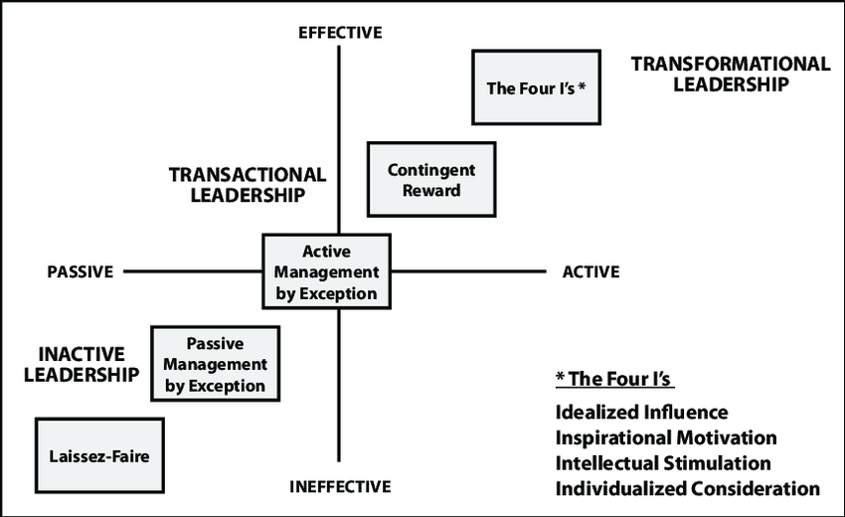
Figure 13 FRL Model (ResearchGate, 2021b)

This experience has taught me the significance of creating an environment where lower ranked Officers and police staff have the confidence and ability to challenge upwards and to put forward ideas. It was not a leadership weakness of mine to adjust my decisions, rather it was a leadership strength, as I had empowered others to generate suggestions.
The police service operates a quasi-military hierarchy structure. Historically, the predominant leadership style of policing has been authoritarian and directive (Russell, 2017). According to Fyfe et al. (1997) as a result of the historic militaristic formation of policing, a style of command and control had been adopted and consequently, presumptions had been incorrectly made that rank equated to good leadership. Martin et al. (2017), supports this notion, a leader centric-lense, promotes a culture where leaders are seen as authorative and powerful and subordinates, must follow and obey orders without question or challenge. This approach hampers modern policing as it can result in subordinates becoming withdrawn and hesitant to make contributions (Uhl-Bien et al., 2014).

2.5 Conclusion

In retrospect, if faced with a similar situation I would do things differently. I should have managed upwards and explained to Chief Officers the significance of allowing the ‘changes to be institutionalised’ (Kotter, 1995) and for me to retain longer-term oversight, to ensure the changes were being fully embedded into organisational culture and to facilitate an evaluation and for the benefits to be realised. Chief Officers, rightly deemed the changes to be part of core organisational day-to-day delivery, however, by completely removing my responsibilities, oversight and focus became lost and old force habits re-emerged.
Reflecting on my experience, I am delighted individuals had the confidence to challenge my decisions, yet I acknowledge the degree to which the workforce has confidence in challenging its leaders in a structure of hierarchy varies considerably (HMICFRS , 2018).
In this context King and Lawley (2016) say, whilst hierarchy is necessary in policing to ensure operational effectiveness, single leader success can be dangerous and at its worst catastrophic (Bones, 2011).
McChrystal et al. (2015) agree and say in a complex landscape, leadership must shift from a hierarchical structure with to one of a team-ethos where leaders of varied ranks and roles exist.

2.6 Action plan

Twelve-months after the conclusion of the project, I identified performance had declined and victims were again, receiving a poor level of service. I approached Chief Officers and sought their authorisation for me to ‘build on the change’ (Kotter, 1995) already generated and to lead on re-embedding momentum and focus, this was agreed.
I was confident the foundations had already been laid and further momentum would ensure a sustainable outcome. This enabled me to do things differently, this time, I retained the programme for eighteen-months and I continuously monitored and evaluated progress and performance.
In the future, when I am leading on a change programme, I will professionally manage upwards to seek longer-term commitment to embed culture, transformation and change and I will ensure, all stakeholders have an opportunity to express their views.

References
Adair, J., 1973. Action Centered Leadership. 1st ed. Aldershot : Gower.
Adair, J., 2006. Effective Leadership Development. London: Chartered Institute of Personnel and Development .
B2U, 2020. Business-to-you. [Online]
Available at: https://www.business-to-you.com/hersey-blanchard-situational-leadership-model/
[Accessed 11 June 2021].
Bass, B. M. and Avolio, B. J., 1990. The Implications of Transactional and Transformational Leadership for Individual, Team and Organizational Development. Research in Organizational Change and Development , Volume 4, pp. 231-272.
Belbin, 2021. Change and Transformation; Belbin Team Roles. [Online]
Available at: https://www.changeandtransformation.co.uk/2016/04/07/belbin-team-roles-personality-profiling/
[Accessed 10th June 2021].
Belbin, M., 1993. Team Roles at Work. Oxford: Butterworth-Heinemann .
Belbin, R. M., 2010. Management Teams; Why they succeed or fail. 3rd ed. Oxford: Elsevier Ltd .
Betaris Box, 2020. Mindtools. [Online]
Available at: https://www.mindtools.com/pages/article/newCS_82.htm
[Accessed 08 June 2021].
Blake, R. and Mouton, J. , 1964. The Managerial Grid; The Key to Leadership Excellence. 1st ed. Houston: Gulf Publishing.
Bones, C., 2011. The Cult of the Leader. 1st ed. Chichester: J. Wiley and Sons.
Brookfield, S., 1995. Becoming a critically reflective teacher. San-Francisco: Jossey-Bass.
Clutterbuck, D., 1999. Raising the Ante on Team Learning. Organisations and People , 6(4), pp. 2-8.
COP , 2014. College of Policing; Code of Ethics - a code of practice for the principles and standards of professional behaviour for the policing profession of England and Wales. [Online]
Available at: https://www.college.police.uk/ethics/code-of-ethics
[Accessed 25 May 2021].
Covey, S., 2017. The Seven Habits of Highly Effective People. 1st ed. London: Simon and Schuster Ltd.
Crocus, 2021. Crocus Coaching; Kübler-Ross Transition Curve. [Online]
Available at: https://crocuscoaching.co.uk/learning-models/the-change-curve1/
[Accessed 08 June 2021].
Diaz-Saenz, H., 2011. Transformational Leadership; in A. Bryman, D. Collinson, K. Grint, B. Jackson and M. Uhl-Bien; The Sage Handbook of Leadership. London: SAGE Publications .
Dye, V., 2011. Reflection, Reflection, Reflection. I'm thinking all the time, why do i need a theory or model of reflection . In: in McGregor, D. and Cartwright, L. (ed). Maidenhead: McGraw-Hill Education , pp. 217-234.
EPM, 2021. Expert Program Management; Tannenbaum-Schmidt Leadership Continuum. [Online]
Available at: https://expertprogrammanagement.com/2018/11/tannenbaum-schmidt-leadership-continuum/#:~:text=The%20advantages%20of%20the%20Tannenbaum-Schmidt%20Leadership%20Continuum%20include%3A,or%20reduce%20your%20team%E2%80%99s%20involvement%20in%20decision%20making.
[Accessed 10 June 2021].
FOE, 2020. Future Operating Environment 2040; Policing in England and Wales, Ryton: College of Policing.
Fyfe, J.J., Greene, J.R., Walsh, W.F., Wilson, O.W., and McLaren, R.C., , 1997. Police Administration. 5th Edition ed. New York: McGraw-Hill.
Gantt, 2021. Gantt.com. [Online]
Available at: https://www.gantt.com/
[Accessed 19 06 2021].
Gibbs, G., 1988. Learning by doing; A guide to teaching and learning methods; Gibbs Reflective Cycle; Further Education Unit. 1st ed. Oxford : Oxford Polytechnic .
Greenleaf, R., 1977. Servant Leadeship; A journey into the nature of legitimate power and greatness. 1st ed. New York: Paulist Press.
Harvard Business School, 2006. Leading People; Pocket Mentor. 1st ed. Boston: Harvard Business School Press .
HDS, 2019. Hogan Development Survey; Insight report for Jolene Mann, dated 12 February 2019, Oklahoma : Hogan .
Heffernan, M., 2012. Dare to disagree; TED Talk on Youtube, dated 06 August 2012 [video]. [Online]
Available at: https://www.youtube.com/watch?v=PY_kd46RfVE
[Accessed 25 May 2021].
Hersey, P. , Blanchard, K. H. and Johnson, D, E. , 2008. Mangagement of Organizational Behaviour: Leading Human Resources. 9th ed. New Jersey: Prentice-Hall.
HMICFRS , 2018. PEEL: Police Leadership; A National Overview; Her Majesty's Inspectorate of Constabulary and Fire and Rescue Service. [Online]
Available at: https://www.justiceinspectorates.gov.uk/hmicfrs/wp-content/uploads/peel-police-leadership-2017.pdf
[Accessed 24 May 2021].
Hogan, R., 2018. Robert Hogan on Personality Psychology, the dark side; youtube; Hoganassessments dated 18th February 2018. [Online]
Available at: https://www.youtube.com/watch?v=bSzhVTjGTP8
[Accessed 07 June 2021].
King, D. and Lawley, S., 2016. Organisational behaviour. 1st ed. Oxford: Oxford University Press.
Kotter, J. P., 1995. Leading Change: Why Transformation Efforts Fail. Harvard Business Review, 73(2), pp. 59-67.
Kübler-Ross, E., 1969. On Death and Dying. 1st ed. London: Routledge.
Marquet, D., 2017. Turn the ship around dated 22 August 2017 [Video]. Talks at Google, You Tube.. [Online]
Available at: https://www.youtube.com/watch?v=IzJL8zX3EVk
[Accessed 25 May 2021].
Martin, H. and Rogers, C. and Samuel, A. and Rowling, M. , 2017. Serving from the top; Police Leadership for the 21st Century. International Journal of Emergency Services , 6(3), pp. 209-219.
MBTI, 2016. Myers-Briggs Type Indicator; Interpretive Report for Organisations. Report prepared for Jolene Mann; dated 8 January 2016, Carmarthen: MBTI.
McChrystal, S., Collins, T., Silverman, D,. and Fussel, C,., 2015. Team of Teams; New rules of engagement for a complex world. 1st ed. London: Penguin.
McGregor, D., 1960. The Human Side of Enterprise. New York : McGraw-Hill.
Mullins, L. J., 2019. Organisational Behaviour in the Workplace with Jacqueline McLean. 12th ed. Harlow: Pearson Education Limited.
Myers-Briggs, 1962. The Myers-Briggs Type Indicator. 1st ed. Palo Alto, CA: Consulting Psychologists Press.
NPCC, 2016. Policing Vision 2025; National Police Chiefs Council. [Online]
Available at: https://www.npcc.police.uk/documents/Policing%20Vision.pdf
[Accessed 24 May 2021].
ORS, 2016. Opinion Research Services; User and Victim Satisfaction Results saved on Excel Document and stored with Jolene Mann, Swansea: Opinion Research Services .
Police Professional , 2020. Serving from the top; Perspectives on Leadership. December 2020. Issue 671. Trowbridge : Modus Media .
ResearchGate, 2021a. ResearchGate; Blake and Mouton's Managerial Grid. [Online]
Available at: https://www.researchgate.net/figure/Blake-and-Moutons-Managerial-Grid_fig1_317115085
[Accessed 09 June 2021].
ResearchGate, 2021b. Research Gate' The Full Range Leadership Model. [Online]
Available at: https://www.researchgate.net/figure/The-Full-Range-Leadership-Development-Model-7_fig1_336956096
[Accessed 12 June 2021].
Roe, K., 2017. Leadership; Practice and Perspectives. 2nd ed. Oxford: Oxford University Print.
Russell, J., 2017. A meta-analysis; The Full Range of Leadership Model Impacting Policing Organizations , Florida: Walden University.
Spears, L., 2009. Servant Leadership - Cultivate 10 Characteristics. Leadership Excellence , 26(5), p. 20.
Stogdill, R. M., 1948 . Personal factors associated with leadership; a survey of the literature. Journal of Psychology, Volume 25, pp. 35-71.
Tannenbaum, R. and Schmidt, W.H., 1958. How to Choose a Leadership Pattern. Harvard Business Review, Volume 36, pp. 95-101.
Tuckman, B.W. and Jensen, M., 1977. Stages of Small Group Development. Group and Organzational Management , 2(1), pp. 419-427.
Uhl-Bien, M., Riggio, R.E., Lowe, K.B, and Carsten, M.K.,, 2014. Followship Theory; A review and research agenda. Leadership Quarterly, 25(1), pp. 83-104.
Wong, P. T. P., 2007. Best Practices in Servant Leadership. London: Regent University.
Yukl, G., 2010. Leadership in Organizations. 7th ed. Upper Saddle River, NJ: Pearson Prentice Hall.

