Marketing Fundamentals

By: Ioan-Alexandru Sas
Lecturer’s name: Tushara Balendran
Module number: (LCBB4004)




BLOG

The history of Apple and its founders.
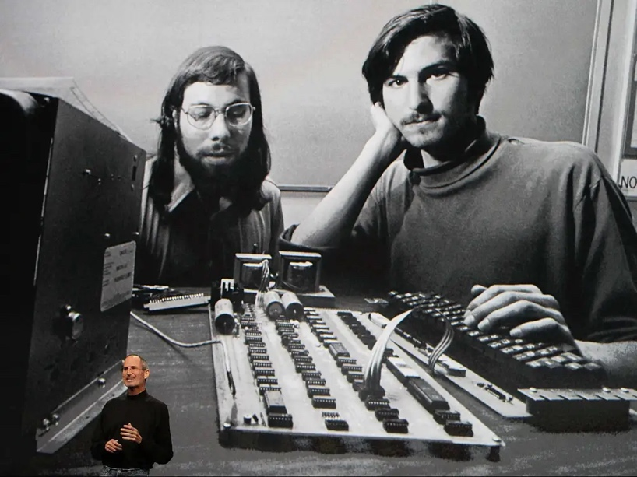
Apple Computers Inc was originally founded by Steve Jobs and Steve Wozniac back on the 1st of April 1976 who were both college dropouts at the time.
Their company mission statement was to bring new smaller computers that would change people’s perception of the home computer and to help bring them in their homes and offices around the world.

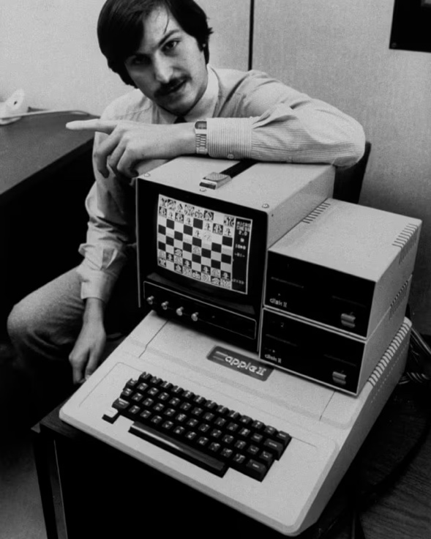
They started building Apple in Steve Jobs’ garage and their first computers were sold without any accessories or peripherals such as the monitor, keyboard etc.
The second computer they released was the Apple II which revolutionised the computer industry as this was the first ever computer with colour graphics. Due to this, their sales grew from $7.8 million back in 1978 to $117 million in 1980, this being a huge step for the future multi trillion-dollar company.

In 1980 Apple went public selling at $22 dollars per share, however during this time Steve Jobs also left Apple, only to return a few years later.
Apple’s success lies in well calculated strategy of offering high tech devices that are so simplistic yet so premium, making customers feel special when purchasing and using their products.

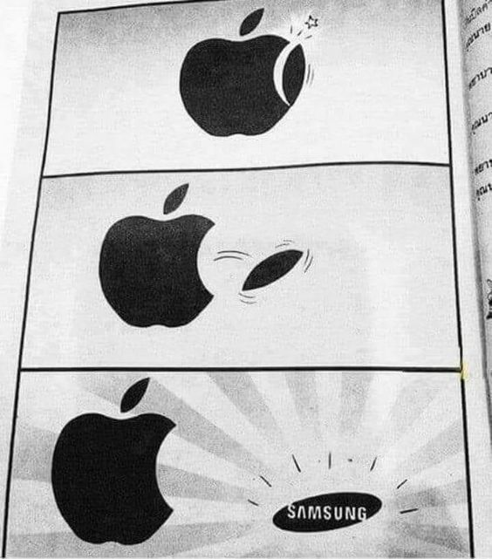
Today Apple grew to be one of the most influential companies in the world and widely recognised by the plain white logo which being just an Apple with a bite taken out of it, proving how good Apple’s strong branding/marketing is against their most fierce competitors, such as Samsung.

Apple Logo

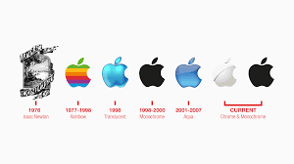
The Apple name was inspired by Eve’s bite out of an apple. The original Apple logo back in 1976 looked completely different to what is it now. The first logo has been designed by Ronald Wayne and shows an image of Isaac Newton sitting under a tree and reading a book, also this captures a falling apple that is about to fall on his head, it also includes a ribbon the includes the company name.

Apple Today

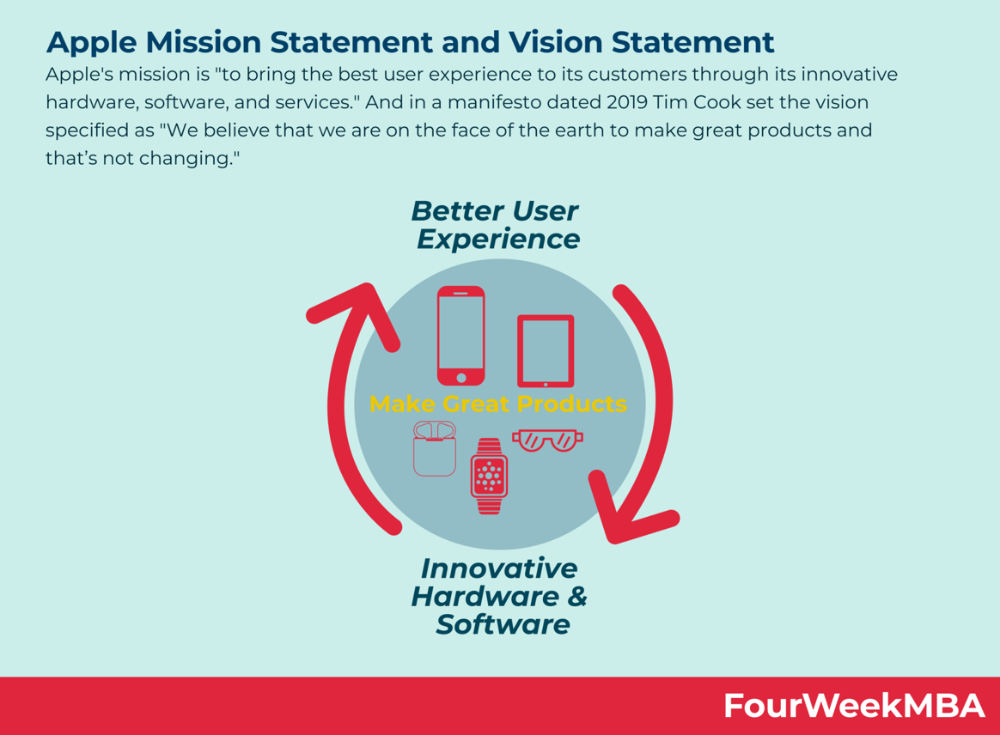
Today, Apple’s vision statement is “to bring the best user experience to its customers through innovative hardware, software, and services.”

As Tim Cook has stated before, he set the vision as
“We believe that we are on the face of the earth to make great products, and that’s not changing.”

Understanding Apple’s mission statement is demanding:
-Better user experience
-Innovative Hardware
-Innovative Software and services
-Continuing to have almost 100% customer satifaction

Because the user’s experience comes first for Apple, designers have a greater power than the engineers furthermore the beautifully crafted designs with the maximum attention to detail.
But at the same time, Apple has worked hard on the software and integrated it into the hardware creating value for the customers.

Products
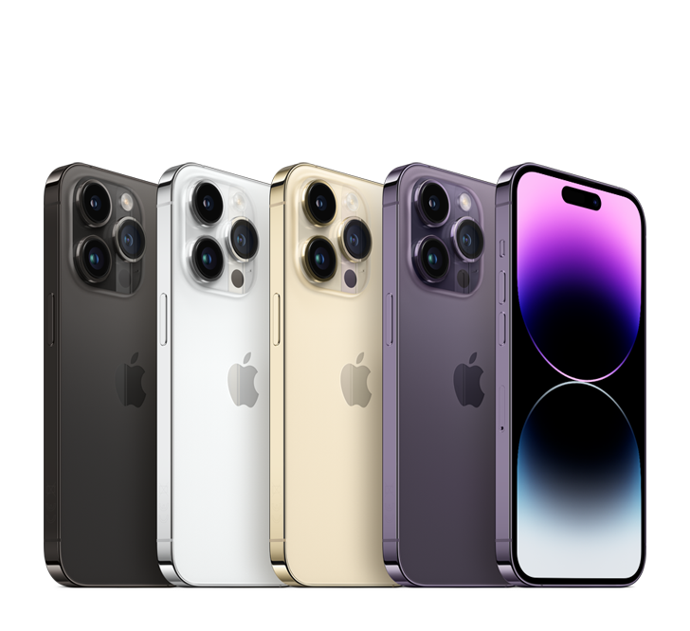

iPhone 14 Pro Max

A new way to interact with iPhone through the new addition of Dynamic Island. An innovative 48MP camera. All day battery and ground-breaking safety powered by the latest chip A16. Coming in four colours: silver, gold, space black and deep purple.

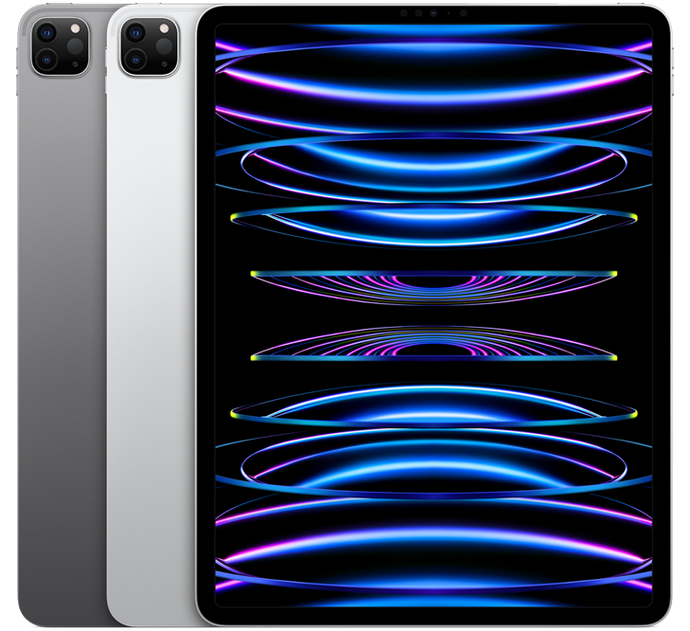
iPad Pro 12

According to Apple, “Astonishing performance. Incredibly advanced displays. Superfast wireless connectivity. Next-level Apple Pencil capabilities. Powerful new features in the new iPadOS 16. The ultimate iPad experience.”

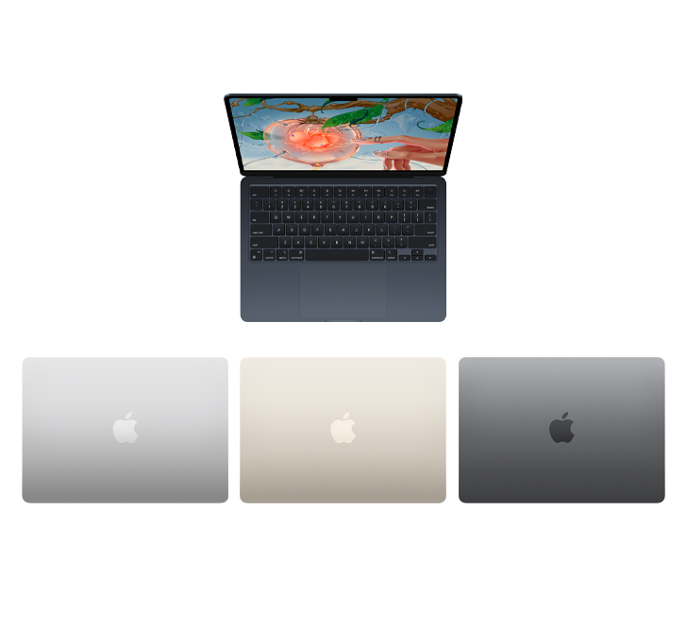
MacBook Air M2

Powered by the M2 chip. New design. Up to 18 hours of battery life. A new Liquid Retina Display. Advanced camera and audio. The new MacBook Air comes in 4 stellar finishes: midnight, starlight, silver and space grey.
Also, the lightest and most premium MacBook Air ever introduced.

Apple Watch Ultra

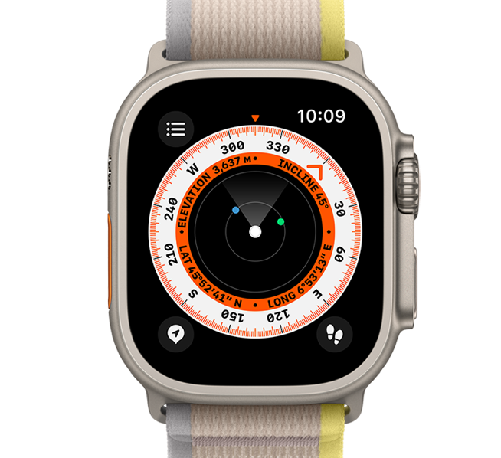
The newest itineration of a most beloved product, built as the ultimate sports watch. A new titanium 49mm case sporting the best balance between weight, corrosion resistance and ruggedness. Water resistance up to 100m, the biggest and brightest Apple Watch display up to 2000 nits. Battery life of 36 hours of normal use and up to 60 hours on low power settings.

Price

To set a competitive price strategy, a company must first determine an appropriate price range. Then they should develop a plan to change prices based on market conditions.

The product’s price usually arises from the next three factors:
- Fixed costs such as the cost of raw materials needed
- Varying costs such as sales tax import-export duties
- The profit which the company makes

Steve Job’s pricing strategy was focused on the creation of a premium products which he could charge premium price. Apple’s cheapest products usually fit midrange but they still offer a high-quality user experience. The software and hardware are designed to provide the best value for the price, but nowadays, Apple faces rough competition from its rivals. Some analysts even say that Apple may lose its number one spot status.

However Apple managed to gain such a reputation for their products and so many repeat customers who chose Apple as their day to day products to use in their life, also as most people have more than one device, of course they ended up in the Apple eco system which means that they have to have more than one Apple product, for example and iPhone and a MacBook also an Apple Watch, the only reason people will stick to just one brand is because Apple makes their products work so well together.

Most families today own at least one Apple product, and the company is a well-known household name.

Product differentiation, which focuses on making products distinctive and appealing to Apple 's customer base, is the foundation of its pricing strategy. Apple 's ability to differentiate itself has led to an increase in consumer demand for itsgoods. This gives the business control over their pricing, along with their brand loyalty. Apple has created an artificial barrier to entry for their rivals by building a devoted customer base and maintaining high prices.
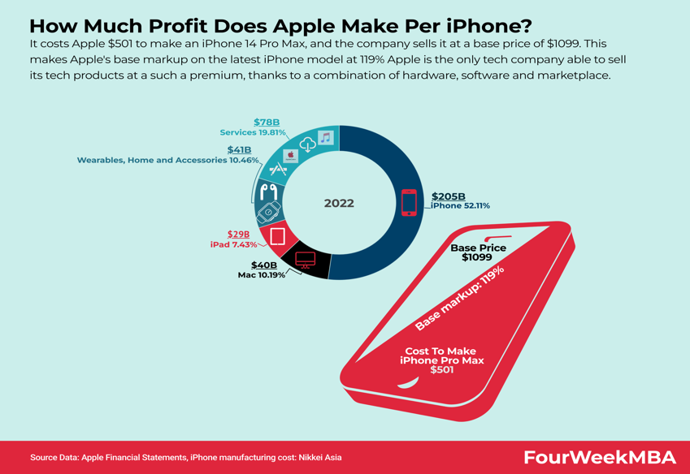

Location and Distribution

Apple designs their products in California but due to cheaper labour and due to the availably of parts they produce most of their products in China, they have also recently opened a new factory in India that makes cheaper iPhone for that market.
Apple uses both direct and indirect channels of distribution.
The direct one is through the official Apple stores and the online Apple store, but they have also third-party retailers such as Curry’s and PC world, Argos, Amazon etc. Apple’s most popular and profitable device is undoubtably the iPhone line up which just in 2021 generated $365 billion in revenue, 52% being just from the iPhones.
As of 2022 62% of Apple sales came just from Indirect channels from other retailers and especially mobile phone cellular companies such as Vodafone, EE, Three and many other international carriers.
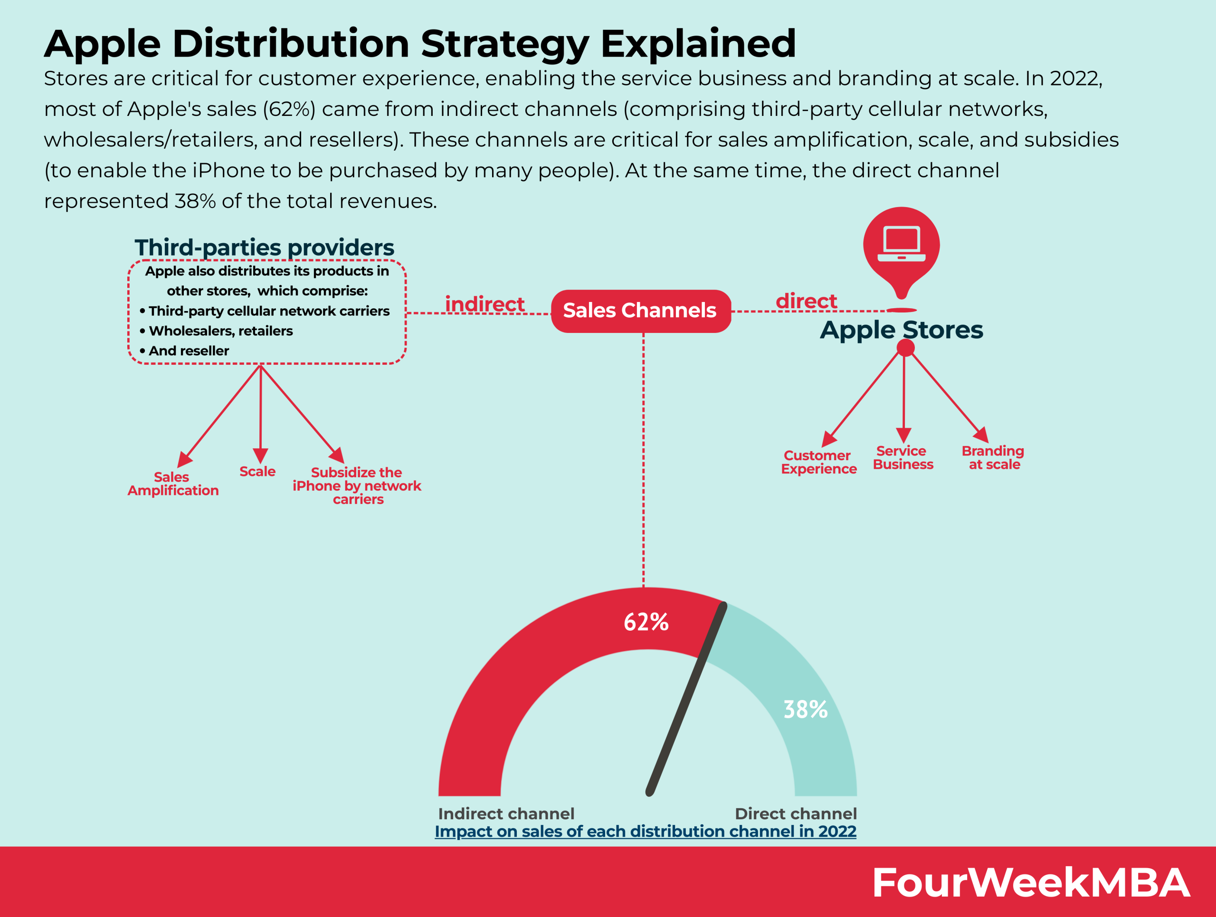

Promotion

Apple a very complex and successful marketing mix for the marketing strategy.
Because Apple is such a marketing genius and because they have so much capital that they can spend on advertisement, they advertise their products on different platforms such as social media, TV, Billboards, Online ads on websites, YouTube Ads and more.
Apple owns their own Instagram account that now has 29 million followers, this is a very clever strategy as the only photos and videos they post are taken by their iPhones. Their Instagram is solely focused on advertising their iPhone cutting edge camera technology and this is a smart marketing move as iPhones bring them the most money, so they continue advertising this to further boost sales.
Apple also offers special discount deals for students offering them 10% discount on Macs or a discount and free Beats headphones to students that qualify for the offer.
Apple’s strength in their marketing is that they really focus on customers interaction with their products in their Apple stores where their employees offer product specific information in the aim of encouraging people to purchase their products. Apple invested and kept in vesting billions annually in new Apple stores around the world or investing money in refurbishing their older Apple stores to be as futuristic, yet simplistic and eye catching for current and potential new costumers.
One example is the of this successful idea is that in the UK there are the most Apple stores in Europe with 39 stores operational as of August 2022.
One of the Biggest Apple Stores in Europe is in London on Regent Street, here people can come try out their products, play and test them and have specialist advice from the employees, people can get quotes on repairs if needed for their products.
Another main promotional strategy Apple uses in their main Apple stores is that they offer free personal and group sessions with music or photography artists for anyone interested, where people can learn how to use their products and software, taught by a professional in a very relaxing and uplifting environment, making anyone who attends feel very special and once again making people want to purchase their products.
In these sessions people can learn for few how to code, design or even take an art tour, the whole idea of this is so people relax and feel good further boosting their confidence using the Apple products and helping to achieve exactly what Apple wants which is impulsive buying.

References

https://guides.loc.gov/this-month-in-business-history/april/apple-computers-founded

https://www.investopedia.com/articles/personal-finance/042815/story-behind-apples-success.asp

https://www.crowdspring.com/blog/apple-logo/

https://fourweekmba.com/apple-mission-statement-vision-statement/

https://globalmarketingprofessor.com/apples-pricing-strategy/

https://www.businessofapps.com/data/apple-statistics/

https://www.statista.com/statistics/1041526/apple-store-numbers-european-countries/

https://www.apple.com/uk/retail/regentstreet/

