Assignment Title: Assessment component 1- Essay
Student Name: Amul Mohanbhai Solanki
Programme: MBA
Module: Entrepreneurship
Module code: LCMB7004
Lecturer: Vasilios Tavlaridis

Table of Contents
Overview: 3
Market Analysis: 3
Effects of Stress: 3
Monetization Strategy: 3
Area and Legal entity 4
Legal Liabilities of the Firm: 4
Needed source for the enterprise. 5
Plans 6
Technical Infrastructure: 6
SWOT analysis for business 6
Strengths 6
Weaknesses 7
Opportunities 8
Threat 8
Financial Projections: 9
12-MONTH CASH FLOW FORECAST 9
Cash In-flows 9
Cash Out-flows 10
Reference: 10

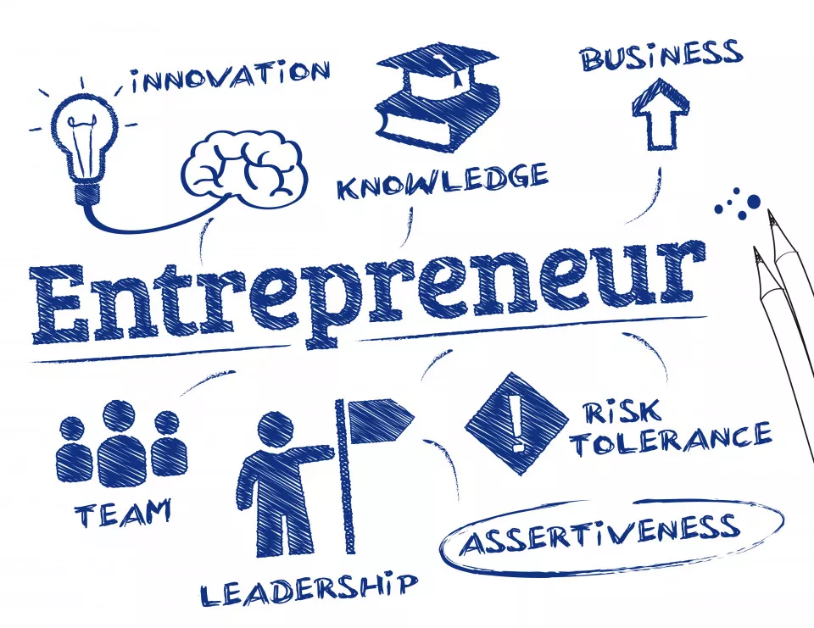
University of Bolton(2023)

Business Idea: Virtual Platform for Stress Relief

Overview:
Entrepreneurship is the process of identifying and pursuing opportunities to create and manage a new business venture. It involves taking risks, being innovative, and leveraging resources to build a successful enterprise.
The proposed business idea is to create a virtual platform that offers comprehensive stress management and relief solutions for working professionals. The platform will leverage technology to provide a wide range of virtual tools, resources, and programs focused on promoting well-being, mindfulness, and work-life balance. By addressing the growing demand for stress reduction and mental health support, the platform aims to help individuals manage and reduce stress in their personal and professional lives.
the virtual platform for stress relief aims to address the growing need for stress management solutions in working professionals' lives by offering an accessible and comprehensive range of virtual tools and resources. By leveraging technology and adhering to legal requirements, the platform can effectively monetize its services while providing personalized and effective stress reduction programs.

Market Analysis:
The market for stress reduction and mental health support has been growing steadily, with an increasing awareness of the importance of well-being in both personal and professional lives. The target audience for this virtual platform includes working professionals across industries who experience high levels of stress due to work-related pressures. According to research, chronic stress leads to various health issues, decreased productivity, and increased absenteeism, highlighting the need for effective stress management solutions. (Barros, 2021)

Effects of Stress:
Stress-related symptoms can affect both physical and mental health, leading to issues such as difficulty concentrating, loss of job confidence and motivation, anxiety, depression, mood swings, fatigue, digestive problems, headaches, and more. (Bupa, 2023)
Bupa (2023) Work-related stress (online) Available at: https://www.bupa.co.uk/health-information/mental-health/stress-workplace (Accessed 3rd July 2023)
914,000 workers suffering work-related stress, depression, or anxiety these statics provide more clarity for previous explanations. (Health and safety statistics, 2021-22)
Health and safety statistics (2021/22) Key figures for Great Britain (online) Available at: https://www.hse.gov.uk/statistics/ (Accessed 3rd July 2023)

Monetization Strategy:
The virtual platform can generate revenue through the following monetization strategies:
Subscription Model: Offer tiered subscription plans, granting access to different levels of content, programs, and features. Higher-priced subscriptions can include additional benefits such as personalized coaching or exclusive workshops. (Oat, 2013)
Partnerships and Sponsorships: Collaborate with organizations, mental health professionals, and well-being experts to provide sponsored content, workshops, or branded programs, generating revenue through partnerships and sponsorships. (Madill et al. 2014)
In-App Purchases: Offer additional premium content, guided meditation sessions, or specialized programs as in-app purchases, providing users with the option to enhance their experience. (Rialti et al. 2022, p.8)

Area and Legal entity
The proposed location for the virtual platform for stress relief is Victoria. The justification for selecting Victoria as the main office location is that it is a well-known area where many people visit to relieve their stress. By having a presence in Victoria, the virtual platform can attract individuals who are already seeking stress relief solutions during their trips to the area. Additionally, being in a popular location can help raise awareness of the virtual platform and attract potential customers.
Regarding the legal entity, the proposed legal entity for the business is a partnership. The justification for selecting a partnership as the legal entity is that different partners can bring their unique approaches and expertise to the business. With a partnership, the management responsibilities and liabilities are distributed among the partners, which can positively impact the growth of the business. Furthermore, a partnership can provide access to additional resources, such as financial capital and industry connections, which can support the expansion and success of the virtual platform for stress relief.

Legal Liabilities of the Firm:
The proposed business would need to have necessary legal entities, including a company registration number, professional association memberships, VAT registration, and a VAT number. Additionally, it should have a contact email address and a website or application to serve as the virtual platform.
This business work virtually so no required physical place for customer but operating this firm it requires therefore, the main office of location selected in the Victoria. There are several reasons for open such as, it is very well-known area and lots of people visit this place every day for relive their stress, but it is temporary, they need strong solution for it so, if they are known about it during their trip, they will visit our web site where they find their solution at their doorstep.
For this startup the legal entity is partnership. It has many advantages like different people have different approach which will use for implementation, mind set provide though to attract all kind of working citizen, management is a more important without it will not succeed, liabilities are distributed among to all partners so, it will affect growth positively. Apart from this it needs some resources to expand it which is described below:

Needed source for the enterprise.
- Human Resources: Stress-reducing firms employ professionals such as psychologists, therapists, counsellors, coaches, or instructors who provide expertise and support to clients. (Fields, 2016)
- Knowledge and Expertise: These firms possess a strong foundation of knowledge and expertise in stress management techniques, mindfulness, relaxation techniques, cognitive-behavioural therapy, and other evidence-based approaches. (Minzlaff, 2019, p. 15-28)
- Programs and Services: Stress-reducing firms offer programs and services such as stress management workshops, mindfulness training, meditation sessions, counselling or therapy, wellness retreats, and corporate stress management programs. (Blumöhr, 2020)

Resource
- Physical Facilities: Some firms may have physical facilities like wellness centres, therapy clinics, or retreat venues to provide a conducive environment for relaxation, healing, and stress reduction. (Tharakan, 2012, p. 52)
- Technology and Tools: Stress-reducing firms may leverage technology and tools such as online platforms, mobile applications, wearable devices, and digital resources to enhance their offerings and support clients in stress reduction. (Patel et al. 2022, p. 2100099)
- Strategic Partnerships: Collaboration with healthcare providers, corporate wellness programs, educational institutions, or mental health organizations can be important resources for stress-reducing firms to expand their reach and enhance their service offerings. (Henderson, 1990, p. 7)

Plans
- Stress Reduction Programs: only weekend (30 pound per session) duration: 3 hours
- Interactive Virtual Spaces: every day (15 pound per session) duration: 1 hour 30 minutes
- Personalized Stress Assessments: every day (10 pound per person) maximum 20 minutes
- d. Community Support: 1st month free, 15% discount for premium membership (nominal charges 15 pound per month)
- Resource Library: 25% discount for premium membership (15 pound per month)

Technical Infrastructure:
The virtual platform will require robust technical infrastructure, including a user-friendly website or application, secure data storage, and scalable servers to accommodate a growing user base. It should also incorporate features for seamless user interactions, such as video conferencing, chat functionalities, and personalized user profiles. (Rimal et al.2011, p. 3-26)

SWOT analysis for business

Strengths
The virtual platform will offer a range of services and features to reduce stress and promote well-being:
- Stress Reduction Programs: Develop and curate virtual programs and courses led by qualified professionals, including mindfulness training, stress management workshops, relaxation techniques, and resilience-building exercises. (Chaudhry et al. 2022, p. e30640)
- Interactive Virtual Spaces: Create virtual environments where individuals can engage in calming activities such as meditation, yoga, and virtual nature walks, providing an immersive and relaxing experience. (Downey, 2015)
- Personalized Stress Assessments: Offer tools for individuals to assess their stress levels and receive personalized recommendations and resources based on their unique needs and circumstances. (Maj et al. 2020, p. 269-293)
- Community Support: Facilitate a virtual community where users can connect with like-minded individuals, share experiences, and receive support from peers and mental health professionals.
- Resource Library: Curate a comprehensive library of articles, videos, podcasts, and other educational resources on stress management, mental health, and well-being. (Duncan, 2018, p. 336-337)
Our organisation is unique because of there are so many options available to get information about your queries such as you can visit website, call to customer care, messages, and mail drop services so later our customer executive calls you and no need to waiting on call till to your turn you can choose time according to your convenience also available in weekend time.
This organisation work for those citizens who are working in stressed environment so this type of behaviour pattern makes changes in person actual nature so it will gradually turn in to rock heart person and this will directly be affected to their social and professional relation not only that, but it shows bed effect on mental strength too.
There are ample of company who working for the stress reduction so this firm has so numbers of new creative plans and strategies which will help to achieve success and some of the ideas are described above.

Weaknesses
- Limited Differentiation:
Reason: The stress management app market is becoming increasingly saturated with a multitude of competitors offering similar features and approaches. It can be challenging for startups to differentiate themselves and carve out a unique value proposition in such a crowded market. Without a clear differentiating factor, startups may struggle to attract and retain users. (Williams et al. 2008, p. 505-517)
- Lack of Personalization:
Reason: Stress management is a highly personal and individualized experience, and apps that fail to provide personalized content and strategies may struggle to meet users' specific needs. Many stress management app startups rely on general techniques and content that may not resonate with all users. This lack of personalization can limit the effectiveness and appeal of the app. (Børøsund et al. 2018, p. e9954)
- Inaccurate or Inadequate Assessments:
Reason: Stress management apps often include assessments or questionnaires to gauge users' stress levels and identify areas of improvement. However, some startups may develop assessments that are not scientifically validated or fail to capture the full range of stressors. Inaccurate or inadequate assessments can lead to incorrect recommendations and may undermine the credibility of the app. (Burgess et al. 2016, p. 1671-1677)
Finally, this are the standard mistakes done by the major firm so in this platform will give more attention on these weaknesses and make sure that it will resolve.

Opportunities
Increased Reach and Accessibility: By offering the program virtually, the organization can reach a broader audience beyond geographical limitations. Working individuals from different locations can access the program, regardless of their physical proximity to a specific facility or centre. This expands the organization's reach and allows them to impact more lives. (Kittur et al.2013, p. 1301)
- Flexibility and Convenience: Virtual programs provide flexibility and convenience for participants. Working individuals can access the program at their own pace and schedule, fitting it into their busy routines. This eliminates the need for commuting or rigid time commitments, making it easier for individuals to engage with the stress-reducing program regularly. (Cheris, and Kramarae, 2001)
- Cost-Effectiveness: Virtual programs often have lower overhead costs compared to physical facilities. There is no need to maintain a dedicated space, which can result in cost savings for the organization. This can potentially lead to more affordable program fees for participants, making stress reduction resources more accessible to a wider range of working individuals. (Proffitt, 2014)
- Scalability: Virtual programs can be scaled up more easily compared to physical programs. As the demand grows, the organization can accommodate a larger number of participants without significant infrastructure or resource constraints. This scalability allows the organization to expand its reach and impact without facing limitations associated with physical space and capacity. (Fox, et al. 2009, p. 2009.)
- Data Collection and Analytics: Virtual programs provide opportunities for data collection and analytics. Organizations can gather anonymized data on participant engagement, program effectiveness, and user feedback. This data can be analysed to identify trends, measure the impact of the program, and make data-driven improvements to enhance the effectiveness of stress-reduction strategies. (Chen et al. 2012, p. 1165-1188)
It's important for organizations to adapt to the virtual landscape by leveraging these opportunities to provide high-quality, engaging, and effective stress-reducing programs for working individuals.

Threat
- Data Breach: Despite efforts to maintain a secure platform, there is a risk of a data breach that could compromise users' personal information and cause significant harm. This could include sensitive data such as personal details, health information, and even payment details if financial transactions are involved. Such a breach could result in identity theft, financial losses, or other malicious activities targeting the users. (Argaw, et al. 2020, p. 1-10)

Financial Projections:
Develop financial projections based on factors such as the number of subscriptions, pricing strategy, operational costs, and marketing expenses. Consider potential growth rates and market trends to estimate revenue and expenses accurately. (Vogel, 2020)

12-MONTH CASH FLOW FORECAST

Cash In-flows
Cash in-flows | Total anticipated sales | Value of your Start Up Loan | Other sources of cash or equity | Existing assets for business purposes | Investment by owner | Total cash in-flows (A)
Starting Point | £0 | £50,000 | £60,000 | £0 | £40,000 | £150,000
1st month | £15,000 | £0 | £5,000 | £0 | £5,000 | £25,000
2nd month | £16,000 | £0 | £5,000 | £0 | £5,000 | £26,000
3rd month | £17,000 | £0 | £5,000 | £0 | £5,000 | £27,000
4th month | £175,000 | £0 | £5,000 | £0 | £5,000 | £185,000
5th month | £18,000 | £0 | £5,000 | £0 | £5,000 | £28,000
6th month | £19,000 | £0 | £5,000 | £0 | £5,000 | £29,000
7th month | £19,000 | £0 | £5,000 | £0 | £5,000 | £29,000
8th month | £18,000 | £0 | £5,000 | £0 | £5,000 | £28,000
9th month | £18,500 | £0 | £5,000 | £0 | £5,000 | £28,500
10th month | £19,000 | £0 | £5,000 | £0 | £5,000 | £29,000
11th month | £20,000 | £0 | £5,000 | £0 | £5,000 | £30,000
12th month | £21,000 | £0 | £5,000 | £0 | £5,000 | £31,000
Total | £375,500 | £50,000 | £120,000 | £0 | £100,000 | £645,500

Cash Out-flows
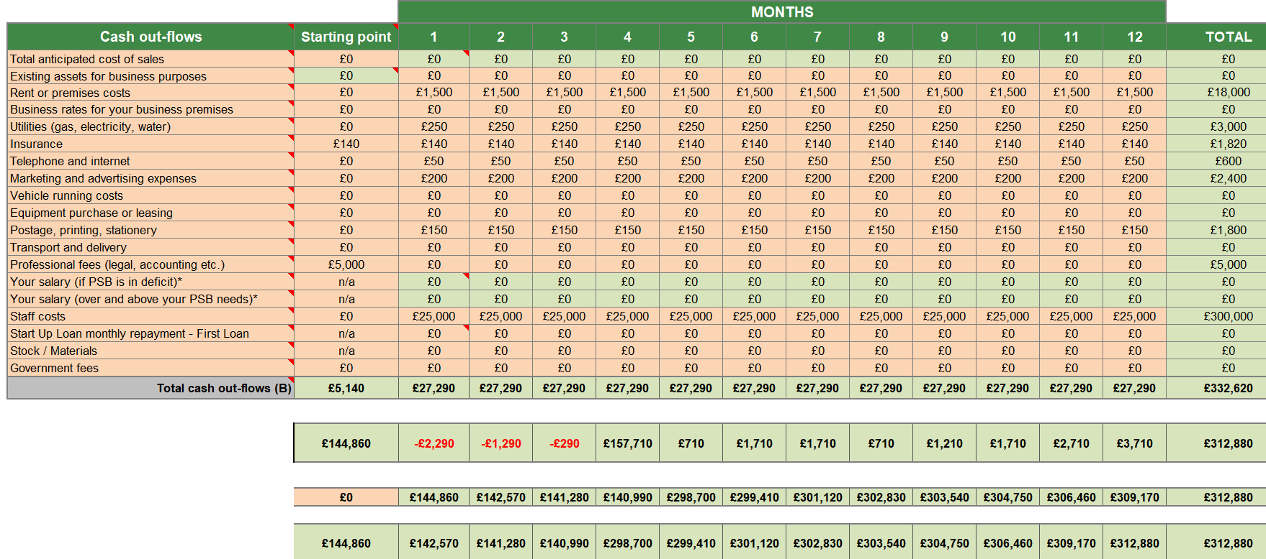

Reference:
Barros, P.P. (2021) 'Introduction to the Expert Panel on Effective ways of investing in health (EXPH) and its mandate', European journal of public health, 31(Supplement_3), pp. ckab164. 147.
https://health.ec.europa.eu/system/files/2021-10/028_mental-health_workforce_en_0.pdf
Oat, E. (2013) 'Analysis of Netflix architecture and business model'.
http://www.cse.tkk.fi/fi/opinnot/T-109.4300/2014/luennot-files/oat.pdf
Madill, J., O'Reilly, N. and Nadeau, J. (2014) 'Financing social marketing programs through sponsorship: implications for evaluation', Journal of Social Marketing, .
https://www.proquest.com/docview/1508549807?accountid=130472&parentSessionId=1th6hn3OpqYGJIOOwDIIosoQpCgGUat08m%2FpjCZ87EY%3D&pq-origsite=primo
Rialti, R., Filieri, R., Zollo, L., Bazi, S. and Ciappei, C. (2022) 'Assessing the relationship between gamified advertising and in-app purchases: a consumers’ benefits-based perspective', International Journal of Advertising, 41(5), pp. 868-891.
https://air.unimi.it/bitstream/2434/898886/2/IJA%20-%20Gamification.pdf
Rimal, B.P., Jukan, A., Katsaros, D. and Goeleven, Y. (2011) 'Architectural requirements for cloud computing systems: an enterprise cloud approach', Journal of Grid Computing, 9, pp. 3-26.
https://dana.e-ce.uth.gr/pdf/Springer_JNL_GRID11rjkg.pdf
Vogel, H.L. (2020) Entertainment industry economics: A guide for financial analysis Cambridge University Press.
https://d1wqtxts1xzle7.cloudfront.net/67955212/bf0210861820210709-360-c1fenb-libre.pdf?1625861719=&response-content-disposition=inline%3B+filename%3DBook_review_of_Entertainment_Industry_Ec.pdf&Expires=1687738156&Signature=a3sLENwVZCfTOUpUyWfG7t8Vckl39B4qQECkpnPY1hmOc0zPkcVJQYsUZvUwiepMYxZE4LqwMhXYuDE7Q9MpT~0yGe91Il7XnBQoFuXMugxKeOZuWTzSv-eJM3RweqKZXBq9led8lQm57cHHOsZjj4ERVy8TerdCcLaaUN0O3dahogTGPBYTioQrhv~k4uFx0jS-ebZ95qCiAz2w340enCPe3iyykTEQH~82Ru6TQUq3CvfIUrTLajU4BjG~-wQKNxM5Q0ZpgRzgHkoz68JE8zcjo~3eksW~pe7S3EmkHv4mymlQeJhHt3VY5-fJ6SGFxSlECf72qd1-5nlakc3ggQ__&Key-Pair-Id=APKAJLOHF5GGSLRBV4ZA
Chaudhry, B.M., Islam, A. and Matthieu, M. (2022) 'Toward designs of workplace stress management mobile apps for frontline health workers during the COVID-19 pandemic and beyond: mixed methods qualitative study', JMIR Formative Research, 6(1), pp. e30640.
https://formative.jmir.org/2022/1/e30640/
Downey, L. (2015) ‘No title’, Well-being technologies: Meditation using virtual worlds [Preprint].
https://nsuworks.nova.edu/cgi/viewcontent.cgi?article=1062&context=gscis_etd/
Maj, M., Stein, D.J., Parker, G., Zimmerman, M., Fava, G.A., De Hert, M., Demyttenaere, K., McIntyre, R.S., Widiger, T. and Wittchen, H. (2020) 'The clinical characterization of the adult patient with depression aimed at personalization of management', World Psychiatry, 19(3), pp. 269-293.
https://onlinelibrary.wiley.com/doi/full/10.1002/wps.20771
Duncan, S. (2018) Promoting individual and community health at the library: Promoting individual and community health at the library, Mary Grace Flaherty, Chicago, IL, ALA, 2018, 121pp., US$50.00 (soft cover), ISBN 978-0-8389-1627-8, pp. 336-337.
Williams, K., Chatterjee, S. and Rossi, M. (2008) 'Design of emerging digital services: a taxonomy', European journal of information systems, 17(5), pp. 505-517.
https://orsociety.tandfonline.com/doi/abs/10.1057/ejis.2008.38?role=button&needAccess=true&journalCode=tjis20
Børøsund, E., Mirkovic, J., Clark, M.M., Ehlers, S.L., Andrykowski, M.A., Bergland, A., Westeng, M. and Nes, L.S. (2018) 'A stress management app intervention for cancer survivors: design, development, and usability testing', JMIR formative research, 2(2), pp. e9954.
https://formative.jmir.org/2018/2/e19
Burgess, J.D., Cameron, C.M., Cuttle, L., Tyack, Z. and Kimble, R.M. (2016) 'Inaccurate, inadequate and inconsistent: a content analysis of burn first aid information online', Burns, 42(8), pp. 1671-1677.
https://www.sciencedirect.com/science/article/pii/S0305417916303734
Fields, A. (2016) 'No title', A grounded theory study of how executive coaches help professionals deal with workplace intimidation, .
https://www.proquest.com/docview/1790114322?pq-origsite=gscholar&fromopenview=true
Minzlaff, K.A. (2019) 'Organisational coaching: Integrating motivational interviewing and mindfulness with cognitive behavioural coaching', Coaching: An International Journal of Theory, Research and Practice, 12(1), pp. 15-28.
https://www.tandfonline.com/doi/pdf/10.1080/17521882.2018.1478437
Barros, P.P. (2021) 'Introduction to the Expert Panel on Effective ways of investing in health (EXPH) and its mandate', European journal of public health, 31(Supplement_3), pp. ckab164. 147.
https://jlupub.ub.uni-giessen.de/bitstream/handle/jlupub/382/BlumoehrLisa-2021-04-14.pdf?sequence=3&isAllowed=y
Tharakan, Y.G. (2012) 'Development of a health and wellness centre at Manipal-an introspection', JOHAR, 7(2), pp. 52.
https://www.proquest.com/docview/1478019634?pq-origsite=gscholar&fromopenview=true
Patel, V., Chesmore, A., Legner, C.M. and Pandey, S. (2022) 'Trends in workplace wearable technologies and connected‐worker solutions for next‐generation occupational safety, health, and productivity', Advanced Intelligent Systems, 4(1), pp. 2100099.
https://onlinelibrary.wiley.com/doi/pdfdirect/10.1002/aisy.202100099
Henderson, J.C. (1990) 'Plugging into strategic partnerships: The critical IS connection', MIT Sloan Management Review, 31(3), pp. 7.
https://onlinelibrary.wiley.com/doi/pdfdirect/10.1002/aisy.202100099
https://www.proquest.com/docview/224962834?pq-origsite=gscholar&fromopenview=true
Kittur, A., Nickerson, J.V., Bernstein, M., Gerber, E., Shaw, A., Zimmerman, J., Lease, M. and Horton, J. (2013) The future of crowd work. pp. 1301.
https://dl.acm.org/doi/pdf/10.1145/2441776.2441923
Cheris, K. and Kramarae, C. (2001) 'The Third Shift: Women Learning Online.', International Women Online Journal Of Distance Education, 4(2).
https://dergipark.org.tr/en/download/article-file/92165
Proffitt, S. (2014) 'Commercially available or home-grown: A cost-effectiveness analysis of K-12 online courses', .
https://scholarscompass.vcu.edu/cgi/viewcontent.cgi?article=4363&context=etd
Fox, A., Griffith, R., Joseph, A., Katz, R., Konwinski, A., Lee, G., Patterson, D., Rabkin, A. and Stoica, I. (2009) 'Above the clouds: A berkeley view of cloud computing', Dept.Electrical Eng.and Comput.Sciences, University of California, Berkeley, Rep.UCB/EECS, 28(13), pp. 2009.
https://d1wqtxts1xzle7.cloudfront.net/43018702/0c960525ae2cc30314000000-libre.pdf?1456339668=&response-content-disposition=inline%3B+filename%3DAbove_the_Clouds_A_Berkeley_View_of_Clou.pdf&Expires=1688041126&Signature=N6ejLALpB6VTOl2eQTb~j0Hi4QTTUI7thXxfFRmvkoDGdX5ASNb~MtFBShGm6hNszmUrQ2upIdESszuKlJIkga2qdpJA-psQ8pScOHR5W81JQJC16RXPok5KWecyLfQdOLUoTGepRZHDG8aGfMzZwUsr~V1MnneMd7K80vGPJsiC0TWkqIE6nhER-It7d2MPSgvz4f8dxNAzBPTIVYseeotI9u8f5cS7aaxjJjWZ-7k6Bqt5~h~HUNwLNePamXNJg0B79VgGX1xBLJNaw312fEIud64IK6RbaEuyIK7adEV1vN0HalimylCTidp1tO5guck0aW3xHXQgbBkTOLlcfw__&Key-Pair-Id=APKAJLOHF5GGSLRBV4ZA
Chen, H., Chiang, R.H. and Storey, V.C. (2012) 'Business intelligence and analytics: From big data to big impact', MIS quarterly, , pp. 1165-1188.
https://www.jstor.org/stable/pdf/41703503.pdf
Argaw, S.T., Troncoso-Pastoriza, J.R., Lacey, D., Florin, M., Calcavecchia, F., Anderson, D., Burleson, W., Vogel, J., O’Leary, C. and Eshaya-Chauvin, B. (2020) 'Cybersecurity of Hospitals: discussing the challenges and working towards mitigating the risks', BMC medical informatics and decision making, 20, pp. 1-10.
https://link.springer.com/article/10.1186/s12911-020-01161-7
Bupa(2023) Work-related stress (online) Available at : https://www.bupa.co.uk/health-information/mental-health/stress-workplace (Accessed 3rd July, 2023)
Health and safety statistics (2021/22) Key figures for Great Britain (online) Available at : https://www.hse.gov.uk/statistics/ (Accessed 3rd July, 2023)

