Community engagement

Student: Vilislav Sofroniev

Student ID: 2019606

Contents

Introduction 2
The concept of community engagement 2
Principles and standards for stakeholder engagement 4
Interpersonal skills that stimulate your creativity 6
Logical thinking in real situations 6
Conclusion 9
Reference list 10

Introduction
In order to participate fully in social life, people need to organize themselves in communities and fulfill commitments. In this way, they are provided with access to basic activities and services. For this reason, in order to perform the activities better, individuals need to develop. They feel that they can learn to live more fully by developing and improving their knowledge, skills, and habits. The human is a social being and belonging to the community is of fundamental importance to him. Intelligence, potential, and, last but not least, feeling are invested in this whole process. The value system of each person is formed in early childhood and this greatly contributes to the understanding of work engagement in adulthood. The value system is learned, but the functioning can be upgraded. Schooling and then university also contribute to this process. It is important to ensure access to basic social conditions and activities ( Reicher,2021).

The concept of community engagement
Sport Unites and Major Events Engagement Fund (MEEF) has prepared a report which they have submitted to the Mayor of London. The aim is to ensure the sports community is coping despite the pandemic. The main goals are the following:
1. To make a successful decision for the sports sector, because it is facing a challenge.
2. Measure the intensity of the impact.
3. Conduct training for both, response and adaptation.
Sport is a sector that prevailed before the crisis caused by the pandemic. It is now necessary to take such a step back, so you can take 2 steps forward. That allows for a sustainable and fair future for the sports community. The Covid-19 pandemic has forced major sporting events in London to be postponed to 2021 or canceled. Six major events have been canceled, postponed, or modified online. They were funded by the activities of the sports community. It turned out that the sports sector had to fight for its survival because the buildings were closed and the people working there were sent home. This naturally led to a loss of funding for the sports community (Lewis,2018).
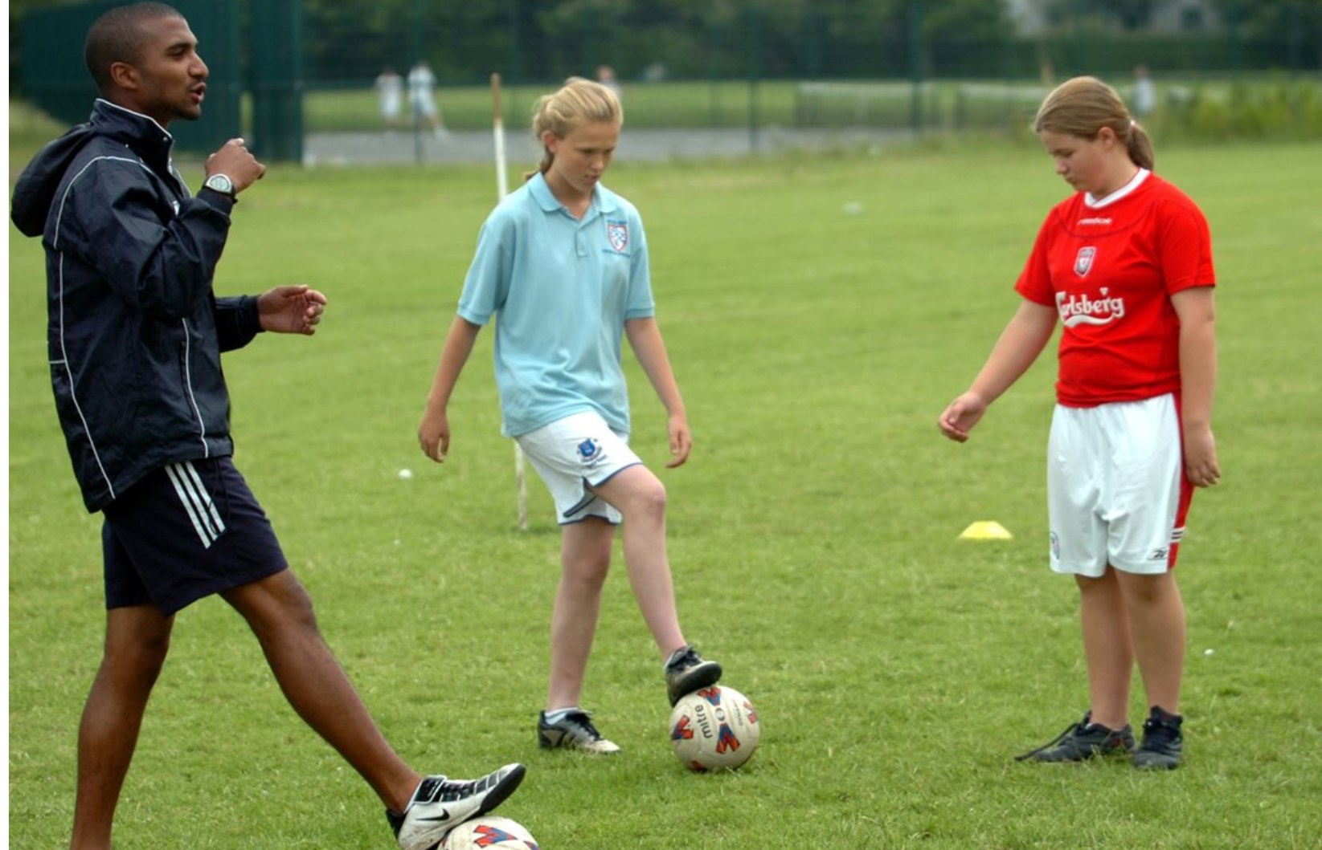
(Westholm,2011).
Sport England, Coalition for Sport and Development, etc.. studied the impact of the pandemic on the sports sector. The study was conducted through an online sample survey. It turned out that:
1.About 20% of the sports organizations have made redundancies.
2. Slightly more than a third have received some form of financial assistance from the government.
3. Slightly less than half have not received any emergency aid.
4. As a consequence of the stay at home, physical activity has decreased, it has become impossible to practice sports in the usual way.
5. Prominent athletes in their field have experienced anxiety 2 times more than usual.
The study found that almost all organizations are concerned that they cannot meet their goals and results. Less than half of the organizations have benefited from staff retention assistance. Only about 35% have laid off more than half of their staff (Alrutz,2012).

Principles and standards for stakeholder engagement
There are various ways to attract the attention of stakeholders in the English sports world. Sports clubs can engage both various prominent athletes and entire teams. They can be involved in initiatives to attract the attention of the average person.
Only motivated people respond to the benefits of sports. There are several ways to hold the attention of stakeholders:
1. Communication
The process of communication is like the sides of the dice. Just as you need to understand people, you need to share information with them. Last but not least, it is important to gather information about stakeholders. Communication is a two-way process. Speak up, but also listen actively. Only positive contact can bring benefits to both the coach and the athletes (Westholm,2011).
2. Talk often and early about problems
When we communicate on time, we gain trust in the other party. Frequent communication prevents the emergence of any ambiguities. This is the prevention of possible problems in the future. In this situation, all the rules of ordinary human communication apply (Reicher,2021).
3. However, we are first of all people and then athletes
It is not human to be in good shape. Do not think that a negative reaction is necessarily related to you. Very often personal problems face professional ones. Do not lose your condition and everything will be fine. To work productively, you need to choose the most appropriate response possible (Lewis,2018).
4. Make a plan
A conscientious approach to people can lead to a positive result. Good begets good. The skills of good time management also give positive results.
5. Your relationship is important
Labor relations are above all human relations. We must make sure that our relationship is based on trust. This makes people work easier and more efficiently. All these techniques will lead to minimizing uncertainty and solving a problem as soon as it arises. This technique facilitates adequate and quick decision-making.
6. Not always simple things are easy
The action taken must be simple and on time. People are obviously worried that something too simple is wrong. For this reason, the principle is hardly implemented.
7. Make compromises
Considering the thesis, that everyone is a person, we can add that everyone can make a mistake. It is important to compromise and to remember we are not perfect (Westholm,2011).
8. Success
Success means something different to everyone. What would success mean for the sports community we are looking at? That means we have 2 winning sides. There is no losing player or coach. There is one peculiarity. The loss should not be seen as a defeat. Valuable experience is gained from each of them, which is more important than a successful competition. We learn for our mistakes (Cruickshank,2012).
9. Be responsible
Everyone on the team needs to understand their responsibilities. The team member must accept his role in the team and communicate adequately with others. The individual competitor has personal responsibility, but within the team, he is part of the whole. Only with the awareness that the private is part of the common can we talk about success (Alrutz,2012).

Interpersonal skills that stimulate your creativity
Every coach must be good at developing creativity in his players. And also individually to stimulate development. Take English football, for example. Some guidelines can help us understand the concept of creativity and development in players.
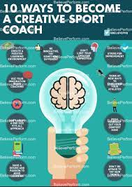
(Lewis,2018).
Every coach who is considered good must learn to radiate faith in improving competencies. He must use an individual approach to each player. It should encourage creative thinking as a way to fulfill the player's competence. Football is a team game and everyone is part of the whole. The individual approach must be used for each player individually. But all this must be combined with the concept of "one for all, all for one". The game is collective and it is necessary to develop skills for collective thinking. Example: assisting in scoring a goal (Cruickshank,2012).
Jean Côte introduced the "S" system in British coaching. It helps coaches improve and develop their knowledge. It offers ways to build connection, confidence, competence, character, and care (Alrutz,2012).

Logical thinking in real situations
The mayor of London has made a statement proposing support for civil society, and the sports sector in particular. This financial support refers to the losses from the pandemic and is the amount of £ 7.6 million. This is one of the solutions to deal with the problem.
Another solution is a series of talks with London sport, entitled "Talking covid". The aim is to provide up-to-date practical information as well as advice and guidance. All this is based on information again. About 700 people took part in the talks ( Reicher,2021).
Various causes have been considered and options have been presented in which sports organizations can support the community. There are ways to get help from organizations that are in the community and have managed to master the sports networks:
1. Delivery of medicines and food to the address of persons at risk, or unable to travel or in isolation
2. Creating food banks
3. Provision of services and equipment to key workers or those at risk
4. Providing access to psychological counseling
5. Ways and useful practices for sports at home to strengthen mental and physical health
A solution is needed by adapting to the new conditions of the pandemic. The response to the coronavirus crisis has led to an upgrade over conventional funding methods. Some sports organizations have focused on measuring and managing the impact of the crisis. In this way, they thought that they would secure future funding (Cruickshank,2012).
A community for the training of sports organizations was established. The aim is to exchange good practices and for sports organizations to learn from failure and success.
The Insight fortnight hosted a webinar on pressing issues related to dealing with the situation. people outside the lock, how to be aware of government constraints, and how to use the hybrid model more often - online and face-to-face activities.
Here we can consider an example of a logical solution to a real situation.
Physical activity during locking decreases rapidly. This applies to young people, and more. Although the majority of children and young people maintain a high level of physical activity, the results are not so good in terms of their mental well-being. The Youth Sports Trust has summarized the most important evidence. 1/3 of young people have experienced a great deal of anxiety, stress, and loneliness (Alrutz,2012).
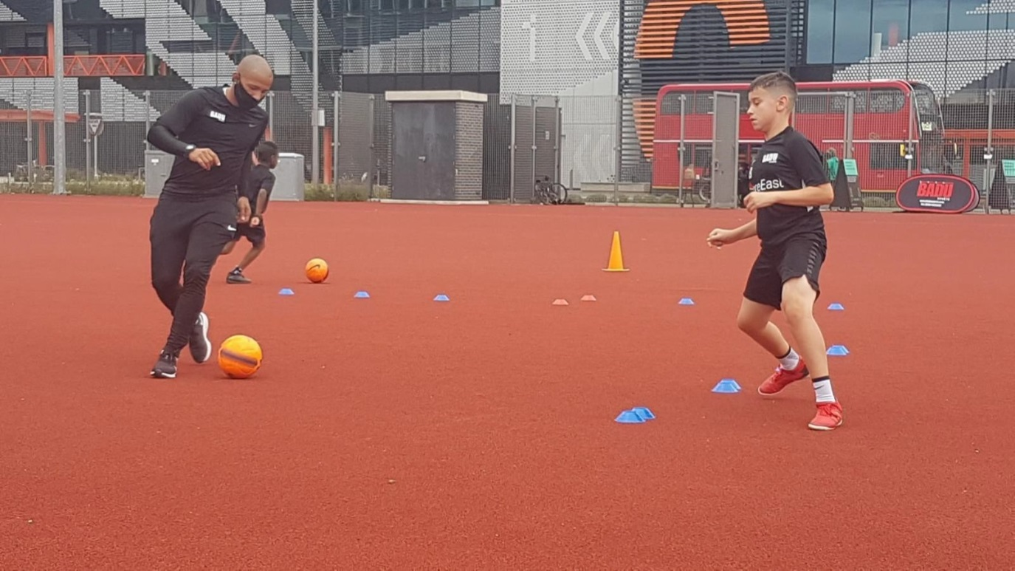
( Reicher,2021).
It is necessary to make a logical decision to get out of this situation with the pandemic and young people. This is the decision made by a significant number of parents in England - homeschooling as a possible and good outcome. A good alternative for closed schools. Physical activity is limited, but apparently, they have learned from the failure. Children and young people now value the benefits of physical activity. There is youth activism concerning the environment and the regional sports sector. The aim is to provide safe methods of sports for children (Cruickshank,2012).
One way is to train on your own at home. It can be practiced at a convenient time and significantly improves mental attitude.
Another way is training in an electronic environment. And here we have the disadvantage of the lack of live communication. But the benefits are not small either. It saves time from traveling to the gym and back. Vital indicators improve, which leads to a better tone. Prevention of mental changes during locking is performed, namely - depression, anxiety, suicidal tendencies ( Reicher,2021).
We can consider 1 more case from the field of British football.
A very big problem is the cancellation of matches, both from a financial point of view and for fans of this sport. If we think logically, how can we alleviate tension and resentment? In the first place, this important sector of sport must be financially and gratuitously secured through state funding. Fans have the opportunity to virtually watch the meetings. Another possibility is to allow a small number of spectators, as this does not interfere with the restrictions. This will reduce the mental load for both the sports community and the fans. Every difficulty is a school for future success. Each successfully solved task is a reward for the work done (Alrutz,2012).

Conclusion
We looked in detail at the concept of community engagement in the sporting sector in England and the principles and standards of inclusion.
As with ordinary human relationships, the same rules apply to children's sports and football. A good action plan, positivism, creativity, and logical thinking are key factors. Only the people involved are successful. The commitment itself makes the participants give their best (Cruickshank,2012).
The coronavirus pandemic is a natural disaster that needs immediate intervention. Logical thinking guides a way out of this drastic situation. For each action, there is a counteraction equal in size and vice versa in strength. There is a solution to every task (Lewis,2018).
The sports sector is one of the most affected by this unforeseen natural disaster. It is necessary to adapt to the new situation and put on the agenda alternatives that were not part of the daily life of the British sports sector.

Reference list
Burgess, R.A., Osborne, R.H., Yongabi, K.A., Greenhalgh, T., Gurdasani, D., Kang, G., Falade, A.G., Odone, A., Busse, R., Martin-Moreno, J.M. and Reicher, S., 2021. The COVID-19 vaccines rush: participatory community engagement matters more than ever. The Lancet, 397(10268), pp.8-10.
Key, K.D. and Lewis, E.Y., 2018. Sustainable community engagement in a constantly changing health system. Learning health systems, 2(3), p.e10053.
Stewart, T. and Alrutz, M., 2012. Meaningful relationships: Cruxes of university-community partnerships for sustainable and happy engagement. Journal of Community Engagement and Scholarship, 5(1), p.6.
Palombaro, K.M., 2009. Creating sustainable community engagement initiatives in a graduate physical therapy program. Metropolitan Universities, 20(3), pp.61-76.
Head, B.W., 2007. Community engagement: participation on whose terms?. Australian Journal of Political Science, 42(3), pp.441-454.
King, C. and Cruickshank, M., 2012. Building capacity to engage: community engagement or government engagement?. Community Development Journal, 47(1), pp.5-28.
Larsen, K., Gunnarsson-Östling, U. and Westholm, E., 2011. Environmental scenarios and local-global level of community engagement: Environmental justice, jams, institutions and innovation. Futures, 43(4), pp.413-423.

