Managing Enterprise in 21st Century/BMSW4006
Lecturer: Ngozi Ibeji
Animal therapy in care homes
Group 2: Siyana Stefanova (2016762) Katia Dimitrova (2019776) Akhtar Uddin (2007955)

Table of Contents

Executive summary 2
Company Overview 3
Product and Services 5
Market Audit – Competitors Analysis, SWOT Analysis, Pestel Analysis 6
SWOT Analysis – Strengths 7
SWOT Analysis – Weaknesses, Threats and Opportunities 7
Pestel Analysis 8
Target Market 9
Marketing Plan 10
Management Team 11
Financial Plan 12
Appendices 16
Appendix 1 16
Appendix 2 17
Appendix 3 18
Appendix 4 19
Appendix 5 20

Executive summary

This report introduces a new business company ‘Ray of Sunshine’ to our potential investors. We are applying to get a start-up grant of £25,000 and hope our proposal will convince you to make an investment in something we consider having a high prospective outcome within similar investments. The report will outline the potential of our business and focus on explaining the company’s current position on the market, competitor’s related strategies and financial forecast for the next 12 months.
Our new business is a partnership of 3 co-founders, and we will contribute to the company with our own investment. The business will promote animal therapy in care homes and advertise on social media or directly into the venues. Our business idea will target elderly people (15.21 % of the UK population is age 70 and over) and their relatives as well as care homes management.
The report is looking at the current and future potential of the company and highlights the advantages of the business. Ray of Sunshine is feeling a gap on the market and will promote the benefits of animal therapy for elderly people in care and nursing home in Birmingham. Our current competitors are nationwide, and our local competitors are very limited. This is giving us a head start on the market industry and confidence that our business is going to succeed.
The report is aiming to indicate the business opportunity and the potential business growth in the close future.

Company Overview

Business History, Ownership, Location, Mission, and Vision statement

Ray of Sunshine is an equal business partnership of 3 co-founders. According to the UK government ‘In a partnership, you and your partners personally share responsibility for your business. This includes any losses your business makes, bills for things you buy for your business, like stock or equipment. Partners share the business’s profits, and each partner pays tax on their share’ (Set up a business partnership, 2021)
Our company is based in Birmingham, the second biggest city in the UK with over 239 care homes and a population of 53,691 elderly people (Appendix 2). In 2021, there were 17,598 care homes across the United Kingdom (UK: Number of care homes 2021 | Statista, 2021). 239 of them are based in Birmingham.
The Business idea for Ray of Sunshine emerged from a regular visit to my mother in low care home where she was moved after needing 24/7 care. The transition into care homes for elderly people is extremely challenging. Our company discovered a gap on the market to make this transition smoother and helped elderly people to settled into their new environment. The business idea introduces animal therapy services into care homes. With a healthy budget of £40,000 (£25,000 grant and £15,000 from personal investment) we are planning to run animal therapy services to provide exclusive interactive sessions to elderly people.
The mission statement of Ray of Sunshine is ‘Every person deserves happiness’, and our vision statement is ‘We are bringing comfort, love and happiness to your life through animal interaction’. The UK nation is designated for its love of animals and one of the most popular projects to support the integration into care homes and care process is pet therapy (or animal therapy).
Pet therapy is a low-cost effective service and aside from personal expenses and business facilities costs could be minimalize. Our animal resources (mainly cats and dogs) will be coming from animal rescue homes where all the pets already passed health checks before they are allowed to visit care homes.
Animal interaction in an elderly person’s life is important for their mental health and quality of life as well as bringing a comfort and a warm feeling of love. The benefits of animal therapy are almost endless. From reducing high blood pressure, stress relief and lower anxiety to providing mental stimulation and a positive mood. Cuddling pets helps release hormones such us oxytocin and serotonin. These hormones are referred as a ‘happy hormones’ because they increase level of happiness. Pets are great mediator for promoting a social interaction between the residents in care homes. They help to connect elderly and engage them into activities. Animals could bring back a happy memory of their own pets to seniors suffering with Dementia and Alzheimer’s. Moving to a care home could be a stressful time and many people feel lonely and separated from their usual surroundings. Integrating cats and dogs into care homes programs, could boost activity levels and encourage residents to overcome their communication boundaries.
While care homes are aimed to provide a natural and safe environment for people who need care, that adjustment from independent living to life in a care home can be challenging, especially in the beginning stage where residents adapt to their new environment and establish new friendships and relationships. Our approach is to customize our clients’ needs and bring a little comfort, love, and happiness to their lives in a place they might struggle to adapt. Our sessions are provided by well-trained and qualified staff, and we hold Animal Therapy Training Certificate.

Product and Services

Market Plan
Our company ‘Ray of Sunshine’ provides a marketing plan which includes three main packages.
1.‘Ray package’ this being 1 hour session at £90 for two animals at a maximum of 6 people.
2. ‘Sunshine package’ is a half a day experience, priced at £300, maximum 8 people interacting with 2 animals.
3. ‘Happiness package’ a full day interaction - £490 up to 12 people engaging with 3 animals.
Our office will be located at Harborne street, near the city center in a suitable location, easily accessible from all parts of Birmingham. ‘Ray of Sunshine’ offer a live stream to access the younger audience. We have Facebook and Instagram account. We are planning to promote our business within articles/newspapers, radio and leaflets which are most accessed by the older generation. Gaining their attention will spread company image across Birmingham. We are hoping to influence the public and make sure that our company is being spoken about in the best light and is highly broadcasted.
To keep the cost down we are planning to use sources from rescue animal center or charity organization dealing with animals. Using this road, we are making sure that the animals are already passed health check and are suitable for interaction with people.

Market Audit – Competitors Analysis, SWOT Analysis, Pestel Analysis

Competitors Analysis
We have three main competitors first of being Critterish All Sorts, Kimmy’s Mobile Zoo and Acehounds friendship dogs. Critterish All Sorts (Appendix 4)
Critterish AllSorts is a company with 10 years of experience dealing with various animals and creatures. The company owner has specific pet therapy qualifications. Through this they have maintained tv programs including their animals as well as live stream every 4pm with their pets. They have published two books about their pet therapy company as well as the benefits. As well as this they all obtain many online YouTube videos which explore more of their company and inform the audience of their aims and goals. Compared with our company they have high prices and in this was we believe them to be a lower threat.
Kimmis Mobile Zoo’s owner had a degree in Zoology and has had this company since 2011, they have 20 separate reptiles/animals. They offer sessions that can be one to one on their bus with their reptiles which have been placed within glass cages that are very similar to their habitats and therefore this makes them comfortable and at ease with the costumers. They have a Facebook page as well as advertising themselves through magazines. Additionally, they partake in various photography experiences with their animals to sell the company at the best rate. They offer sessions about animal phobias specifically about spiders, snakes, and otters. Their company prices are high then ours expect for the full day package which is lower than our price of £490. This makes them a fair threat for us as a company. However, ‘Ray of sunshine is animal therapy certification company. Our animals provide not only entertainment but also physical and mental help to our clients which makes our business completely different from the services Kimmis Mobile Zoo offers.
Ace hounds’ friendship dogs. The owner of this company takes in dogs after dogs have completed their racing lives. They are taken to care homes and are offered for walks and simple pet therapy in these industries. We can’t compare prices with them as they have been funded through the lottery as well as the fact that they are part of a large shop chain. They also only have a Facebook page to advertise themselves through. As a company they pose a lower threat to us because of these reasons.

SWOT Analysis – Strengths

‘Ray of Sunshine’ Strengths
1.Location – Birmingham has around 239 care homes

2.Full time availabilities. Open 7 days in the week with extended working hours

3.Social media communication (WhatsApp, Facebook, Instagram, Twitter, Viber) life stream and an online chat

4.Animal therapy certification organization with trained staff

5.Using resources (animals) from animal rescue centres and charity organizations

6. One to one live sessions and face to face interaction with elderly people relatives

7. Different packages and product offers at competitive prices

SWOT Analysis – Weaknesses, Threats and Opportunities

Weakness | Threats | Opportunities
1.A new starter company  2. Providing staff training might be cost effective and increase our budget  3. Underdeveloped Network  As a new company we will not have the contacts to establish our position on the market right way | 1.Non-profit organizations provide animal therapy using volunteers  2.Competitors  3.National Disaster (Covid -19) | 1.Offer a new packages and products. Our company constantly evolve new and creative ways to deliver our Vision and Mission  2.Extend company business out of Birmingham across the UK  3.Reach out different sectors (schools, hospitals). We are determined to fully expand the potential of Animal Assisted Therapy

Pestel Analysis
Economic factors, social factors, technological factors, legal factors, environmental factors

Ray of Sunshine Pestel Analysis

Economic factors
Economic growth
Interest rates
Unemployment
Inflation

Social factors
Social trends. Ray of Sunshine is using social media to advertise and interact.

Technological factors
Technology is progressing continuously
Technology development will affect our business in many ways from communication with customers to offering products and services through digital devices

Legal factors
Consumer Law

Environmental factors
Pandemics (Covid-19)

Many external factors would affect any business but not all of them will be relevant to all businesses. Based on the nature of our company there are three external factors might be considered to make an impact on our services.
Environmental factors
The last two years showed us how national disaster like Covid 19 could affect business and have massive impact on the UK and word economic situation.
Technological factors
Technology plays main role for business progression. Using technology tools makes services much easier and efficient. Modern technology allow business to have access to range of devices and applications to manage their operations. Business technology can boost communication with customers. Digital applications and live chat systems become convenient way to trace services and offer products to potential clients.
Social factors
Social media platforms are one of the most powerful tools to reach an audience. But social media trends are changing rapidly, and businesses should keep up with the changes on daily bases to reach their best potential.

Target Market

The target market of our company ’Ray of Sunshine’ is nursing homes and care homes. Through our research we found around 235 care homes in Birmingham alone. In the future our target market will be based on hospitals, mental health trusts, primary care trusts, community providers, NHS organizations etc. Our company offers pet therapy which we found most effectively working with this our chosen target elderly residents. Animal therapy has huge potential to be extended not only in care homes but in different sectors (hospitals, schools) in the future. According to statistics in 2021 the Birmingham population was 2 million people and 13% of this population was dominated by elderly people. Nowadays, people seem to have longer life expectancy and due to this we have a much larger potential customer base as the audience seems to be growing over time. Knowing the power of social media, we can use this to our advantage and create live streams. Our target audiences are not just seniors in care homes. We planning to target younger generation related to elderly people. Grandchildren, children, and younger family members can get involved following us on social media or simply being part of our life shows. This will help to spread the word to their grandparents, neighbors, or elderly neighbors/ friends. Ray of sunshine focuses on building image through people and marketing promotions. Part of our marketing plan was a survey we have done (see appendix 1) with thirteen questions all based around the subject of pets and the consumer need for animals as well as if they had any personal preference towards what they would like to be presented with. In this way we can more accurately appeal to a target audience and fulfill their desires and needs as a consumer base. We used three graphs as visual imagery which present the most wanted / liked animals in England. These being cats and dogs at the top of the most desired pet interactions. This is perfect as we provide exactly that, and this way lean towards exactly what the customer wants from the organization. We can also see through the graphs that pet therapy was not popular and low in demand yet over the years the demand for pet therapy has significantly increased. This being due to a potential acceptance of it as well as statistics that prove the benefits of pet therapy.

Marketing Plan

Our company ‘Ray of Sunshine’ provides a marketing plan which includes three main packages. First off being the…
‘Ray package’ this being 1 hour £90 for two animals at a maximum of 6 people. Secondly...
‘Sunshine package’ this being half a day £300 maximum 8 people interacting with 2 animals. Finally...
‘Happiness package’ this being a full day package £490 up to 12 people interacting with 3 animals.
Our office will be located at Harborne street, which is near the city center and a suitable location which is easily accessible from all parts of Birmingham. This way we are most continentwide as a company have a live stream account to access the younger audience, a Facebook account, and Instagram. We are usually promoted within articles/newspapers, radio and leaflets which are most accessed by the older generation, and this was we gain their attention and spread the message of our company. Through this we are able to influence the public and make sure that our company is being spoken about in the best light and is highly broadcasted.

Management Team

Management team are a group who manage the company or the organization. (Cambridge dictionary, 2021)
‘Ray of Sunshine’ is a partnership business compromising of three co-founders. Our management team including Siyana Stefanova Chief Executive Officer (CEO) who is the operational manager, Katia Dimitrova Chief Marketing Officer (CMO) is the sales and marketing manager, and Akhtar Uddin Chief Financial Officer (CFO) is the account manager.


Siyana Stefanova CEO has a BA Hons in Business Management and Public Relations
and NVQ level four in Animal Therapy. Siyana has ten years' experience in operating a co business and has five years leadership, management, and interpersonal skills. Her role is managing overall operations, structure, and strategies of the company.

Katia Dimitrova CMO has a BA Hons in Business Management. NVQ level four in animal management and Animal Therapy. Katia is also a pet adaption counsellor, and she has ten years individual experiences in managing sales, marketing and promoting skills. Her role is managing sales, promotions, and marketing campaigns.

Akhtar Uddin CFO has a BA Hons in Business Management and has NVQ level four in Pet Therapy. He is accredited by Association of Chartered Certified Accounts (ACCA) and Chartered Institute of Management Accounts (CIMA). Akhtar has ten years' experience in finance and accounts and has IT, accounting, and analytical skills. His job role within the company is managing the financial operations, planning and analysis.

Financial Plan

Financial Plan
Financial plan is essential to any business. As entrepreneurs it is important to use scorecards for strategies in our organization. There are three basic statement to track a business, which are Income Statement, Cash flow Statement and Balance Sheet. Together these statements help to keep the business healthy. It is a good practice to do cashflow monthly and finalise it after twelve months.
Cashflow Forecast
Cashflow statement is important in business as it keeps a track of the total amount of the company's income that shows what comes in and out of the business. (Stock Analysis,2021)
Cash keeps the business moving, it pays expenses, and it shows how successful the business is, from start to finish. Managing cash is more critical than managing sales.
Ray of Sunshine cash forecast from January 2022 to December 2022. Gives a clear picture of the cash position of the company. It shows the breakdown of inflows and out flows relating to the operation, investment, and the financing. (Appendix 5).
We are investing £5000 each into the business. Investment from Lottery Company UK is £25000.This is a total investment of £40,000.00
First month January 2022 the cashflow total income is predicted to be £43,600 and total out goings is to be £15,618. This will leave an opening balance for February of £27,982. Sales will increase month on month to year ending December 2022. For the twelve month there will be no negative income. April to September the sales will increase due to activity moving from indoors to outdoors because of warmer weather.
As a start-up business, we collectively will not take any wages for January, February, and March. Instead, we will take a total drawing for personal needs of £4,500.00 in total between the three of us per month collectively
Cash flow total incoming will be £211,600, which includes investment, grant, sales income Total outgoings £160,342, which includes all cost for equipment's, utilities, accountant fees, training, etc (see the cash forecast).
That will leave the closing bank balance at £51,256. So, in year 1 the closing balance forecast will be £51,256. Year two forecast growth is 5% and year three forecast growth is 7%.

Profit and Loss
Profit and lost statement(P&L) show the company's revenue and expenses for the 12 months. When the profit is greater than the expenses than the business is profitable. When costs are greater than the sales the business is at a loss (Business accounting basic, 2021)
To work out the breakeven point for Ray of sunshine, take the sales figure and multiply by cost and divide by the net profit you will get the breakeven point for the 12 months totalling £145,092.00
The revenue (sales) for Ray of Sunshine is £171.600.00
The Expenses (cost) for Ray of Sunshine is £145,092.00
Drawings is £4.500.00
The net profit is £13,008.00
Breakeven point is £145,092.00
(Appendix 3)

Conclusion

We believe Ray of sunshine will be a successful business and establish itself on the market because our mission is to provide a comfortable existence to elderly people and improve their quality of life in care homes using animal therapy. Our company is feeling a gap in the market and aiming to expand animal therapy business by covering different organizations – hospitals, schools in the future. Our competitors are nationwide which is giving us the advantage to take over the local market and become a threat to our outside Birmingham competitors with the new packages and approach we offer. Our business has got massive potential to grow along side with the increase of life expectancy and percentage of old people living longer and needing more care.

.

References
BBC, 2021. Environmental factors - External factors - National 5 Business management Revision - BBC Bitesize. [online] BBC Bitesize. Available at: https://www.bbc.co.uk/bitesize/guides/zgfrpbk/revision/6 [Accessed 30 November 2021].
Dictionary.cambridge.org. 2021. organization. [online] Available at: https://dictionary.cambridge.org/dictionary/english/organization [Accessed 30 November 2021].
GOV.UK. 2021. Set up a business partnership. [online] Available at: https://www.gov.uk/set-up-business-partnership [Accessed 30 November 2021].
Inc.com. 2021. How to Define Your Target Market. [online] Available at: https://www.inc.com/guides/2010/06/defining-your-target-market.html [Accessed 29 October 2021].
Kimmy’s Mobile Zoo Animal Parties Fun Days Animal Workshops. 2021. Special needs, Care Homes, Nurseries & Pre-Schools. [online] Available at:https://www.kimmyszoo.co.uk/services-prices/sensory-care-homes/#1d0cf5aeaad4158d1 [Accessed 30 November 2021].
Petsastherapy.org. 2021. Pets As Therapy. [online] Available at: https://petsastherapy.org/ [Accessed 30 November 2021].
Regencybirmingham.com. 2021. Birmingham Dementia Care Facility | Regency Retirement Birmingham. [online] Available at: https://regencybirmingham.com/birmingham-retirement-community-services/birmingham-dementia-care-community/ [Accessed 30 November 2021].
Statista. 2021. UK: Number of care homes 2021 | Statista. [online] Available at: https://www.statista.com/statistics/1236800/residential-care-homes-and-nursing-homes-in-the-united-kingdom/ [Accessed 28 November 2021].
Venngage. 2021. What is a Marketing Plan and How to Make One? - Venngage. [online] Available at: https://venngage.com/blog/marketing-plan/ [Accessed 1 December 2021].White, C., 2021. What's a Competitive Analysis & How Do You Conduct One? [online] Blog.hubspot.com. Available at: https://blog.hubspot.com/marketing/competitive-analysis-kit [Accessed 2 December 2021].
Stock analysis (2021), Cash Flow Statement [web], available at: https: //stockanalysis.com term cash flow statement (Accessed on 3rd Dec 2021)

Appendices

Appendix 1

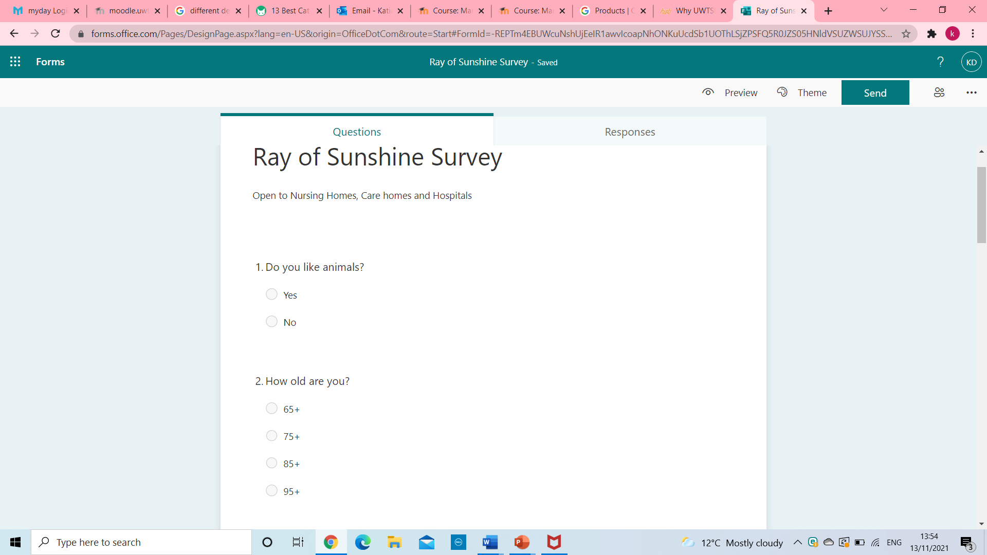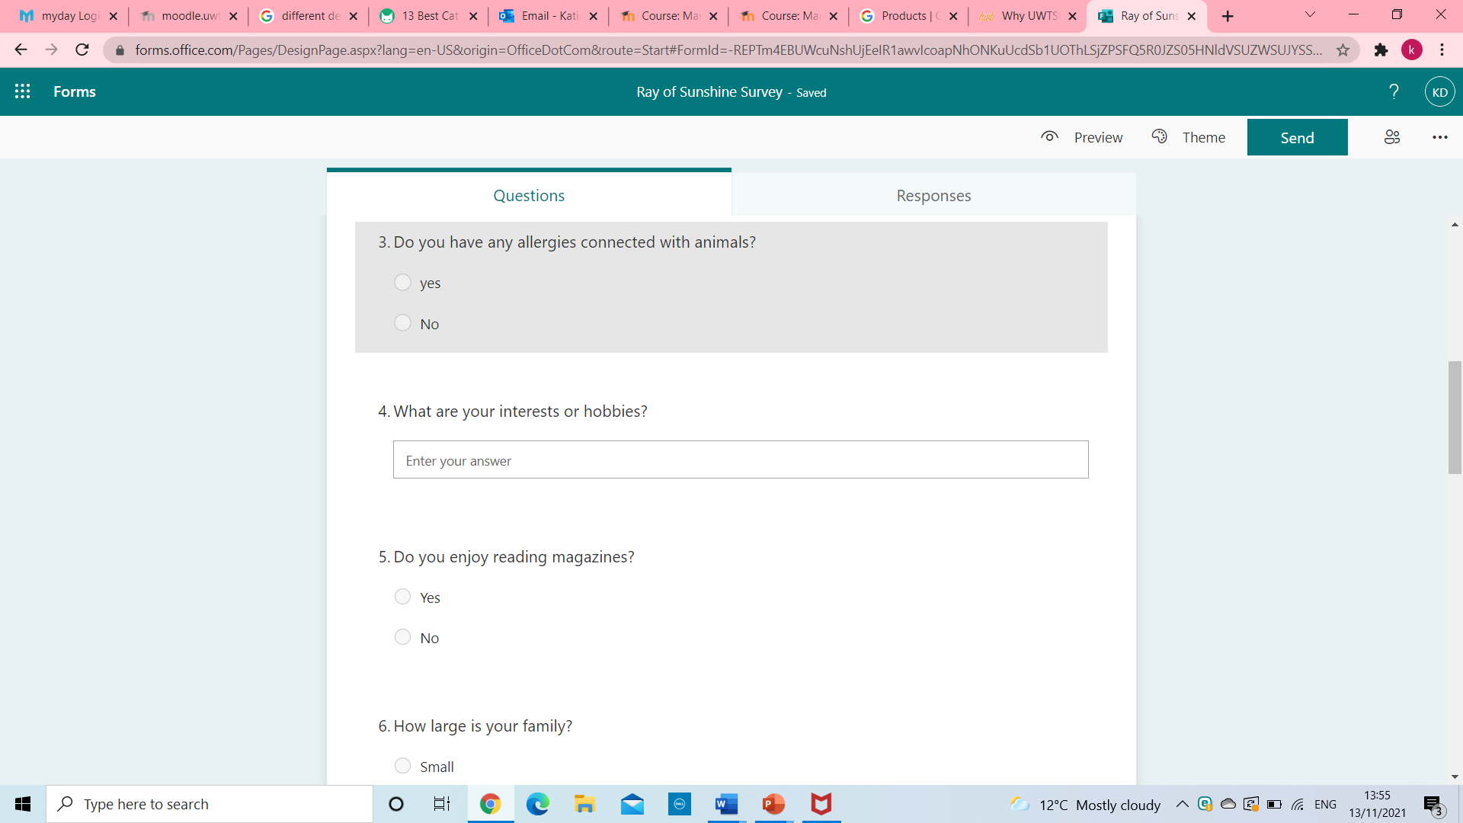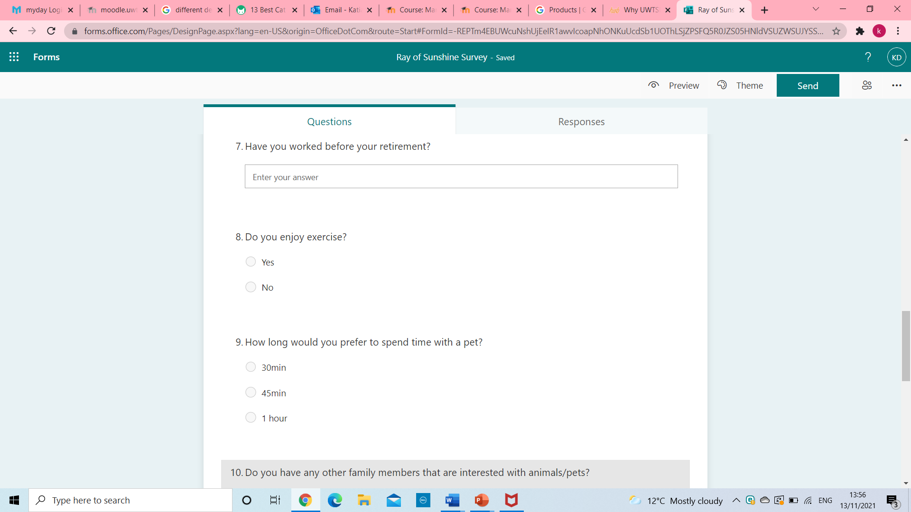
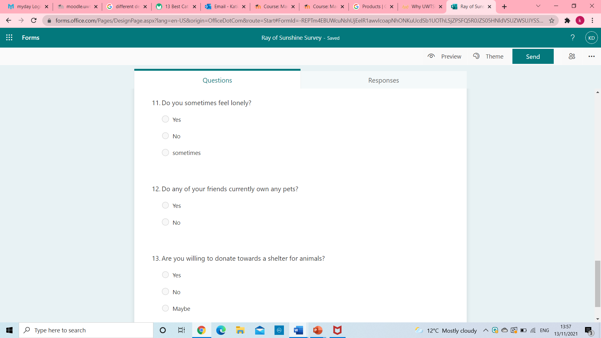

Appendix 2

People aged 65 and over living alone, projected to 2020
Birmingham | 53,691 | 54,297
West Midlands | 376,287 | 389,365
England | 3,482,542 | 3,607,069

Appendix 3

Forecast of profit and loss

Business: Ray of Sunshine
Period: Jan ‘22 to Dec ‘22
Sales £171,600 (A)

Less direct (variable) costs:
Materials £
Direct wages £
Other £
Total direct costs
Gross profit/contribution £171,600 (B)

Fixed costs (overheads):
Wages/salaries (Inc. Taxes) £40,500
Drawing £13,500
Rent £12,000
Utility £840
Advertising £4,080
Insurance £600
Transport/travel £8,974
Telephone/mobile phones/
internet £2,400
Stationery/postage £600
Outsourcing pets £69,500
Depreciation £800
Uniforms £300
Web Designs £970
Training £1,788

Local taxes: £
Other prof.fees £540
Other sundry £1,200

Total fix costs: £145,092 (C)
Net profit £ 26,508
Less drawings or dividends £ 13,500
Profit retained in the business £13.008

Break-even point = A x C / B
£145.092

Appendix 4

Factors | Our company:  Ray of Sunshine | Competitor A  Critterish All Sorts | Competitor B  Kimmis Mobile Zoo | Competitor C  Acehounds Friendship Dogs
Product and Services | Cats and dogs | Critter, invertebrates | Mammals, reptiles, amphibians | Greyhound dogs
What makes us different | Bespoken services  Instant communication 24/7 chat line  Using animals from rescue centers  Live streams, social media, | The owner is fully qualified in animal assisted therapy. They only use certain type of animals - critter assisted therapy | They have mammals, reptiles, amphibians.  Providing animals shows and films | Dog walking for exercise offering a chance to spend time in kennels learning dog care.
Industry | Animal Therapy | Entertainment | Entertainment | Physical Exercise
Current strategy and future | An active Facebook, Instagram accounts, and influencer outlook. | Work through media, tv and press | Facebook page | Facebook supported by Hold East Herts Lottery £25,000 jackpot.
Prices | Offer 3 packages with affordable prices  1hour session £90  Half Day (up to 6 hours) £300  Full day £490 | Expensive for customers  From £125 for one hour session to  £500 for a full day | Reasonable prices  45 minutes show - £115  90 minutes show £205  Full day £400 | Depending on charity funding
Location | Harborne Road B17 ODH | No address, two phone numbers for contact-  07794342355  01543326779 | East London they have a van where you can book sessions | The Pines, Start Hill, Bishops Stortford CM227TG  Phone: 07505307810
Company Threats | Fair | Low | Fair | Low

Appendix 5

Cash Flow Forecast for Ray of Sunshine


