Module Code: ACCA4024
Module Title: Networks and Cyber Security Essentials
Assignment Title: Cybersecurity and Data Governance Framework for Health Plus Analytics (HPA)
Student I.D- 2436555
Student Name- Dinesh Pandey
Group-2

Table of Contents
1. Introduction 4
2. Identification of Threats 4
2.1 External Threats 4
2.2 Internal threats (Weaknesses and Threats Analysis) 5
2.3 CIA Triad Impact 5
3. Security Policies (Governance Framework) 6
3.1 Access Control Policy 6
3.2 Remote Working & BYOD Policy 6
3.3 Data Classification Policy 7
4. Risk Mitigation 7
4.1 Zero Trust Architecture 7
4.2 Encryption 7
4.3 Immutable Backups 8
4.4 Endpoint Security 8
4.5 Network Segmentation 8
5. Monitoring and Incident Response 8
5.1 Continuous Monitoring 9
5.2 Incident Response Framework 9
6. Training and awareness program 9
6.1 Phishing Awareness Training 10
6.2 Job-Specific Training 10
6.3 Continuous Learning 10
7. Conclusion 10
References 11
Appendix: Presentation (HPA Cybersecurity Framework) 13

1. Introduction
Health Plus Analytics (HPA) is a healthcare information technology services company for UK hospitals to manage patient data. It recently experienced several cybersecurity incidents, such as unauthorised access to its cloud data and a ransomware attack on its analytics platform. The attacks reflect a weak cybersecurity for HPA.
Data security is important in a cyber hostile environment with hybrid and personal devices. Health data is valuable and sensitive, and makes the health sector an attractive target. So, the report suggests a cybersecurity and governance policy that meets the UK General Data Protection Regulation (GDPR), Data Protection Act 2018, NHS Data Security and Protection Toolkit (DSPT), ISO 27001, and NIST Cybersecurity Framework.
This will help to support data confidentiality, integrity, and availability (CIA) and security culture.

2. Identification of Threats
The HPA cybersecurity threats can be classified as external and internal (CIA).

2.1 External Threats
Porter's Five Forces model can be applied to the cybersecurity environment of Health Plus Analytics (HPA) to understand the external factors that are contributing to the growth in cybersecurity threats in health data.
Threat of New Cyber Entrants (High): The cyber industry is easy to join, as "hacking as a service" and ransomware kits are being sold on the dark web. This increases the threat of ransomware attacks as simple hackers will use advanced ransomware to attack HPA (Moore, 2023).
Power of Cyber Threat Actors (High): Malicious hackers and cyber terrorists are sneaky. This enables malicious cyber-attacks like Advanced Persistent Threats (APTs) to be more covert and steal critical health information.
Threat of Substitutes (High): Cyber threat actors are continually looking for ways to successfully breach security. For instance, if a threat actor is not able to do ransomware attacks, they may do social engineering and phishing attacks to steal the passwords of the employees, particularly in hybrid and remote working (Kumar, 2023).
Competition (High): Cyber threat actors compete with each other for profits and reputation, resulting in more and bigger attacks. This may result in attacks against high-value targets, such as health analytics, an issue for HPA.
Vendor Power (Medium to High): HPA relies on cloud vendors, exposing vendor risk. Poorer security or configurations could result in cloud misconfigurations, affecting patient data in a multi-tenant environment (Prabhu and Thompson, 2022).

2.2 Internal threats (Weaknesses and Threats Analysis)
Weaknesses (Internal Vulnerabilities)
Weaknesses include control over access controls and over-privileged staff. This could result in the misuse of data. There's also inadequate cybersecurity knowledge of staff in terms of the use of email, cloud computing, and personal devices for remote access. And the lack of policies for management of Bring Your Own Device (BYOD) in organisations is an issue, as these devices may not be encrypted and patched. Data management in departments may also result in accidental breaches of health data (Polu et al., 2022).
Threats (Internal Risks)
Dishonest staff may steal and/or sell data for money or during favours. Or simply user error such as incorrect settings of cloud storage, emailing data to the wrong addresses or poor passwords. Or shadow IT where people store and process patient data in unauthorised software (such as instant messaging) which is not controlled and lacks security processes (O'Brien et al., 2023).

2.3 CIA Triad Impact
The Cyber Security CIA Triad - Confidentiality, Integrity and Availability - is a basic understanding of the impact of cyber security risks to the Health Plus Analytics (HPA), processing and storing of personal patient data.
Confidentiality
Confidentiality is the disclosure of patient data only to the appropriate parties. HPA confidentiality attacks are commonly a result of phishing, insider and cloud. Data breaches adhere to the UK General Data Protection Regulation (UK GDPR) and Data Protection Act 2018, but also have a major impact on reputation and trust (Jamarani et al., 2024).
Integrity
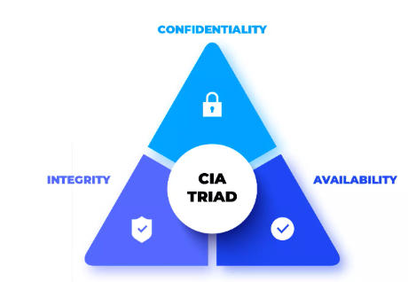
Integrity is medical data is correct. If an analytics (medical data or diagnosis data) was corrupted, then this could lead to an inaccurate diagnosis. This could be a safety concern for the patient and HPA's analytics.
Figure 01: CIA Triad for health care data (Source: IDstrong, 2026)
Availability
Availability is the availability of data and systems. Health Protection Australia (HPA) analytics servers may go down, because of ransomware and DDoS. This could impact on health service provision and hospital and patient decision making (Jones et al., 2023).

3. Security Policies (Governance Framework)
In order for Health Plus Analytics (HPA) to be resistant to the ever-growing cybersecurity threats, a governance framework is required. The policies adhere to the ISO 27001, National Institute of Standards and Technology (NIST) Cybersecurity Framework (CSF), UK General Data Protection Regulation (GDPR) and NHS Data Security and Protection Toolkit (DSPT) to ensure they are compliant, reduce risk and resilient.

3.1 Access Control Policy
The Access Control Policy aims to restrict access to health sensitive systems and data to the minimum necessary. HPA should follow the Least Privilege Access (LPA) principle and only have access to the systems they need to do their work. This will protect data from misuse in case of compromised accounts. Multi-Factor Authentication (MFA) should be used to protect passwords, if possible. This will prevent malicious use of passwords through phishing. Role-Based Access Control (RBAC) policies should be developed to manage access to patient data based on job roles and responsibilities to formalise access to patient data (Oyekunle et al., 2025). Access reviews should be conducted by HPA every quarter to remove dormant and obsolete accounts and ensure policy and regulatory compliance.

3.2 Remote Working & BYOD Policy
The move to hybrid working should prompt HPA to develop a Remote Working and BYOD Policy. Remote access should be via encrypted Virtual Private Networks (VPNs). Only devices registered with the corporate network should be allowed to connect to corporate systems via Mobile Device Management (MDM) software that will also enable IT administrators to control devices remotely. Devices should be encrypted (BitLocker or File Vault) in case of loss or theft of the device (Rawindaran et al., 2023). To avoid the risk, employees should not be allowed to copy or download sensitive information to a device to store data in a mobile device and data should be stored securely in corporate systems.

3.3 Data Classification Policy
A Data Classification Policy is needed to classify health data according to sensitivity. Health and Personal Analytics should define Public, Internal, Confidential and Highly Sensitive (patient) data. This data should have access, encryption, and sharing controls in place. For instance, Highly Sensitive (patient) data should be encrypted in use, in transit, and should only be shared with a team of trusted medical/analytics personnel (Chowdhury, 2025). This allows appropriate security controls to be applied to the information and ensures that data can't be breached accidentally or deliberately. HPA staff will report any potential security incidents to the IT Security Team within one hour. This will minimise the risks. In addition, HPA should report data breaches to the Information Commissioner's Office (ICO) within 72 hours, as required by the UK GDPR, to ensure transparency and accountability (Mudunuri, 2023). This enhances preparedness and response.

4. Risk Mitigation
Health Plus Analytics (HPA) needs to implement technical and process security controls to minimise cybersecurity risks. This is to eliminate vulnerabilities, risks and incident response.

4.1 Zero Trust Architecture
A Zero Trust Architecture (ZTA) is critical in today's healthcare environment with increased remote access and cloud computing. This means no one and nothing is trusted, either inside or outside the network. Rather, trust is granted through user authentication (including contextual cyber risk, device, and user ID). This is achieved by authentication (using Multi-Factor Authentication (MFA) and monitoring (Rahaman and Islam, 2023). HPA's Zero Trust approach provides security against unauthorised access through stolen credentials and insiders and rogue devices, and controls access to patient data and data analytics systems.

4.2 Encryption
Encryption is critical to protect data confidentiality and abiding by the UK GDPR. HPA should implement the Advanced Encryption Standard (AES-256) for data at rest, which is the newest encryption standard to secure data at rest (e.g. patient data and databases). For data in transit, HPA should use Transport Layer Security (TLS) 1.3 which should be used to encrypt data between systems, to the cloud and to devices (Khan et al., 2022). This will ensure that if the data is intercepted it will be secured from attacks.

4.3 Immutable Backups
To secure against ransomware attacks, HPA should have immutable backups to provide Write-Once-Read-Many (WORM) capabilities. This will mean that information stored in the backup can't be altered or deleted while the backup is in place. This will mean that they can be restored safely if they are damaged or encrypted by ransomware attacks (He et al., 2022).

4.4 Endpoint Security
Laptops, tablets and smartphones are prime targets for cyberattacks HPA should have an advanced Endpoint Detection and Response (EDR) system, in addition to antivirus, to detect, analyse and respond to attacks in real time (Tyagi et al., 2023). Backups also need to be tested regularly to ensure they can be restored to avoid downtime and ensure availability of critical health care analytics services.

4.5 Network Segmentation
Network Segmentation is critical to contain cyberattacks on HPA's network. Healthcare analytics systems should be separated from the corporate network so hackers won't be able to freely move around the network if they were to access the system. This will stop them from accessing systems with patient data, even if they are able to access a segment of the network. This can be done by using virtual LANs (VLANs), firewalls, and access control lists (ACLs) between the segments of the network (Johnson et al., 2024). So, these controls provide a layered (defence-in-depth) approach for HPA to be better prepared for the new and ever-evolving cyber threats.

5. Monitoring and Incident Response
For Health Plus Analytics (HPA), monitoring and incident response is crucial to quickly detect, respond and recover from cybersecurity threats. Because of the high value of the data, we need to have a proactive and systematic approach to minimise the incident impact, and comply with the UK General Data Protection Regulation (GDPR) and National Health Service (NHS) Data Security and Protection Toolkit (DSPT) guidelines (Moore, 2023).

5.1 Continuous Monitoring
HPA should have a Security Information and Event Management (SIEM) system, which will continuously monitor the network, servers, cloud computing and end user devices. The SIEM system will collect the logs from various sources and help the security analyst to identify anomalies. It gives the following capabilities: threat detection, which can detect pattern-matching attacks like phishing and malware; behavioural anomaly detection to detect abnormal user behaviour or system activities that may be a potential threat; and real-time alerting to provide the IT security team with real-time alerting for a potential threat (Kumar, 2023).

5.2 Incident Response Framework
HPA should establish an Incident Response (IR) process based on the National Institute of Standards and Technology (NIST) Cybersecurity Lifecycle, to have a structured approach to respond to incidents.

Figure 02: Incident Response Process (Source: Created by Author, 2026)

People and systems are prepared, incident response plans are developed. During the Detection phase, security information and event management (SIEM) systems and intrusion detection system (IDS) discover an incident. In the Containment phase, the attack is halted.
At Eradication, vulnerabilities and viruses are removed. At Recovery, files and data are recovered from backups and systems and processes are safely restored (Prabhu and Thompson, 2022).
Finally, the Post-Incident Review process includes reviewing the incident, reporting breaches to the Information Commissioner's Office (ICO) within 72 hours and learning from the incident to prevent future incidents. This will lead to quick recovery with minimal downtime, and a cyber-attack-resistant system

6. Training and awareness program
Human error is one of the reasons for cybersecurity breaches in health organisations with patient data. So, Health Plus Analytics (HPA) should have a training and awareness program to reduce risks and increase security awareness.

6.1 Phishing Awareness Training
Healthcare organisations are often victims of phishing attacks. HPA should simulate phishing attacks to gauge the awareness and response to phishing attacks. They can then notify and educate these staff. They should alert anyone who clicks a link and micro train them not to click on links (Polu et al., 2022).

6.2 Job-Specific Training
Training should be job-specific. Programmers should be trained in secure programming, vulnerability analysis, and secure coding practices. Admins need to be trained in data management, privacy, and secure communications for patient data. Managers require training on compliance, incident management, and policies like UK GDPR and NHS DSPT. Customised training educates staff about their role in security (O'Brien et al., 2023).

6.3 Continuous Learning
Cyber threats are constantly evolving so learning must be ongoing. HPA should provide monthly micro-learning to provide short and focused information on threats and trends. Staff should also be provided with regular security bulletins to keep them updated on threats, policies and changes HPA should create an incentive program to reward staff for security-related incidents, to encourage positive behaviour (Jamarani et al., 2024). Cybersecurity awareness-raising marketing items (posters, workshops, newsletters) should be introduced in the organisation to promote cybersecurity awareness

7. Conclusion
Cybersecurity threats are continually evolving, and HPA needs a combined approach to cybersecurity. A policy, state-of-the-art technology, monitoring, and training will reduce the threats to HPA. This approach is CONFIGURED to ISO 27001, NIST Cybersecurity Framework, UK GDPR, and NHS DSPT, so it's compliant and instils confidence in the provision of health data services. This will improve security, privacy, and trust of patients.

References
Chowdhury, R., 2025. Quantitative Assessment of Predictive Analytics for Risk Management in US Healthcare Finance Systems. ASRC Procedia: Global Perspectives in Science and Scholarship, 1(01), pp.1570-1602.
He, Y., Maglaras, L., Aliyu, A. and Luo, C., 2022. Healthcare Security Incident Response Strategy‐A Proactive Incident Response (IR) Procedure. Security and Communication Networks, 2022(1), p.2775249.
Jamarani, A., Haddadi, S., Sarvizadeh, R., Haghi Kashani, M., Akbari, M. and Moradi, S., 2024. Big data and predictive analytics: A systematic review of applications. Artificial intelligence review, 57(7), p.176.
Johnson, O.B., Olamijuwon, J., Cadet, E., Osundare, O.S. and Weldegeorgise, Y.W., 2024. Developing real-time monitoring models to enhance operational support and improve incident response times. Int J Eng Res Dev, 20(11), pp.1296-1304.
Jones, M.C., Stone, T., Mason, S.M., Eames, A. and Franklin, M., 2023. Navigating data governance associated with real-world data for public benefit: an overview in the UK and future considerations. BMJ open, 13(10), p.e069925.
Khan, S.U., Yedlapati, S.H., Lone, A.N., Hao, Q., Guyatt, G., Delvaux, N., Bekkering, G.E.T., Vandvik, P.O., Riaz, I.B., Li, S. and Aertgeerts, B., 2022. PCSK9 inhibitors and ezetimibe with or without statin therapy for cardiovascular risk reduction: a systematic review and network meta-analysis. bmj, 377.
Konki, A., Pachava, S., Pavani, N.P. and Bhavani, V.D., 2023. Strength, weaknesses, opportunities, and threats analysis on the current scenario of primary health care in India. International Journal of Community Medicine and Public Health, 10(8), p.3016.
Kumar, I., 2023. Emerging threats in cybersecurity: A review article. International Journal of Applied and Natural Sciences, 1(1), pp.01-08.
Moore, K.E., 2023. Analyzing small business strategies to prevent external cybersecurity threats (Doctoral dissertation, Walden University).
Mudunuri, L.N.R., 2023. Risk mitigation through data analytics: A proactive approach to sourcing. Excel International Journal of Technology, Engineering and Management, 10(4), pp.159-170.
O'Brien, N., Li, E., Chaibva, C.N., Gomez Bravo, R., Kovacevic, L., Kwame Ayisi-Boateng, N., Lounsbury,
Oyekunle, S.M., Olaniyi, O.M., Oluyinka, E.A., Gbadebo, M.O. and Olasege, R.O., 2025. Adaptive AI pipelines in population health analytics for enhanced security and data governance. Journal of Engineering Research and Reports, 27(10), pp.338-358.
Polu, A.R., Narra, B., Buddula, D.V.K.R., Patchipulusu, H.H.S., Vattikonda, N. and Gupta, A.K., 2022. Blockchain Technology as a Tool for Cybersecurity: Strengths, Weaknesses, and Potential Applications. Unpublished manuscript.
Prabhu, S. and Thompson, N., 2022. A primer on insider threats in cybersecurity. Information Security Journal: A Global Perspective, 31(5), pp.602-611.
Rahaman, M.M. and Islam, A., 2023. Automation And Risk Mitigation in Healthcare Claims: Policy And Compliance Implications. Review of Applied Science and Technology, 2(04), pp.124-157.
Rawindaran, N., Nawaf, L., Alarifi, S., Alghazzawi, D., Carroll, F., Katib, I. and Hewage, C., 2023. Enhancing cyber security governance and policy for SMEs in industry 5.0: a comparative study between Saudi Arabia and the United Kingdom. Digital, 3(3), pp.200-231.
Tyagi, P., Grima, S., Sood, K., Balamurugan, B., Özen, E. and Eleftherios, T. eds., 2023. Smart analytics, artificial intelligence and sustainable performance management in a global digitalised economy. Emerald Publishing Limited.

Appendix: Presentation (HPA Cybersecurity Framework)
Slide 1
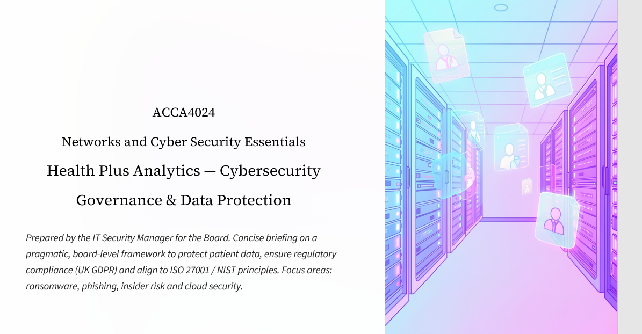

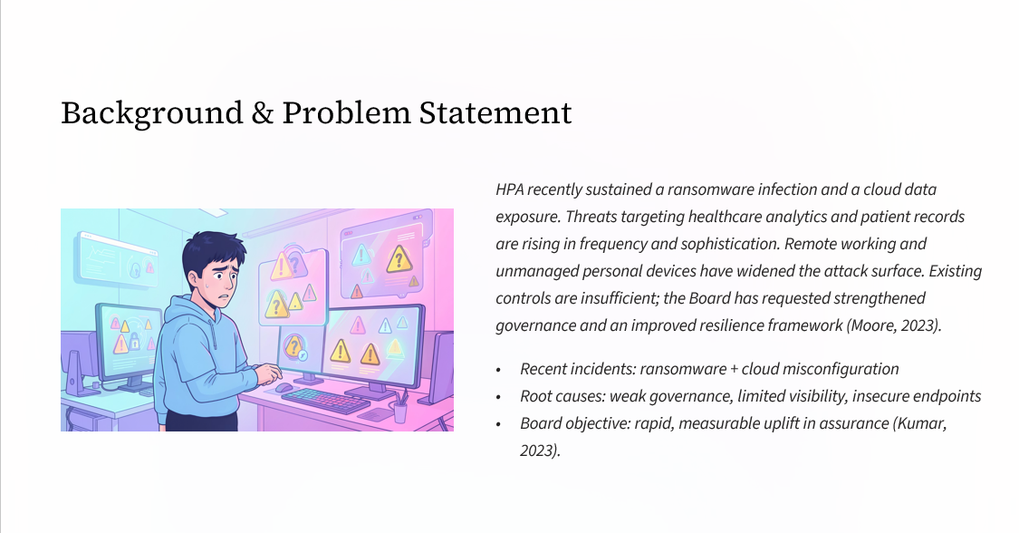
Slide 2

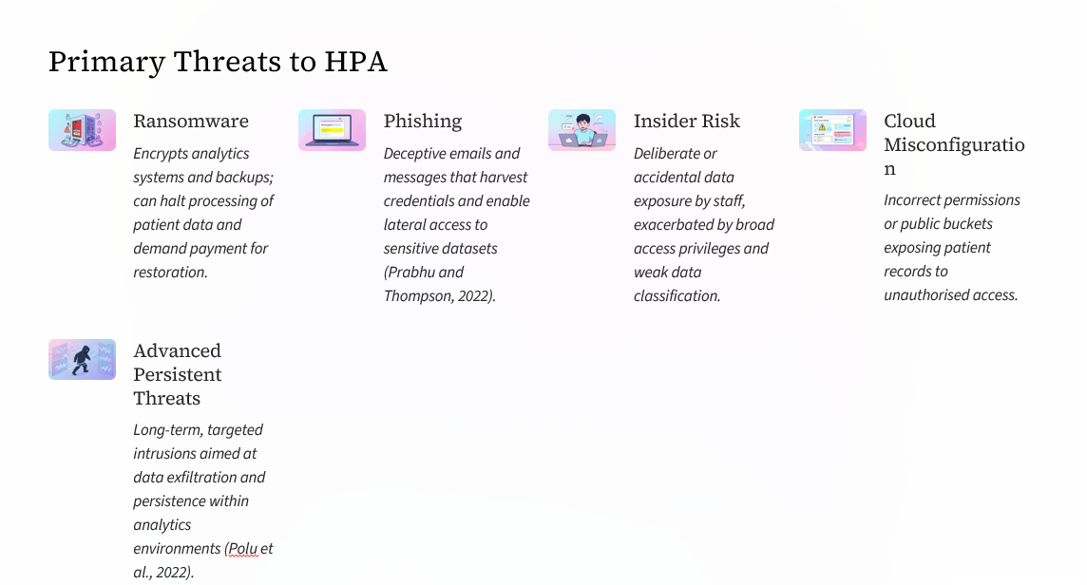
Slide 3

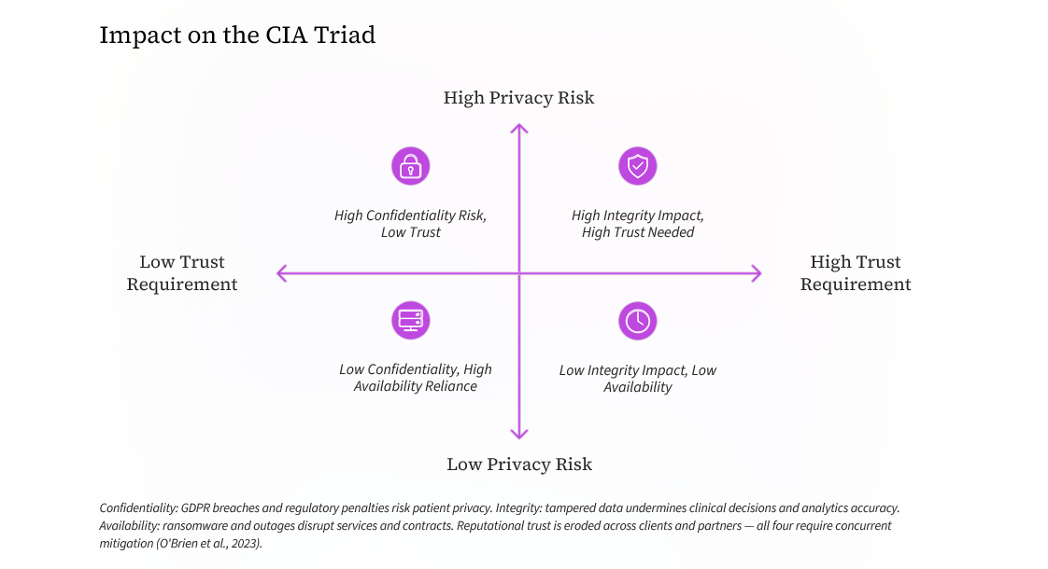
Slide 4

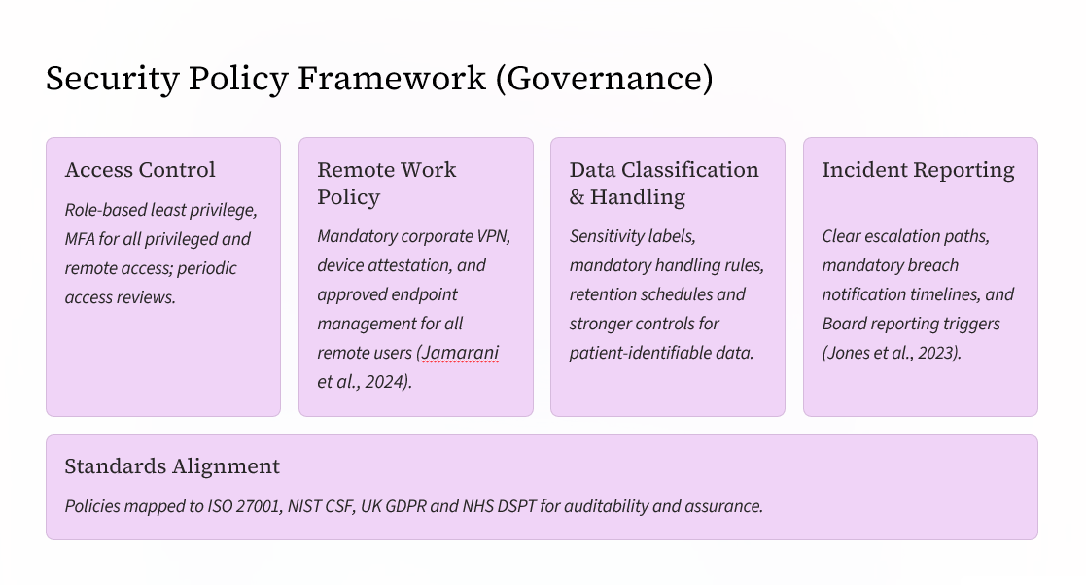
Slide 5

Slide 6
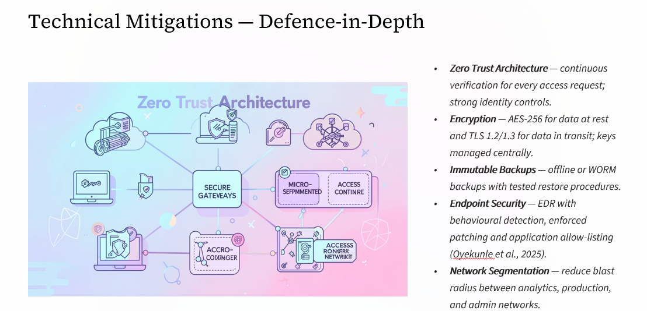

Slide 7
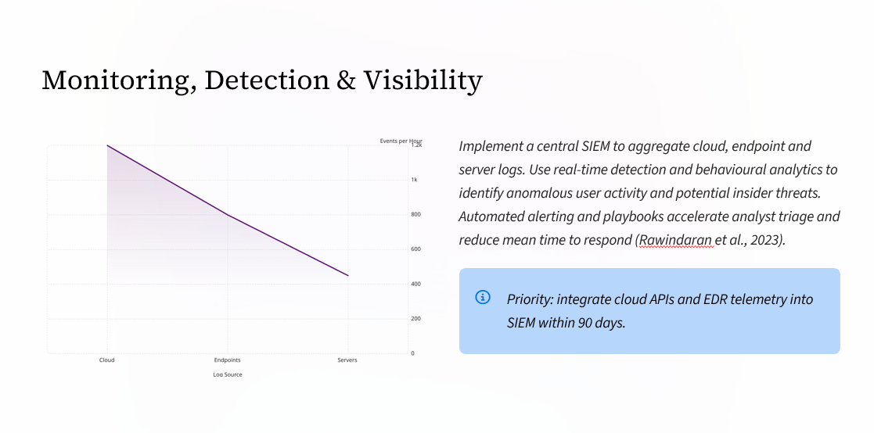

Slide 8
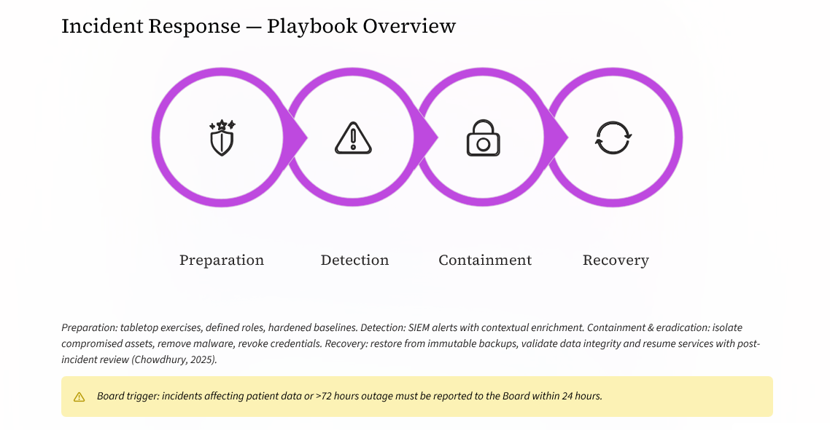

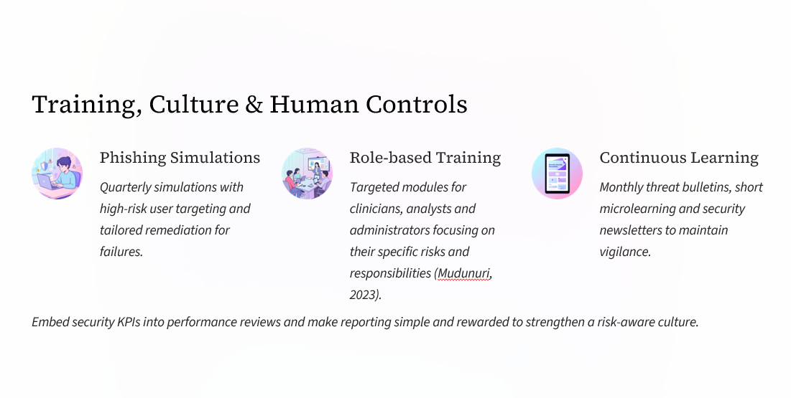
Slide 9

Slide 10


