Williams, Matthew
HND Yr. 2: 2023

digital signal processing
HND Electrical & Electronic Engineering DSP and Communications
Table of Contents
Task 1 - Brief 2
Task 1 - Solution 2
Task 2 - Brief 3
Task 2 - Solution 4
Task 3(a) - Brief 11
Task 3 (a) Solution 12
Task 3 (b) - Brief 19
Task 3 (b) - Solution 20
Task 4 - Brief 25
Task 4 - Solution 26
References 36
Appendices 37
Appendix A - Task 2 Code 37
Appendix B - Task 3a Code 39
Appendix C - Task 3b Code 40
Appendix D - Task 4a Code 41
Appendix E - Task 4b Code 41
Appendix F - Task 4c Code 42
Appendix G - Task 4d Code 42

Task 1 - Brief
The evolution of mobile communications places ever increasing demands on capacity in mobile networks. Discuss how this is achieved in practice, and compare the approach used in a TDMA GSM system with that employed in a WCDMA (UMTS) system.
You should describe how frequencies are re-used along with the different approaches to the problems related to interference

Task 1 - Solution
What are the differences between GSM and UMTS? Global System for Mobile Communication (GSM) was the most widely deployed technology behind the second generation of wireless networks (2G), while Universal Mobile Telecommunications System (UMTS) is the dominant group of technologies behind third generation of wireless networks (3G), compared to its predecessors, UMTS made it possible to deploy a wider range of data-intensive IoT applications. Although it has since been eclipsed by LTE (Long-Term Evolution) 4G technologies.
In mobile communication systems, capacity is achieved by allocating radio spectrum efficiently. This is done by segmenting the spectrum into multiple channels and using each channel for transmitting multiple conversations simultaneously. This technique is known as frequency reuse.
TDMA GSM systems use frequency division multiple access (FDMA) to allocate the frequency spectrum. FDMA allocates a specific frequency band to each conversation and the bandwidth is divided into time slots, which are assigned to different users. Each user occupies a time slot, which is then repeated in a new time frame. In this way, TDMA GSM systems efficiently reuse frequencies and handle multiple conversations within the same bandwidth, simultaneously.
WCDMA (UMTS), on the other hand, uses code division multiple access (CDMA) to maximize spectrum efficiency. CDMA allows multiple users to use the same frequency band by separating them using unique codes assigned to each user. This is done by using spread spectrum technology where each conversation is spread across a much larger bandwidth than required. This allows multiple users to share the same frequency band, which in turn increases the capacity of the network.
The approaches to handle interference also differ between TDMA GSM and WCDMA (UMTS). TDMA GSM uses a technique called frequency hopping, which changes the frequency on which the conversation is transmitted at a regular interval. This helps to reduce interference from other conversations.
WCDMA (UMTS) uses a technique called soft handover, which allows a mobile device to communicate with multiple base stations simultaneously. This improves the quality of the communication and reduces interference. Additionally, WCDMA (UMTS) uses power control, which dynamically adjusts the power level of the transmitter to minimize the level of interference experienced by other users on the same frequency band.
In summary, both TDMA GSM and WCDMA (UMTS) utilize frequency reuse to achieve capacity in mobile networks. However, TDMA GSM uses FDMA, while WCDMA (UMTS) uses CDMA. The approaches to handle interference also differ, with TDMA GSM using frequency hopping and WCDMA (UMTS) using soft handover and power control.
(Ghayas, 2019)

Task 2 - Brief

You have been tasked to look at a Telephone Mobile Power Ringing System (TMPRS) generates an audio sound consists of four different frequencies f1, f2, f3 and f4. The amplitude of the frequency f1 exponentially decays with time from very loud (high amplitude) to low amplitude. While the amplitude of f3 exponentially growth with time from low to high. The two frequency f1 & f3 cause unpleasant sound of the ringing system. As specialist you need to identify, and completely silence and remove the unwanted frequencies (f1&f3) using Matlab DSP filter that stop these two signals at the output. You will be provided with an audio file which contains the telephone mobile power ringing with audio tone.

This task requires you to write fully functioning Matlab code to achieve the following objectives:
Each objective contains an output which should be displayed in Matlab’s output window. The coursework submission should contain the full code with appropriate comments.

It is recommended that the code is copied and pasted directly from Matlab into your word-processing document with no further formatting so that we may copy and paste it back into Matlab for testing when marking. Your task is to write Matlab Computer program doing the following:-

- Read the provided TMPRS .wav file.
- Determine the frequencies of the tones.
- Design a filter to remove the cause of the unpleasant sound.
- Retaining clean version of tone contain only two frequencies.
- Provide a new version of the uncorrupted TMPRS.

In order to complete the task you will need to supply relevant plots of each of the objectives.

Task 2 - Solution
Objective (a) Read the provided TMPRS .wav file.
% DSP Assignment Task 2
% a) Read the provided TMPRS .wav file.

clear all
close all
clc

newfilename = 'New_Filltered_Audiofile.wav';
Waiting_Time = 7.0; % wating time in s

[s,fs]=audioread('wav_Matthew.wav'); %(S = No. Samples)
fs %display (FS Sampling Frequency)
t=(0:length(s)-1)/fs;

figure(1)
plot(t,s, 'b')
xlabel('Time in Seconds')
ylabel('Value in Volts')
title('Plot of the Provided TMPRS File') % Corrupted File
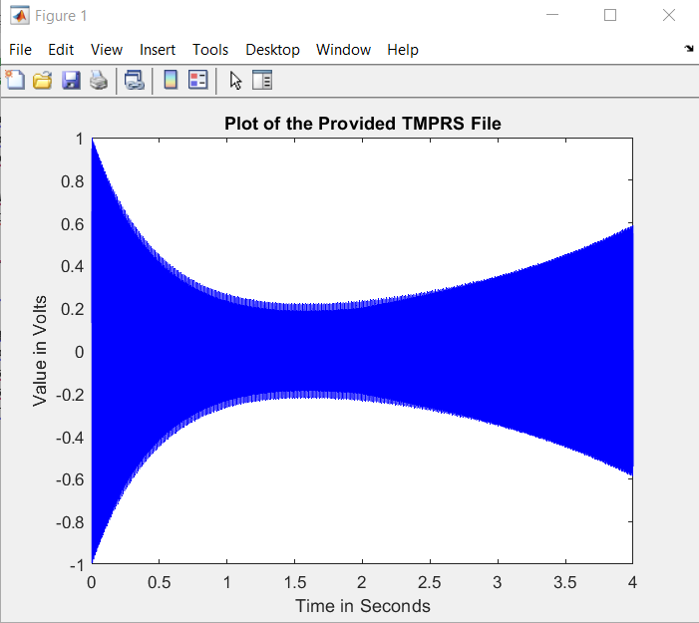
Plot of objective (a) Read the provided TMPRS .wav file.

Plot part of the signal

pause(Waiting_Time /2) % Inserted Pause between procedures

figure(2) % Plot part of the signal
n = 250; % Sampling Points
plot(t(1:n),s(1:n), 'b')
xlabel('Time in Seconds')
ylabel('Value at Each Sampling Point')
title('Plot Part of the Signal of TMPRS File')

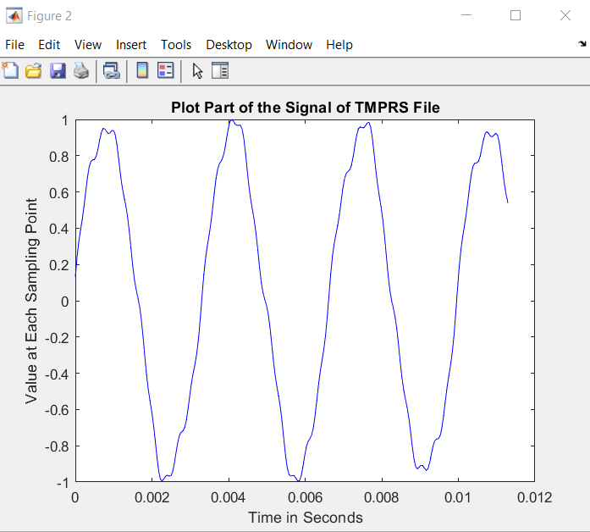

Plot of part of the signal

Objective (b) Determine the frequencies of the tone.

% b) Determine the frequencies (f1, f2, f3 & f4) of the tone.

sound(s,fs); % Generate sound

pause(Waiting_Time + 1.0); % waiting for sound end

Fast_FT=fft(s); %Fast Fourier Transform
L=length(s); % length of the whole signal (ie S)
Value_2=abs(Fast_FT/L); %absolute value... the real part oof the function
Value_1=Value_2(1:L/2+1);
Q1=fs*(8:(L/2))/L;

figure(3) %this changes from time to frequency domain, identifies the spikes we need to eliminate the noise.

plot(Q1(1:17500),Value_1(1:17500), "b")
grid
xlabel('Frequency in Hertz')
ylabel('Magnitude of the Frequency')
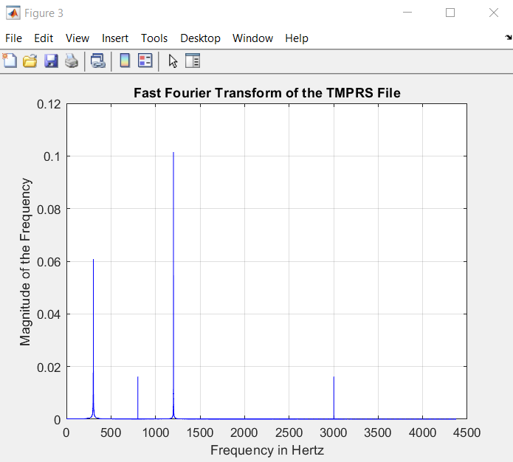
title ('Fast Fourier Transform of the TMPRS File')

Plot of objective (b) Determine the frequencies of the tone.

Objective (c) Design a filter to remove the cause of the unpleasant sound.

% c) Design a filter to remove the cause of the unpleasant sound.
% Use fir1 filter to eliminate frequency 1
% eleiminate the first frequency from the signal

Low_Cut_Off1=50/(fs/2); % low cutoff frequency % A RANGE BEFORE THE FIRST SPIKE
High_Cut_Off1=700/(fs/2); % high cutoff frequency % A RANGE AFTER THE FIRST SPIKE
Order1=800; % order of FIR bandstop filter %the higher the better quality filtration
Cut_Off_Filter1=fir1(Order1, [Low_Cut_Off1, High_Cut_Off1], 'stop'); % returns the filter coefficients in length ORD1+1 vector filtcoeffi

Partially_Filltered_Sound= filter(Cut_Off_Filter1,1,s); % generate a new voice after removing f1

% Use firi filter to eliminate frequency 3
% eleiminate the third frequency from the signal

pause(Waiting_Time+ 1.0); % Pause between processes

% eleiminate the second frequency from the voice signal
Low_Cut_Off2 = 900/(fs/2); % low cutoff frequency
High_Cut_Off2 = 1600/(fs/2); %high cutoff frequency
Order2=800; % order of FIR bandstop filter.
Cut_Off_Filter2=fir1(Order2, [Low_Cut_Off2, High_Cut_Off2], 'stop');
% returns the filter coefficients in length ORD2+1 vector filtcoeff2

Filltered_TMPRS_Sound=filter(Cut_Off_Filter2,1, Partially_Filltered_Sound); % These write the picture an new sound
sound(Filltered_TMPRS_Sound, fs);

Code of objective (c) Design a filter to remove the cause of the unpleasant sound.

Objective (e) Provide a new version of the uncorrupted TMPRS.

% e) Provide a new version of the uncorrupted TMPRS.

figure (4)
LT=length(t); %this might need to be removed or changed
plot(t(2500:LT-1), Filltered_TMPRS_Sound (2500:LT-1), 'r')
grid
xlabel('Time in Seconds')
ylabel('Value in Volts')
title('Plot of Filtered TMPRS Signal')

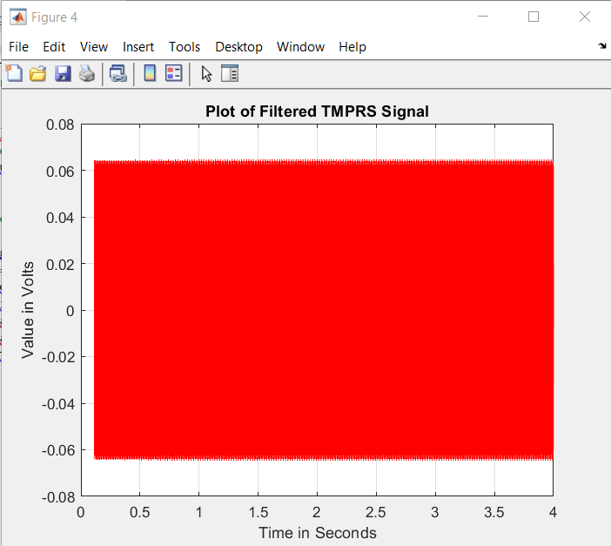

Plot of objective (e) Provide a new version of the uncorrupted TMPRS.

Plot part of the NEW filtered signal

pause(Waiting_Time); % waiting for sound end

figure(5) % Plot part of the NEW signal
n = 250; % Sampling Points
plot(t(1:n), Filltered_TMPRS_Sound (1:n), 'r')
xlabel('Time in Seconds')
ylabel('Value at Each Sampling Point')
title('Plot Part of the Signal of the NEW TMPRS File')

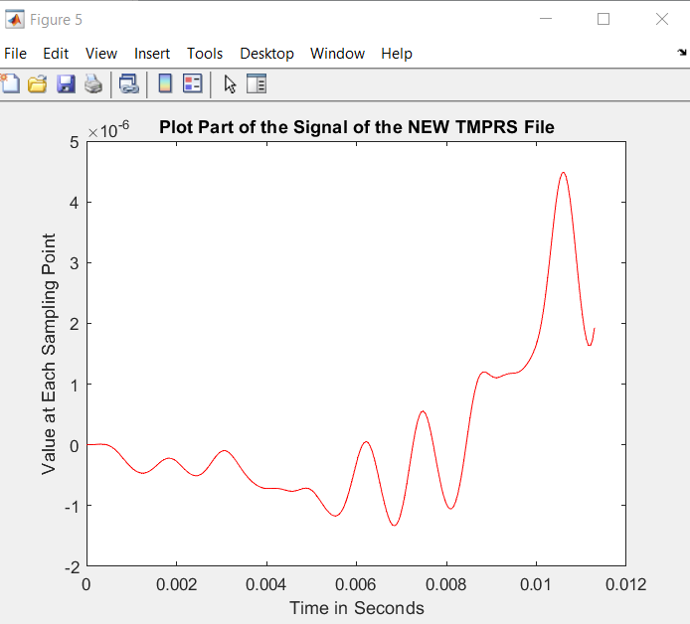

Plot of part of the NEW filtered signal

Objective (d) Retaining a clean version of tone containing only two frequencies.

pause(Waiting_Time /2) % Inserted Pause between procedures

figure(6)
LV=length(Filltered_TMPRS_Sound);
mag1=abs(fft(Filltered_TMPRS_Sound)); % Magnitude
Q2=fs*((0:(LV-1))/LV);
plot(Q2(1:17500),mag1(1:17500), 'r')
grid
xlabel('Frequency in Hertz')
ylabel('Magnitude of the Frequency')
title ('Fast Fourier Transform of the NEW TMPRS Filltered File')

% d) Retaining clean version of tone contain only two frequencies.
% Save wav file to disk

audiowrite(newfilename,Filltered_TMPRS_Sound,fs);

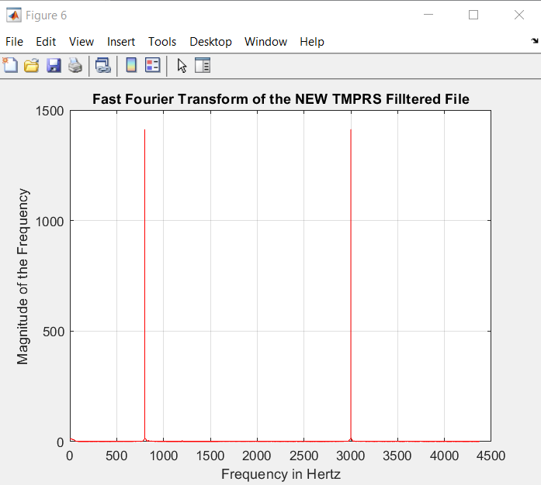

Plot of objective (d) retaining a clean version of tone containing only two frequencies.

Task 3(a) - Brief

- Biomedical signal processing involves the application of digital signal processing techniques for smoothing signals slightly corrupted by noise that represent for example heart rate, Oxygen saturation levels, Nerve conduction, Brain activity. Signal free of fluctuation can provide useful information upon which clinicians can gain insights into the physiological process and aid in clinical assessments. In different cases, the response of these signals consists of exponential positive growth, followed by a slowly negative growth or decay. As specialist you need to reduce the fluctuation in such digital signal using Moving average filtering techniques with different filter length, compare and analyse the results.

This task requires you to write fully functioning Matlab code to achieve the following objectives:

- Generate a uncorrupted signal ‘s’ consists of linear growth followed by a slowly real exponentially decay given by:

$s=3n{0.9}^{n}$ Where n is a sampling point

- Generate a random noise ‘noi’ uniformly distributed between (-1 and 1)

$$noi=2.\left(rand\left(r,1\right)-0.5\right) where r is length of the samplying points$$

- Generate a corrupted signal by adding the uncorrupted signal ‘s’ and the transpose of the noise i.e. ${noi}^{'}$
- Implement a moving average FIR filter Matlab function of order M to smooth the complex signal.
- Run the program for different filter length M and compare and analyse the results.

In order to complete the task you will need to supply relevant plots of each of the objectives.

Task 3 (a) Solution
- Generate a uncorrupted signal ‘s’ consists of linear growth followed by a slowly real exponentially decay given by:

$s=3n{0.9}^{n}$ Where n is a sampling point

Objective 3a (i) Generate an Uncorrupted Signal.
clc
% Generate the input signal
R=101;
n =0:R-1;
s=3*n.*(0.9.^n); %Generates uncorrupted Signal

% Display the output signal
plot(n,s);
axis([0, 100, -2, 12]);
xlabel ('Time index n');
ylabel('Amplitude');
title('Uncorrupted signal');
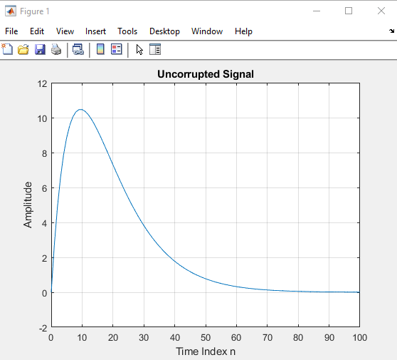
grid on

Plot of objective 3a (i) Generate an Uncorrupted Signal.

- Generate a random noise ‘noi’ uniformly distributed between (-1 and 1)

$$noi=2.\left(rand\left(r,1\right)-0.5\right) where r is length of the samplying points$$
Objective 3a (ii) Generate Random Noise.

clc
% Generate the input signal
R=101;
noi=2.0*(rand(R,1)-0.5); %Generates random noise
n =0:R-1;
s=3*n.*(0.9.^n); %Generates uncorrupted Signal

% Display the input signals
plot(n,noi);
axis([0, 100, -1.2, 1.2]);
xlabel('Time Index n');
ylabel('Amplitude');
title('Random Noise Signal');
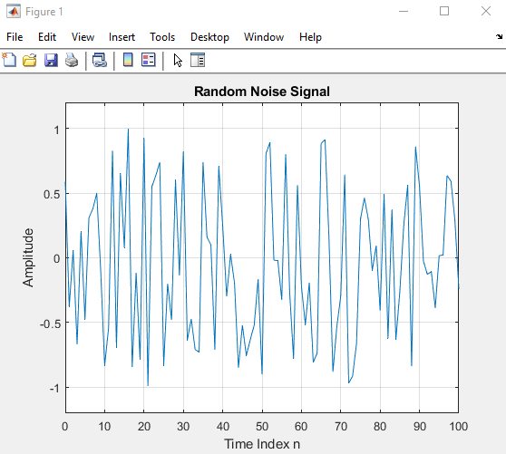
grid on

Plot of objective 3a (ii) Generate Random Noise.

- Generate a corrupted signal by adding the uncorrupted signal ‘s’ and the transpose of the noise i.e. ${noi}^{'}$

Objective 3a (iii) Generated Corrupted Signal.

clc
% Generate the input signal
R=101;
noi=2.0*(rand(R,1)-0.5); %Generates random noise
n =0:R-1;
s=3*n.*(0.9.^n); %Generates uncorrupted Signal
x=s+noi'; %Generates noise corrupted signal
% Display the input and output signals

plot(n,x);
axis([0, 100, -2, 12]);
xlabel('Time Index n');
ylabel('Amplitude');
title('Corrupted Input Signal');
grid on
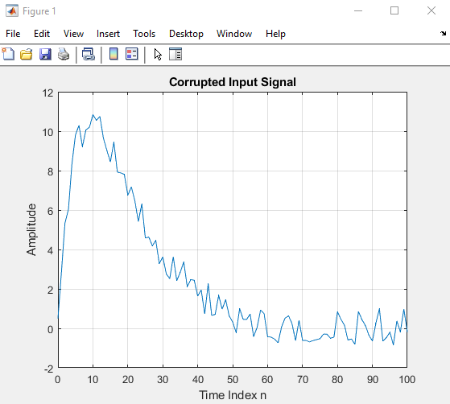

Plot of objective 3a (iii) Generated Corrupted Signal.
- Implement a moving average FIR filter Matlab function of order M to smooth the complex signal.
Objective 3a (iv) Smooth Filtered Signal.

clc
% Generate the input signal
R=101;
noi=2.0*(rand(R,1)-0.5); %Generates random noise
n =0:R-1;
s=3*n.*(0.9.^n); %Generates uncorrupted Signal
x=s+noi'; %Generates noise corrupted signal
%%%%%M = input('Desired length of the filter = ');
num = ones(1,M);
y = filter(num,1,x)/M;
% Display the input and output signals

plot(n, y);
axis([0, 100, -2, 12]);
xlabel('Time index n');
ylabel('Amplitude');
title('Smooth Output Signal');
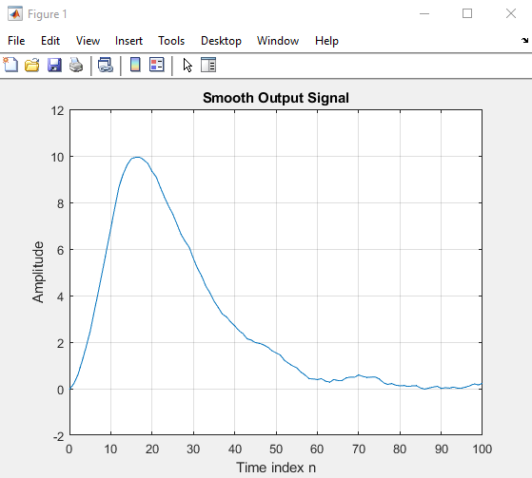

Plot of objective 3a (iv) Smooth Filtered Signal.
- Run the program for different filter length M and compare and analyse the results.

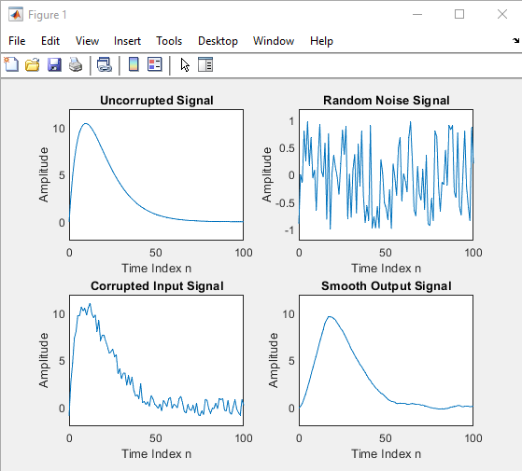
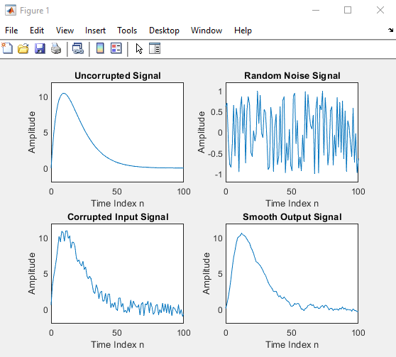
Objective 3a (v) Filter run at M = 5 Objective 3a (v) Filter run at M = 15

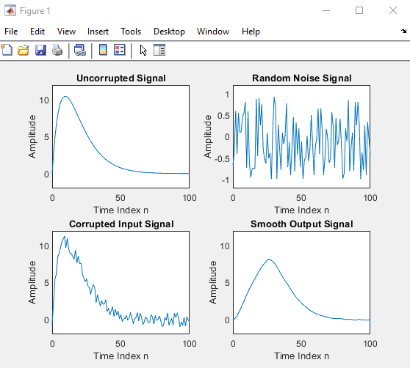
Objective 3a (v) Filter run at M = 20 Objective 3a (v) Filter run at M = 25
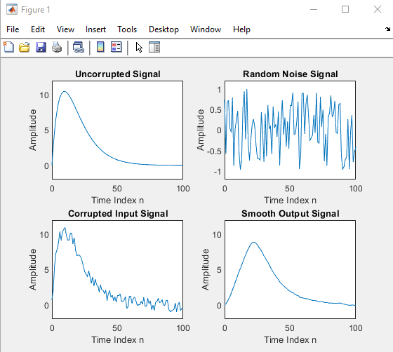

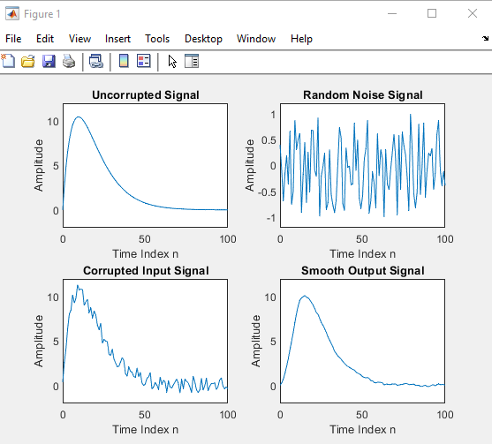
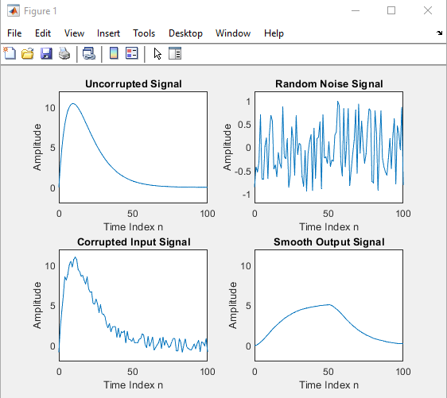
Objective 3a (v) Comparison and Analysis of the Results of running different Filter Lengths
Objective 3a (v) Filter run at M = 10 Objective 3a (v) Filter run at M = 50

Conclusions
From the above screenshots we are able to see that there are several trade-offs from smoothing out a complex signal. The two that are most obvious are:
- Over Smoothing
- Signal Delay

Over Smoothing: When increasing the filter length excessively there is a risk of over smoothing the complex signal. From the screenshot where the filter length was set to M = 50 we can see that the original signal has almost been lost completely. The output signal bears no resemblance to the original uncorrupted signal. Over smoothing leads to a loss of detail in the signal.

Signal Delay: While increasing the filter length improves the smoothing effect, it also introduces a delay in the filtered output signal. From the screenshot where the filter length was set to M = 25 we can see that the Smooth Output Signal is delayed compared to the original Uncorrupted Signal considerably.

We see this better in the below plot…….
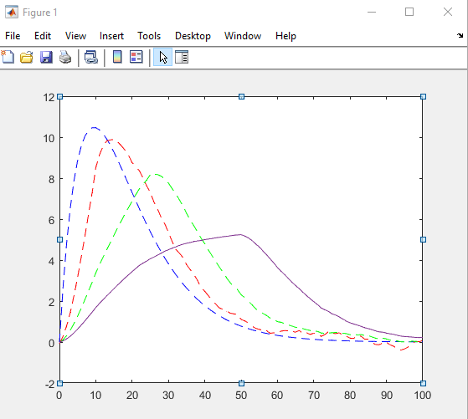

Task 3 (b) - Brief

- Using MATLAB codes, generate a complex signal consists of low frequency sinusoid f1=0.05Hz
Signal and high frequency sinusoidal signal f2=0.47Hz.
Implement a moving average FIR filter Matlab function of order M in filtering the high frequency component of the complex signal.

Run the program for different filter length M and various value of frequencies.
The coursework submission should contain the full code with appropriate comments.

Task 3 (b) - Solution
clc

% Simulation of an M-point Moving Average Filter

% Set Parameters
n=0:100;
Frequency1=input('Desired Low Frequency =') %Input Low Frequency in the Command Window
Frequency2=input('Desired High Frequency =') %Input High Frequency in the Command Window

Signal1=cos(2*pi*Frequency1*n); % A low-frequency sinusoid
Signal2=cos(2*pi*Frequency2*n); % A high frequency sinusoid

x=Signal1+Signal2; %Complex Signal

M=input('Desired length of the filter = ') % Filter

num=ones(1,M); % variable M

y=filter(num,1,x)/M;

% Display the input and output signals

subplot(4,1,1);
plot(n, Signal1);
axis([0, 100, -2, 2]);
xlabel('Time n');
ylabel('Amplitude');
title('Frequency #1 Sinusoidal');
grid on

subplot(4,1,2);
plot(n, Signal2);
axis([0, 100, -2, 2]);
xlabel('Time n');
ylabel('Amplitude');
title('Frequency #2 Sinusoidal');
grid on

subplot(4,1,3);
plot(n, x, 'r');
axis ([0, 100, -2, 2]);
xlabel('Time n');
ylabel('Amplitude');
title('Complex Signal');
grid on

subplot(4,1,4);
plot(n, y, 'g');
xlabel('Time n');
ylabel('Amplitude');
title('Filtered Signal');
grid on

Task 3(b) moving average FIR filter:
Frequency 1 = 0.05 Hz, Frequency 2 = 0.47 Hz, Filter Length M = 5: PLOT
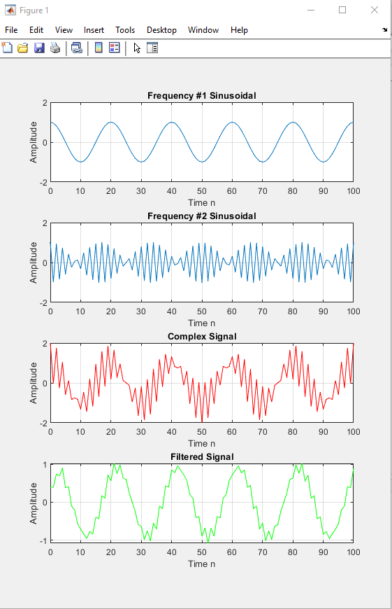
Task 3(b) moving average FIR filter:
Frequency 1 = 0.05 Hz, Frequency 2 = 0.47 Hz, Filter Length M = 10: PLOT
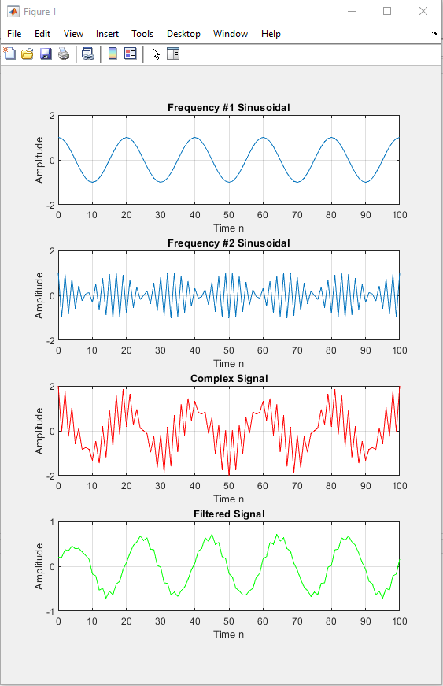
Task 3(b) moving average FIR filter:
Frequency 1 = 0.05 Hz, Frequency 2 = 0.47 Hz, Filter Length M = 15: PLOT
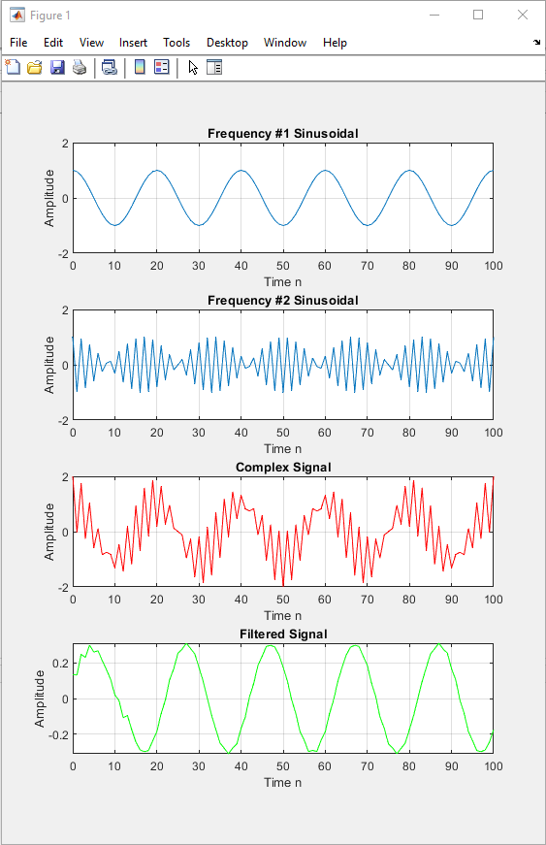
Task 3(b) moving average FIR filter:
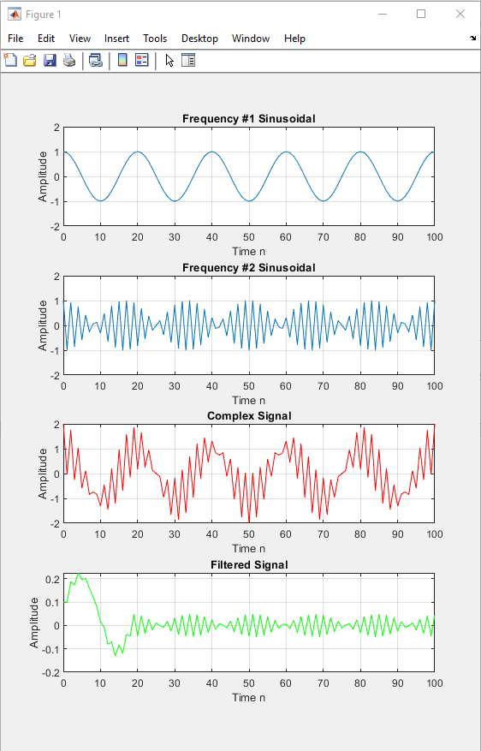
Frequency 1 = 0.05 Hz, Frequency 2 = 0.47 Hz, Filter Length M = 20: PLOT

Task 4 - Brief
Low frequency signal given by:
x=[-0.001 -0.0045 -0.01 -0.0042 0.002 0.005 0.006 0.007 0.004 -0.001 -0.005 -0.009 -0.01 -0.001 0.005 0.004 -0.001 0.005 0.004 -0.002 0.007 0.008 -0.004 -0.005 -0.012 -0.007 -0.005 -0.001];
- Compute the impulse response of the low pass function:

y[n] = 3.6y[n–1]+5.0y[n–2]–3.2y[n–3]+.82y[n–4] +.013x[n]–.032x[n–1]+.044x[n–2]–.033x[n–3] +.013x[n–4]

- Compute the output low pass filter

- Compute the impulse response of the high pass function
y[n] = 2.7y[n–1]–3.3y[n–2]+2.0y[n–3]–.57y[n–4] +.35x[n]–1.3x[n-1]+2.0x[n–2]–1.3x[n–3] +.35x[n–4]

- Compute the output high pass filter

Plot results and discuss your finding.

Task 4 - Solution
- Compute the impulse response of the low pass function:

y[n] = 3.6y[n–1]+5.0y[n–2]–3.2y[n–3]+.82y[n–4] +.013x[n]–.032x[n–1]+.044x[n–2]–.033x[n–3] +.013x[n–4]

Objective (a) Compute the impulse response of the low pass function:
CODE

% Program impulse response
% Compute the impulse response of the following function (h)
% y[n] = 3.6y[n-1]+5.0y[n-2]-3.2y[n-3]+.82y[n-4]
% +.013x[n]-.032x[n-1]+.044x[n-2]-.033x[n-3]+.013x[n-4]
clc;
N=7;
num = [.013 -0.32 .044 -0.033 0.013];
den = [1 -3.6 -5.0 3.2 -.82];
h = impz(num,den,N);
% Plot the impulse response
hold on
stem (h, 'r');
h % no semicolon as i want to see the output in the script
xlabel('Time index n');
ylabel('Amplitude');
title('Impulse Response');
grid on;

Objective (a) Compute the impulse response of the low pass function:
SCRIPT OUTPUT

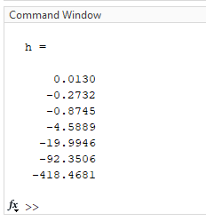

Objective (a) Compute the impulse response of the low pass function:
PLOT
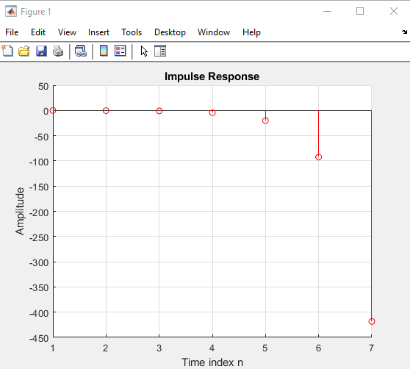

- Compute the output low pass filter

Objective (b) Compute the output low pass filter:
CODE

% Compute the output low pass filter

clc;
h= [0.013 -0.273 -0.874 -4.5889 -19.994 -92.3506 -418.4681];

x1 = [-0.001 -0.0045 -0.01 -0.0042 0.002 0.005 0.006 0.007 0.004 -0.001 -0.005 -0.009 -0.01 -0.001 0.005 0.004];

x2 = [-0.001 0.005 0.004 -0.002 0.007 0.008 -0.004 -0.005 -0.012 -0.007 -0.005 -0.001];

x = [x1 x2];
y1=conv(x,h); % or y1 = filter (h,1,x);
% Plot the impulse response

figure(1)
stem(x,'r');
xlabel('Time Index n');
ylabel('x[n]');
title('Low Pass Output');
grid on;

figure (2)
stem(y1, 'g');
y1
xlabel('Time Index n');
ylabel('y[n]');
title('Low Pass Output');
grid on;

Objective (b) Compute the output low pass filter:
SCRIPT OUTPUT

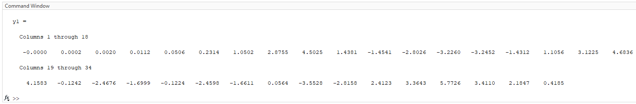

Objective (b) Compute the output low pass filter:
PLOT x[n]
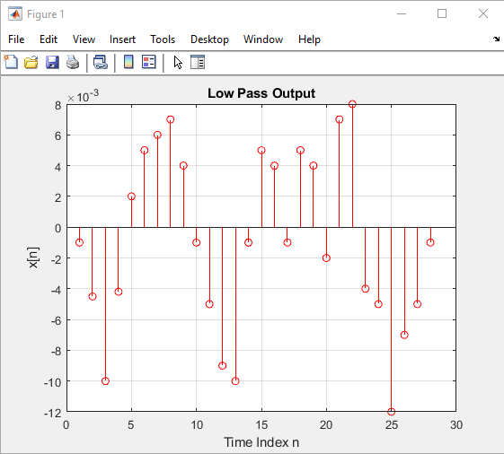

Objective (b) Compute the output low pass filter:
PLOT y[n]
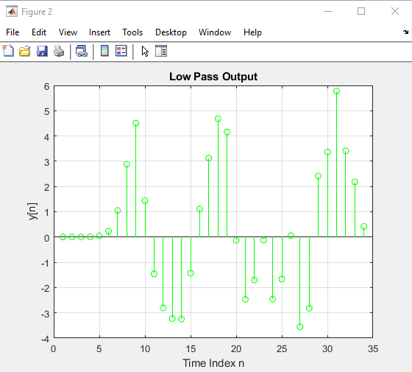

- Compute the impulse response of the high pass function
y[n] = 2.7y[n–1]–3.3y[n–2]+2.0y[n–3]–.57y[n–4] +.35x[n]–1.3x[n-1]+2.0x[n–2]–1.3x[n–3] +.35x[n–4]

Objective (c) Compute the impulse response of the high pass function:
CODE

% Program impulse response
% Compute the impulse response of the following function
% y[n] = 2.7y[n-1]-3.3y[n-2]+2.0y[n-3]-.57y[n-4] +.35x[n]-1.3x[n-1]+
% 2.0x[n-2]-1.3x[n-3]+.35x[n-4]

clc;
N = 7;
num = [.35 -1.3 2.0 -1.3 .35];
den = [1-2.7 3.3-2.0 0.57];
h = impz(num,den,N);
% Plot the impulse response
hold on
stem(h, 'b');
h
xlabel('Time index n');
ylabel('Amplitude');
title('Impulse Response');
grid;

Objective (c) Compute the impulse response of the high pass function:
SCRIPT OUTPUT

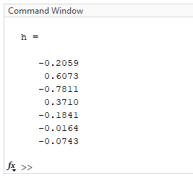

Objective (c) Compute the impulse response of the high pass function:
PLOT
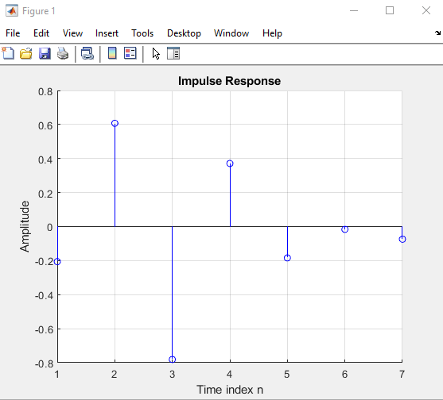

- Compute the output high pass filter

Objective (d) Compute the output high pass filter:
CODE

% Compute the output high pass filter
clc;
h = [0.3500 -0.3550 -0.1135 0.2650 0.5307 0.5335 0.2841 ];

X1=[-0.001 -0.0045 -0.01 -0.0042 0.002 0.005 0.006 0.007 0.004 -0.001 -0.005 -0.009 -0.01 -0.001 0.005 0.004];

x2=[-0.001 0.005 0.004 -0.002 0.007 0.008 -0.004 -0.005 -0.012 -0.007 -0.005 -0.001];

X=[x1 x2];
y1 = conv(x,h); % or y1 = filter(h,1,x);
% Plot the impulse response

figure(1)
stem (x,'b');

xlabel('Time index n');
ylabel('x[n]');
grid;

figure (2)
stem (y1, 'Color',[0.4940, 0.1840, 0.5560])
y1
xlabel('Time index n');
ylabel('y[n]');
title('high pass output');
grid;

Objective (d) Compute the output high pass filter:
SCRIPT OUTPUT
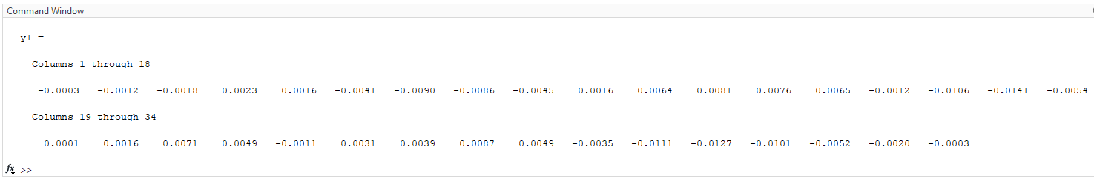

Objective (d) Compute the output high pass filter:
PLOT x[n]
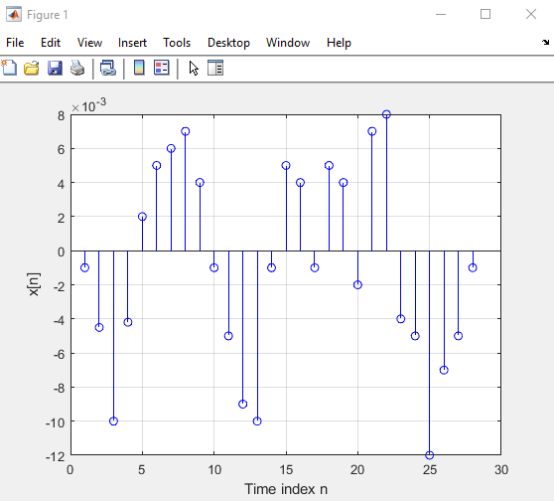

Objective (d) Compute the output high pass filter:
PLOT y[n]
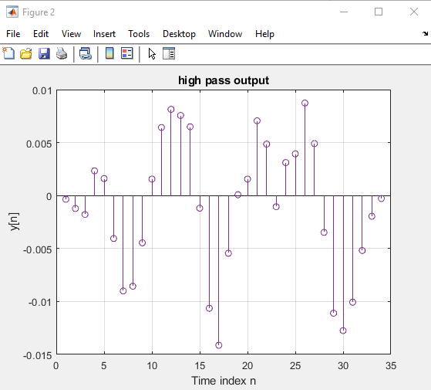

Observations
Low Pass Filter: By applying the input signal to the low pass filter's difference equation, we can compute the output signal. This output signal is then filtered to retain low-frequency components while attenuating high-frequency components.
High Pass Filter: By applying the input signal to the high pass filter's difference equation, we can compute the output signal. The output signal is then filtered to retain high-frequency components while suppressing low-frequency components.

References
Ghayas, A., 2019. What is the difference between GSM, UMTS and LTE?. [Online]
Available at: https://commsbrief.com/difference-between-gsm-umts-lte/
[Accessed 28 May 2023].

Appendices
Appendix A - Task 2 Code
% DSP Assignment Task 2
% a) Read the provided TMPRS .wav file.

clear all
close all
clc

newfilename = 'New_Filltered_Audiofile.wav';
Waiting_Time = 7.0; % wating time in s

[s,fs]=audioread('wav_Matthew.wav'); %(S = No. Samples)
fs %display (FS Sampling Frequency)
t=(0:length(s)-1)/fs;

figure(1)
plot(t,s, 'b')
xlabel('Time in Seconds')
ylabel('Value in Volts')
title('Plot of the Provided TMPRS File') % Corrupted File

pause(Waiting_Time /2) % Inserted Pause between procedures

figure(2) % Plot part of the signal
n = 250; % Sampling Points
plot(t(1:n),s(1:n), 'b')
xlabel('Time in Seconds')
ylabel('Value at Each Sampling Point')
title('Plot Part of the Signal of TMPRS File')

% b) Determine the frequencies (f1, f2, f3 & f4) of the tone.

sound(s,fs); % Generate sound
pause(Waiting_Time + 1.0); % waiting for sound end

Fast_FT=fft(s); %Fast Fourier Transform
L=length(s); % length of the whole signal (ie S)
Value_2=abs(Fast_FT/L); %absolute value... the real part oof the function
Value_1=Value_2(1:L/2+1);
Q1=fs*(8:(L/2))/L;

figure(3) %this changes from time to frequency domain, identifies the spikes we need to eliminate the noise.

plot(Q1(1:17500),Value_1(1:17500), "b")
grid
xlabel('Frequency in Hertz')
ylabel('Magnitude of the Frequency')
title ('Fast Fourier Transform of the TMPRS File')

% c) Design a filter to remove the cause of the unpleasant sound.
% Use fir1 filter to eliminate frequency 1
% eleiminate the first frequency from the signal

Low_Cut_Off1=50/(fs/2); % low cutoff frequency % A RANGE BEFORE THE FIRST SPIKE
High_Cut_Off1=700/(fs/2); % high cutoff frequency % A RANGE AFTER THE FIRST SPIKE
Order1=800; % order of FIR bandstop filter %the higher the better quality filtration
Cut_Off_Filter1=fir1(Order1, [Low_Cut_Off1, High_Cut_Off1], 'stop'); % returns the filter coefficients in length ORD1+1 vector filtcoeffi

Partially_Filltered_Sound= filter(Cut_Off_Filter1,1,s); % generate a new voice after removing f1

% Use firi filter to eliminate frequency 3
% eleiminate the third frequency from the signal

pause(Waiting_Time+ 1.0); % Pause between processes

% eleiminate the second frequency from the voice signal
Low_Cut_Off2 = 900/(fs/2); % low cutoff frequency
High_Cut_Off2 = 1600/(fs/2); %high cutoff frequency
Order2=800; % order of FIR bandstop filter.
Cut_Off_Filter2=fir1(Order2, [Low_Cut_Off2, High_Cut_Off2], 'stop');
% returns the filter coefficients in length ORD2+1 vector filtcoeff2

Filltered_TMPRS_Sound=filter(Cut_Off_Filter2,1, Partially_Filltered_Sound); % These write the picture an new sound
sound(Filltered_TMPRS_Sound, fs);

% e) Provide a new version of the uncorrupted TMPRS.

figure (4)
LT=length(t); %this might need to be removed or changed
plot(t(2500:LT-1), Filltered_TMPRS_Sound (2500:LT-1), 'r')
grid
xlabel('Time in Seconds')
ylabel('Value in Volts')
title('Plot of Filtered TMPRS Signal')

pause(Waiting_Time); % waiting for sound end

figure(5) % Plot part of the NEW signal
n = 250; % Sampling Points
plot(t(1:n), Filltered_TMPRS_Sound (1:n), 'r')
xlabel('Time in Seconds')
ylabel('Value at Each Sampling Point')
title('Plot Part of the Signal of the NEW TMPRS File')

pause(Waiting_Time /2) % Inserted Pause between procedures

figure(6)
LV=length(Filltered_TMPRS_Sound);
mag1=abs(fft(Filltered_TMPRS_Sound)); % Magnitude
Q2=fs*((0:(LV-1))/LV);
plot(Q2(1:17500),mag1(1:17500), 'r')
grid
xlabel('Frequency in Hertz')
ylabel('Magnitude of the Frequency')
title ('Fast Fourier Transform of the NEW TMPRS Filltered File')

% d) Retaining clean version of tone contain only two frequencies.
% Save wav file to disk

audiowrite(newfilename,Filltered_TMPRS_Sound,fs);
Appendix B - Task 3a Code
%Signal Smoothing using M-Point Moving Averaging filter
clc
% Generate the input signal
R=101;
noi=2.0*(rand(R,1)-0.5); %Generates random noise
n =0:R-1;
s=3*n.*(0.9.^n); %Generates uncorrupted Signal
x=s+noi'; %Generates noise corrupted signal
M = input('Desired length of the filter = ');
num = ones(1,M);
y = filter(num,1,x)/M;
% Display the input and output signals

subplot(2,2,1);
plot(n,s);
axis([0, 100, -2, 12]);
xlabel ('Time index n');
ylabel('Amplitude');
title('Uncorrupted signal');

subplot(2,2,2);
plot(n,noi);
axis([0, 100, -1.2, 1.2]);
xlabel('Time index n');
ylabel('Amplitude');
title('noise Signal');

subplot(2,2,3);
plot(n,x);
axis([0, 100, -2, 12]);
xlabel('Time index n');
ylabel('Amplitude');
title('Corrupted Input Signal');

%
subplot(2,2,4);
plot(n, y);
axis([0, 100, -2, 12]);
xlabel('Time index n');
ylabel('Amplitude');
title('Smooth Output Signal');

Appendix C - Task 3b Code
clc

% Simulation of an M-point Moving Average Filter

% Set Parameters
n=0:100;
Frequency1=input('Desired Low Frequency =') %Input Low Frequency in the Command Window
Frequency2=input('Desired High Frequency =') %Input High Frequency in the Command Window

Signal1=cos(2*pi*Frequency1*n); % A low-frequency sinusoid
Signal2=cos(2*pi*Frequency2*n); % A high frequency sinusoid

x=Signal1+Signal2; %Complex Signal

M=input('Desired length of the filter = ') % Filter

num=ones(1,M); % variable M

y=filter(num,1,x)/M;

% Display the input and output signals

subplot(4,1,1);
plot(n, Signal1);
axis([0, 100, -2, 2]);
xlabel('Time n');
ylabel('Amplitude');
title('Frequency #1 Sinusoidal');
grid on

subplot(4,1,2);
plot(n, Signal2);
axis([0, 100, -2, 2]);
xlabel('Time n');
ylabel('Amplitude');
title('Frequency #2 Sinusoidal');
grid on

subplot(4,1,3);
plot(n, x, 'r');
axis ([0, 100, -2, 2]);
xlabel('Time n');
ylabel('Amplitude');
title('Complex Signal');
grid on

subplot(4,1,4);
plot(n, y, 'g');
xlabel('Time n');
ylabel('Amplitude');
title('Filtered Signal');
grid on

Appendix D - Task 4a Code
% Program impulse response
% Compute the impulse response of the following function (h)
% y[n] = 3.6y[n-1]+5.0y[n-2]-3.2y[n-3]+.82y[n-4]
% +.013x[n]-.032x[n-1]+.044x[n-2]-.033x[n-3]+.013x[n-4]
clc;
N=7;
num = [.013 -0.32 .044 -0.033 0.013];
den = [1 -3.6 -5.0 3.2 -.82];
h = impz(num,den,N);
% Plot the impulse response
hold on
stem (h, 'r');
h % no semicolon as i want to see the output in the script
xlabel('Time index n');
ylabel('Amplitude');
title('Impulse Response');
grid on;

Appendix E - Task 4b Code
% Compute the output low pass filter

clc;
h= [0.013 -0.273 -0.874 -4.5889 -19.994 -92.3506 -418.4681];

x1 = [-0.001 -0.0045 -0.01 -0.0042 0.002 0.005 0.006 0.007 0.004 -0.001 -0.005 -0.009 -0.01 -0.001 0.005 0.004];

x2 = [-0.001 0.005 0.004 -0.002 0.007 0.008 -0.004 -0.005 -0.012 -0.007 -0.005 -0.001];

x = [x1 x2];
y1=conv(x,h); % or y1 = filter (h,1,x);
% Plot the impulse response

figure(1)
stem(x,'r');
xlabel('Time Index n');
ylabel('x[n]');
title('Low Pass Output');
grid on;

figure (2)
stem(y1, 'g');
y1
xlabel('Time Index n');
ylabel('y[n]');
title('Low Pass Output');
grid on;

Appendix F - Task 4c Code
% Program impulse response
% Compute the impulse response of the following function
% y[n] = 2.7y[n-1]-3.3y[n-2]+2.0y[n-3]-.57y[n-4] +.35x[n]-1.3x[n-1]+
% 2.0x[n-2]-1.3x[n-3]+.35x[n-4]

clc;
N = 7;
num = [.35 -1.3 2.0 -1.3 .35];
den = [1-2.7 3.3-2.0 0.57];
h = impz(num,den,N);
% Plot the impulse response
hold on
stem(h, 'b');
h
xlabel('Time index n');
ylabel('Amplitude');
title('Impulse Response');
grid;

Appendix G - Task 4d Code
% Compute the output high pass filter
clc;
h = [0.3500 -0.3550 -0.1135 0.2650 0.5307 0.5335 0.2841 ];

X1=[-0.001 -0.0045 -0.01 -0.0042 0.002 0.005 0.006 0.007 0.004 -0.001 -0.005 -0.009 -0.01 -0.001 0.005 0.004];

x2=[-0.001 0.005 0.004 -0.002 0.007 0.008 -0.004 -0.005 -0.012 -0.007 -0.005 -0.001];

X=[x1 x2];
y1 = conv(x,h); % or y1 = filter(h,1,x);
% Plot the impulse response

figure(1)
stem (x,'b');

xlabel('Time index n');
ylabel('x[n]');
grid;

figure (2)
stem (y1, 'Color',[0.4940, 0.1840, 0.5560])
y1
xlabel('Time index n');
ylabel('y[n]');
title('high pass output');
grid;

