

Student name: sofia sanday
Student ID: 2526564
Module name: Introduction to health and social care
Module code: LCH4003
Lecturer name: Muhammad Aliyu
Content page

Element 1 ……………………………………………………………. page


TWO CHALLENGES FACE BY THE SERVICE1: shortages of midwives and staff, a shortage of qualified midwives can increase workload and may affect staff wellbeing and continuity of care.2: mental health challenge. Some pregnant women experience anxiety, depression, or other mental health conditions, community midwives may have limited time or access to specialist mental health services, making it harder to provide the support needed.

BRIEF HISTORY OF THE SERVICE
Community antenatal midwifery services have developed from traditional support given by experienced women in local communities into a professional and regulated health service. In the past, pregnancy and childbirth were usually supported at home by family members, local birth attendants or midwives. Midwifery became more formalised in the United Kingdom after the Midwives Act 1902, which helped regulate training and protect the title of midwife. When the NHS was introduced in 1948, maternity care became more widely available, and midwives played an important role in supporting women during pregnancy, birth and after childbirth. Over time, antenatal care became more focused on prevention, early identification of risks, health education and regular monitoring of the mother and baby. Today, community antenatal midwifery services continue this development by providing accessible care in local settings such as clinics, GP surgeries, children’s centres and sometimes the home, helping pregnant women receive safe, person-centred support close to their community.

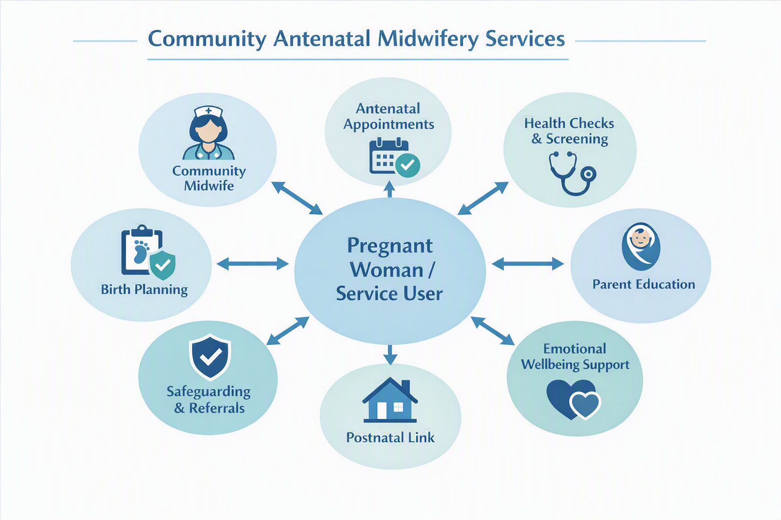 Community antenatal midwifery services are important because they support pregnant women and their families throughout pregnancy within the local community. The diagram shows that the pregnant woman or service user is at the centre of care, with the community midwife working alongside other health and social care professionals to provide joined-up support. These services include antenatal appointments, health checks, screening, birth planning, parent education, emotional wellbeing support and referrals to other services when needed. This type of care helps to identify risks early, promote healthy pregnancy, prepare parents for birth and ensure that women feel informed, supported and involved in decisions about their care. Community antenatal midwifery also improves access to support because appointments can take place in local clinics, children’s centres, GP surgeries or sometimes in the home. Overall, the service enhances quality of life by promoting safety, confidence, wellbeing and person-centred care during pregnancy.

The image shows the three main stages of pregnancy and how both the fetus and the mother’s body change over time. It illustrates the fetus growing from a small embryo in the first trimester to a fully developed baby in the third trimester. The first trimester highlights early organ development, while the second trimester shows rapid growth, visible abdominal changes, and fetal movement. By the third trimester, the fetus is fully developed and positioned head-down in preparation for birth. Overall, the image helps learners understand key developmental milestones and the physical changes that occur throughout pregnancy.
CURRENT FUNCTIONING OF THE SERVICE
Community antenatal midwifery services today operate as part of NHS maternity care, providing structured, evidence-based support to pregnant women GP surgeries, maternity hubs, and through home visits for those with additional needs. Midwives lead most of the routine antenatal care, carrying out comprehensive assessments, monitoring maternal and fatal wellbeing, offering health education, and coordinating screening tests and referrals to specialist teams. where women are supported by the same midwife, birth and the postnatal period, improving safety, trust, and personalised care. Community midwives also play a vital safeguarding role, identifying issues such as domestic abuse, mental health concerns,
EXPLANATION OF THE CHOSEN HEALTH SERVICE
community antenatal midwifery services provide care and support to women during pregnancy and after childbirth within the community surgeries and local healthcare centres to monitor the health of mothers and babies. Service provides routine antenatal appointments and health check, blood pressure and urine monitoring, blood test and pregnancy screening, checking baby’s growth, position and heartbeat. birth choices, breastfeeding and newborn care, emotional support and referral to specialist services when needed.
Community antenatal midwifery services
Student Name, Sofia sanday
Course Name, Health and social care. Email: sofiasanday1189@gmail.com

Element 2

DOMICIALIARY CARE SERVICES WITHIN THE COMMUNITY.

1:Domiciliary care services originated from informal care provided by families, neighbours and charitable organisations. Before formal health and social care systems developed, older people, people with disabilities and individuals experiencing illness were often supported at home by relatives or local community groups. Over time, the need for more organised support became clear, especially as people began living longer and more individuals required help to remain independent in their own homes.
The historical development of domiciliary care was strongly influenced by changes in government policy and attitudes towards care. The National Assistance Act 1948 gave local authorities greater responsibility for welfare services, which helped develop organised support in the community. Later, health and social care services began moving away from institutional care, such as long-term hospital stays and residential homes, towards supporting people to live safely at home. The NHS and Community Care Act 1990 was a key development because it encouraged local authorities to assess people’s needs and arrange community-based services.
Today, domiciliary care is an important part of adult social care because it promotes independence, dignity and choice. It allows people to receive support in familiar surroundings while remaining connected to their community. This shows how domiciliary care has developed from informal family support into a structured service shaped by social, political and healthcare reforms.

2: CRITICALLY EVALUATE HOW THE SERVICE FUNCTIONS TODAY.
Today, domiciliary care services function as a key part of adult social care by supporting people to remain safely in their own homes and communities. The service usually provides help with personal care, medication prompts, meals, mobility and daily routines, which can promote independence, dignity and choice. This is important because many older people, disabled people and individuals with long-term health conditions prefer to receive care in familiar surroundings rather than move into residential care. However, the service also faces significant challenges. Care visits can sometimes be short and task-focused, which may limit emotional support and reduce the quality of person-centred care. Workforce pressures, including staff shortages, low pay, high turnover and difficulties with recruitment, can also affect continuity of care and make it harder for service users to build trusting relationships with care workers. Domiciliary care providers in England are regulated by the Care Quality Commission when they provide personal care, which helps to maintain standards of safety and quality. Nevertheless, regulation alone cannot solve wider problems such as underfunding, rising demand and inequality in access, especially because adult social care is means-tested. Overall, domiciliary care is valuable because it helps people live independently and remain connected to their communities, but it requires better funding, stronger workforce support and more consistent standards to meet people’s needs effectively.

3. Discuss its significance in enhancing the quality of life of service users
Domiciliary care is significant in enhancing the quality of life of service users because it allows individuals to receive support while remaining in their own homes and communities. This can improve emotional wellbeing, as many people feel more comfortable, secure and independent in familiar surroundings. The service supports daily living needs such as personal care, medication prompts, meals and mobility, which can reduce the risk of neglect, accidents or unnecessary hospital admissions. It also promotes dignity and choice because service users can be involved in decisions about their routines, preferences and care plans. This reflects the principles of person-centred care and the Care Act 2014, which places wellbeing at the centre of adult social care. Domiciliary care can also reduce social isolation
REFERENCES
Community Based Midwifery Teams - St George's University Hospitals NHS Foundation Trust
Catheter Care | Care skills Academy

