Upper Ogmore Windfarm Environemntal impact Assessment report  DNS Environmental Statement Example | MATEUSZ MORGA (1705592)  Environmental Planning and Policy

Table of Contents
1.Introduction 2
2.0 EIA in General 3
Underpinning Legislation 3
Determinants of an ‘EIA Development’? 4
Development of National Significance (DNS) 6
Standard EIA Steps (DNS Projects) 6
Available Guidance 7
3.0. Proposed Development Outline 8
4.0. Evaluation of Upper Ogmore WF Environmental Statement (ES) 9
Description of a Development 9
Design Evolution & Reasonable Alternatives 10
Upper Ogmore WF Impacts Significance & Mitigation 12
Ecology & Biodiversity Assessment 15
Public Consultation and Non-technical Summary 18
5.0 Conclusion 18
6.0 References 20

Table of figures
Figure 1Screening Flowchart (Friends of the Earth, 2020) 5
Figure 2 Location of Upper Ogmore Windfarm (RES, 2020). 8
Figure 3 Requisite Demolition and Land Alteration Works During Construction Phase (RES Limited, 2020c). 9
Figure 4 Potential Significant Effect Resulted From the Environmental Surveys (Res Limited, 2020). 10
Figure 5 Turbine Layout Design Evolution (Upper Ogmore WF) (Res Limited, 2020). 11
Figure 6 Sensitivity Criteria Matrix Categorisation for Upper Ogmore WF (RES Limited, 2020d). 12
Figure 7 Developer Responses to NRW Meeting Concerning Hydrology and Water Quality (Res Limited, 2020c). 13
Figure 8 Reasoning for the ruling out of Cumulative effects caused by the Upper Ogmore Development (RES Limited, 2020f). 14
Figure 9 Other Wind Farm Locations Found within 3 Miles Frome the proposed WF Development (RES Limited, 2020d). 14
Figure 10 List of Environment Relevant National, Regional and Local Planning Policies (RES Limited, 2020e). 16
Figure 11 Fig 11 Extensive List of Surveys Conducted in the Ecology Biodiversity Assessment (RES Limited, 2020e). 16
Figure 12 Mitigation proposed in Chapter 13 Concerning Breeding Birds (RES Limited, 2020b). 17

Table 1 ES Relevant Thresholds and Criteria for Energy Industry (UK Government, 2017). 5
Table 2 EIA Stages Included in DNS Projects (The Planning Inspectorate, 2019a). 6

1.Introduction
With the rapid growth of the global population and rising life quality and standards due to smart technology, the demand for electric energy is also increasing. Combining with human-induced ‘climate change’, they drive a global push for more sustainable development solutions, including alternative renewable energy production sources.
Wind-generated energy is one of the favourites amongst many counties, and it often comes in the form of gigantic onshore/offshore wind farm (WF) infrastructures. Almost all new WF development creates unavoidable pressure in the broader environment causing habitat loss and fragmentation. Air pollution increases during the construction phase, and many post-construction long-term effects of noise pollution and shadow flickering are present, causing visual and economic impacts on tourism, not to mention the decommissioning phase impacts.
Nonetheless, the highly evolving wind technology fits many essential strategies, including the elimination of burning of fossil fuels to reduce the global warming effect below 1.5- 2 degrees Celsius in line with the 2015 Paris Agreement, followed by the UK impressive 68% reductions in greenhouse gas emissions reductions by the end of 2030, announced by the UK Government in a recent Climate Ambitions Summit letter. Also, Boris Johnsons’ ‘Built Back Better, and Greener’ plans to increase investment in more renewable energy (primarily wind-generated) in the post-pandemic recovery plans favour renewables.
The assessed Upper Ogmore WF proposed in Bridgend County, like most WF projects, is a large-scale development often located within a specific, upland environment in Wales. The title project is to be erected in South Wales, a post-industrial, highly devastated (but slowly recovering) upland region that forms a cluster of multiple operational wind farm developments. Therefore, to support the successful planning application, a rigorous and systematic Environmental Impact Assessment (EIA) procedure was requested as various environmental effects are ‘most likely to arise’ from the project realisation (The Planning Inspectorate, 2019a).
Therefore, this report aims to assess if the theory and the law regarding EIA’s are put in practice and their effectiveness in identifying negative and positive environmental effects of the proposed WF with the inclusion of adequate mitigation measures and stakeholder’s consultation.

2.0 EIA in General
An EIA is a highly regulated, consistent, and methodological information gathering process conducted by the project developer. It aims to present the highest quality, up to date information concerning the proposed development in the form of an Environmental Statement (ES). It should highlight the most significant environmental effects of the project, including mitigation for the planning authority to facilitate an informed decision to accept or reject the planning proposal. EIA also ensures early public participation in all stages of the decision-making process, albeit it should not be perceived as a ‘barrier to growth’ (Friends of the Earth, 2020; Ministry of Housing Communities & Local Government, 2020).

Underpinning Legislation
EIA was formerly introduced in the UK through the European Union ‘EIA Directive’ (85/337/EEC) in 1985, then updated in 2014 (Directive 2014/52/EU) to be finally transposed into all EU members legislation by 2017. The amendments aimed to incorporate climate change into ES and decision-making processes and make EIA reports more transparent and more accessible for the public (e.g. through Technical Summaries) while involving more competent experts (European Commission, no date; IEMA, 2015).
In Wales, the EIA is legally regulated by Town and Country Planning (EIA) (Wales) Regulations 2017, giving Welsh Ministers powers to declare what projects qualify as EIA development. The inclusion of relatively big energy projects (e.g. wind farms below 50MW) under the Town and Country Planning Act (TCPA 2017) was aimed at allowing for the involvement of local communities in the application processes of proposed WF projects in their local areas (Department for Business, Energy & Industrial energy, 2013).

Determinants of an ‘EIA Development’?
Not all developments require an ES, and therefore, the ‘screening’ step is essential to be conducted at the beginning of the planning permission process. It helps to define if the project is a Schedule1 with mandatory EIA (e.g., railway, major road schemes, chemical or power plants except for national/military defence) or a Schedule2 that is “likely to have significant effects on the environment under factors such as its nature, size or location” but must be ‘screened out’ before the EIA decision is made (Welsh Government, 2018, p:6). The latter can be very tricky to assess and often cause disputes between local authorities, developers and concerned stakeholders. Example projects are golf courses, open cast mines, smaller energy plants (e.g. onshore WF, brewing, and even holiday villages) (Welsh Government, 2018; Friends of the Earth, 2020).
Figure 1 below shows a flow chart that breaks down the screening procedure. The process is guided by clear flow charts and threshold tables, which makes it very systematic. However, the Planning Practice Guidance warns that consenting EIA decisions are never ‘black and white’ and project falling below the ‘screening thresholds’ can still be located in environmentally sensitive areas and cause unforeseen impacts (Friends of the Earth, 2020).
Regarding the ‘likely significant environmental effects’ (Fig.1, Step 2), the Institute of Environmental Management & Assessment (IEMA) recommends the involvement of early mitigation measures engaging project designers, decisive authorities and local community very early (possibly at the screening stage) to ensure the most significant effects are forwarded into EIA assessment (IEMA, 2016).
Table 1 presents example ‘thresholds and criteria’ applicable for the energy industry that local planning authority must adhere to when declaring an EIA development according to The Town and Country Planning (EIA) Regulations 2017 (Description of Development, Schehdule2, p.24) (UK Government, 2017; Welsh Government, 2018).
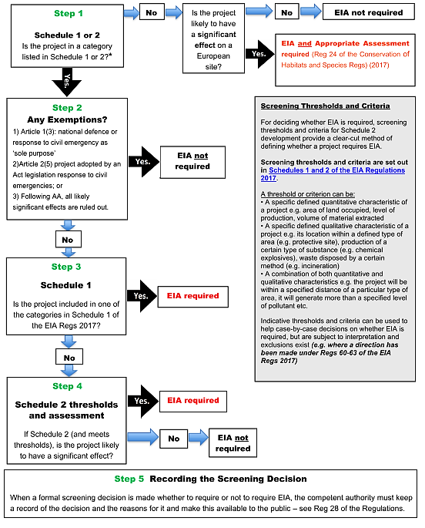
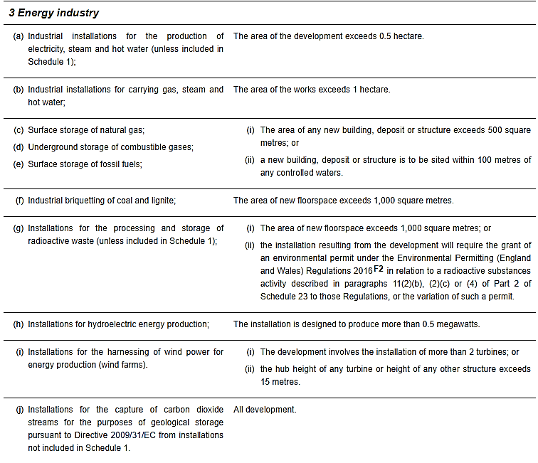
Figure 1Screening Flowchart (Friends of the Earth, 2020)
Table 1 ES Relevant Thresholds and Criteria for Energy Industry (UK Government, 2017).
The relevant thresholds and criteria regarding the WF projects are highlighted in point ‘(i)’ (Table 2). It is worth mentioning that most criteria are either qualitative, quantitative or the combination of both and are subject to interpretation. On some occasions, they can be excluded under the EIA 2017 regulations, e.g. “projects serving national defence purposes in Wales” (Reg 61) (Part 11, Exemptions) (Welsh Government, 2018).

Development of National Significance (DNS)
Declaring proposals as DNS projects ensures that planning applications with potentially more significant influence on Wales receive more attention from statutory, specialist consultees and all decisions are timely and maximally benefit the Welsh community/environment (The Planning Inspectorate, 2019b). Also, the DNS (Wales) Regulations 2016 appoints The Local Planning Authority (LPA) together with the NRW and Cadw a ‘specialist consultees’ in the EIA application process that must be consulted before submitting to Welsh Ministers (Natural Resources Wales, 2017; The Planning Inspectorate, 2019b).
The DNS has a statutory basis in Wales provided by the Planning (Wales) Act 2015 (amending the TCPA 2017) as well as the Developments of National Significance (Wales) Regulations 2016 (as amended) (The Planning Inspectorate, 2019a). In line with the 2016 Regulations, most of the energy generation projects (like proposed WF) “must be applied directly to the Welsh Ministers with the support of Planning Inspectorate Wales (Section 62D, TCPA 2017) with the inclusion of special DNS list of relevant secondary consents (e.g. Commons Act 2006-Section 38: Works on Common Land) (Department for Natural Resources, 2016; The Planning Inspectorate, 2019b).
Regulation 4 in the DNS (Wales) Regulations 2016 states that generating stations with installed generating capacity between 10-50 MW (like the Upper Ogmore WF project) are DNS development (Welsh Government, 2016).

Standard EIA Steps (DNS Projects)
When the initial screening unlocks the EIA requirement for the planning application process, applicants are encouraged to engage with the Planning Inspectorate (PINS) at the scoping stage very early for the fluent DNS application examination to avoid later rejection.
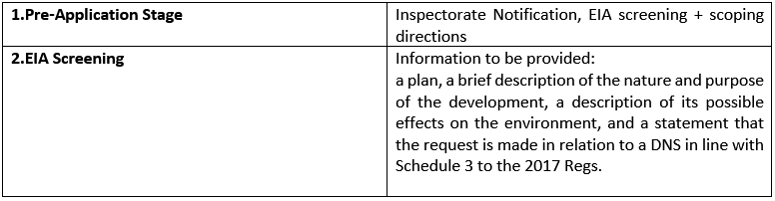
Table 2 EIA Stages Included in DNS Projects (The Planning Inspectorate, 2019a).
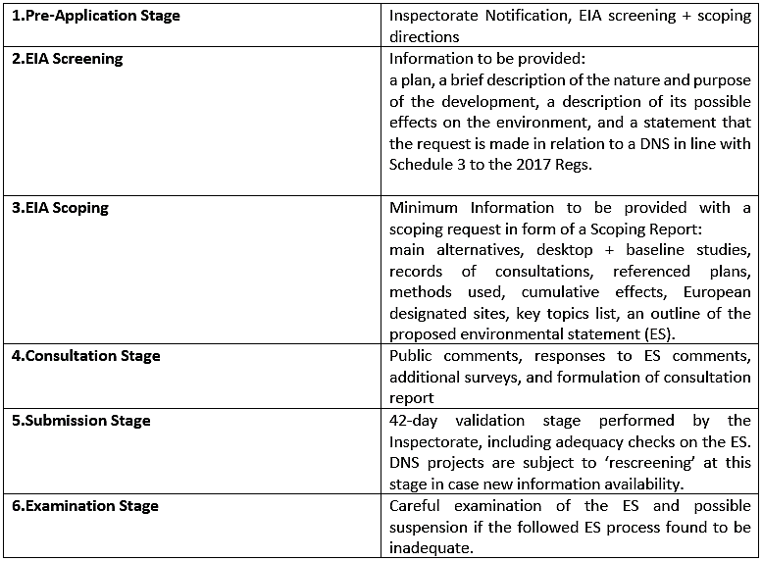
The screening direction must be issued within 21 days by the PINS providing all the minimum required information included in the screening request (in line with the Schedule 3, 2017 TCPA Regulations) (Table 2., 2). It is vital to ensure that “all aspects of the development likely to be significantly affecting the environment were considered” (Welsh Government, 2018, p:71). Similarly, the formal scoping direction request should be included at an early stage in the form of a ‘scoping report’. The PINS can only issue a scoping direction with ‘high-level comments’ within the statutory five weeks, providing all-sufficient and extensive information concerning the significant environmental effects (including the ES proposal) were present (Table 2., 3). It is advised that ‘the worst-case scenario’ is assumed, although PINS can always request additional information and suspend the process (The Planning Inspectorate, 2019a).
The consultation stage should be long enough to collect the consultees comments (including the proposed ES feedback), and they should be handed in as a Consultation Report. Some additional surveys are often performed. The submission stage is used to validate the DNS project, and its ES is checked extensively for its adequacy. Sometimes ‘rescreening’ process is commissioned in case new information is available. Lastly, a detailed examination is performed to check the followed ES process was sound and in case of infringements, the whole process can be suspended, and more information requested.

Available Guidance
It is vital to mention many professional bodies issue valuable guidance and updates to help to incorporate the constantly evolving EIA requirements into the DSA application process. Examples are the Welsh Government, The PINS, Natural Resources Wales (NRW), the Institute of Environmental Management and Assessment (IEMA), including relevant NGOs like Friends of the Earth.

3.0. Proposed Development Outline
The Upper Ogomre WF development was proposed by Renewable Energy Systems Limited (RES) company in March 2018. The company is considered one of the world’s leading renewable energy developer, with over 17 thousand MW of renewable energy is installed worldwide.
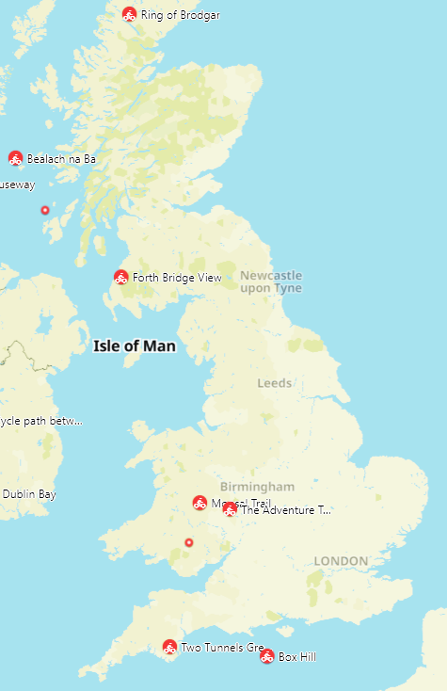
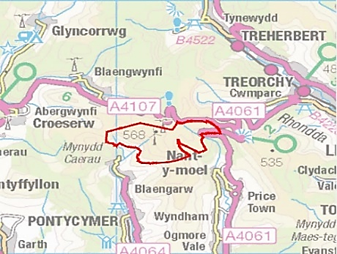

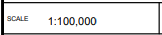
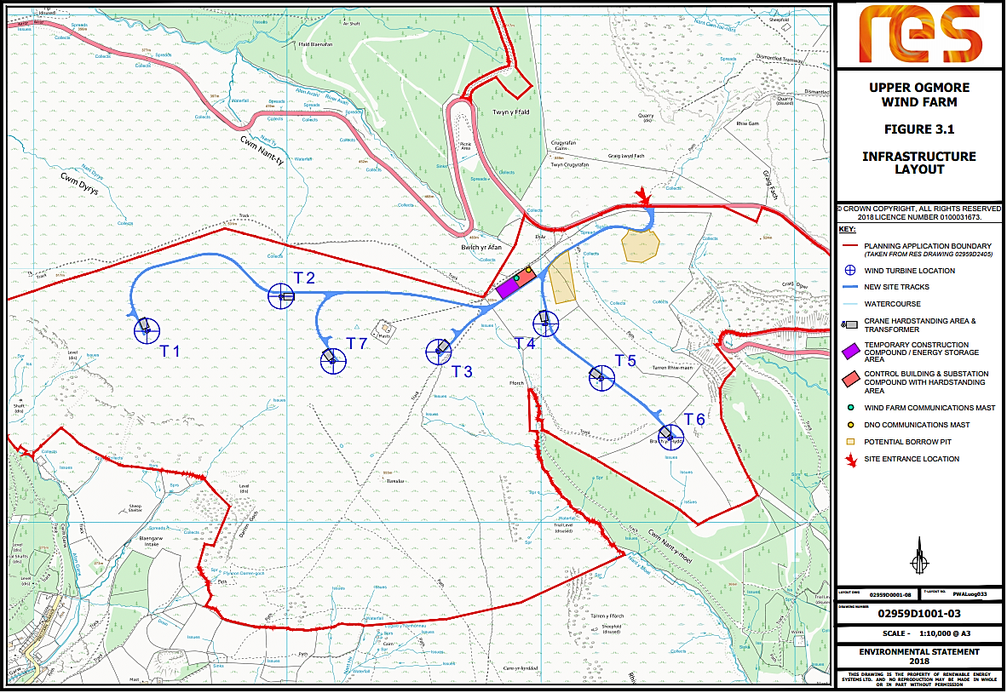
The chosen site location is in Bridgend County near three mid-size villages (Nantymoel, Blaengarw and Blaengwynfi) located south of the A4107 (Grid ref: E29150 N19450) (Fig.2), centred on the summit of Werfa (568m). The proposed WF will occupy 16.81 ha of private agriculture land near small watercourses present to the south east and west. The land is an upland moorland consisted of acid and marshy upland grassland mainly used for grazing. Also, mosaics of dwarf shrub heath scatter across, and some adjoining larch (Larix decidua) plantations to the ease and west are present. Several public rights of way (i.e., footpaths and bridleways) are located on-site, including enclosed pastures in easternmost sectors (RES Limited, 2020f).
Figure 2 Location of Upper Ogmore Windfarm (RES, 2020).

The wind farm will consist of “seven three-bladed, horizontal axis wind turbines” of maximum heights of 130m to 149.9m and a total installed energy capacity of 25MW supplying 25000 homes in the area (RES Limited, 2020a, p:1). It will also require “new access tracks with improved site entrance, hard crane standings, control building and substation compound, electricity transformers, underground cabling, energy storage containers, drainage works and upgrades to a forestry track and associated tree felling, and a possible short diversion of the forestry track’’ (all contributing to substantial land transformation ) (RES Limited, 2020b, p:1). Through the screening and scoping exercises the project was declared a DNS development and it was classified Schedule 2 (EIA regs.) as an “installation for the harnessing of wind power for energy production (wind farm)” with likely significant environmental impacts (RES Limited, 2020a, p:1). Therefore, an EIA process involving number of legislations and regulations was implemented which will be assessed in the Chapter 4 (Analysis).

4.0. Evaluation of Upper Ogmore WF Environmental Statement (ES)

Description of a Development
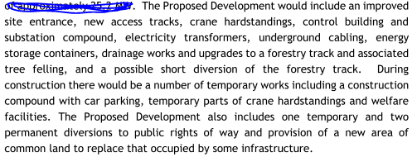
EIA guidance recommends starting an ES evaluation at the description stage (Friends of the Earth, 2020). According to Schedule 4 TCPA 2017 Regulations as well as the Planning Inspectorate Guidance (Point 9), a good description needs to include the location type, relevant land-use requirements with demolition work coverage, expected resources use for the operational phase (e.g. energy, water, land, soil) as well as estimations of the expected pollution types caused (Welsh Government, 2018; The Planning Inspectorate, 2021). In Chapter 3 of (ES), the proposed development includes an excellent description of the location, including grid references, location map (red line boundary) followed by all relevant requisite demolition involved in the construction phase (Fig.3).
Figure 3 Requisite Demolition and Land Alteration Works During Construction Phase (RES Limited, 2020c).
There are much fewer details on the type of the location as only referring to it being an "agriculture land". The project required 16.81 ha of the agriculture land to be acquired through the Commons Act 2006 procedures (in line with the DNS relevant secondary consents) (The Planning Inspectorate, 2019b; RES Limited, 2020d). All the necessary actions, including access track widening (3.6 km long section), route diversions and access alterations, has been provided, including lengths and widths (all numbers included in the 'Figures' attachment). Regarding the materials and quantities, ES states that there is no watercourse crossing involved and borrow pits were suggested at two locations as a source of 'won rock' used for road construction. Nevertheless, the required quantity and geological data are not included at this stage. ES vaguely states that "it is not anticipated that these areas would be fully exploited" (RES Limited, 2020, p:6).
Similarly, regarding the prevention of pollution caused by the borrow pits construction involving stone blasting (2-5 times a week), erection of turbines and crane hardstandings, it is mentioned vaguely stating that the working area will always be minimised and "appropriate dust suppression at the borrow pits and any materials storage areas will be provided as required" (RES Limited, 2020, p:10). In turn, water quality monitoring and pollution prevention received more attention. The Construction & Decommissioning Method Statement (CDMS) created by RES Limited limits all excavation activities during substantial rainfalls, designating refuelling points and no unapproved discharges of processed, contaminated water within the site. Also, the water buffer zones and surface run-off controls to protect watercourses and groundwater will be implemented in line with the Sustainable Drainage Systems (SuDs) guidance. Lastly, emergency response procedures in the unlikely pollution event, a Hotline number and immediate notification of NRW are advised. Consultations with specialist consultees (public bodies like NRW) are in line with the DNS ES steps guidance provided by the Welsh Government (The Planning Inspectorate, 2019b). Surprisingly, there is no information on water sourcing for the construction phase, and detailed quantification of the materials used and the expected residual pollution are also not included.

Design Evolution & Reasonable Alternatives
According to EIA 2017 Regulations (Schedule 4., 2), a description of the good reasonable site and design alternatives should give sufficient reasons on why a particular site was chosen for the project. It is required in the context of other sites and their potential environmental effects to consult all stakeholders to avoid further third-party objections and potential legal challenges (Welsh Government, 2018; Friends of the Earth, 2020). Moreover, they should be included early in the scoping request and the ES (The Planning Inspectorate, 2019b). According to RES Limited, the proposed site location and WF design are specified to balance the factors influencing maximisation of the energy produced (e.g., wind speed, topography or access) against the overall environmental, economic, and technical criteria which determine the viability of WF.
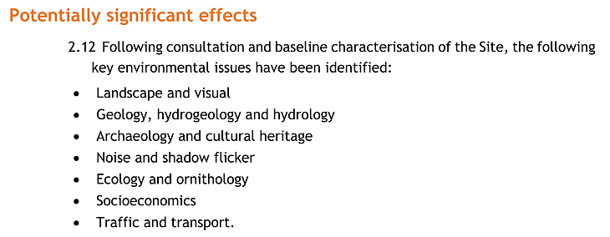
The most significant 'environmental constraints to the proposed development, according to RES Limited, were identified through series of environmental surveys presented in Fig.4. Those will be addressed in the following' Impacts Assessment' subheading. The proposer states that he aimed to "design out those significant effects" during the "iterative design process" (Res Limited, 2020).
Figure 4 Potential Significant Effect Resulted From the Environmental Surveys (Res Limited, 2020).

The public consultations were commenced in 2017 so almost three years before the planning application submission, to make sure the consultation process was effective and constructive and addressed all concerns (Res Limited, 2020). It shows a 'good-practice example' of initiating an early discussion on alternatives (in line with the DNS Procedural Guidance, Appendix 7) (The Planning Inspectorate, 2019b). Nevertheless, this report does not summarise the public comments and avoids commenting on the overall public attitude to the project. Concerning the site design options and alternatives, the prosper informs he used a GIS system as a key tool in choosing the exact site boundaries to eliminate the potential constraints. There are no other alternatives proposed elsewhere as the most effective method of site selection available, according to RES Limited, are the GIS systems (Res Limited, 2020). Additionally, Several modifications of the WF infrastructure and turbine layout were tested. According to RES Limited, the best environmental mitigation was obtained through technological design influenced by feedback from consultees, including policy and technical recommendations (In line with the TCPA 2017 guidance).
The 'Alternatives' Chapter does not elaborate much on the site selection or comparison with other potential sites, neither it provides specific reasons justifying the chosen shape of the WF site. In turn, it informs on multiple efforts to relocate the site's main entrance due to the near located scheduled monument highlighted at Cultural Heritage Consultation. As before, the GIS software assessment tool was the only factor determining the shape and size of the proposed WF. Moreover, the ES focuses in this chapter more on eliminating design constraints resulting from the baseline environmental study (e.g., removing Turbine T8 including reducing turbine tip height being adjusted I line with local Landscape Consultant) rather than looking for more appropriate alternative site locations.
The overall impression when assessing the 'Alternatives’ chapter is that methods used to find the most feasible WF site used by the applicant are “the best”, and the process of locating suitable sites is based on the eliminations of ‘environmental constraints’ like potential geological instability that may affect the turbines themselves rather than prioritising of minimalisation of the environmental impacts (example, Figure 5).
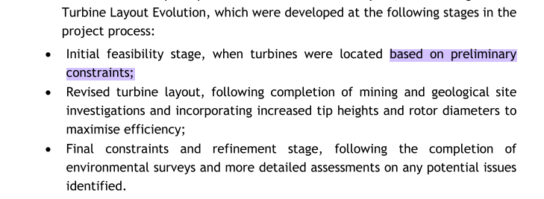
Figure 5 Turbine Layout Design Evolution (Upper Ogmore WF) (Res Limited, 2020).

Interestingly, no project layout constraints were resulted from the Ecological Consultant feedback according to the Upper Ogmore ES (Res Limited, 2020). It might suggest that sizeable DNS energy projects are favoured and receive some form of leniency towards them.

Upper Ogmore WF Impacts Significance & Mitigation
IEMA reminds that in line with the Directive 2014/52/EU, all EIA’s should deliver more proportionate assessments of impacts solely focusing on significant impacts specific of the development based on the scientific evidence available aimed to simplify ES for more straightforward interpretation. Also, to ensure that the latest climate change trends (DNS projects to be carbon-capture ready) and population health and well-being are addressed (IEMA, 2015; The Planning Inspectorate, 2019b). The TCPA 2017 EIA Regulations in Schedule 4 emphasise the need to include factors that influence the environment, social and economic aspects, including cumulative effects and their significance (Welsh Government, 2018).
The initial ES analysis shows that a large part of the ES focuses on impacts from the construction phase in almost all chapters (1,2 3 and 5-12). Chapters 1-3 indicate that the most likely significant effects during the construction will be the excavation of borrow pits, construction of access and transportation routes including noise, extensive excavation, turbine foundations and erection of turbines using cranes, all causing disturbance to the sensitive peat bog habitats including water quality and affecting visual aspects.
The matrix explaining the ‘sensitivity criteria’ categorisation used to assess the likely significant effects in the Upper Ogmore ES is presented in Fig.6. It combines the magnitude and the environmental sensitivity to assess the site(RES Limited, 2020d).
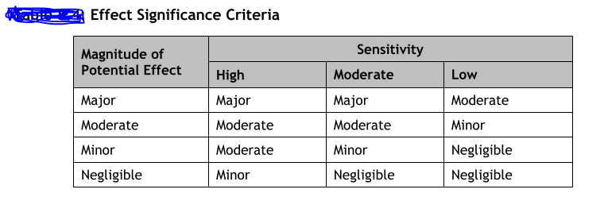
Figure 6 Sensitivity Criteria Matrix Categorisation for Upper Ogmore WF (RES Limited, 2020d).

Thanks to the water surveys and extensive peat probing, it was established that turbines should be positioned a minimum of 50 metres away from the watercourses. Additionally, watercourse buffer zones should be applied to reduce sudden increases of flow and encourage filtration and a unique silt control system to promote permeability of stock-pile materials (in line with SuDS guidance and climate change trends). Moreover, digging where peat depths exceeded 0.5m was prohibited and ‘floated construction methods’ were used (in line with the carbon storage and climate change inclusion guidance). Importantly, NRW was part of the consultation to assist the decision-making process and facilitate adequate licencing (in line with the IEMA guidance), which shows a good consultation practice example (Res Limited, 2020).
Chapter 8 informed on potential significant effects on water quality and hydrology of the peatland. Also, human health was mentioned as one of the potential sensitive receptors. However, it was only associated with potential accidents or injuries of the work crew crossing the river in case of a flood event (RES Limited, 2020c). Despite consultations with Bridgend County Borough Council (BCBC) and NRW, the explanations of exact mitigation methods were formulated into ‘SuDS Management Plan’, but no detailed description was provided at this stage. The ES statement was rather vague and unclear concerning the exact mitigation steps (example, Figure 6).
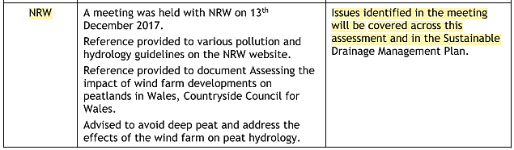
Figure 7 Developer Responses to NRW Meeting Concerning Hydrology and Water Quality (Res Limited, 2020c).

Regarding the potential chemical spillages, NRW Guidance for Pollution Prevention was applied so things like refiling away from watercourses and using risk assessments (RES Limited, 2020g). The overall level of consultation on water quality aspects is satisfying, although, like before, the mitigation lacks specific details.
Chapters 5, 8 and 11 (in line with EIA guidance) highlighted the issues of potential cumulative significant effects arising from the WF development (including construction phase, shadow flickering, affected hydrology and visual aspects). They confirmed all impacts being assessed within a 15 km study area (visual amenity radius) using desktop studies (e.g., LANDMAP database) and field-based assessments (e.g. all inhabited properties assessed within 1100m diameter in line with a 2011 legislative Update to Shadow Flicker Evidence Base). Most of the suggested impacts were ruled out due to the secluded location (2km from the nearest housing development) (RES Limited, 2020b). Surprisingly, the assessment does not mention the effect on the adjacent A4107 road and the passing-by commuters.
Similarly, regarding the hydrological effects, the local authority and the PINS consultations suggest no other ongoing or planned significant development within 10km of the Upper Ogmore site. Therefore, potential significant cumulative effects are ruled out (reasoning in Fig.8). The ten already operational WF (Fig.9) were not taken into account.
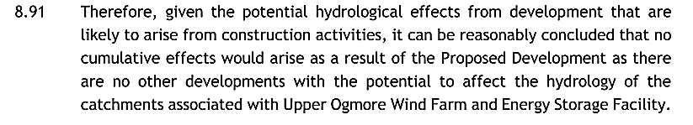
Figure 8 Reasoning for the ruling out of Cumulative effects caused by the Upper Ogmore Development (RES Limited, 2020f).

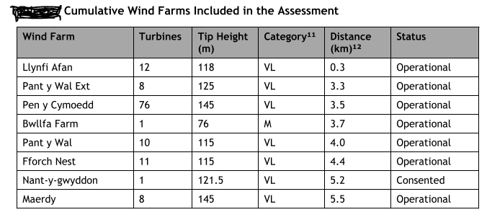
It is unclear why cumulative effects (e.g., disturbed hydrology and visual effects) were only accounted for ongoing projects in the construction phase. For some reason, other adjacent WF developments, including llynfi Afan (12 turbines only 0.3 km away) (Fig. 9), were not considered to be adding to the cumulative impacts (RES Limited, 2020e).
Figure 9 Other Wind Farm Locations Found within 3 Miles Frome the proposed WF Development (RES Limited, 2020d).

Socioeconomics is another aspect influenced by the WF that was included in the ES in Chapter 12. The potential benefits and impacts were estimated based on the information relevant to the project description, including evidence-based assumption methods used, including the quantitative method of Oxford Economics (i.e., Economic Impact Inputs-Outputs Model). The overwhelming part of this chapter was focusing on the benefits, therefore suggesting that the location of the WF in a highly deprived region was convenient to everyone. The main benefits, according to the ES, are £22.49 capital investment spent on the proposed project resulting in “110 job-years of employment” (£3.44 million of created directional wages) during the construction phase only (RES Limited, 2020c, p:25). Furthermore, WF would provide renewable energy for 22,000 homes every year, which was estimated to reduce Wales yearly CO2 emissions by 38,5 tonnes (in line with climate change commitments).
Regarding tourism, the report suggests that based on the scientific research, including analysis of impacts in Scotland ((e.g., Wind Farms and Tourism Trends in Scotland (2016) and 2016 BiGGAR Economics (2017)) there is currently no clear evidence of significant impacts on tourism in the UK. Interestingly, the report also points out “ a lack of literature focussing on the WF impacts on tourism in Wales” (RES Limited, 2020c, p:21). This somewhat optimistic chapter, although based on some scientific research, it omits the harmful effects of onshore WF highlighted in various other studies suggesting some negative effects on tourism (e.g., on frequency and duration of local visits) (Welsh Government, 2015; Brudermann, Zaman and Posch, 2019). Lastly, the humans stress management issues resulting from the long term WF effects suggested in research (e.g., potential post-construction cumulative impacts linked to long-term health effects) (van Kamp and van den Berg, 2018). Lastly, no post-construction checks or long-term monitoring management plans were considered or suggested by the project proposer.

Ecology & Biodiversity Assessment
Chapter 6 (Ecology and Biodiversity) was assessed separately due to being the most extensively covered subject of the DNS ES Report. The 2017 TCPA EIA Regulations (as amended) require the preparation of ES only by competent experts (Regulation 18(5)(a)) (Friends of the Earth, 2020). Moreover, the Planning Inspectorate and IEMA guidance remind the latest EIA updates, especially regarding DNS projects that require demonstration of not just mitigation/compensation but also post-construction long-term maintenance plans (i.e. Environmental Management Plans) aimed to enhance the affected environment (IEMA, 2016; Planning Dirrectorate, 2019). Another relevant EIA guidance stresses that “The potential for significant effects to protected species should be a principal consideration for an EIA” (Friends of the Earth, 2020, p:20).
Firstly, ES informs on project supervision by senior ecologist Gareth Lang (ACIEEM, BSG Ecology) and the NRW expertise. It was clarified that specialist experts with licences were involved, which is in line with the legislation. Additionally, an extensive list of national/regional planning policies relevant to Chapter 6 was presented (Fig. 10), proving the site’s ecology was taken seriously (RES Limited, 2020f).
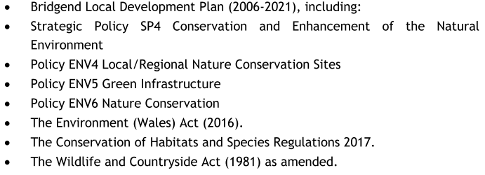
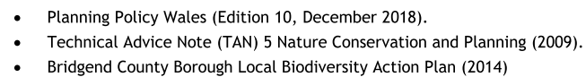
Figure 10 List of Environment Relevant National, Regional and Local Planning Policies (RES Limited, 2020e).

The initial response from the NRW at the pre-application and screening stage was crucial for the ES ecology assessment as the Special Site of Scientific Interest (SSSI) was located downhill, right below the proposed WF. Although it is not an EU protected site (therefore, no statutory Habitat Regulation Assessment as per 2017 EIA Regulation 27/Part5 required), the Planning Inspectorate and NRW insisted that Environment Management Plans, including biodiversity management, was designed for the duration of the project (with post-construction monitoring inclusion). Despite some resistance from RES Limited, it was declared “essential for granting the planning permission”, which shows the critical role of Regional/Local Authorities consultations in large scale DNS projects, especially concerning environmental protection (Jones, 2021, p:21).
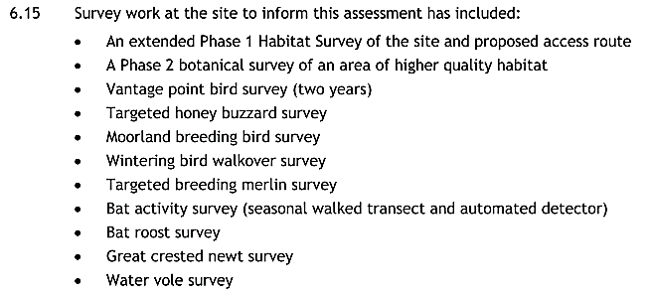
Extensive, seasonal ecological surveys were conducted, including Phase 1 extended habitat surveys (Fig.11) (e.g. bird, bat and water vole surveys, some lasting even two years showing adhering to seasonality check), resulting in the location of some protected species on-site (e.g. kestrels, bats and water voles). The involvement of BSG Ecology licenced ecologists combined with the NRW expertise and PINS guidance shows good practice example of collaboration between the developer, scientist, and the overseeing local authority ((in line with the 2017 EIA Regulations (Regulation 18(5)(a)).
Figure 11 Fig 11 Extensive List of Surveys Conducted in the Ecology Biodiversity Assessment (RES Limited, 2020e).

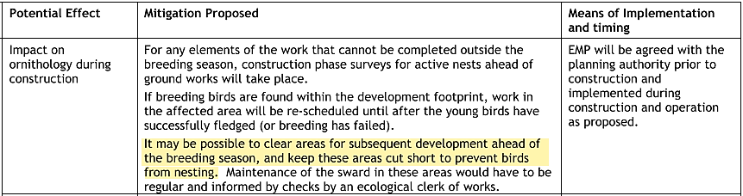
Ecological Management Plan (EMP) was introduced ((in line with The Conservation of Habitats and Species Regulations 2017 (as amended) including Planning Inspectorate and IEMA guidance). It included critical Collision Risk Analysis V2 (in Appendix 06, ES Report) concerning birds and the modelling with clear conclusions, which were very good according to NRW examinations (Jones, 2021). Mitigation was offered in line with the Wildlife and Countryside Act 1981 (as amended, updated in March 2016) to protect specific birds and nests during the breeding season (March-August). However, like previously, it was rather vague and lacking specific details. Also, some EMP mitigation proposed in Chapter 13 (Fig. 12) (RES Limited, 2020c) may prove counterproductive, opposite the Friends of the Earth guidance on “using the development as an opportunity to enhance the biodiversity” (Friends of the Earth, 2020, p:20).
Figure 12 Mitigation proposed in Chapter 13 Concerning Breeding Birds (RES Limited, 2020b).

Additionally, kestrel’s habitat loss ( kestrel is conservation species under WCA 1981, Section 1) (Association of Drainage Authorities, 2017), including water voles (WCA 1981, Schedule 5) (as amended), were declared significant at ‘local to district level’ due to the cumulative effect of multiple turbine development in the area’. Unfortunately, the mitigation efforts proposed during the construction phase were “financial contribution to local initiatives focussed on the management of moorland habitats” (RES Limited, 2020e, p:86) which shows the responsibility of habitat mitigation/enhancement being passed onto somen one else and difficult to trace in post-construction phase.
It can be noted that the primary EMP focus was only on the short-term protection of species and habitats during the construction phase. Also, habitat ‘no net loss’ requested by the Welsh Government (since 2019 updates), including habitat enhancement, according to the proposer, was deemed impossible “due to the isolated nature of the site” (RES Limited, 2020e, p:80). Therefore, no pinpointing of exact water voles’ locations was performed, neither loss of crucial moorland/wetland habitat concerning the long term (post-construction) phase was addressed (in line with habitat enhancement also required by the Environment Wales ACT 2016). Once again, the only mitigation offered was through ‘’contribution to local habitat restorations initiatives’’(RES Limited, 2020e, p:80).

Public Consultation and Non-technical Summary
Legislation regarding the ES formal consultations points out the importance of local advertisements and publicity of any new or updated decisions made regarding the proposed development, including the full ES report as required by the updated 2017 TCPA Regulations (Schedule 2) (Welsh Government, 2018). In line with the regulations, the PINS office requested notice in a local newspaper and article on the public website) (The Planning Inspectorate, 2019b).
In response, a detailed index of issues concerning the ES consulted with PINS were attached in ES (Appendix 1.3). Moreover, the project was presented for stakeholders’ consultations since the pre-application stage, starting in 2017, 33 months before the final ES submission. All essential details concerning the project design and extent were presented in several public exhibitions to engage with the local community, address all significant issues, and collect feedback (in line with the 2017 TCP Regulations). The Pre-Application Community Consultation Report presenting all the received feedback was also drawn up to facilitate project decisions. In line with the legislation, the news on the plans of erecting a new 25MW Welsh wind and storage facility by RES Limited was published in an online newspaper article in December 2020 (reNEWS.BIZ, 2020). Additionally, the official website sharing all the information regarding WF development was also created (RES Limited, 2021).
It is worth mentioning that the recently updated Welsh Government EIA guidance has also included the Covid-19 pandemic restrictions asking local planning authorities and proposers not to produce hard copies of any ES related documents and create their electronic form making them available online (Ministry of Housing Communities & Local Government, 2020).
It was confirmed that all ES chapters were presented online on RES Limited website in great detail of 13 separate chapters for everyone to read and comment on. The Non-technical summary was also provided in line with the 2017 TCPA Regulations (as amended) (Part5, 18e) in an electronic file form (Volume1, six whole chapters) in more cognised and more accessible to rad form, including Introduction, description, and significant impacts of the proposed development. On the negative side, no location maps or any plans and drawing were included, and most significant impacts were usually declared ‘acceptable’, ‘minimal’ or ‘negligible’ and the information on impacts mitigation were minimal (RES Limited, 2020h).

5.0 Conclusion
The EIA assessments produced for DNS developments are complex documents full of many legal and procedural guidance that involve a high number of different expertise to be completed. Many impacts are interrelated and covered under various themes and subheadings, which creates extra difficulty. Perhaps focusing on the most significant ones, in line with the guidance, especially in large-scale development, simplifies the EIA assessment process and makes it more effective. Through this assessment, it can be concluded that EIA is a powerful tool, and with the engagement of specialist, licenced experts, local authorities, and public participation, they can be very effective in eliminating severe environmental threats imposed by new structures. Government bodies like NRW and ecological surveyors helping in WF projects are essential to achieve an excellent overall level of protection/mitigation throughout the consecutive steps of the EIA process. On the negative side, it was observed that big energy projects like Upper Ogmore WF, of national strategic status, may be treated with priority by statutory bodies, and therefore a form of leniency in terms of mitigation and enhancement requirements is present. It was especially noticeable within the habitat mitigation and post-construction enhancements chapters surrounded with some ambiguity. Many impacts were easily neglected, and proposed mitigations were missing essential details. It can also be observed that there is a high level of personal interpretation involved in examining the proposed actions, which can cause potential issues in the long run. Lastly, it can be stated that modern EIAs, although far from perfect, do very well on incorporating climate change and human health, including public participation, and they will be indispensable when dealing with those issues in a near, post-pandemic world.

6.0 References
Association of Drainage Authorities (2017) Kestrel Action Plan for Incorporation Within Internal Drainage Board BAPs.
Brudermann, T., Zaman, R. and Posch, A. (2019) ‘Not in my hiking trail? Acceptance of wind farms in the Austrian Alps’, Clean Technologies and Environmental Policy. Springer Berlin Heidelberg, 21(8), pp. 1603–1616. doi: 10.1007/s10098-019-01734-9.
Department for Business, E. & I. energy (2013) Consents and planning applications for national energy infrastructure projects -, GOV.UK. Available at: https://www.gov.uk/guidance/consents-and-planning-applications-for-national-energy-infrastructure-projects#history (Accessed: 10 April 2021).
Department for Natural Resources (2016) DEVELOPMENTS OF NATIONAL SIGNIFICANCE. Available at: http://gov.wales/topics/planning/developcontrol/developments-of-national- (Accessed: 10 April 2021).
European Commission (no date) Review of the Environmental Impact Assessment (EIA) Directive. Available at: https://ec.europa.eu/environment/eia/review.htm (Accessed: 10 April 2021).
Friends of the Earth (2020) Environmental Impact Assessment (EIA).
Hoare, D. (2019) ‘Impact Assessment Outlook Journal Perspectives upon Nationally Significant Infrastructure Projects and Development Consent Orders Thought pieces from UK practice’, IEMA, 2(April), p. 22.
IEMA (2015) ‘Environmental Impact Assessment Guide To Climate Change Resilience and Adaptation’, (November), p. 32. Available at: https://www.iema.net/assets/templates/documents/iema_guidance_documents_eia_climate_change_resilience_and_adaptation (1).pdf.
IEMA (2016) ‘Environmental Impact Assessment Gide to Delivering Quality Development’, pp. 1–20. Available at: https://www.iema.net/assets/newbuild/documents/Delivering Quality Development.pdf.
Jones, L. (2021) Upper Ogmore - Wind Turbines.
van Kamp, I. and van den Berg, F. (2018) ‘Health Effects Related to Wind Turbine Sound, Including Low-Frequency Sound and Infrasound’, Acoustics Australia. Springer Singapore, pp. 31–57. doi: 10.1007/s40857-017-0115-6.
Ministry of Housing Communities & Local Government (2020) Environmental Impact Assessment, GOV.UK. Available at: https://www.gov.uk/guidance/environmental-impact-assessment#history (Accessed: 9 April 2021).
Natural Resources Wales (2017) Developments of National Significance - Guidance for Applicants. Available at: www.naturalresourceswales.gov.ukwww.naturalresourceswales.gov.ukwww.naturalresourceswales.gov.uk (Accessed: 10 April 2021).
Planning Dirrectorate (2019) Securing Biodiversity Enhancements.
reNEWS.BIZ (2020) RES submits 25MW Welsh wind and storage plans. Available at: https://renews.biz/65148/res-submits-25mw-welsh-wind-and-storage-plans/ (Accessed: 16 April 2021).
Res Limited (2020) Chapter 2 Design Evolution & Alternatives Environmental Statement.
RES Limited (2020a) Chapter 1 Upper Ogmore Wind Farm & Energy Storage Facility Introduction Environmental Statement.
RES Limited (2020b) Chapter 11 Shadow Flicker & Reflected Light Background Information.
RES Limited (2020c) Chapter 13 Upper Ogmore Wind Farm- Schedule of Mitigation.
RES Limited (2020d) Chapter 3 Upper Ogmore Wind Farm & Energy Storage Facility Proposed Development Environmental Statement.
RES Limited (2020e) Chapter 5 Landscape and Visual.
RES Limited (2020f) Chapter 6 : Ecology and Biodiversity.
RES Limited (2020g) Chapter 8 Hydrology & Hydrogeology ES.
RES Limited (2020h) Upper Ogmore Wind Farm and Energy Storage Facility Non Technical Summary. Available at: www.upperogmore-windfarm.co.uk (Accessed: 16 April 2021).
RES Limited (2021) Upper Ogmore Wind Farm | DNS APPLICATION. Available at: http://www.upperogmore-windfarm.co.uk/dns-application/ (Accessed: 16 April 2021).
The Planning Inspectorate (2019a) Developments of National Significance Appendix 3: Environmental Impact Assessment.
The Planning Inspectorate (2019b) Developments of National Significance Procedural Guidance.
The Planning Inspectorate (2021) EIA: Process, Preliminary, Environmental Information, and Environmental Statements. Available at: http://infrastructure.planninginspectorate.gov.uk/legislation-and-advice/advice- (Accessed: 13 April 2021).
UK Government (2017) The Town and Country Planning (Environmental Impact Assessment) Regulations 2017. Available at: https://www.legislation.gov.uk/uksi/2017/571/schedule/4 (Accessed: 8 April 2021).
Welsh Government (2015) Study into the Potential Economic Impact of Wind Farms and Associated Grid Infrastructure on the Welsh Tourism Sector. Available at: www.regeneris.co.uk (Accessed: 22 February 2021).
Welsh Government (2016) The Developments of National Significance (Specified Criteria and Prescribed Secondary Consents) (Wales) Regulations 2016. Available at: https://www.legislation.gov.uk/wsi/2016/53/regulation/4/made (Accessed: 10 April 2021).
Welsh Government (2018) ‘Preparation of an Environmental Statement’, National Infrastructure Planning Handbook 2018, (571), p. 76. doi: 10.5040/9781526508126.ch-061.

