Module Name: Learning In the Digital Era
Module Code: ACCA 4025

Student Name: Joanna Grabowska
Student ID: 2511424
Group: 2
Lecturer’s Name: Koushik Modak
University of Wales Trinity Saint David

Table of Contents
Introduction 2
Task 1: Essential Academic and Employment Skills for the Future Career Path 3
Task 1 (a): Report on Essential Academic and Employment Skills 5 Source 3
Task 1 (b): Evaluation of Task 1 (a) based on Similarity Report 4
Task 2: Collaborative Mind Map and Individual Poster 6
Mind Map (Collaborative) 6
Poster (Individual) 8
Introduction 8
Significance of Teamwork in Education 9
Teamwork Significance in Career 9
Benefits of Teamwork 9
Conclusion 9
Task 3: Virtual Collaboration and RefWorks 11
Report on Virtual Collaboration 11
Step-By-Step Process of Using Refworks With Visuals 12
Task 4: E-Portfolio Creation and Evaluation 15
Task 4 (a): E-Portfolio Creation 15
Task 4 (b): Illustrative Review of E-Portfolio tool Selection 15
Conclusion 16
Bibliography 17

Introduction
The key skills needed in any type of work environment are the so-called employability skills, the skills and personal qualities and values that help you be successful in your workplace. They are also referred to as enterprise skills, communication skills or work place skills. These skills are built up in terms of group projects and mind-map exercises. These experiences equip the students with employment opportunities in the future as they develop the ability to collaborate and solve problems. Also, virtual team-building software, such as Microsoft Teams, and document management tools based on the cloud has become all the more important. They are used to streamline the workflow and professional communication and become more productive. The efficient use of this set of skills, as well as using citation managements such as RefWorks, can guarantee academic integrity and professional efficiency.

Task 1: Essential Academic and Employment Skills for the Future Career Path

Task 1 (a): Report on Essential Academic and Employment Skills 5 Source
The communication skills play a crucial role in communicating ideas in an effective manner with writing, speaking, or digital media. Communication among peers, instructors, and employers leads to collaboration and avoids misunderstandings with help of effective communication.

Figure 1: Employment Skills
Communication: The communication skills play a crucial role in communicating ideas in an effective manner with writing, speaking, or digital media [5]. Communication among peers, instructors, and employers leads to collaboration and avoids misunderstandings with help of effective communication.
Adaptability: It is becoming prominent in the present world of fast changes. Resilience and readiness to learn can be shown by the ability to adapt to new technologies, environment, and expectations which the employers highly appreciate [6].
Teamwork: The vast majority of academic assignments and work-related activities require teamwork. Capability to collaborate effectively with others, listen, share duties, and solve a conflict are part of the achievement of the shared goals effectively [7].
Critical Thinking: Critical thinking helps people to think over information, assess facts and make conclusions. In educational institutions, it assists in the process of problem solving and research, and in the work place, it assists in decision-making and innovation.
Time Management: It aids students and employees to manage various tasks. Setting deadlines, prioritizing activities and keeping discipline results in better productivity and less stress which is relevant to the academic and professional needs [8].

Task 1 (b): Evaluation of Task 1 (a) based on Similarity Report

Figure 2: Similarity Report
My Turnitin similarity rate was 11% which means that similarity was not high and it was composed mostly of original writing. The small overlaps were due to shared expressions and definitions. In a bid to score higher in the future, I will embark on becoming a better paraphraser and use synthesis over direct quotations. I will also use more personal insights and interpretations to make my work more personal. According to the Generic Assessment Criteria, I would be rated 90 percent with good subject knowledge, clear writing and compliance with requirements. Nevertheless, I understand that I have to constantly enhance originality to make further reductions in the similarity of the next submissions.

Task 2: Collaborative Mind Map and Individual Poster

Mind Map (Collaborative)
Collaborative Mind Map: Life is a Team Sport
The concept of teamwork is that of individuals working together in a way that they accomplish a common goal. An effective and obvious goal is critical towards establishing effective relationships within the team members. This common goal can be used to guarantee the team achieves its goals. A collaborative environment needs to be present so that the members can exchange knowledge, skills, and expertise to achieve effective collaboration. Research points out the need of being focused on one goal, which is vital in academic and professional life. It has become apparent in many organizations that teamwork is a good idea hence the importance of encouraging collaborative skills in tertiary education. Establishing an effective team dynamic implies team coordination and participation. Instead of individualistic or competitive objectives, cooperation and social interdependence are to be stressed. Studies outline fundamental qualities of a successful team such as a willingness to achieve common goals, interdependence, open communication, and high social skills. Additionally, the support of leadership, accountability, and proper team design will be additional guarantor of productive and unified working.
Central Theme: Effective teamwork is essential for academic and career success.
Key Branches:
1. Communication
2. Trust and Respect
3. Roles and Responsibilities
4. Conflict Resolution
5. Leadership and Motivation
6. Benefits

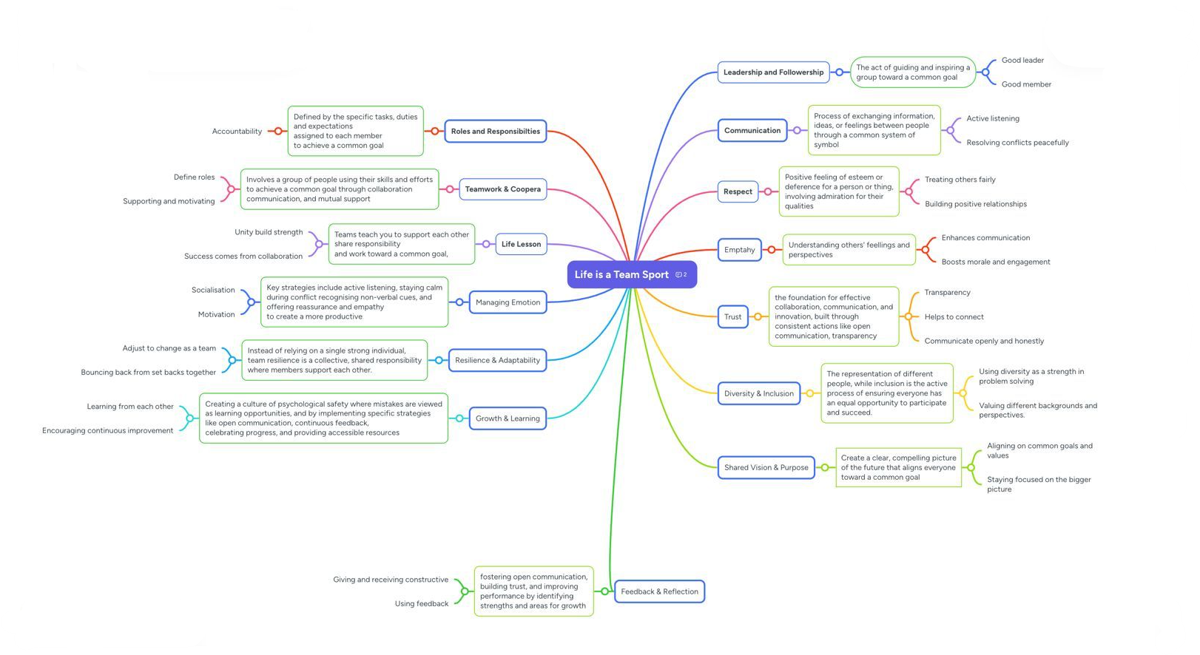
Figure: Mind-Map
Source: (Self-Made)
Link: 👉 https://mm.tt/map/3845106917?t=zkVUczRebZ

Poster (Individual)
Poster Title: “Collaborative Teamwork and Academic Success”

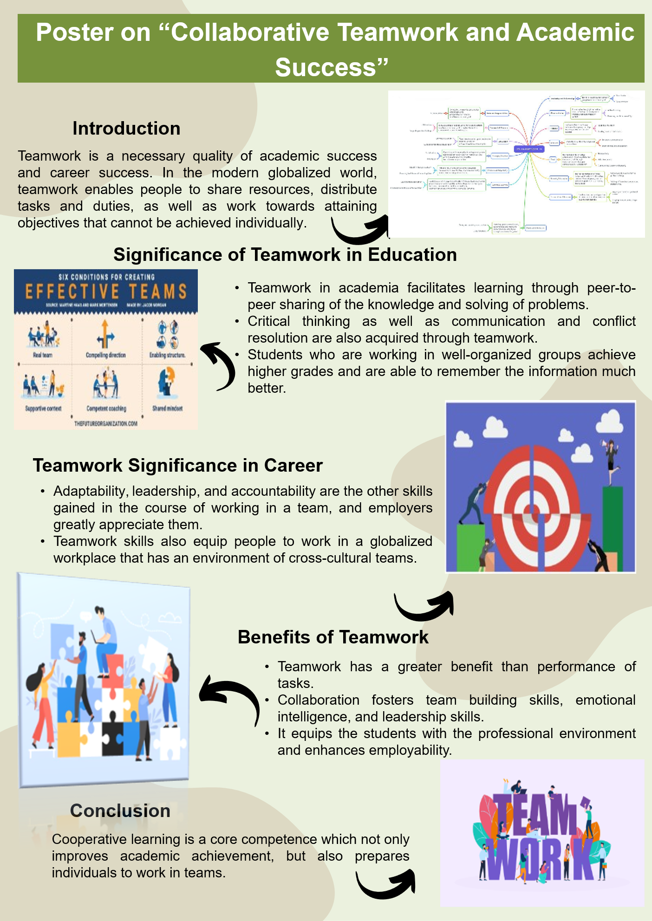

Introduction
Teamwork is a necessary quality of academic success and career success. In the modern globalized world, teamwork enables people to share resources, distribute tasks and duties, as well as work towards attaining objectives that cannot be achieved individually. In the Moodle Unit 2, Topic 4, Life is a Team Sport, it is stated that successful teamwork depends on communicating, working with each other, and dedication to a common cause. This poster examines the reasons of teamwork being important, some of the important aspects of teamwork, and the benefits of teamwork in learning and the workplace. It also takes into consideration the insights gained during a collaborative mind-map activity that was an exercise during the unit.

Significance of Teamwork in Education
Teamwork in academia facilitates learning through peer-to-peer sharing of the knowledge and solving of problems. The projects in groups, laboratory, and research can enable students to have different points of view, which in most cases results in new ideas. Critical thinking as well as communication and conflict resolution are also acquired through teamwork. Students who are working in well-organized groups achieve higher grades and are able to remember the information much better.

Teamwork Significance in Career
Teamwork is also important in the workplace. Teams are critical to organizations because they help organizations meet the deadlines, create products and solve complex problems. Efficiency, minimization of errors, and creation of a positive working environment are the result of effective collaboration. Adaptability, leadership, and accountability are the other skills gained in the course of working in a team, and employers greatly appreciate them. Teamwork skills also equip people to work in a globalized workplace that has an environment of cross-cultural teams.

Benefits of Teamwork
Teamwork has a greater benefit than performance of tasks. Collaboration fosters team building skills, emotional intelligence, and leadership skills. It equips the students with the professional environment and enhances employability. Team work also fosters confidence, hardiness and a feeling of collective success, which is essential in the long run success.

Conclusion
Finally, cooperative learning is a core competence which not only improves academic achievement, but also prepares individuals to work in teams. Through the establishment of a positive communication, cooperation, and sense of collective responsibility. Also, people are able to reach combined objectives together with the development of personal and professional skills. Incorporating teamwork in education equips students with the future working environments hence they are able to make significant contributions towards the success of the organization. The lessons learned during the collaborative mind-map activity also support the significance of the mentioned principles and give a visual representation of how to see the successful practice of teamwork.

Task 3: Virtual Collaboration and RefWorks

Report on Virtual Collaboration
Chosen Topic: Effective Communication and Collaboration in Remote Teams
Virtual collaboration is the new mainstay of the academic and professional sphere, especially with remote work and distance learning becoming a popular practice. It is essential to communicate and cooperate with remote teams to be productive, engaged, and complete shared targets [1]. This report outlines the key arguments on strategies, tools and best practices towards improving virtual teamwork.
- Digital Communication Platforms: Microsoft Teams, Zoom, and Google Meet are the tools, which remote teams utilise to conduct both synchronous and asynchronous communication. Through these platforms, team members can be able to exchange ideas, have discussions, and hold meetings despite the geographical location, hence the continuity of work and cohesion.
- Team-based Document Management: Cloud-based services like Google Drive and Office 365 enable many people to collaborate to work on documents and comment and follow the modifications in real-time [2]. This brings about transparency, minimizes redundancy and enhances efficiency of the team in general. By combining collaborative documents with project management tools such as Trello or Asana, one will be presented with a central workspace where they can effectively track their tasks and manage deadlines.
- Role Clarity and Accountability: These are the duties that are assigned and checked in regularly to increase the accountability of the teams. When the team members know their tasks and time limits, they have time to do the tasks on time, and the number of conflicts is decreased. Well-defined work processes also lessen confusion and facilitate the coordination of team work.
- Digital Literacy and Adaptability: To achieve successful virtual collaboration, one needs to be skilled in using digital tools, as well as adapt to new technologies [3]. Developing digital literacy is a process that makes team members able to use software in order to communicate, share documents, and manage projects, which will eventually lead to team success.
- Automatic Citation Tools: Programs such as RefWorks make citation management easier since the software is able to produce in-text citations and reference lists in the IEEE format. RefWorks saves time and eliminates mistakes by importing sources, grouping them into folders, and placing them in documents to provide consistency in an academic or professional report [4]. RefWorks screenshots would show how to import references, create citations and organize the reference list.

Step-By-Step Process of Using Refworks With Visuals
RefWorks is an effective source management system and automatic citation resource. First log in using your institutions access in order to make use of it in IEEE style.
- Step 1: (Screenshot 1: RefWorks login page)
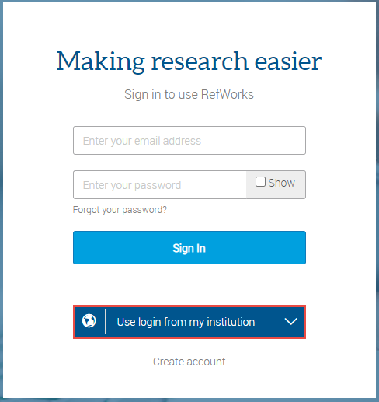
- Step 2: (Screenshot 2: “Add New Reference” interface)
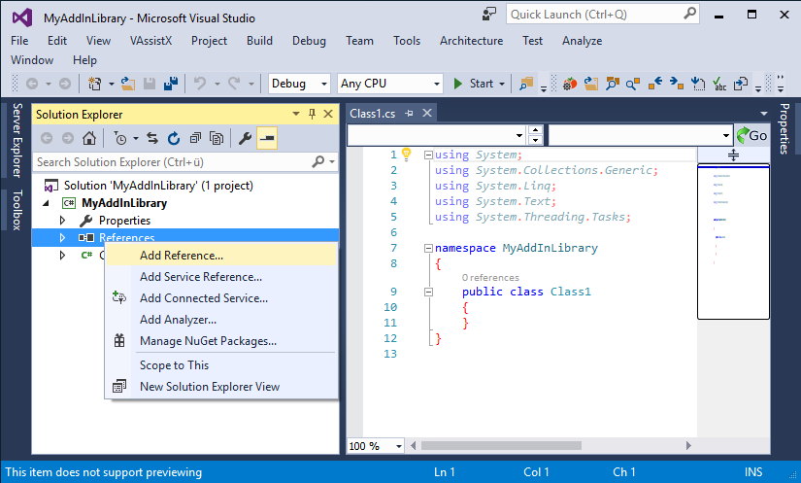
- Step 3: (Screenshot 3: Example of a folder named “Virtual Collaboration”)
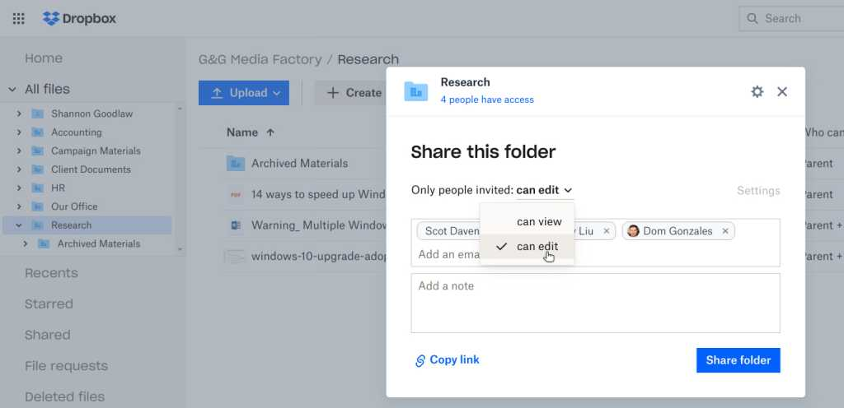
- Step 4: (Screenshot 4: IEEE citation style selection and copy tool)
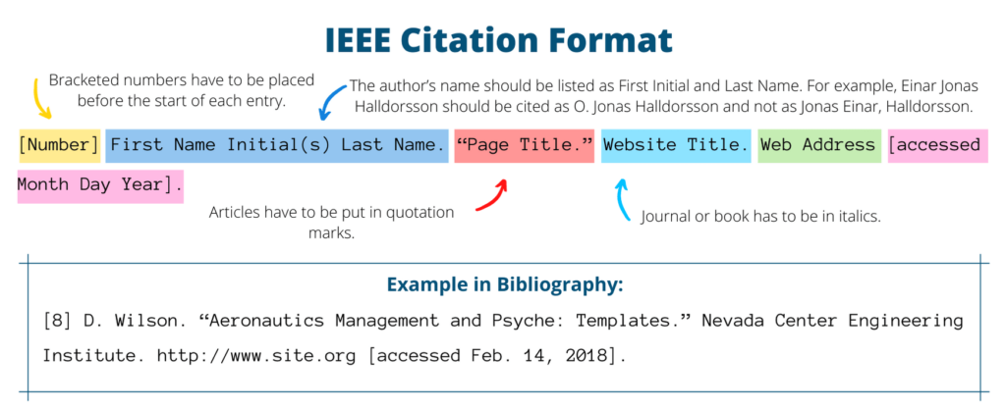
- Step 5: (Screenshot 5: Exporting bibliography from RefWorks)
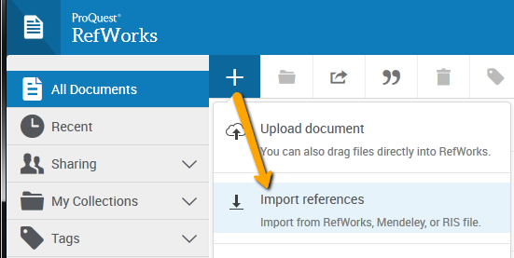

Task 4: E-Portfolio Creation and Evaluation

Task 4 (a): E-Portfolio Creation
E-Portfolio Link: 👉 https://2511424.wixsite.com/learning

Task 4 (b): Illustrative Review of E-Portfolio tool Selection

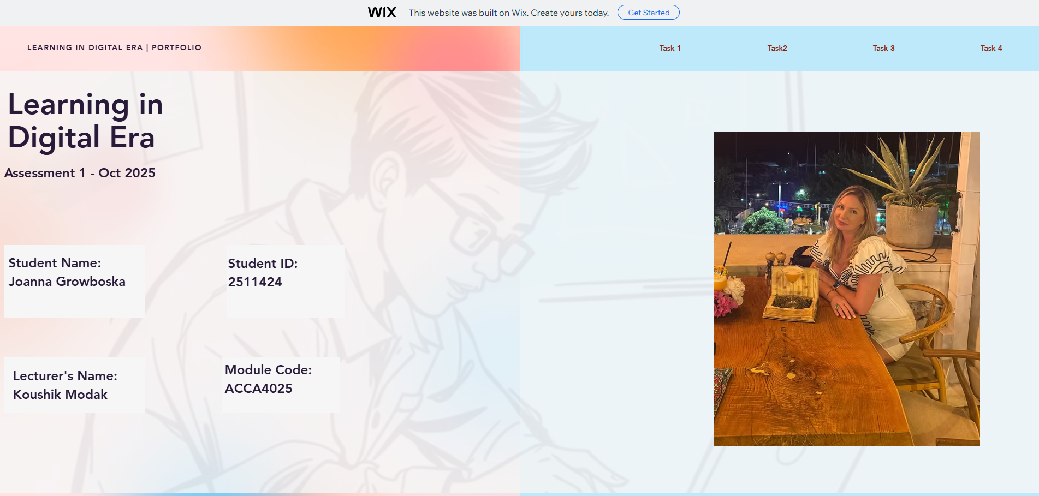

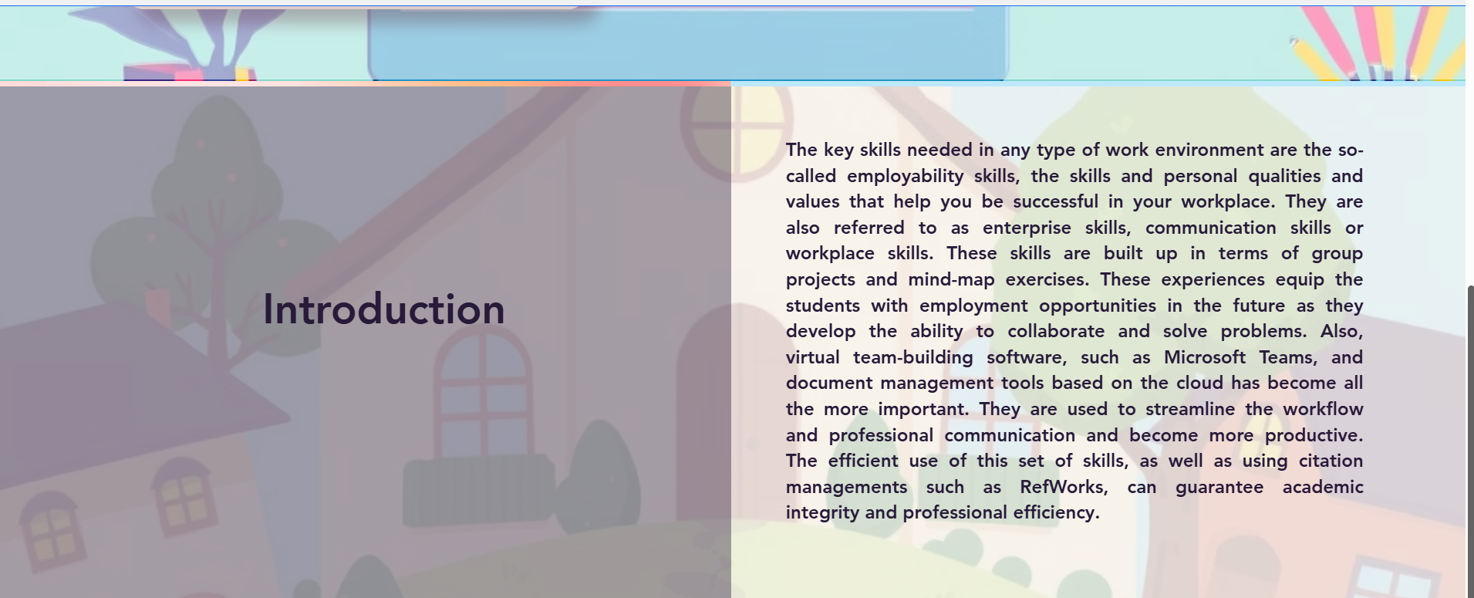
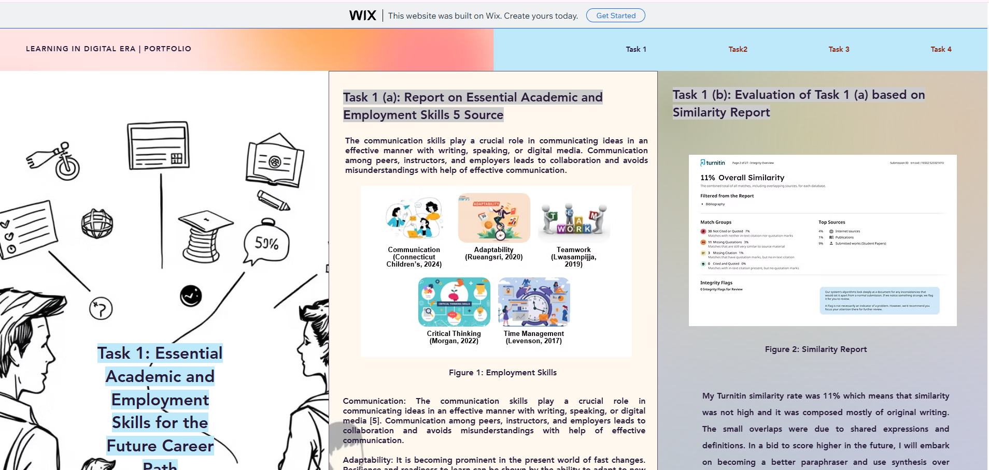

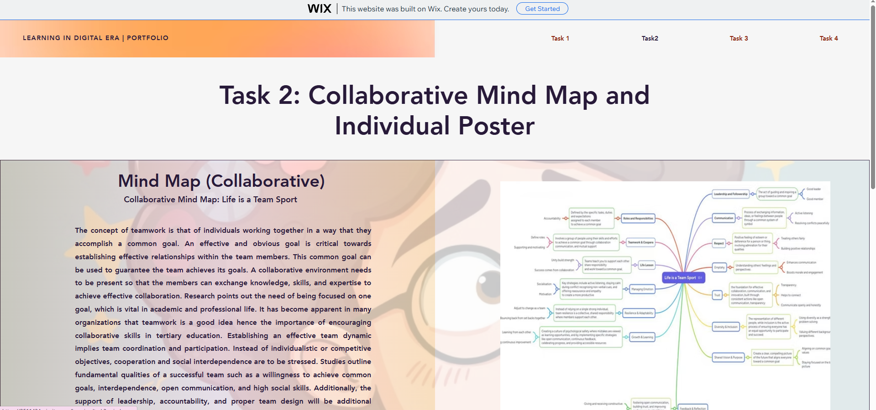

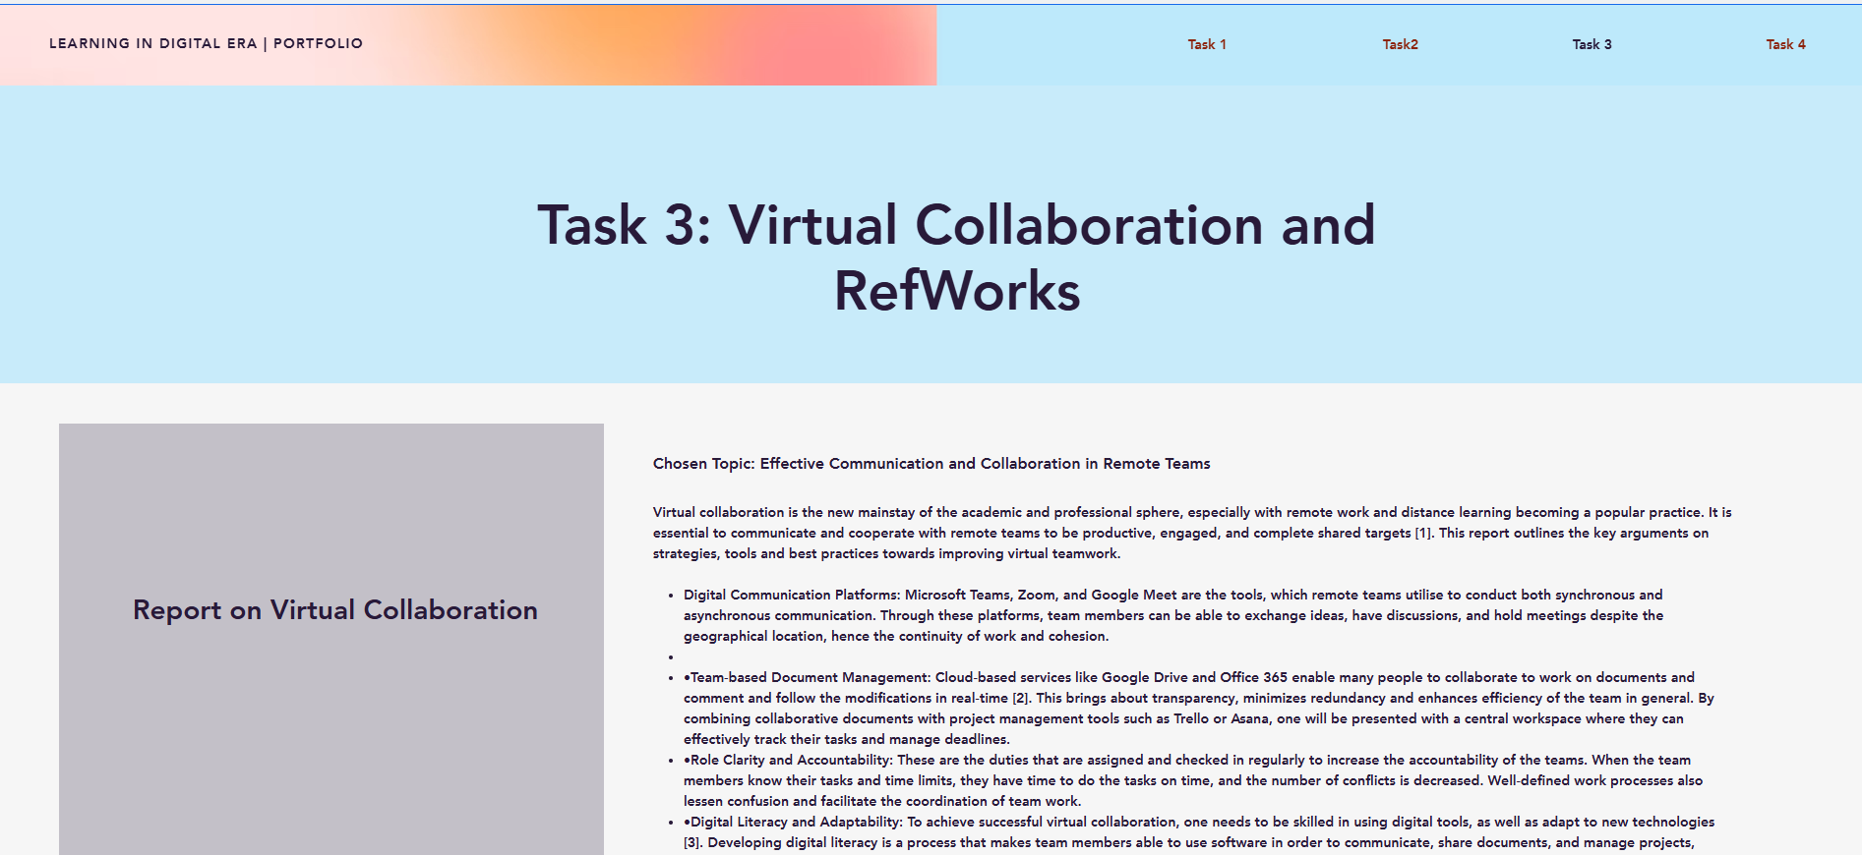
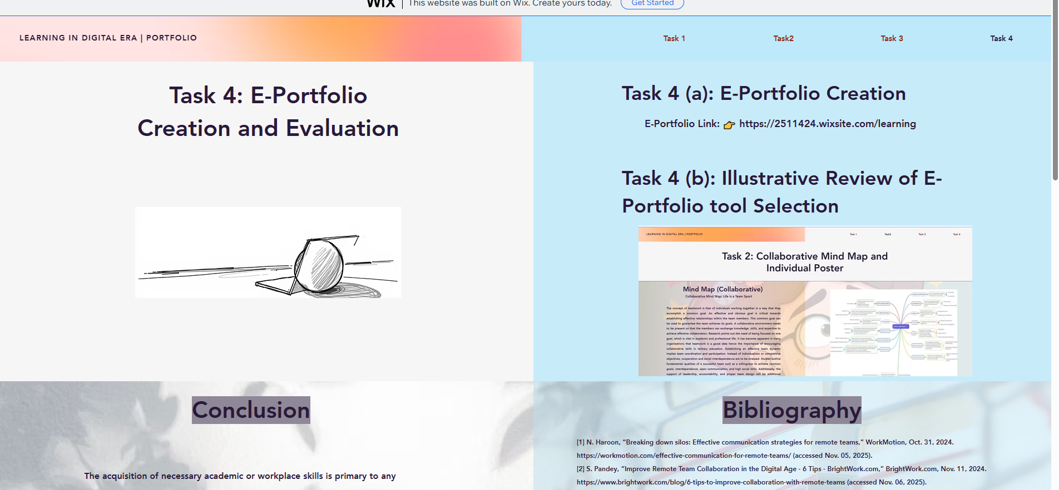

Conclusion
The acquisition of necessary academic or workplace skills is primary to any success in school and the workplace. Teamwork, communication, flexibility, critical thinking, and time management enable one to play significant roles in group work, as well as, workplace assignments. The virtual teamwork further expands these capabilities by allowing remote work teams to organize effectively through online means and project management software. Accuracy and credibility of academic work is maintained through the use of automatic referencing tool, such as RefWorks. Altogether, the combination of these skills into the learning and professional practice facilitates productivity, personal development, and provides the abilities needed to succeed in the contemporary, team-oriented, and technologically oriented world.

Bibliography
[1] N. Haroon, “Breaking down silos: Effective communication strategies for remote teams,” WorkMotion, Oct. 31, 2024. https://workmotion.com/effective-communication-for-remote-teams/ (accessed Nov. 05, 2025).
[2] S. Pandey, “Improve Remote Team Collaboration in the Digital Age - 6 Tips - BrightWork.com,” BrightWork.com, Nov. 11, 2024. https://www.brightwork.com/blog/6-tips-to-improve-collaboration-with-remote-teams (accessed Nov. 06, 2025).
[3] C. Fuchs and A. Reichel, “Effective communication for relational coordination in remote work: How job characteristics and HR practices shape user–technology interactions,” Human Resource Management, vol. 62, no. 4, pp. 511–528, Jan. 2023, doi: https://doi.org/10.1002/hrm.22161.
[4] J. N. Lane, P. M. Leonardi, N. Contractor, and L. A. DeChurch, “Teams in the Digital Workplace: Technology’s Role for Communication, Collaboration, and Performance,” Small Group Research, vol. 55, no. 1, 2023, doi: https://doi.org/10.1177/10464964231200015.
[5] H. Tushar and N. Sooraksa, “Global employability skills in the 21st century workplace: A semi-systematic literature review,” Heliyon, vol. 9, no. 11, p. e21023, Nov. 2023, doi: https://doi.org/10.1016/j.heliyon.2023.e21023.
[6] K. Gallagher, Essential Study and Employment Skills for Business and Management Students, 1st ed. Oxford University Press, 2022. doi: https://doi.org/10.1093/hebz/9780198809883.001.0001.
[7] K. Gallagher, Essential Study And Employment Skills For Business And Management Students., 2nd ed. S.L.: Oxford Univ Press, 2022.
[8] N. Fajaryati, Budiyono, M. Akhyar, and Wiranto, “The Employability Skills Needed To Face the Demands of Work in the Future: Systematic Literature Reviews,” Open Engineering, vol. 10, no. 1, pp. 595–603, 2020, doi: https://doi.org/10.1515/eng-2020-0072.
[9] L. Lwasampijja, “Interesting Attributes About 3 of My Teammates and LFA That I Have Interacted With This Week,” Medium, Jan. 16, 2019. https://medium.com/@llwasampijja/interesting-attributes-about-3-of-my-teammates-and-lfa-that-i-have-interacted-with-this-week-ecfaf98b51b7 (accessed Nov. 19, 2025).
[10] J. Morgan, “Six Conditions For Creating Effective Teams,” Medium, Mar. 17, 2022. https://jacobm.medium.com/six-conditions-for-creating-effective-teams-22f9085d683d (accessed Nov. 19, 2025).
[11] A. Levenson, “Systems diagnostics are essential to create high performance,” Linkedin.com, Dec. 18, 2017. https://www.linkedin.com/pulse/systems-diagnostics-essential-create-high-performance-alec-levenson/ (accessed Nov. 19, 2025).
[12] Connecticut Children’s, “The Power of People: How Co-Design Enhances Project Management Tools,” Connecticut Children’s, Jul. 31, 2024. https://www.connecticutchildrens.org/advancing-kids/power-people-how-co-design-enhances-project-management-tools (accessed Nov. 19, 2025).
[13] S. Rueangsri, “Behavior-Driven Development,” Medium, Apr. 16, 2020. https://medium.com/software-engineering-kmitl/behavior-driven-development-a65505f72753 (accessed Nov. 19, 2025).

