

Lecturer: Jenifer Prince Devaraj

Module: ACDA6001 Electronics II
BEng (Hons) Electrical and Electronic Engineering

15th January 2024

Critical Evaluation of Braun’s multiplier and Wallace tree multiplier using VHDL Shaun Galsworthy 2218900

Table of Contents
Figures & Tables 3
1 Introduction 7
2 Background Research 7
2.1 Digital Electronics 7
2.2 Logic Gates 8
2.2.1 Not Gate 8
2.2.2 AND Gate 8
2.2.3 OR Gate 9
2.2.4 NAND GAte 9
2.2.5 NOR Gate 10
2.2.6 XOR Gate 10
2.3 Binary Multiplication 11
2.4 Combinational Circuits 11
2.4.1 Half adder 11
2.4.2 Full adder 12
2.4.3 Binary Multipliers 13
3 Methodologies 15
4 Task One Braun’s mutilplier 20
4.1 Circuit Designs / Multipliers Diagram 21
4.2 Details of Testing and Results 22
4.3 Schematic Diagrams 24
4.4 Simulation Results 26
5 Task Two Wallace Tree Multiplier 28
5.1 Circuit Designs / Multipliers Diagram 30
5.2 Details of Testing and Results 30
5.3 Schematic Diagrams 33
5.4 Simulation Results 36
6 Task Three Performance Evaluation 39
6.1 Manual Calculation for longest delay path for Braun’s 8 bit multiplier 39
6.2 Manual Calculation for longest delay path for Wallace Tree 8 bit multiplier 40
6.3 Comparision of the overall delay of both Multipliers 40
6.4 Power Consumption 40
6.4.1 Braun’s multiplier Power Summary 41
6.4.2 Wallace tree multiplier 42
6.4.3 Comparision of power consumption of both multipliers 43
6.5 Utilization of Both Multipliers 43
6.5.1 Comparision of Utilization of both multipliers 44
7 Applications and Advantages of Multipliers 45
8 Conclusion 45
8.1 Recommendations Of Future Work 45
9 References 45
10 Appendix 46
10.1 Braun’s Logic Circuit 46
10.2 Wallace Tree Logic Circuit 47
10.3 Braun Pseudocode 47
10.4 Wallace Pseudocode 55

Figures & Tables
Table 1 NOT gate truth table 8
Table 2 AND gate truth table 8
Table 3 OR gate truth table 9
Table 4 NAND gate truth table 9
Table 5 NOR gate truth table 10
Table 6 XOR gate truth table 10
Table 7 example of binary multiplication 11
Table 8 Component quantities Braun’s multiplier circuit 20
Table 9 Component quantities of the Wallace tree multiplier 29
Table 10 Advantages and applications of multipliers 45

Figure 1 Digital signal 7
Figure 2 NOT gate designed in Visio 8
Figure 3 AND gate designed in Visio 8
Figure 4 OR gate designed in Visio 9
Figure 5 NAND gate designed in Visio 9
Figure 6 NOR gate designed in Visio 10
Figure 7 XOR gate designed in Visio 10
Figure 8 Half adder 11
Figure 9 Logic circuit for half adder designed in Visio 12
Figure 10 Truth table for half adder 12
Figure 11 Full adder 12
Figure 12 Logic circuit of full adder designed in Visio 13
Figure 13 Truth table of full adder 13
Figure 14 2 bit multiplier block diagram 13
Figure 15 2 bit multiplier circuit design 14
Figure 16 Flow chart of series of events 15
Figure 17 'Vivado' force clock 16
Figure 18 'Vivado' force constant 17
Figure 19 'Vivado' synthesis design 17
Figure 20 'Vivado' schematic 18
Figure 21 'Vivado' combination delays 18
Figure 22 'Vivado' timing restraints 19
Figure 23 Braun’ multiplier design 20
Figure 24 Braun’ multiplier full and half adders 20
Figure 25 Braun's multiplier circuit design 21
Figure 26 Braun's calculation 1 22
Figure 27 Braun's calculation 2 23
Figure 28 Braun's calculation 3 23
Figure 29 Braun's multiplier schematic 24
Figure 30 Braun's multiplier RTL analysis 24
Figure 31 Braun’s I/O planning 25
Figure 32 Braun’ multiplier package 25
Figure 33 Braun’s timing constraints 26
Figure 34 Braun's maximum delay 26
Figure 35 Braun’s updated timing constraints 27
Figure 36 Braun’s max delay path 27
Figure 37 Wallace tree multiplier design 28
Figure 38 Wallace dot diagram 28
Figure 39 Wallace multiplier circuit design 30
Figure 40 Wallace tree calculation 1 31
Figure 41 Wallace tree calculation 2 32
Figure 42 Wallace tree calculation 3 33
Figure 43 Wallace tree multiplier schematic 34
Figure 44 Wallace tree multiplier RTL analysis 34
Figure 45 Wallace tree I/O planning 35
Figure 46 Wallace Package 36
Figure 47 Wallace tree timing constraints 36
Figure 48 Wallace tree maximum delay 37
Figure 49 Wallace tree max delay path 38
Figure 50 Braun’s multiplier longest delay 39
Figure 51 Wallace tree multiplier longest delay 40
Figure 52 Power report setup 41
Figure 53 Power summary generated by the software for Braun's 41
Figure 54 power summary generated by the software for Wallace 42
Figure 55 Project summary for Braun’s multiplier 42
Figure 56 Project summary for Wallace multipliers 43
Figure 57 Braun’s utilization 43
Figure 58 Wallace tree utilization 44
Figure 59 Braun’s utilization 44
Figure 60 Wallace tree utilization 44

1 Introduction
This aim of this assignment is to carry out research on logic gates, combinational circuits and multipliers. Then design 8 bit Braun and Wallace tree multipliers, once complete they will be compared, synthesised and critically evaluated using very high speed integrated circuit hardware descriptive language (VHDL) software called Vivado.
The software will also be used to compare the speed, delay and power consumption of both multipliers whilst also recommendations given to improve the performance of both.

2 Background Research

2.1 Digital Electronics
Whereas analogue electronics operates using a varied output voltage with respect to voltage and time and up to the maximum quantity of the power source, digital electronics operate with only two quantified outputs. Either a 1 for high or 0 for low. [1]
An example of this is shown in fig 1 where 5V gives a logic output of 1 referred to as high and 0V gives a logic output of 0 referred to low. These high and low signals are used as inputs to logic gates which are used to control different electronic circuits. [1]
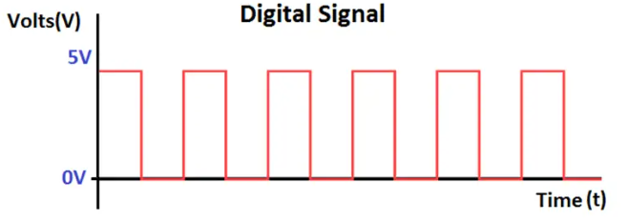
Figure 1 Digital signal
[2]

Digital electronics differs from analogue electronics and also has some advantages, such as, having a higher data capacity, unlimited data transmission and higher noise immunity. Some of the disadvantages are they require a power source to function, they require hardware to convert to analogue or converting from analogue. The circuits also have more expensive production costs, require more time to transmit signals and sometimes can suffer from quantization error. [1]

2.2 Logic Gates

2.2.1 Not Gate
The NOT gate which is sometimes called an inverter can be seen in figure 1, hence the input gives an inverted output as displayed in table 1.
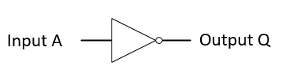
Figure 2 NOT gate designed in Visio
[3]
Input A | Output Q
0 | 1
1 | 0
Table 1 NOT gate truth table
$$Q=NOT A \\ Q= \overline{A}$$

2.2.2 AND Gate
The AND gate requires two high inputs A and B for the output Q to be high as shown in figure 3 and table 2 below. This circuit’s inputs are in series.
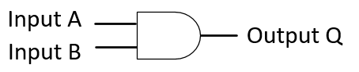
Figure 3 AND gate designed in Visio
[3]
Input B | Input A | Output Q
0 | 0 | 0
0 | 1 | 0
1 | 0 | 0
1 | 1 | 1
Table 2 AND gate truth table
$$Q=A AND B \\ Q= A∙B$$

2.2.3 OR Gate
The OR gate will give an output of 1 when either of the inputs are high the inputs are a parallel circuit as shown in figure 4 and table 3 below.
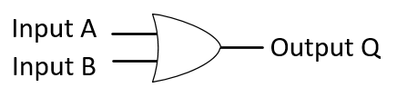
Figure 4 OR gate designed in Visio
[3]
Input B | Input A | Output Q
0 | 0 | 0
0 | 1 | 1
1 | 0 | 1
1 | 1 | 1
Table 3 OR gate truth table
$$Q=A OR B \\ Q= A+B$$

2.2.4 NAND GAte
The NAND gate is a combination of a NOT gate and an AND gate meaning that the output will be the opposite of an AND gate as shown in figure 5 and table 4 below.
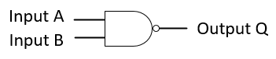
Figure 5 NAND gate designed in Visio
[3]
Input B | Input A | Output Q
0 | 0 | 1
0 | 1 | 1
1 | 0 | 1
1 | 1 | 0
Table 4 NAND gate truth table
$$Q=A NAND B \\ Q= \overline{A∙B}$$

2.2.5 NOR Gate
The NOR gate is a combination of a NOT gate and a OR gate meaning that the output will be the opposite of an OR gate as shown in figure 6 and table 5 below.
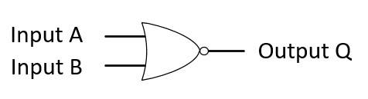
Figure 6 NOR gate designed in Visio
[3]
Input B | Input A | Output Q
0 | 0 | 1
0 | 1 | 0
1 | 0 | 0
1 | 1 | 0
Table 5 NOR gate truth table
$$Q=A NOR B \\ Q= \overline{A+B}$$

2.2.6 XOR Gate
The operation of the Exclusive-OR gate is similar to the OR gate where a high output is achieved if either input is high. Where it differs is that if both inputs are high then the output will be low as can be seen in in figure 7 and table 6.
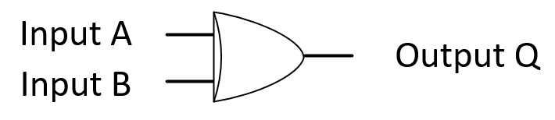
Figure 7 XOR gate designed in Visio
[3]
Input B | Input A | Output Q
0 | 0 | 0
0 | 1 | 1
1 | 0 | 1
1 | 1 | 0
Table 6 XOR gate truth table
$$Q=A XOR B \\ Q= A⊕B$$

2.3 Binary Multiplication
Binary multiplication is similar to carrying out long multiplication using decimal numbers, the first step is to multiply the top number by the furthest right digit of the bottom number then move left until all digits have been used then add all the answers together.
See example of this below in table 7.
Multiplicand |  |  |  |  | 1 | 0 | 1 | 0 | 1 | 0 | 1 | 0
Multiplier |  |  |  |  |  |  |  |  | 0 | 1 | 0 | 1
Carry |  |  |  | 1 |  | 1 |  | 1
 |  |  |  |  | 1 | 0 | 1 | 0 | 1 | 0 | 1 | 0
 |  |  |  | 0 | 0 | 0 | 0 | 0 | 0 | 0 | 0 | x
 |  |  | 1 | 0 | 1 | 0 | 1 | 0 | 1 | 0 | x | x
 |  | 0 | 0 | 0 | 0 | 0 | 0 | 0 | 0 | x | x | x
Answer |  | 0 | 1 | 1 | 0 | 1 | 0 | 1 | 1 | 0 | 0 | 0
Table 7 example of binary multiplication

2.4 Combinational Circuits
When different gates are combined together to form a circuit it is known as a combination circuit, these circuits can have many inputs and outputs where the output is determined by the input level. Due to the combination circuit having no memory the input previously inputted has no effect on the current state of the circuit.
Some applications that use combinational circuits are decoders, encoders and multiplexers where they can use half adders, full adders, half subtractors or full subtractors.

2.4.1 Half adder
The half adder is the most elemental combination circuit where it carries out addition of two binary digits it can be seen in figure 8 that it has two inputs A and B and two outputs S (sum) and C (carry).
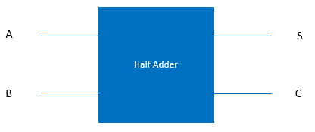
Figure 8 Half adder
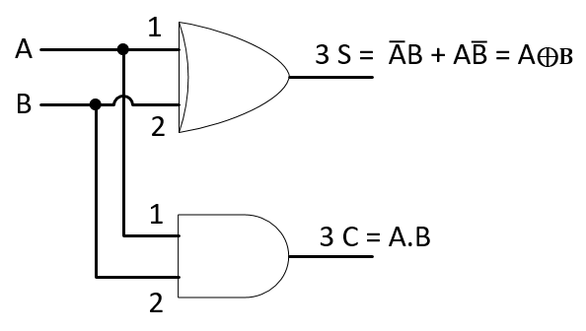
Figure 9 Logic circuit for half adder designed in Visio
Inputs |  | Outputs
A | B | Sum | Carry
0 | 0 | 0 | 0
0 | 1 | 1 | 0
1 | 0 | 1 | 0
1 | 1 | 0 | 1
Figure 10 Truth table for half adder

2.4.2 Full adder
The full adder circuit carries out addition of three binary digits it can be seen in figure 11 that it has three inputs A, B and Cin (carry in) and two outputs S (sum) and Cout (carry).

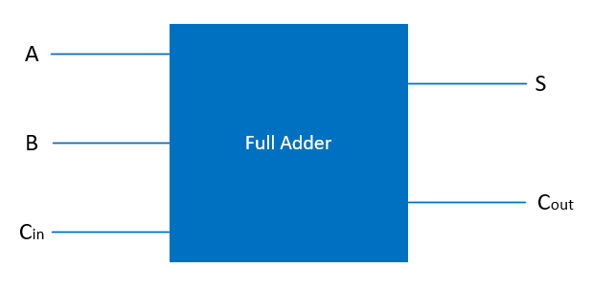
Figure 11 Full adder

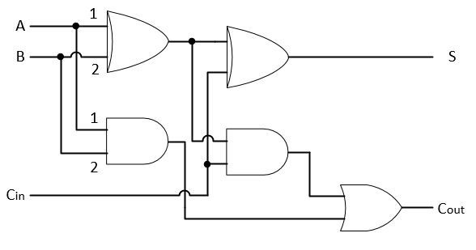
Figure 12 Logic circuit of full adder designed in Visio
Inputs |  |  | Outputs
A | B | Cin | Cout | Sum
0 | 0 | 0 | 0 | 0
0 | 0 | 1 | 0 | 1
0 | 1 | 0 | 0 | 1
0 | 1 | 1 | 1 | 0
1 | 0 | 0 | 0 | 1
1 | 0 | 1 | 1 | 0
1 | 1 | 0 | 1 | 0
1 | 1 | 1 | 1 | 1
Figure 13 Truth table of full adder

2.4.3 Binary Multipliers
To carry out binary multiplication in digital electronics of two binary numbers a multiplier is used an example of this process is shown in figure 15.
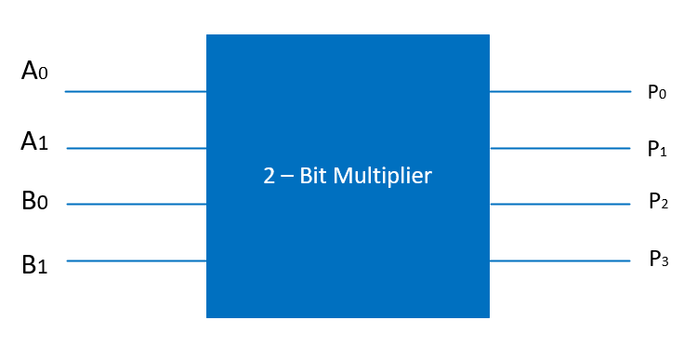
Figure 14 2 bit multiplier block diagram
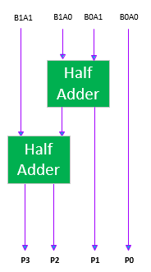
Figure 15 2 bit multiplier circuit design
There are many different types of multipliers available all with different characteristics some examples of these are shown below.
- Braun’s multiplier
- Wallace tree multiplier
- Booth’s multiplier
- Combinational multiplier
- Sequential multiplier
- Shift and add multiplier
This assignment will focus on the Braun’s multiplier and the Wallace tree multiplier.

3 Methodologies
The method of creating both multipliers is demonstrated in the step by step order shown in the flow chart of figure 14.
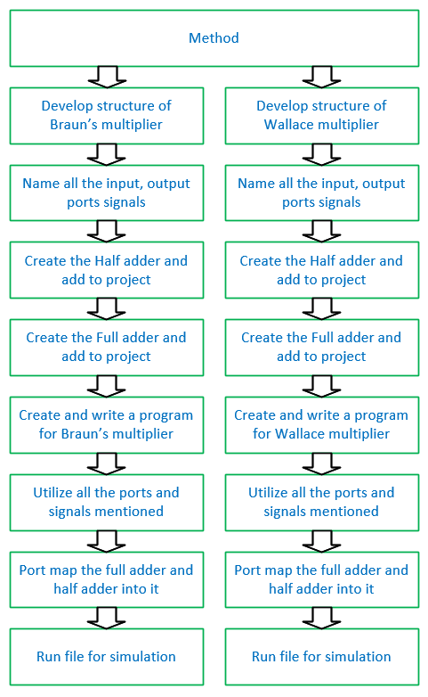
Figure 16 Flow chart of series of events
Once the programming was complete using the Vivado software the following procedure was followed for both multipliers to complete tasks one and two.
Step 1 – Run behavioural simulation
Step 2 – The force clock option was selected and the below options were selected.
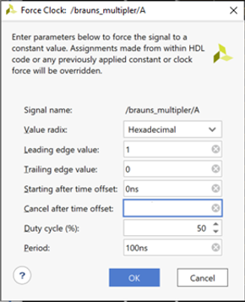
Figure 17 'Vivado' force clock
Step 3 – Force constant was selected next with the following values inputted and results recorded in ?????:
$$08 × 07$$
$$56 × 2A$$
$$FE× EA$$

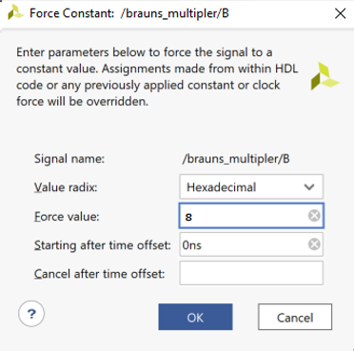
Figure 18 'Vivado' force constant
Step 4 – Open synthesis design
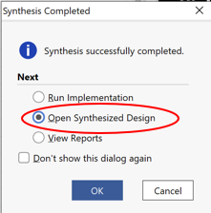
Figure 19 'Vivado' synthesis design
Step 5 – Select schematic and select I/O devices
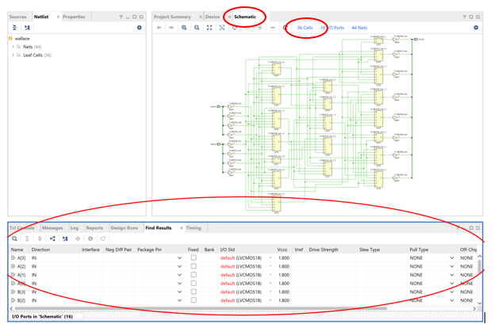
Figure 20 'Vivado' schematic
Step 6 – Assign the pin package
Step 7 – Run Implementation, view reports, open implementation design and select report timing summary.
Step 8 – Select the Datasheet and option combinational delays

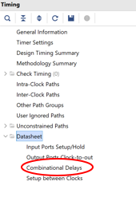
Figure 21 'Vivado' combination delays
Step 9 – Find the largest delay and the path of the input and output signals from the list.
Step 10 – Select edit timing restraints and create a clock then add the maximum delays.
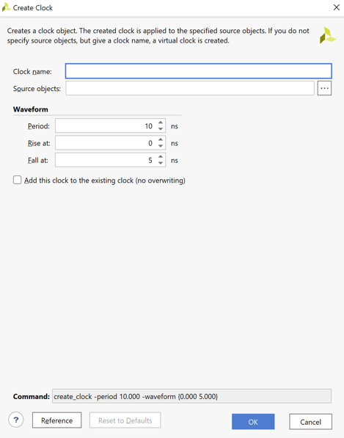
Figure 22 'Vivado' timing restraints
The flowing steps were then carried out for Task 3
Step 11 – Once the user specified timing constraints are met complete the step for Wallace also and compare the overall delay for both multipliers.
Step 12 – Create a power report for both multipliers and also compare.
Step 13 – Investigate the project utilization and compare for both multipliers.
Step 14 – Calculate the longest delay in both multipliers, assuming the AND gate delay is $t_{g = 1ns}$ and n adder delay is $t_{ad = 2ns}$ by computing the delay manually.

4 Task One Braun’s mutilplier
The Braun’s multiplier was designed by modifying two unsigned numbers the structure of the design can be seen in figure 23.
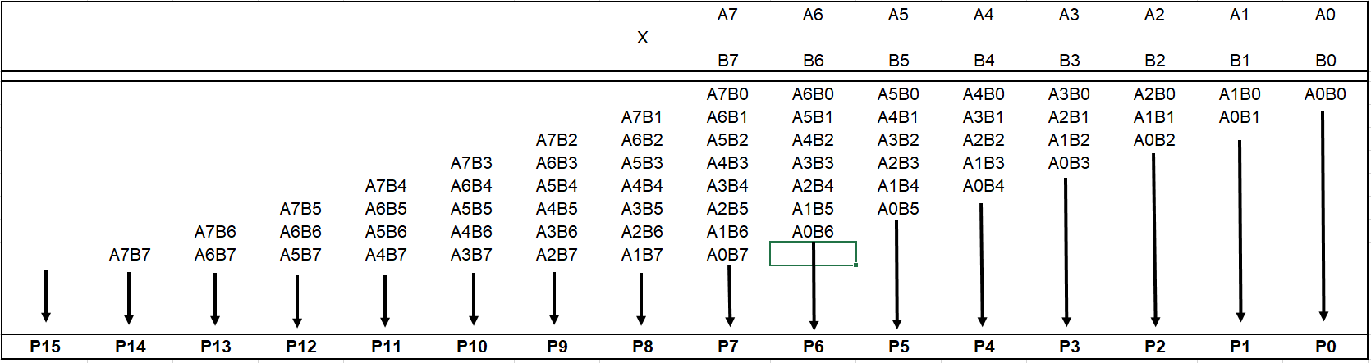
Figure 23 Braun’ multiplier design
From the design it can be seen that the quantities of how many half adders and full adders are needed once the Sum and Carry is added to the design shown in figure 24 and table 8.

Number of | Quantity
Full Adders | 48
Half Adders | 8
AND Gates | 64
Inputs | 8
Outputs | 16
Table 8 Component quantities Braun’s multiplier circuit
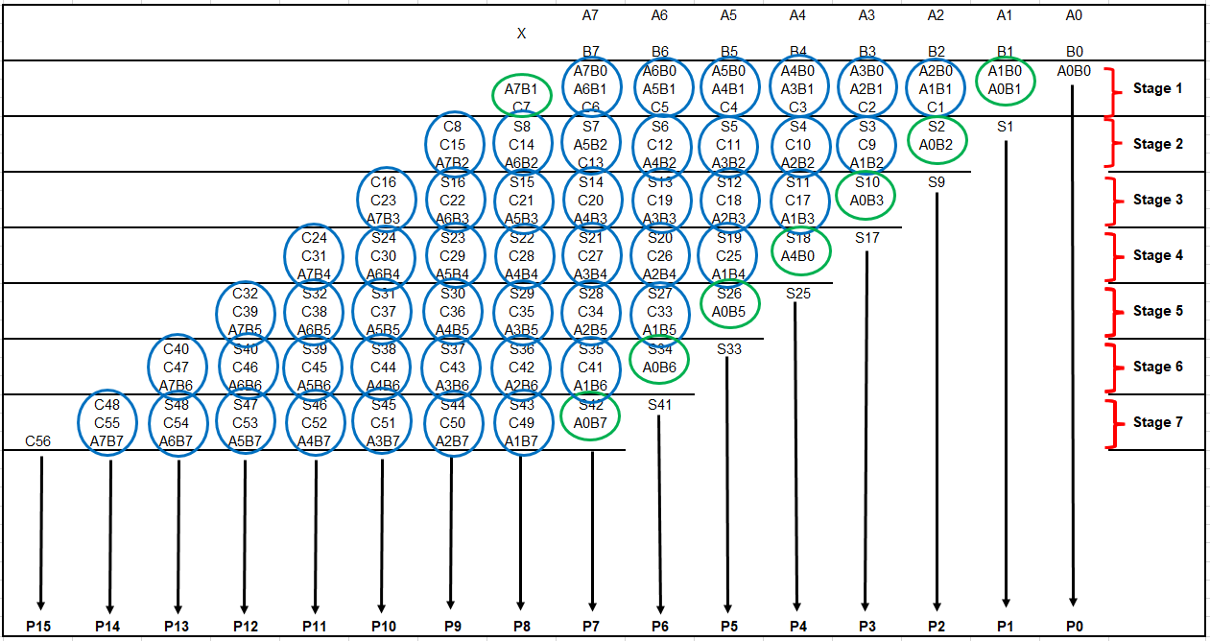
Figure 24 Braun’ multiplier full and half adders

4.1 Circuit Designs / Multipliers Diagram
The completed logic design is shown in figure 25 below.
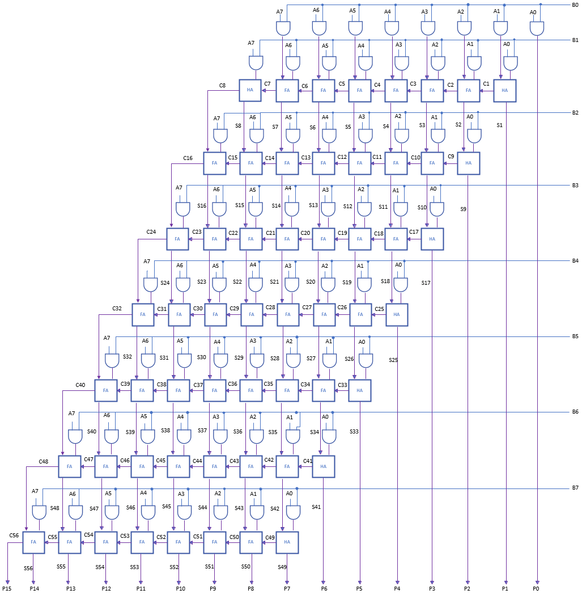
Figure 25 Braun's multiplier circuit design

4.2 Details of Testing and Results
The program was written into Vivado using the logic design see appendix 10.3 for the code used.
Once the code had been entered the process previously mentioned in section 3 was followed.
The behavioural simulation was run and the force clock details were entered along with the force constant with the given values and the results below were achieved proving the multiplier’s correct function.
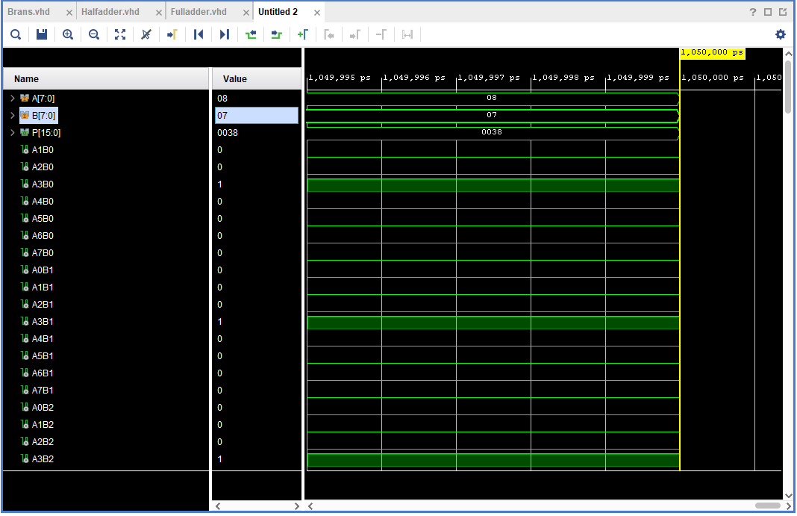
Figure 26 Braun's calculation 1
The following calculation was completed in the Braun’s multiplier in the program and the result was a success shown in figure 26 $08 × 07=0038$.

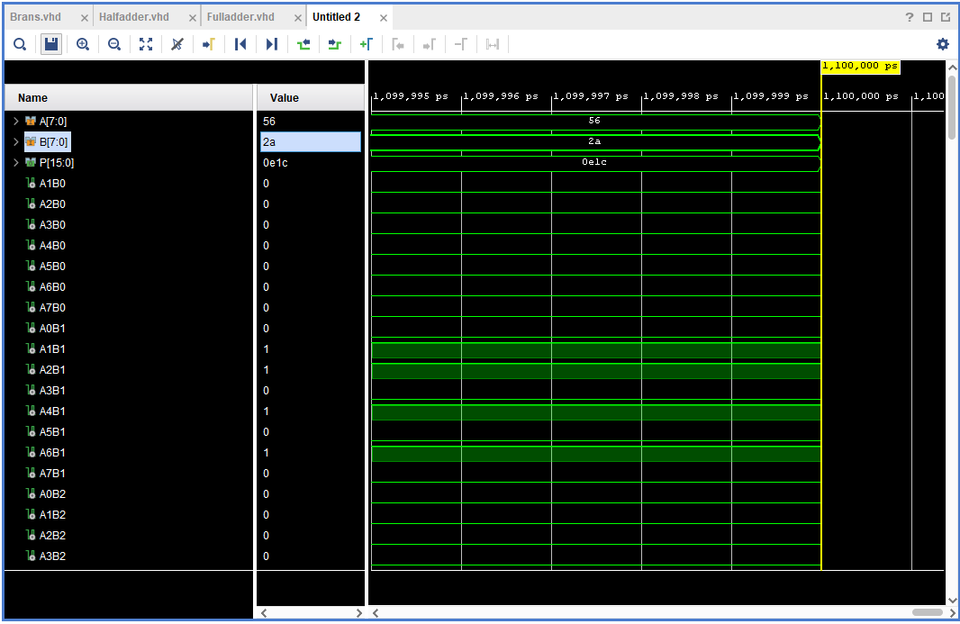
Figure 27 Braun's calculation 2
The following calculation was completed in the Braun’s multiplier in the program and the result was a success shown in figure 27 $56 × 2A=0E1C$

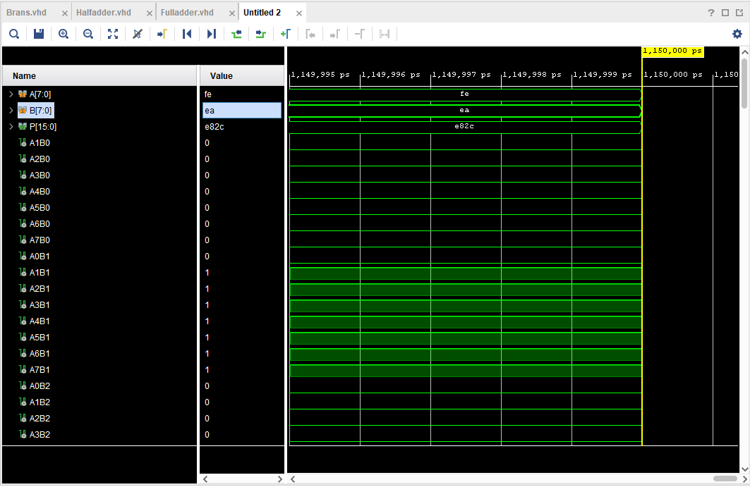
Figure 28 Braun's calculation 3
The following calculation was completed in the Braun’s multiplier in the program and the result was a success shown in figure 28 $FE× EA=E82C$.

4.3 Schematic Diagrams
Steps 4-7 from section 3 were followed and the following schematics and diagrams were created in figure 29, 30, 31 and 32.
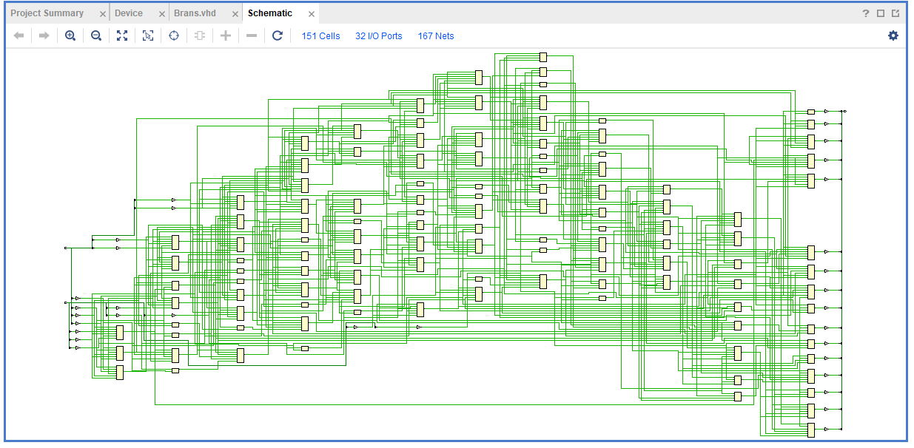
Figure 29 Braun's multiplier schematic
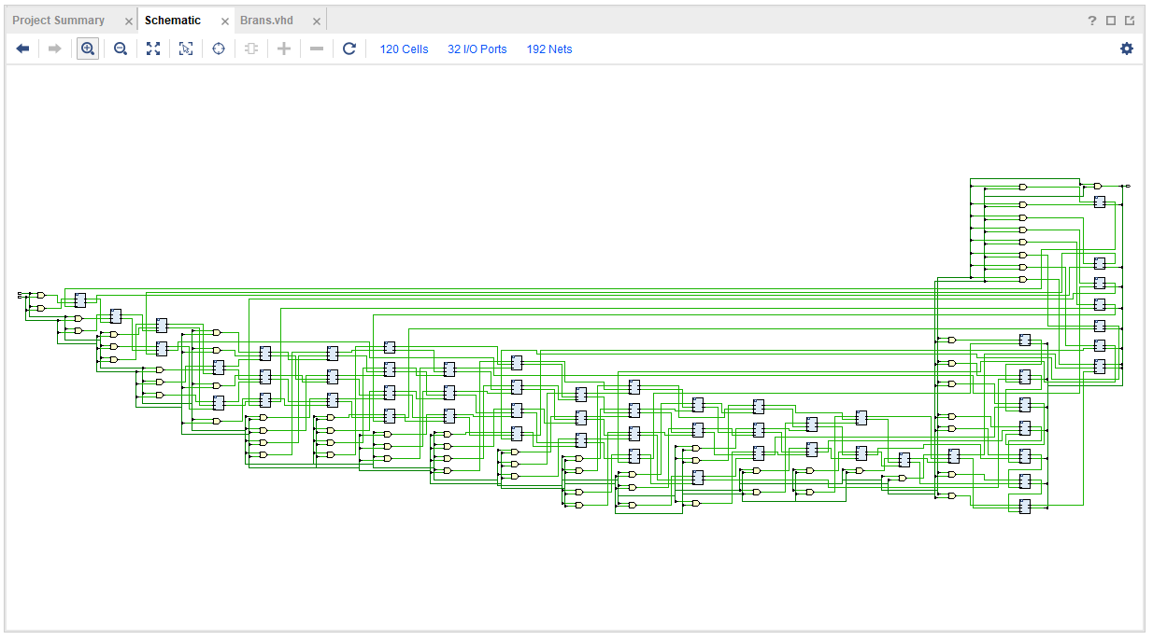
Figure 30 Braun's multiplier RTL analysis
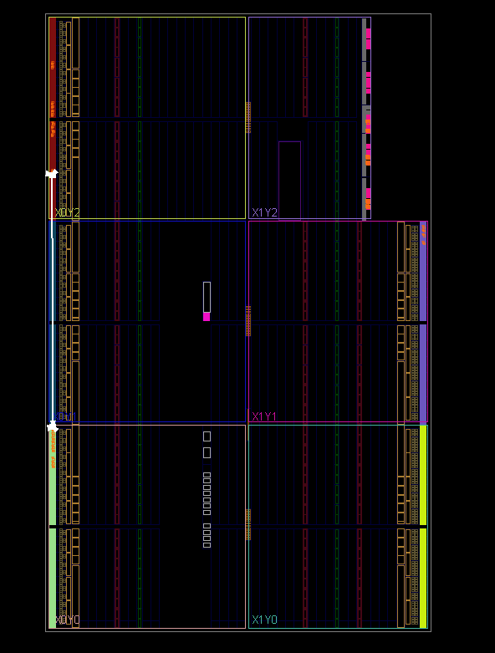
Figure 31 Braun’s I/O planning
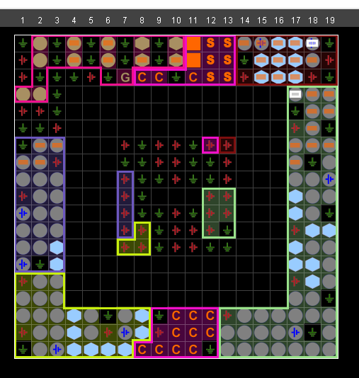
Figure 32 Braun’ multiplier package

4.4 Simulation Results
Steps 8 to 10 were followed from section three and the longest delay was shown adjustments were then made to meet the timing restraints.
As can be seen in figure 33 the signal was arriving late.
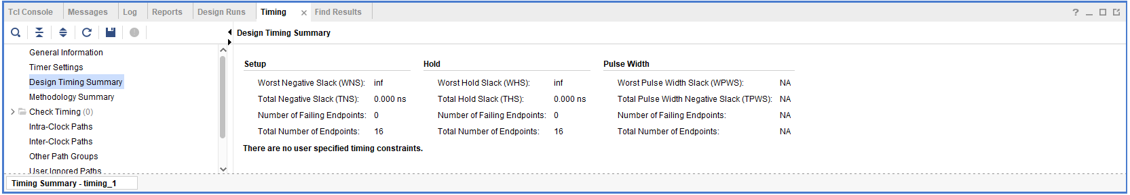
Figure 33 Braun’s timing constraints
The maximum delay was found in the list shown in figure 34 which was 13.872 between A1 and P13.
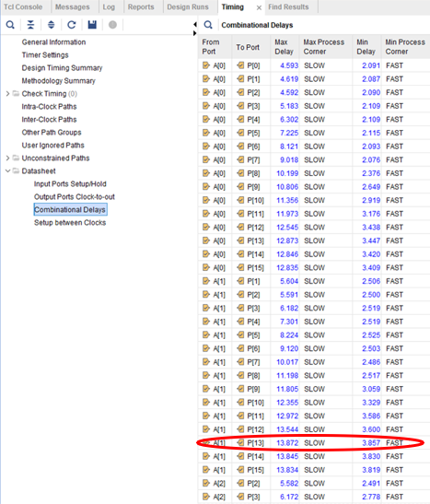
Figure 34 Braun's maximum delay
Once the changes had been made the WNS was then 0ns meaning there is no signal missing the timing.
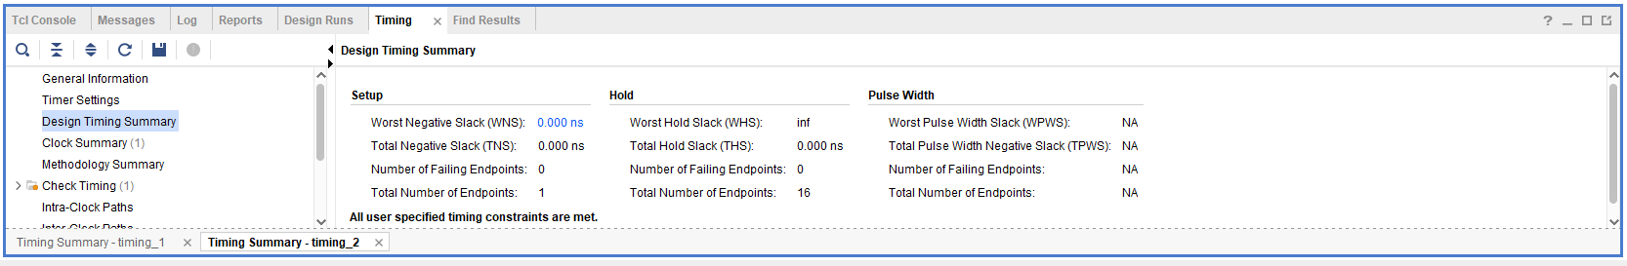
Figure 35 Braun’s updated timing constraints
The max delay path is shown in figure 36.
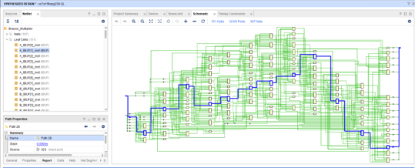
Figure 36 Braun’s max delay path

5 Task Two Wallace Tree Multiplier
The 8 bit Wallace tree multiplier was designed by modifying two unsigned numbers the structure of the design can be seen in figure 41 and 42.
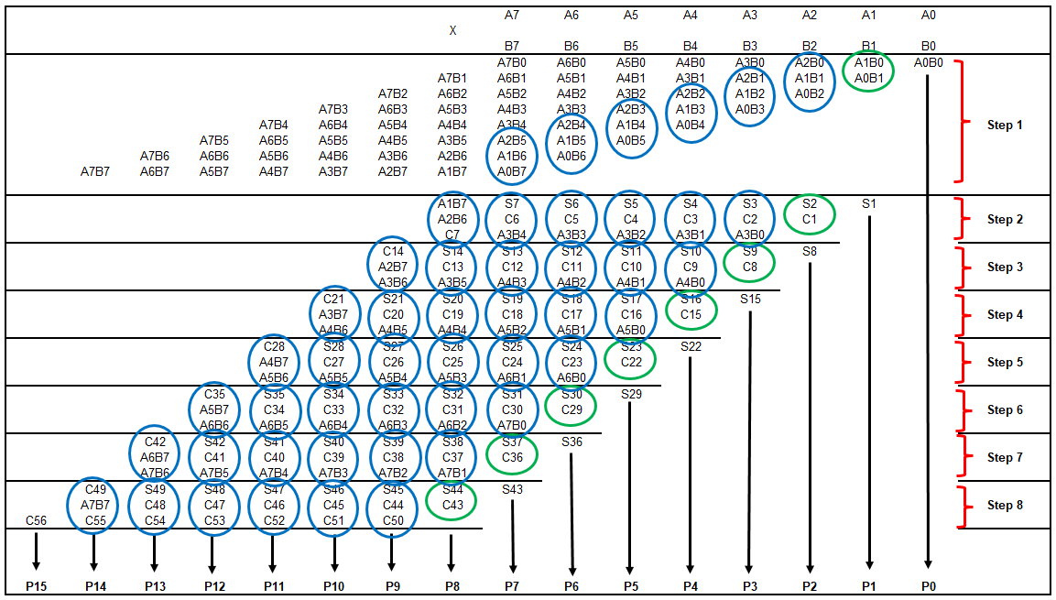
Figure 37 Wallace tree multiplier design
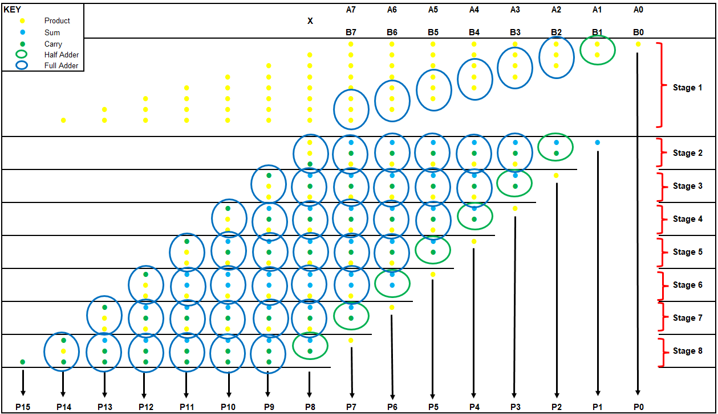
Figure 38 Wallace dot diagram
From the designs in figure 41 and 42 it can be seen the quantities of half adders and full adders that are needed and these are shown in table 9.

Number of | Quantity
Full Adders | 48
Half Adders | 8
Inputs | 8
Outputs | 16
Table 9 Component quantities of the Wallace tree multiplier

5.1 Circuit Designs / Multipliers Diagram
The completed logic design is shown in figure 44 below.
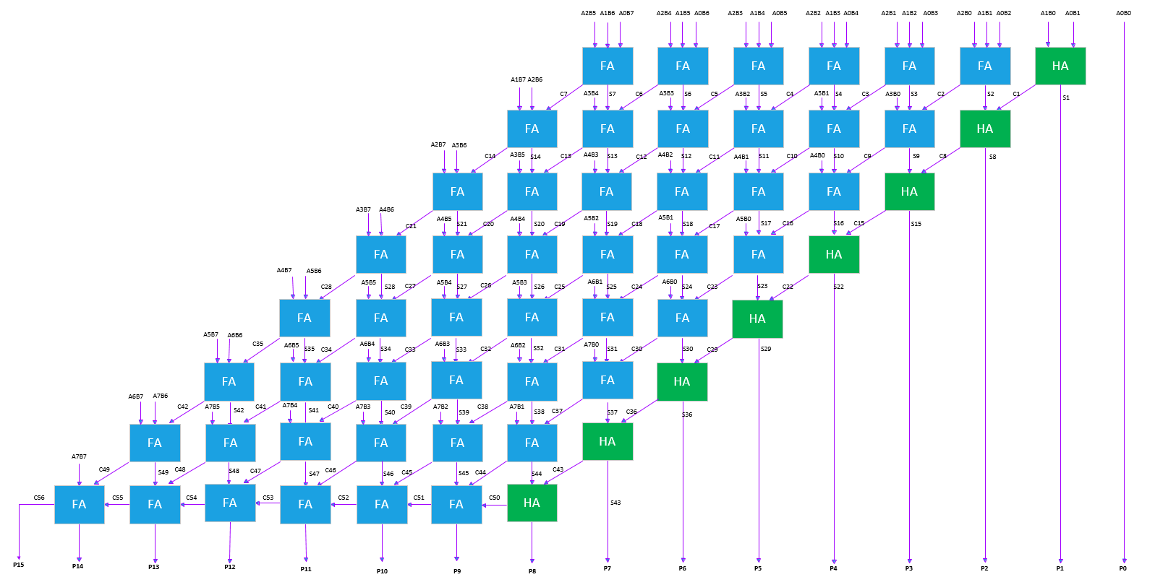
Figure 39 Wallace multiplier circuit design

5.2 Details of Testing and Results
Again the same process was followed as the Braun’s multiplier, the program was written into Vivado using the logic design see appendix 10.4 for the code used.
Once the code had been entered the process previously mentioned in section 3 was followed.
The behavioural simulation was run and the force clock details were entered along with the force constant with the given values and the results below were achieved proving the multiplier’s correct function.
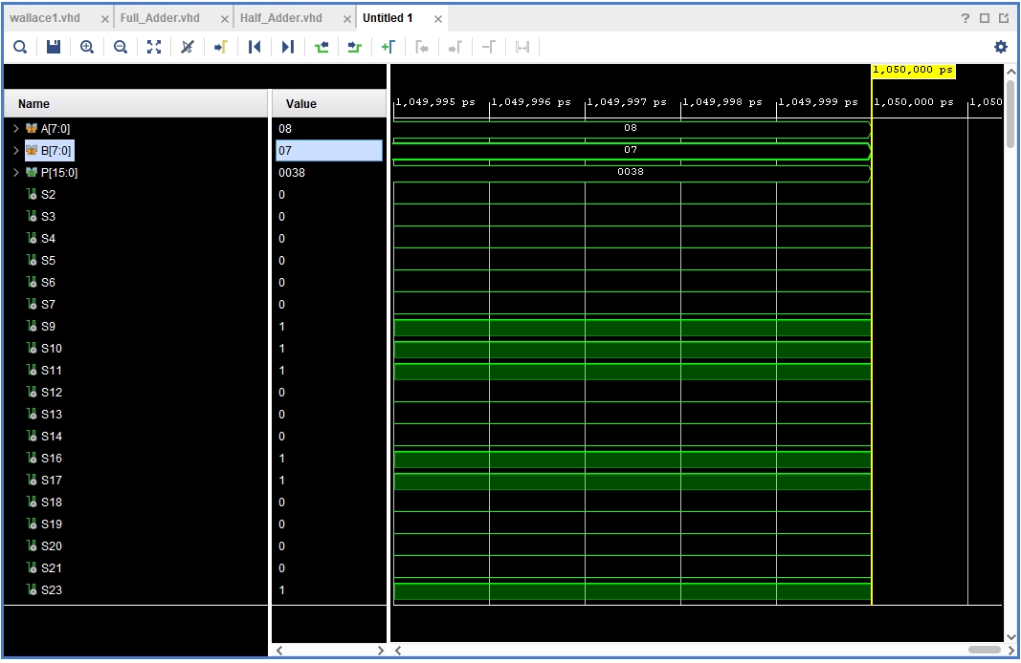
Figure 40 Wallace tree calculation 1
The following calculation was completed in the Wallace tree multiplier in the program and the result was a success shown in figure 26 $08 × 07=0038$.

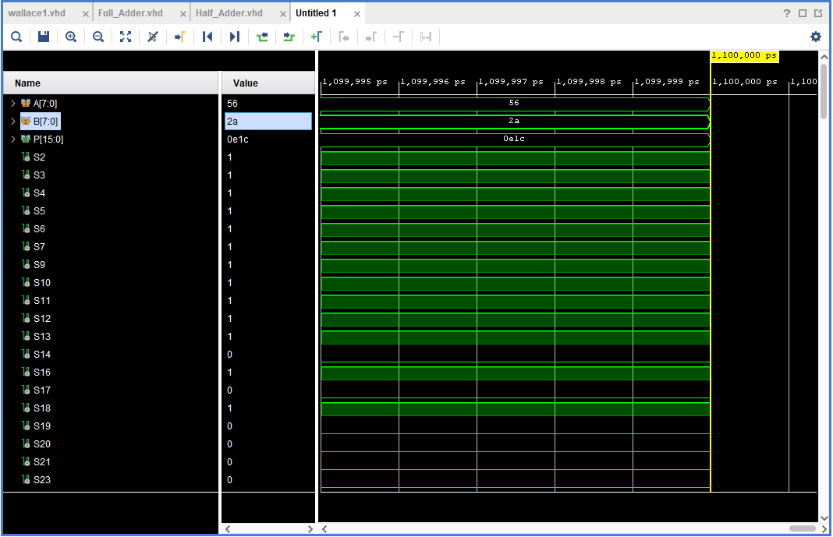
Figure 41 Wallace tree calculation 2

The following calculation was completed in the Wallace tree multiplier in the program and the result was a success shown in figure 27 $56 × 2A=0E1C$

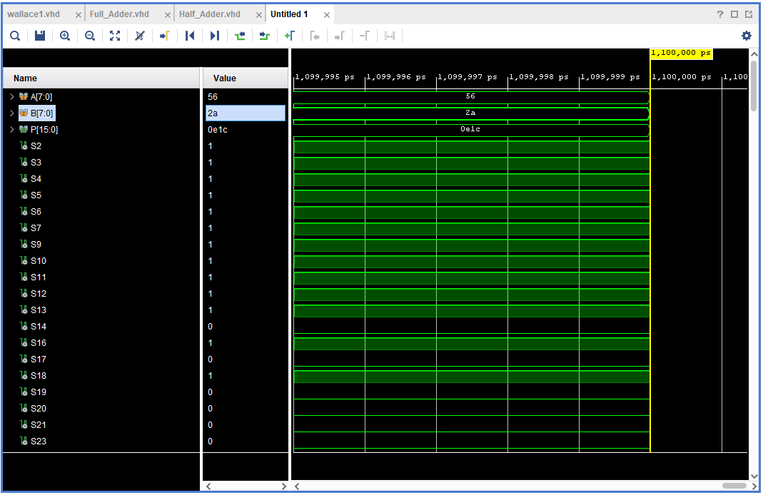
Figure 42 Wallace tree calculation 3
The following calculation was completed in the Wallace tree multiplier in the program and the result was a success shown in figure 28 $FE× EA=E82C$.

5.3 Schematic Diagrams
Steps 4-7 from section 3 were followed and the following schematics and diagrams were created in figure , 44, 45 and 46.

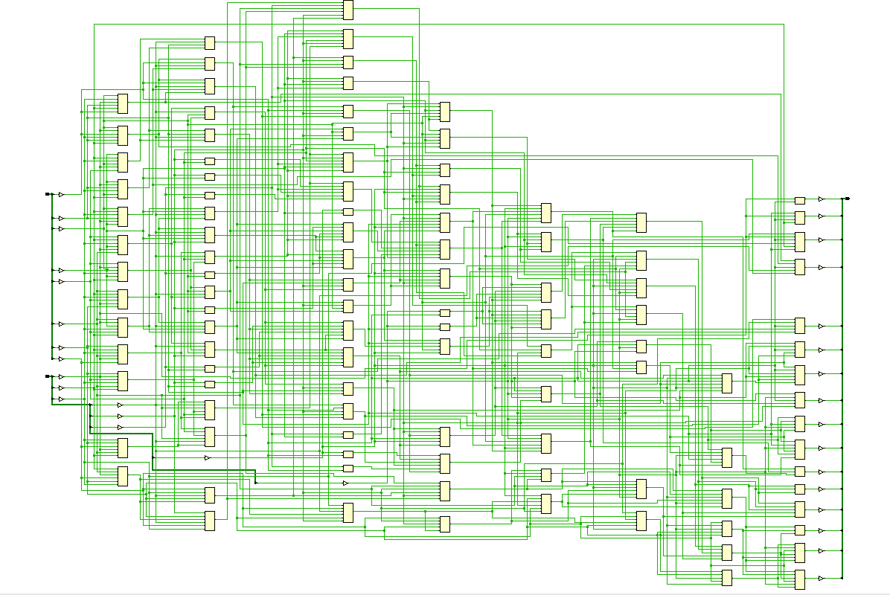
Figure 43 Wallace tree multiplier schematic
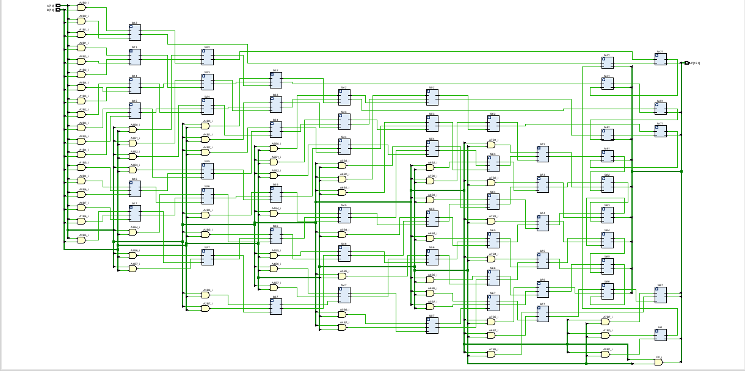
Figure 44 Wallace tree multiplier RTL analysis

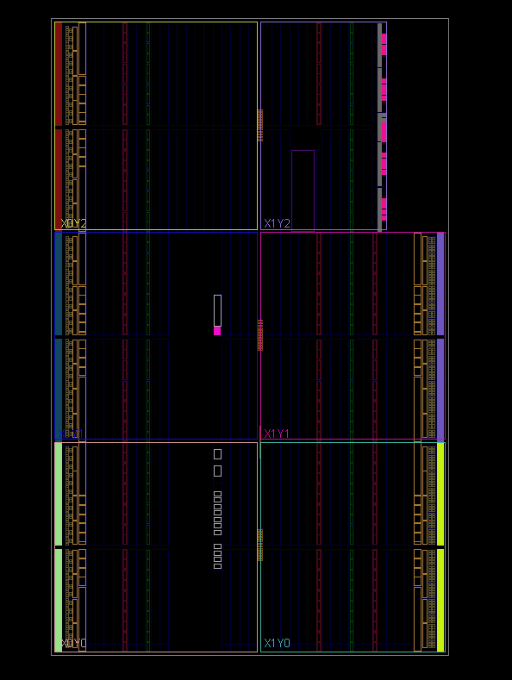
Figure 45 Wallace tree I/O planning
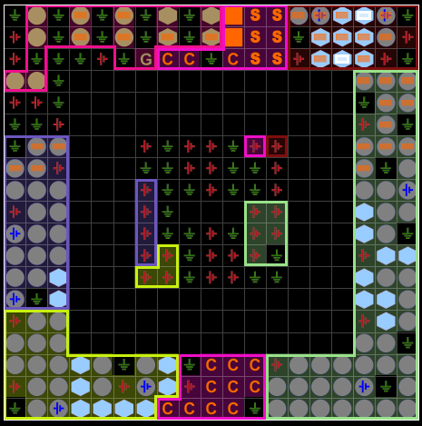
Figure 46 Wallace Package

5.4 Simulation Results
Steps 8 to 10 were followed from section three and the longest delay was shown adjustments were then made to meet the timing restraints.
As can be seen in figure 47 the signal was arriving late.
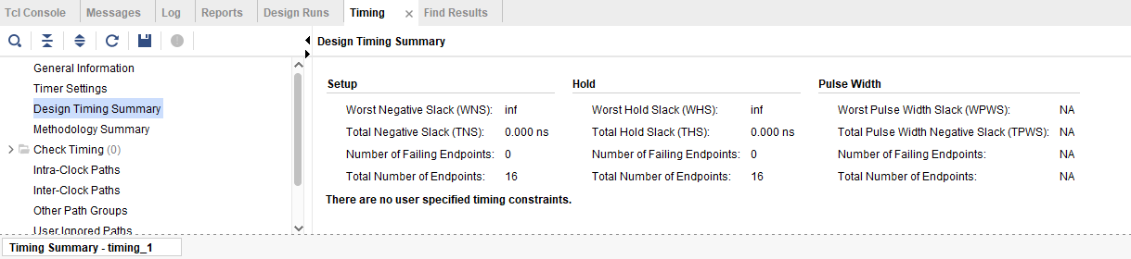
Figure 47 Wallace tree timing constraints
The maximum delay was found in the list shown in figure 48 which was 11.698 between A1 and P13.

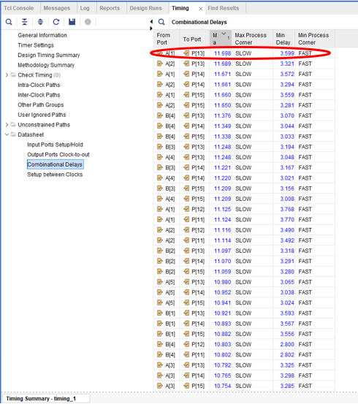
Figure 48 Wallace tree maximum delay
Once the changes had been made the WNS was then 0ns meaning there is no signal missing the timing.
The max delay path is shown in figure 49.

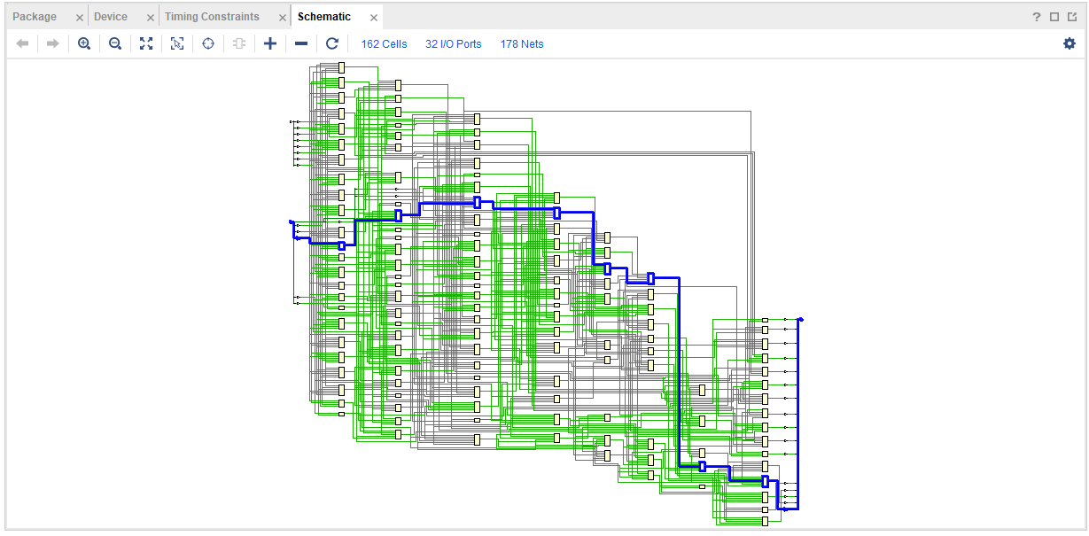
Figure 49 Wallace tree max delay path

6 Task Three Performance Evaluation
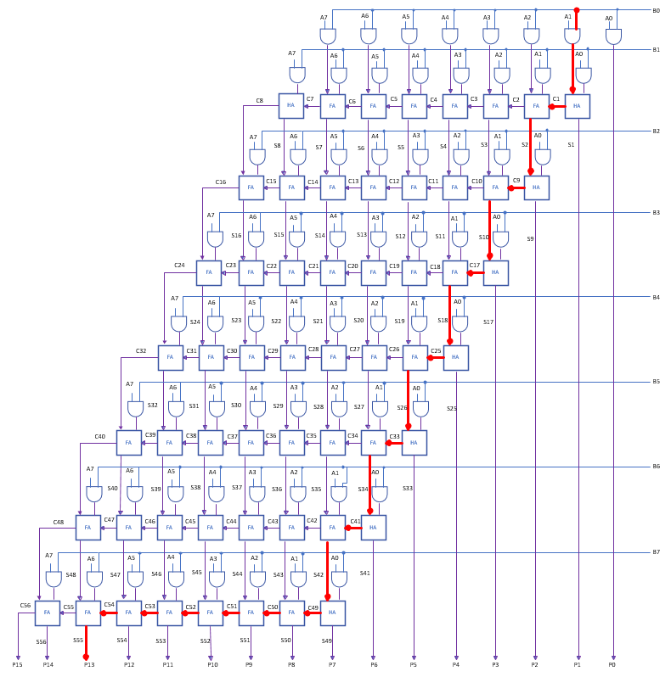
Figure 50 Braun’s multiplier longest delay

6.1 Manual Calculation for longest delay path for Braun’s 8 bit multiplier
Given that:
AND gate delay is = 1ns
Full adder delay/ half adder delay is 2ns
$$Longest delay=Delay of 1st AND gate+7 ×\left(half adder delay\right)+12 (full adder delay)$$
Therefore:
$$1ns+7×\left(2ns\right)+12 ×\left(2ns\right)=39ns$$
Hence the manually calculated longest delay for Braun’s is 39ns.
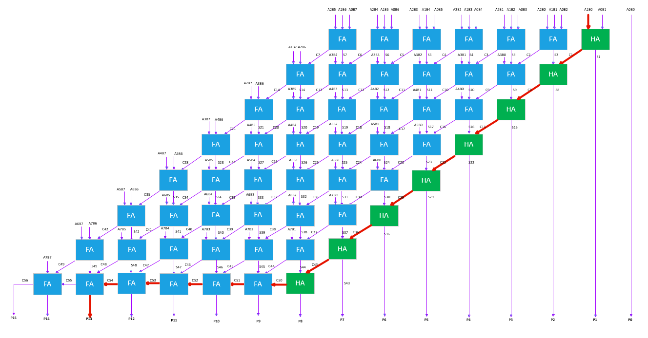
Figure 51 Wallace tree multiplier longest delay

6.2 Manual Calculation for longest delay path for Wallace Tree 8 bit multiplier
Given that:
AND gate delay is = 1ns
Full adder delay/ half adder delay is 2ns
$$Longest delay=Delay of 1st AND gate+8 ×\left(half adder delay\right)+5 (full adder delay)$$
Therefore:
$$1ns+8×\left(2ns\right)+5 ×\left(2ns\right)=27ns$$
Hence the manually calculated longest delay for Wallace tree is 27ns.

6.3 Comparision of the overall delay of both Multipliers
As can be seen from the previous calculations the Wallace tree multiplier is the quickest of the two. The main reason for this is that the Braun uses a more sequential approach whereas the Wallace tree adopts a more parallel process which has less calculations to compute reducing the overall time.

6.4 Power Consumption
A power report was created for both multipliers following step 12 from section 3. Shown in figure 52
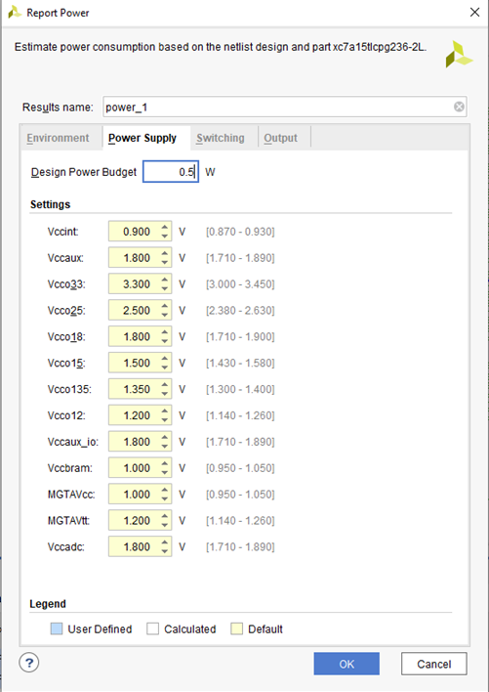
Figure 52 Power report setup
The power consumption for both were as follows (shown in figure 53 and 55):

6.4.1 Braun’s multiplier Power Summary
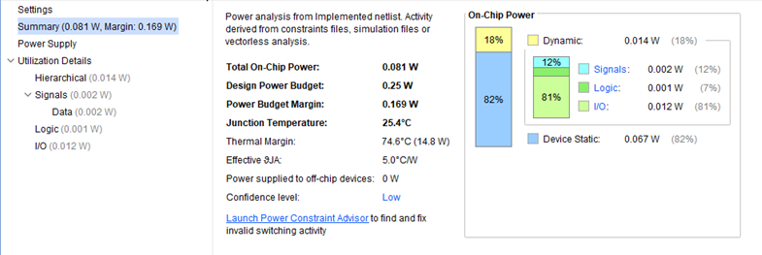
Figure 53 Power summary generated by the software for Braun's

6.4.2 Wallace tree multiplier
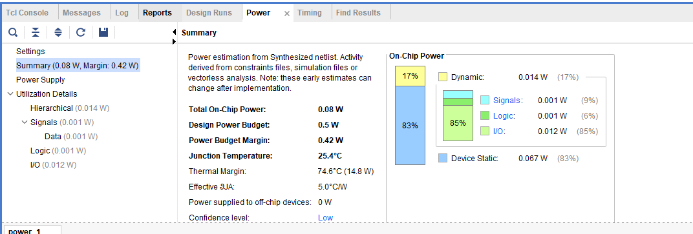
Figure 54 power summary generated by the software for Wallace

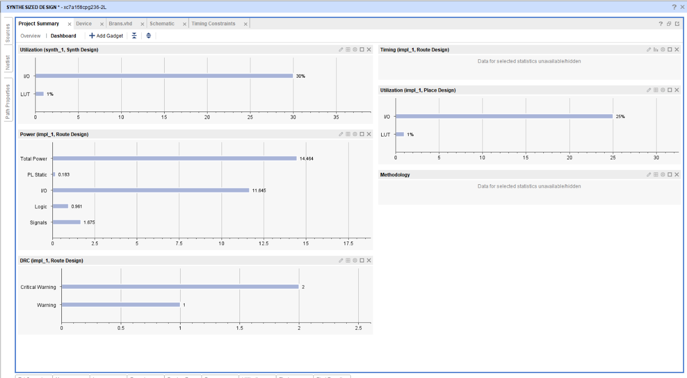
Figure 55 Project summary for Braun’s multiplier

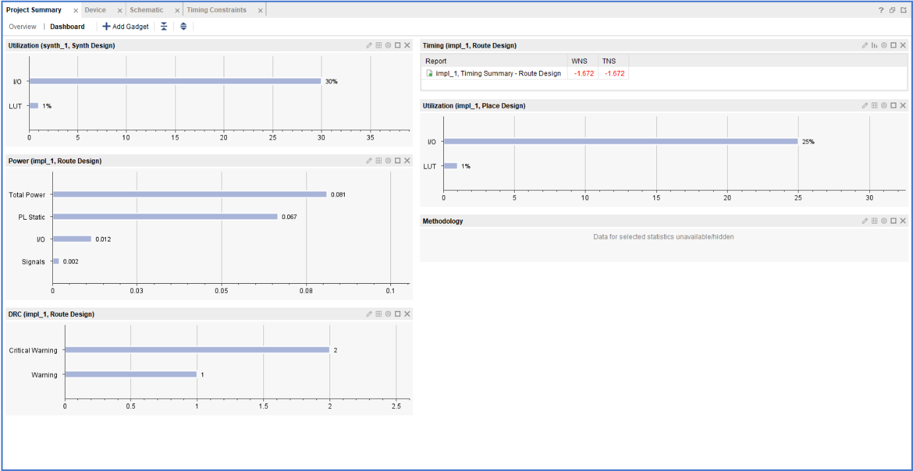
Figure 56 Project summary for Wallace multipliers

6.4.3 Comparision of power consumption of both multipliers
As can be seen the Braun’s multiplier consumes more power to carry out its processes compared to the Wallace tree. This reason for this is again the sequential process that the Braun’s multiplier uses longer critical paths than the parallel processes of the Wallace tree.

6.5 Utilization of Both Multipliers
The software was then used to generate a report for the utilization of both multipliers as shown in figures 58-
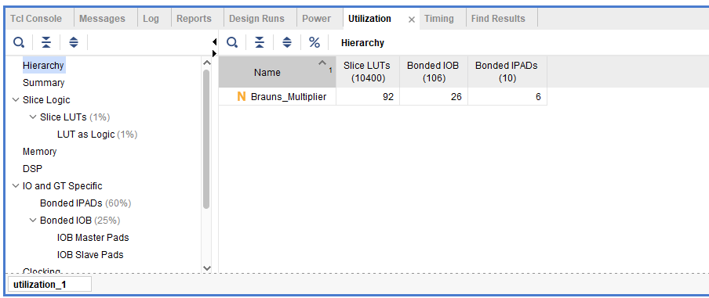
Figure 57 Braun’s utilization

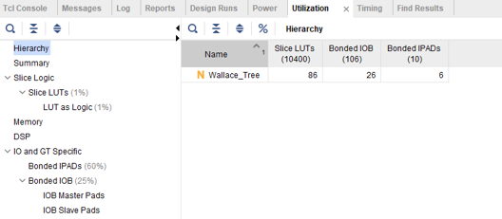
Figure 58 Wallace tree utilization
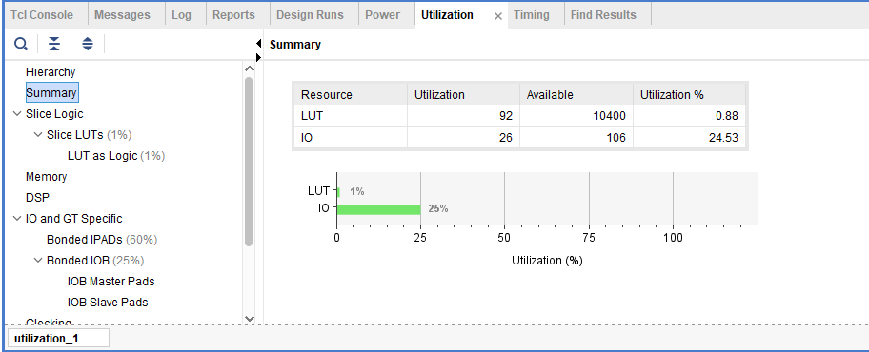
Figure 59 Braun’s utilization
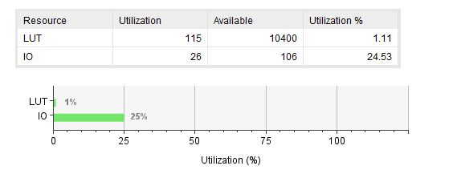
Figure 60 Wallace tree utilization

6.5.1 Comparision of Utilization of both multipliers
Out of the both multipliers the Wallace tree utilizes the resources’ better than the Braun’s and also uses more efficient resources due to it parallel function

7 Applications and Advantages of Multipliers

Advantages | Applications
Very economical | Mobile phones
Uncomplicated circuit design when compared to binary adders and subtractors | High speed calculators
Reduces processing time within processors | Computers
Available in IC's for easy installation in different applications | Digital communication systems
with multiplier of various bit sizes which can be varied | Controlling devices
Intermediate product terms are generated simplistically with ease | Digital signal processors
Table 10 Advantages and applications of multipliers

8 Conclusion
After completing the design, development and simulation of both multipliers it can clearly be seen that the superior one is the Wallace tree, if the reason for application is to have less delay and use less power but because the circuitry uses parallel processes it will be a lot more complex to manufacture so costs will be higher so if a more simple application is required the Braun’s may also be a good choice.
The Wallace tree was designed approximately 25 years later than the Braun’s so the technology available at the time would have been used to make these improvements to the Wallace tree.

8.1 Recommendations Of Future Work
Some recommendations for future work would be to try and improve the both multipliers by changing the design or looking at ways to reduce the delay and efficiency.
Also both multipliers could be used to run a variety of applications with further analysation of the results.

9 References

[1] | e. f. u, “www.electronicsforu.com,” 09 01 2023. [Online]. Available: https://www.electronicsforu.com/technology-trends/learn-electronics/digital-electronics-basics. [Accessed 15 12 2023].
[2] | R. J. M. Rao, “instrumentationtools.com,” instrumentation tools, 2023. [Online]. Available: https://instrumentationtools.com/what-are-analog-and-digital-signals-differences-examples/. [Accessed 15 12 2023].
[3] | T. Lindsey, electronics for electricians, London: Edward Arnold, 1990.
[4] | P. H. W. Hill, The Art of Electronics, New York: Cambridge University Press, 2015.
[5] | WJEC, “resource.download.wjec.co.uk/vtc/2016-17/16-17_1-9/gce-electronics-book-chapter-1.pdf,” 2017. [Online]. Available: https://resource.download.wjec.co.uk/vtc/2016-17/16-17_1-9/gce-electronics-book-chapter-1.pdf. [Accessed 15 12 2023].
[6] | M. A. L. &. M. G. Say, Electrical Engineer's reference book, London: Butterworth & Co, 1985.

10 Appendix

10.1 Braun’s Logic Circuit

10.2 Wallace Tree Logic Circuit

10.3 Braun Pseudocode
library IEEE;
use IEEE.STD_LOGIC_1164.ALL;

-- Uncomment the following library declaration if using
-- arithmetic functions with Signed or Unsigned values
--use IEEE.NUMERIC_STD.ALL;

-- Uncomment the following library declaration if instantiating
-- any Xilinx leaf cells in this code.
--library UNISIM;
--use UNISIM.VComponents.all;

entity Brauns_Multiplier is
Port ( A : in STD_LOGIC_VECTOR (7 downto 0);
B : in STD_LOGIC_VECTOR (7 downto 0);
P : out STD_LOGIC_VECTOR (15 downto 0));
end Brauns_Multiplier;

architecture Behavioral of Brauns_Multiplier is

component Full_Adder
port (A : in STD_LOGIC;
B : in STD_LOGIC;
Cin : in STD_LOGIC;
S : out STD_LOGIC;
Cout : out STD_LOGIC) ;
end component;

component Half_Adder
port (A : in STD_LOGIC;
B : in STD_LOGIC;
S : out STD_LOGIC;
Cout : out STD_LOGIC) ;
end component;

signal A1B0, A2B0, A3B0, A4B0, A5B0, A6B0, A7B0 : std_logic;
signal A0B1, A1B1, A2B1, A3B1, A4B1, A5B1, A6B1, A7B1 : std_logic;
signal A0B2, A1B2, A2B2, A3B2, A4B2, A5B2, A6B2, A7B2 : std_logic;
signal A0B3, A1B3, A2B3, A3B3, A4B3, A5B3, A6B3, A7B3 : std_logic;
signal A0B4, A1B4, A2B4, A3B4, A4B4, A5B4, A6B4, A7B4 : std_logic;
signal A0B5, A1B5, A2B5, A3B5, A4B5, A5B5, A6B5, A7B5 : std_logic;
signal A0B6, A1B6, A2B6, A3B6, A4B6, A5B6, A6B6, A7B6 : std_logic;
signal A0B7, A1B7, A2B7, A3B7, A4B7, A5B7, A6B7, A7B7 : std_logic;

signal C1, C2, C3, C4, C5, C6, C7, C8 : std_logic;
signal C9, C10, C11, C12, C13, C14, C15, C16 : std_logic;
signal C17, C18, C19, C20, C21, C22, C23, C24 : std_logic;
signal C25, C26, C27, C28, C29, C30, C31, C32 : std_logic;
signal C33, C34, C35, C36, C37, C38, C39, C40 : std_logic;
signal C41, C42, C43, C44, C45, C46, C47, C48 : std_logic;
signal C49, C50, C51, C52, C53, C54, C55, C56 : std_logic;

signal S2, S3, S4, S5, S6, S7, S8 : std_logic;
signal S10, S11, S12, S13, S14, S15, S16 : std_logic;
signal S18, S19, S20, S21, S22, S23, S24 : std_logic;
signal S26, S27, S28, S29, S30, S31, S32 : std_logic;
signal S34, S35, S36, S37, S38, S39, S40 : std_logic;
signal S42, S43, S44, S45, S46, S47, S48 : std_logic;

begin

A1B0 <= A (1) and B (0) ;
A2B0 <= A (2) and B (0) ;
A3B0 <= A (3) and B (0) ;
A4B0 <= A (4) and B (0) ;
A5B0 <= A (5) and B (0) ;
A6B0 <= A (6) and B (0) ;
A7B0 <= A (7) and B (0) ;

A0B1 <= A (0) and B (1) ;
A1B1 <= A (1) and B (1) ;
A2B1 <= A (2) and B (1) ;
A3B1 <= A (3) and B (1) ;
A4B1 <= A (4) and B (1) ;
A5B1 <= A (5) and B (1) ;
A6B1 <= A (6) and B (1) ;
A7B1 <= A (7) and B (1) ;

A0B2 <= A (0) and B (2) ;
A1B2 <= A (1) and B (2) ;
A2B2 <= A (2) and B (2) ;
A3B2 <= A (3) and B (2) ;
A4B2 <= A (4) and B (2) ;
A5B2 <= A (5) and B (2) ;
A6B2 <= A (6) and B (2) ;
A7B2 <= A (7) and B (2) ;

A0B3 <= A (0) and B (3) ;
A1B3 <= A (1) and B (3) ;
A2B3 <= A (2) and B (3) ;
A3B3 <= A (3) and B (3) ;
A4B3 <= A (4) and B (3) ;
A5B3 <= A (5) and B (3) ;
A6B3 <= A (6) and B (3) ;
A7B3 <= A (7) and B (3) ;

A0B4 <= A (0) and B (4) ;
A1B4 <= A (1) and B (4) ;
A2B4 <= A (2) and B (4) ;
A3B4 <= A (3) and B (4) ;
A4B4 <= A (4) and B (4) ;
A5B4 <= A (5) and B (4) ;
A6B4 <= A (6) and B (4) ;
A7B4 <= A (7) and B (4) ;

A0B5 <= A (0) and B (5) ;
A1B5 <= A (1) and B (5) ;
A2B5 <= A (2) and B (5) ;
A3B5 <= A (3) and B (5) ;
A4B5 <= A (4) and B (5) ;
A5B5 <= A (5) and B (5) ;
A6B5 <= A (6) and B (5) ;
A7B5 <= A (7) and B (5) ;

A0B6 <= A (0) and B (6) ;
A1B6 <= A (1) and B (6) ;
A2B6 <= A (2) and B (6) ;
A3B6 <= A (3) and B (6) ;
A4B6 <= A (4) and B (6) ;
A5B6 <= A (5) and B (6) ;
A6B6 <= A (6) and B (6) ;
A7B6 <= A (7) and B (6) ;

A0B7 <= A (0) and B (7) ;
A1B7 <= A (1) and B (7) ;
A2B7 <= A (2) and B (7) ;
A3B7 <= A (3) and B (7) ;
A4B7 <= A (4) and B (7) ;
A5B7 <= A (5) and B (7) ;
A6B7 <= A (6) and B (7) ;
A7B7 <= A (7) and B (7) ;

PO : P (0) <= A (0) and B (0) ;

P1 : Half_Adder port map (A1B0, A0B1, P (1), C1) ;

S2_1 : Full_Adder port map (A2B0, A1B1, C1, S2, C2) ;
P2 : Half_Adder port map (A0B2, S2, P (2), C9) ;

S3_1 : Full_Adder port map (A3B0, A2B1, C2, S3, C3) ;
S10_1 : Full_Adder port map (A1B2, S3, C9, S10, C10) ;
P3 : Half_Adder port map (A0B3, S10, P (3), C17) ;

S4_1 : Full_Adder port map (A4B0, A3B1, C3, S4, C4) ;
S11_1 : Full_Adder port map (A2B2, S4, C10, S11, C11) ;
S18_1 : Full_Adder port map (A1B3, S11, C17, S18, C18) ;
P4 : Half_Adder port map (A0B4, S18, P (4), C25) ;

S5_1 : Full_Adder port map (A5B0, A4B1, C4, S5, C5) ;
S12_1 : Full_Adder port map (A3B2, S5, C11, S12, C12) ;
S19_1 : Full_Adder port map (A2B3, S12, C18, S19, C19) ;
S26_1 : Full_Adder port map (A1B4, S29, C25, S26, C26) ;
P5 : Half_Adder port map (A0B5, S26, P (5), C33) ;

S6_1 : Full_Adder port map (A6B0, A5B1, C5, S6, C6) ;
S13_1 : Full_Adder port map (A4B2, S6, C12, S13, C13) ;
S20_1 : Full_Adder port map (A3B3, S13, C19, S20, C20) ;
S27_1 : Full_Adder port map (A2B4, S20, C26, S27, C27) ;
S34_1 : Full_Adder port map (A1B5, S27, C33, S34, C34) ;
P6 : Half_Adder port map (A0B6, S34, P (6), C41) ;

S7_1 : Full_Adder port map (A7B0, A6B1, C6, S7, C7) ;
S14_1 : Full_Adder port map (A5B2, S7, C13, S14, C14) ;
S21_1 : Full_Adder port map (A4B3, S14, C20, S21, C21) ;
S28_1 : Full_Adder port map (A3B4, S21, C27, S28, C28) ;
S35_1 : Full_Adder port map (A2B5, S28, C34, S35, C35) ;
S42_1 : Full_Adder port map (A1B6, S35, C41, S42, C42) ;
P7 : Half_Adder port map (A0B7, S42, P (7), C49) ;

S8_1 : Half_Adder port map (A7B1, C7, S8, C8) ;
S15_1 : Full_Adder port map (A6B2, S8, C14, S15, C15) ;
S22_1 : Full_Adder port map (A5B3, S15, C21, S22, C22) ;
S29_1 : Full_Adder port map (A4B4, S22, C28, S29, C29) ;
S36_1 : Full_Adder port map (A3B5, S29, C35, S36, C36) ;
S43_1 : Full_Adder port map (A2B6, S36, C42, S43, C43) ;
P8 : Full_Adder port map (A1B7, S43, C49, P(8), C50) ;

S16_1 : Full_Adder port map (A7B2, C8, C15, S16, C16) ;
S23_1 : Full_Adder port map (A6B3, S16, C22, S23, C23) ;
S30_1 : Full_Adder port map (A5B4, S23, C29, S30, C30) ;
S37_1 : Full_Adder port map (A4B5, S30, C36, S37, C37) ;
S44_1 : Full_Adder port map (A3B6, S37, C43, S44, C44) ;
P9 : Full_Adder port map (A2B7, S44, C50, P(9), C51) ;

S24_1 : Full_Adder port map (A7B3, C16, C23, S24, C24) ;
S31_1 : Full_Adder port map (A6B4, S24, C30, S31, C31) ;
S38_1 : Full_Adder port map (A5B5, S31, C37, S38, C38) ;
S45_1 : Full_Adder port map (A4B6, S38, C44, S45, C45) ;
P10: Full_Adder port map (A3B7, S45, C51, P(10), C52) ;

S32_1 : Full_Adder port map (A7B4, C24, C31, S32, C32) ;
S39_1 : Full_Adder port map (A6B5, S32, C38, S39, C39) ;
S46_1 : Full_Adder port map (A5B6, S39, C45, S46, C46) ;
P11: Full_Adder port map (A4B7, S46, C52, P(11), C53) ;

S40_1 : Full_Adder port map (A7B5, C32, C39, S40, C40) ;
S47_1 : Full_Adder port map (A6B6, S40, C46, S47, C47) ;
P12: Full_Adder port map (A5B7, S47, C53, P(12), C54) ;

S48_1 : Full_Adder port map (A7B6, C40, C47, S48, C48) ;
P13: Full_Adder port map (A6B7, S48, C54, P(13), C55) ;

P14: Full_Adder port map (A7B7, C48, C55, P(14), C56) ;
P15: P(15) <= C56 ;

end Behavioral;

10.4 Wallace Pseudocode
library IEEE;
use IEEE.STD_LOGIC_1164.ALL;

-- Uncomment the following library declaration if using
-- arithmetic functions with Signed or Unsigned values
--use IEEE.NUMERIC_STD.ALL;

-- Uncomment the following library declaration if instantiating
-- any Xilinx leaf cells in this code.
--library UNISIM;
--use UNISIM.VComponents.all;

entity Wallace_Tree is
Port ( A : in STD_LOGIC_VECTOR (7 downto 0);
B : in STD_LOGIC_VECTOR (7 downto 0);
P : out STD_LOGIC_VECTOR (15 downto 0));
end Wallace_Tree;

architecture Behavioral of Wallace_Tree is

component Full_Adder
port (A : in STD_LOGIC;
B : in STD_LOGIC;
Cin : in STD_LOGIC;
S : out STD_LOGIC;
Cout : out STD_LOGIC) ;
end component;

component Half_Adder
port (A : in STD_LOGIC;
B : in STD_LOGIC;
S : out STD_LOGIC;
Cout : out STD_LOGIC) ;
end component;

signal S2, S3, S4, S5, S6, S7 : std_logic;
signal S9, S10, S11, S12, S13, S14 : std_logic;
signal S16, S17, S18, S19, S20, S21 : std_logic;
signal S23, S24, S25, S26, S27, S28 : std_logic;
signal S30, S31, S32, S33, S34, S35 : std_logic;
signal S37, S38, S39, S40, S41, S42 : std_logic;
signal S44, S45, S46, S47, S48, S49 : std_logic;

signal C1, C2, C3, C4, C5, C6, C7 : std_logic;
signal C8, C9, C10, C11, C12, C13, C14 : std_logic;
signal C15, C16, C17, C18, C19, C20, C21 : std_logic;
signal C22, C23, C24, C25, C26, C27, C28 : std_logic;
signal C29, C30, C31, C32, C33, C34, C35 : std_logic;
signal C36, C37, C38, C39, C40, C41, C42 : std_logic;
signal C43, C44, C45, C46, C47, C48, C49 : std_logic;
signal C50, C51, C52, C53, C54, C55 : std_logic;

signal A1B0, A2B0, A3B0, A4B0, A5B0, A6B0, A7B0 : std_logic;
signal A0B1, A1B1, A2B1, A3B1, A4B1, A5B1, A6B1, A7B1 : std_logic;
signal A0B2, A1B2, A2B2, A3B2, A4B2, A5B2, A6B2, A7B2 : std_logic;
signal A0B3, A1B3, A2B3, A3B3, A4B3, A5B3, A6B3, A7B3 : std_logic;
signal A0B4, A1B4, A2B4, A3B4, A4B4, A5B4, A6B4, A7B4 : std_logic;
signal A0B5, A1B5, A2B5, A3B5, A4B5, A5B5, A6B5, A7B5 : std_logic;
signal A0B6, A1B6, A2B6, A3B6, A4B6, A5B6, A6B6, A7B6 : std_logic;
signal A0B7, A1B7, A2B7, A3B7, A4B7, A5B7, A6B7, A7B7 : std_logic;

begin

A1B0 <= A (1) and B (0) ;
A2B0 <= A (2) and B (0) ;
A3B0 <= A (3) and B (0) ;
A4B0 <= A (4) and B (0) ;
A5B0 <= A (5) and B (0) ;
A6B0 <= A (6) and B (0) ;
A7B0 <= A (7) and B (0) ;

A0B1 <= A (0) and B (1) ;
A1B1 <= A (1) and B (1) ;
A2B1 <= A (2) and B (1) ;
A3B1 <= A (3) and B (1) ;
A4B1 <= A (4) and B (1) ;
A5B1 <= A (5) and B (1) ;
A6B1 <= A (6) and B (1) ;
A7B1 <= A (7) and B (1) ;

A0B2 <= A (0) and B (2) ;
A1B2 <= A (1) and B (2) ;
A2B2 <= A (2) and B (2) ;
A3B2 <= A (3) and B (2) ;
A4B2 <= A (4) and B (2) ;
A5B2 <= A (5) and B (2) ;
A6B2 <= A (6) and B (2) ;
A7B2 <= A (7) and B (2) ;

A0B3 <= A (0) and B (3) ;
A1B3 <= A (1) and B (3) ;
A2B3 <= A (2) and B (3) ;
A3B3 <= A (3) and B (3) ;
A4B3 <= A (4) and B (3) ;
A5B3 <= A (5) and B (3) ;
A6B3 <= A (6) and B (3) ;
A7B3 <= A (7) and B (3) ;

A0B4 <= A (0) and B (4) ;
A1B4 <= A (1) and B (4) ;
A2B4 <= A (2) and B (4) ;
A3B4 <= A (3) and B (4) ;
A4B4 <= A (4) and B (4) ;
A5B4 <= A (5) and B (4) ;
A6B4 <= A (6) and B (4) ;
A7B4 <= A (7) and B (4) ;

A0B5 <= A (0) and B (5) ;
A1B5 <= A (1) and B (5) ;
A2B5 <= A (2) and B (5) ;
A3B5 <= A (3) and B (5) ;
A4B5 <= A (4) and B (5) ;
A5B5 <= A (5) and B (5) ;
A6B5 <= A (6) and B (5) ;
A7B5 <= A (7) and B (5) ;

A0B6 <= A (0) and B (6) ;
A1B6 <= A (1) and B (6) ;
A2B6 <= A (2) and B (6) ;
A3B6 <= A (3) and B (6) ;
A4B6 <= A (4) and B (6) ;
A5B6 <= A (5) and B (6) ;
A6B6 <= A (6) and B (6) ;
A7B6 <= A (7) and B (6) ;

A0B7 <= A (0) and B (7) ;
A1B7 <= A (1) and B (7) ;
A2B7 <= A (2) and B (7) ;
A3B7 <= A (3) and B (7) ;
A4B7 <= A (4) and B (7) ;
A5B7 <= A (5) and B (7) ;
A6B7 <= A (6) and B (7) ;
A7B7 <= A (7) and B (7) ;

PO : P(0) <= A (0) and B(0);

hall: Half_Adder port map (A1B0, A0B1, P(1), C1) ;
fa12: Full_Adder port map (A2B0, A1B1, A0B2, S2, C2) ;
fa13: Full_Adder port map (A2B1, A1B2, A0B3, S3, C3) ;
fa14: Full_Adder port map (A2B2, A1B3, A0B4, S4, C4) ;
fa15: Full_Adder port map (A2B3, A1B4, A0B5, S5, C5) ;
fa16: Full_Adder port map (A2B4, A1B5, A0B6, S6, C6) ;
fa17: Full_Adder port map (A2B5, A1B6, A0B7, S7, C7) ;

ha21: Half_Adder port map (S2, C1, P(2), C8) ;
fa22: Full_Adder port map (A3B0, S3, C2, S9, C9) ;
fa23: Full_Adder port map (A3B1, S4, C3, S10, C10) ;
fa24: Full_Adder port map (A3B2, S5, C4, S11, C11) ;
fa25: Full_Adder port map (A3B3, S6, C5, S12, C12) ;
fa26: Full_Adder port map (A3B4, S7, C6, S13, C13) ;
fa27: Full_Adder port map (A2B6, A1B7, C7, S14, C14) ;

ha31: Half_Adder port map (S9, C8, P(3), C15) ;
fa32: Full_Adder port map (A4B0, S10, C9, S16, C16) ;
fa33: Full_Adder port map (A4B1, S11, C10, S17, C17) ;
fa34: Full_Adder port map (A4B2, S12, C11, S18, C18) ;
fa35: Full_Adder port map (A4B3, S13, C12, S19, C19) ;
fa36: Full_Adder port map (A3B5, S14, C13, S20, C20) ;
fa37: Full_Adder port map (A3B6, A2B7, C14, S21, C21) ;

ha41: Half_Adder port map (S16, C15, P(4), C22) ;
fa42: Full_Adder port map (A5B0, S17, C16, S23, C23) ;
fa43: Full_Adder port map (A5B1, S18, C17, S24, C24) ;
fa44: Full_Adder port map (A5B2, S19, C18, S25, C25) ;
fa45: Full_Adder port map (A4B4, S20, C19, S26, C26) ;
fa46: Full_Adder port map (A4B5, S21, C20, S27, C27) ;
fa47: Full_Adder port map (A4B6, A3B7, C21, S28, C28) ;

ha51: Half_Adder port map (S23, C22, P(5), C29) ;
fa52: Full_Adder port map (A6B0, S24, C23, S30, C30) ;
fa53: Full_Adder port map (A6B1, S25, C24, S31, C31) ;
fa54: Full_Adder port map (A5B3, S26, C25, S32, C32) ;
fa55: Full_Adder port map (A5B4, S27, C26, S33, C33) ;
fa56: Full_Adder port map (A5B5, S28, C27, S34, C34) ;
fa57: Full_Adder port map (A5B6, A4B7, C28, S35, C35) ;

ha61: Half_Adder port map (S30, C29, P(6), C36) ;
fa62: Full_Adder port map (A7B0, S31, C30, S37, C37) ;
fa63: Full_Adder port map (A6B2, S32, C31, S38, C38) ;
fa64: Full_Adder port map (A6B3, S33, C32, S39, C39) ;
fa65: Full_Adder port map (A6B4, S34, C33, S40, C40) ;
fa66: Full_Adder port map (A6B5, S35, C34, S41, C41) ;
fa67: Full_Adder port map (A6B6, A5B7, C35, S42, C42) ;

ha71: Half_Adder port map (S37, C36, P(7), C43) ;
fa72: Full_Adder port map (A7B1, S38, C37, S44, C44) ;
fa73: Full_Adder port map (A7B2, S39, C38, S45, C45) ;
fa74: Full_Adder port map (A7B3, S40, C39, S46, C46) ;
fa75: Full_Adder port map (A7B4, S41, C40, S47, C47) ;
fa76: Full_Adder port map (A7B5, S42, C41, S48, C48) ;
fa77: Full_Adder port map (A7B6, A6B7, C42, S49, C49) ;

ha81: Half_Adder port map (S44, C43, P(8), C50) ;
fa82: Full_Adder port map (S45, C44, C50, P(9),C51) ;
fa83: Full_Adder port map (S46, C45, C51, P(10), C52) ;
fa84: Full_Adder port map (S47, C46, C52, P(11), C53) ;
fa85: Full_Adder port map (S48, C47, C53, P(12), C54) ;
fa86: Full_Adder port map (S49, C48, C54, P(13), C55) ;
fa87: Full_Adder port map (A7B7, C49, C55, P(14), P(15)) ;

end Behavioral;

