WIAV - History of the vocal Repertoire
From the Point of View of the Performer

Session 4 - 21 January 2019
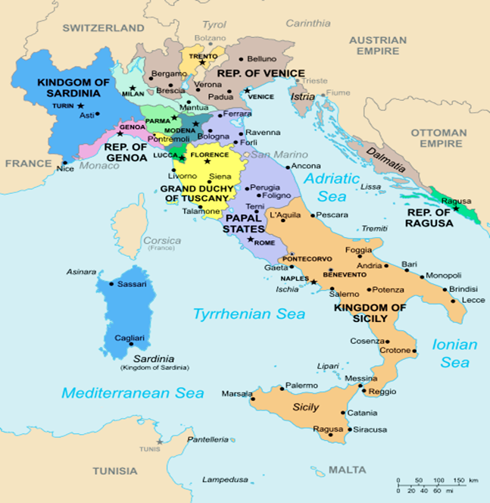
The golden Age of Opera: the eighteenth Century

With minor alterations due to dynastic wars throughout the sixteenth and seventeenth centuries, the situation of the Italian peninsula does not change massively in the eighteenth century:

- Series of different states rules by different, often foreign rulers
- No political, economical, language, unity
- No national/nationalistic sentiments
- Several different cultural and political centres (capital cities)

As the quintessentially ‘Italian’ cultural product, musical theatre/opera in musica held quite an important role in this fragmented situation. A network of venues/theatres started to link the cities of the Italian peninsula, transcending the state borders.

These theatres, with a few exceptions (the old court theatres), were run through the sistema impresariale (impresario system), i.e. entrepreneurial system which turned Italian opera into a money-making machine and caused the expansion and dissemination of the genre.

How did an impresario work?
What was the role of the audience in this system?
What was the role of the singers in this system and which place did they occupy in the artists’ hierarchy? Conversely, which place did the composer and librettist occupy?

An invaluable sketch of the eighteenth-century operatic world and its vices is contained in Benedetto Marcello’s pamphlet Il teatro alla moda (The fashionable Theatre), 1720. Here are some excerpts dedicated to singers [attachment].
What can you infer from these texts?
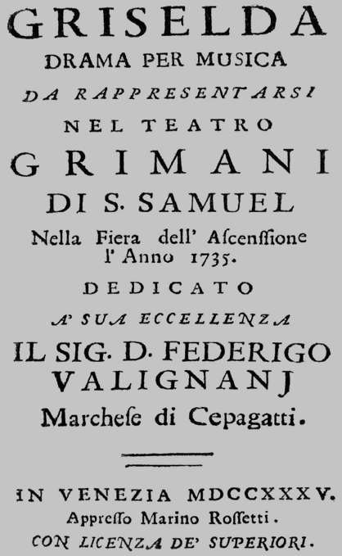
The main operatic genre, involving the most celebrated singers, composers and venues, and generating the most significant income was opera seria (serious opera), although the individual works were seldom or never called like this (tragedia per musica, dramma per musica, dramma eroico per musica, melodramma, et.). Characterized by:
- Subjects from the glorious past, especially Rome/ancient Greece or the Middle Ages (seen as the age of bravery, chivalry, great kings, etc.)
- High-status characters such as kings, emperors, military heroes, knights, intellectuals, ladies, etc.
- High emotions, values and virtues traditionally associated to the political elite (bravery, patriotism, goodwill, disregard for personal feelings for the greater good, sacrifice, pure love, etc.)
- Moralistic/educative plots and endings
- Strict hierarchy between singers, divided in primo uomo/prima donna, secondo uomo/seconda donna and so on, reflected in the number and character of solo pieces given
- Alternation between recitativo (secco) and aria, with little ensemble pieces (usually just a few love duets); virtually no choral scenes/numbers apart from particularly lavish productions
- Arie tailored to the vocal skills and features of the single singers
- Orchestrally poor

Example of a ‘showpiece’ for Costanza (Constance), the prima donna in Vivaldi’s La Griselda
Singers as international stars
Male heroes sung more often by sopranos and altos than by tenors (the introduction of the tenor hero will be a very nineteenth-century matter): this is partially caused by and partially causes the practice of castrating young promising boys to make them retain their high range. Castration and the subsequent hormonal imbalance had several (negative and positive effects); those important for singers were:
- abnormal bone growth
- lack of larynx elongation
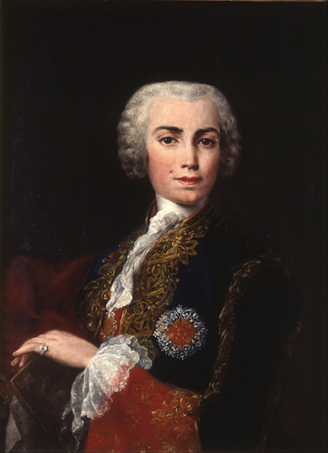
Castrati (sing. castrato, from the verb castrare, to castrate) could not do anything else but become professional musicians. They undertook a musical training like no other, their voices, but also their discipline turning them into singing (and money-making) machines.

The major centres of ‘production’ of castratos were/became Rome (where they had been used for some time in the world-famous choir of the Sistine Chapel) and Naples, rapidly becoming the Italian capital of opera. In Naples, we can also observe the institution of the first so-called Conservatori, previously religious institutions training lower-class children as professional musicians to give them the means to survive, and specializing in sacred music and composition.
- Conservatorio Santa Maria di Loreto (1537): Francesco Durante, Nicola Porpora, Domenico Cimarosa, Farinelli, Caffarelli
- Conservatorio Sant'Onofrio a Capuana (1578): Nicola Jommelli, Giovanni Paisiello, Niccolò Piccinni
- Conservatorio della Pietà dei Turchini (1583): Leonardo Leo, Saverio Mercadante, Gaspare Spontini
- Conservatorio dei Poveri di Gesù Cristo (1589): Giambattista Pergolesi

So-called ‘scuola napoletana’, revolving around the composition of opera buffa alongside opera seria (next session).

