UNIVERSITY OF WALES TRINITY SAINT DAVID
CLOUD COMPUTING

Database Management Systems Quality Estate Database - Report

AUTHOR: CLAUDIU OCTAVIAN ALBUS
STUDENT ID: 1809254

London
2019
Table of Contents

- Meaning and Purpose________________________________________1
- Database Management System (DBMS)_________________________2
- Quality Estate Database______________________________________3
- Entity Relationship Diagram (ERD)____________________________4
- SQL Queries & Results Screenshot in Microsoft SQL Server_______7
- Bibliography_______________________________________________12

Meaning and Purpose

A database management system is a set of data stored on media, which is accessible using the PC, to meet multiple users at the same time in a selective and timely manner.
Another definition closer to the physical representation would be one according to which a database is a set of interrelated files that contains the core of data required for complex computing applications (Faroult, 2013).
In a database are recorded data on real or abstract objects, but also the associations (relationships) that can be established between them. Between the data of a database there is a logical interdependence. The interdependencies that can be established between the collections of data stored in a database help to ensure the functional integrity of the database (Elmasri and Navathe, 2000).
A database is a model of a real system. The content of a database (sometimes called extension) is at one point, a state of the system being modelled. The changes from the database are represented by events that occur in the environment and change the state of the modelled system. It is obvious that we must structure a database, so that it represents the system that needs to be modelled (Silberschatz, Korth and Sudarshan, 2001).

The fundamental objectives of a database system
- Data centralization - Allows centralized control of data and elimination of repetitions (redundancies).
- Independence between data and processing - The database, being a model of a reality, is always changing (for example, in estate field some properties has been sold to the customers and the database must be updated, personnel changes, etc.).
- Making links between data - The data representing the model of a system are not separated, there are logical links between them.
- Data integrity - Provides the reliability and consistency of the database.
- Data security - The database must be protected against any type of threats.
- Data confidentiality - It refers to the secret nature of the data, which can only be accessed by authorized persons.
- Data sharing - Allows service to users accessing the same database data simultaneously (Sumathi and Esakkirajan, 2007).

Database Management System (DBMS)

These days, most of estate companies all around the world are using a database management system, because it is very easy to use and reliable. But some of them are still using an ordinary filling system, which is limited compared with the new technologies.
The software system that allows the construction of a database, the introduction of information in the database and the development of applications is called database management system (Ramakrishnan and Gehrke, 2000).
An DBMS gives the user the ability to access data using high-level language that is close to the usual mode of expression, to obtain information. It is not necessary for the user to know how the data they want is selected or how they are stored. Therefore, it is said that DBMS is an interface between users and the database, a tool for assembling, coding, arranging, protecting and retrieving data in the database (Ramakrishnan and Gehrke, 2000).

The main functions of a DBMS
- Data storage on external media (through the file management system);
- Data management and links between them, in order to quickly retrieve them through the access system;
- Entering and extracting data from / to the outside, in the form required by the user. The DBMS can process multiple applications, coming from multiple application programs. At the same time, most DBMSs also provide control over the transmission of data to and from terminals. The DBMS provides users with distinct languages ​​for:
- Database Description: Data Description Language (LDD).
- Use (manipulation) of the database: Data Handling Language (LMD). The database manipulation (query) languages ​​can be:
- Statements - allow the user to declare what information’s needs.
- Procedural - which obliges the user to describe how to obtain the information (Ramakrishnan and Gehrke, 2000).

Limits of storing data into an ordinary filing system
- It’s a way to store all the data into a single file or a table, but is not that helpful if it is used a big amount of data.
- Lack of a rigorous formalism for defining and validating data.
- Poor data processing performance, especially when it is necessary to associate data stored in separate files.
- Maintaining high redundancy in data collections stored on technical media (Silberschatz, Korth and Sudarshan, 2001).

The limits of data organization in files and the possibilities offered by new information technologies have led to promote a method to organize the data into databases. The purpose was to collect all the data, to organize them in a suitable way and to develop programs to read and update the actual data collection.

Quality Estate Database

The ‘Quality Estate’ database was designed using Microsoft SQL Server Studio software, which is used to create and configure someone’s own database. This kind of software is very used these days in this field.
To keep the tracking of every single property is the important part, if someone is running this type of business.
The Database contains:
- Primary Key for each table;
- Referential integrity constraints (Foreign Keys);
- Check Constraint for the password column;
- Security Level Permission for each user;
- Transaction rollback;
- Commit operations.

Database Design Advantages
The database design contains tables to store information about properties, appointments, buyers, vendors, offers, service category details to keep track of customers, sales agents and branch information.
In the database, there are presented separate table for storing category of different services offered by the estate management company. It currently has three values like sales, maintenance and valuation. In future there can be options for lease, rent and other service categories that can be included in same design.
Also, the database design model has the option to move the sales agents from one of the branch to another branch, because future changes may appear.
In the database model, has been used a ‘check constraint’ for the password policy, where it must be maintained a minimum length of eight characters. This type of integrity will be used for all users from the database.

Entity Relationship Diagram (ERD)

ERD Diagram of Quality Estate Management database
First diagram it shows the existing entities and the relationship between them, as follows.

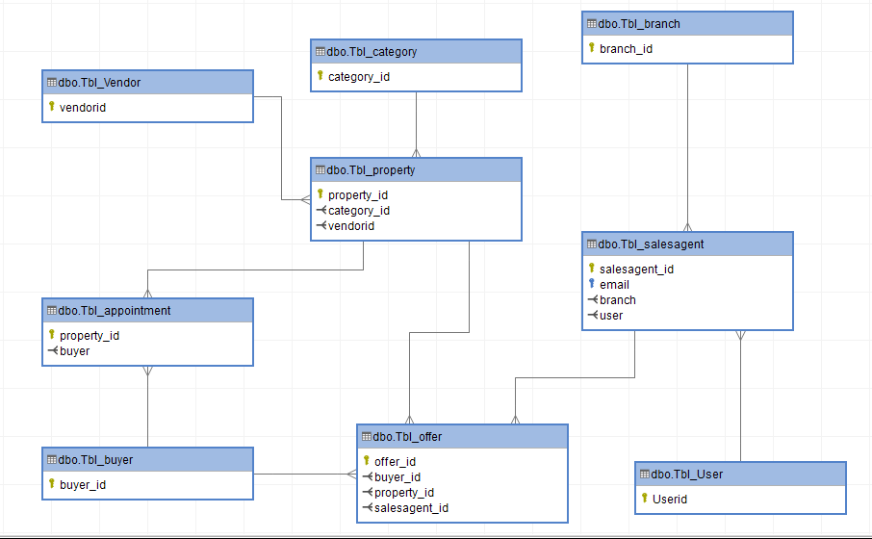

Relationships between the entities:

- Quality Estate management company offer different category of service to customers like sales, valuation, maintenance etc.
- One Vendor it has many Properties for sale.
- Sales Agent has many Properties to offer for sale. Also, they have a User to record all the activities.
- Every Branch has two Sales Agents, who manage the sales. They discuss the offers with the potential buyers.
- A Property has many Offers from the potential buyers. Only one Offer can be placed by only one Buyer.
- One Buyer can make many Appointments to check different Properties.
- One Property can have many Appointments, in the same day or in the same week, for different hours.

The second diagram is the same as the one from above, but this time it contains all the attributes from each entity.

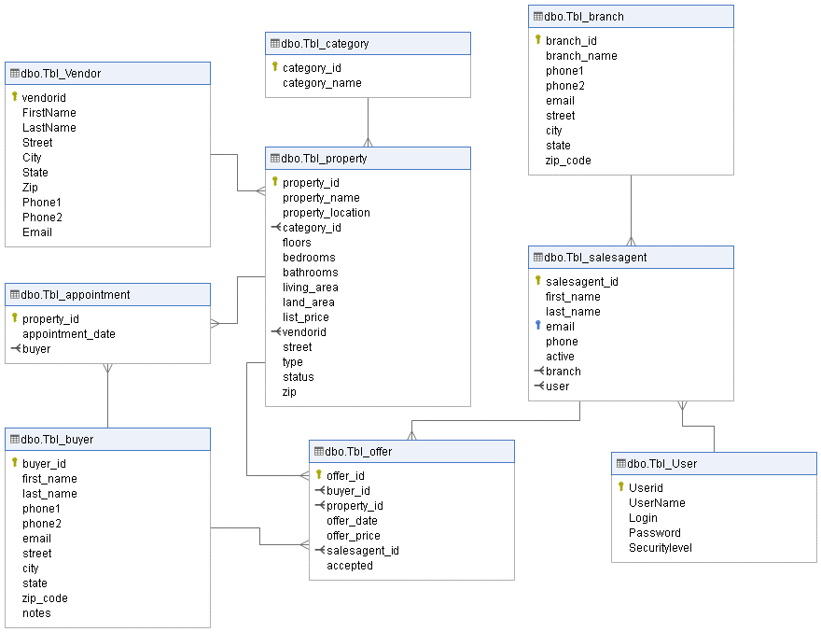

Same diagram taken from Microsoft SQL Server Database for Quality Estate DB

SQL Queries & Results Screenshot in Microsoft SQL Server

Below, queries give information about the sales of the properties, the business activities of its branches; and the performance of their sales agents.

The below query shows the sales with the name of the properties and the amount of each sale.

SELECT p.property_name as Property_Name ,o.offer_price as Sold_Amount
FROM Tbl_property p join Tbl_offer o ON o.property_id=p.property_id WHERE o.accepted=1

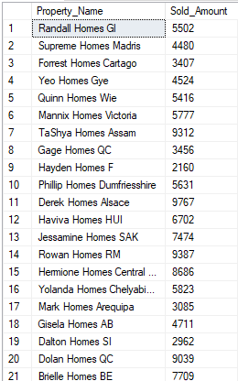

The below query shows the sales with the name of the staff making the sales, the properties sold, and the amount of each sale.

SELECT sg.first_name as Sales_Personal_Name ,p.property_name as Property_Name ,o.offer_price as Sold_Amount FROM Tbl_property p
JOIN Tbl_offer o ON o.property_id=p.property_id
JOIN Tbl_salesagent sg ON o.salesagent_id=sg.salesagent_id
WHERE o.accepted=1

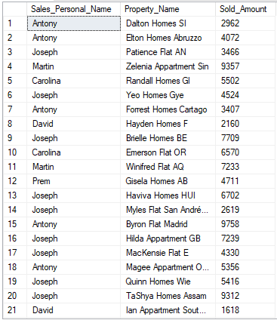

The below query shows the sales for a year with the name of the staff making the sale, the properties sold, and the amount of each sale for each branch.

SELECT b.branch_name as Branch_Name,sg.first_name as Sales_Personal_Name,p.property_name as Property_Name ,o.offer_price as Sold_Amount, o.offer_date as Sold_date FROM Tbl_property p
JOIN Tbl_offer o ON o.property_id=p.property_id
JOIN Tbl_salesagent sg ON o.salesagent_id=sg.salesagent_id
JOIN Tbl_branch b ON b.branch_id=sg.branch
WHERE o.accepted=1 and o.offer_date between '01-01-2019' and '12-31-2019' ORDER BY b.branch_name

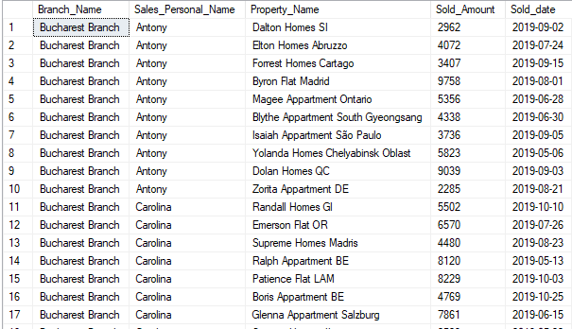

PIVOT Table and Chart

The picture below shows the sales with the name of the properties and the amount for each sale in pivot table and graph.
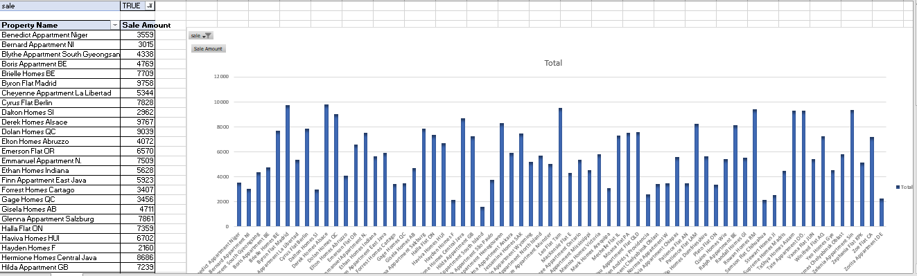

ii. List all the sales with the name of the personnel who made the sale, the property sold,
and the amount of each sale.

Below are listed the sales with the name of the staff making the sale, the properties sold, and the amount of each sale in pivot table and graph.

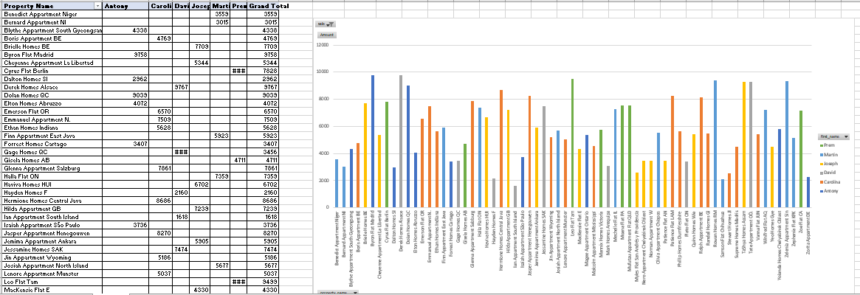

The table below shows the sales for a year with the name of the staff making the sale, the properties sold, and the amount of each sale for each branch in pivot table and chart.

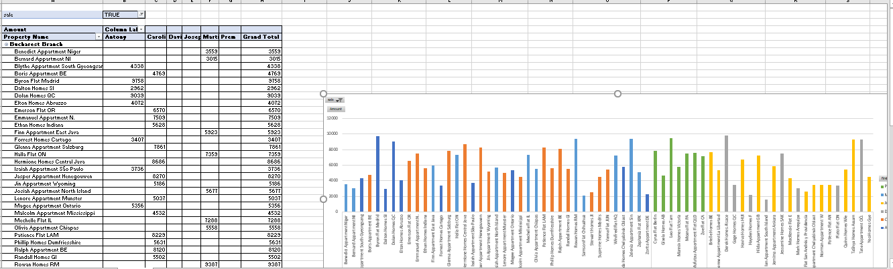

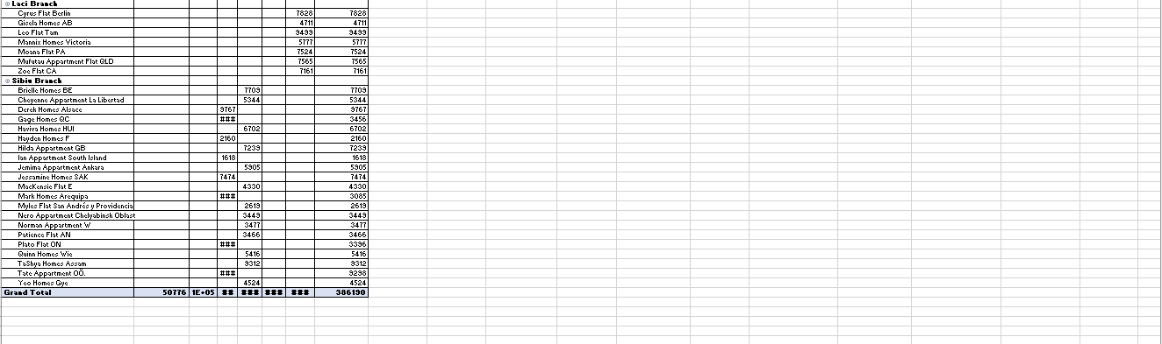

Bibliography

- Elmasri, R., Navathe, S., (2000), Fundamentals of Database Systems, Pearson, pp. 24-25.
- Abraham Silberschatz, Henry F. Korth, S. Sudarshan (2001), Database System Concepts, Fourth Edition, McGraw-Hill, pp. 3-6.
- R Ramakrishnan, J Gehrke (2000), Database management systems, Second Edition, Mc Graw-Hill, pp. 3-11.
- S Sumathi, S Esakkirajan (2007), Fundamentals of relational database management systems, Springer, pp. 4.
- Faroult, S., (2013), SQL Success: Database Programming Proficiency, Roughsea, pp. 23-24.

