



Applied Computing Department - Wales Institute of Science and Art
ASSESSMENT
on
“Digital Forensics Analysis”
(ACCA7031)
NAME: SNEHA SINDHE
STUDENT ID: 2304464

TABLE OF CONTENTS
CHAPTER 1: TASK - 1 3
1.1 CURRENT STATE OF THE FIELD 3
1.2 INTERSECTION OF DIGITAL FORENSICS AND CYBERSECURITY 4
1.3 EMERGING TRENDS 4
1.4 KEY CHALLENGES 8
1.5 NATIONAL AND INTERNATIONAL JOB MARKET 9
CHAPTER 2: TASK - 2 11
2.1 FEATURES AND CAPABILITIES OF DIGITAL FORENSIC TOOLS 11
2.2 EVALUATION OF OPEN SOURCE WITH COMMERCIAL FORENSIC
TOOLS 15
CHAPTER 3: TASK - 3 18
CHAPTER 4: TASK - 4 22
ANNEXURES 27
REFERENCES 28

LIST OF FIGURES

Figure 1.1: System for Cloud Forensic Readiness 5

Figure 1.2: IoT Affecting Factors 6

Figure 1.3: Social Media Forensic in Investigating Crime 7

Figure 3.1: Hard Disk 19

Figure 4.1: Mobile Phone 22

Figure 4.2: Cellebrite Extraction Summary 24

Figure 4.3: Cellebrite Audio Files 24

Figure 4.4: Geographic Location 25

Figure 4.5: Location Dots 26

CHAPTER 1
TASK - 1

1.1 CURRENT STATE OF THE FIELD

Digital forensics is a rapidly evolving field that involves collecting, preserving, analyzing, and presenting digital evidence to investigate and prevent cybercrimes. It has evolved due to technological advancements, and increasing complexity due to encryption, cloud computing, and sophisticated malware. The integration of AI and machine learning in digital forensics tools is making the process more efficient, enabling quicker and more accurate analysis of large datasets. Practitioners are adapting their skills to handle emerging technologies and sophisticated cyber threats. Digital forensics is a scientific field that employs scientific concepts to examine evidence found in digital devices and reassemble the pattern of incidents that led to them [1]. It first appeared in the latter part of the 1990s and early 2000s in response to the increasing use of technological devices and the Internet. Technology has advanced, making it harder to perform forensic investigations involving modern digital data [2][3]. Digital forensics is a new phrase that has emerged from the development of modern digital devices and the rising frequency of detecting such devices in investigations. The primary national threat source is still computer and internet crime, with terrorism coming in second. Investigating any kind of media that may store digital information is now covered by this new phrase while conducting a forensic examination.

1.2 INTERSECTION OF DIGITAL FORENSICS AND CYBERSECURITY

Digital forensics and cybersecurity are interconnected, with digital forensics playing a crucial role in incident response and recovery. Digital forensics helps identify and mitigate security incidents, while cybersecurity strategies increasingly incorporate forensic techniques to enhance incident response capabilities. The findings of digital forensics investigations often have legal implications, contributing to prosecution or defense in legal cases [4]. The intersection of digital forensics and cybersecurity emphasizes the need for proactive measures to prevent incidents and effective response strategies when they occur.

Cybersecurity focuses on protecting digital assets, while digital forensics focuses on investigating incidents after they occur. The relationship between digital forensics and cybersecurity is complementary, as digital forensics collects and analyzes digital evidence to identify attackers, determine the effect of damage, and protect organizations for the future. Digital forensics can also inform cyber security strategies, identifying weaknesses in an organization's cybersecurity measures and informing improvements to prevent similar incidents from occurring in the future. Both disciplines are essential for modern organizations to protect their digital assets from cyber threats. Because of the complexity of cyber threats and the rapid advancement of technology, cybersecurity, and digital forensics are becoming more and more mixed together [5]. Digital forensics is the process of locating, conserving, recovering, and documenting digital evidence for investigations, whereas cybersecurity is the defense of systems, networks, and data against digital threats. Combining these fields can strengthen an organization's defenses against cyberattacks since successful investigation techniques in cybersecurity need the application of digital forensics concepts [6].

1.3 EMERGING TRENDS

The area of digital forensics is always changing, and new developments have an impact on how investigations are carried out [7].

- Cloud Forensics:
Cloud computing has grown in popularity Because of its advantages, which include lower IT expenses, scalability, and business continuity. However cloud environments present issues for businesses due to security and rising cybercrimes [9]. One of the most well-known trends in the digital forensic field is cloud forensics, which focuses
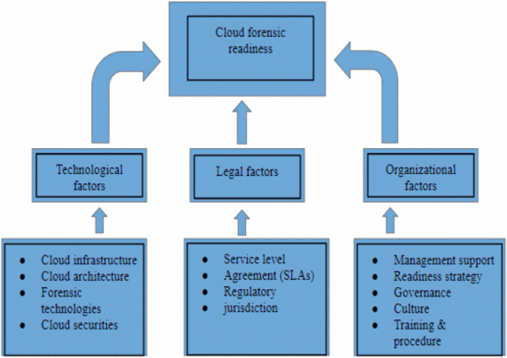

Figure 1.1: System for Cloud Forensic Readiness

on the authentication, authorization, and accounting (AAA) protocol. It entails utilizing distributed forensic processing, computing capacity, scalability, reporting, and reporting to analyze cloud assaults. Three categories apply to cloud forensics: legal, organizational, and technical. Reconstructing events is made possible by the way it processes incidents in cloud environments using established techniques, technological practices, and scientific ideas [8]. Nonetheless, enterprises continue to face formidable obstacles due to the intricacy of cloud forensics and the rise in cybercrimes within cloud environments.

- IoT Forensics:
In mobile telecommunications, the Internet of Things (IoT) is a rapidly expanding paradigm that enables people to share data and communicate with gadgets such as PCs, smartphones, tablets, laptops, and personal digital assistants [10][12]. On the other hand, ransomware, denial of service (DoS), network devastation, and mass monitoring are security risks associated with IoT devices. IoT forensics teams investigate digitally at crime scenes to mitigate these hazards [11][13]. However, there are special difficulties with IoT forensics, like handling massive volumes of data and
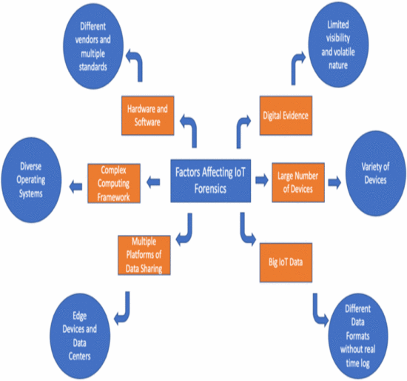

Figure 1.2: IoT Affecting Factors

protecting the chain of custody. IoT forensics are made more difficult by elements like standardized hardware and software, dynamic computer architecture, service-level contract limits, and restricted crime scenes. IoT forensics must adhere to computer forensics and standard digital forensics procedures, and the final report must provide the panel of judges with credible evidence [14][15].

- Social Media Forensics:
A key element of network forensics is social media forensics, which addresses the difficulties investigators encounter while utilizing data stored on social networking websites [8]. Numerous threats and attacks, both inside and outside the system, have been directed toward these websites, including Facebook, MySpace, Twitter, and LinkedIn [16]. Cyberattacks have a major target in these sites' databases. However, because social media posts include a variety of data sources, such as text messages, contact lists, photos, GPS coordinates, and demographic information, they can be a useful resource for criminal investigations [17]. Network and metadata data can support forensic investigations and verify information from online social
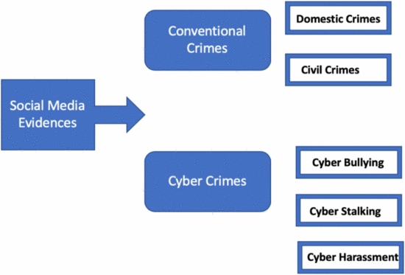

Figure 1.3: Social Media Forensic in Investigating Crime

networks, which may help determine guilty or not guilty verdicts. However, there are legal and technological obstacles that investigators must overcome, like the complex nature of artifacts and the legality of evidence in judgment [18][19]. Researchers need to look at preservation and storage strategies as well as chain of custody protocols in social media forensics to guarantee trustworthy evidence.

1.4 KEY CHALLENGES

- Complexity Problem:
The complexity issue arises from the fact that data is collected in the lowest format—binary—with growing amounts and variety. This necessitates the use of advanced data reduction techniques before analysis can begin [20].
- Diversity Problem:
The diversity issue is brought on by both the naturally growing volumes of data and the dearth of standard methods for examining and analyzing the growing variety of sources, which include a wide range of file formats, operating systems, and other forms. The complexity of exchanging digital evidence between domestic and foreign law enforcement agencies is also further increased by the lack of standards in the storing of digital evidence and the structuring of related metadata [20].
- Consistency And Correlation Problem:
The issue with consistency and correlation arises from the fact that current technologies are made to locate evidence fragments rather than to support investigations in any other way [20].
- Volume Problem:
The volume issue stems from growing storage capacity and the quantity of information-storing devices, as well as insufficient automation to support analysis [20].
- Unified Time-Lining Problem:
The challenge of unified time-lining arises from variations in time zone references provided by many sources, various readings of timestamps, clock skew/drift problems, and syntax complexity in creating a single timeline [20].
- Privacy Problem:
Digital forensics must strike a balance between privacy and the retrieval of crucial evidence. Privacy concerns arise as investigations collect more data as storage capacity increases. Big data may result in invasions of privacy. To reduce data seizure and privacy violations, investigators need to take into account broad inquiries. Although encryption is meant to safeguard privacy, hackers utilize it to cover up their illegal behavior [21].

1.5 NATIONAL AND INTERNATIONAL JOB MARKET
Professionals in digital forensics have access to a wide range of work prospects across multiple industries.
- Law Enforcement: To look into cybercrimes and bolster court cases, several law enforcement organizations use specialists in digital forensics.
- Private Sector: To safeguard company digital assets and look into internal issues, corporations use experts in digital forensics.
- Global Cybercrimes: Experts in Digital Forensics have the chance to collaborate globally, partnering with law enforcement agencies and organizations throughout the globe, thanks to the international scope of these crimes.

Demand for digital forensics specialists is high across several industries, including law enforcement, government, commercial industry, and cybersecurity companies. Credentialing courses like Certified Information Systems Security Professional (CISSP) and Certified Digital Forensics Examiner (CDFE) are highly prized [22]. Due to the worldwide severity of cyber threats and the expanding digitization of economies, there is a growing demand for qualified digital forensics specialists on a global scale. Detailed industry analysis with an emphasis on types, applications, and geographies can be found in the "Digital Forensics Market" research study 2023. A CAGR status is provided, along with a summary of market development factors, movements, opportunities, and concerns. The global market is projected to expand at a compound annual growth rate (CAGR) of 13.38% by 2028, from its 2022 valuation of USD 2453.06 million. To assist criminal and civil courts, digital forensics gathers, locates, retrieves, and examines evidence from digital devices [23].

The biggest producers of digital forensics in the world:
- Paraben Corporation
- Digital Detective Group Ltd
- Oxygen Forensics Inc.
- Magnet Forensics
- FireEye Inc.
- ADF Solutions
- Secureworks Inc.
- Cellebrite

The factors influencing the market for digital forensics:

- Telecommunication & IT
- Retail
- Automotive
- Government
- Healthcare
- Manufacturing
- Others (Utility, Transportation & Logistics)

CHAPTER 2
TASK - 2

2.1 FEATURES AND CAPABILITIES OF DIGITAL FORENSIC TOOLS
Investigators need digital forensic tools to gather, examine, and store digital evidence. As of right now, a wide variety of technologies are available to support different facets of digital investigations. The field of digital forensic tools has advanced greatly, offering a variety of features and functionalities to tackle the always-changing cyber threat environment [29].
- Cellebrite (UFED)-
Cellebrite is the preferred tool supplier for mobile forensics because of its extensive support for mobile devices and cutting-edge data exfiltration capabilities. Cellebrite provides many platforms for mobile device forensics, such as Cellebrite Inspector, Cellebrite Premium as a Service, Cellebrite Universal Forensic Extraction Device, and Cellebrite Premium Enterprise. Its goods are compatible with other digital forensics equipment [24]. For instance, using Magnet Axiom for computer forensics, a cybersecurity investigator can transition to Cellebrite for the extraction and analysis of mobile data. Businesses can get prices and information from Cellebrite regarding which digital forensics technology best meets their requirements.

Overview of Cellebrite Digital Forensics Tools:
- Device Support: Offers support for a large variety of devices with operating systems such as iOS, Android, BlackBerry, and Windows Mobile, as well as smartphones, tablets, and GPS units.
- Data Extraction: This process retrieves a wide range of information from devices, such as contacts, messages, call logs, multimedia files, browsing history, and application data. Both logical and physical extractions are capable of being carried out.
- File System examination: Provides access to hidden data, erased files, and other artifacts through the examination of the device's file system.
- Password Bypass: On compatible devices, certain tools may be able to crack or circumvent passwords.
- Data Decoding: Able to decode and understand data for investigators in a variety of forms.
- Reporting and Documentation: Tools for creating thorough reports and keeping track of conclusions and supporting data.
- Database Parsing: Able to parse and examine data from databases on devices.
- Customization and Updates: Gives users the ability to personalize extraction procedures and keep up with the newest operating system and device versions.
- Training and Support: Offers law enforcement organizations, experts in digital forensics, and other users training programs and assistance.

- Wireshark -
For network analysis, Wireshark is an open-source program that has been around for more than 20 years. An investigator can identify the kind of traffic in addition to its source and destination thanks to its ability to display each network packet that originates from and is received by a device [24]. Finding the location of the attacker's compromised data transmission is useful when assessing a possible data breach. To determine connection details and even the contents of a single packet, Wireshark can analyze both wired and wireless network traffic.

- Packet Capture: Gathers and shows unprocessed network data in real-time or from a file that has been stored.
- Protocol Support: Allows for the investigation of a large number of network protocols at various OSI model layers.
- Filtering: Offers strong filtering features to concentrate on particular kinds of traffic.
- Colorization: Packet types are color-coded to facilitate identification.
- Conversation View: Facilitates simple communication by arranging collected data into conversation views.
- Export and Save: Stores intercepted packets for subsequent sharing or analysis.
- Statistics and Monitoring: Offers statistical instruments for troubleshooting and network traffic analysis.
- Support for Decryption: If keys are provided, can decrypt encrypted traffic.
- Show and Track TCP Streams: This enables users to reconstruct and examine the content of conversations.
- VoIP Analysis: Tools for examining VoIP (Voice over IP) communications.
- Time-Related Analysis and Timestamps: Offers timestamps for every packet.
- Plug-ins and Customisation: Allows for the inclusion of new functionality and supports the usage of plug-ins.

- Forensic Toolkit (FTK) -

It is a sophisticated password recovery and code-breaking tool. This tool is complete Ascii and offers code Page Support. It offers sophisticated email support as well. Powerful Search Functionality [25]. FTK provides Registry Supplemental Reports. As an interface, it is fairly simple to use. FTK is produced by Access Data Group. They are the main source of certification and training in forensics tools. Around the world, more than 130,000 governing organizations and legal companies use FTK. It is capable of analyzing mobile devices, laptops, desktop PCs, and network communications. It searches and filters more quickly unlike any other tool on the market [26].

Features of FTK include:
- Gathering and storing data from 3,500 mobile devices; • Gathering information from across the network.
- Identifies data leaks, resentment, and missing data.
- Recognizes alterations to the locations of data storage.
- Recognises transfers of data between mobile devices and systems.
- Compiles data for use in static analysis.
- Operates with a USB drive.
- Provides expert evaluation and contrast with testimony.
- Retrieves passwords.
- Image discs using FTK Imager.
- Conducts Boolean and hashing searches on data.
- Views Word, Excel, and PowerPoint.
- Performs email analysis.
- Multilingual support is provided.
- Exports proof as a Tiff or PDF file.

- Encase -
EnCase, created by Guidance Software, is a widely used forensic tool used by 90% of consumer goods companies, 93% of banks, 100% of federal agencies, 75% of power distributors, and 80% of US universities [25]. It securely investigates multiple machines, collects only relevant data, and efficiently audits large groups for sensitive information.

Features of EnCase Forensic:
- Collects information from several sources, including mobile devices, networks, and clouds.
- Produces massive amounts of reports while retaining evidence integrity.
- Targeted device gathering using hash values, information, and keywords.
- Carries out disc imaging and memory acquisition.
- Can gather information from live machines via USB drive.
- Carves data.
- Facilitates the recovery of passwords.
- Makes it possible to gather and process data remotely [26].

2.2 EVALUATION OF OPEN SOURCE WITH COMMERCIAL FORENSIC TOOLS
Cellebrite UFED vs Autopsy:
Consideration Factors: Cellebrite UFED is essential if mobile device forensics is the main emphasis, particularly in law enforcement or high-stakes investigations. Autopsy offers a customizable, affordable solution with support from the community for more extensive digital forensics requirements.
Wireshark vs FTK:
Consideration Factors: With a focus on disk-based forensics and networks, respectively, Wireshark and FTK have diverse uses. Even though they cover various areas of the investigation, merging them can result in a more thorough comprehension of the actions and circumstances [27][28].
Recommendations:
- Case-individual Decision: Coordinate open-source and commercial tools like Cellebrite, EnCase, Wireshark, and FTK according to every investigation's demands.
- Balanced Approach: Taking into account both tools' advantages and disadvantages, integrate them based on the needs of the scenario.
- Training and Experience: To increase accuracy and efficiency, take into account the forensic analysts' experience with particular technologies.
- Frequent Toolkit Updates: Utilise the most recent iterations of your tools to benefit from developments.
- Open-source Tools: Autopsy, Wireshark, Volatility, and ideal for cases when money is tight.
- Commercial Tools: EnCase, FTK, X-Ways Forensics for broad features and advanced analysis.
Open-Source Tools:
Advantages -
- Cost-effective: Since open-source technologies are typically provided without charge, a variety of users, including lone detectives and small businesses, can make use of them.
- Community Support: By creating a collaborative atmosphere, the open-source community helps to develop and enhance tools.
- Openness: By allowing users to view the source code, the tool's functionality is guaranteed to be transparent.
Disadvantages -
- Restricted Features: When contrasted to their commercial counterparts, some open-source programs may offer fewer features.
- Less Formal Support: Although there is a society as a whole there may not be as much formal support or documentation available.
Commercial Forensic Tools:
Advantages -
- Advanced Features: Advanced features like complete reporting, combined analysis, and compatibility for a variety of file systems and devices are frequently included in commercial tools.
- provider Support: The tool's provider offers users specialized assistance, frequent updates, and training materials.
- Legal Compliance: For evidence to be admitted into evidence in court, commercial tools frequently make sure that their features and procedures adhere to legal requirements.
Disadvantages -
- Cost: Because business equipment can be pricey, smaller organizations or lone investigators may find it difficult to use them.
- Dependency on Vendor: For bug patches, updates, and support, users rely on the vendor.
The decision between open-source and proprietary tools ultimately comes down to the particular needs of the research, the available resources, and the degree of support that is required. It's advised to keep up with the most recent advancements and user opinions within the field of digital forensics.

CHAPTER 3
TASK - 3
Team members:
The six members of our team each bring a different set of abilities to the table, such as knowledge of computer science, coding, cybersecurity, digital forensics, and data analysis.
Resources:
- Hard Disk (1 per team)
- Theme: Financial crime
- Digital Forensic Tools: FTK, Steganography, Encryption, Screencapture, RDP Session, SEtoolkit, and Msfvenom
Analyzing Data:
An attacker hacks a victim's wireless connection and sends a phishing email with a reverse shell payload. The victim executes the payload, establishing a meterpreter session. The attacker monitors user activities using shell commands and remote screen-capturing techniques. The victim orders products from Amazon.com using the victim's login credentials. The attacker launches a remote desktop connection with the victim's machine and orders exclusive products. The victim finds the crime and recovers from it using evidence collected with the timestamp. The task is executed within an Oracle VirtualBox, with the attacker's machine Kali Linux and the victim's machine Windows 10 Home. Digital forensic tools are used to hide evidence, including steganography and PGP encryption. The evidence is then divided into Windows and Kali Linux images and the chain of custody form is filled in. The evidence is then exchanged back to Team A. The team used a steganography technique to hide files in the E drive and image files in the F drive. The evidence was stored in both drives, with the image files hidden in the F drive. The Amazon account was locked, proving the protection mechanism for customer accounts. The team also exchanged the hard drive, filling in the Chain of custody form.
Deliverables:
Task 3 Data Collection Link (Click here)

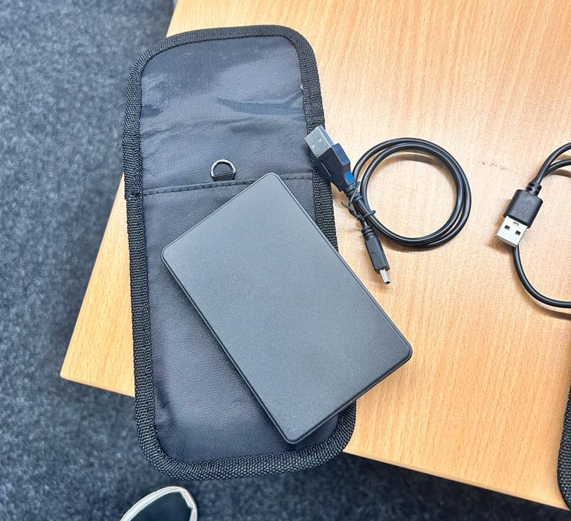

Figure 3.1: Hard Disk
My Contribution:
My contribution to my team includes Disk Partition Technique, Phishing Email Creation, and Hiding Attributes. I have also worked with digital forensic tools like hiding files and encryption of data in Kali Linux and Windows. Hiding folders with Windows 10 machine using RDP sessions. I also did disk management to do the hard drive partition in the hard disk.
AFTER EXCHANGING THE HARD DRIVE
Exchanging Data:
  - Used ChatGPT for an anonymous exchange with other teams, ensuring that reciprocal exchanges were not allowed.
  - Shared the digital evidence, scenario, and investigation challenge with another team.
Analyzing Data:
Call logs, social media chats, and a police report were used to investigate a case of cyberbullying. Emmy James was named as the victim and Justine Elias as the suspect in the police report. Seven encounters between Justine Elias and Seer Musta were found through social media analysis, with Justine striking up chats despite her lack of interest. Call logs showed that Alfred Adam was phoning a particular number often, raising worries about cyberbullying. Initially discovered to be empty, the hard drive contained hidden data and directories.
My Contribution:
After working on the social media analysis on several platforms, including Facebook, WhatsApp, and Instagram, I concluded that cyberbullying did occur. Next, I looked over the phone records. This particular piece of information gave me a thorough picture of numerous instances involving distinct individuals on different communication platforms. I then checked the disc partition, but I couldn't see any disc partitions anywhere. Next, utilize the commands to display the concealed files and folders by going to the location where they are represented. I handled the image processing verification, documentation, and storage while working with the FTK pictures. Using the well-known FTK Imager tool, I produced an image of the evidence to confirm the information we got from Team B.
Conclusion:
Our group demonstrated its adeptness in managing a Cyberbullying scenario by conducting a successful simulation of a digital forensic investigation. By working together and utilizing a range of digital forensic technologies, we were able to locate important evidence and provide a comprehensive case analysis. The hard drive, report, and presentation all function as thorough records of our team's proficiency in the field of digital forensics.
Task 3 Group Report Link (Click here)
PPT Link (Click here)

CHAPTER 4
TASK - 4
Resources:
- Mobile Phone (1 per team)
- Digital Forensic Tools: Cellebrite UFED, Oxygen Forensic Detective, Magnet AXIOM, and other tools covered during lectures.
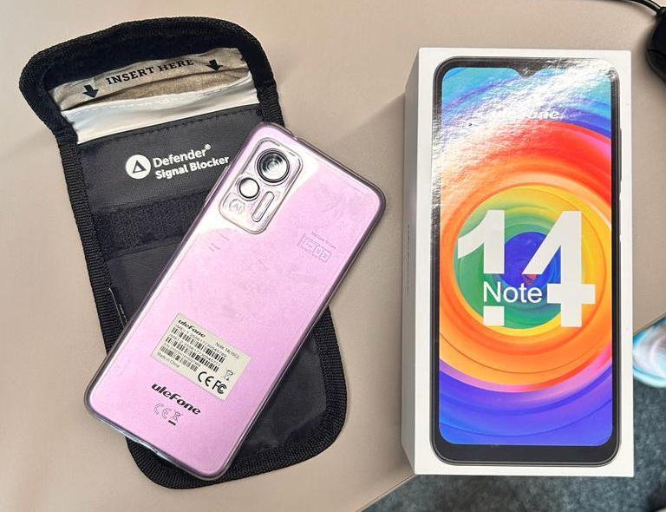

Figure 4.1: Mobile Phone
Forming the Team:
Reassembled the same team as Task 3, ensuring continuity and effective collaboration.
Collecting the Mobile Phone:
Received the mobile phone from the Lecturer, adhering to proper documentation and maintaining the chain of custody.
Analyzing the Mobile Phone:
The Ulefone Note 14 (16G) phone case was examined using the Cellebrite UFED tool for mobile forensics. The phone was password-protected and attempted to crack the password using various methods. However, challenges arose, such as contacting the manufacturer, attempting to jailbreak the device, and attempting a 'brute-force attack'. The team determined the number of possible password combinations and implemented a rate-limiting mechanism. The total time required for all 216 combinations was estimated to be approximately 12,900 seconds or 3.58 hours. The team then analyzed the audio transcripts, contacts, and images of the suspect. The audio transcripts provided clues about the suspect's whereabouts, while the contacts were associated with a UK number. The images were analyzed for their geo-location data and location names. The team concluded that the suspect had employment ties in the UK and had contact numbers from various countries. The suspect's travel timeline includes 104 media files, with 57 unique locations. They travel from Dubai to Chennai, India, and then to various locations in India, the UK, and possibly Poland. Dubai appears to be used as a transit hub, suggesting their primary destinations were elsewhere. The suspect's frequent travel between the UK and India, culminating in their return to Swansea, suggests professional obligations. The investigation revealed 23 audio recordings between July and September 2023, with a notable concentration on specific dates.
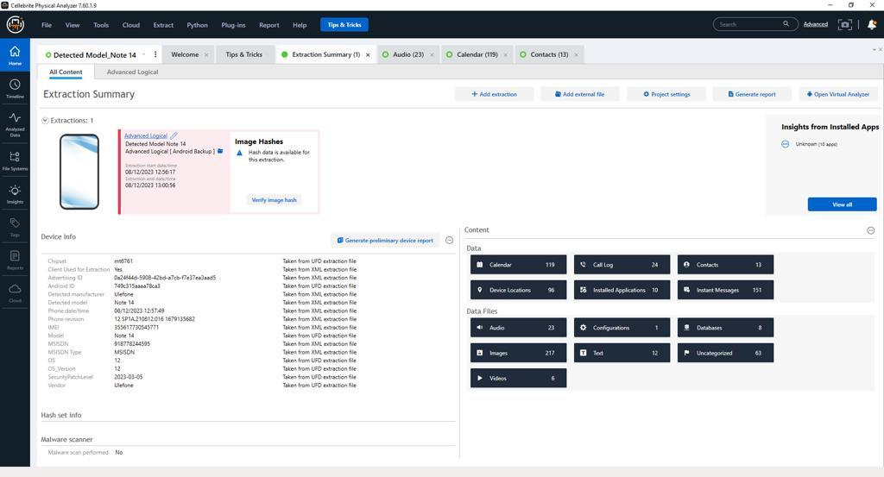

Figure 4.2: Cellebrite Extraction Summary

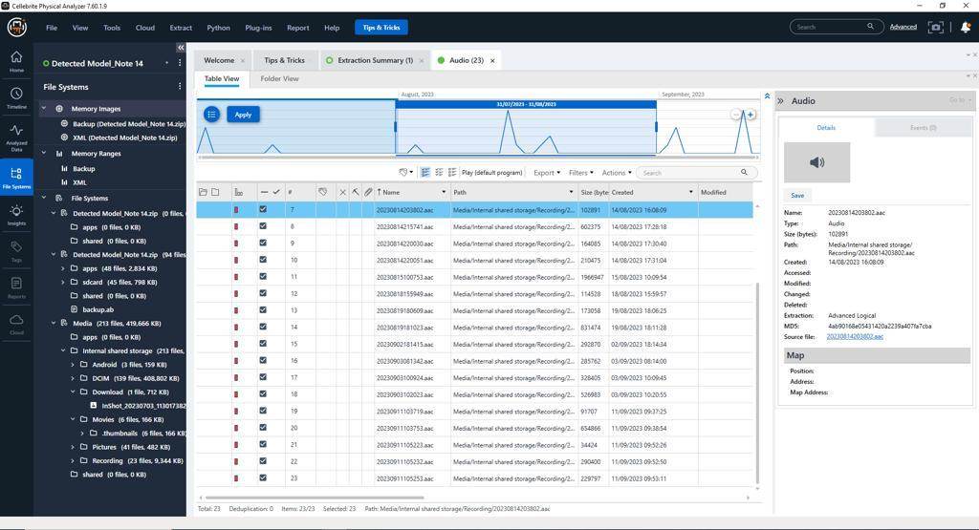

Figure 4.3: Cellebrite Audio Files

Task - 4 Report (Click Here)
Chain of Custody (Click Here)

My Contribution:
First, the summary was extracted from the phone using Cellebrite. A lot of content, including contacts, audio files, video files, images, and text files, was extracted. I performed forensic imaging as well. And used the Cellebrite SIM card adaptor to extract data from the SIM card. All of the audio files were then analyzed by me and I created an Excel sheet explaining the events captured in the audio recordings. Then I confirmed all of the call logs, listened in on the conversations, and determined all of the installed coordinates that the user had accurately traveled. Thoroughly went through all the data that had been there inside the phone. And made the notes for everything.
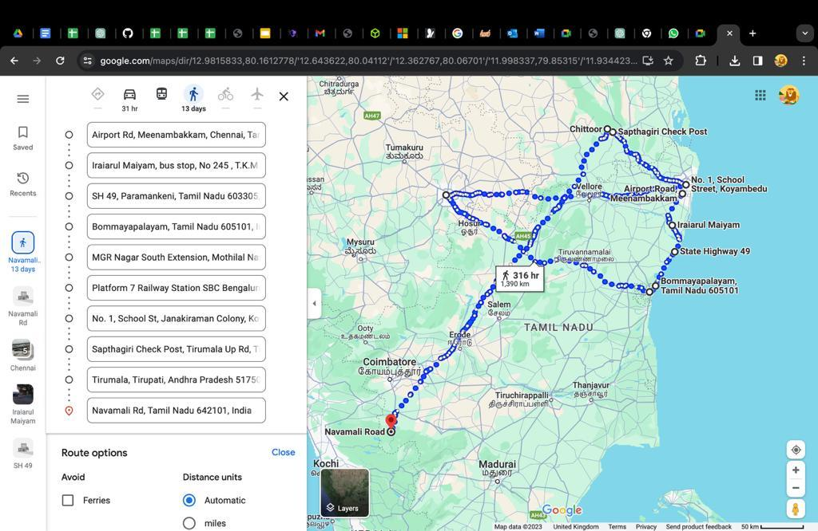

Figure 4.4: Geographic Location
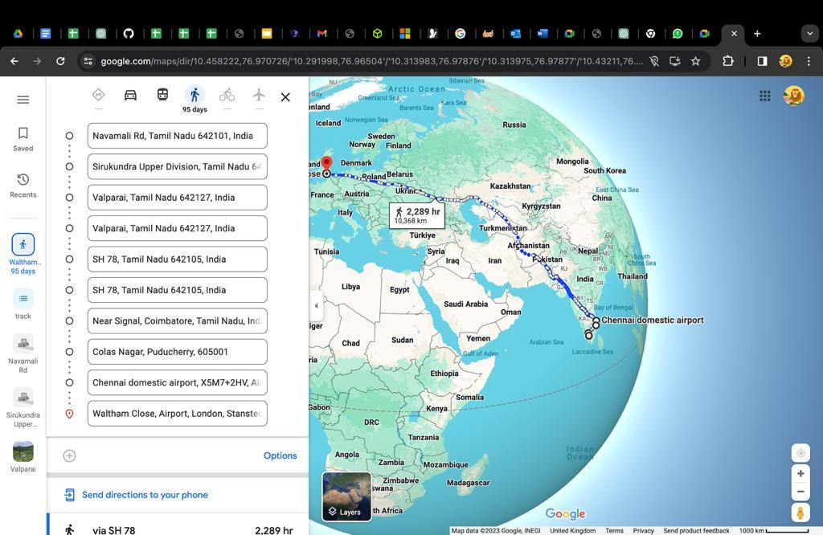

Figure 4.5: Location Dots
Conclusion:
Our group adhered to ethical and legal guidelines while conducting a comprehensive mobile forensic investigation. The team discussions, recorded chain of custody, analytic procedure, and results offer a thorough summary of our methodology and the data acquired. The cell phone and other digital evidence have been safely turned over for additional examination. This assignment not only demonstrates our technical proficiency but also our teamwork and practical application of our knowledge in real-world situations.

ANNEXURES

ALl of these files can be found in the OneDrive Folder.
- Chain of Custody
  - Team C - Task 3 - Receiver.docx
  - Team C - Task 3 - Sender.docx
  - Team C - Task 4.docx
- Minutes of Meeting
  - Meeting Notes - 1.docx
  - Team Discussions/Meeting Notes.docs
- Video Presentation
  - Group C - Task 3 - Video Presentation.mp4
- Data Collection Report.pdf
- Team Reports
  - Group C - Task 3 - ACCA7031 - Digital Forensics Analysis.docx
  - Group C - Task 4 - ACCA7031 - Mobile Digital Forensics Analysis.docx
- Google Sheet
  - Google Sheet - Task 3 & 4.xlsx

REFERENCES
[1]S. Raghavan, “Digital forensic research: current state of the art,” CSI Transactions on ICT, vol. 1, no. 1, pp. 91–114, Nov. 2012, doi: https://doi.org/10.1007/s40012-012-0008-7.
[2]G. Inc, “In U.S., 11% of Households Report Computer Crimes, a New High,” Gallup.com, Dec. 13, 2010. http://www.gallup.com/poll/145205/new-high-householdsreport-computer-crimes.aspx (accessed Jan. 08, 2024).
[3]E. Casey, Digital Evidence and Computer Crime : Forensic Science, Computers and the Internet, 3rd ed. Waltham, Ma: Academic Press, 2011.
[4]Lucifer, “Digital Forensics and Cybersecurity: Interrelated Different Approach,” Forensics Insider, Apr. 27, 2023. https://www.forensicsinsider.com/digital-forensics/digital-forensics-and-cybersecurity/?utm_content=cmp-true (accessed Jan. 08, 2024).
[5]J. Price, “The Intersection of Cybersecurity and Digital Forensics | SubRosa,” www.subrosacyber.com, Oct. 06, 2023. https://subrosacyber.com/blog/cybersecurity-digital-forensics (accessed Jan. 08, 2024).
[6]H. Jordaan, “The Evolution of Digital Forensics: Embracing Cybersecurity,” www.linkedin.com, Aug. 15, 2023. https://www.linkedin.com/pulse/evolution-digital-forensics-embracing-cybersecurity-hannes-jordaan/ (accessed Jan. 08, 2024).
[7]B. K. Sharma, M. A. Joseph, B. Jacob, and B. Miranda, “Emerging trends in Digital Forensic and Cyber security- An Overview,” 2019 Sixth HCT Information Technology Trends (ITT), Nov. 2019, doi: https://doi.org/10.1109/itt48889.2019.9075101.
[8]M. Sarfraz, Cybersecurity Threats with New Perspectives. BoD – Books on Demand, 2021. Accessed: Jan. 08, 2024. [Online]. Available: https://www.google.co.uk/books/edition/Cybersecurity_Threats_with_New_Perspecti/LbdaEAAAQBAJ?hl=en&gbpv=0
[9]M. D. Kohn, M. M. Eloff, and J. H. P. Eloff, “Integrated digital forensic process model,” Computers & Security, vol. 38, pp. 103–115, Oct. 2013, doi: https://doi.org/10.1016/j.cose.2013.05.001.
[10]Q. Zhou and J. Zhang, “Research prospect of Internet of Things Geography | IEEE Conference Publication | IEEE Xplore,” ieeexplore.ieee.org, 2011. https://ieeexplore.ieee.org/document/5981045 (accessed Jan. 08, 2024).
[11]Md. M. Hossain, M. Fotouhi, and R. Hasan, “Towards an Analysis of Security Issues, Challenges, and Open Problems in the Internet of Things,” 2015 IEEE World Congress on Services, Jun. 2015, doi: https://doi.org/10.1109/services.2015.12.
[12]M. A. Khan and K. Salah, “IoT security: Review, blockchain solutions, and open challenges,” Future Generation Computer Systems, vol. 82, pp. 395–411, May 2018, doi: https://doi.org/10.1016/j.future.2017.11.022.
[13]Z. A. Baig et al., “Future challenges for smart cities: Cyber-security and digital forensics,” Digital Investigation, vol. 22, pp. 3–13, Sep. 2017, doi: https://doi.org/10.1016/j.diin.2017.06.015.
[14]A. MacDermott, T. Baker, and Q. Shi, “Iot Forensics: Challenges for the Ioa Era | IEEE Conference Publication | IEEE Xplore,” ieeexplore.ieee.org, 2018. https://ieeexplore.ieee.org/abstract/document/8328748?casa_token=ZXsE7Xmj84YAAAAA:3mLSqpNFh6oM7JzPTGwPAK1OTaWIX-94IytU1T6pzYOBLYdlWaswcQBensm7wHeWNMBATnL6APa6 (accessed Jan. 08, 2024).
[15]A. Alenezi, H. Atlam, R. Alsagri, M. Alassafi, and G. Wills, “IoT Forensics: A State-of-the-Art Review, Challenges and Future Directions,” Proceedings of the 4th International Conference on Complexity, Future Information Systems and Risk, 2019, doi: https://doi.org/10.5220/0007905401060115.
[16]B. Hay, K. Nance, and M. Bishop, “Storm Clouds Rising: Security Challenges for IaaS Cloud Computing | IEEE Conference Publication | IEEE Xplore,” ieeexplore.ieee.org, 2011. https://ieeexplore.ieee.org/abstract/document/5719003?casa_token=orad3guXn9YAAAAA:rugctEhTCFE2H5MVsBJsjQgkSFKcdaxPRMcyG2PMxh5GbaJj2mPXrwSzZsdK1SmZ4Y_YayQLYTlk (accessed Jan. 08, 2024).
[17]M. Al Fahdi, N. L. Clarke, and S. M. Furnell, “Challenges to digital forensics: A survey of researchers & practitioners attitudes and opinions,” 2013 Information Security for South Africa, Aug. 2013, doi: https://doi.org/10.1109/issa.2013.6641058.
[18]D. Walnycky, I. Baggili, A. Marrington, J. Moore, and F. Breitinger, “Network and device forensic analysis of Android social-messaging applications,” Digital Investigation, vol. 14, pp. S77–S84, Aug. 2015, doi: https://doi.org/10.1016/j.diin.2015.05.009.
[19]M. Huber, M. Mulazzani, M. Leithner, S. Schrittwieser, G. Wondracek, and E. Weippl, “Social snapshots: digital forensics for online social networks,” ACM Digital Library, Dec. 05, 2011. http://dl.acm.org/authorize?6519720
[20]D. Lillis, B. Becker, T. O'sullivan, M. Scanlon, and Scanlon, “Current Challenges and Future Research Areas for Digital Current Challenges and Future Research Areas for Digital Forensic Investigation Forensic Investigation Scholarly Commons Citation Scholarly Commons Citation,” Annual ADFSL Conference on Digital Forensics, vol. 10, p. 30, 2016, Available: https://commons.erau.edu/cgi/viewcontent.cgi?article=1346&context=adfsl
[21]E. A. Vincze, “Challenges in digital forensics,” Police Practice and Research, vol. 17, no. 2, pp. 183–194, Jan. 2016, doi: https://doi.org/10.1080/15614263.2015.1128163.
[22]“Digital Forensics Market: Current and Future Growth Analysis | 2030,” www.linkedin.com, Sep. 15, 2023. https://www.linkedin.com/pulse/digital-forensics-market-current-future-growth-analysis/ (accessed Jan. 08, 2024).
[23]A. D. F. Solutions, “The State of Digital Forensics,” www.adfsolutions.com, Dec. 30, 2022. https://www.adfsolutions.com/news/the-state-of-digital-forensics
[24]R. Shapland, “5 digital forensics tools experts use in 2023 | TechTarget,” Security, Aug. 14, 2023. https://www.techtarget.com/searchsecurity/tip/Digital-forensics-tools-experts-use
[25]D. Kamble and N. Jain, “DIGITAL FORENSIC TOOLS: A COMPARATIVE APPROACH,” Feb. 2015. Available: https://embeddedsw.net/doc/Openpuff_paper_Digital_forensic_tools_a_comparative_approach.pdf
[26]M. Simms, “Portable Storage Forensics: enhancing the value of USB device analysis and reporting,” openrepository.aut.ac.nz, 2012. https://openrepository.aut.ac.nz/items/e15ad39c-3456-4034-ba47-be90c99b32dd (accessed Jan. 11, 2024).
[27]H. Hibshi, T. Vidas, and L. Cranor, “Usability of Forensics Tools: A User Study | IEEE Conference Publication | IEEE Xplore,” ieeexplore.ieee.org, 2011. https://ieeexplore.ieee.org/abstract/document/5931114?casa_token=3o3FwwI8HkcAAAAA:FGroFtKlpbZZUeXfRbbFAuKKLyYxPVPDrKNrd7D8LjjPTMY4uGlImx-JM-koqGdvyTu9TF8sq1bW (accessed Jan. 11, 2024).
[28]K. Ghazinour, D. M. Vakharia, K. C. Kannaji, and R. Satyakumar, “A study on digital forensic tools,” 2017 IEEE International Conference on Power, Control, Signals and Instrumentation Engineering (ICPCSI), Sep. 2017, doi: https://doi.org/10.1109/icpcsi.2017.8392304.
[29]V. R. Ambhire, “Digital Forensic Tools,” IOSR Journal of Engineering, vol. 02, no. 03, pp. 392–398, Mar. 2012, doi: https://doi.org/10.9790/3021-0203392398.

