EMPLOYABILITY SKILLS

BY
Mahsa Kazem
Student number: 1812624

Contents page:

- Introduction 3

- Main Findings 3

2.1 Employability skills for a newly Appointed Line Manager 5

2.1.1 Time Management 6
2.1.2 Inter Personal Communication 7
2.1.3 Negotiation 8
2.1.4 Other Skills 10

2.2 Skills Analysis 10

2.2.1 What skills do you currently have? 10
2.2.2 What gaps are there in your skills? 11

3.0 Conclusion 11

4.0 Recommendations 12

5.0 Reference List 13

1.0 Introduction
What are employability skills? What are other skills that a line manager would require? Moreover, why these skills are essential?
Today, management is the most critical factor in the success or destruction of a business; for this reason, management knowledge has progressed rapidly in all branches. This progress has brought some developments in this context.
One of the essential functions of manager Skills is employability Skill. Getting a good position is necessary. Nowadays, most people will hold jobs with a different employer and move across variety employment sectors in their working life. For this reason, there are points to comprehend that all have a series of employability skills.
Moreover, finding a managerial job is not easy. Management is a collection, but obviously, some management skills are of higher importance. For example, this is a advertise for Employability Relationship Manager - Lloyds Banking Group. We need someone with excellent organizational skills, good project/contract administration experience and excellent and accurate.
On the other hand, to create effective communication between manager and staffs, managers with themselves, and manager and stakeholders cause improvement in the level of management and reducing conflict.
Communication is a method of sharing views, knowledge, and information with others in a singular place and time. It includes talking and lettering, as well as non-verbal communication such as facial expressions, body languages or gestures, visible communication (the use of images or pictures, like picture-taking, video or movie) and electronic communication (emails, calls, or satellite programmes). Communication is an essential element of life and it is necessary for business, and any other situations that characters face each other (Encarta, 1998).

2.0 Main Findings
At first, this is important to remind; many skills are the foundation of the employability skills which were taught to us in this term. They included referencing, paraphrasing, presenting, and reflecting.
Referencing; each manager uses the authoritative and relevant resources to prepare the report or assessment, so should be able to use reference. We use Harvard referencing way in this course.
Paraphrasing; a manager should be able to paraphrase content in different condition.
paraphrasing means rewriting someone else’s writing in your own words. You should also mention reference of all sources.
Presenting; a good manager can deliver topics accurately and has a affection for listeners. Professor Albert Mehrabian did much research into how we present in information during a presentation. He concluded that only 7% is context and we take 55% of the information in optical.
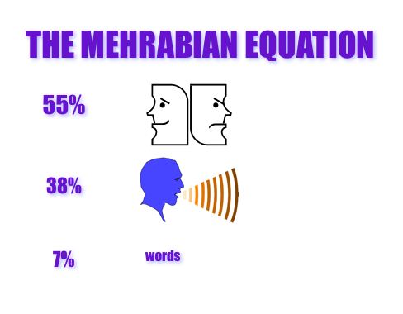
This Photo by Unknown Author is licensed under CC BY-SA-NC
Reflecting; Reflective writing is a necessary element of personal, expert and academic development. There are two useful model for writing reflection. Gibb’s reflective cycle (1988) and Kolb’s model (1984).
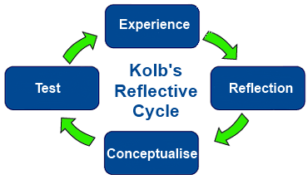
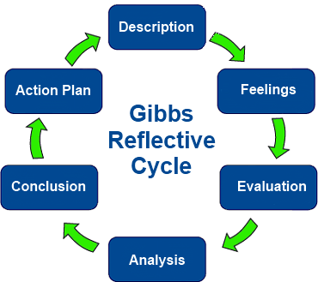

What is employability and why is it important?
“Employability and Career Success are Bridging the Gap Between Theory and Reality” Robert Hogan Tomas Chamorro ‐ Premuzic Robert B. Kaiser, 2012
when someone has graduated and has her or his technical and educational skills, she or he needs to have the personal ability to interact harmoniously with other people that can move amongst confirm and different parts at the interview.
On the other hand, having good employability skills is the necessity to advantage and remain in a formal employment or find another employment. Often, economic problems are the main reason for unemployment, but psychological features connected to lack of access to employability skills also contribute it. Industrial-organizational psychologists should be finding suitable resolutions for boosting it. This evaluation starts by measuring the most common research on successful career employability, which psychologists accept as true in logical abilities, and educational prosperity. Then, analyse the achievement of pros about demands of employers. These sectors highpoint the emphasis of sociality skills in a critical system. Then we offer a final model by using elements of employability psychologically to fill the gap between employers require and psychologist’s advice.
In summary, definition of employability skills shows, employability skills are general skills that it needs in most jobs. They include communication, teamwork and problem-solving. This skill is not the same as gaining a job, but also it is a capability to function successfully in a role and ability to act between tasks, that cause of improving employable throughout life.
2.1 Employability skills for a newly Appointed Line Manager
A line manager has direct managerial responsibility for a specific employee. For a newly appointed line manager, managing is more difficult than an experienced manager, but that reward is a continuous learning journey. There are many skills required that an employer expects for this position. The most important of them are personal and communication skills, time management, negotiation, and conflict.

2.1.1Time management
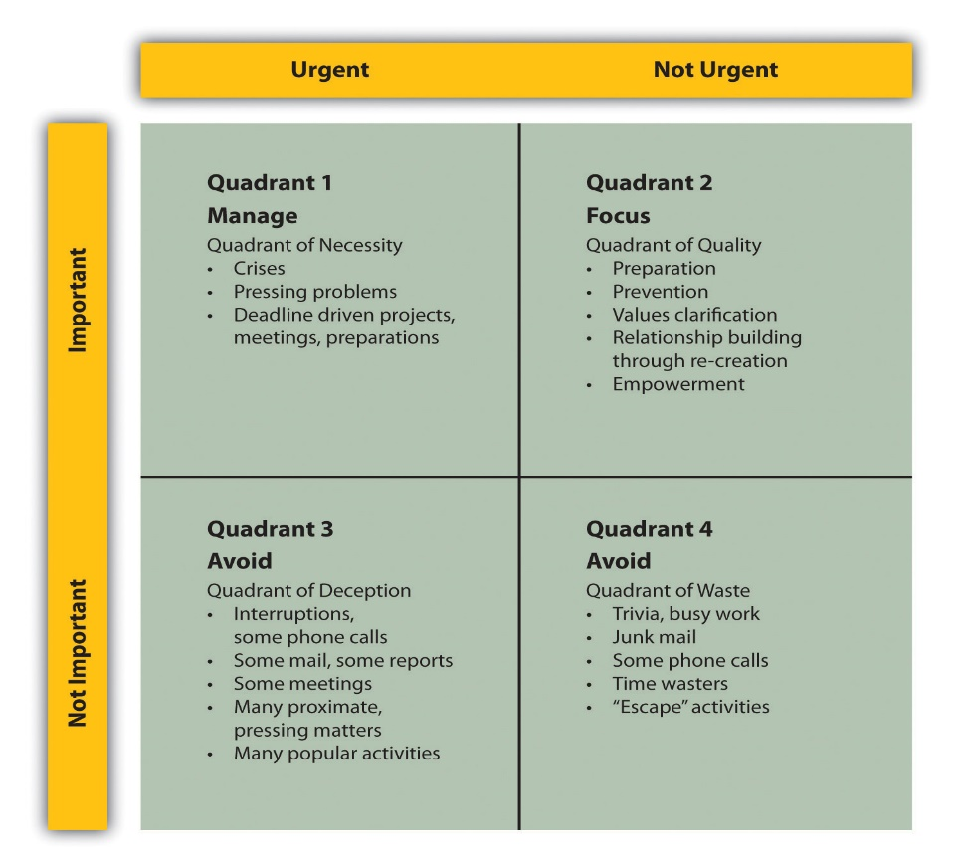
This Photo by Unknown Author is licensed under CC BY-SA-NC

Time management is the procedure of determining the order in responsibilities and ensure that they do due to timetable. That is the analysis of hours working which spent as long as the task prioritization to improve personal efficiency in the workplace. Collins English Dictionary. Copyright © HarperCollins Publishers utilize time, and individuals must first be able to predict how much time need for this process. (Kelly, 2002). When each person knows what they want to do, and what they need to do in target date, he or she will enhance effective in using their time (Soucie, 1986). People require more self-controlled in their use of time by cosidering their priorities while lessening interruptions from others and states that can reposition priorities in terms of time and energy (Soucier, 1986).
According to Crusting (1994), time management contains determining. It should consider the goals, deciding which events have the most important and understanding which happenings will have to plan around them (prioritizing), decisions on the amount of time for doing specific tasks (time estimation), regulating to the unexpected events (problem-solving), identifing aims and priorities on the daily data (evaluation), and detecting forms trends and behaviours.
An exact discussion exists about effective time management. For instance, Shipman (1983) merged six effective time management laws. These rules involved self-awareness, perfect time structure, setting aims and preferences, developing their own efficient, scheduling project time, and scheduling rest time. These behaviours have more define as organizing, setting goal, making lists, regularly evaluating one’s schedule, and separation responsibilities into simpler parts (Kelly, 2002).
In the current academic work environment challenged with time pressures in crossing daily experimental facility and training actions and distractors like e-mails, time to wide-ranging inscription doings can seem like an impossible effort. McDonnell's 1-h workday demonstrates an effective time management strategy that fosters improved publication routine and occupation pleasure by ordering the critical matter of focused writing during a time with minimal distractions. Author Contributions: All authors established they have donated to the logical satisfied of this paper and have met the resulting 3 necessities: (a) significant contributions to the conception and design, acquisition of data, or examination and understanding of data; (b) enrolling or reviewing the item for knowledgeable contented; and (c) last admiration of the published article.

2.1.2 Interpersonal communication
David Berlo (1960) cited Berlo’s Sender-Message-Channel-Receiver (SMCR) model of communication that explained affecting elements about the components in the communication making more efficient communication.
This model also emphasizes that encoding and decoding happens before sending and receiving the message respectively. According to this model an effective communication done when all these stages are completed correctly.

Berlo’s SMCR Model of Communication
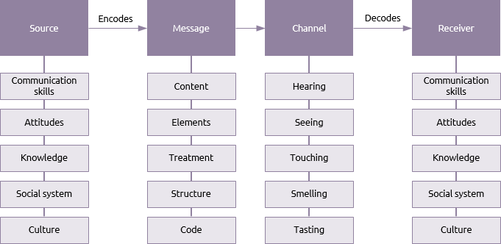
This Photo by Unknown Author is licensed under CC BY-SA

Interpersonal communication skills include; Employers would like employee who really understand what others say and can organize this perception then state etheir them correctly. Communication becomes active under an ideal situation. On the other hand, when it comes to an effective communication that all components include; sender, message and receiver, swap comparable meanings to the message and listen sensibly to realize the sender feel by overhearing.
An effective communication is composed of a way to speak as well as many other skills such as, ability to understand your own emotions and others, non-verbal communication, active listening, ability to speak energetic. Another definition of interpersonal communication is a procedure that a convention to shape relationships with others over communication by effectively obligation.
Effective communication combines some skills such as active listening, verbal communication, and two-way communication. Another definition of interpersonal communication is a procedure that a convention to shape relationships with others over communication by effectively obligation.
Influencing listen; People like to listen when listening is in common grounds and issues. The conversation is effective when could be build a win-win condition. By doing this, we will reach the highest impact and inspire on others.
Communicating in the right manner. By reconsidering our comprehension of the other person, we find out the best purpose and ideas to that individual. The purpose of communication is to grasp a common thought, decide on what to do next if an act is required, and make better contact.

2.1.3 Negotiation

This Photo by Unknown Author is licensed under CC BY-SA-NC
Negotiation means the skills to focus at reaching an agreement and solving the problem, which may be a failure in communication, to advantage both sides of the problem instead of having the ability to seek a diversity of explications to people with negotiation skills have concentrated on his or her goal for the problems.
Creating a strong position is a good starting opinion for a negotiation. However, it becomes too entrenched, conflict can quickly arise, and the argument may break down. It can sidestep this by using a kind of win-win negotiation named "principled negotiation."
by Harvard Law School professor Roger Fisher, academic, anthropologist, and negotiation expert William Ury developed in their 1981 book, "Getting to Yes." They recognized five levels of principled negotiations* and argued that negotiations are successful when they encourage cooperation toward a common goal. Let us look at the five stages of principled negotiation:
1.Separate People from their Problems
Avoid identifying the opposite number “opponent." Be positive to concentrate in argument and to character differences. To practice this way, be respected of three elements: emotion, perception, and communication.
2. Use Objective Norms
She or he is not just "setting out the facts," as different primary requirements. Many factors such as, benefits, views, and aim can cause people to have differently understanding of facts.
3. Two-sided Profit
Each group is probably able to have a better information over the other's interests. It may be accepted; If not, use the negotiation skill to figure out options and wait for the view of a new condition.
4. Focus on benefits
People always have different ability to use in different situations. Everyone may influence by problems on the way, such as their privileges, situation, perspective, sense of responsibilities and cultural background.
When everyone is aware of that their interests have been considered, they are more likely to be respective to other’s different opinion and try to keep the conversation in a polite way.
5. Best Alternative to a Negotiated Agreement
BATNA is a fall-back choice if cannot reach to the required. It is not the same as a "bottom line," which is a constant position that can restrict options and may avoid from detecting a new work.

2.1.4 Other skills
Here look at this from another perspective. Newly appointed managing can be an unnerving time, knowing that the future of career is somewhat formed by other people and their activities and it will take a bit of alteration to get things right.
Personal management skill includes, the capacity to represent and manage several assignments and duties that are set priorities and adapt to different conditions.
Interpersonal effectiveness: generally, it is important for employers to note that whether an employee can associate with colleagues and build relationships with others in the company.
Computer skills: employers expect to provide training on job-specific software, they also prefer employees with basic computer skills.
Management skills: The ability to take responsibility and manage. Employers look for signs of leadership potentials.
Learning skills: Jobs are repeatedly growing and changing, and employers want people who can update.
Ability in reading and math: all jobs require the ability to read and comprehend instructions and perform basic account.
Solid work values: Honesty, reliability, self-confidence and a positive attitude are award qualities. Employers look for personality.

2.2 Skills analysis
A manager needs all above the skills that it described, and it is a more successful manager with higher skills. As everyone knows, a manager is an average person with managerial abilities and knowledge which has several strengths and weaknesses. These cause differences between managers.
On the other hand, all employability skills just along the experience can make a great manager. Experience is the only item that cannot be taught in any university and courses. It only comes from placing in different condition over time. Therefore, as a new line manager, facing many problems is predictable.
2.2.1 What skills do I currently have?
As a manager, I am professional in time managing. I always have a time table for everything. Prioritization needs the skill that I have it and use it for time managing. Besides, I have excellent interpersonal communication skill for example, I am a good team worker and cooperative. all these skills create the ability to operate smoothly and efficiently within a group.
I can encourage other team members to do better duties. I have the emotional intelligence to better understand team members’ behaviour, actions, and responses.
2.2.2 What gaps are there in my skills?
Other interpersonal skills are such as negotiation, influencing, advising and interpreting. I need to improve these skills. Negotiation solves the conflict between staffs. It needs to have some ability to persuade employees. I am an honest person, so it is hard for me to give advice when I am not sure about the final issue solving. However, I must try to achieve a better negotiation skill. I know that is my weakness and a kind of gap that must fill it.
As an employer, negotiation skill is important because most of the time, specific in storming step, through the creating teams, between team worker, are very conflict. When the manager cannot solve conflicts between staffs, the employer is disappointed. Employers would like to employ manager that can use of creativity, and past experiences solve problems.

3.0 Conclusion
In conclusion, I have found out employability skills are essential for all employees as well as newly appointed Line managers.
An employer requires many skills for the position as a newly appointed manager such as having interpersonal communication and time management, high level of negotiation, conflict and other skills that through this report is explained.
In my point of view, all these skills lead to success for a manager which is significant for employers; Management is a collection of skills that complete through gaining experience.
A successful manager is a manager who can take an excellent managerial position through his/her high-level employability skills, also knows what her/his employer wants from them with a full understanding the goals of the organization and steps towards it.

4.0 Recommendation
Put together a list of some valuable advice for new managers to remember and understand.
- Allow changing and be flexible
Management needs flexibility, and these methods can change between each team and team worker. Some difference is necessary so do not be afraid to merge it up.
- Do not be a teacher:
No matter whereby the managerial position is, never treat the team, employees like students.
- Emotional balance:
An important factor for the success of a manager is finding the right balance. Calm down and be fluent in yourself in all condition.
- try to be an expert:
As a newly appointed manager, should try to get to enclasp company. Learn more and more to realize everything to build a high level of knowledge.
- Remember past experiences:
When managing a team, it is value with the benefit of hindsight at the skill of actuality managed. What went well, and what did not? Were there any things managers failed? What were some things to approve?
- have planned for the future:
An excellent way to start when planning move is to look at the next year and were to want to be in 12 months. By using this way, you can decide the activities that necessity to be taken for work.
- Be ready for the unpredicted:
As a new manager should expect that issues do not always go according to the plan, therefore prepare for the unexpected condition.
- Enjoy it!
It can be so stressful for you as a new manager. However, keep in mind, in the first step, your experience, skills and personality grown in this role. So enjoy it.

Reference List
- Maund, Andrew, Michaela Schriek, Paul K. Tinkler, University of Wales Trinity Saint David, and Trinity College. Certificate in Higher Education: Skills for the Workplace Student Yearbook. London: Sage, 2017.

- Morgan, P., 2016. The Business Student's Guide to Study and Employability. Sage. Pub date: November 2016.

- https://www.skillsyouneed.com/general/employability-skills.html

- http://www.opportunityjobnetwork.com/job-resources/help/top-10-skills.html

- Hogan, R., Chamorro-Premuzic, T., & Kaiser, R. B. (2012). Employability and career success: Bridging the gap between theory and reality. Industrial and Organizational Psychology: Perspectives on Science and Practice, 6, 3-16.

- https://www.ed.ac.uk/employability/staff-information/what-why-employability-important

- COMMUNICATION WITHIN THE WORKPLACE. https://minds.wisconsin.edu/bitstream/handle/1793/41715/2005mallett-hamerb.pdf?sequence=1

- https://theundercoverrecruiter.com/tips-for-new-managers/

- Collins English Dictionary. Copyright © HarperCollins Publishers

- Stoilov, Todor, Ed. Time Management. InTech. 41 Madison Avenue 31st Floor, New York, NY 10010. Tel: 917-769-7640; E-mail: Info@intechopen.com; Web Site: Http://www.intechopen.com, 2012. Web.

- Colón-Franco, Jessica, and Nichole Korpi-Steiner. "Busy Doing What? An Effective Time Management Strategy for Writers on the Go." Clinical Chemistry 63.12 (2017): 1910-911. Web.

- https://bemycareercoach.com/soft-skills/communication-skills/interpersonal-communication-definition.html

- https://www.mindtools.com/CommSkll/NegotiationSkills.htm

- Grundke, Robert, Luca Marcolin, and Mariagrazia Squicciarini. "Which Skills for the Digital Era?: Returns to Skills Analysis." IDEAS Working Paper Series from RePEc (2018): IDEAS Working Paper Series from RePEc, 2018. Web.

- Top 10 Skills - Opportunity Job Network. http://www.opportunityjobnetwork.com/job-resources/help/top-10-skills.html

- https://www.businesstopia.net/communication/berlo-model-communication

