Script 1 output
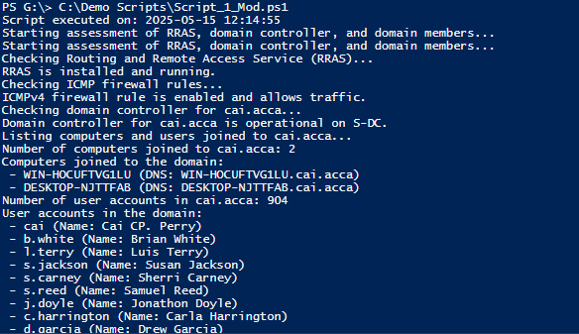

Script 2 output
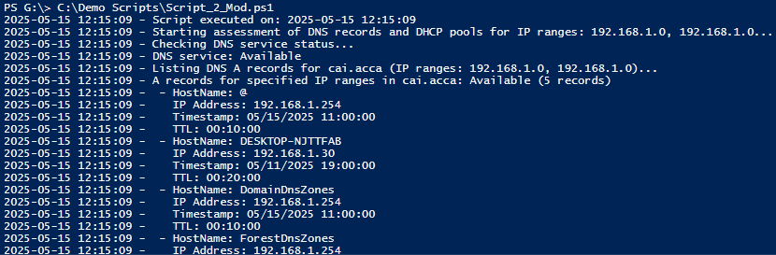
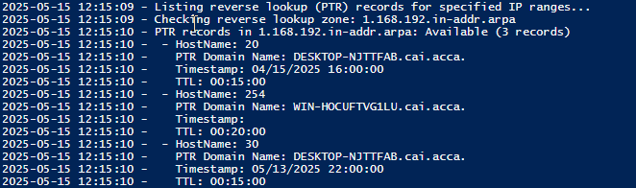
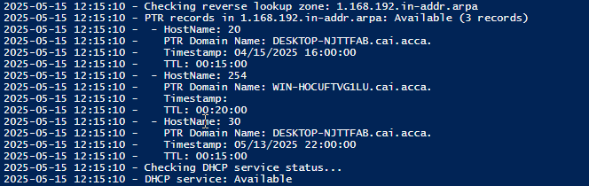
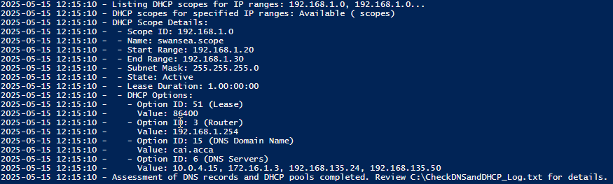

Script 3 output


