

Postgraduate/Distance Learning
Assignment coversheet & feedback form

THIS SHEET MUST BE THE FIRST PAGE OF THE ASSIGNMENT YOU ARE SUBMITTING (DO NOT SEND AS A SEPARATE FILE)

For completion by the student:
Student Name: Anna Hokynarova

Student University Email: 2307833@student.uwtsd.ac.uk
Module code: HPCA7015  Module title: Foundations in Cultural Astronomy and Astrology | Student ID number:  2307833 |  |  | Educational support needs:  No
Assignment title: Sky Journal: Clouds in a Day Sky

Assignment due date: 06.11.2023
This assignment is for the 1st 2nd 3rd 4th 5th 6th module of the degree
I confirm that this is my original work and that I have adhered to the University policy on plagiarism.
Signed ……………Anna Hokynarova………………………………………………
Email submission: if you are submitting this form via email, please tick this box □
(as a substitute for your signature) to confirm that you agree to the above declaration.
Assignment Mark
1st Marker’s Provisional mark
2nd Marker’s/Moderator’s provisional mark
External Examiner’s mark (if relevant)
Final Mark

NB. All marks are provisional until confirmed by the Final Examination Board.

For completion by Marker 1 :
Comments:

Marker’s signature: |  |  | Date:
For completion by Marker 2/Moderator:

Comments:

Marker’s Signature: |  | Date:
External Examiner’s comments (if relevant)

External Examiner’s Signature: |  | Date:
The sense in which I have studied the clouds in my Sky Journal for a month could be described as a bit disorganized but fulfilling. I explored the clouds in a day sky, but I did not set a specific time or a place to observe them from; the clouds are way too unpredictable to be captured at a specific moment. The clouds travel in the day sky while changing their shape, their significant moment that influences me during the day might happen at any point in it, therefore it would have been unfitting of their nature to restrict them to a particular time frame and location. The way I conducted my journal was in the form of a short meditation that I happened to find time for during the day. Whenever I would remember to look up at the sky during my days, I would take up this moment to try to live in it and later on see where the chain of my thoughts would lead. Normally, I would not have the opportunity to ponder about the clouds and the sky and how they affect me, but this assignment has granted me a space to track my thoughts regarding an ever-changing phenomenon in the sky which would otherwise come and go unnoticed.
Clouds come in an infinite variety it seems almost impossible to make sense of them. There are countless recognized different kinds that have the ability to change within a short period of time. “Clouds stretch the resources of description to their breaking point and beyond. At one extreme, they invite Ruskin’s endless ekphrasis, as words multiply, never quickly enough to catch up with their protean referents. On the other, they enforce the most blinkered discipline, as observers all over the world try to coordinate eyes, words, and things into a stable, commensurable record of the face of the sky.” There are many different kinds of clouds; we do not differentiate between them just by their scientific compounds but also by their essence, the things that make them different from one another in an everyday person’s mind. Each cloud carries different energy which is a part of a bigger picture of our surroundings that affects how we feel, this can make our thoughts range anywhere from positive through neutral to negative. On top of that, all these different kinds of clouds might influence each individual differently. This also beautifully plays into different kinds of thinking that people have. In the end, it is certain that clouds and other natural phenomena have to capacity to influence us and give us space to think or to feel but the way in which they do it might differ from individual to individual.
In the Weatherland: Writers and Artists under English Skies, Alexandra Harris talks about how the elements influence poets such as Wordsworth or Coleridge. The variety of the weather influences their poetic work so I focused on how the clouds influence my train of thought; “to think is to walk among clouds”. The vagueness of clouds is what forces us to think; they are not complete and they change as the wind blows on. It is therefore up to our imagination and our thinking to fill up their full image. Harris talks about the clouds and the elements predominantly in connection with romanticism, that the cloud served among many other natural phenomena as an inspiration for artistic endeavours. In my case, I used the clouds and their observation as an opportunity to detach myself from the ground and my surroundings. It allowed my mind to wander off in any kind of direction it desired. Thoughts are very much like clouds in their essence: constantly flowing reflections of their environment, a part of a bigger structure. Thinking then signifies one being aware of their thoughts clearly, so clearly, they are able to walk among them. There must have been other factors which influenced what I was thinking about and in which light I did so such as getting a good night’s sleep, simply knowing I will have a busy day, or specific instances that would happen around me as I move on my way. Generally, I would like to say that I have found a pattern that works together with how I feel and how the sky looks at the moment.
I would like to share some examples of the pictures of clear skies I took during my journaling period, explain how they influenced me and what kinds of thoughts I was having at the moment.
I was not fond of when the sky was completely or almost clear. Those days I felt a bit disoriented and deceived at times because, by the end of October and the start of November period in central Europe, it tends to get quite cold. No clouds would mean warm sunshine waking me up and my expectations for the day would be ruined, that would of course be the case if I had to go to work or run errands around the town. My cloudless days would feel overly energetic and by the end of the day, I would be completely exhausted. The way I recorded my thoughts could almost be described as frantic. It almost makes me feel like the clouds on the day sky serve as a form of blanket or cover that lets me go about my day unexposed and allows me to have moments to catch my breath and have the space to think.
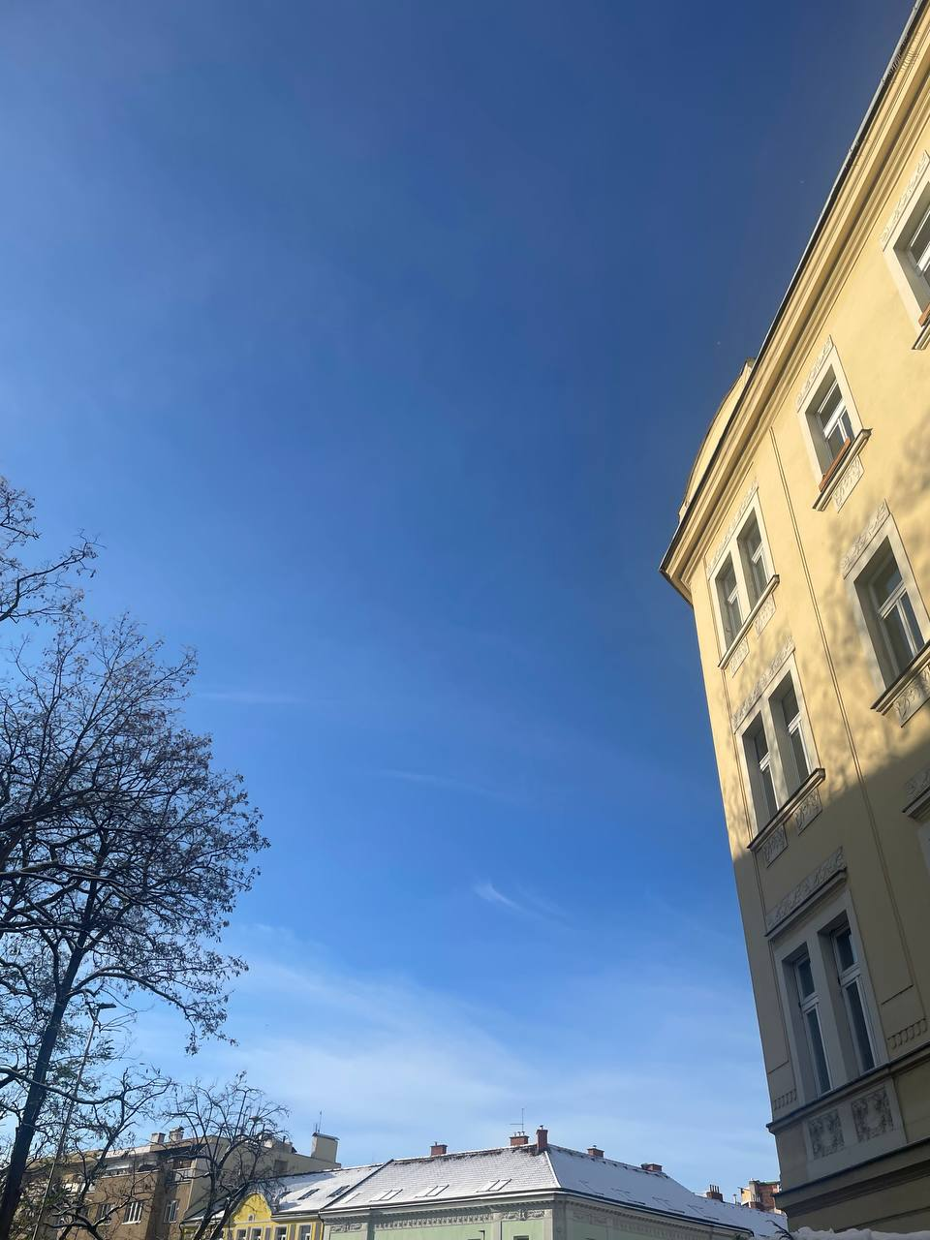
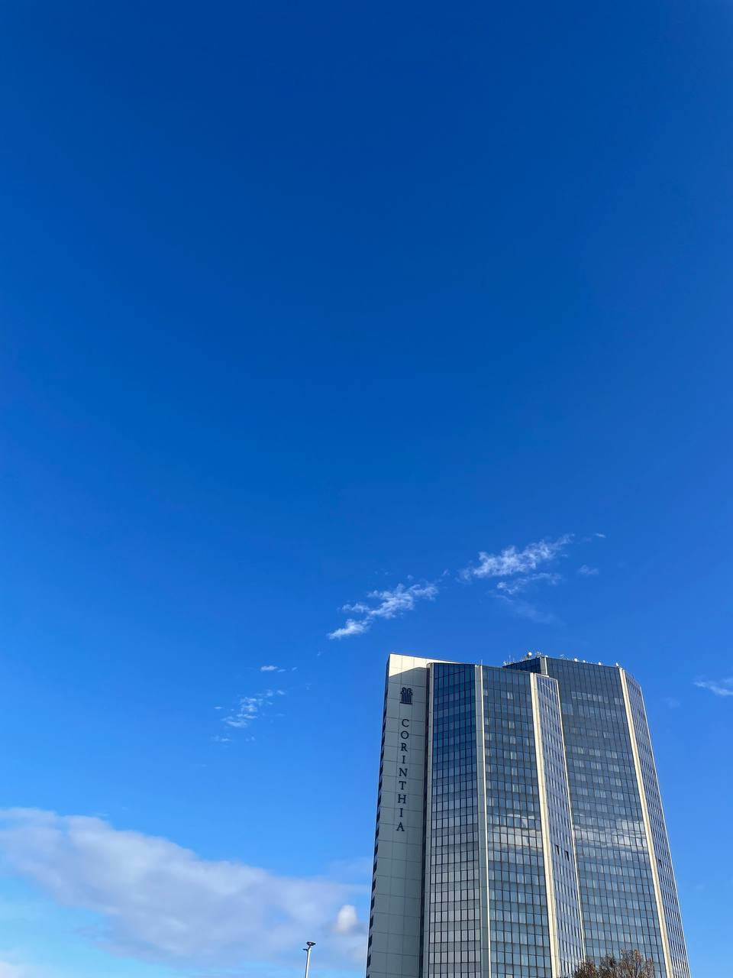
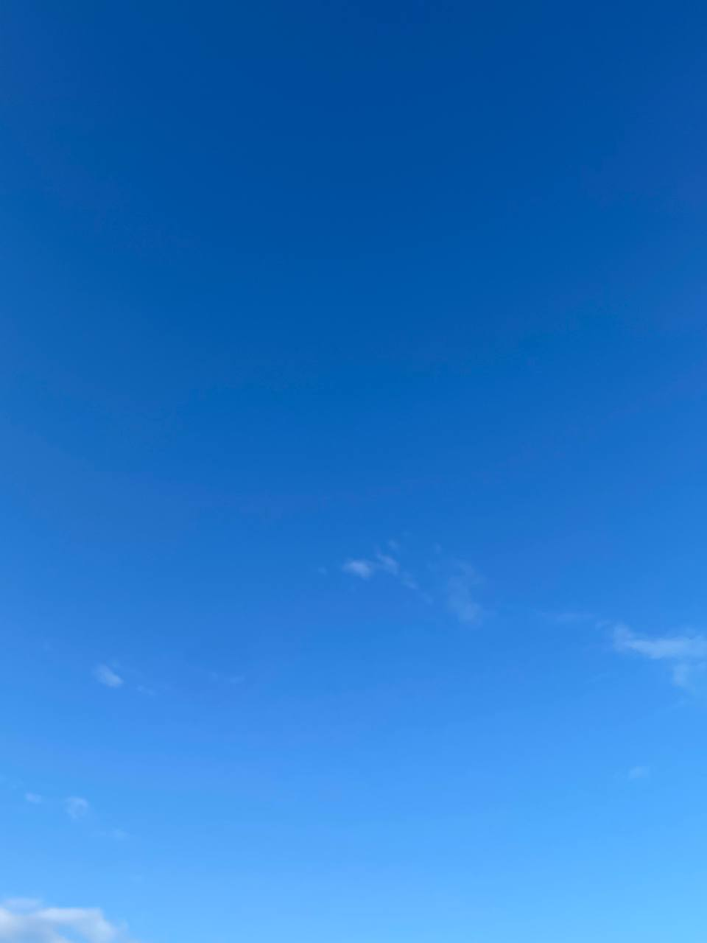
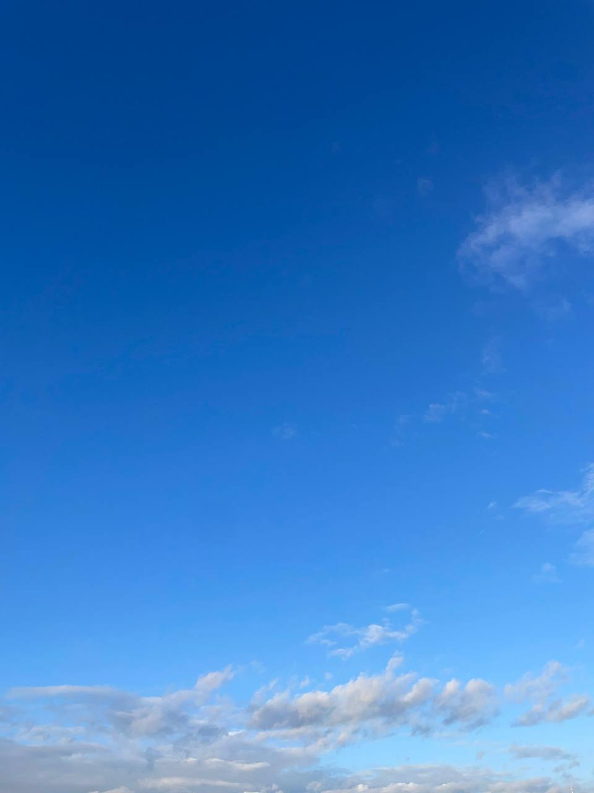
The first picture on the left was taken on the 19th of October 2023 as I was walking towards the metro station close to my house. The sky itself was very clear except for a distant layer of grey clouds that was yet to come closer. While the hues of the blue were beautiful, at times the sun was blinding. I had a busy day in front of me, so my thoughts were all over the place, I was mostly trying to guess what people around me were doing or thinking when I got the catch my breath on some of the trams I was taking. The picture next to it was taken on the 21st of October, was going to my doctor’s appointment, I was determined to get there but exhausted at the same time. The picture with the skyscraper was taken on the 27th of October, I took it as I was going to work, I was thinking of the way people perceive colours. The last picture was taken during the early morning of the 14th of November, the snow fell overnight, but the sun was so bright it made me tear up. I felt sad, November days are much more beautiful when they are a bit muted, and bright blue days are way more enjoyable in the summer. The fallen snow made me think of the changing seasons and how grateful I am to experience so many different kinds of days.
Only one other type of cloud in the day sky made me feel worse than the empty one when the sky is full of grey clouds that are stagnant. This type of sky made me feel stuck, longing just for one thing; to take a breath full of fresh, moving air that was missing. It reminded me of times when I would be swimming below the surface of the water, ready to reach out and take a breath. During these kinds of days, I wanted to stay in bed and let them pass. The thoughts that I captured within my journal are usually on the negative side. Because I have made a decision that has led to an enormous change, stagnant days like these would let the negative feelings of doubt flow towards the surface.

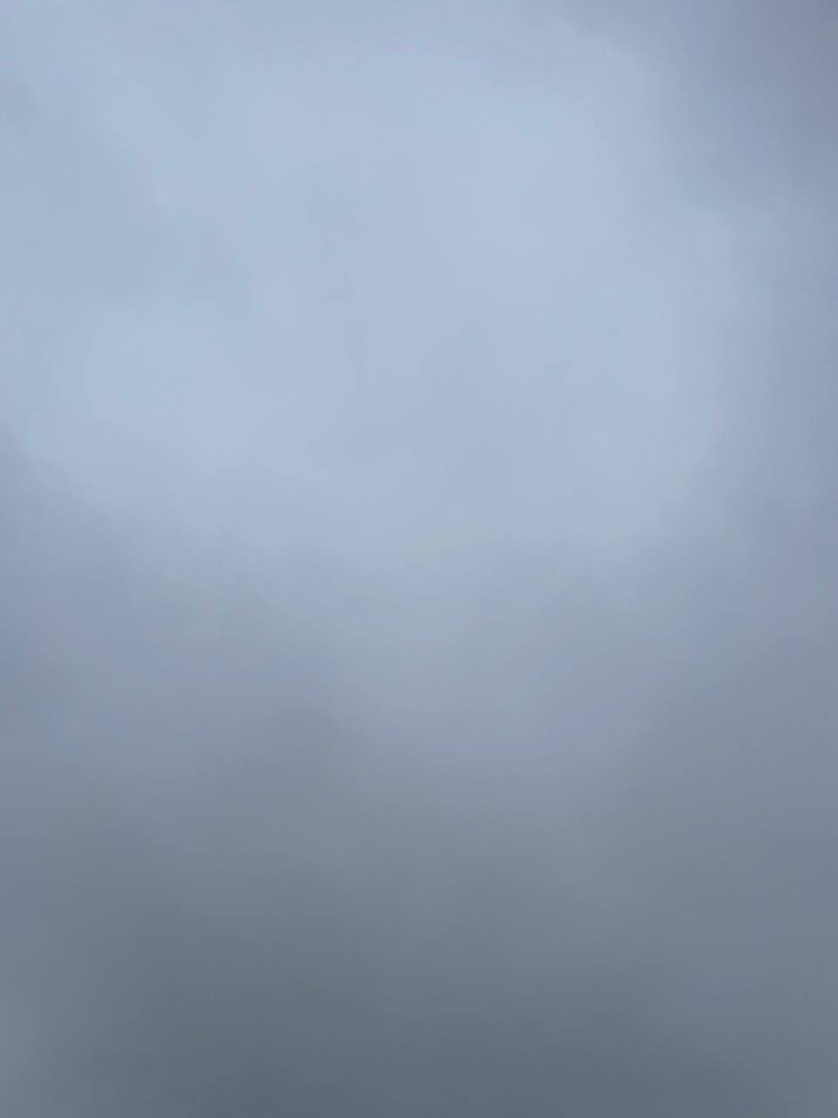

This picture was taken on the 25th of October. The weather felt suffocating that day, so I managed to take this picture from the balcony. I was feeling depressed and stuck. Because of the Sacred Geography module, I would often question if I had chosen the right place to live in and these kinds of clouds would try to convince me that I did not. I was too much of an optimist as a child and a teenager, and living on my own in a place I once knew that felt completely new was more like a slap of the reality of adulthood that is not always perfect. This thought process inspired me to study the philosophy of Buddhism in greater detail.
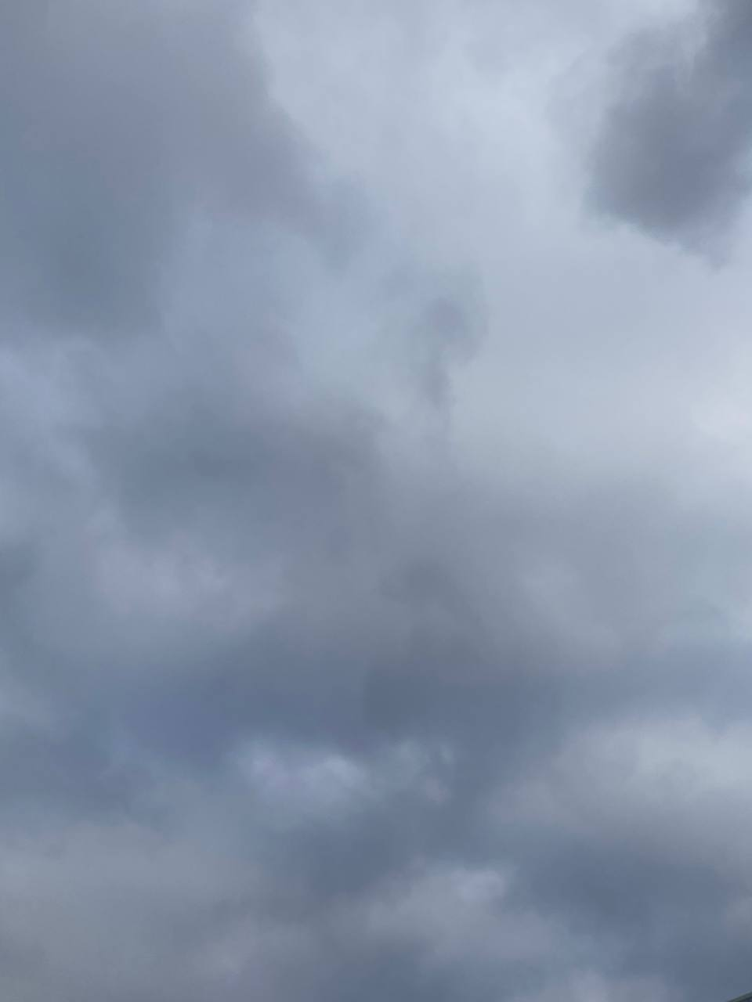

This picture was taken on the 3rd of November. I was walking towards the local library to study, but I wished for nothing else but to be able to stay in bed. This day I was questioning whether I was on the right path in my life, with everything going on in the world, the atrocities and discrimination, my values and beliefs started to completely change as I mature.

After experiencing a few different kinds of clouds in the sky I have started noticing that I have felt the best and my train of thought was the clearest when the sky is dramatic in some way. I was the most productive when the sky was full of clouds that moved fast. The deep bold colours that would change within minutes would influence my thinking process the most. I would often find myself wondering about more existential questions which were usually inspired by the rare fleeting scenery. An extension of these kinds of skies would be the dark and stormy ones. The dark skies filled me with excitement, it is quite rare for great storms to come where I am from so I always appreciate the change of scenery and the deepness the dark clouds bring during the day. Rather than questioning my surroundings and life itself, I would not think of anything and simply enjoy the moment, spending the first few moments of the storm outside or on the balcony to fully immerse myself in the gift that the clouds have brought us.
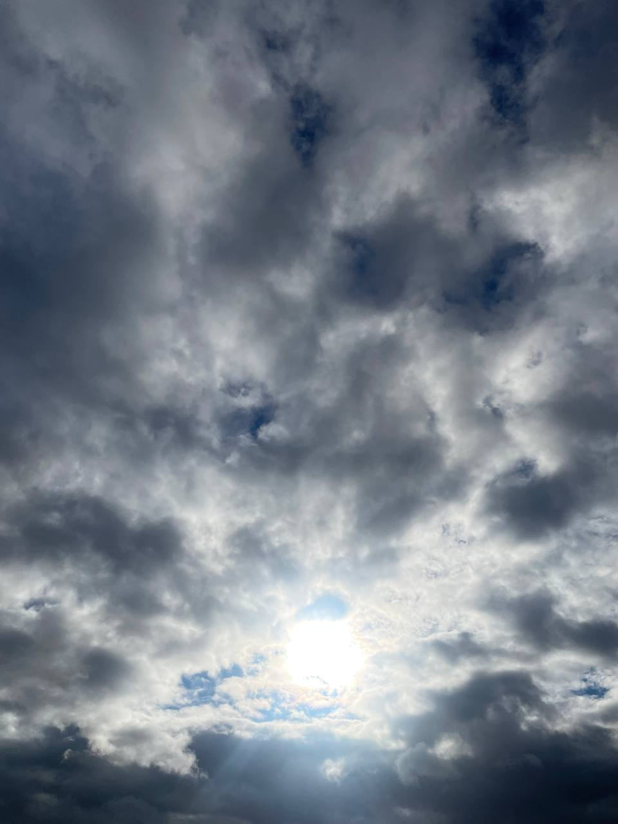
The clouds I saw in the sky on the 31st of October were completely gorgeous. They were fast-moving and dramatic in a way that just made me want to stop what I was doing, sit, and look at them. In moments like these, I like to think about whether there is someone someplace else looking at the same clouds or whatever they will transform into. Then I continued to wonder about how fleeting our moments are and how everything moves at a different pace.

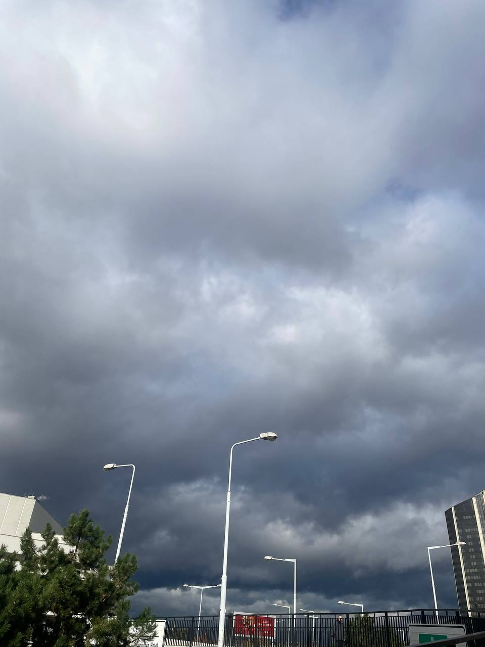
This picture was taken on the 5th of November. The air felt heavy, and the clouds started to gather, eventually a storm would take place. These kinds of clouds remind me of the complexity of nature and its beauty. I was pondering how storms were viewed in ancient times and how people must have felt about them then without the scientific explanation of what was happening.

The last way I categorised the clouds on the day sky was them being connected to a special occasion. By the special occasions, I refer to the clouds when they are hit by the light of the sun in a specific way, this would usually happen later in the day closer to the sunset, or when other celestial phenomena occur, such as the rainbow. During these moments I would find myself very positively influenced and appreciated the beauty around me.

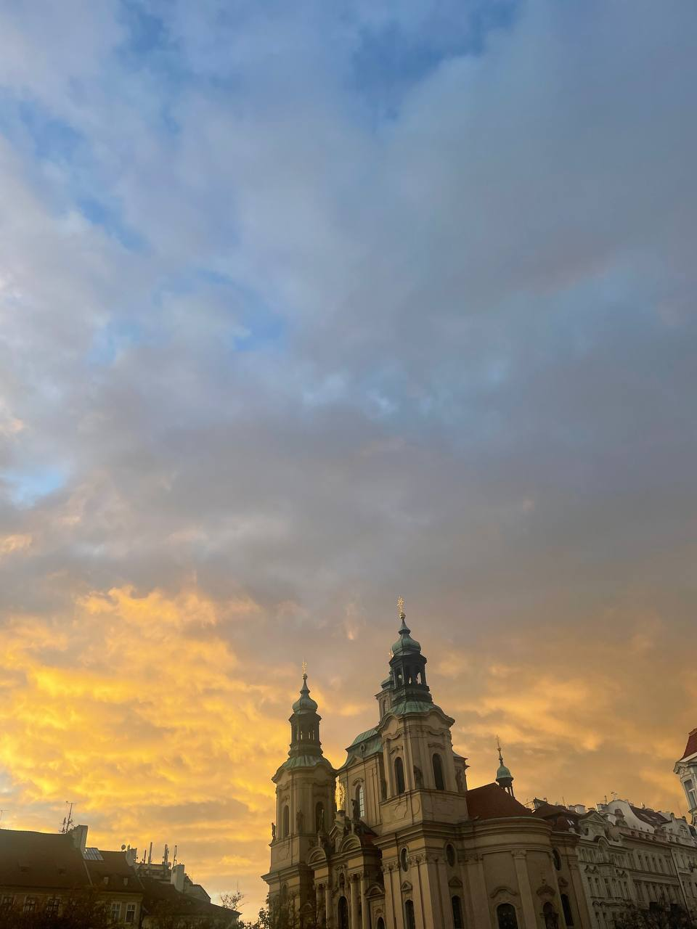
This picture was taken on the 19th of November while I was attending a silent protest to commemorate the deaths of Palestinian children in Gaza. The atmosphere was incredibly heavy, the protest consisted of reading out the names of the young victims which took over several hours. By the end of it, the most beautiful sunshine was peeking through the clouds and then a rainbow appeared as if children were letting us know that they are playing among the clouds. I went to the lengths of describing it as an almost religious experience.
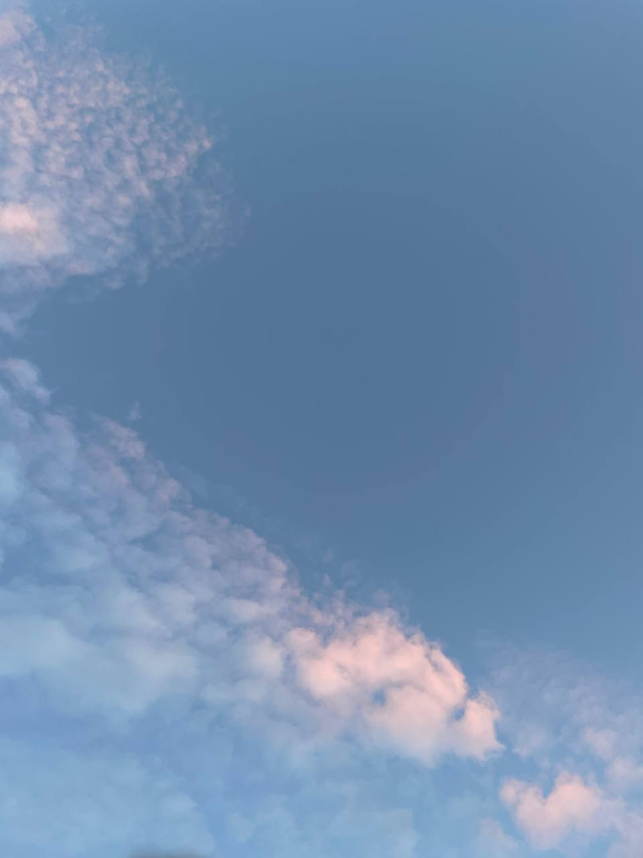
This picture was taken on the 8th of November. The clouds were a bit pinkish when I was going on a walk around the neighbourhood which made me appreciate the world.

To conclude, clouds are incredible celestial phenomena that have the capacity to enhance the imagination or thinking process of any being. It depends entirely on the individual, their experience and how they see the world around them. Because of their different essence and their ever-changing nature, there is an infinite number of possibilities of how clouds can make an individual feel.

Bibliography
Daston, Lorraine. 2016. ‘Cloud Physiognomy’, Representations: 45–71 <https://www.jstor.org/stable/26420565>
Harris, Alexandra. 2016. Weatherland : Writers and Artists under English Skies (London: Thames And Hudson)

Daston, Lorraine. 2016. ‘Cloud Physiognomy’, Representations: 45–71 https://www.jstor.org/stable/26420565, pp. 48.
Harris, Alexandra. 2016. Weatherland : Writers and Artists under English Skies (London: Thames And Hudson), pp. 201.

