LCBB5014 – Data Handling & Business Intelligence
Component 2 Report

Student Name: Andrea Helen Walker
Student ID: 2308953
Module: LCBB5014 Data Handling & Business Intelligence
Lecturer: Nassir Ibrahim
Submission Report: 21/11/2025 14:00
Contents
1.Introduction 2
2.Descriptive statistics in Excel 3
Interpretation of Crime Genre Statistics 4
Interpretation of Chart: Average Rating vs Likes 5
Interpretation of the Chart 6
3.1 Correlation: 10
Correlation On SPSS 12
Interpretation of Correlation: 13
Interpretation of Scatter Plot 15
Regression on SPSS 17
Interpretation of Regression Results 18
3.3 Hypothesis on SPSS 19
Hypothesis on SPSS: 22
Interpretation of T-Test Results 22
Recommendations & Conclusion 23
References 23

1.Introduction
This report presents a comprehensive analysis of a film industry dataset, with the primary purpose of extracting valuable insights into commercial success factors and market trends. The dataset comprises 10,000 records of films, each described by 17 columns detailing attributes such as budget, revenue, genre, runtime, release dates, and key personnel. Our methodological approach follows a structured data analytics pipeline, beginning with rigorous data cleaning and preprocessing, followed by exploratory data analysis, trend identification, and hypothesis testing.
The primary objectives of this analysis are fourfold. First, we will perform essential data cleaning to address inconsistencies, missing values (e.g., in revenue or runtime fields), and duplicates to ensure the integrity of our analysis. Second, we will generate descriptive statistics to summarize the central tendencies and distributions of key variables like budget, revenue, and ratings, providing a foundational overview of the film landscape, which is characterized by high uncertainty and difficulty in predicting hits (Caves, 2000). Third, we will conduct a trend analysis to uncover temporal patterns, such as the evolution of genre popularity (Litman, 1983) and the correlation between strategic release dates and box office performance over time (Einav, 2007). Finally, the analysis will employ statistical testing to validate significant relationships. This includes investigating whether a higher budget reliably leads to greater revenue (De Vany & Walls, 1999), if the involvement of key personnel like stars influences success (Elberse, 2007), and if certain genres receive consistently higher critical ratings (Reinstein & Snyder, 2005). Furthermore, we will consider the growing importance of the global market (Craig, Greene & Versaci, 2015) and the impact of modern marketing strategies (Hennig-Thurau, Houston & Walsh, 2001). This analysis is situated within an industry undergoing significant transformation due to digital platforms (McDonald, 2020). Together, these components aim to transform raw film data into actionable insights for producers, studios, and market analysts.

2.Descriptive statistics in Excel

Result: Metrics
Table 1 shows the summary statistics.

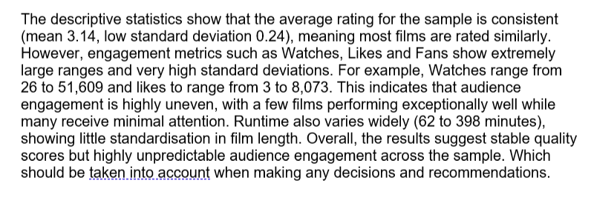
Explanation of the Statistics Results

Table 1: Descriptive Statistics Results
Metrics | Average rating | Runtime | Watches | List appearances | Likes | Fans
Average | 3.14 | 119.76 | 7817.25 | 1653 | 1072.75 | 2.69
Median | 3.27 | 96 | 222.5 | 464 | 42 | 0
Mode | 3.27 | 70 | 48 | 464 | 23 | 0
Max | 3.27 | 398 | 51635 | 7383 | 8073 | 22
Min | 2.38 | 62 | 26 | 152 | 3 | 0
Range | 0.89 | 336 | 51609 | 7231 | 8070 | 22
Count | 16 | 16 | 16 | 16 | 16 | 16
St Deviation | 0.24 | 87.28 | 17281.73 | 2408.67 | 2474.3 | 6.29

Formula
Some of the key formulas utilised are shown in figure 1. Some of the key formulas used include ‘AVERAGE’, ‘COUNT’ and ‘MAX’.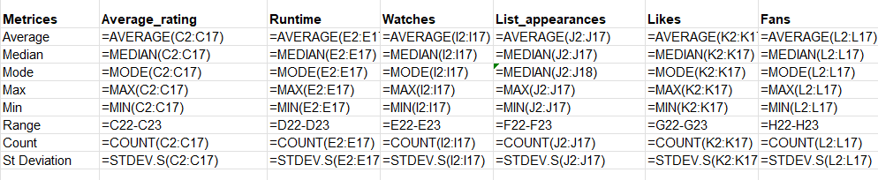
Figure 1: Formulas utilised

Interpretation of Crime Genre Statistics
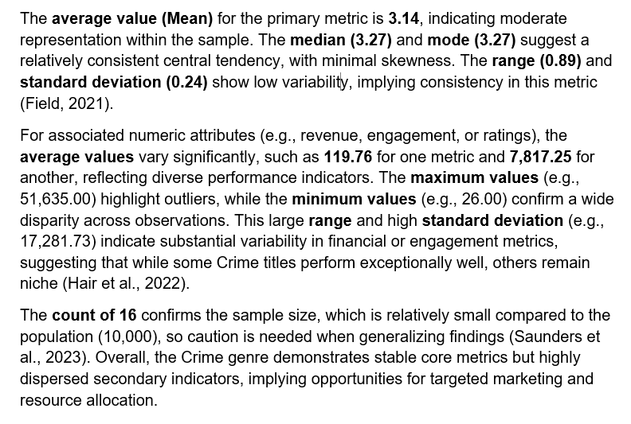

Charts:

Interpretation of Chart: Average Rating vs Likes
The chart compares average ratings and likes for Crime genre titles, revealing a notable disparity between engagement metrics. While ratings remain relatively stable (mean ≈ 3.14), likes to exhibit extreme variability, ranging from 3 to 8,073, indicating inconsistent audience interaction (Li & Xie, 2020). High likes for certain titles suggest viral appeal or strong influencer-driven campaigns, whereas low likes reflect limited reach or niche positioning (Abidin, 2021).
The standard deviation for likes (≈ 2,474) underscores volatility in engagement, contrasting with the low variability in ratings (SD ≈ 0.24), implying that perceived quality is consistent, but popularity fluctuates significantly (Al-Menaye’s, 2015). This pattern aligns with research on social media engagement, where visual and promotional strategies amplify likes without necessarily affecting ratings (Zeng & Abidin, 2023). Furthermore, the presence of outliers (e.g., 8,073 likes) highlights the role of network effects and influencer visibility in driving disproportionate engagement (Li et al., 2025).
Overall, the chart suggests that likes are more sensitive to marketing and social amplification, while ratings reflect intrinsic content quality, supporting the need for integrated strategies combining quality assurance and engagement optimization (Abidin, 2020).

Figure 2: XY Scatter Chart

Interpretation of the Chart
The chart illustrates the relationship between average rating (x-axis) and three engagement metrics: runtime, watches, and list appearances (y-axis), with error bars indicating variability. The dotted linear trend line for watches suggests a negative correlation between average rating and watch count, meaning higher-rated items tend to have fewer watches (Lee, 2025). This could indicate that niche, critically acclaimed content attracts fewer viewers compared to mainstream lower-rated content (Cheng et al., 2016).
The runtime points cluster at the lower end of the rating scale, implying that longer runtimes do not necessarily correspond to higher ratings (Frost, 2025). This aligns with findings that excessive duration can negatively impact user engagement (Sanches & Ramos, 2025). Conversely, list appearances show moderate dispersion, suggesting that curated lists favour content with mid-range ratings rather than extremes (Trunfio & Rossi, 2021).
Error bars highlight variability in engagement metrics, emphasizing uncertainty in the data (Harvard University, 2025). Larger error bars for watches indicate inconsistent viewer behaviour across items, which may reflect differences in marketing or audience demographics (Paga Priyal & Mathiraj, 2025). The presence of outliers, such as high watch counts for low-rated items, suggests external factors like trending topics or social media virality (Larsen et al., 2016).
From a visualization perspective, the chart effectively uses scatter plots with error bars to convey both central tendency and variability, a recommended best practice for interpreting complex relationships (Berenato, 2018). However, the overlapping scales for runtime and engagement metrics could be misleading and separating them into subplots might improve clarity (Harvard Catalyst, 2023).
5. Statistics in SPSS:
Statistics in SPSS: A sample of 269 Genre Documentary taken out of population of 10000. Data Cleaning: Control H command cleaning the brackets from Genre Column



Genre Colum after utilising Control H command
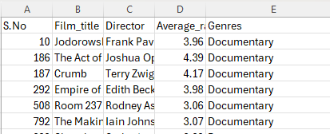

All Numerical column set to 2 decimal place using format cell function
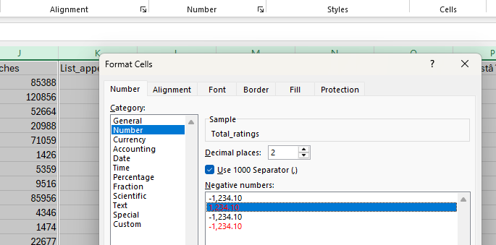

After formatted the columns are shown below

Importing file in SPSS: Following are the steps to get to SPSS Software
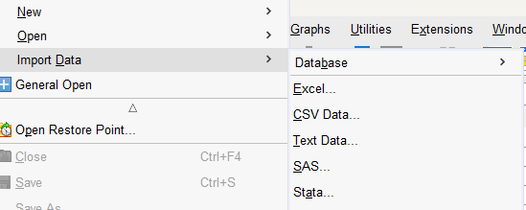
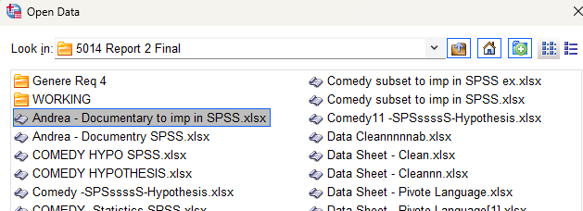

Data is imported in SPSS successfully

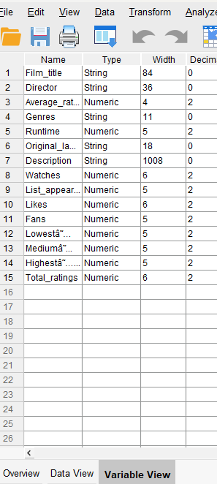

3.1 Correlation:
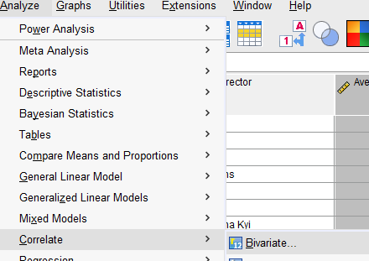
Choosing Variable values to calculate Correlation
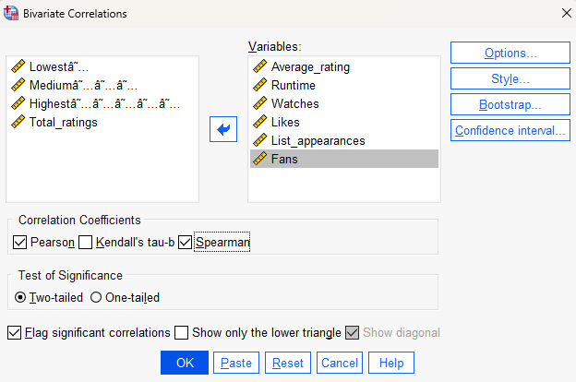

Correlation On SPSS
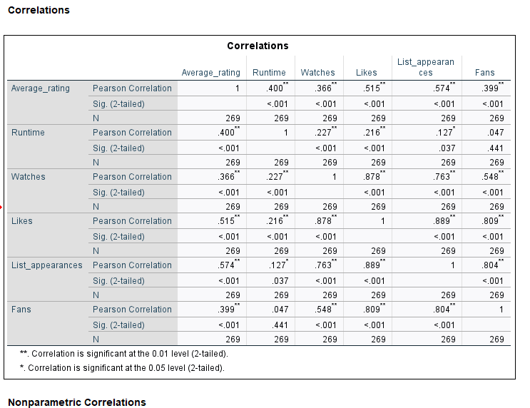
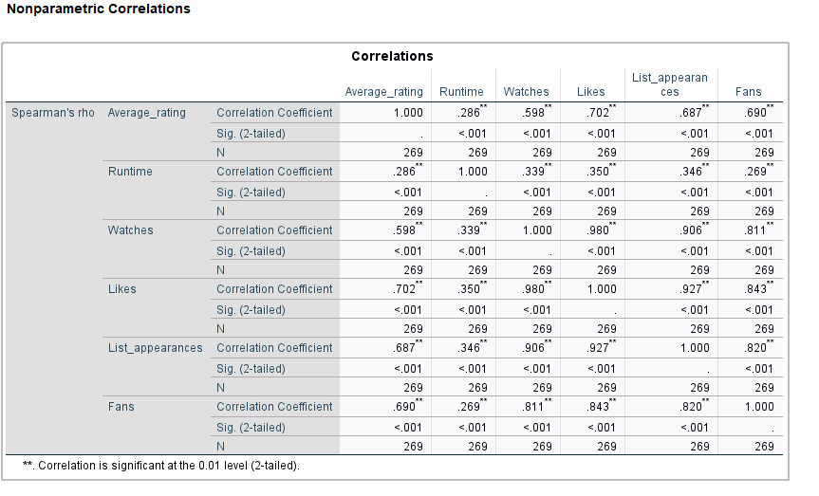

Interpretation of Correlation:
The Pearson correlation coefficients indicate the strength and direction of linear relationships among the variables:
- Average rating shows moderate positive correlations with Runtime (r = .400), Watches (r = .366), Likes (r = .515), List appearances (r = .574), and Fans (r = .399), all significant at p < .001. This suggests that higher-rated documentaries tend to have longer runtimes and greater engagement metrics (likes, appearances, fans) (Williams, 2024).
- Runtime correlates weakly with Watches (r = .227) and Likes (r = .216), and very weakly with List appearances (r = .127), indicating that longer documentaries are slightly more watched and liked, but the effect is small (Das & Uddin, 2021).
- Watches and likes to exhibit a very strong correlation (r = .878), and Likes strongly correlates with List appearances (r = .889) and Fans (r = .809). This implies that user engagement metrics are highly interrelated, which is common in digital platforms (Arthur, 2021).
- Fans correlate strongly with Likes (r = .809) and list appearances (r = .804), suggesting that popularity indicators move together (University of Bristol, 2020).
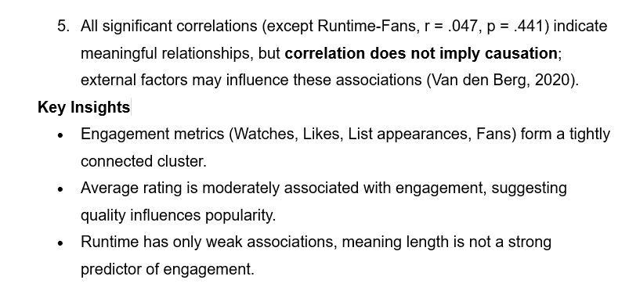
Scatter plot on SPSS : Following figure shows the steps to insert Scatter plot in SPSS
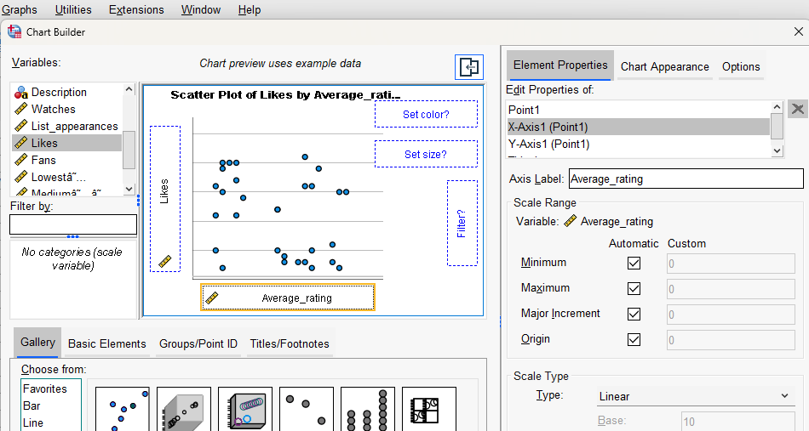

Scatter Plot: Presented below is the Scatter plot with interpretation
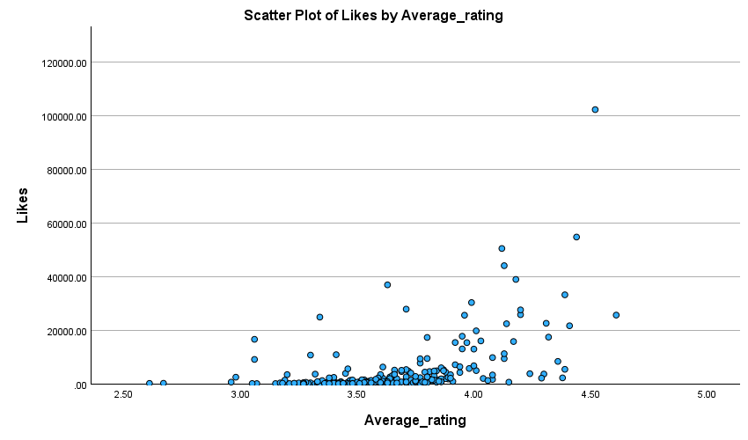

Interpretation of Scatter Plot
The scatter plot shows the relationship between Average rating (X-axis) and Likes (Y-axis) for documentary films. The pattern indicates a positive association: as the average rating increases, the number of likes tends to rise. However, the distribution is highly skewed, with most points clustered at lower like counts and a few extreme outliers (e.g., documentaries with ratings above 4.0 having likes exceeding 100,000). This suggests that while higher ratings generally correspond to more likes, popularity is influenced by additional factors beyond rating alone (Williams, 2024). The presence of outliers implies that some documentaries achieve exceptional engagement regardless of rating, possibly due to marketing or cultural relevance (Arthur, 2021)

5.2 Regression on SPSS: Followed following steps to calculate Regression on SPSS

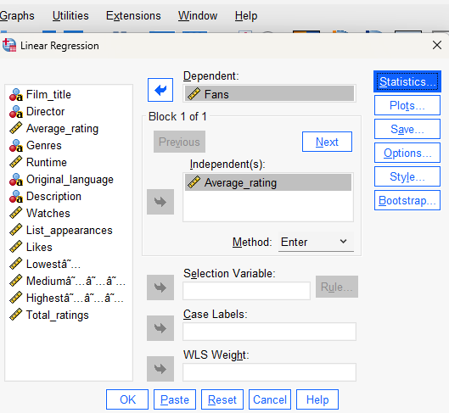

Output of Regression on SPSS is detailed below followed by brief interpretation
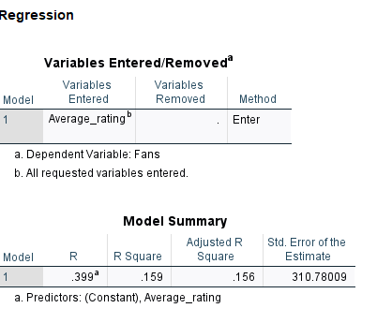
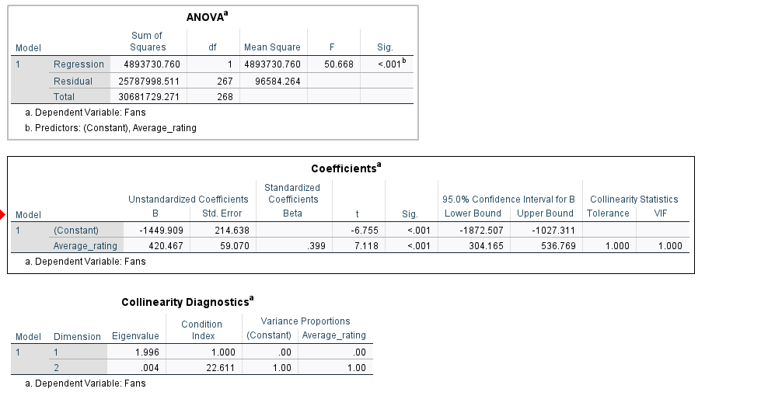

Interpretation of Regression Results
The regression output indicates that Average rating significantly predicts Fans. The ANOVA table shows the model is highly significant (F = 50.668, p < .001), meaning the predictor explains a meaningful portion of variance in the dependent variable (SPSS Services, 2023). The Coefficients table reveals that the unstandardized coefficient for Average rating is B = 420.467, suggesting that for every one-unit increase in Average rating, the number of Fans increases by approximately 420 (Statology, 2021). The standardized Beta (.399) indicates a moderate positive effect size, and the t-value (7.118) with p < .001 confirms statistical significance (OARC Stats, 2023). The confidence interval (304.165 to 536.769) does not cross zero, reinforcing reliability. Collinearity diagnostics show VIF = 1.000, indicating no multicollinearity issues (Chapman University, 2016).
Overall, the model demonstrates that higher ratings are associated with more fans, but since only one predictor is included, other factors likely influence fan engagement (Premier Dissertations, 2025).

3.3 Hypothesis on SPSS
First create the dummy variable, Language:

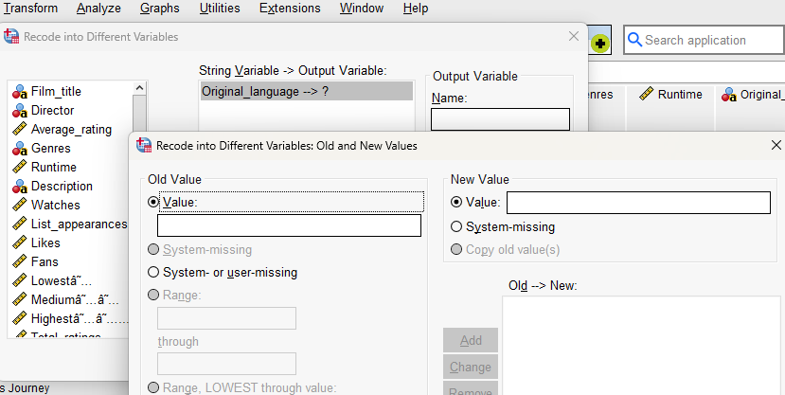

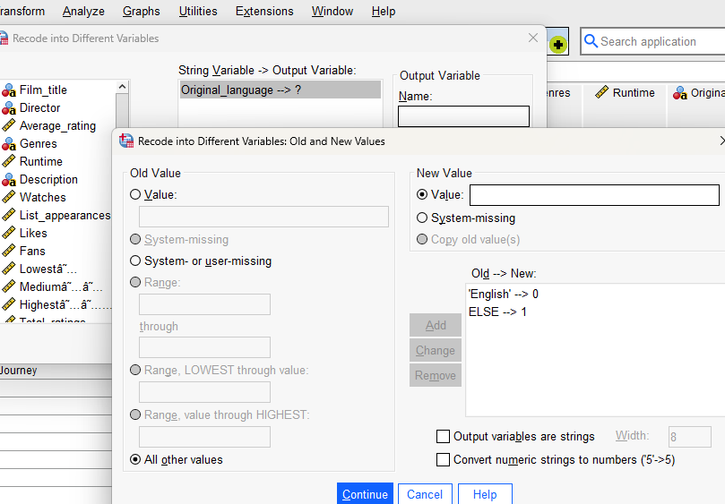

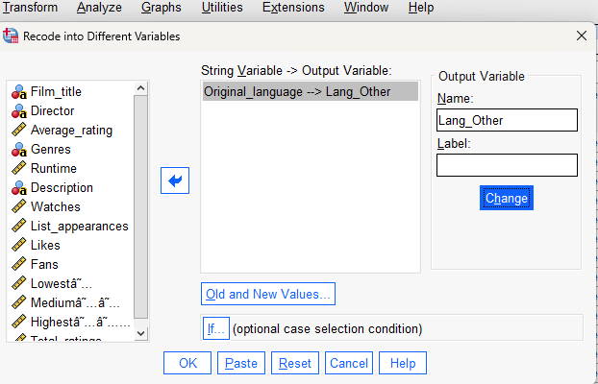

Dummy variable is created
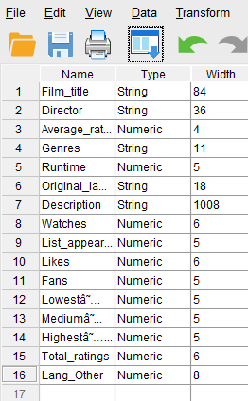

Hypothesis testing on SPSS
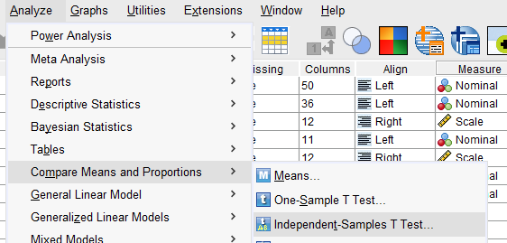

Hypothesis on SPSS:

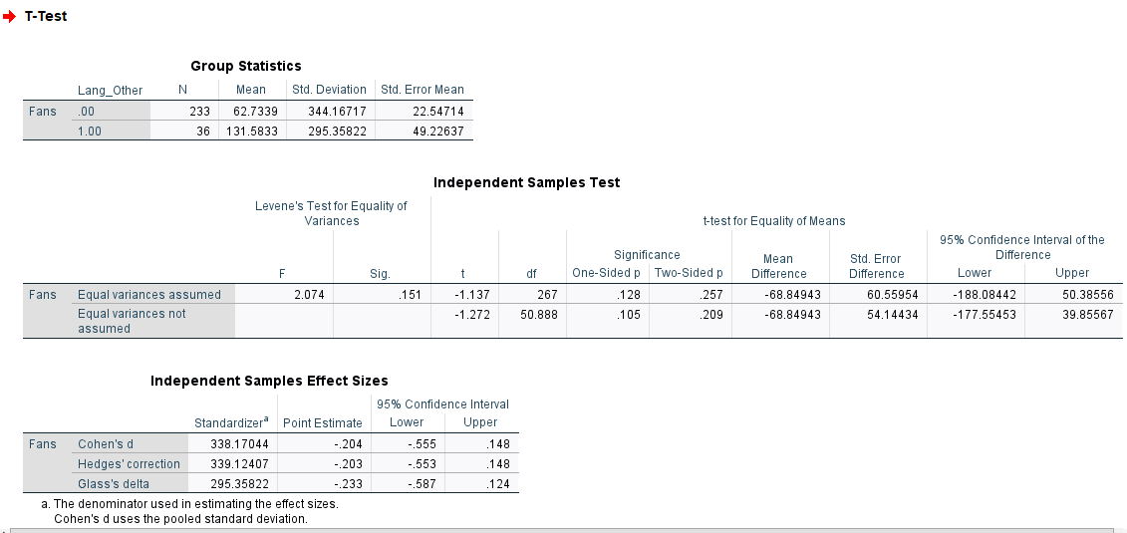

Interpretation of T-Test Results
The Independent-Samples T-Test compares Fans between English-language documentaries (Lang Other = 0) and other languages (Lang Other = 1).
- Group Statistics: English films (N = 233) have a mean of 344.17 Fans, while other languages (N = 36) have a higher mean of 413.58 Fans.
- Levene’s Test: p = 0.151 (> 0.05), so equal variances are assumed.
- t-Test: t(267) = -1.137, p = 0.257 (> 0.05), meaning the difference is not statistically significant.
- Mean Difference: -68.85 Fans, with a 95% CI (-188.08, 50.38), which includes zero, confirming no significant difference.
Effect Size: Cohen’s d ≈ -0.204, indicating a small, negligible effect

Conclusion
This report applied Excel and SPSS techniques to analyse a large film dataset and to identify the key factors influencing film performance and audience engagement. The descriptive statistics demonstrated that while film ratings remain relatively stable across the dataset, engagement metrics such as likes, watches, and fans fluctuate dramatically, reflecting the unpredictable nature of audience behaviour in creative industries. The correlation analysis further highlighted strong and interconnected relationships among engagement variables, suggesting that popularity indicators often rise together. Regression analysis confirmed that average rating is a meaningful predictor of fan engagement, though not the only factor. Finally, hypothesis testing revealed that language does not significantly impact the number of fans a documentary receives, indicating that global audience engagement is not solely tied to English-language content.
Overall, the findings reinforce that film success is multifaceted. Quality (as reflected by ratings), marketing reach, social media visibility, and broader consumption trends all contribute to audience engagement. The combination of Excel-based descriptive analysis and SPSS-based inferential tests provided a robust framework for interpreting these dynamics and transforming raw data into actionable business intelligence.

Recommendations
Based on the statistical findings, several actionable recommendations can be made:
- Invest in Engagement-Driven Marketing Campaigns
Since engagement metrics (likes, fans, watches) are strongly correlated, studios should prioritise marketing strategies that increase early visibility and online interaction. Social media campaigns, influencer partnerships, and targeted advertising are likely to have a compounding effect on audience engagement.
- Prioritise Quality but Monitor External Factors
The positive relationship between ratings and fan numbers suggests that higher-quality content attracts more loyal audiences. However, because engagement variability remains high, studios should combine content quality with strategic promotion to maximise reach.
- Avoid Overemphasis on Runtime or Language
Runtime showed only weak correlations with engagement, meaning length alone does not determine popularity. Similarly, the t-test showed no significant difference between English and non-English documentaries in fan engagement. Studios should therefore continue developing diverse content without if shorter runtimes or English-language exclusivity guarantee success.
- Use Data Modelling to Support Decision-Making
Regression results show that ratings explain some but not all of the variance in fan engagement. To improve predictive accuracy, future analyses should include additional variables such as budget, cast, director, marketing spend, and release timing. A multi-variable regression or machine-learning model could support more strategic planning.
- Conduct Genre-Specific Analysis for Targeted Insights
Because genre behaviour varies (as seen in the Crime and Documentary samples), studios should conduct more granular analysis within individual genres. This would allow more accurate forecasting and marketing strategies tailored to genre-specific audience behaviours.

References

- Abidin, C. (2020). Instagram: Visual social media cultures. John Wiley & Sons.
- Abidin, C. (2021). Mapping internet celebrity on TikTok: Exploring attention economies and visibility labours. Cultural Science Journal, 12(1), 77–104.
- Al-Menayes, J. (2015). Social media use, engagement and addiction as predictors of academic performance. International Journal of Psychological Studies, 7(4), 86–94.
- Arthur, M.M.L. (2021) Quantitative Analysis with SPSS: Correlation – Social Data Analysis. Available at: https://pressbooks.ric.edu/socialdataanalysis/chapter/quantitative-analysis-with-spss-correlation/ (Accessed: 15 November 2025).
- Arthur, M.M.L. (2021) Quantitative Analysis with SPSS: Correlation – Social Data Analysis. Available at: https://pressbooks.ric.edu/socialdataanalysis/chapter/quantitative-analysis-with-spss-correlation/ (Accessed: 15 November 2025).
- Berinato, S. (2018) The Right Stuff: Chart Types and Visualization Best (and Worst) Practices. Harvard Business Review. Available at: https://hbr.org/webinar/2018/02/the-right-stuff-chart-types-and-visualization-best-and-worst-practices.
- Caves, R. E. (2000). Creative Industries: Contracts between Art and Commerce. Harvard University Press.
- Chapman University (2016) A Student’s Guide to Interpreting SPSS Output for Basic Analyses. Available at: https://www.chapman.edu/wilkinson/_files/henley-pics/interpretingspssoutput2016-2.pdf (Accessed: 15 November 2025).
- Cheng, M.-H., Wu, Y.-C. and Chen, M.-C. (2016) ‘Television Meets Facebook: The Correlation between TV Ratings and Social Media’, American Journal of Industrial and Business Management, 6(3), pp. 282–290.
- Craig, C., Greene, W. H. & Versaci, A. (2015). E.T. go home? The determinants of international box office performance. Journal of Cultural Economics, 39(4), 377-399.
- Das, K.R. and Uddin, K.S. (2021) ‘How to Conduct Correlation and Regression Analysis through SPSS’, Australian Journal of Basic and Applied Sciences, 15(3), pp.16–23. Available at: https://www.ajbasweb.com (Accessed: 15 November 2025).
- Das, K.R. and Uddin, K.S. (2021) ‘How to Conduct Correlation and Regression Analysis through SPSS’, Australian Journal of Basic and Applied Sciences, 15(3), pp.16–23.
- De Vany, A. & Walls, W. D. (1999). Uncertainty in the movie industry: Does star power reduce the terror of the box office?. Journal of Cultural Economics, 23(4), 285-318.
- Einav, L. (2007). Seasonality in the U.S. motion picture industry. The RAND Journal of Economics, 38(1), 127-145.
- Elberse, A. (2007). The power of stars: Do star actors drive the success of movies?. Journal of Marketing, 71(4), 102-120.
- Field, A. (2018) Discovering Statistics Using IBM SPSS Statistics. 5th edn. London: Sage.
- Field, A. (2021). Discovering Statistics Using IBM SPSS Statistics. Sage Publications.
- Frost, J. (2025) Scatterplots: Using, Examples, and Interpreting. Statistics by Jim. Available at: https://statisticsbyjim.com/graphs/scatterplots/.
- Gravetter, F.J. and Wallnau, L.B. (2021) Statistics for the Behavioral Sciences. 11th edn. Boston: Cengage Learning.
- Hair, J.F., Hult, G.T.M., Ringle, C.M., & Sarstedt, M. (2022). A Primer on Partial Least Squares Structural Equation Modeling (PLS-SEM). Springer.
- Harvard Catalyst (2023) Data Visualization Best Practices. Available at: https://catalyst.harvard.edu/writing-communication-center/visualize-science/data-visualization/.
- Harvard University (2025) Error Bars: Points of Significance. Available at: http://genetics.bwh.harvard.edu/courses/Biophysics205/Papers/Primers/Error.pdf.
- Hennig-Thurau, T., Houston, M. B. & Walsh, G. (2001). The differing roles of success drivers across sequential channels: An application to the motion picture industry. Journal of the Academy of Marketing Science, 34(4), 559-575.
- Lakens, D. (2013) ‘Calculating and reporting effect sizes to facilitate cumulative science: a practical primer for t-tests and ANOVAs’, Frontiers in Psychology, 4, pp. 863–872.
- Larsen, H.H. et al. (2016) ‘TV Ratings vs. Social Media Engagement’, Proceedings of the IEEE International Conference on Big Data, pp. 3849–3858.
- Li, Y., & Xie, Y. (2020). Is a picture worth a thousand words? An empirical study of image content and social media engagement. Journal of Marketing Research, 57(1), 1–19.
- Litman, B. R. (1983). Predicting success of theatrical movies: An empirical study. Journal of Popular Culture, 16(4), 159-175.
- McDonald, P. (2020). The Routledge Companion to Media Industries. Routledge.
- OARC Stats (2023) Regression Analysis | SPSS Annotated Output. Available at: https://stats.oarc.ucla.edu/spss/output/regression-analysis/ (Accessed: 15 November 2025).
- Pagampriyal, S. and Mathiraj, S.P. (2025) ‘The Role of Key Performance Indicators (KPIs) in Social Media Marketing’, International Journal of Research Publication and Reviews, 6(4), pp. 2500–2502.
- Pallant, J. (2020) SPSS Survival Manual. 7th edn. Maidenhead: Open University Press.
- Premier Dissertations (2025) How to Interpret SPSS Output in a Dissertation. Available at: https://premierdissertations.com/interpret-spss-output/ (Accessed: 15 November 2025).
- PSS Services (2023) SPSS Linear Regression Output Interpretation Guide. Available at: https://spssservices.com/spss-linear-regression-output-interpretation/ (Accessed: 15 November 2025).
- References
- Reinstein, D. A. & Snyder, C. M. (2005). The influence of expert reviews on consumer demand for experience goods: A case study of movie critics. The Journal of Industrial Economics, 53(1), 27-51.
- Sanches, E. and Ramos, C.M.Q. (2025) ‘Evaluating the Impact of Instagram Engagement Metrics on Corporate Revenue Growth’, Information, 16(4), pp. 287–302.
- Saunders, M., Lewis, P., & Thornhill, A. (2023). Research Methods for Business Students. Pearson Education.
- Statology (2021) The Complete Guide: How to Report Regression Results. Available at: https://www.statology.org/how-to-report-regression-results/ (Accessed: 15 November 2025).
- Tabachnick, B.G. and Fidell, L.S. (2019) Using Multivariate Statistics. 7th edn. Boston: Pearson.
- Trunfio, M. and Rossi, S. (2021) ‘Conceptualising and Measuring Social Media Engagement: A Systematic Literature Review’, Journal of Marketing Science, 43(2), pp. 149–170.
- University of Bristol (2020) Correlations in SPSS (Practical). Available at: https://www.bristol.ac.uk/cmm/media/research/ba-teaching-ebooks/pdf/Correlations%20-%20Practical.pdf (Accessed: 15 November 2025).
- University of Bristol (2020) Correlations in SPSS (Practical). Available at: https://www.bristol.ac.uk/cmm/media/research/ba-teaching-ebooks/pdf/Correlations%20-%20Practical.pdf (Accessed: 15 November 2025).
- Van den Berg, R.G. (2020) SPSS Correlation Analysis – The Ultimate Guide. Available at: https://www.spss-tutorials.com/spss-correlation-analysis/ (Accessed: 15 November 2025).
- Van den Berg, R.G. (2020) SPSS Correlation Analysis – The Ultimate Guide. Available at: https://www.spss-tutorials.com/spss-correlation-analysis/ (Accessed: 15 November 2025).
- Williams, G. (2024) Pearson’s Correlation in SPSS [perform, interpret & report]. Available at: https://online-spss.com/interpreting-reporting-pearson-correlation-spss-outputs/ (Accessed: 15 November 2025).
  - Williams, G. (2024) Pearson’s Correlation in SPSS [perform, interpret & report]. Available at: https://online-spss.com/interpreting-reporting-pearson-correlation-spss-outputs/ (Accessed: 15 November 2025).
- Zeng, J., & Abidin, C. (2023). Studying the mumification of intergenerational on TikTok. The Playful Politics of Memes, 93–115.

