

PROGRAMME: MASTER OF BUSINESS ADMINISTRATION
MODULE NAME: INTERNATIONAL MARKETING: PRINCIPLES AND PRACTICES
MODULE CODE: LCMB7026

TITLE: INTERNATIONAL MARKETING STRATEGY OF PIZZA HUT- A COMPARATIVE ANALYSIS OF THE U.S. AND INDIA
LECTURER NAME: TUSHARA BALENDRAN
STUDENT’S NAME: SONAL ARJAN KHISTARIYA
STUDENT’S ID: 2522475

Table of Contents
1. Section 1: Report 4
1.1 Introduction 4
1.1.1 Background and mission of Pizza-Hut 4
1.2. Comparative analysis of the Macro environment of Pizza Hut 5
1.2.1 PESTLE Analysis of the U.S. and India 5
1.2.2 Comparative summary 12
1.3. Comparative analysis of the culture 13
1.3.1 Hofstede's Cultural Dimensions - U.S. vs. India 13
1.4. Comparative STP Analysis 14
1.4.1 Market Segmentation 14
1.4.2 Targeting 15
1.4.3 Positioning 15
1.4.4 Comparative summary of STP analysis 16
1.5. International Marketing Mix using 7Ps 16
1.5.1 Product 17
1.5.2 Price 18
1.5.3 Place 18
1.5.4 Promotion 18
1.5.5 People 18
1.5.6 Process 19
1.5.7 Physical Evidence 19
1.5.8 Summary 20
1.6. Market Entry Strategy 20
1.6.1 Overview of Pizza Hut Entry in India 20
1.6.2 Analysis of the Entry Mode 20
1.6.3 Challenges faced 22
1.6.4 Critical evaluation of the entry strategy 22
1.7. Ethical issues in Pizza Hut’s Marketing in India 22
1.7.1 Identification of the ethical issues 22
1.7.2 Evaluation of ethical implications 23
1.7.3 Application of ethical framework 24
1.8. Recommendations 25
1.8.1 Recommendation 1: Expanding digital marketing and delivery partnerships 25
1.8.2 Recommendation 2: Strengthening localised and culturally relevant marketing 25
1.8.3 Recommendation 3: Adopting ethical and sustainable marketing practices 25
1.9. Conclusion 26
2. Section 2: Reflective Account 26
2.1 Introduction 26
2.2 Description 27
2.3 Feelings 28
2.4 Evaluation 28
2.5 Analysis 29
2.6 Conclusion 29
2.7 Action Plan 30
Reference List 32
Appendices 37
Appendix 1: Positioning Map for Pizza Hut in the American Market 37

1. Section 1: Report

1.1 Introduction
Pizza-Hut, LLC is an American multi-national restaurant chain specialised in Pizza. This present report focuses on a comparative analysis of Pizza Hut’s International Marketing Strategy in both the home (the U.S.) and host (India) country. Therefore, the culture, macro environment and position along with marketing strategy of the company have been done in this report. The section 1 focuses on comparing the marketing strategies used by Pizza Hut in both the US and India. It also uses a PESTLE analysis and focuses on several important factors of each country, such as social, cultural, environmental, political, legal and technological and economic. Further this report uses the Hofstede model in terms of comparing the culture of both the countries and to understand the customer it uses STP analysis. Later to understand the marketing method of Pizza Hut 7Ps of Marketing Mix is also incorporated. Lastly, this report explains the entry method of Pizza Hut in India, ethical issues and recommendations. In section 2 a reflection is provided to understand the complete research process.

1.1.1 Background and mission of Pizza-Hut
Pizza Hut is a globally recognised fast-food restaurant chain, which is known for its pan Pizzas, pasta and wings. As per Pizza Hut (2026) in 1988 two brothers borrowed $600 from their mother and decided to open a pizza place in Wichita, Kansas. However, in the present situation the restaurant chain has more than 19,000 restaurants around over 100 countries (Pizza Hut Franchise, 2025). Further, the mission of the company is to make perfect pizza and service all time.
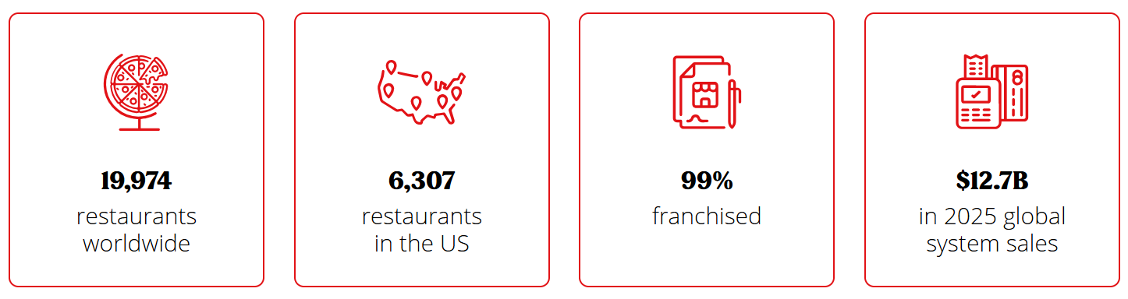
Figure 1: Overview of Pizza Hut in 2025
(Source: Pizza Hut Franchise, 2025)

1.2. Comparative analysis of the Macro environment of Pizza Hut

1.2.1 PESTLE Analysis of the U.S. and India
- Political factor of the U.S.
The political atmosphere of the U.S. is much disrupted. As per Trading Economics (2026), in 2023 the political stability of the U.S. was at 0.029 points, which is very low.
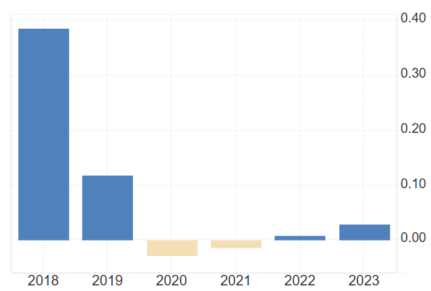
Figure 2: Political Stability Index of the U.S.
(Source: Trading Economics, 2026)
Impact on Pizza Hut: The unstable political environment of the U.S. can hamper the business operations, supply chain and investment decisions of Pizza Hut.
- Political factor of India
The political environment of India is quite stable. As per Trading Economics (2026b), in 2022, the political stability of India was at 24.05%, which was a bit higher than the previous years.
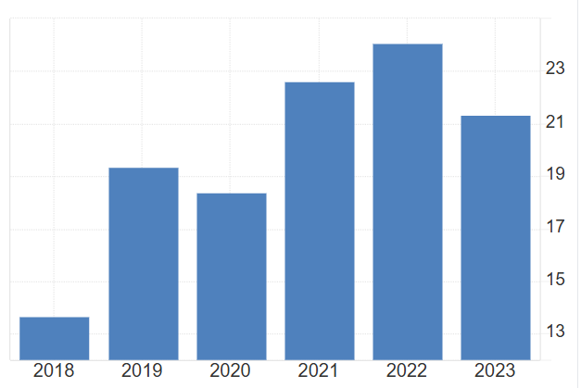
Figure 3: Political Stability of India
(Source: Trading Economics, 2026b)
Impact on Pizza Hut: A steady political environment is beneficial for Pizza Hut, providing opportunities to expand franchise across India.
- Economic factors of the U.S.
The inflation of the U.S. is also increasing heavily. As highlighted by Trading Economics (2026a), in 2026 May the inflation rose to 4.2% in the U.S.
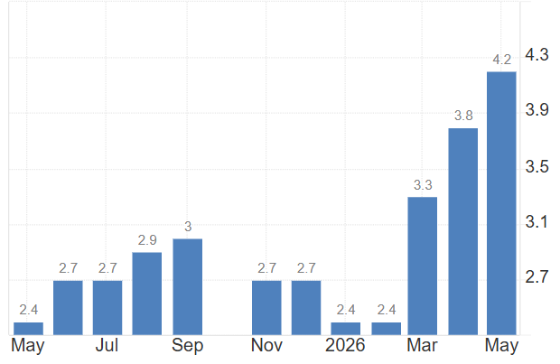
Figure 4: Inflation rate of the U.S.
(Source: Trading Economics, 2026a)
Impact on Pizza Hut: Increasing rate of inflation can simultaneously increase the price of raw materials and operational cost, creating pressure on Pizza Hut to either increase their price or reduce their profit margin.
- Economic factor of India
In India the inflation is also increasing. As per Trading Economics (2026c) in the Month of May 2026 the inflation rate of India was 3.93%, which is quite higher than previous months.
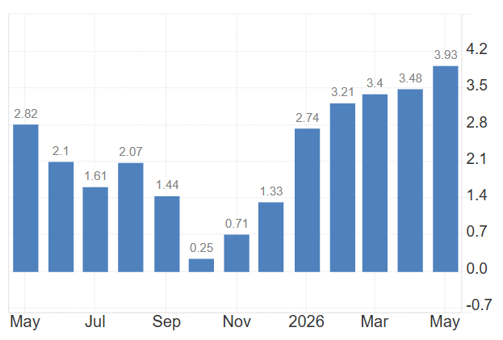
Figure 5: Inflation Rate of India
(Source: Trading Economics, 2026c)
Impact on Pizza Hut: Increasing inflation rate can increase the operational cost of Pizza Hut, eventually increasing price, which can negatively impact the customers of India as they are quite price sensitive.
- Social factor of the U.S
In the United States, fast food has become one of their culinary statements. According to Statista (2025), it was found that in 2024 the fast-food consumers spent over 42 billion U.S. dollars at quick service pizza restaurants.
Impact on Pizza Hut: The U.S. has a strong fast-food culture, which is helping Pizza Hut to maintain a strong and wide customer base.
- Social factor of India
In India, consumption of vegetarian food is very common due to religious beliefs. As per Sahgal et al. (2021) 39% of people followed a vegetarian diet. In addition to this, family dining culture is highly popular in the country.
Impact on Pizza Hut: It is crucial for Pizza Hut to maintain a pure vegetarian menu and also should provide a family friendly dining experience.
- Cultural factor of the U.S.
U.S. culture holds the idea of freedom where individualism is the key. In the U.S. people prefers freedom, innovation and self-expression is strongly valued.
Impact on Pizza Hut: The culture of the U.S. influences the high-demand for convenient and fast-food support for Pizza Hut.
- Cultural factor of India
Indian culture is highly collectivist with strong preference for regional food and strong family values.
Impact on Pizza Hut: Pizza hut offers localised menu in the Indian market preferring the culture of the nation. Thus, the brand sells tandoori veg and Paneer Tikka pizza in the Indian markets.
- Technological factor of the U.S
Consumers of America are using various online applications, like Uber Eats and Door Dash, to get their food from the comfort of their home (Grand View Research, 2025). In addition to this, the fast-food chains in the U.S are also incorporating AI in their operations to ensure high customer satisfaction.
Impact on Pizza Hut: Improving the digital presence of Pizza Hut is beneficial for the company by using AI, eventually enhancing customer experience.
- Technological factor of India
In India online food delivery is also very popular through renowned mobile applications named, Swiggy and Zomato (You Gov, 2020). In addition to this, digital payments are also highly popular in the country through applications like Google Pay and Phone Pay.
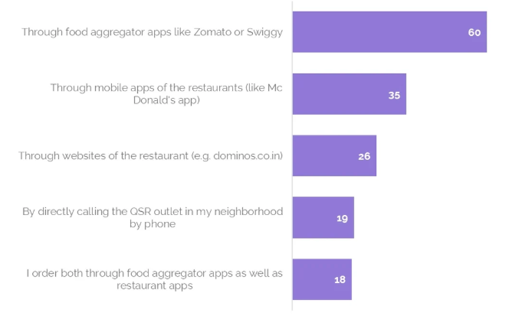
Figure 6: Survey showing the popular food delivery of India
(Source: You Gov, 2020)
Impact on Pizza Hut: Due to the high demand of online food delivery through apps, Pizza Hut partnered with Swiggy and Zomato and it also accepts online payment methods to ensure that the customers are satisfied.
- Legal factor of the U.S
In the U.S. labour laws are quite strict with different regulations, in terms of daily wages, health and safety and employee benefits (Dol.gov, 2026).
Impact on Pizza Hut: It is important for Pizza Hut to strongly adhere to the legal aspects of the U.S., while maintaining a safe and fair working environment.
- Legal factor of India
In India, any restaurant business needs to adhere to “FSSAI Food safety Standard” and “Local Labour Laws”, as they are mandatory by the Indian Law.
Impact on Pizza Hut: Pizza Hut also needs to adhere with FSSAI and maintain the labour laws to ensure legal safety.
- Environmental factor of the U.S
In the U.S waste generated through packaging and carbon footprints are two major environmental concerns. As per the US EPA (2020) in 2018, 292.4 million tonnes of waste generated and only 69 million tons were recycled.
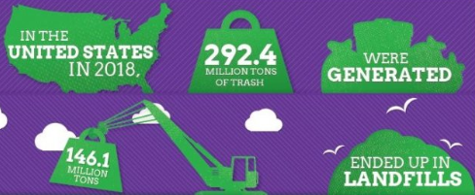
Figure 7: Waste generated through packaging in the U.S.
(Source: US EPA, 2020)
Impact on Pizza Hut: Pizza Hut should focus on adopting eco-friendly packaging and also incorporate sustainable practices, which will be effective for meeting the needs of the environment conscious customers and reduce any change of legal issues.
- Environmental factor of India
As per Gov.in (2022) from 2022 India put a ban on single use plastic. In addition to this, consumers of India are also becoming more environmentally friendly.
Impact on Pizza Hut: Pizza Hut needs to use environment friendly packaging options instead of plastic to ensure that customers are happy and the environment is protected.

1.2.2 Comparative summary
Similarities: It can be clearly seen from the Pestle analysis that both the countries, India and the U.S are facing extreme inflation, which is responsible for increasing cost for Pizza Hut, and in future it may lead to the price of menus. Both countries also inherit a strong digital food delivery culture, where customers often order through food ordering applications (India- Swiggy, Zomato; U.S- Uber Eats, DoorDash) and also depend on online payment. Further, it is also important for Pizza hut in both the countries to maintain the legal and labour regulations in terms of gaining operational safety. The environmental awareness is also similar in both countries, which pushed Pizza Hut to become more eco-friendly in terms of packaging.
Dissimilarities: Despite so many similarities, both the countries also experience some major dissimilarity. First of all, the political environment of the U.S is very unstable, whereas India has a more stable atmosphere. In addition to this, socially America also has a strong fast-food culture, where Indian people mainly prefer vegetarian options with family-friendly dining. Lastly, in terms of environmental factors, America is facing problems in managing plastic waste; whereas, India has already put a ban on the use of single use plastic. Such dissimilarities often push pizza hut to incorporate different approaches for both Indian and American Market.

1.3. Comparative analysis of the culture

1.3.1 Hofstede's Cultural Dimensions - U.S. vs. India
As per the figure 8 provided below the comparison of both the country’s cultures can be seen clearly using Hofstede's Cultural Dimensions. This model is effective for helping businesses to understand the cultural difference while enhancing communication and management across countries.
Advantages of the model: Hofstede Model is a simple method, which also provides a clear numerical score, which eventually makes it easier for businesses to quickly compare the culture of countries. This model is also effective for companies like Pizza Hut, as it helps in terms of developing suitable marketing strategies. In addition to this, Hofstede model also helps in avoiding cultural mistakes by understanding values.
Disadvantages of the model: Despite such advantages, this model also has some drawbacks, such as it oversimplifies culture and also treats countries as identical, while ignoring internal diversity, such as religion, region or age. In addition to this, the data is quite old, which may not be effective in terms of reflecting today’s changing society.
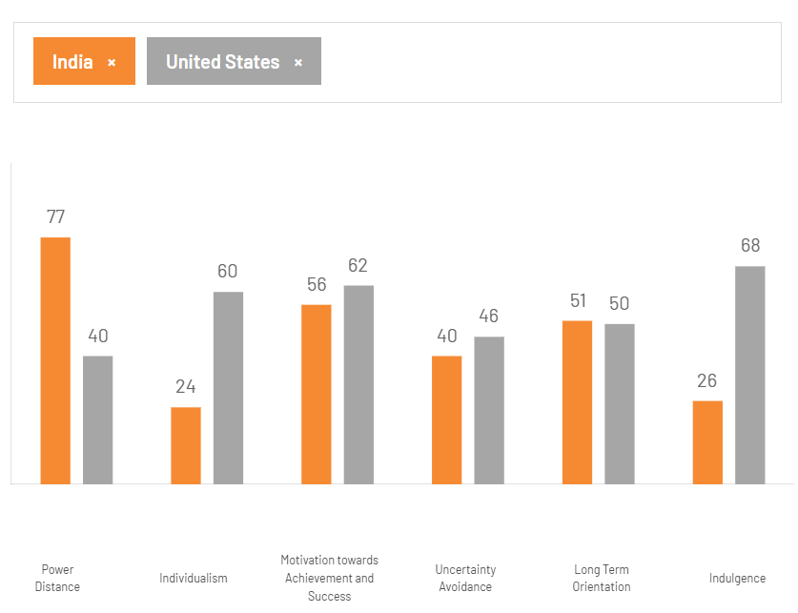
Figure 8: Comparison of Cultural Dimension of the U.S. and India
(Source: The Culture Factor, 2026)
In terms of Power distance India’s score is higher (77) than the United States (40), which mean that in Indian Culture people, are fonder of hierarchy and authority than the U.S. As per the Individualism aspect, India scored lower (24) than the U.S. (60), indicating an American culture, where people value individualism. On the other hand, Indians are more collectivist. In terms of the factor Motivation towards achievement and success both countries have scored similar to India (56) and the U.S. (62). This means both the countries have a highly competitive and success-driven culture. In the factor uncertainty avoidance, both countries have similar scores (India: 40; U.S. 46), which means both the countries are comfortable with change and uncertainty. Similarly, in Long term orientation both the countries again got similar scores, India (51) and the U.S. (50), which means that both countries' cultures are able to find a proper balance between tradition and future planning. The last segment is Indulgence, where India (26) scored lower than the U.S. (68), which means that American people are able to enjoy gratification more than Indians, who are more resistant in nature.

1.4. Comparative STP Analysis
Marketing segmentation refers to a process, which helps business owners to recognise and focus on different types of customers, eventually helping in improving market assessment and developing crucial marketing strategies. As stated by Clarke, Freytag and Cortez (2024) with the help of segmentation efforts and aligning it with the organisational goals, it is easier for organisations to navigate the critical marketing landscape. It is also crucial for gaining competitive advantage.

1.4.1 Market Segmentation
In the United States, the market segmentation is done by Pizza hut on the basis of demographics, where the restaurant chain mainly targets families, college students and young adults as their major customers. In addition to this, behavioural segmentation is followed by Pizza Hut, where it mainly focuses on those customers who mainly rely on online ordering. Lastly, in terms of psychographic segmentations, the company targets people who love to treat themselves and love the fast-food culture.
In India, the demographic segmentation of Pizza Hut is mainly done on the basis of people, who belong from urban-middle class families and young generations. In terms of behavioural segmentation, the company targets customers who visit places during occasions, like festivals and weekends. For psychographic segmentation, Pizza Hut targets customers, who consider eating out is a premium but affordable option.

1.4.2 Targeting
Targeting is mainly defined as a way of selecting the most appropriate segment, which is primarily based on the marketing efforts. In the United States, Pizza Hut mainly targets families and young customers, who prefer both dine-in and delivery options. In addition to this, Pizza Hut also has a loyalty programme named “Hut Reward Programme”, which helps in encouraging repetitive purchase from the customers (Pizza Hut, 2026a). On the other hand, in India Pizza Hut mainly targets customers, who are from urban-middle class families. Along with this, the company also focuses on vegetarian customers.

1.4.3 Positioning
Positioning refers to a way in which brands represent themselves in the market to target the customers. In terms of the United States, Pizza Hut positioned itself as “American Favourite Pizza”, mainly focusing on indulgence, homely feelings and comfort food. In addition to this, the brand is also motivated to stay ahead of its competitors, like Dominos and Papa John’s by focusing innovation, such as stuffed crust pizza [Refer to Appendix 1]. In India, the positioning of Pizza Hut mainly focuses on a family-focused approach with an affordable dining experience. In addition to this, despite being a western brand, Pizza Hut is able to adapt to Indian style, taste and culture.
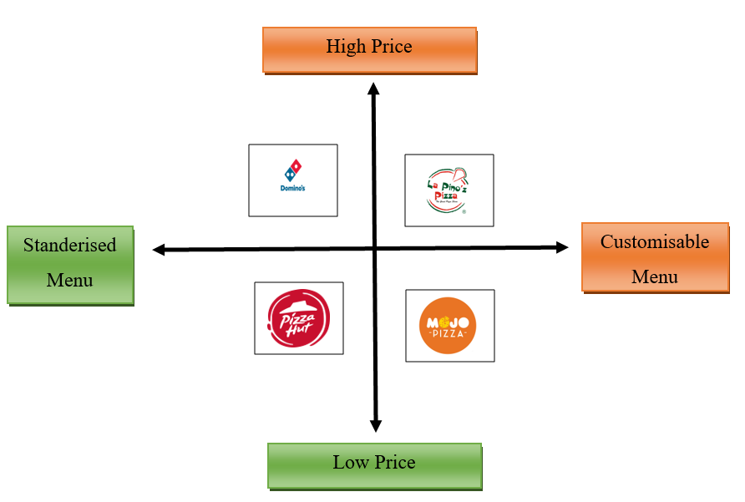
Figure 9: Positioning Map for Pizza Hut in the Indian Market
(Source: self-developed)

1.4.4 Comparative summary of STP analysis
In summary, it can be stated that Pizza Hut's key approach is based on a family-oriented approach in the United States and India. However, no major difference can be seen in terms of cultural adaptation. In terms of the United States, Pizza Hut mainly focuses on customers, who are indulgent, loyal and convenient. On the other hand, in India, the targeted customers of Pizza Hut mainly focus on affordability, vegetarian options and an emotional bond with the family.

1.5. International Marketing Mix using 7Ps
Marketing Mix refers to a set of marketing tools or strategy, which is mainly used in terms of promoting a product or services in the market and selling it (Išoraitė, 2021). Using the 7Ps of marketing mix Pizza Hut’s marketing strategies are explained below.

1.5.1 Product
The product strategy of Pizza Hut is quite different in the United States and India. In terms of the United States, the pizzas are available in more westernised flavours, like pepperoni, BBQ flavours, which compliments the test palates of the U.S. customers. On the other hand, in India, Pizza Hut’s menu is more localised with flavours like Makhani sauce and tandoori with a wide vegetarian option (Pizza Hut, 2026b). In addition to this, due to Hindu religious belief Pizza Hut completely removed its Beef products from the Indian Menu. Therefore, it is quite clear that in the Indian Market Pizza Hut uses a localised strategy, while in the states the brand is more about a standardised approach.
The product difference can be better understood through the idea of product line depth and width. The depth of the product line mainly focuses on the variations that exist within one line. In terms of Pizza Hut in India, the company added more depth in its product line by creating extra variations, like tandoori and Makhani, which aims to suit the taste of locals. On the other hand, the width of a product line mainly refers to how many product lines a company offers (pizzas, sides and desserts). In terms of Pizza Hut, it keeps a smaller width in both countries; however, it changes the depth of pizza line in order to match the local demand.
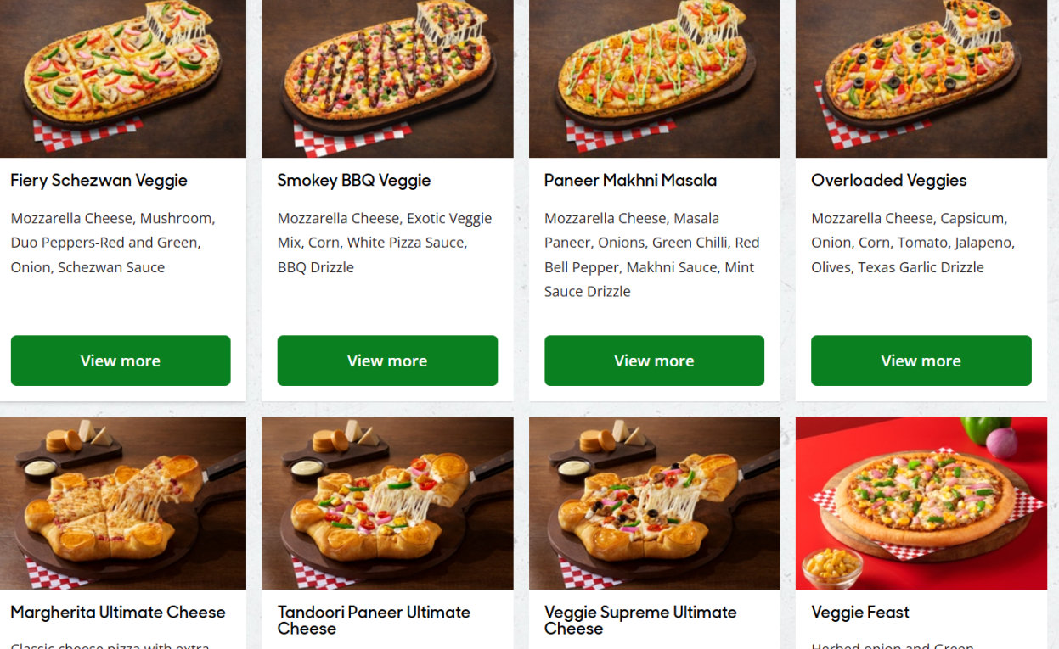
Figure 10: Indian Vegetarian Menu by Pizza Hut
(Source: Pizza Hut, 2026b)

1.5.2 Price
In the American Market, the pricing strategy used by Pizza Hut is a mid-range pricing strategy, where the brand mainly focuses on selling combo offers and value meals in terms of attracting a wider customer base. On the other hand, Pizza Hut uses a high-low pricing strategy to attract price-sensitive customers. As per Wu, Ran and Zhu (2022), high-low pricing strategy is effective for reaching more price-sensitive customers through lower prices. Therefore, it is clear that despite positioning itself as a premium brand, Pizza Hut prices its products based on the economic situation.

1.5.3 Place
In the United States, Pizza Hut mainly operates its business through dine-in restaurants, drive-through and online food delivery services, like Uber Eats and Door Dash. On the other hand, in India, the outlet of Pizza Hut is mainly seen inside malls in major cities. In addition to this, the brand is also highly reliable on food delivery apps, such as Zomato and Swiggy. These are some of the most effective ways through which Pizza Hut reaches a wider customer base.

1.5.4 Promotion
The promotional aspect is also quite different for Pizza Hut in both the countries. In the United States, the brand mainly promotes its product through television commercials, digital marketing and also focuses on big budget campaigns, like super bowl advertisements. As per Smith (2022), digital marketing is effective for a brand to increase its online visibility as well as brand awareness. On the other hand, in India Pizza Hut focuses on campaigns that is highly driven by emotions. In addition to this, promotional campaigns in regional language and social media promotions are other promotional strategies.

1.5.5 People
Pizza Hut employs more than 350,000 employees in more than 100 countries (Pizza Hut, 2026c). In the United States, the staffs hired by Pizza Hut are mainly focused on efficiency and speed, which is best for working in such a fast-paced environment. On the other hand, in India, staffs are mainly trained to work in a friendly manner and maintain cultural sensitivity while they separate veg and non-veg menus as these are considered as important in the Indian Market. As per Boger, Bradford and Lin (2025) maintaining cultural sensitivity is important for fostering customer satisfaction and enhancing brand reputation.

1.5.6 Process
The ordering process of Pizza Hut mainly focuses on mobile apps, self-service kiosks and through third-party delivery platforms, especially in the American Market. On the contrary, in the Indian market, the brand prioritises UPI digital payments through apps, like Google pay and Phone pay. In terms of fostering a smooth delivery process the brand is also partnered with Zomato and Swiggy.

1.5.7 Physical Evidence
In the United States, the classic red roof branding is maintained by Pizza Hut along with a modern interior design. On the contrary, in India the design of the restaurant is more family friendly and done based on the preference of local people. In addition to this, the packaging is another important aspect, where in the Indian market each pizza box needs to have a red or green dot in it to denote whether it is vegetarian or non-vegetarian.
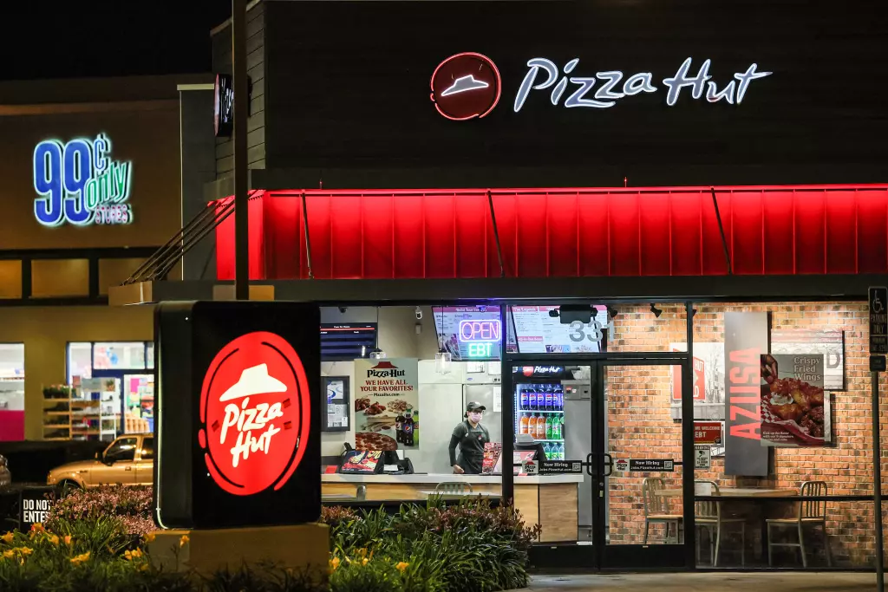
Figure 11: Diagram of Pizza Hut’s Store in the USA
(Source: LA Times, 2026)

1.5.8 Summary
Overall, it can be stated from the comparative 7P analysis that Pizza Hut has the ability to effectively keep a balance between its global consistency and local adaptation. In terms of the Indian Market, the brand is more focused on cultural, religious and economic factors. Therefore, in this market, the brand needs a completely different marketing approach than the home market.

1.6. Market Entry Strategy

1.6.1 Overview of Pizza Hut Entry in India
Pizza Hut entered the market of India in 1996 and the first branch was in Bengaluru. In this time, the company adopted localisation strategies and therefore vegetarian pizza was introduced. The importance of localisation strategies is mentioned with respect to meeting regulatory compliance (Kugler, 2022). In this time, the company focused on research work and introduced such kinds of menus which included local tastes. Pizza Hut was able to be competitive in the Indian market through innovation and competitive pricing.

1.6.2 Analysis of the Entry Mode
There are different ways through which a company can enter in the international market and it includes direct export, joint venture and franchising among others.

Market Entry Mode

Direct Export

Indirect Export

Joint Venture

Franchise
Figure 12: Market Entry Mode
(Source: Self-Created)
Pizza Hut entered the Indian market through a joint venture model with Indian business group RJ Corp. One of the main benefits of joint venture entry mode is to increase the local knowledge (Hsiao and Lin, 2023). Joint venture helps businesses to share resources, cost and experience, which are beneficial for entering a new market. However, it can also create conflicts between partners due to differences in goals, management and decision-making. Local knowledge is very important to deal with the preference pattern of customers in this particular country. Because of following this entry mode, the company did not face problems regarding dealing with regulatory compliance as well. The importance is mentioned with respect to managing the supply chain as well. On the other hand, wholly-owned subsidiaries demand high capital investment and franchise models have less control over operations. This is the reason for which joint ventures have been chosen by the said brand over wholly-owned subsidiaries and franchise models.

1.6.3 Challenges faced
Intense competition: Pizza Hut faced strong competition from local food chains and it was tough competition because the price of most products of local food chains is very low. The food business of Pizza Hut lies under the perfect competition market. Companies under perfect competition are price makers (Triani, 2023). This is one of the main reasons for which the competition was extremely high.
Price sensitivity: Most Indian customers are very much sensitive to prices and from that respect it is said that the price elasticity of this kind of product is extremely high. For this reason, Pizza Hut had to be focused on research work, especially for taking decisions regarding price.
Diverse customer preferences: India is full of different kinds of cultures and backgrounds and the social background is an important factor to be considered (Desai, 2023). This is the reason for which the business enterprise found it difficult to make various kinds of business decisions. The number of customers who prefer quality has started to increase but the price-sensitive customer aspect should not be ignored as well.

1.6.4 Critical evaluation of the entry strategy
In the above section, it is mentioned that Pizza Hut chose a joint venture for entering the Indian market. As stated by Razak and Marsasi (2023), joint venture strategy helps in expanding business. With the help of this strategy, it is possible to reduce different kinds of risks. The aspect of reduction of cost is also required to be mentioned as well. Lasserre and Monteiro (2022), mentions that joint venture strategy can lead to problems like cultural clashes and therefore it becomes quite difficult to fulfil long term objectives. For this reason, it is not considered as an effective strategy under global static management.

1.7. Ethical issues in Pizza Hut’s Marketing in India

1.7.1 Identification of the ethical issues
Pizza Hut has faced different kinds of ethical issues in the Indian market and one of the main issues is to not provide proper nutritional information. Provision of nutritional information is extremely important because it helps in building customers' trust (Pillen et al., 2024). In this way, the company was responsible for improving the unhealthy pattern of eating within customers, especially within young customers. Apart from that, it is mentioned that the company did not provide proper information on sourcing as well. This particular aspect is related to product under marketing mix because this section is concerned with nutritional value and product quality. The ethical aspect is required to be mentioned with respect to not considering cultural aspects of India properly. In this way, Pizza Hut creates various kinds of ethical issues under various aspects.

1.7.2 Evaluation of ethical implications
Under the consideration of ethical implication, it is said that Pizza Hut was one of the main responsible companies which contributed to the market of high calorie foods. In this way it increased the number of customers in India who have obesity and diabetes. In order to understand the aspect in a proper way, it is required to consider the following figure.
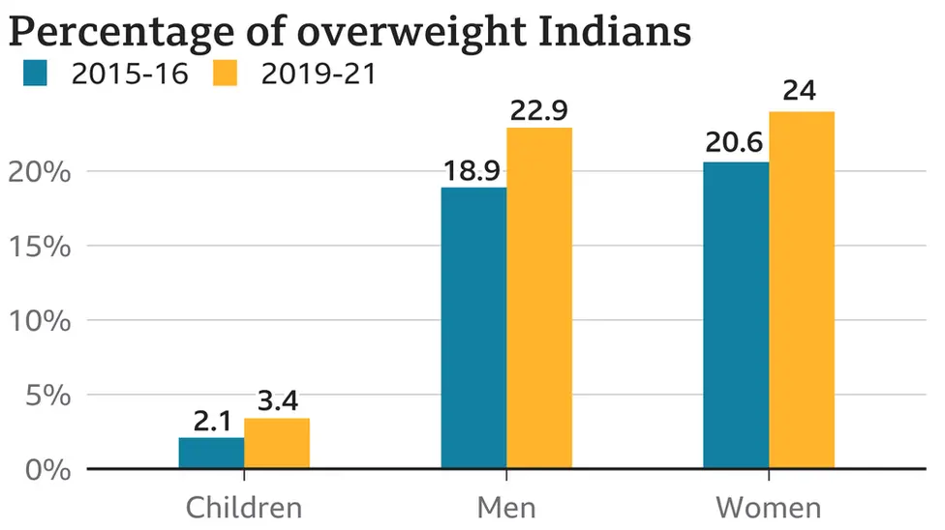
Figure 13: Percentage of overweight Indians
(Source: Pandey, 2022)
The above figures denote that the percentage has increased for all types of human beings in India compared to the time. As per the above figure, in between 2019-21 there have been 22.9% of overweight Indian men in the country compared to higher percentage of women who were around 24%. However, 3.4% of children in India were also overweight. The aspect of misleading information is required to be mentioned in this context. Pizza Hut is one of the largest brands and it is even considered for India and therefore it is not expected from a company like it. The company was not able to consider cultural values and social responsibility and therefore it faced public criticism as well. This factor must be changed for improving customer trust. The significance is mentioned with respect to deal with competition under the particular industry as well.

1.7.3 Application of ethical framework
Based on the overall discussion, it can be said that The Utilitarianism Framework is best situated for understanding the ethical aspect which is mentioned in the above section. Considering this particular framework, it is said that Pizza Hut should be more focused on promotional activities in future. According to the framework, Pizza Hut should maximise benefits by prompting healthier menu options and it is also important to provide proper nutritional value. 23% of men and 24% of Indian women are obese and therefore making healthier choices is important for reducing the cost of social health and it is also significant for improving overall welfare (NDTV, 2026). This particular factor will help the company to gain the trust of customers. Gaining customers' trust is very important in order to be ahead of the edge of competition (Pristiyono et al., 2022). With the help of this framework, the company can understand the way information should be provided to customers. This particular thing will help in dealing with other stakeholders as well. Encouraging balanced consumption and adopting responsible advertising practices will be improved through this framework as well. In order to maintain long term business sustainability, it is important to have focus on maximising social welfare as well.

1.8. Recommendations

1.8.1 Recommendation 1: Expanding digital marketing and delivery partnerships
Pizza Hut should invest more on digital marketing because the numbers of customers who are associated with different kinds of digital channels have increased in the present times. Digital marketing includes the benefit of cost-effectiveness as well as global reach (Chuunga et al., 2025). Considering the delivery partnership, it is said that the company should have collaboration with more delivery partners. It will help international customers to enjoy more convenience which is preferred by costumes much in recent times. In order to benefit from this, the pizza company should be focused on incorporation of social media campaigns as well.

1.8.2 Recommendation 2: Strengthening localised and culturally relevant marketing
As India is full of culture and localisation is a very important factor here, Pizza Hut should be focused on strengthening localised and culturally relevant marketing. However, for this, it is extremely important to have proper focus on research work and it may not be a problematic thing to the company because it did not face financial problems in recent times. In the process, Pizza Hut should consider family values as well as festivals. Consideration of family values in business is important because it helps in providing emotional connection to customers (Razzak, 2023). It will help in getting insight about local cultural expectations as well.

1.8.3 Recommendation 3: Adopting ethical and sustainable marketing practices
Adopting ethical and sustainable marketing practices are important because it helps in strengthening brand loyalty (Rastogi et al., 2024). In order to adopt these practices in the business, the company must enhance brand credibility. The competition of Pizza Hut is not low and therefore the company should not be very relaxed about the current brand image even in the international context. Commitment to social responsibility must be considered for improving consumer well-being.

1.9. Conclusion
Based on the overall discussion, it can be concluded that entering the Indian market through joint ventures was one of the most effective business strategies. However, the company should be focused on cultural factors of India and it can be considered for other countries mentioned in the above section as well. Based on an ethical framework, it is said that Pizza Hut should be focused on responsible marketing. Provision of information is another factor that needs to be considered as well. It is also said that Pizza Hut should be more focused on digital marketing and increasing delivery partners in future.

2. Section 2: Reflective Account

2.1 Introduction
Reflection is a crucial factor in learning as it helps to critically evaluate the obtained experiences and identify the opportunities for continuous improvement. Using insight from Gibbs Reflective Cycle helps in exploring the process which is used in research, analysis and preparation of global marketing reports on Pizza hut’s operation in the U.S and India. Gibbs Cycle is mainly used in academic practices and it is a remarkable tool for self-reflection, academic learning and mental wellbeing assessment for personal and professional growth (Galli and New, 2022).
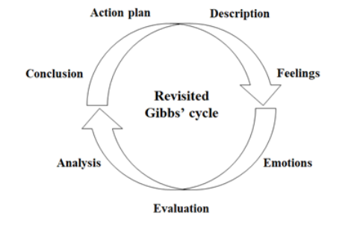
Figure 14: Gibbs’ Reflective Cycle
(Source: Galli and New, 2022)

2.2 Description
The entire assignment involved the preparation of comparative global marketing reports which explored the operation of Pizza Hut in its Home market U.S and the host market India. In the report I used various secondary research comprising academic journals, industry reports, company publications and various government data sources. Initially, I conducted a literature review. Literature review presented as a procedure including activities like searching, identifying, and reading, summarising, compiling, analysing, interpreting and referencing (Chigbu et al., 2023). Similarly, I have also collected data about macro environmental conditions of both the countries with PESTLE analysis and compared the cultural difference with Hofstede’s model. Moreover, further research focuses on Pizza Hut’s market segmentation, targeting and positioning tactics and assesses through marketing mix around two countries. Focus also maintained the company’s entry strategy and the ethical issues aligned with marketing practices.

2.3 Feelings
At the initial phase of this assignment, I was feeling very confident to apply relevant marketing theories. However gradually I became concerned about obtaining updated and reliable data about Pizza Hut’s global operation. The broad scope of the assignment was appealed initially as it needed to integrate different analytical frameworks while upholding argument. Along with the progression of the research my confidence got enhanced as I became more familiar with necessary global market context and identifying relevant academic sources. Moreover, I have also experienced difficulty while comparing the cultural influence among the US and India. Correlations along with background variables assist in the explanation of the cultural factors (Fog, 2023). In spite of the challenges, I found that the process is intellectually stimulating mainly while exploring how Pizza Hut adapts its operations to diversified economic circumstances and culture.

2.4 Evaluation
Various perspectives of this assignment were successful. For example, the strength of this report was its remarkable use of present industry data and academic literature which helps in improving the report credibility. Application of different frameworks and also helped me in developing a holistic understanding about how external circumstances can influence global marketing decisions. The comparison among India and the U.S also offers vital insight into standardisation versus adaptation tactics in global marketing. However, there were also some limitations. For example, one remarkable challenge was the availability of in-depth company centric data about Pizza Hut’s strategic decisions mainly concerning current functional practices in India. In some cases, conclusions are also obtained from secondary sources and industry reports rather than direct organisational data. Balancing the descriptive content with critical analysis is tough in initial drafting stages. Descriptive writing is crucial around several domains, which needs both creativity and precision (Choudhary, 2024). I realised that some presented information was also insufficient and it needed strong justification to meet the standard. Comprehensively, the overall experience strengthened my skill to critically evaluate the marketing tactics and information synthesis from diverse sources.

2.5 Analysis
I obtained vital insight into my analytical capacity and research skills. One of my main strengths was my ability to accumulate data from a wide range of academic journals and company sources. It helped me in developing a significant understanding about Pizza Hut’s global marketing strategy. Moreover, I was also able to apply theoretical models properly which helped me in structuring logical flow in the report. Insight from Gibbs’ reflective model inspires in-depth assessment of experiences and along with it I can recognise how a theoretical framework can offer vital structure for exploring complicated business. The PESTLE framework helps in exploring external environmental influences (Qawasmeh et al., 2025). This observation aligns with academic criticism which continually updates to remain relevant. Hofstede’s cultural dimension offered a useful basis for comparing cultural differences among two different nations (Yeganeh, 2025). Through it, I learned that, depending completely on cultural indicators, oversimplifies the consumer behaviour as individual preferences can vary in countries.
However, the assignment also highlights some weaknesses in my research process. I found it challenging to balance the critical analysis and description. I also faced difficulties in finding current company specific data. These limitations lead me to depend more on secondary sources from different authors. In order to mitigate these challenges, I adopted critical approaches to read various academic literatures. I also refined my note taking process for better understanding about practical business experience. These overall experiences through this report help me in enhancing my confidence and conducting in depth research for the future.

2.6 Conclusion
Reflection on the assignment process helped me in enhancing my understanding about global marketing tactics and its practical application in the multinational organisation. The research process also enhanced my ability to explore the external market condition and tactical marketing decisions from critical aspects. In challenging circumstances in assessing company specific information a strong analytical ability contributed to vital learning experiences. Comprehensively, the assignment strengthened my academic research capability and improved my confidence in applying global marketing theories to practical business contexts.

2.7 Action Plan
In my future assignment I intend to strengthen my critical analysis skill by enhancing it with existing academic databases and theoretical aspects.
- Target capability 1: Improved Deep Analysis
Actionable Strategy and Specific Method:
- Comparing different expert opinions.
- Clear explanation of Hofstede’s Models weak points.
Timeline: First 2 weeks of any new project.
Success metrics: Metric: No framework is only descriptive but includes necessary critique.
- Target capability 2: Finding Better Data
Actionable Strategy and Specific Method:
- Use of corporate investors report.
- Use of the official government website and database.
Timeline: During data collection.
Success metrics: Metric: Minimum of 10 to 15 academic and corporate sources per report.
- Target capability 3: Saving Research Time
Actionable Strategy and Specific Method:
- Doing a strict review of reading first.
- Comparison table preparation.
Timeline: First quarter of the project timeline.
Success metrics: Metric: First drafts are completed exactly on target words.
- Target capability 4: Mastering Local Marketing
Actionable Strategy and Specific Method:
- Gaining knowledge about regional and local food habits in countries.
Timeline: Ongoing
Success metrics: Metric: Ability to design hyper localised plans for different target individuals.

Reference List
Boger, C.A., Bradford, B.S. and Lin, L.C. (2025). ‘Rethinking cultural inclusiveness in the hospitality discipline: A strategic imperative.’ Journal of Teaching in Travel & Tourism, 25(2), pp.75-81. Available at: https://doi.org/10.1080/15313220.2025.2499831 (Accessed: 16 June 2026).
Chigbu, U.E., Atiku, S.O. and Du Plessis, C.C. (2023) ‘The Science of Literature Reviews: Searching, Identifying, Selecting, and Synthesising’, Publications, 11(1), pp. 1-16. Available at: https://doi.org/10.3390/publications11010002 (Accessed: 18 June 2026).
Choudhary, P.S. (2024). ‘Quick: Strategies Composition of Strong Descriptive Paragraphs for Improvement.’ Journal Publication of International Research for Engineering and Management (JOIREM), 2(11). Available at: https://joirem.com/wp-content/uploads/journal/published_paper/volume-02/issue-11/J_tdQ9Uqwq.pdf (Accessed: 14 June 2026)
Chuunga, K., Mpundu, M., and Qutieshat, A. (2025). ‘The Role of Digital Marketing in the Flourishing of International Businesses.’ International Journal of Advanced Business Studies, 4(2), 7-21. Available at: https://doi.org/10.59857/LHHJ1084 (Accessed: 16 June 2026).
Clarke, A.H., Freytag, P.V. and Cortez, R.M. (2024). ‘Revisiting the strategic role of market segmentation: Five themes for future research.’ Industrial Marketing Management, 121, pp.A7-A10. Available at: https://doi.org/10.1016/j.indmarman.2024.07.012 (Accessed: 15 June 2026).
Desai, A. R. (2023). Social background of Indian nationalism. Popular Prakashan.
Dol.gov (2026). Summary of the Major Laws of the Department of Labor. Available at: https://www.dol.gov/general/aboutdol/majorlaws (Accessed: 15 June 2026).
Fog, A. (2023). ‘Two-dimensional models of cultural differences: Statistical and theoretical analysis.’ Cross-Cultural Research, 57(2-3), pp.115-165. Available at: https://www.academia.edu/download/93010380/Two_dimensional_models_of_culture.pdf (Accessed: 15 June 2026)
Galli, F. and New, C. (2022) ‘GibbsCycle review. Emotions as a Part of the Cycle’, e-Motion: Revista de Educación, Motricidad e Investigación, 19(19), pp. 92-101. Available at: https://doi.org/10.33776/remo.vi19.7224 (Accessed: 18 June 2026).
Gov.in (2022). Ban on identified Single Use Plastic Items from 1st July 2022. Available at: https://www.pib.gov.in/PressReleasePage.aspx?PRID=1837518&reg=48&lang=2#:~:text=India%20will%20ban%20manufacture%2C%20import%2C,country%20from%20July%201%2C%202022. (Accessed: 17 June 2026).
Grand View Research (2025). GVR Report covers Online Food Delivery Services Market (2025 - 2030). Available at: https://www.grandviewresearch.com/industry-analysis/online-food-delivery-services-market (Accessed: 15 June 2026).
Hsiao, Y. C., and Lin, J. Y. (2023). ‘Knowledge management and innovation: evidence of international joint venture’. Scientometrics, 128(1), 87-113. Available at: https://doi.org/10.1007/s11192-022-04562-9 (Accessed: 12 June 2026).
Išoraitė, M. (2021). ‘7 P marketing mix literature review.’ International Journal of Trend in Scientific Research and Development (IJTSRD)., 5(6), pp.1586-1591. Available at: https://vb.vtdko.lt/object/elaba:109973123/ (Accessed: 5 August 2026).
Kugler, K. (2022). ‘The impact of data localisation laws on trade in Africa’. Policy Brief, 8, 337-357. Available at: https://www.wits.ac.za/media/wits-university/faculties-and-schools/commerce-law-and-management/research-entities/mandela-institute/documents/research-publications/PB%2008%20Data%20localisation%20laws%20and%20trade.pdf (Accessed: 18 June 2026).
LA Times (2026). Pizza Hut closing hundreds of locations around the U.S. Available at: https://www.latimes.com/business/story/2026-02-06/pizza-hut-closing-hundreds-of-locations-around-u-s (Accessed: 5 August 2026).
Lasserre, P., and Monteiro, F. (2022). Global strategic management. Bloomsbury Publishing.
NDTV (2026). Obesity Rising At Alarming Rate, Unhealthy Diets And Lifestyle Changes Responsible: Economic Survey 2025-26. Available at: https://www.ndtv.com/health/obesity-rising-at-alarming-rate-unhealthy-diets-and-lifestyle-changes-responsible-economic-survey-2025-26-10905681 (Accessed: 15 June 2026)
Pandey, G. (2022). NFHS-5: Indians are getting fatter - and it's a big problem. Available at: https://www.bbc.com/news/world-asia-india-61558119 (Accessed: 14 June 2026).
Pillen, H., Withall, L., Tonkin, E., Ward, P. R., Meyer, S. B., Henderson, J., ... and Wilson, A. M. (2024). ‘Understanding how healthcare providers build consumer trust in the Australian food system: A qualitative study’. Nutrition and Dietetics, 81(2), 180-189. Available at: https://doi.org/10.1111/1747-0080.12809 (Accessed: 16 June 2026).
Pizza Hut (2026). Our Story. Available at: https://pizzahut.com/our-story/ (Accessed: 15 June 2026).
Pizza Hut (2026a). Hut Rewards Loyalty Program Terms and Conditions. Available at: https://www.pizzahut.com/terms-hutrewards (Accessed: 17 June 2026).
Pizza Hut (2026b). Our Pizzas. Available at: https://www.pizzahut.co.in/menu/pizzas (Accessed: 17 June 2026).
Pizza Hut (2026c). More Than Great Food. Available at: https://jobs.pizzahut.com/whoweare/#:~:text=Who%20We%20Are (Accessed: 5 August 2026).
Pizza Hut Franchise (2025). No One OutPizzas the Hut. Available at: https://franchise.pizzahut.com/ (Accessed: 15 June 2026).
Pristiyono, P., Juliana, J., and Prayoga, Y. (2022). ‘Measuring customer trust through digital transformation of banking as a competitive advantage’. Jurnal Ekonomi Bisnis Dan Kewirausahaan, 11(2), 214. Available at: http://dx.doi.org/10.26418/jebik.v11i2.51986 (Accessed: 16 June 2026).
Qawasmeh, F.M., Qawasmeh, E.F., Daoud, M.K., Alfityani, A. and Maali, H. (2025) ‘The Impact of Environmental Analysis on Business Strategy: A Qualitative Approach’, Advances in Science, Technology & Innovation, pp. 345-353. Available at: https://doi.org/10.1007/978-3-031-90558-2_43 (Accessed: 16 June 2026).
Rastogi, T., Agarwal, B., and Gopal, G. (2024). ‘Exploring the nexus between sustainable marketing and customer loyalty with the mediating role of brand image’. Journal of Cleaner Production, 440, 140808. Available at: https://www.sciencedirect.com/science/article/abs/pii/S0959652624002555 (Accessed: 18 June 2026).
Razak, O. P., and Marsasi, E. G. (2023). Implementation of Joint Venture Based of Multinational Corporation in the Expanding Business Market for Europe Area Marketing Program. Jurnal Darma Agung, 31(1), 594-604. Available at: http://dx.doi.org/10.46930/ojsuda.v31i1.3077 (Accessed: 16 June 2026).
Razzak, M. R. (2023). ‘Emotions, identity, social bonds and commitment to the family business: moderating role of controlling generation’. Journal of Entrepreneurship in Emerging Economies, 15(6), 1392-1415. Available at: https://doi.org/10.1108/JEEE-01-2022-0014 (Accessed: 16 June 2026).
Sahagal, N., Evans, J., Salazar, A.M., Starr, K.J., Corichi, M. (2021). Religion and food. Available at: https://www.pewresearch.org/religion/2021/06/29/religion-and-food/ (Accessed: 16 June 2026).
Smith, P.R. (2022). Digital marketing excellence: planning, optimizing and integrating online marketing. Routledge.
Statista (2025). Fast food restaurants in the U.S. - statistics & facts. Available at: https://www.statista.com/topics/863/fast-food/?srsltid=AfmBOooozyypiMfahUPYq_jDNWeRa1YRHeu0Q-VEDxa6tu8KAQOFRUBx#topicOverview (Accessed: 15 June 2026).
The Culture Factor (2026). Country Comparison tool. Available at: https://www.theculturefactor.com/country-comparison-tool?countries=india%2Cunited+states (Accessed: 17 June 2026).
Trading Economics (2026). United States - Political Stability And Absence Of Violence/Terrorism: Estimate. Available at: https://tradingeconomics.com/united-states/political-stability-and-absence-of-violence-terrorism-estimate-wb-data.html (Accessed: 15 June 2026).
Trading Economics (2026a). United States Inflation Rate. Available at: https://tradingeconomics.com/united-states/inflation-cpi (Accessed: 15 June 2026).
Trading Economics (2026b). India - Political Stability And Absence Of Violence/Terrorism: Percentile Rank. Available at: https://tradingeconomics.com/india/political-stability-and-absence-of-violence-terrorism-percentile-rank-wb-data.html (Accessed: 16 June 2026).
Trading Economics (2026c). India Inflation Rate. Available at: https://tradingeconomics.com/india/inflation-cpi (Accessed: 15 June 2026).
Triani, N. V. (2023). Perfect Competition Market. Available at SSRN 4338530. Available at: https://papers.ssrn.com/sol3/papers.cfm?abstract_id=4338530 (Accessed: 18 June 2026).
US EPA (2020). National Overview: Facts and Figures on Materials, Wastes and Recycling. Available at: https://www.epa.gov/facts-and-figures-about-materials-waste-and-recycling/national-overview-facts-and-figures-materials (Accessed: 15 June 2026).
Wu, M., Ran, Y. and Zhu, S.X. (2022). ‘Optimal pricing strategy: How to sell to strategic consumers?.’ International Journal of Production Economics, 244, pp.1-16. Available at: https://doi.org/10.1016/j.ijpe.2021.108367 (Accessed: 15 June 2026).
Yeganeh, H. (2025) ‘Hofstede, GLOBE, Schwartz and Inglehart’s cultural dimensions: a critical examination and assessment’, European Business Review, pp. 1-18. Available at: https://doi.org/10.1108/ebr-05-2025-0144 (Accessed: 16 June 2026).
You Gov (2020). Zomato & Swiggy lead the food delivery race in India, yet many prefer ordering through QSR mobile apps. Available at: https://yougov.com/articles/33383-zomato-swiggy-lead-food-delivery-race-india-yet-ma (Accessed: 16 June 2026).

Appendices

Appendix 1: Positioning Map for Pizza Hut in the American Market
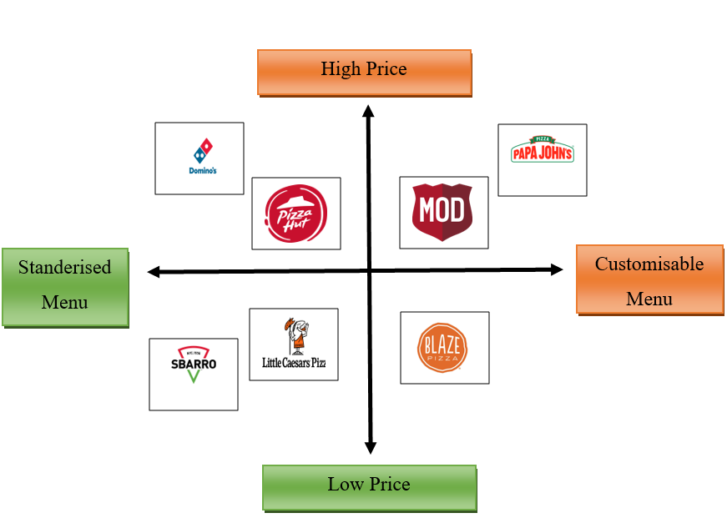
(Source: Self-Developed)

