
Module: Social Epidemiology and Public Health Development
Module Code: LCHS7000
Assignment Title: Health Inequality in Older Adults
Lecturer: Dr Jolly Nwankwo
Student Name: Pratham Ravindrakumar Luhar
Student ID: 2426580

Table of Contents
Task 1: Social Epidemiological Analysis 4
Introduction 4
Contextual Background and Underlying Factor 4
Three Diseases/ Illness experienced by UK Elderly People 4
Three Social Issues faced by UK Elderly People 5
National Responses to reduce Health Inequalities in the UK Elderly People 6
Organisations that support the UK Ageing Population 6
Conclusion 7
Task 2: Epidemiological Analysis 9
Introduction 9
Main Body 10
Public health measurement to evaluate impact of Obesity on adults 10
Key factors to cause Obesity 11
Usage of Epidemiological Studies and Health Needs Assessment 12
Epidemiological methods to monitor Obesity 12
Usage of epidemiology to determine Public Health Impact 13
Evaluation of Health Intervention Programme 13
Strengths and Weaknesses of the Identified Epidemiological Approach 13
Conclusion 14
References 15

List of Figures
Figure 1: Prevalence of CHD among aged over 50 years in England 5
Figure 2: Core20PLUS5 Framework 7
Figure 3: Worldwide adults number who overweight or obese 9
Figure 4: Prevalence of adults who obese in England 10
Figure 5: 3P’s Framework 10
Figure 6: Leading factors of Obesity 11
Figure 7: Trends of overweight and obese in UK adults 12

Task 1: Social Epidemiological Analysis
Title: Health Inequality in Older Adults: A Review of Challenges in an Ageing UK Population

Introduction
Health inequalities are defined as unfair differences in evaluating health outcomes which can be noticed between populations based on the presence of diversified social groups, position (McCartney et al., 2021). The perception of inequality depends on multiple phenomena such as age group, ethnicity, disability and others. Within this context, the study will outline how health disparities affect the UK elderly people. Around 2 million UK people aged above 65 years have experienced health inequalities and need long-term care to survive the end-of-life stage (Age UK, 2024). Due to several reasons, the target age group might be at risk of accessing proper healthcare outcomes that lead to health disparities. According to Jefferies and Williams (2025), lower socio-economic status is the primary reason that tends to increase high risk of health behaviours among UK older people and hinder proper healthcare accessibility. Age discrimination is another old-age stereotype that causes healthcare stigma and produces negative health outcomes like high mortality rate, dementia (UK Parliament, 2021). Thus, the UK healthcare setting needs to improve its practices to generate fruitful outcomes for elderly people. In this regard, NHS England (2023) outlined that the NHS Digital Plan already aims to reduce health inequalities among UK older people through bridging gaps in accessibility and improving healthcare service quality.

Contextual Background and Underlying Factor

Three Diseases/ Illness experienced by UK Elderly People
Dementia/ Alzheimer’s: Age is considered as a high-risk factor for dementia which profoundly impacts older people's behaviour, thinking ability, memory (Aggarwal et al., 2022). Currently, 982,000 UK people are experiencing this healthcare disease and are expected to increase to 1.4 million within 2040 (Alzheimer's Society, 2024). For fixing dementia care, NHS bodies will be required to collaborate with the Alzheimer's Society which aims to offer physical and mental well-being to older people through care homes (Alzheimer's Society, 2016).
Diabetes: It is the most common metabolic long-term health issue which is characterised by vascular complications and disability (BGS, 2018). In the UK, approximately 1.5 million older people live with diabetes who are above 65 years (Diabetes UK, 2024). In this context, the association with the NHS Diabetes Prevention Programme should encourage people to lead a healthy lifestyle where the NHS already aims to reduce risk of diabetes (NHS England, 2025).
Heart Diseases: High prevalence in older age which limits physical activity and erodes people's quality of life (Rodgers et al., 2019). In England, the high risk of Coronary Heart Diseases (CHD) present among elderly people.
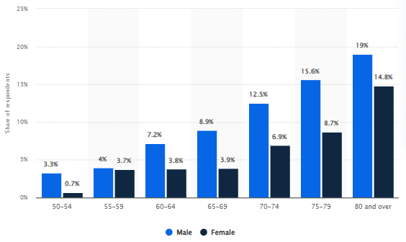
Figure 1: Prevalence of CHD among aged over 50 years in England
(Source: Stewart, 2025)
It is seen that around 12.5% of men diagnosed with CHD are aged between 70 to 74 years (Stewart, 2025). For preventing cardiovascular diseases, the healthcare setting should provide guideline-directed therapies to older adults and nurture a holistic approach of care (Townsend et al., 2025).

Three Social Issues faced by UK Elderly People
Social Isolation: It is an underlying factor of health inequalities and highlighted as a robust predictor of mortality rate (Umberson and Donnelly, 2023). Loneliness is a major issue towards the UK elderly people. Over 2 million older people live alone in England due to various reasons like getting older, spouses’ deaths, disability and others (NHS, 2025). Community-based intergenerational programmes will support older adults to connect with younger generations and reduce loneliness.
Low Economic Status: A fundamental cause of health inequality is lower socioeconomic status which limits high-quality healthcare access or exposing risks like high mortality (Zhang et al., 2019). Financial insecurity is a growing concern for the UK ageing population that negatively affects people's health and mental well-being (Local Government Association, 2015). For strengthening financial stability, social security systems allow older people to access pensions or get income support from the government (World Bank Group, 2014).
Shortage of Care Workers: It leads to poor health outcomes for an ageing population as care worker shortages create gaps to deliver quality service (Brimblecombe and Cartagena Farias, 2022). Due to staffing crisis in the healthcare context, the UK elderly people experience poor healthcare services which causes inequalities (Britannia School of Health Care, 2025). Training and certification programmes will contribute to healthcare professionals successfully managing ageing populations' poor physical and mental conditions.

National Responses to reduce Health Inequalities in the UK Elderly People
A critical element of the healthcare setting is “Power” which contributes to dealing with health inequalities and implementing system-level changes to assess an equitable outcome (McCartney et al., 2021). According to the Fundamental Cause Theory, health inequalities persistently increase the rate of mortality and morbidity. It outlines how a specific population negatively affects due to economic position, wealth and many factors (McCartney et al., 2021). In this regard, the UK healthcare context has taken multiple effective ways to address inequalities and manage social injustice of the ageing population.
To support the UK’s ageing population and diminish people's health inequalities, NHS England launched the “NHS Long-Term Plan”. According to Charles and Ewbank (2019), the plan is considered as a strategic framework and policy document that commits to reducig health inequalities by integrating a systematic approach. With the help of this plan, the UK healthcare setting also aims to overcome staffing shortfalls and deliver quality service to the ageing population (Ferreira and Collins, 2023). Thus, it is considered that the plan is beneficial to offer proactive and integrated support to the ageing population and improve the UK community-based care service.
Another effective public campaign is the “National Healthcare Inequalities Improvement Programme (HiQiP)” which was established by NHS England in 2021. The campaign acknowledges delivering quality healthcare for all people and promotes the existence of equitable access with optimal outcomes (NHS England, 2025a). Hence, it is emphasised HiQiP is an effective source to tackle the elderly healthcare disparities and promote population health management system.

Organisations that support the UK Ageing Population
To raise awareness regarding health inequalities or societal justice, charitable organisations play a significant role in contributing to patient welfare by allocating resources and embracing hospital capacity (Bowles et al., 2023). In this context, the UK charitable organisations advocate policy changes by promoting awareness and empowering communities (elderly people) to access health equity.
A renowned charitable organisation is the British Geriatrics Society (BGS) which follows the “Core20PLUS5 Framework” to reduce healthcare inequalities among ageing populations (BGS, 2025).
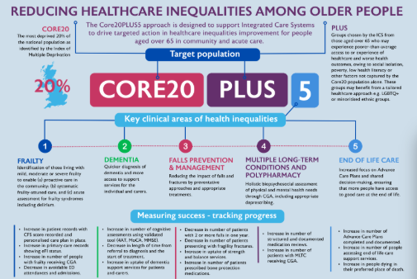
Figure 2: Core20PLUS5 Framework
(Source: BGS, 2025)
The framework is developed by NHS England and also set goals to deliver greater quality healthcare service by considering five different clinical areas (dementia, frailty, polypharmacy, long-term conditions, falls prevention and management) (BGS, 2025). Thus, it is considered that BGS plays a pivotal role in UK society to advocate person-centered care and ensure the presence of equitable healthcare access.
A well-known UK Humanitarian Charity is the British Red Cross which works to succeed the NHS 10-year plan (British Red Cross, 2025). The organisation acknowledges the strain on the NHS like helping older people to reach home safely and recover wellness after medication. The organisation also increases emergency availability like hospital admission in 14 sites across England (British Red Cross, 2025). Hence, it is determined that the British Red Cross acknowledge to bridge gaps in NHS care and provide emotional support to the UK elderly people.

Conclusion
From the above discussion, it can be summarised that the UK ageing population is experiencing health inequalities where several reasons affect society as well as communities. It is seen that the identified people are experiencing multiple illnesses and social issues which affect their physical and mental well-being. Within this context, NHS Long-Term Plan and HiQiP programme plays an important role in reducing health inequalities. Lastly, UK charitable organisations are also responsible for promoting awareness in society regarding societal injustice.
Within this context, it is recommended that the UK healthcare setting improve accessible healthcare systems. Additionally, investment in community resources such as accessible housing for vulnerable people, public transport for seniors to promote social inclusion.

Task 2: Epidemiological Analysis

Introduction
Currently, “Obsesity” is highlighted as a global public health concern due to its negative impact on people's health. According to the WHO (World Health Organisation) this public health issue is declared as a global epidemic (Mohajan and Mohajan, 2023). This specific health issue is increasing day by day across the world and enhances the rate of mortality and morbidity. It not only carries out social and cultural consequences but also affects health outcomes. As a significant issue, obesity widely affects UK adults who are obese or overweight such as heart diseases, diabetes and many more. According to Elflein (2025), obesity is a global problem and approximately 42% of the world's population is experiencing obesity and being overweight.
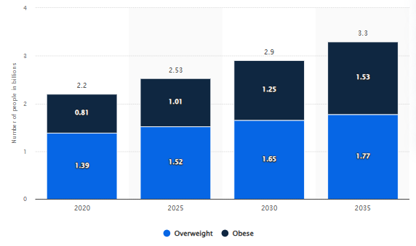
Figure 3: Worldwide adults number who overweight or obese
(Source: Stewart, 2025a)
As of 2020, an estimated 2.2 billion adults aged over 20 years are experiencing the public health issue and expected to increase 3.3 billion by 2035 (Stewart, 2025a).
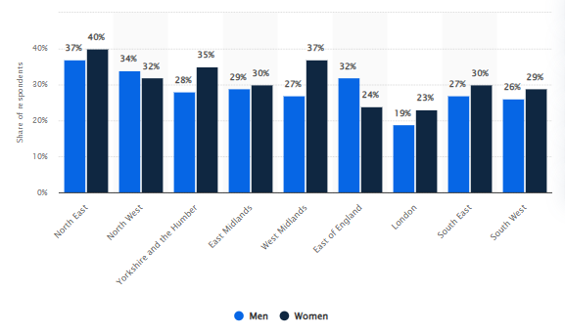
Figure 4: Prevalence of adults who obese in England
(Source: Stewart, 2025b)
In 2022, 37% of men and 40% of women were experiencing obesity in England (Stewart, 2025b). Nowadays, the obesity prevalence is continuously increasing with around 2.7 thousand men being admitted to UK hospitals as of 2019/20 (Stewart, 2025c). Therefore, in the societal context obesity leads to psychological distress among adults and highlights negative health consequences like health problems. According to Bannuru (2025), weight stigma also creates cultural barriers for adults to access mental well-being.

Main Body

Public health measurement to evaluate impact of Obesity on adults
The 3P’s framework emphasises an evidence-based approach to ensure patient safety in the healthcare setting (Nathwani and Rahman, 2021).
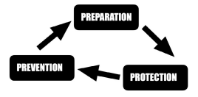
Figure 5: 3P’s Framework
(Source: Nathwani and Rahman, 2021)
Within this context, the application of the 3P’s model outlines a profound impact of obesity on adults along with a holistic perspective to treat the non-communicable disease prudently.
Preparation: It facilitates clinical guidance to evaluate risks and identify the root cause of obesity (Nathwani and Rahman, 2021). According to WHO (2025), as a chronic disease obesity negatively affects adults who are overweight by more than 25. As of 2022, 2.5 billion adults are living with obesity worldwide. This disparity is also associated with morbidities that also entrench health inequalities (The King’s Fund, 2019). In this regard, the NHS Long-Term Plan contains risk-related awareness towards healthcare professionals and target populations. The converse patient needs to follow a healthy diet for managing their overweight (The King’s Fund, 2019).
Protection: Focus on managing the health risk through proper mitigating strategies (Nathwani and Rahman, 2021). In the UK, the proportion of obesity has gradually increased where clinical judgement is an effective source to manage the identified health problem. As an example, NICE-based guidance illustrates the necessity of following clinical assessment to diagnose the BMI category (Balogun, 2023).
Prevention: Highlight actions that aim to reduce the identified health risk cautiously (Nathwani and Rahman, 2021). For treating obesity in adults, NHS England introduced its Digital Weight Management Programme which is a 12 week-based online behavioural and lifestyle programme. It streamlined the collaboration between healthcare professionals and patients. Therefore, people are enabled to access behavioural therapy from healthcare specialists and go through weight loss treatment (NHS England, 2025b).

Key factors to cause Obesity
Multiple factors are contributing to obesity among adults. According to Ahmed and Mohammed (2025), biological factors (primarily genetics) is one of the vital sources to lead obesity whereas metabolic dysfunctions gain weights of individuals.
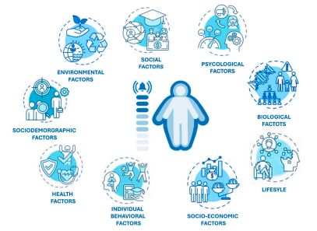
Figure 6: Leading factors of Obesity
(Source: Ahmed and Mohammed, 2025)
Additionally, behavioural factors like unhealthy eating patterns, physical inactivity increase people's fat deposition (Ahmed and Mohammed, 2025).

Usage of Epidemiological Studies and Health Needs Assessment
Examining and diagnosing a health issues distribution and state in a specific population is considered as an epidemiological study (Merrill, 2024). As per the statement of GOV.UK (2024), 64% of adults in England are living with obesity who aged over 18 years in the period 2022/23. In this context, CRPD analysis outlines that the trend of this health disparity is continuously increasing and primarily impacts adult women (aged between 18 to 40 years) (CRPD, 2022). According to the NHS (2025a), one in every four adults are experiencing obese and face multiple chronic problems like high blood pressure, cholesterol, cancer, diabetes and others.
Alternatively, the Obesity Health Needs Assessment demonstrates that reducing body weight is considered a healthy lifestyle which needs to be managed by adults to optimise their healthy weight (Havering London Borough, 2024). Thus, it needs to understand the impact of health problems and manage those in effective ways.

Epidemiological methods to monitor Obesity
According to Smieszek and Salathé (2013), the epidemiological method is an effective parameter to identify risk factors of a disease by considering its intervention, prevention and controlling process. Within this context, several parameters are used to surveillance obesity patterns and its impact on population health.
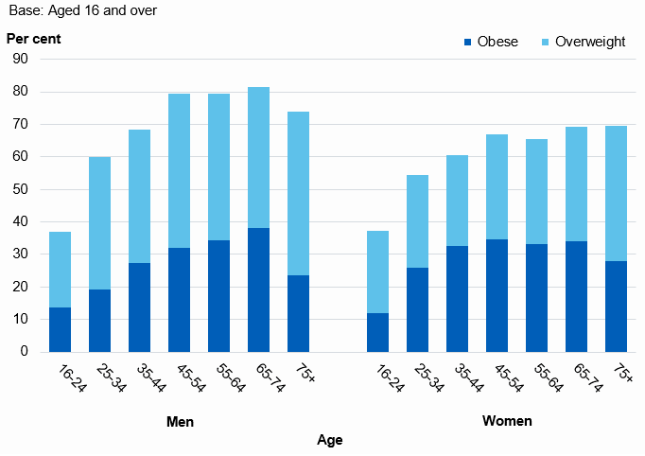
Figure 7: Trends of overweight and obese in UK adults
(Source: NHS England, 2020)
Based on the “Health Survey for England 2019”, it is demonstrated that multiple factors make adults obese such as eating disorders, hypertension, alcohol consumption, smoking and others (NHS England, 2020). In addition, the “HSE 2022 Methods Report” outlines that NHS England is responsible for monitoring the health disparity prevalence in adults which is measured through individual BMI (Body Mass Index) (NHS England, 2024).

Usage of epidemiology to determine Public Health Impact
To determine obesity-related conditions among patients, epidemiological consideration plays an important role. Depending on the clinical perspective, long-term based obesity management focuses on graded strategies like physical activity, caloric restriction that can be followed by patients. Alternatively, appropriate resource allocation, clinical awareness lead to short-term consequences (Singh et al., 2022). In England, BMI threshold is a strong predictor of long-term consequences of obesity in adults. It not only helps to measure weight circumference but also highlights the accounting of birth cohort effects (Gray and Opazo Breton, 2025). In addition, the infusion of environmental-behavioural approach is highlighted as a primary source of obesity prevention in the UK. It contributes to mapping out building blocks on the public health intervention and evaluates output on a short-term basis (Roy-Highley and Briggs, 2023).
Thus, to prevent obesity in adults, a digital health intervention programme will be a beneficial source that encourages target audiences (UK adults who are aged over 18) to bring positive changes in behaviour. It will also connect with multidisciplinary medical programs. According to the Parliament.UK (2013), NICE guidelines stated that digital-based intervention programme is a valuable source to tackle obesity which is the current most public health concern.

Evaluation of Health Intervention Programme
A point-based structured weight management health intervention programme will help to make a connection between personalised nutrition, cutting-edge technology that supports UK adults to achieve weight loss goals. Besides this, integrated medical programs will ensure the presence of board-certified physicians to support individual healthy lifestyles.
It will have a positive impact in helping UK adults successfully deal with weight loss journeys and manage obesity with standard care. According to Ahern et al. (2011) people lifestyle-based a group weight programme influences UK adults to lose weight who are considered as overweight or obese. It not only offers long-term support to patients but also significantly impacts their weight-loss journey.

Strengths and Weaknesses of the Identified Epidemiological Approach
Strengths: Diagnosis and screening of obesity carry out multiple advantages. As per the opinion of Sweatt et al. (2024), body weight measurement outlines a quick assessment that is easy to calculate BMI and identify health risks like high blood pressure, diabetes, cancers and many more.
Weaknesses: Clinical components of obesity diagnosis also have several limitations which hinder measuring health status. Within this context, Sweatt et al. (2024) argues that the identified epidemiological approach adversely affects individual life and reflects inconsistency in measuring health status. From inadequate individual assessment to ethnic differences inhibit the progress to diagnose overweight or fat mass contents of patients.

Conclusion
The above discussion depicts that the current global public health concern is obesity. This health disparity not only increases day by day but also enhances morbidity and mortality rates in adults. The application of the 3P’s framework is used to evaluate the impact of obesity in adults along with identifying key factors. From the usage of epidemiological studies and health needs assessment to methods that observe the existing obesity pattern with its impact on target population. Lastly, a new health intervention programme is proposed for its further implication in the UK healthcare setting to reduce obese or overweight adults.

References
Age UK (2024) State of Health and Care of Older People in England 2024. Available at: https://www.ageuk.org.uk/discover/2024/september/state-of-health-and-care-of-older-people-in-england-2024/ (Accessed: 12 December 2025).
Aggarwal, H., Chaware, S. and Aggarwal, H. (2022) ‘A critical study on the impact of dementia on older people undergoing treatment in care homes’, Cureus, 14(10). Available at: https://doi.org/10.7759/cureus.30056
Ahern, A.L., Olson, A.D., Aston, L.M. and Jebb, S.A. (2011) ‘Weight Watchers on prescription: an observational study of weight change among adults referred to Weight Watchers by the NHS’, BMC public health, 11(1), p.434. Available at: https://link.springer.com/content/pdf/10.1186/1471-2458-11-434.pdf
Ahmed, S.K. and Mohammed, R.A. (2025) ‘Obesity: Prevalence, causes, consequences, management, preventive strategies and future research directions’, Metabolism Open, p.100375. Available at: https://doi.org/10.1016/j.metop.2025.100375
Alzheimer's Society (2016) Fix Dementia Care NHS and care homes. Available at: https://www.alzheimers.org.uk/sites/default/files/migrate/downloads/fix_dementia_care_nhs_and_care_homes_report.pdf (Accessed: 12 December 2025).
Alzheimer's Society (2024) How many people have dementia in the UK?. Available at: https://www.alzheimers.org.uk/blog/how-many-people-have-dementia-uk (Accessed: 12 December 2025).
Balogun, B. (2023) Obesity policy in England. Available at: https://researchbriefings.files.parliament.uk/documents/CBP-9049/CBP-9049.pdf (Accessed: 12 December 2025).
Bannuru, R.R. (2025) ‘Weight stigma and bias: standards of care in overweight and obesity—2025’, BMJ open diabetes research & care, 13(Suppl 1). Available at: doi:10.1136/ bmjdrc-2025-004962 (Accessed: 12 December 2025).
BGS (2018) Diabetes. Available at: https://www.bgs.org.uk/diabetes-0#:~:text=Diabetes%20is%20the%20commonest%20metabolic,hospital%20admissions%2C%20and%20increased%20institutionalisation. (Accessed: 12 December 2025).
BGS (2025) Core20PLUS5 Framework: Reducing healthcare inequalities among older people. Available at: https://www.bgs.org.uk/core20plus5 (Accessed: 12 December 2025).
Bowles, J., Clifford, D. and Mohan, J. (2023) ‘The place of charity in a public health service: inequality and persistence in charitable support for NHS Trusts in England’, Social Science & Medicine, 322, p.115805. Available at: https://doi.org/10.1016/j.socscimed.2023.115805
Brimblecombe, N. and Cartagena Farias, J. (2022) ‘Inequalities in unpaid carer's health, employment status and social isolation’, Health & Social Care in the Community, 30(6), pp.e6564-e6576.
Britannia School of Health Care (2025) The Demand for Skilled Adult Care Workers in the UK. Available at: https://schoolofhealthcare.co.uk/the-demand-for-skilled-adult-care-workers-in-the-uk/ (Accessed: 12 December 2025).
British Red Cross (2025) British Red Cross responds to the government's NHS 10-year plan. Available at: https://www.redcross.org.uk/about-us/news-and-media/media-centre/press-releases/british-red-cross-responds-to-nhs-10-year-plan (Accessed: 12 December 2025).
Charles, A. and Ewbank, L. (2019) The NHS long-term plan explained. Available at: https://www.kingsfund.org.uk/insight-and-analysis/long-reads/nhs-long-term-plan-explained (Accessed: 12 December 2025).
CRPD (2022) Weight loss and reproductive outcomes in women with overweight or obesity: a population-based cohort study using the UK clinical practice research datalink. Available at: https://www.cprd.com/approved-studies/weight-loss-and-reproductive-outcomes-women-overweight-or-obesity-population-based (Accessed: 12 December 2025).
Diabetes UK (2024) Research priorities to improve care for older people with diabetes. Available at: https://www.diabetes.org.uk/about-us/news-and-views/research-priorities-improve-care-older-people-diabetes#:~:text=Over%20a%20third%20of%20people,with%20diabetes%20even%20more%20challenging. (Accessed: 12 December 2025).
Elflein, J. (2025) Obesity worldwide - Statistics & Facts. Available at: https://www.statista.com/topics/9037/obesity-worldwide/?srsltid=AfmBOor19Hgx92BKwQmy5SqjSMfoWAh9slKlo0SfhpTq8gpgzbyZ__sI#topicOverview (Accessed: 12 December 2025).
Ferreira, T. and Collins, A.M. (2023) ‘The NHS Long Term Workforce Plan: an ambitious leap or a misstep?’, Journal of the Royal Society of Medicine, 116(11), pp.368-370. Available at: http://dx.doi.org/10.1177/01410768231198373
GOV.UK (2024) Obesity Profile: short statistical commentary May 2024. Available at: https://www.gov.uk/government/statistics/update-to-the-obesity-profile-on-fingertips/obesity-profile-short-statistical-commentary-may-2024 (Accessed: 12 December 2025).
Gray, L.A. and Opazo Breton, M. (2025) ‘Long-term trends in central obesity in England: an age-period-cohort approach: Epidemiology and Population Health’, International Journal of Obesity, pp.1-8. Available at: https://www.nature.com/articles/s41366-025-01949-5.pdf (Accessed: 12 December 2025).
Havering London Borough (2024) Obesity Health Needs Assessment. Available at: https://consultation.havering.gov.uk/public-health/healthy-weight-strategy-consultation/supporting_documents/Havering%20Obesity%20Health%20Needs%20Assessment%20V1.0.pdf (Accessed: 12 December 2025).
Jefferies, D. and Williams, E. (2025) What are health inequalities?. Available at: https://www.kingsfund.org.uk/insight-and-analysis/long-reads/what-are-health-inequalities#:~:text=For%20example%2C%20as%20noted%20above,than%20higher%20socio%2Deconomic%20groups. (Accessed: 12 December 2025).
Local Government Association (2015) Ageing: the silver lining. Available at: https://www.local.gov.uk/sites/default/files/documents/ageing-silver-lining-exec-1cb.pdf (Accessed: 12 December 2025).
McCartney, G., Dickie, E., Escobar, O. and Collins, C. (2021) ‘Health inequalities, fundamental causes and power: towards the practice of good theory’, Sociology of health & illness, 43(1), pp.20-39. Available at: doi: 10.1111/1467-9566.13181
Merrill, R.M. (2024) Introduction to epidemiology. Jones & Bartlett Learning.
Mohajan, D. and Mohajan, H.K. (2023) ‘Obesity and its related diseases: a new escalating alarming in global health’, Journal of Innovations in Medical Research, 2(3), pp.12-23.
Nathwani, S. and Rahman, N. (2021) ‘The 3 P’s model enhancing patient safety during the COVID‐19 pandemic’, Oral Surgery, 14(3), pp.246-254. Available at: https://doi.org/10.1111/ors.12607
NHS (2025) Loneliness in older people. Available at: https://www.nhs.uk/mental-health/feelings-symptoms-behaviours/feelings-and-symptoms/loneliness-in-older-people/ (Accessed: 12 December 2025).
NHS (2025a) Overview: Obesity. Available at: https://www.nhs.uk/conditions/obesity/ (Accessed: 12 December 2025).
NHS England (2020) Health Survey for England 2019 [NS]. Available at: https://digital.nhs.uk/data-and-information/publications/statistical/health-survey-for-england/2019/main-findings (Accessed: 12 December 2025).
NHS England (2023) Inclusive digital healthcare: a framework for NHS action on digital inclusion. Available at: https://www.england.nhs.uk/long-read/inclusive-digital-healthcare-a-framework-for-nhs-action-on-digital-inclusion/ (Accessed: 12 December 2025).
NHS England (2024) Health Survey for England 2022 Methods. Available at: https://files.digital.nhs.uk/6C/753EC3/Health%20Survey%20for%20England%202022%2C%20Methods.pdf (Accessed: 12 December 2025).
NHS England (2025) NHS Diabetes Prevention Programme (NHS DPP). Available at: https://www.england.nhs.uk/diabetes/diabetes-prevention/#:~:text=People%20on%20the%20face%2Dto,doing%20any%20of%20the%20following: (Accessed: 12 December 2025).
NHS England (2025a) National Healthcare Inequalities Improvement Programme. Available at: https://www.england.nhs.uk/about/equality/equality-hub/national-healthcare-inequalities-improvement-programme/ (Accessed: 12 December 2025).
NHS England (2025b) The NHS Digital Weight Management Programme. Available at: https://www.england.nhs.uk/digital-weight-management/ (Accessed: 12 December 2025).
Parliament.UK (2013) Health Committee: Written evidence from Weight Watchers UK Ltd (NICE 03). Available at: https://publications.parliament.uk/pa/cm201213/cmselect/cmhealth/782/782vw02.htm (Accessed: 12 December 2025).
Rodgers, J.L., Jones, J., Bolleddu, S.I., Vanthenapalli, S., Rodgers, L.E., Shah, K., Karia, K. and Panguluri, S.K. (2019) ‘Cardiovascular risks associated with gender and aging’, Journal of cardiovascular development and disease, 6(2), p.19. Available at: https://doi.org/10.3390/jcdd6020019
Roy-Highley, E. and Briggs, A.D. (2023) ‘A clinician's guide to obesity prevention in the UK’, Clinical Medicine, 23(4), pp.292-298. Available at: https://doi.org/10.7861/clinmed.2023-0150
Singh, A., Hardin, B.I., Singh, D. and Keyes, D. (2022) Epidemiologic and etiologic considerations of obesity.
Smieszek, T. and Salathé, M. (2013) ‘A low-cost method to assess the epidemiological importance of individuals in controlling infectious disease outbreaks’, BMC medicine, 11(1), p.35. Available at: https://link.springer.com/content/pdf/10.1186/1741-7015-11-35.pdf
Stewart, C. (2025) Prevalence of diagnosed coronary heart disease (CHD) among those aged over 50 years in England in 2018/19, by gender and age. Available at: https://www.statista.com/statistics/983023/england-chd-among-older-people/?srsltid=AfmBOopspUSpRsXniNSTYZSf_VNl5LM8XBGwb0ktIb3-0nh9caZBbtqu (Accessed: 12 December 2025).
Stewart, C. (2025a) Number of adults aged 20 years and older worldwide who were overweight or obese in 2020 and forecasts to 2035. Available at: https://www.statista.com/statistics/1386134/number-of-overweight-or-obese-people-worldwide-forecasts/?srsltid=AfmBOooGME6OahbWp37WcEKbmCpTjAxetCzG4FOT6jbPJftspqz8RzRF (Accessed: 12 December 2025).
Stewart, C. (2025b) Prevalence of adults who were obese in England in 2022, by gender and region. Available at: https://www.statista.com/statistics/375902/obesity-prevalence-by-gender-and-region-in-england/?srsltid=AfmBOoqQ4EQg793CdqYvtfrwv0o5KZgTuWd8hbuOYrWlZqAUmIBPiGDD (Accessed: 12 December 2025).
Stewart, C. (2025c) Obesity prevalence among individuals in England from 2000 to 2022, by gender. Available at: https://www.statista.com/statistics/334126/obesity-prevalence-by-gender-in-england-uk/?srsltid=AfmBOopAEx0iwlwuC6uWb6UgFy-3EImp-1842h6q6TKh-8bsqr5ulb5D (Accessed: 12 December 2025).
Sweatt, K., Garvey, W.T. and Martins, C. (2024) ‘Strengths and Limitations of BMI in the Diagnosis of Obesity: What is the Path Forward?’, Current obesity reports, 13(3), pp.584-595. Available at: https://doi.org/10.1007/s13679-024-00580-1 (Accessed: 12 December 2025).
The King’s Fund (2019) Tackling obesity: The role of the NHS in a whole-system approach. Available at: https://assets.kingsfund.org.uk/f/256914/x/cead3911f6/tackling_obesity_role_nhs_whole_system_approach_2021.pdf (Accessed: 12 December 2025).
Townsend, N., Timmis, A., Erglis, A., Miličić, D., Perrone-Filardi, P., Weidinger, F., Guzik, T. and Gale, C.P. (2025) ‘Challenges in the prevention, treatment and management of cardiovascular disease among older adults’, The Lancet Regional Health–Europe, 56. Available at: https://doi.org/10.1016/j.lanepe.2025.101372
UK Parliament (2021) Centre for Ageing Better response to – The role of the GEO: embedding equalities across Government. Available at: https://committees.parliament.uk/writtenevidence/22776/html/ (Accessed: 12 December 2025).
Umberson, D. and Donnelly, R. (2023) ‘Social isolation: An unequally distributed health hazard’, Annual Review of Sociology, 49(1), pp.379-399. Available at: https://doi.org/10.1146/annurev-soc-031021-012001
WHO (2025) Obesity and overweight. Available at: https://www.who.int/news-room/fact-sheets/detail/obesity-and-overweight (Accessed: 12 December 2025).
World Bank Group (2014) Summary of the UK Social Security Benefit System. Available at: https://www.worldbank.org/content/dam/Worldbank/document/eca/croatia/efc%20conference/russian/EFC%20Workshop%20Opatija%20Brief%20on%20UK%20Benefits.pdf (Accessed: 12 December 2025).
Zhang, C.Q., Chung, P.K., Zhang, R. and Schüz, B. (2019) ‘Socioeconomic inequalities in older adults' health: the roles of neighborhood and individual-level psychosocial and behavioral resources’, Frontiers in Public Health, 7, p.318. Available at: https://doi.org/10.3389/fpubh.2019.00318

