Study skills
Portfolio
Charles R McCallum

Contents

Page 1. Front cover page
Page 1,2&3. The reasons for my choices
Page 4. How does music make you feel? (Summary 300 words)
Page 6. References for 400-word summary
Page 7. Infographic (Essential skills for writing an essay)
Page 8. Screenshots of literature from the library
Page 9&10. Essay outline for a 400-word document on the ‘Psychological and Physical Benefits of Owning a Pet’.
Page 10. Acknowledgement use of AI

How Does Music Make You Feel?
I decided to use ‘How does music make you feel’ because I listen to a lot of music in different genres, I also play a few different instruments including guitar. I have always been interested in how the ability to listen to a certain track has so much influence on how we are feeling at that specific time. Music seems to bring a world of emotions and feelings that we do not think about in other activities, it gives us sadness and joy all at the same time. There is a vast amount of literature available on music as a therapy, especially in those who are on the autism spectrum. I have noticed that people who are in that spectrum particularly enjoy listening to music through earphones or similar devices, because of the nature of the condition, the sounds of loud sudden noises can be disturbing. There is much to be said about the use of music in Alzheimer’s disease, there is much more to learn in the treatment of such conditions.
The Psychological and Physical Benefits of Owning a Pet
I have chosen the ‘Benefits of having a pet’ because who does not like animals? They are full of fun and yet sympathy at the same time, they make us feel loved, because their love is unconditional, even when we may be feeling sorrow, or just feeling down, a pet can give great comfort, in fact I would say that humans could learn a great deal from animals. When we think about the complexity of the tasks performed by working dogs, such as sheepdogs and police dogs, one cannot help to think of the intelligence of these animals. There is a great deal of satisfaction in having a pet, the benefits of having a companion who is forever ready to stand by our sides through whatever difficult times we are in. The animals that can help those with hearing and sight impairment can have a much better quality of life with the help of having an animal to be the eyes and ears of someone. There is much to be said for other animals, such as cats and smaller animals, although not as the working abilities of dogs, cats can certainly help with loneliness and sadness, especially in elderly people.

Music has been around for thousands of years; it is thought that the ancient Greek philosopher Pythagoras 570-490 BCE discovered the tuning arrangement for stringed instruments. In modern times, music is a fundamental part of life, from radio to various music platforms. Music can bring varied emotions and feelings, and sometimes a certain song can almost place the listener back to a time in their life that holds special memories.
Nendick (2022) suggests that music in different keys have opposite emotions and feelings, for example, a piece played in a major key sounds happy, whilst another piece played in a minor key sounds sad, this theory is possibly why a certain song makes the listener want to dance or to bring on a negative feeling such as cry. Studies suggest that the medial frontal cortex, ventral striatum and amygdala, the reward and pleasure areas in the brain are roused when we listen to a piece of music that we enjoy (Blood & Zatorre, 2001).
The revised BRECVEMA framework is made up of eight different responses in the listener's brain, Brain Stem Reflex, Rhythmic Entrainment, Evaluative Conditioning, Contagion, Visual Imagery, Episodic Memory, Musical Expectancy, and Aesthetic Judgment (Juslin, 2013). Since the 1950s, music has gained much interest in psychological studies, in a book authored by Leonard Meyers, titled, Emotion and Meaning in Music (1956), he developed a theory that music can contribute to different emotions in one’s mood.
It is thought that a person with a negative personality (neuroticism) is more likely to have feelings of nostalgia while listening to music (Barrett et al., 2010). According to Fraile et al., (2019), music therapy can increase memories in people with Alzheimer’s disease, by awakening memories that were thought to be lost, although early in trials, the nostalgic nature of a certain song or piece of music that has been associated with a time of happiness, seems to enhance the recall of that period of a person’s life.

Barrett, F. S., Grimm, K. J., Robins, R. W., Wildschut, T., Sedikides, C., & Janata, P. (2010). Music-evoked nostalgia: Affect, memory, and personality. Emotion, 10(3), 390–403. https://doi.org/10.1037/a0019006
Blood, A. J., & Zatorre, R. J. (2001). Intensely Pleasurable Responses to Music Correlate with Activity in Brain Regions Implicated in Reward and Emotion. Proceedings of the National Academy of Sciences, 98(20), 11818–11823. https://doi.org/10.1073/pnas.191355898
Fraile, E., Bernon, D., Rouch, I., Pongan, E., Tillmann, B., & Lévêque, Y. (2019). The effect of learning an individualised song on autobiographical memory recall in individuals with Alzheimer's disease: A pilot study. Journal of clinical and experimental neuropsychology, 41(7), 760-768.
Joslin, P. N. (2019). Blast from the Past. Musical Emotions Explained, 316–329. https://doi.org/10.1093/oso/9780198753421.003.0022
Nendick, Z. (2022, September 12). How does music make you feel? - The British Psychological Society. Www.bps.org.uk. https://www.bps.org.uk/psychologist/how-does-music-make-you-feel

‌
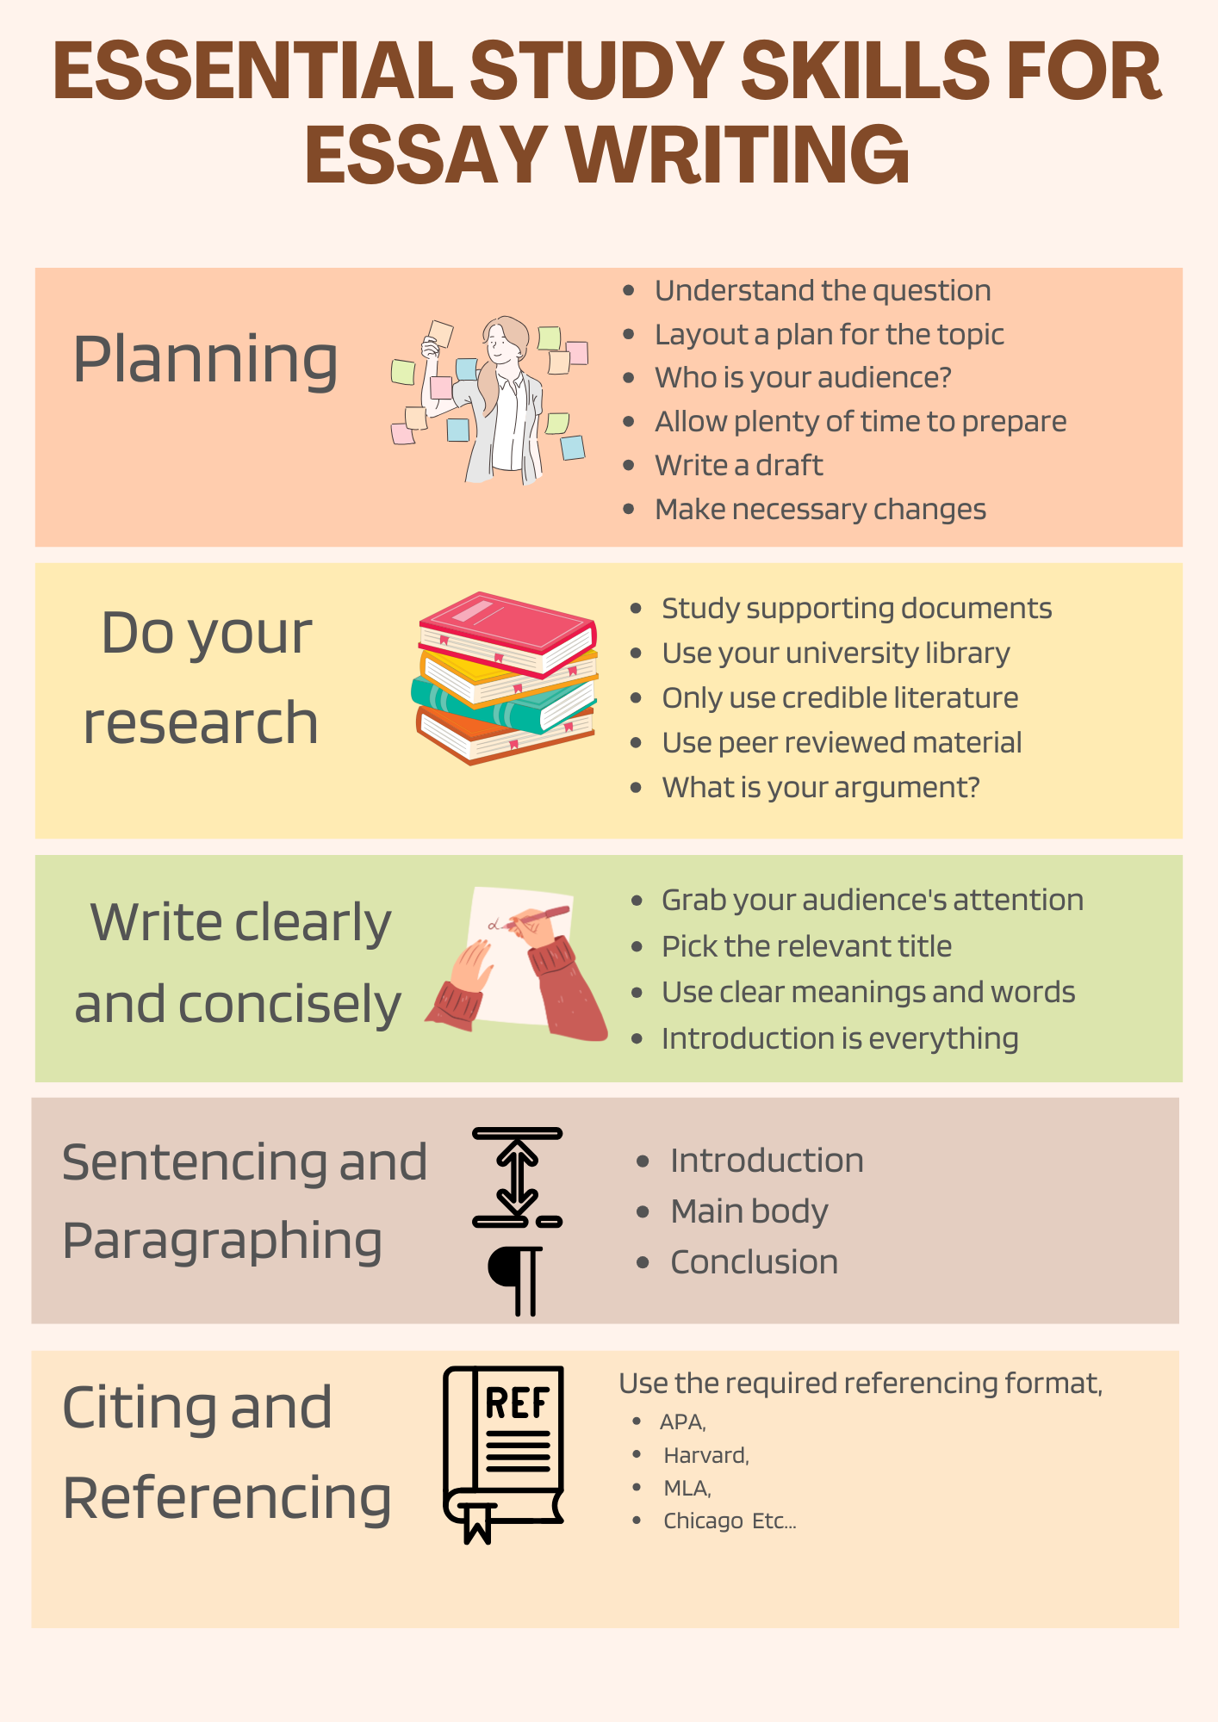

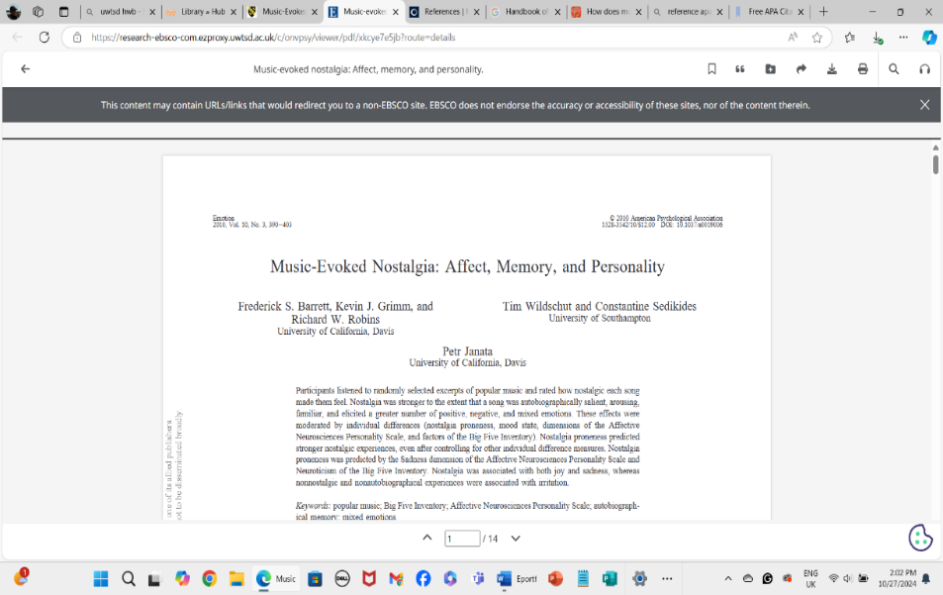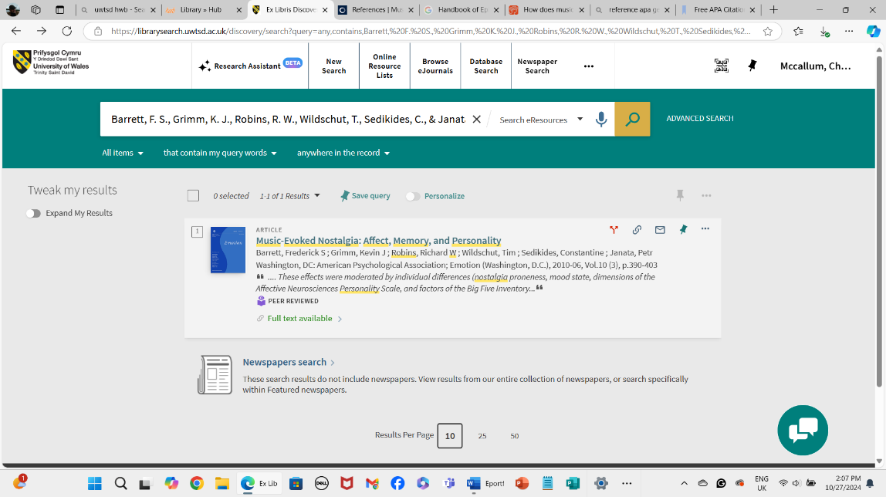

  - 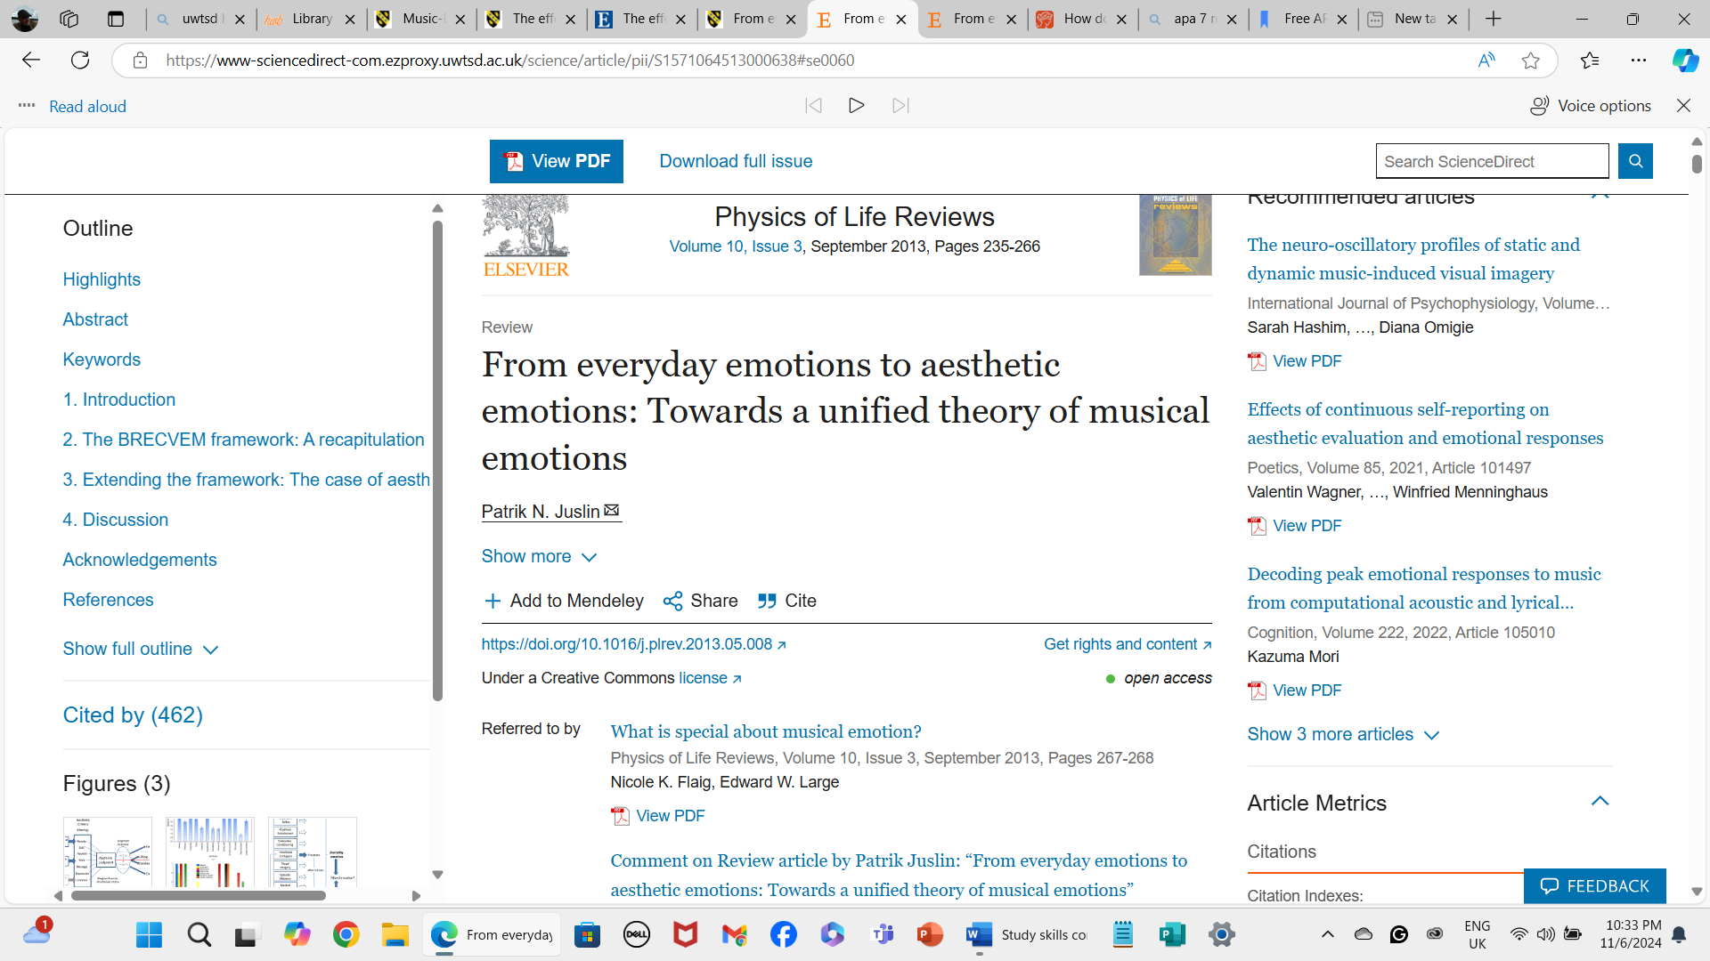

  - The Psychological, Social and Physical Benefits of Owning a Pet (400 words).

  - Introduction: (40-50 words)
  - Open the discussion with the history of animals and how we have become dependent on them as much as they depend on us.
Bring points of the discussion to the surface to grab the reader's attention.

Main body
Paragraph one: (100 words), 2-6 references
- State how humans have had pets for thousands of years (citations).
- Mention how the ancient Egyptians worshipped cats (citations).
- Talk about the diverse ways in which humans can become lonely (citations).
- Describe the different suitable breeds of dogs (citations) for therapy.
- Mention how dogs and cats are good companions.
Paragraph two: (100 words) 2-6 references
- Talk about the different animal breeds when choosing an animal.
- Include the psychological benefits (citations).
- Talk about dogs for dementia and how they can help with memory (citations).
- Using supportive trials and the outcomes (citations).
- supportive information on therapy animals (citations).
- The physical benefits of walking a dog.
Paragraph three: (100 words) 2-6 references
- Talk about the psychology of pets in a wider area of brain injuries (citations).
- Talk in detail about the use of dogs for the blind (citations).
- Hearing dogs for people living with hearing impairment (citations).
- Include the work of therapy dogs in military veterans with PTSD (citations).
- Go into detail about the benefits of animals for depression and anxiety (citations)
Conclusion: (40-50 words)
Bring all the information together and argue whether more animals and further studies could indeed be introduced in different therapies for people with other illnesses and disabilities.
References in APA Styling (10 or more references)
.Acknowledgement use of AI
The use of My BIB was used to help with references and also checked with the APA-7 Handbook.
Screenshots were used from Windows.
The infographic was generated by Canva (2024).

