
Reflective piece
Placement with PAL, Peer assisted learning.

BY
Rebecca Smith

Table of contents

Reflective summary of work placement with PAL…………………………………….. 2
References ……………………………………….. 4

Portfolio of evidence…………………………. 5
Evidence 1: Photo…………………………………………6
Evidence 2: Training Schedule…………………………………………7
Evidence 3: Training communications ……………………………………….. 11
Evidence 4: Debrief……………………………………….. 12
Evidence 5: Missed training……………………………………….. 16

Appendix ………………………………… 19
Application and acceptance emails……….19
Approval from module leader……….20
Placement information form……. 21
Log book of hours…….. 22

Reflective summary of work placement with PAL

The first time I heard about PAL was at university. Several recruiters had come in to discuss volunteer roles with vacancies. I became interested when one of the recruiters explained what a PAL mentor does. He explained that PAL stands for peer assisted learning and described the volunteer role as follows- A PAL mentor is someone from a higher level of study who can offer support and guidance to lower level students that are new to the university. I thought this role sounded really interesting and that I might be able to learn new skills and be able to support new students as someone who had been in their shoes the previous year. I signed up to become a volunteer alongside two other students from my psychology class. I heard back from Christopher, the PAL mentor recruiter, who became my supervisor about a week later who welcomed me into the role and sent me training to do at home via Moodle.
I completed the training in a couple of days and was pleased to know that I had successfully moved on to the next stage of training, which would take place at university with the other two volunteers who joined from my course. I was familiar with them both and felt comfortable working through the next level of training with them. The training took part over two days but due to being sick I was unable to attend the second day of training. This had a negative impact on my confidence as it involved role play of different scenarios in a group setting. I felt at the time that I did not have the knowledge I needed to partake in a group setting PAL situation. I spoke to the other two volunteers who said they would be happy to role play any situations that I might not feel confident with. I then also spoke to Christopher who said there maybe future training in this area.
Over the next couple of weeks several team meetings were arranged where we discussed a plan of action about how the first sessions would work. We all decided that the other two volunteers would cover an hour on Wednesdays and Fridays and I would do an hour on Mondays. The first session I covered I felt anxious as I was not sure if I would be able to offer the support someone may need. I had spent the previous evening making sure I knew where to signpost people and reread all the training material I had received so I felt that I knew what to do. In that session I was able to signpost a student successfully to a study unit at the library. At the next team meeting we all discussed our experiences and found that there was not enough interest from students and we were not interacting with as many people as we would have hoped for. Myself and the other volunteers felt disheartened and felt that another route was necessary to reach the lower level students. The other two volunteers went into class at the end of a lecture and spoke about our services. We also linked up on teams with the class and sent messages as to when we would be available and where we would be situated. However, this also did not bring more students to us. We felt that this was because students have many other opportunities to seek support such as from lecturers and student services. I think that it was good that we had many opportunities to chat via teams and discuss what was happening and to find new ways to reach the new students as this made us feel we were working as a team. On another teams meeting our point of contact, Christopher, had changed to Jo as Christpher left for a new jo. It felt good to have a new perspective from Jo but also uncomfortable as I had known Christopher from the start. Jo suggested that I could go into the end of lecture to talk to students again about PAL mentoring and suggested I took some ice breakers and did a group session after. This felt very exciting and terrifying at the same time, as it was out of my comfort zone. I felt it would be a good opportunity for me and would potentially bring more students to PAL, however prior commitments unfortunately meant that I was unable to attend and I feel like the experience could have improved my confidence.
What went well with PAL is that all volunteers were supportive of each other and had good communication. This has been shown to be a key ingredient for work environments (McClay, 2009). Mentor leaders such as Christopher and Jo were also in close contact offering advice and guidance. The training was also informative, but I think I would have gained more from attending the second training session. Training has been shown to create more confident and competent team players (Buchanan, et al.,2017). Prior to joining PAL I had not had much experience with Teams but now feel I have more skills and understanding of this programme with being able to communicate with larger groups of people and navigate between programmes such as Word. I feel students have many areas of support at UWTSD and although this is a good thing it did mean students were not so much in need of our services. I also feel that myself and PAL would have benefited if I was able to attend the after-lecture class with a group session; although this was out of my comfort zone I think with more positive experiences like this I would gain more confidence. The experience of having a debrief and minutes taken meant that everybody could be kept up to date and in the know - this is considered important for having an informed work force (Vanassche, 2023)
If I continue to work with PAL I would ensure that I am able to take up any training opportunities and have better time management skills, such as keeping a online diary with notifications so as to be able to take up any opportunities that may arise without double booking. I will continue to keep a reflective log such as this using Gibbs, G. (1998) to understand my work experience better.

References
Buchanan, J., Finegold, D., Mayhew, K., & Warhurst, C. (2017). The Oxford handbook Of Skills And Training . Oxford: Oxford University Press.
Gibbs, G. (1998). Learning By Doing: A Guilde To Teaching And Learning Methods . Oxford: Oxford Polytechnic.
McClay, R. (2009). 10 Steps To Successul Teams. London: ASTD Press.
Vanassche, E. (2023). Talking To Learn : Patterns Of Discursive Interaction InPost-Lesson Debriefs. Teaching And Teacher Education, 104301.

Portfolio of evidence
1.Photo evidence of communications via Teams

2.Trainning program

3.Communications for more training

4.Debrief and PAL meeting minutes

5. Missed training

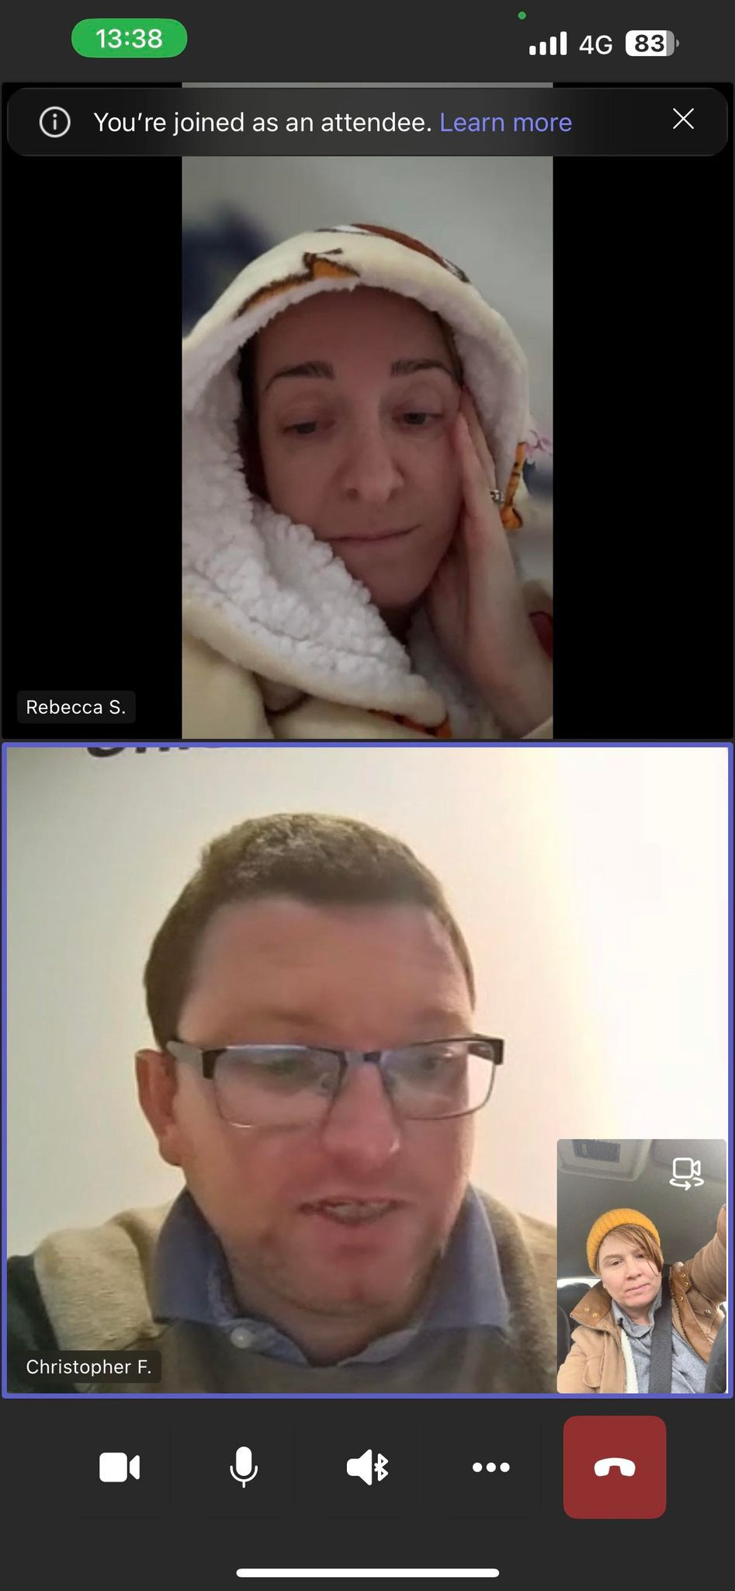
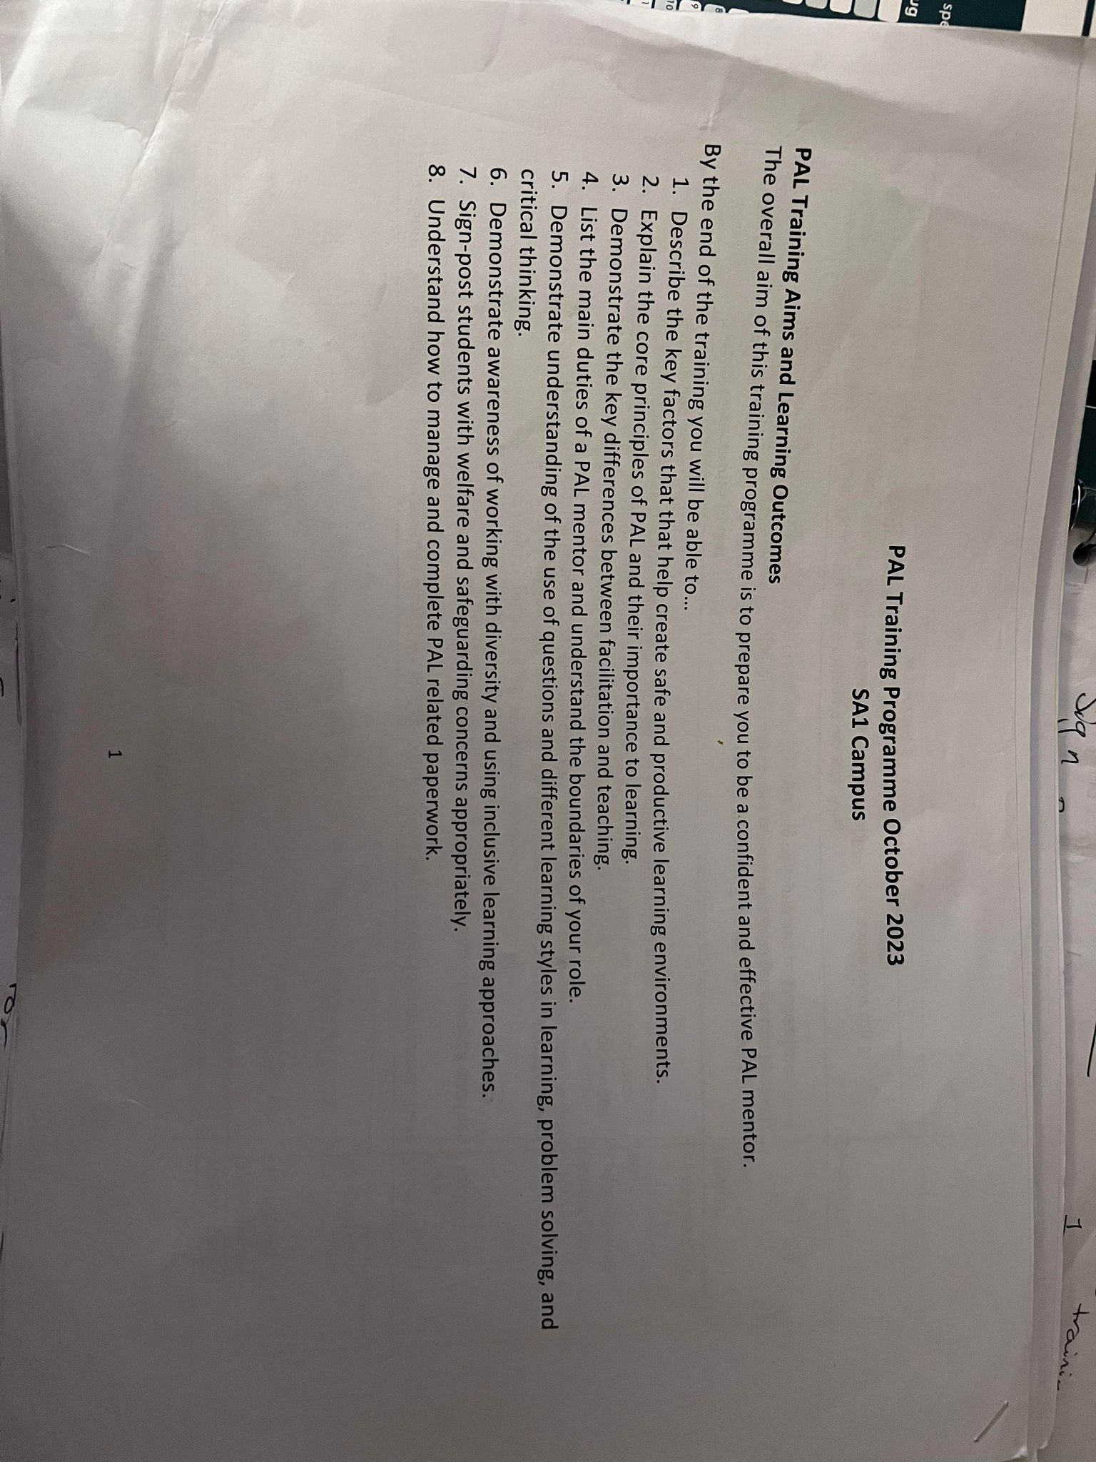

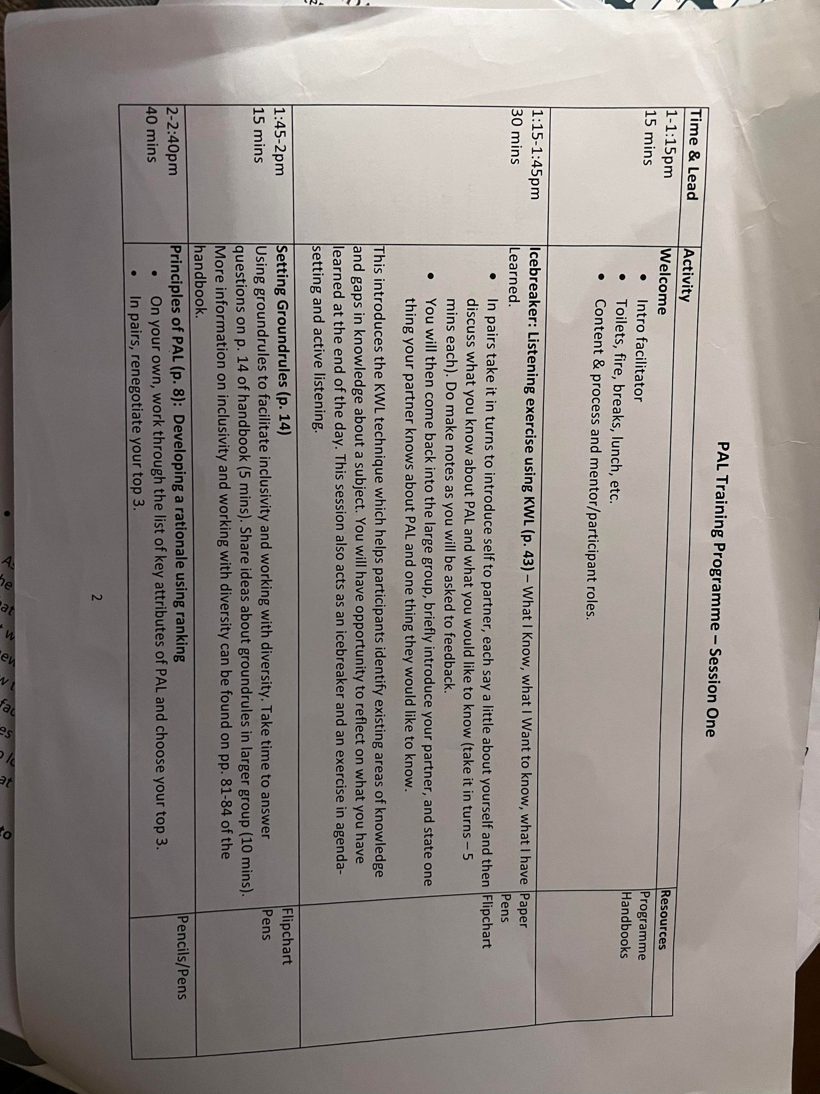

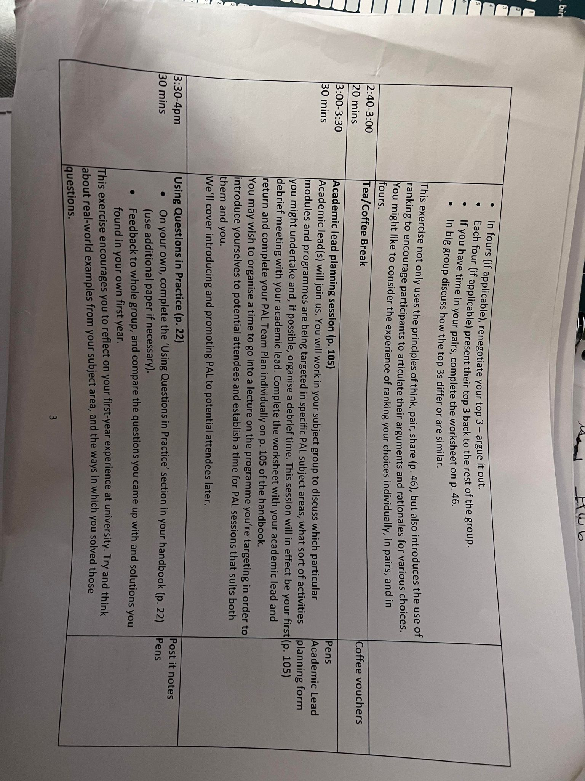
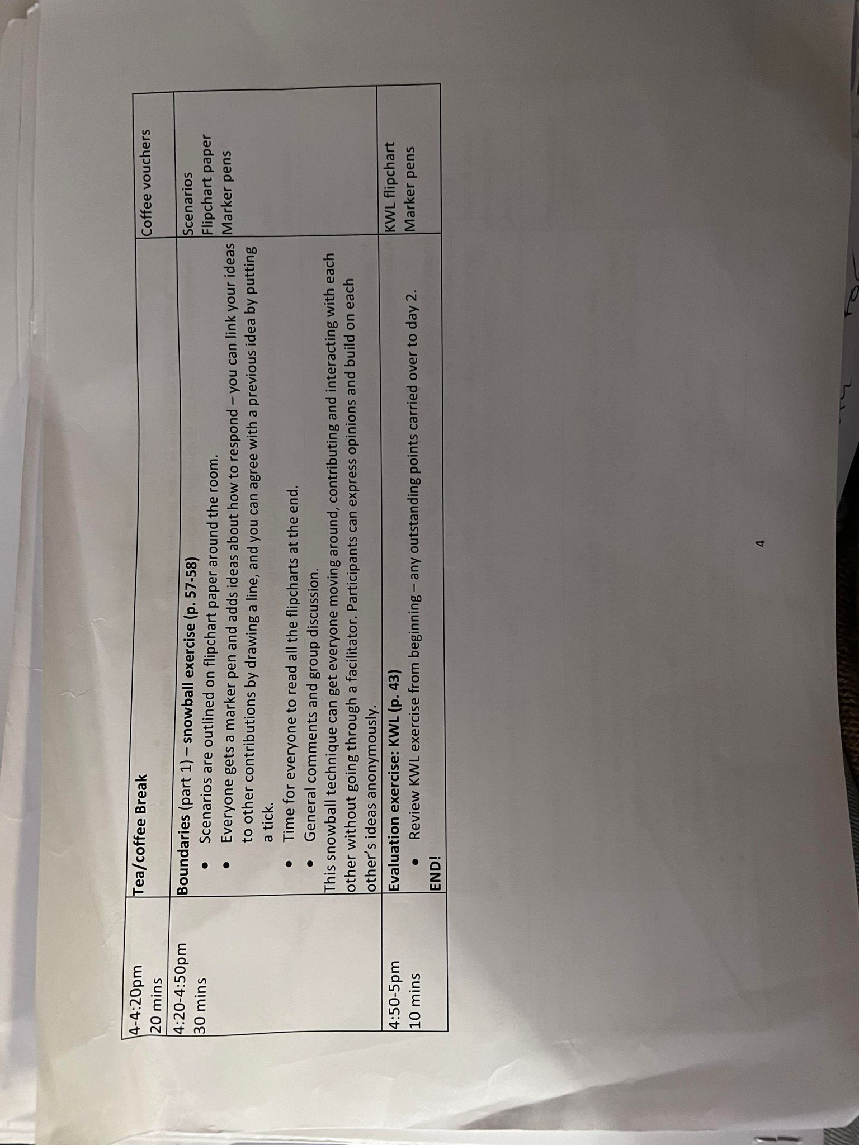

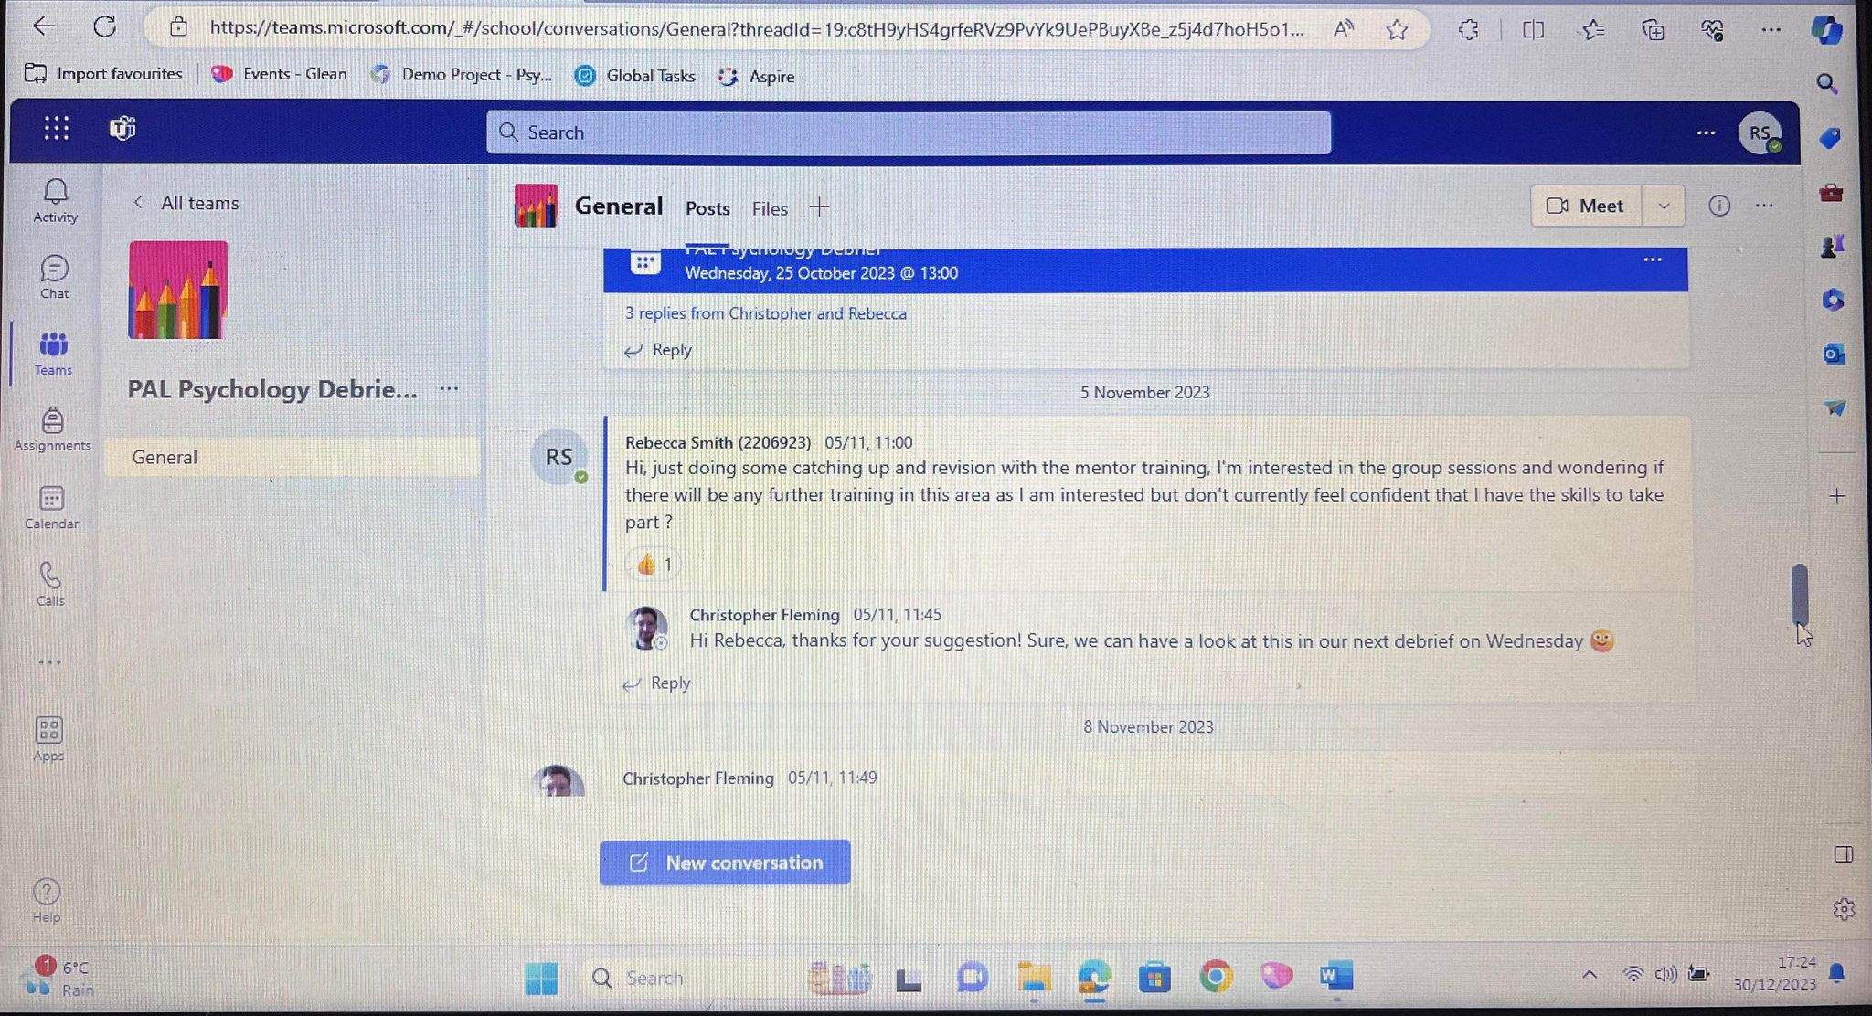

PAL Debrief Proforma
Name of PASS Group:  Psychology | Semester number:  1 | Date of debrief:  11/10/23 | Date of last session:  n/a (in training)
Present:  Ember, Rebecca, Angharad, Kate, Chris |  | Attendance at session:  n/a
General overview of session or in seminar activity:  n/a |  | Academic issues:  - Several pathways within Psychology – Psychology; Applied Psychology; Psychology and Counselling; Psychology and Criminology.  - Psychology programmes have recently been revalidated, so first year modules are different to last year.  - Most students (c. 45 first years) are based in Swansea, with a few (c. 5) based in Carmarthen.  - We agreed to target two modules in particular – ‘Study Skills in Psychology’ (semester 1) and ‘Research Methods’ (semester 2).  - Most of the first year students within Psychology will be in these modules.  - Zoe Cooke is teaching the Study Skills module.  - First years have on campus classes on Wednesdays, 9am-12pm and Fridays, 9am-12pm.
Process issues:  - We agreed that a drop-in approach would be best.  - This will take place face to face in IQ Foyer on ground floor.  - We also discussed possibility of offering online drop ins via Teams meeting and Live Chat.  - ---  - Debriefs – weekly, Fridays, 2-3pm on Teams.  - ---  - All mentors are using PAL hours as part of their placement. Please present Chris (or later on, Jo) with any hours sheets to sign off.  - ---  - Chris leaving PAL at UWTSD next month (last day Fri 10th Nov). Jo Kelleher (PAL Supervisor for Management and Health) will take over your supervision. |  | Plans for next session:  - First drop in – Friday 27th Oct from 12pm in IQ Foyer.  - This is then followed by Reading Week (week beginning 30th Oct), so sessions in that week TBC.  - Subsequent drop ins – Wednesdays from 12pm and Fridays from 12pm.  - Set up Teams page to communicate with first years.  - We’ll need to populate Teams page with list of first years from Kate (e.g. Study Skills register/MyTSD).  - Write PAL copy and send to Kate for circulation.  - ---  - Chris to message Zoe about PAL mentor(s) going in at end of her Study Skills lecture on Fri 27th Oct to introduce themselves and invite first years to the drop in.  - ---  - Talk through PAL Mentor form.  - ---  - Resources: pens, post it notes, PAL registers/paper, PAL banners (Kate offered Psychology banners too). Anything else?
Leader welfare - impact on studies, achievement, skills development:  - PAL Training partially complete. Outstanding items:  - Signposting  - Further mock activity practice  - Introducing and Promoting PAL  - Revisit KWL - any outstanding items?  - Further training needs:  - ‘Look After Your Mate’ and ‘SafeTALK Suicide Prevention’ via Wellbeing.  - Microsoft Teams training on running a Teams group and setting up sessions via IT. |  | Any actions to be taken:  - Chris to request mentors are added to relevant moodle pages for targeted modules.  - Chris to explore possibility of Live Chat (like in the Hwb) for PAL activity.  - Chris to source PAL banners in Swansea.  - Chris to invite Jo Kelleher to a future debrief.
Confidential matters: |  | Kate – borrow Psychology banners

PAL Debrief Proforma
Name of PASS Group:  Psychology | Semester number:  1 | Date of debrief:  25/10/23 | Date of last session:  n/a (in training)
Present:  Ember, Rebecca, Angharad, Chris |  | Attendance at session:  n/a
General overview of session or in seminar activity:  n/a |  | Academic issues:  Need info on location of Zoe’s lecture on Friday – IQ 106  Reading week – 30th Oct – 3rd Nov
Process issues:  Short speech for Fri Intro to PAL – done.  Created Teams page to communicate with first years.  Discussed possibility of offering drop in sessions on Mondays, Wednesdays, and Fridays (all starting at 12pm) after reading week.  Discussed best way to engage first years – catching them at end of their lectures. They have lectures 9-12pm on Mondays, Wednesdays, Fridays.  Possibility of holding online sessions via the new Teams page was raised. |  | Plans for next session:  Intro to PAL at end of Zoe’s lecture on Fri 27th Oct, 11:45am ish.  Drop in session – following above, on ground floor of IQ.

PAL Training Programme – Session Two
SA1 campus
Time and Lead | Activity | Equipment
1-1:45pm | Lunch | Vouchers
1:45-2pm  15 mins | Housekeeping – review groundrules.  Warm up: agenda setting  - Revisit leftover points from KWL on first day and write any new questions on a post it (one question per post it).  - Recap Boundaries exercise from session one. | Post its  Pens  Flipchart
2-3pm  15 mins | Simulated drop-in PAL session exercise using a carousel technique  - In your handbook, complete ‘Using questions in practice’ (p. 24).  - In groups of three, we’ll undertake a simulated PAL session, each taking turns to act as the student, mentor, and observer.  - As the student, your role is to ask a question from p. 24 (or another question off the top of your head if you prefer) and participate in the PAL session.  - As the mentor, your role is to respond to the question and facilitate the session. Be mindful of the material we’ve covered so far (e.g. using questions, active listening, wait-time, signposting, different ways in which people learn, etc.).  - As the observer, you will silently observe the simulated session. Make notes on how you think it’s going (you can use p. 111 as a guide), as you will be asked to feedback at the end.  We’ll swap roles every few minutes and we’ll keep going until everyone is happy. We can stop and generate more questions if necessary. | Post-its  Pens  Flipchart
3-3:20pm | Tea/coffee break | Vouchers
3:20-4pm  40 mins | Student Welfare - how and where to refer (p. 80):  - In the group we will take it in turns to read out typical scenarios experienced by first year students in particular, and the whole group will come up with suitable points of referral, p. 80 of the handbook.  - One of the trainers will show you the Safeguarding forms on the UWTSD website. | Handbook
4-4:30pm  30 mins | Introducing and Promoting PAL - jigsaw approach (p. 70 & 73)  Firstly, split into two groups (A and B).  Group A: Introducing PAL  - On your own, spend a few minutes preparing a short speech to introduce PAL to a group for the first time. Use the space on p. 70 of your handbook to write.  - Volunteers will then get up and give their speech.  Group B: Promoting PAL  - The main ways you will be communicating with your potential attendees is via your university email and through Microsoft Teams. In this session, we’ll set up your own Teams page and discuss how to add attendees to it, as well as how to communicate with them.  This exercise introduces the jigsaw technique (p. 52), which can be used to break large tasks into smaller chunks in a group-work setting. Each sub-group provides a piece of the puzzle by working on a chunk and then feeding it into the large task. | Computer/laptop  Handbook  Pens
4:30-4:45pm  15 mins | General Q & A session (if time allows)  We will discuss the following:  - Key duties of a PAL mentor (p. 14).  - Paperwork including online form.  - Mentor self-evaluation (p. 112).  - Review debriefs and supervision questions (p. 72).  - Observations (p. 111).  - Managing your own workload.  - What happens next?  - CPD – other training (Wellbeing). | Handbook  Paper  Pens
4:45-5pm  15 mins | Closing exercise  Agenda – review KWL  Evaluation Forms  Goodbyes  END | Evaluation forms

Appendix
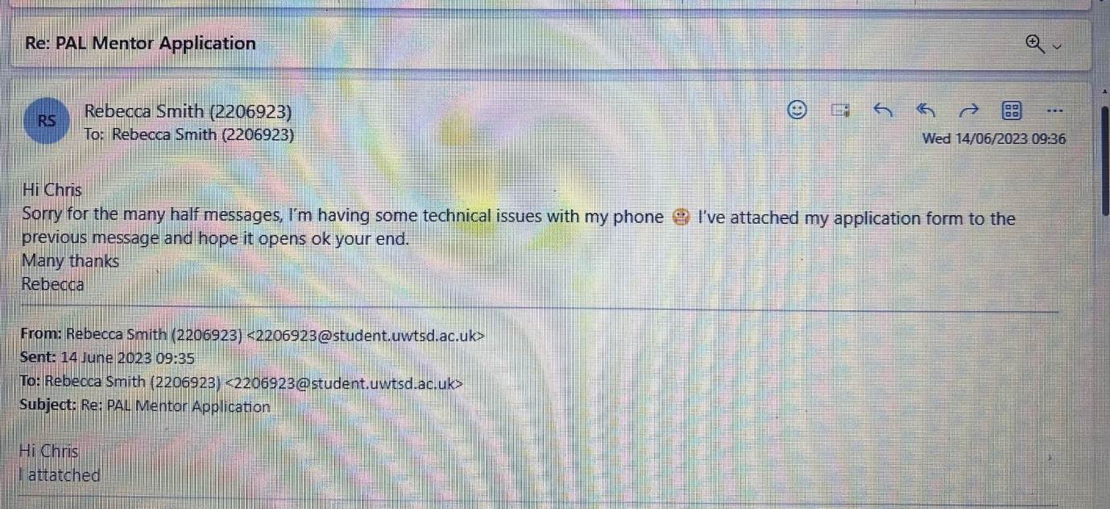

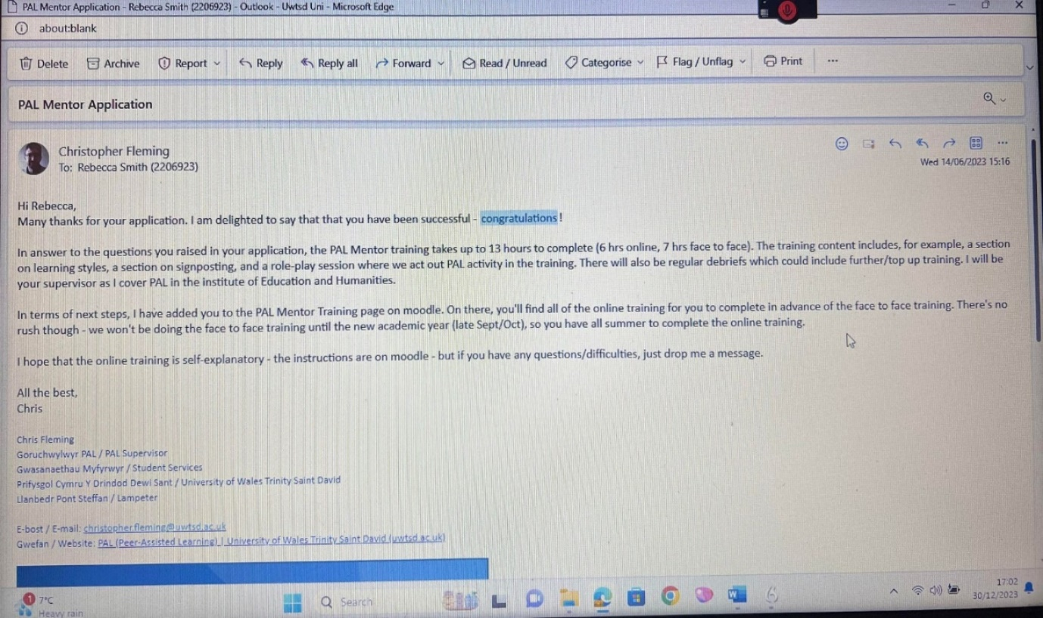

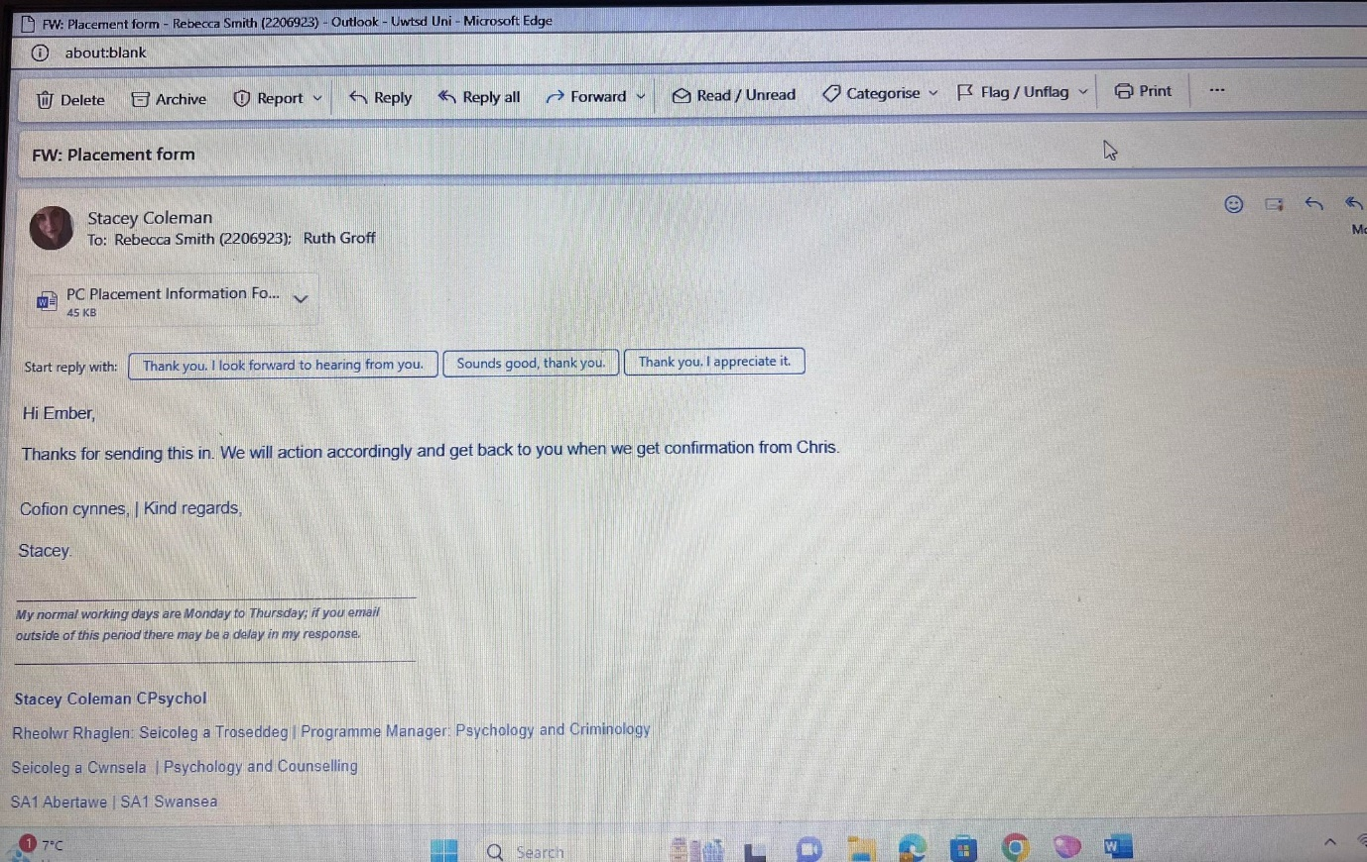


Placement Information Form
Name of student: | Rebecca Smith
Proposed placement setting and address: | PACT, UWTSD Swansea
Proposed dates of placement: | New academic year
Name and position of contact: | Christopher Fleming
Email address: | Christopher.fleming.@uwtsd.ac.uk
Telephone number: | Not given
Is a DBS required for you to attend this placement: | - No  If Yes, have you applied for this?  - Yes applied on ________________  - No
Explain how your role in this organisation/on this placement meets the criteria for the assessment for the module  (e.g., what duties/tasks will you be undertaking that are relevant for the module assessment) | Mentoring new students
ALL information must be provided. Incomplete forms will be returned to the student.Please return this form to Stacey Coleman (stacey.coleman@uwtsd.ac.uk) AND Ruth Groff (ruth.groff@uwtsd.ac.uk) by one of the following submission points.
12pm (midday) on Monday 12th June12pm (midday) on Wednesday 12th July.
Work Log, Training log

Online training – 14.6.2023 | 6 hours
In person training -11.10.2023 | 4 hours
Debrief 16.10.2023 | 1 hour
Debrief 23.10.2023 | 1 hour
Debrief 25.10.2023 | 1 hour
Debrief 3.11.2023 | 1 hour
Debrief 8.11.2023 | 1 hour
Various teams messaging | 1 hour
Uni PAL session 6.11.2023 | 1 hour
Uni PAL session 13.11.2023 | 1 hour
Uni PAL session 20.11.2023 | 1 hour
Uni PAL session 27.11.2023 | 1 hour
Uni PAL session 4.12.2023 | 1 hour
AI for PAL teams chat recording 29.11.2023 | 1 hour 15 minutes

