
STUDENT NAME : GAJJAR SAMIK

STUDENT ID : 2208900

Programme: MBA- Masters of Business Administration

Module: Marketing Management – Assessment 1

Module code: LCMB7001

Contribution to Overall Module Assessment (%): 75%

Table of Contents
Introduction 2
Background – Tesla Motors 2
Communication 3
Communication Definition 3
Communication Model of Tesla 3
Integrated Marketing Communications 4
Communication in Marketing 5
Promotional Strategy for Tesla 5
Event sponsorship and collaboration: 5
Influencer marketing 5
Social media campaigns: 6
Brand and Brand Equity 6
What is a Brand? 6
What is Brand Equity? 6
Keller’s Brand Equity model – TESLA 6
Customer journey – TESLA 7
Customer Journey Map: 9
Conclusion: 10
Recommendation: 11
Reference list 12

Introduction

The chosen firm is Tesla, and this report will go into detail regarding Tesla's marketing strategy, marketing strategy in general in the vehicle business, and marketing strategy in general. The study begins with a fundamental understanding of marketing concepts such as Claude Shannon and Waren Weaver's definition of communication and communication model.

Background – Tesla Motors

The chosen organization for this report is Tesla motors. Tesla, Inc. is a Palo Alto, California-based American multinational firm that specializes in electric automobiles, energy storage, and solar panel production. Founded in July 2003, Tesla focuses on electric vehicles, lithium-ion battery energy storage, household solar panels (through its subsidiary Tesla Energy), and home batteries. Tesla Motors was formed by a group of Silicon Valley engineers who aimed to demonstrate that electric vehicles could outperform gasoline-powered vehicles. Martin Eberhard and Marc Tarpenning founded the company. The Tesla Roadster, the company's first vehicle, was introduced in 2008. The recent CEO was Elon Musk.

The goal statement of the firm is to speed the world's transition to sustainable energy by designing and manufacturing electric cars and energy storage solutions. Tesla's ambition is to become a worldwide leader in the transition to electric mobility and to contribute to reducing the world's reliance on fossil fuels. The company has also declared that it is devoted to using its goods and business operations to have a beneficial influence on the environment and society.

Tesla has produced a variety of electric cars, including the Tesla Roadster, Model S, Model X, Model 3, Model Y, and Cybertruck, as well as energy storage devices for households, companies, and utilities, in pursuit of this aim. Tesla Energy, the company's subsidiary, also manages a global network of charging stations and has invested in solar energy goods and technologies. Tesla aims to hasten the world's transition to sustainable energy and reduce its reliance on fossil fuels, resulting in a cleaner, healthier, and more sustainable future. (Tesla, 2021)

Communication

Communication Definition
Communication is the exchange of thoughts, messages, or information between individuals or groups, whether vocal or nonverbal. It is a basic mechanism that allows people to exchange ideas, information, and feelings with others, as well as develop and sustain relationships. Communication may occur in a variety of ways, including spoken or written language, gestures, facial expressions, and body language, as well as through diverse media such as print, radio, television, and the internet. Effective communication requires the ability to clearly explain one's views and ideas, as well as the ability to actively listen and grasp the viewpoints of others. (Golinkoff, 1993)

Communication Model of Tesla

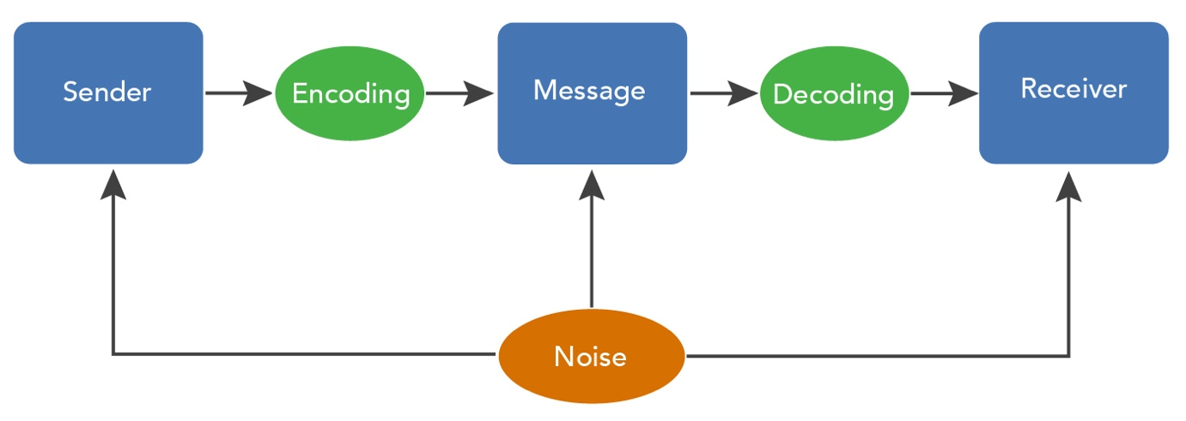

A communication model is a framework that describes the actions and processes of communication. In the case of Tesla, the following phases may be included in the company's communication model: (Duncan and Moriarty, 1998)

Identifying the communication's purpose: Before any communication takes place, it is critical to explicitly establish the communication's goal and the anticipated consequence. This might include determining the intended audience, the message to be delivered, and the desired reaction.

Choosing an appropriate communication channel: Tesla is utilizing a variety of communication channels, including email, social media, press releases, or in-person meetings, depending on the goal and audience of the communication.

Preparing the message: After determining the goal and channel, the message must be presented clearly and succinctly, using language suited for the audience. This might include writing a message or constructing a presentation.

Message transmission: The message is then transferred over the selected communication channel.

The message is received and interpreted by the target audience, who may interpret it in many ways depending on their own experiences, beliefs, and views.

After reading the message, the audience may opt to offer feedback via a response or another method, such as a survey or follow-up chat.

Evaluating communication effectiveness: To ensure that communication is effective, Tesla may assess communication success by monitoring the reaction and feedback received and making any required improvements to the communication process.

Overall, Tesla's communication strategy aims to successfully communicate information and ideas to its different stakeholders, which include workers, customers, investors, and the general public. The organization can guarantee that its communications are clear, succinct, and effective by using an organized and systematic approach to communication.

Integrated Marketing Communications
Integrated marketing communications (IMC) refers to the coordination and integration of all marketing communication tools, channels, and activities within an organization to effectively reach and influence the target audience. In the case of Tesla, the company uses a variety of IMC strategies and tactics to promote its products and brand to different audiences. (Camilleri, 2017)

Tesla employs the following IMC methods and tactics:

Tesla promotes its goods and brand through many means of advertising, including television, radio, print, and internet commercials.

Public relations: To create and maintain connections with the media and other stakeholders, Tesla uses public relations methods such as news releases, media relations, and corporate social responsibility activities.

Tesla employs sales incentives, such as discounts and special offers, to entice customers to buy its products.

Tesla uses personal selling strategies, such as in-person sales, to contact with and persuade potential consumers to purchase its products.

Tesla uses direct marketing strategies such as email and direct mail campaigns to reach out to particular target populations and promote its products.

Social media marketing: Tesla engages and influences customers through content marketing, influencer marketing, and paid advertising on social media sites like as Twitter and Instagram.

Tesla can reach and impact a wide range of people effectively and coherently by merging these numerous IMC methods and approaches. The organization may guarantee that its message is clear and coherent across all platforms and touchpoints by harmonizing its marketing communication activities.

Communication in Marketing
Communication in marketing refers to the many ways and channels that a firm use to interact with and promote its target audience and products or services. Advertising, public relations, personal selling, sales promotion, and social media are all examples of marketing communication. The purpose of marketing communication is to successfully promote the company's brand and its services to reach potential consumers and influence their purchase decisions.

Marketing communication is an important component of a company's overall marketing strategy and plays an important part in creating and sustaining consumer connections. It entails meticulously organizing and carrying out numerous promotional actions to ensure that the appropriate message reaches the right audience at the right time. This might include creating marketing campaigns that reach out to potential consumers using a range of strategies and channels, such as television and radio advertisements, print and internet ads, social media posts, and email marketing. Building and maintaining connections with media outlets and influencers to generate greater awareness and credibility for the company's products or services are also part of marketing communication. (Duncan and Moriarty, 1998)

Promotional Strategy for Tesla

Tesla might utilize a variety of promotional techniques to increase brand awareness:

Event sponsorship and collaboration: Tesla might explore sponsoring events or collaborating with other firms or groups that share its values and objectives. This might involve sponsoring sporting events, music festivals, or charity activities, as well as collaborating with other firms or organizations concerned with sustainability or renewable energy.

Influencer marketing Tesla might harness the power of influencer marketing by collaborating with social media influencers or celebrities who have a significant following and can help promote the brand to a larger audience.

Tesla may offer engaging and immersive experiences that allow people to connect with and learn about the brand in a hands-on manner. This might involve organising experiential marketing events or setting up pop-up shops where customers can test drive or experience the company's items directly.

Tesla may employ virtual reality (VR) and augmented reality (AR) to build immersive and interactive experiences that allow consumers to connect with the brand in a new and engaging way. This might involve developing VR or AR content that highlights the company's products or allows customers to learn about the brand's production processes or sustainability initiatives.

Social media campaigns: Using content marketing, influencer marketing, and paid advertising, Tesla might employ social media campaigns to engage and influence consumers. Creating compelling and shareable material on social media platforms, such as videos, infographics, or blog entries, or executing paid advertising campaigns targeting certain demographics or interests, might be examples of this.

Tesla can easily build brand awareness and interact with consumers in a meaningful and impactful way by utilizing these promotional methods.

Brand and Brand Equity

What is a Brand?
A brand is a distinct identity or image associated with a company or product, which includes features such as the firm's name, logo, motto, and general design and look. It describes how people view a firm or product and might include associations with quality, value, and customer experience. (Wood, 2000)

What is Brand Equity?
Brand equity refers to consumers' favorable or negative opinions of a brand, as well as the value that these perceptions provide to a company or product. Brand awareness, brand loyalty, brand associations, and brand image are all elements that impact it. A company's brand equity may lead to increased sales, improved consumer loyalty, and a higher price for its products. Marketing and branding tactics such as advertising, public relations, and social media marketing may help businesses create and retain brand equity. (Wood, 2000)

Keller’s Brand Equity model – TESLA

Keller's Brand Equity model is a framework for assessing the power and worth of a brand. This model might be applied to Tesla as follows: (Keller and Brexendorf, 2019)

Brand Identity:
Tesla's brand identity is inextricably linked to its goods, which are noted for their innovative technology, durability, and performance. The logo, design, and brand message all add to the company's strong and distinct identity. (Long et al., 2019)

Brand Meaning:
Tesla's brand meaning is inextricably linked to its aim of moving the planet to renewable energy and lowering greenhouse gas emissions. The environmental advantages of the company's offers are highlighted in its goods and marketing activities.

Brand Response:
Tesla has a large and dedicated customer base, and the brand inspires a good response from customers. Tesla's goods are often evaluated and reviewed, and the corporation has a solid reputation for customer service.

Brand Knowledge:
Tesla is a well-known and recognized brand, and consumers are well-versed in the company's goods and ideals. The brand has a significant media presence and is frequently included in news and industry reports.

Brand image:
Tesla's brand iconography is inextricably linked to its creative and futuristic goods, as well as the company's emphasis on sustainability. The brand is frequently connected with technology, innovation, and an innovative mindset.

Customer journey – TESLA

Tesla's customer journey may differ depending on the unique product and the demands and preferences of the individual consumer. Here is a more extensive breakdown of the client journey:

Awareness:
A potential buyer learns about Tesla and its goods through a variety of channels, including advertising, social media, media coverage, and word-of-mouth. The consumer may get knowledge of the company's goal and ideals, as well as the characteristics and advantages of its goods.

Interest: The potential consumer exhibits an interest in Tesla's products and begins researching and comparing alternatives. Visit the company's website, read reviews and ratings, and compare costs and features with other electric car alternatives.

Evaluation: The potential client assesses if Tesla's products satisfy their wants and preferences by evaluating their features and advantages. This might include going to a Tesla dealership or test-driving a Tesla vehicle to get a personal look. Customers may also think about the company's reputation, customer service, and financing choices.

Purchase: The consumer decides to buy a Tesla product and does so through the company's online store or a retail location. The consumer may be able to customize their product by selecting the color, wheels, or interior choices.

Delivery: The client receives their Tesla product and may be able to further modify or adjust it via the company's mobile app or in person at a service facility. The consumer may also be instructed on how to utilize and maintain their goods.

Use: The client starts using their Tesla product and, if necessary, seeks help or assistance from the company's customer care channels. Contacting the firm through phone, email, or the mobile app, or visiting a service facility for maintenance or repair, may be required.

Loyalty: If a consumer has a favorable experience with their Tesla product and customer service, they may become a loyal customer and continue to purchase from Tesla in the future. To boost client retention, the corporation may also provide loyalty programs or rewards.

Total Engagement Model – TESLA

The Total Engagement Model is a paradigm for analyzing how a firm interacts with its consumers across several touchpoints and channels. Here's a more in-depth look at how this concept may potentially be used by Tesla:

Awareness:
Tesla raises brand and product awareness using a range of methods, including advertising, social media, events, and collaborations. To build excitement about its products, the corporation also relies on word-of-mouth and media publicity.

Interest:
When potential consumer becomes aware of Tesla and its goods, the firm employs a variety of strategies to pique their interest and push them to learn more. This may involve presenting thorough product information on the company's website, allowing test drives, and emphasizing the benefits and features of its products.

Evaluation: To assist potential customers in determining if a Tesla product is suitable for them, the firm offers a variety of materials to assist them in making educated decisions. Product demos, comparisons with choices, and information on financing and customization possibilities are all possible.

Purchase:
When a consumer is ready to buy, Tesla offers a smooth and easy shopping experience through its online store or physical locations. To make it easier for clients to acquire its items, the firm also provides financing and leasing alternatives.

Delivery:
Tesla works hard to guarantee that its products are delivered in a timely and convenient manner for consumers. This may entail collaborating with the customer to set a delivery time, giving product training, and offering customization choices.

Use:
After a client begins using a Tesla product, the business provides continuing assistance via its customer care channels. This may involve giving maintenance and repair information, resolving inquiries or concerns, and providing clients with extra resources or incentives.

Loyalty: If a consumer has a favorable experience with their Tesla product and customer service, they may become a loyal customer and continue to purchase from Tesla in the future. To boost client retention, the corporation may also provide loyalty programs or rewards.

Customer Journey Map:

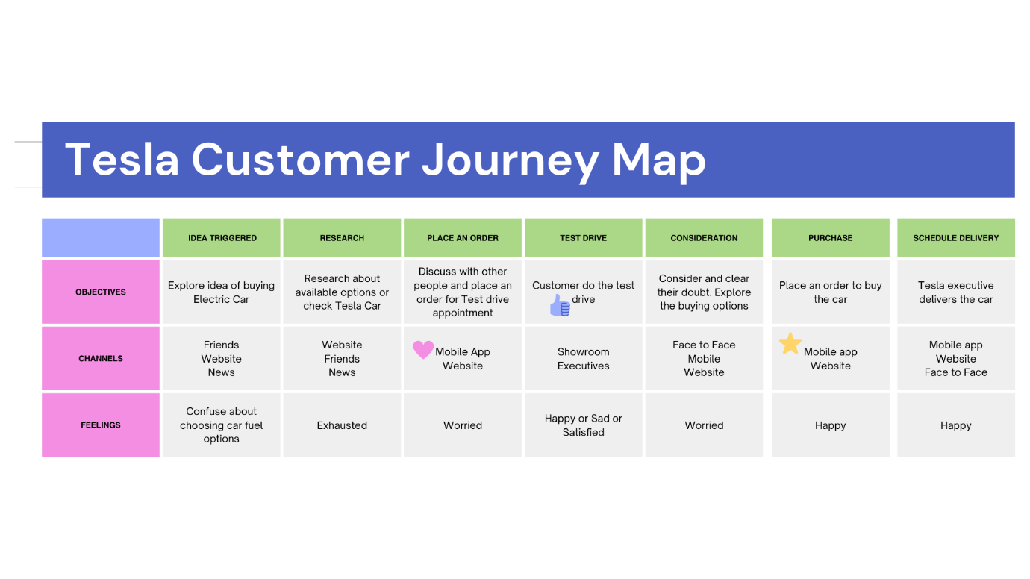
Source: (Tesla,2022)

The infographics above describe the consumer route to the Tesla automobile.

Idea Triggered:
The first step is to consider purchasing an automobile. When you consider purchasing an automobile, two alternatives come to mind. How many sitters will there be, and what will be the Fuel? It is important to how much fuel would the automobile requires.

Research:
As soon as they settle on an electric automobile, they begin looking for other aspects of the car and conduct research online or through friends and family. The factors include Performance and handling, Range and charging, Technology and features, Sustainability and environmental impact, and the price of the car. They consider other Electric car providers as well.

Place an Order:
When they decide to test drive a Tesla vehicle. The test drive is the greatest alternative for determining whether or not they are comfortable with the Tesla vehicle. they Visit the Tesla website (www.tesla.com) and click on the "Book a Test Drive" option, then choose the model to test drive and a chosen place and time for the test drive. Tesla has showrooms and test drive centers located all over the world.

Test Drive:
A Tesla test drive is a one-of-a-kind and exhilarating experience. The electric engine is smooth and quiet, providing quick torque and powerful acceleration, while innovative technology, like the touch screen dashboard display and Autopilot, contributes to the overall sense of driving a cutting-edge car. A qualified salesperson is generally present throughout the test drive to answer questions and explain the characteristics of the automobile. Test drives are an excellent way to get a sense of the car's performance and handling, as well as to ask any questions you may have regarding the vehicle. Overall, having a Tesla test drive may be a memorable and pleasurable experience that will allow customers to decide whether the brand is perfect or not.

Consideration:
A Tesla representative may be a great resource for a consumer thinking about buying a Tesla car and can assist address any queries or concerns the customer may have about features, comparison, and performance.

Purchase and Delivery:
The Tesla buying process is intended to be simple and straightforward for customers. One may explore and test drive several Tesla models, design and configure your vehicle online, review and verify the order, and purchase and take delivery of the vehicle all from the comfort of own home or a Tesla dealership. The firm provides financing alternatives as well as home delivery or pickup at a delivery location, making it simple to obtain your new Tesla vehicle. The process is intended to be simple and easy, with an emphasis on giving customers the information and assistance they need to make an informed decision regarding the vehicle.

Conclusion:

Tesla has established a strong brand image as a pioneer in electric and sustainable transportation, and the firm is known for its innovative technology and high-performance automobiles. The user experience at the firm is intended to be convenient and smooth, with an emphasis on giving consumers the information and assistance they have to make an informed choice about their vehicle. This offers facilities for online research and configuration, as well as test drives and a variety of financing alternatives. Tesla also provides delivery service or pick up at a delivery facility, making it simple for consumers to obtain their new vehicle. Furthermore, Tesla has a solid reputation for customer service, with experienced staff accessible to answer inquiries and handle problems.

Recommendation:

Tesla's marketing strategy has evolved over time, but the business has remained committed to developing strong brand recognition and providing a distinctive consumer experience. Here are some specific recommendations for how Tesla might enhance its marketing efforts in the future:

Sustainability should be emphasized: Tesla has a good reputation for sustainability and innovation, which it can continue to promote in its marketing efforts. Highlighting the environmental benefits of electric vehicles, as well as the company's efforts to decrease its own carbon footprint and employ renewable energy, might be part of this.

Utilize customer reviews and recommendations: Tesla has a devoted customer base, which the firm can continue to harness to generate positive word-of-mouth and referrals. This might involve emphasizing customer evaluations and testimonials in marketing materials and giving incentives for consumers to recommend friends and family.

To reach new customers, Tesla can continue to broaden its marketing efforts outside traditional media such as television and print advertising. Investing in digital marketing, social media marketing, and influencer marketing might be examples of this.

Collaboration with complementary brands: Tesla may explore collaborating with other brands that have similar ideals and target customers, such as firms in the technology, sustainability, or luxury industries. This might assist the firm in entering new markets and reaching a larger audience.

Innovate and differentiate: Tesla has always been a pioneer in innovation, and the firm can continue to separate itself apart from the competition by releasing new technology and services. Investing in research & development to generate new products or services that match evolving client wants and preferences is one example.

Reference list

Camilleri, M.A. (2017). Integrated Marketing Communications. Tourism, Hospitality & Event Management, [online] 1(1), pp.85–103. doi:10.1007/978-3-319-49849-2_5.
Duncan, T. and Moriarty, S.E. (1998). A Communication-Based Marketing Model for Managing Relationships. Journal of Marketing, [online] 62(2), pp.1–13. doi:10.1177/002224299806200201.
Golinkoff, R.M. (1993). When is communication a ‘meeting of minds’?. Journal of Child Language, 20(1), pp.199–207. doi:10.1017/s030500090000920x.
Keller, K.L. and Brexendorf, T.O. (2019). Measuring Brand Equity. Handbuch Markenführung, pp.1409–1439. doi:10.1007/978-3-658-13342-9_72.
Long, Z., Axsen, J., Miller, I. and Kormos, C. (2019). What does Tesla mean to car buyers? Exploring the role of automotive brand in perceptions of battery electric vehicles. Transportation Research Part A: Policy and Practice, 129(1), pp.185–204. doi:10.1016/j.tra.2019.08.006.
Wood, L. (2000). Brands and brand equity: definition and management. 0025–1747th ed. [online] Available at: https://www.emerald.com/insight/content/doi/10.1108/00251740010379100/full/html?journalCode=md&utm_source=TrendMD&utm_medium=cpc&utm_campaign=Management_Decision_TrendMD_1&WT.mc_id=Emerald_TrendMD_1 [Accessed 30 Dec. 2022].

