
STUDENT NAME: SEKOU KONE
STUDENT ID: 2439873
MODULE NAME: EMPLOYABILITY AND CAREER DEVELOPMENT
MODULE NUMBER: LCLM4005
LECTURER NAME: LAKSHANI NISSANGA MENDIS

TABLE OF CONTENTS
Task 1: Comparison of Job Adverts for Mobile Soft Services Supervisor 3
Task 2: Reflective Self-Assessment and Evidence of Readiness 5
Self-Assessment Using SWOT Analysis 5
Reflection on Personal Development 6
Evidence of Readiness for Employability and Personal Advancement 7
Task 3: Employment Goals and Personal Development Plan 7
References 9

Task 1: Comparison of Job Adverts for Mobile Soft Services Supervisor
This task will compare two job advertisements for the position of the Mobile Soft Services Supervisor on Hays (2026) and on Indeed (2026). These two positions have their base at Watford and entail overseeing catering and cleaning services at a medical facility. This comparison is aimed at determining the essential skills and knowledge needed in this occupation. First, both job adverts emphasise the role of leadership and supervisory abilities. According to the advert by Hays, the supervisor will be in charge of delivering services to the catering and cleaning staff, whereas in the Indeed advert, staff management and support are also highlighted. This demonstrates that strong leadership skills, task allocation, and general consistent operations are needed in this job (Indeed, 2026; Hays, 2026).
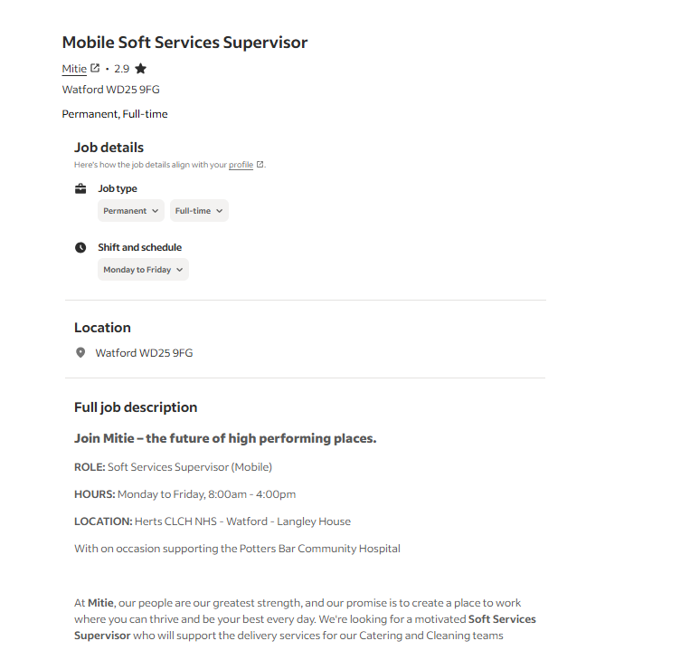
Figure 1 Job Advert 1

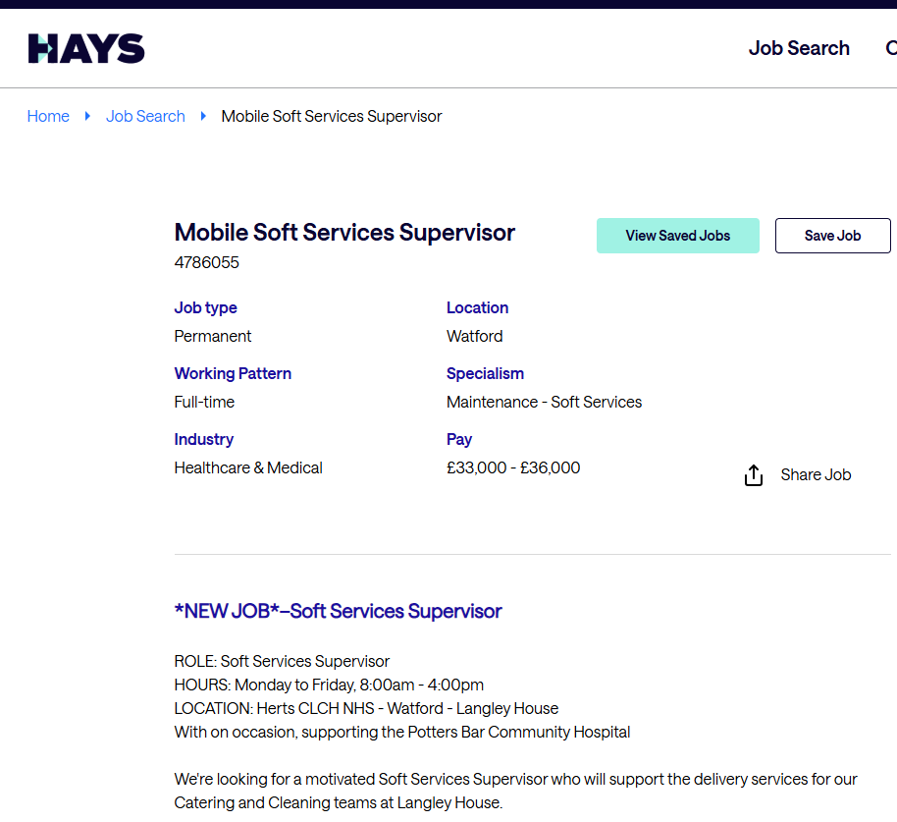
Figure 2 Job Advert 2

Secondly, both adverts require skills in communication. The supervisor has to communicate with the staff, management and occasionally clients at the professional level. Communication must be effective so that instructions are easily delivered and any problem solved promptly, particularly in a busy healthcare environment. Organisation and time management are other popular skills. Both advertisements refer to a working schedule (Monday to Friday, 8:00am-4:00pm), meaning that there is a necessity to divide the daily workload into the most effective spheres. Supervisors are to plan the personnel schedule, control the performance, and make sure that all the tasks are done within the time limit. Moreover, the two adverts need expertise in cleaning and catering services. As the position facilitates both teams, it is important to learn about hygiene standards, food safety and cleaning processes because working in a hospital setting, health and safety are crucial.
Leadership is one of the essential common skills of this profession, especially. The reason why leadership is necessary is that the supervisor has to lead a team, and whatever level of service is required is to be delivered. Mistakes, which can lead to sloppiness or even food hygiene issues, may cause damage to patient health in a healthcare environment. Team motivation is sustained with good leadership, productivity is enhanced, and the services provided are of high standards. It also enables the supervisor to manage the issues efficiently, including the shortages of staff or customer complaints. To conclude, similar core skills can be identified in both job adverts, such as leadership, communication, organisation, and industry knowledge. Leadership is the most significant of these skills as it directly affects the performance of the team and the quality of the services in the workplace.

Task 2: Reflective Self-Assessment and Evidence of Readiness

Self-Assessment Using SWOT Analysis
Reflective self-assessment is a significant process that enables people to know their strengths and weaknesses concerning employability. Tong and Gao (2022) observe that self-awareness, which individuals develop to achieve sustainable career development, will help a person to match skills with work demands. Throughout this part of the assignment, I have applied the SWOT analysis model to analyse my personal and professional attributes in the framework of my career in the hospitality industry.
Strengths | Weaknesses
My areas of strength are good communication skills acquired by exchanging comments with the customers, teamwork, and good customer service skills. I also find quick resolutions to certain problems in fast scenarios, which helps sustain service quality and ensure customer satisfaction during the restaurant service. | I have weaknesses, such as time management during the busy shifts, and experience with formal leadership. I am working to build confidence in decision-making, especially under pressure, which can affect my ability to make effective decisions and lead effectively.
Opportunities | Threats
The hospitality industry has career prospects for supervisory or managerial positions. I would also be able to utilise training programmes and learning through experienced managers, which will help me in developing leadership skills and enhancing my overall growth in professional life and career opportunities. | Some of the threats include stiff competition within the hospitality sector and the stressful workplace environment. Furthermore, the constantly evolving industry needs and expectations might necessitate constant growth of skills, which, as a result, necessitate my change and keeping up with new practices.
Based on this analysis, I have several strengths that enhance my employability, especially in communication and teamwork. Such abilities are crucial in the hospitality sector, where communication with customers and colleagues is important in the delivery of services. Nevertheless, I also understand such weaknesses as time management and lack of experience as a leader, which can influence my future ascent to a higher rank. Donald, Baruch and Ashleigh (2024) state that employability develops as various types of capital are developed, such as human capital (skill, knowledge) and social capital (relationships, networks). The given strengths show that I have good social capital, and weaknesses pinpoint areas where human capital should be developed further.

Reflection on Personal Development
Considering personal experience, I have acquired a range of skills, having worked in a restaurant setting. I have learned how to manage any customer complaints, multitask, and work under pressure. The experiences have enabled me to become resilient and adaptable, which are valuable qualities of employability. According to Ho et al. (2023), the development of career learning has proven to play a significant role in enhancing the perception of the employability of the students since they are able to bridge the gaps between theoretical knowledge gained and practical experiences. Personally, a combination of theoretical and practical studies and work experience has empowered me in my pursuit of getting into the labour market. At the same time, I need to strengthen my leadership and decision-making skills. Later in my career, I aim to take on more responsibilities, such as supervising junior employees or supporting managers. This will help me in gaining confidence and preparing for greater positions. Healy, Hammer and McIlveen (2022) note that employability is more than having a set of skills; it is also a process of constant updating of these skills through experience and reflection. Thus, I am concentrated on continual enhancement and not perfection.

Evidence of Readiness for Employability and Personal Advancement
I am employability prepared, and this can be reflected by a blend of academic performance, professional experience and personal growth. On the academic level, I have mastered some concepts on business and employability, such as teamwork, communication, and problem-solving. The skills are practical and can be transferred and used in work settings. In work experience, the role in the restaurant industry has helped me to get a hands-on experience in customer service, teamwork, and the operational aspect of management. To illustrate, I have been able to match busy shifts where there should be clear communication and coordination to get the service going smoothly. This will show that I am able to put theoretical knowledge to practical use. Huang et al. (2022) suggest that work experience contributes to graduate employability as it enables one to gain job-related skills. Additionally, other colleagues and supervisors provided valuable feedback to me to improve. I have been identified to possess a positive attitude, teamwork and the personal ability to relate with customers. This feedback shows I can fulfil expectations at the workplace and adapt to the work environment. Finally, my self-reflection indicates that I possess a solid base of employability skills that has been facilitated by not only my studies but also my work experience. Although I have some aspects to improve on, including leadership and time management, I am in the process of building upon them. I am prepared to be employable and to grow personally, as I continue to develop my strengths and innovate to improve my weaknesses.

Task 3: Employment Goals and Personal Development Plan
In the weaknesses that are found in my SWOT analysis, I have established short-term and long-term employment objectives to help in shaping my career growth in the hotel industry. My immediate objective is to develop time management and decision-making skills and have first leadership experience. I plan to do this in the next 6 to a year by accepting more responsibility in my workplace, e.g. helping my supervisors on a busy shift. This is a valuable goal as it will make me more confident and ready to take superior positions.
In the next 2 to 3 years, I want to be a Restaurant Supervisor or Assistant Manager. This is in line with my career goal of being part of the management in the hospitality industry. By accomplishing this objective, I will be able to be a team leader, enhance the quality of services, and make the business a success. I think it matters to me because it offers me career stability, career growth, and a sense of professional development.
In order to accomplish these objectives, I have worked out my personal development plan. In order to manage my time better, I will adopt daily task planning and prioritisation skills when shifting. I will also practice decision-making through observing the experienced managers and requesting them to comment when situations have been dealt with. My way of learning leadership skills is to volunteer, train new employees, and participate in team coordination activities.
The action plan of these will carry on throughout the next 6 to 12 months with monthly reviews of progress. The support of supervisors, training at the workplace and online learning resources pertaining to leadership and hospitality management are some of the resources required. The feedback provided by managers, better performance during busy shifts, and the confidence to manage the responsibilities will be the indicators that will guide my improvement.

References
Donald, W.E., Baruch, Y. and Ashleigh, M.J., 2024. Construction and operationalisation of an Employability Capital Growth Model (ECGM) via a systematic literature review (2016–2022). Studies in Higher Education, 49(1), pp.1-15.
Hays (2026) Mobile soft services supervisor – Watford. Available at: https://www.hays.co.uk/job-detail/mobile-soft-services-supervisor-watford_4786055 (Accessed: 22 April 2026).
Healy, M., Hammer, S. and McIlveen, P., 2022. Mapping graduate employability and career development in higher education research: A citation network analysis. Studies in Higher Education, 47(4), pp.799-811.
Ho, T.T.H., Le, V.H., Nguyen, D.T., Nguyen, C.T.P. and Nguyen, H.T.T., 2023. Effects of career development learning on students’ perceived employability: a longitudinal study. Higher Education, 86(2), pp.297-315.
Huang, X., Cao, J., Zhao, G., Long, Z., Han, G. and Cai, X., 2022. The employability and career development of finance and trade college graduates. Frontiers in psychology, 12, p.719336.
Indeed (2026) Mobile soft services supervisor. Available at: https://uk.indeed.com/viewjob?jk=0cc2986ba0e1bfaf (Accessed: 22 April 2026).
Tong, M. and Gao, T., 2022. For sustainable career development: Framework and assessment of the employability of business English graduates. Frontiers in psychology, 13, p.847247.

