

NAME: HARSHA VARDHAN MACHERLA
STUDENT NUMBER: 2215773

MODULE: LCBM7001 MARKETING MANAGEMENT

TITLE: MARKETING MANAGEMENT ASSESSMENT 1

LECTURER: TUSHARA BALENDRAN

WORD COUNT: 3500 WORDS OR EQUIVALENT

TABLE OF CONTENT | Pg. No
- INTRODUCTION | 3
- COMMUNICATION | 3
- DEFINITION OF COMMUNICATION | 3
- SHANNON AND WEAVER COMMUNICATION MODEL | 3 - 4
- INTEGRATED MARKETING COMMUNICATION (IMC) | 4
- NEW PROMOTIONAL STRATEGIES | 4
- ONLINE PROMOTION | 5
- OFFLINE PROMOTION | 5
- BRANDING AND BRANDING EQUITY | 5
- KELLER’S BRAND EQUITY MODEL | 5 - 7
- ADVANTAGES AND DISADVANTAGES OF KELLER’S BRAND EQUITY MODEL | 7
- COUSTOMER JOURNEY | 7 - 8
- COUSTOMER TOUCHPOINTS | 8
- PRE-PURCHASE | 8
- PURCHASE | 9
- POST PURCHASE | 9
- THE CUSTOMER JOURNEY MAP AND CRITICAL ANALYSIS OF CUSTOMER JOURNEY MAP | 10 - 11
- STRENGTHS AND WEAKNESSES OF CUSTOMER JOURNEY MAP | 11
- KANO’S CUSTOMER DELIGHT MODEL | 11 - 12
- CONCLUSION | 12
- RECOMMENDATIONS | 12
- REFERENCES | 13 - 14
INTRODUCTION OF FERRARI

The following report will critically analyze how the luxury sports car company Ferrari is utilizing their marketing strategies to raise their brand awareness and sales. The report will also critically analyze communication channels, customer satisfaction models, customer touchpoints, and customer journey. The report will also highlight recommendations for new promotional strategies and touchpoints that would be beneficial for the organization.
Ferrari is an Italian luxury car manufacturer based in Maranello, Italy. Founded by Enzo Ferrari in 1939.
About Enzo Ferrari: Enzo Ferrari, who was born in Modena, Italy in the year 1898, started his career as a race car driver. He won several racing awards in the 1920’s as a driver with Alfa Romeo. Enzo Ferrari founded the Scuderia Ferrari in the year 1929. It is now the official racing car division for Ferrari. At the time, a division of Alfa started working on race cars for gentleman drivers. This was the time when sports cars were taking off as an activity for the rich people. Enzo retired from his racing career the year 1931.
Early years: In the year 1945, Ferrari introduced a V12 engine. This is one of Ferrari’s signature engines. Ferrari released its first model 125 sport in the year 1947. During World War 2, after a few bombs partially destroyed Ferrari’s Modena factory, the company has shifted its operations to Maranello and established a new factory which Ferrari uses till date. For the next few decades, Ferrari competed and won major races like the Mille Miglia (1948) and World Championship Grand Prix (1951). In the year 1987, Ferrari released the F40. This was the Final model created under Enzo Ferrari, as he died the following year, at the age of 90. Following his death, 90% of Ferrari’s stake was bought by Fiat group. After Enzo Ferrari’s death, the new chairman Luca Cordero di Montezemolo was appointed in 1991 by Ferrari and he remained as the chairman till October 2014. Ferrari became an IPO and launched on the New York Stock Exchange with a of nearly $10 billion, and Milan Stock Exchange in the year 2016.
Ferrari Today: The Ferrari is a premium brand with worldwide recognition. The Italian automobile manufacturer won over 5,000 prices and competed in all the tracks over the world since it first began. Ferrari holds the title of the longest standing and most successful competitor in Formula One racing (Autosprint, 2017).

COMMUNICATION

DEFINITION OF COMMUNICATION:
Communication is the exchange of meaning between individuals through a common system of symbols (Gordon, 2023). To communicate, two people must know a common set of means to understand one another. Every communication includes at least one sender, a message, and a receiver. The transmission of the message from sender and receiver can be affected by a wide range of things like emotions, medium being used to communicate, cultural situation and location (Skillsyouneed, 2011).

SHANNON AND WEAVER COMMUNICATION MODEL:
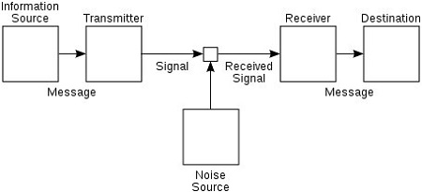
(Fig 1 Source: https://study.com/learn/lesson/shannon-weaver-model-communication-theory-parts-transmission-model.html)

In Shannon and weaver communication model, an encoded message is sent by the sender, and the receiver receives that message through a communication channel like telegraph or telephone. The sender’s message is converted into codes comprehensible by the device and is transmitted in the form of codes through a medium and the receiver would be decoding that message to understand it. In a few cases, the receiving device acts as a decoder. Sometimes, the receiver might not be able to decode the message due to noise in the channel, causing problems in the communication process (Businesstopia, 2018). For instance, Let’s say that the brain of an individual acts as a sender, while mouth acts as encoder. Meanwhile another individual’s ears act as a receiver and that person’s brain acts as a decoder. Similarly, air acts as a channel and the disturbance in their environment is the noise and the response from the receiver is the feedback. Shannon developed this model to improve technical communication, and main the purpose was to minimize the noise in telephonic communication.
Later, to develop effective communication, weaver applied it for all kinds of communication and the model became famous as Shannon and Weaver communication model. In the field of engineering, Shannon’s model is also called Information theory and it is used to calculate transmissions through machines (Businesstopia, 2018).

INTEGRATED MARKETING COMMUNICATION (IMC)

Integrated marketing communication (IMC) is a process that is used by marketing communication elements, such as social media, business development principles, public relations, advertising, and audience analytics into brand identity which remains consistent across different media channels. IMC allows businesses, private and public organizations to deliver an engaging consumer experience for a product and its services. This is to optimize an organization’s relationship and image with stakeholders. IMC makes marketing effective and efficient because it relies on multiple customer touchpoints and communication methods to deliver a consistent message in a compelling way thought multiple means (Lumen, no date).

NEW PROMOTIONAL STRATIGIES FOR FERRARI

Ferrari is a luxury sports car brand with a vast history. However, there are online and offline promotional strategies that Ferrari could use to further raise its brand awareness.

ONLINE PROMOTIONAL STRATEGY:
A digital marketing approach that Ferrari could add to its promotional strategies is to sponsor Instagram and TikTok celebrities to include a Ferrari in their videos and spread awareness among the youth who watch their videos, this could lead them to buy a Ferrari. Ferrari could conduct an online lucky draw contest and attract customers to sign up to the contest and reward 1 winner, a brand new Ferrari. By doing this, A Ferrari will attract a lot of attention, and this could raise their sales.

OFFLINE PROMOTIONAL STRATEGY:
To promote itself, Ferrari could develop a limited-edition car themed around historically famous figures. This could lead to Ferrari getting a boost in sales. Ferrari advertise their cars using Formula 1 racing champions to endorsement for them. Ferrari could exhibit their cars in major cities and attract customers who are looking for a sports car.

BRAND AND BRAND EQUITY

BRAND:
A brand is the way a company, individual or product is perceived by those who experience it. A brand is much more than a name, it evokes a recognizable feeling (Lischer, 2020).
Every brand has a unique recognition, and each brand has its own identity. The concept brand is invented to differentiate a similar product created by different manufacturers, so that consumers can identify the right product.
A brand is an emotional, cultural, rational, and visual proprietary visual that one associates with. The fact that a person remembers a brand name and has positive interactions with that brand makes product selection easier and enhances the value and satisfaction from owning that product (Bhasin, 2022).

BRAND EQUITY:
Brand equity is the identity of brand name and the value of owning them in a consumer’s mind. An organization can establish brand equity by giving consumers positive experiences with their brand and enticing consumers to buy their products over their competitors with similar products. Brand equity can be attained by generating awareness among consumers through campaigns and delivering the promises made by the brand. When a good quality product is bought by a consumer, the brand gets their loyalty and that consumer would become a retained customer, increasing the brand equity (Marketing Evolution, 2022).

KELLER’S BRAND EQUITY MODEL:

Keller’s brand equity model is also known as Customer based brand equity model (CBBE). Keller’s brand equity model is a pyramid with 4 main stages. The model’s author is Kevin Way Keller, he was teacher at Ford institute of business at Dartmouth school. The logic behind Keller’s model is, “To have a strong brand, one must create right brand image, by constructing ideal brand encounters or experiences” (Hawker, 2019). The customers or potential customers must experience positive thoughts, convictions, and emotions with each brand encounter. Using CBBE model, brands can know the strategies that can be implemented to give their customers the right experiences (Bhasin, 2019).
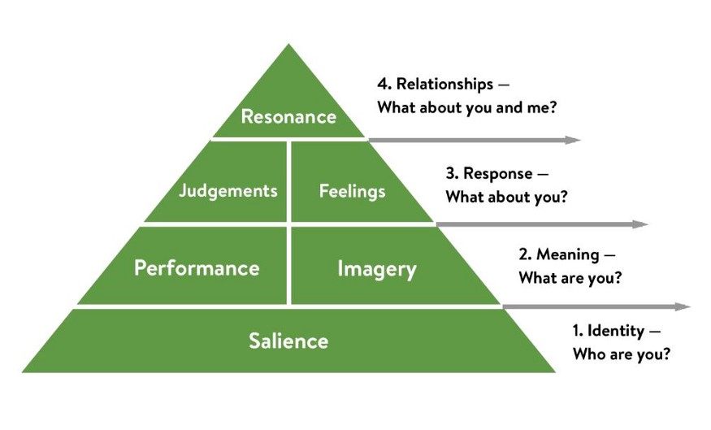
(Fig 2 Source: https://medium.com/@keatonhawker/kellers-brand-equity-model-what-it-is-how-to-use-it-84e42d562299)
- Identity: It is the identity of the brand or brand awareness among the consumers (Hawker, 2019). Every Brand has a unique identity, and this differentiates every brand from one another among the customers. Ferrari is a brand famous for its sophisticated luxury, incredible speeds, dignified ostentatiousness and for being the creators of the most expensive car ever sold (McDonald, 2018). People view Ferrari as luxury brand that is only owned by the rich and famous and they consider it a symbol of prestige.
- Meaning: Meaning is to understand a brand and what it means. This can be divided into the performance and imagery. While performance indicates how well a customer is satisfied with your product. Imagery refers to a brand’s social currency, it is about how customers or potential customers view your brand (Hawker, 2019). Ferrari is a luxury brand with delivers great performance to its customers. Ferrari is viewed as premium brand
- Response: Response is the feedback received from the public about the brand (Hawker, 2019). Ferrari is a luxury sports car brand with a magnitude of people appreciating it. Ferrari is a symbol of prestige. To a common customer, owning a Ferrari is dream come true. This is the reason why everyone wants to own a Ferrari. For instance, when public see someone getting off a Ferrari, they will automatically think that person is rich (Rossi, 2018).
- Relationships: The Brand Resonance is how a customer identifies themselves with a brand. The stronger the relationship, the more the customer a business will gain over the time (Hawker, 2019).
Ferrari maintains a great relationship with its customers. Ferrari offers limited edition collector models to its loyal customers, making them feel special. When a customer purchases their first Ferrari, they join an exclusive club. Ferrari creates a purchasing profile and offer perks and a personal thankyou letter to their repetitive customers (Rossi, 2018).

ADVANTAGES AND DISADVANTAGES OF KELLER’S BRAND EQUITY MODEL
The marketing professionals have studied and applied the customer-based Keller’s brand equity model to build a company’s brand equity. This is one of the most popular models among other similar models. However, like any other model, Keller’s brand equity model has its share of strengths and weaknesses.
Keller’s equity model is great for identifying the stage in which brand belongs to. This model helps a brand to create brand equity. The 4 key stages in the Keller’s brand equity model allow a company to structure itself in an organized way allowing a marketing professional to analyze and understand the areas which require development. The drawback of Keller’s brand equity model is that it is not easy to build a brand and some companies cannot reach the top of the pyramid (Bhasin, 2019). Hence, this model is unable to support newer brands. To make use of the Keller’s brand equity model, all departments across every location need to work towards a common goal (Bhasin, 2019).

CUSTOMER JOURNEY

A set of interactions that a customer has in buying a product or service with a brand is called customer journey. The customer journey considers the interactions from discovery to purchasing a brand and after sales. The customer journey does not only focus on transactions and customer experience with the brand, but it also focuses on a customer’s throughout buying experience. The objective of customer journey is to evaluate and measure how customers are interacting with their brand, and in what way their brand can delight their customers experience with the brand even further (Bhat, 2018).

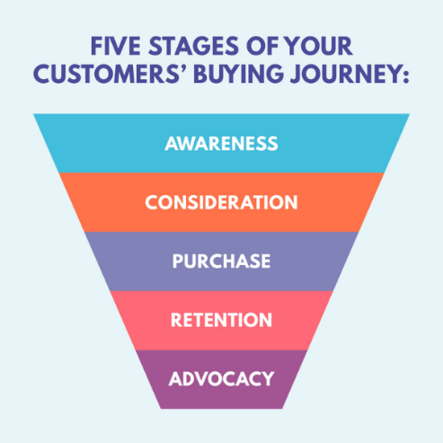
(Fig 3 source: https://www.cim.co.uk/content-hub/blog/five-stages-of-your-customers-buying-journey/)

STAGES OF CUSTOMER JOURNEY

Awareness:
This is the stage of discovery. This is the stage where a customer encounters a product or service and becomes aware of it. It could be with an advertisement, word of mouth or through other source of marketing or research. In this stage the customer would be exposed to the options available and gathers information (Commbox, 2019).
Consideration: In this stage the customers would put in some thought and actively think about buying a product or service. Increasingly customers have lost their trust in advertising. They would instead trust the advice of their friends and family when they want to make a purchase. Here, they would consider the worth of the product and the benefits of investing in this product. A product with a good brand name makes consideration easier (CIM Team, 2022).
Purchase: Once a customer considers purchasing a product or service, a customer would move towards purchasing it. At this stage the customer completes the payment and buys their product or service. Here, in addition to the product cost, sometime the customer can also be charged for a shipping cost and additional taxes (CIM Team, 2022).
Retention: After purchasing, the customers would use their product and sometimes seek support or advice regarding the product. It is important that a company provide after-sales assistance to their customers by maintaining proper contact information in their websites (CIM Team, 2022).
Advocacy: Once a customer is satisfied with a product or service, they would promote this product to their families and friends. Advocacy would include both criticism and praise to showcase the true value of the product. In recent years, customers have started to post their reviews in in social media platforms like YouTube and Instagram, Praising and criticizing the products. It is important for a brand reach the customers criticizing their product and assist them to increase brand loyalty (CIM Team, 2022).

CUSTOMER TOUCHPOINTS

A customer touch point is generated every time a customer interacts with your service or brand. For example, A touch point is created if a customer looks at an advertisement or downloads an app related to your brand. The interactions between the customers and brands are how relationships are formed. Touch points are the points of interactions which are noted to create and analyze a customer journey map. Managing these interactions properly is vital for a business to be successful (Edwards, 2017).

FERRARI BRAND PRE-PURCHASE:
For instance, a young entrepreneur in his late 20’s named Adam wants to purchase a luxury sports car to celebrate the success of his newly found business. Being brought up in middle class family, Adam always dreamed of owning a luxury sports car and driving it. However, Adam knows which luxury brand he wants to choose. He remembered the time when a friend of Adam’s father, who is also a family friend, visited their house in a blazing red Ferrari and praised his car. It was when Adam first dreamed of owning a Ferrari. This can be considered as ‘touch point 1’. Now Adam must decide which latest model he wants to buy, he watched videos on YouTube to find out latest models and searched google to know which model is popular with celebrities. Upon his research, Adam became interested in Ferrari SF90, which is the top of the line sports car offered by Ferrari ‘touch point 2'. Adam decided to visit the closest Ferrari dealership to test drive the Ferrari SF90. After his test drive Adam got infatuated with Ferrari SF90 ‘touch point 3'.

FERRARI BRAND PURCHASE:
Adam decided to buy Ferrari SF90, He spoke with the salesperson about his interest in purchasing the car. After speaking with the salesperson, Adam decided to customize his car a little from the available options ‘touch point 4’. He wanted to purchase the car right away. He finished signing all the required documentation and paid for his purchase without opting for instalments. Adam has requested his car to be delivered to his house and is expected to receive his Ferrari SF90 within a month together with his requested customization ‘touch point 5’.

FERRARI BRAND POST-PUSCHASE:
However, Adam received a phone call from the Ferrari dealership a month later regarding the delay in delivery causing Adam disappointment. They apologized and said that he must wait for an additional 2 weeks for the delivery. They also Emailed an apology letter mentioning the same, receiving their apology has calmed Adam ‘touch point 6’. As promised, Adam received the delivery of his blazing red colored Ferrari SF90 within 2 weeks and a thank you card ‘touch point 7’. 6 months passed, and Adam was very happy with his purchase ‘touch point 8’. He suggested this car to his friends and family members ‘touch point 9’

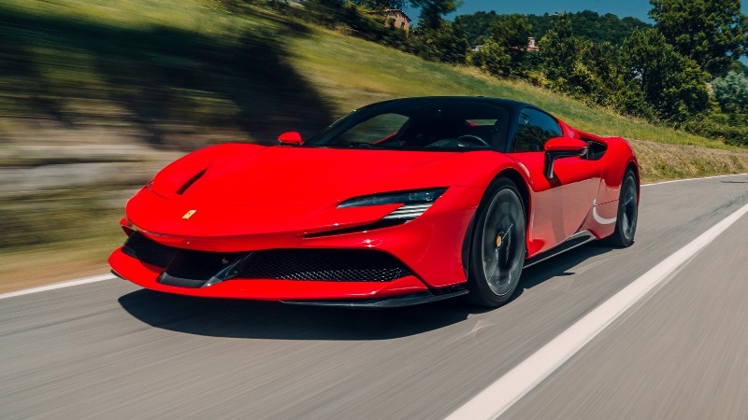
FERRARI SF90
(Fig 4: https://www.topgear.com/car-reviews/ferrari/sf90-stradale)

CUSTOMER JOURNEY MAP
CUSTOMER JOURNEY MAP | AWARENESS | DISCOVER | PURCHASE | USE | BOND
Pain point |  |  |  |  | 6.  Apology phone call and email from the dealership for the delay in delivery.
Sales support |  |  | 4.  Speaking with the sales executive about purchase and customization options.
Usage of product |  |  |  | 8.  Great user experience
Delivery |  |  |  | 7.  Receiving delivery of the car.
Purchase |  |  | 5.  Completing the required documentation and purchasing Ferrari SF90.
Word of mouth | 1.  A family friend’s suggestion |  |  |  | 9.  Recommending Friends and family.
Visiting dealership |  | 3.  Visiting Ferrari dealership for a test drive of Ferrari SF90
Research options | 2.  Online research in YouTube, Google, and Ferrari’s website
(Table 1 Source: Author)
CRITICAL ANALYSIS OF CUSTOMER JOURNEY MAP
The customer journey map covers the end-to-end journey of a new Ferrari customer, purchasing a new Ferrari SF90. The Customer journey map in Table 1, shows different touchpoints where a new customer discovers, purchases, uses and advocates a Ferrari SF90. There is a touch point where the customer encounters a pain point, due to a delay in delivery. However, Ferrari apologized regarding the same through a phone call and email, calming the customer. After the customer received and drove his Ferrari SF90, the customer became very satisfied with the product, this allowed the customer to form a bond with the brand and advice the product to their family and friends.

STRENGTHS AND WEAKNESSES OF FERRARI CUSTOMER JOURNEY MAP
Ferrari has established itself as a luxury brand with rich heritage, the company is a decade close to completing century. Since it first started its operations back in 1929 (Autosprint, 2017).
As a premium brand, there are a lot of strengths in Ferrari’s customer journey map. Ferrari has a friendly and resourceful sales team which can offer a high standard of service. Researching Ferrari in search engines like google and on social media platforms like YouTube will provide credible information and it is easy to cross check this information with Ferrari’s official website. Ferrari’s website is user friendly, and it is easy to find information on all the current models of Ferrari’s line up and compare them. Ferrari provides an option to book a test drive, letting the customers experience their product first. This allows the customers to choose the right model.
One of the weaknesses in Ferrari’s customer journey map is Ferrari’s delivery schedule. This was a pain point as there was a delay in delivery. Ferrari should improve here and deliver their cars to their customers on the promised schedule. However, Ferrari handled the situation professionally by apologizing to the customer through phone call and email, calming the customer.

KANO’S CUSTOMER DELIGHT MODEL
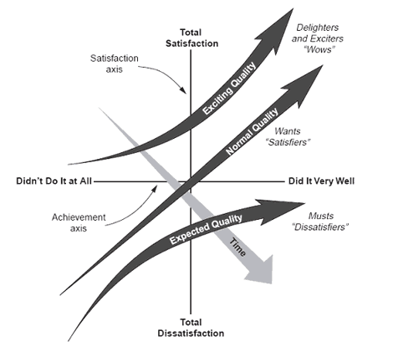
(Fig 5 source: https://asq.org/quality-resources/kano-model)
The Kano’s customer delight model was developed by Noriaki kano. This is a model that distinguishes product quality between three forms of quality. These are expected needs, normal needs and exiting needs.

Expected needs are the basic needs that a product or service can fulfil. Fully satisfying these needs will bring a supplier into the market. These are sometimes known as dissatisfiers because these needs themselves cannot completely satisfy a customer.
Normal needs are the quality, characteristics and attributes that keep a supplier in the market. These include the expectations and wants of a customer. Customers are either satisfied or dissatisfied depending on the presence or absence of a specification.
Exiting needs are the features and unique properties that will make a supplier in the market a leader. This offers the highest level of customer expectations and includes wow level qualities, properties or attributes as termed by kano (ASQ, no date). These expectations are sometimes referred to as delighters because they go beyond the customer’s expectations. The absence of these delighters would not decrease the possibility of sale. However, the presence of these delighters increases the possibility of purchase (ASQ, no date).
Ferrari as an organization focuses on the exciting needs of their customers by going the extra mile to deliver the best product with cutting-edge technology and impressive features for the delighters to enjoy. Ferrari has always been a brand from which one could expect a lot and never get disappointed. By delivering to their customers’ exiting needs on top of the expected and normal needs, Ferrari has become known as a successful brand throughout the world.

CONCLUSION AND RECOMMENDATIONS
To conclude this report, it is vital for a brand to focus on a customer journey map to identify the strengths and drawbacks of each customer touchpoint. By doing so, a brand can improve the sales of their products. It is important to develop new and innovative promotional strategies to attract customers in an innovative way. Ferrari as a luxury does everything flawlessly.
Recommendations
Ferrari could do a seasonal exhibition of their best collection of cars in major cities across the globe to attract new customers and increase brand awareness. Ferrari could create a customization smartphone app allowing the customer to customize their own unique Ferrari.

REFERENCES
Autosprint (2017) ‘The history of Ferrari’, Autosprint LTD, 04 July. Available at: https://www.autosprintchicago.com/blog/2017/6/7/history-of-a-ferrari (Accessed: 02 January 2023).
Gordon, G.N. (2023) Communication. Available at: https://www.britannica.com/topic/communication (Accessed: 04 January 2023).
Skillsyouneed (2011) What is communication?. Available at: https://www.skillsyouneed.com/ips/what-is-communication.html (Accessed: 02 January 2023).
Businesstopia (2018) Shannon and Weaver Model of Communication. Available at: https://www.businesstopia.net/communication/shannon-and-weaver-model-communication (Accessed: 02 January 2023).
Lumen (no date) Integrated Marketing Communication (IMC) Definition. Available at: https://courses.lumenlearning.com/wm-introductiontobusiness/chapter/integrated-marketing-communication-imc-definition/ (Accessed: 02 January 2023).
Lischer, B. (2020) What is a brand?. Available at: https://www.ignytebrands.com/what-is-a-brand/ (Accessed: 04 January 2023).
Bhasin, H. (2022) What is a brand. Available at: https://www.marketing91.com/what-is-a-brand/ (Accessed: 06 January 2023).
Marketing Evolution (2022) Brand Equity: What is it & why it’s key to your business. Available at: https://www.marketingevolution.com/marketing-essentials/what-is-brand-equity-marketing-evolution (Accessed: 04 January 2023).
Hawker, K. (2019) Keller’s Brand equity model - What is it and how to use it. Available at: https://medium.com/@keatonhawker/kellers-brand-equity-model-what-it-is-how-to-use-it-84e42d562299/ (Accessed: 04 January 2023).
Bhasin, H. (2019) Keller’s Brand equity Model – CBBE Model by Keller. Available at: https://www.marketing91.com/kellers-brand-equity-model/ (Accessed: 04 January 2023).
McDonald, T. (2018) Why is Ferrari called Ferrari?. Available at: https://www.rewindandcapture.com/why-is-ferrari-called-ferrari/ (Accessed: 05 January 2023).
Rossi, P. (2018) Ferrari: Where Customers Become Family. Available at: https://artplusmarketing.com/ferrari-where-customers-become-family-885e0da0bdbd (Accessed: 04 January 2023).
CIM Team (2022) ‘Five stages of your customers’ buying journey’, The Chartered Institute of Marketing, 01 September. Available at: https://www.cim.co.uk/content-hub/blog/five-stages-of-your-customers-buying-journey/ (Accessed: 02 January 2023).
Bhat, A. (2018) ‘Customer Journey: What it is & Examples’, QuestionPro, 14 May. Available at: https://www.questionpro.com/blog/customer-journey-map/ (Accessed: 02 January 2023).
Commbox (2019) 5 Phases of customer journey when onboarding, a guide. Available at: https://www.commbox.io/the-5-phases-of-the-customer-journey-when-onboarding-a-guide/ (Accessed: 04 January 2023).
Edwards, S. (2017) What are customer touchpoints?. Available at: https://makeitclear.com/what-are-customer-touchpoints/ (Accessed: 03 January 2023).
ASQ (no date) What is the Kano model?. Available at: https://asq.org/quality-resources/kano-model (Accessed: 04 January 2023).
Buttle, F. (2009) Customer relationship management. Available at: https://r4.vlereader.com/Reader?ean=9780080949611 (Accessed: 07 January 2023).

