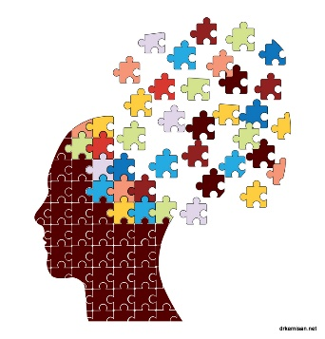

joanne Rogers
April 2019

Dementia Approaches
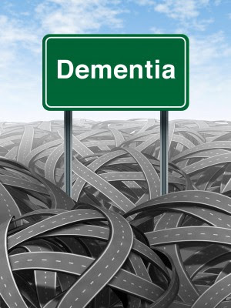
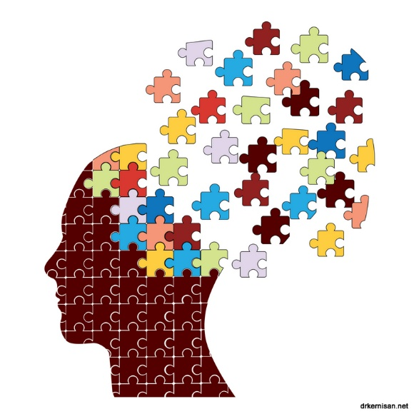

Contents Page
Introduction Page 2
Main Body Page 3
Impacts on Dementia for patients and family Page 4 & 5
Person Centred Care Page 5
Carers Training Page 6
Conclusion Page 6 & 7
Appendix Page 7
References Page 8 & 9

Dementia
Introduction
This report’s purpose is to deliver details of the effect that what every day is like for a dementia sufferer in the United Kingdom. In general, there is a stigma that dementia is thought of a normal part of the aging process. We do not know what the cause of dementia is and there are studies happening to find all this out for us. This report will identify what everyday life is like for an individual with dementia, looking at how much support and resources are available for individuals with the disease. The help that is available is not just for the individual but for family and carers too. Person centred care is a key part of the support network that the patients receive, but also proper training for carers are very important nit just for the patient but for the family and carers as well.

Main Body
The Alzheimer’s Association (2019) state that Dementia is a term for a weakening in the memory function of the brain, which does affect the daily life of some people with dementia. Memory loss, thinking properly, problem solving, and language are some the major symptoms of dementia. These changes are small to start off with, but noticeable with the changes in their behaviour such as mood swings according to the Alzheimer’s Society (2019). Alzheimer’s disease accounts for 60 to 80% of cases in the United Kingdom with 850,000 people living with the disease (appendix 1). The Dementia Care Central website (2019) identifies that there are different types of dementia the more common diseases are vascular dementia, dementia with Lewy bodies and frontotemporal dementia. But there are some that are rarer to get such as Parkinson’s, Huntington’s, Dementia with HIV/AIDS and a traumatic brain injury. The National Health Service (2019) identifies that dementia can affect all types of an individual’s everyday life. If you have dementia, remember that you are still you, just because you have a memory problem you can still enjoy life and do activities. Keeping in touch and engaging with other people who have dementia is great for the individual’s confidence and mental wellbeing. Going to the cinema, or leisure centre to go swimming helps you meet other people as well, if the individual has a carer or family member that cares for an individual it can help them with their social life too.
Bailey et al (2017) identifies that we as individuals need to listen to someone with dementia, as they are living with it and experiencing it. Dementia can be lived with; it doesn’t have to beat you. It is good also to get an early diagnosis as the individual can plan their every move with family members or carers. The individual will be more prepared and get lots of information they require. There are seven stages of dementia according to Dementia.org (2019) ranging from non-cognitive decline, which is normal functioning brain, through to mild dementia where know the individual is forgetting where they have placed items, getting lost and forgetting names and faces. Then to the final stages of dementia where the individual is losing willpower, has an obsessive behaviour to loosing the ability to speak and needing help with carers to live a good quality of life every day.

Impacts on Dementia for patients and family
Davida (2017) a dementia patient is in the early stages of the disease. She says that the disease has been hard for her to adjust as some of her family had the disease and saw how people treated them, so Davida waited a while before telling them. The disease can affect family members in many different ways. The family members can change their perception of the person with dementia, but they are still the same person. Davida (2017) says that dementia is a lonely place, and awareness of dementia needs to be more supported. The disease can have impacts on the patient and family members like it did for Davida, she lost her grandchildren in the process. She never thought that she could be thought of an unfit person to look after her grandchildren.
There are many impacts on family and friends while caring for dementia loved ones. Family members find they are overcome with grief, guilt, loss, and anger. This is normal according to the Alzheimer’s Society (2017) the loss feeling is because of the relationship you once had. It is good to remember if young children are involved that they understand the disease, some children think they can catch what the family member has, and that this is not the case. The children will be able to get help with counsellors and school teachers as well if they are worried. If the individual writes their thoughts and feelings down, also important events this can help them remember certain events better. The dementia patient and family members lives change completely after diagnosis, there are factors to take into consideration as the home will have many obstacles and dangers for the individual while they are at home. According to UKEssays (2018) the home should be changed to make it safer for the them, for example putting locks on doors and windows, putting chemicals in safe place and knives away. As their memory gets worse, they forget how to use these items properly. A positive impact for the individual with Dementia is the power of music. According to Age Concern (2019) a way of helping with dementia, music is shown to be a great activity to bring forward the long-forgotten memories. Singing is to be said that it unlocks the memories and it can kick start a great social life. Keeping active is great for dementia patients.
There are impacts to patients with dementia behaviour while in nursing homes. According to Helping Hand (2019) patients don’t have consistency in their daily life, they have different carers so they can get confused, the patient is one of many individuals that a carer must see and you don’t have much attention. Unlike at home you would have a carer all the time. The individual is not as mobile as if they were at home, you can go around your own home at ease. They can have family and friends around the home for company, but in nursing homes it is very rare or sometimes some patients don’t have anyone at all. Campbell (2013) states that care homes have been found not giving good practice as they were not preventing, detecting and properly treating patients and they have been going into hospital with dehydration, pneumonia and infections. Campbell (2013) also states that 80% of patients in a care homes have dementia, and many of the staff have not been adequality been trained to deal with dementia patients and support them, the family and friends.
Person Centred Care.
The person-centred approach came about from a gentleman called Carl Rogers, the approach was defined as non-directive, but changed the idea that the therapist was the expert and towards the theory that actually the patient is according to British Association the person-centred approach (2018). Manthorpe and Samsi (2016) identifies that person-centred care is a valued aspect of supporting people with dementia and is a guiding principle in the care sector. Person-centred care can be personalised to the patient’s needs. The Alzheimer’s Society (2019) agrees and states that person-centred care helps to ensure that people with dementia can take part in their own care plan. They are the centre of all decisions. Age concern (2019) identifies that person-centred care will be an effective route of support to dementia patients. The care offers patients people having their own space to consider their needs and aspirations. It is also said that this type of support can reduce anxiety and aggression.

Carers Training.
It has come to light that carers in care homes with residents with dementia are being attacked whilst at work, this is because the staff are not getting the proper training according to Learner (2012). One third of care home staff are being attacked on daily basis. This could be prevented if staff are trained properly. Forya (2013) agrees with Learner and says that training should be mandatory to all acute care staff. This will give the staff an understanding of a dementia patient and how they can feel like while in their care. Davis (2010) states that a training scheme is available for staff on dementia which gives them the sense of empathy with residents. There is a lot of training available for carers of dementia patients according to the Alzheimer’s Society (2019). The society gives training for anyone who is interested in getting more information about illness. The training can give the signs and symptoms, how to communicate with dementia patients and how to build a good relationship with the dementia patients. O’Brian et al (2018) state that in hospital, dementia patients are taking up beds, and because of the lack of confidence and training from the staff the patients are there longer than they should. Training was provided to these staff members and they took part in simulations and video workshops over a two-day period. Actors were bought in as dementia patients; the staff had found the training very rewarding as they found their confidence shoot up and was able to communicate better with their patients.

Conclusion
In conclusion, dementia is a growing disease which unfortunately has no cure. We have identified how little important training some care homes and even hospitals have had to care patients with dementia. Person-centred care is a key support for the patients which still gives them the independence to a certain degree that they require. Training should be a key part of any training for anyone who is wanting to care for people in the health sector. If training is not given properly, staff can get hurt and a turnaround of staff is inventible which then unsettles the patients as they don’t get consistency. We had found out that adequate training helps the staff in which work in the hospitals with dementia patients that were taking up beds because the staff didn’t want to talk them. This is wrong and unsettling for patients. After the video and simulation training for the staff they felt better to give care. The disease can have impacts of the family, which was identified by a patient of loosing he grandchildren and was told that she was unfit to look after them. This can be I’m sure devastating for a patient with dementia and support from a carer is key with proper training.

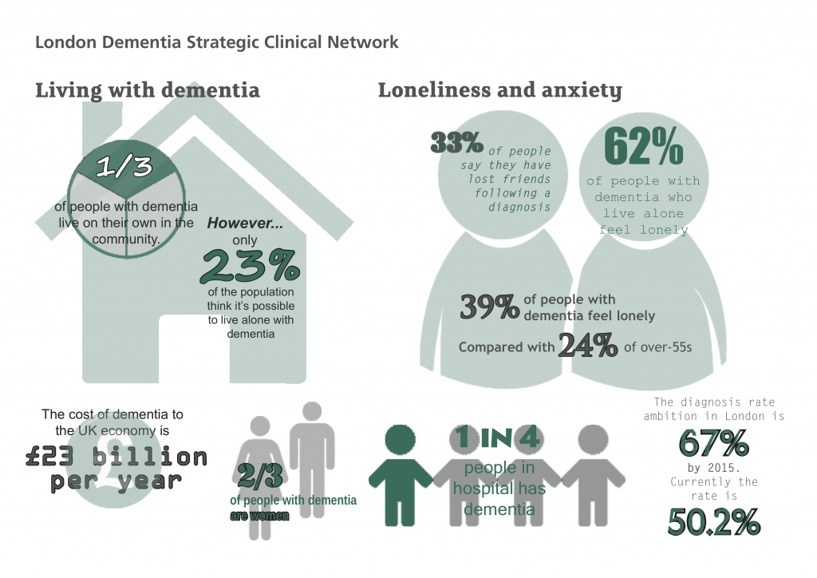
Appendix 1 – People living with the disease.

Age Concern (2019) Dementia and Music. Available at https://www.ageuk.org.uk/information-advice/health-wellbeing/conditions-illnesses/dementia/dementia-and-music/ [Accessed 30 April 2019]
Alzheimer’s Association (2019) What is Dementia. Available at https://www.alz.org/alzheimers-dementia/what-is-dementia [Accessed 27 April 2019]
Alzheimer’s Society (2019) What is Dementia. Available at https://www.alzheimers.org.uk/about-dementia/types-dementia/what-dementia [Accessed 27 April 2019]
Alzheimer’s Society (2017) Impacts on family and friends. Available at https://alzheimer.ca/en/Home/Living-with-dementia/Staying-connected/How-relationships-change/Impact-of-the-disease/Family-and-friends [Accessed 30 April 2019]
Alzheimer’s Society (2019) Person-Centred Care. Available at https://www.alzheimers.org.uk/about-dementia/treatments/person-centred-care [Accessed 1 May 2019]
Bailey, C. Brittain, K and Tiplady, S. (2017) What’s it’s really like to live with dementia. Available at http://theconversation.com/what-its-really-like-to-live-with-dementia-77988 [Accessed 27 April 2019]
British Association of Person-Centred Approach. (2018) What is the person-centred approach Available at https://www.bapca.org.uk/about/what-is-it [Accessed 1 May 2019]
Campbell, D. (2013) “Care homes and hospital failing people with dementia”. The Guardian 12th March
Dementia Action Alliance (2013) Dementia 4 Schools project. Available at https://www.dementiaaction.org.uk/dementiafriendlyschools/dementia_4_schools_project [Accessed 1 May 2019]
Dementia.org (2019) Stages of dementia. Available at https://www.dementia.org/stages-of-dementia [Accessed 28 April 2019]
Dementia Care Central (2018) From common to rare types of dementia. Available at https://www.dementiacarecentral.com/aboutdementia/facts/types/ [Accessed 27 April 2019]
Forya, B. (2013) Dementia should be core element of training for all acute staff. Available at https://www.nursingtimes.net/roles/older-people-nurses/hospital-audit-reveals-lack-of-basic-dementia-training/5061057.article [Accessed 1 May 2019]
Helping Hand Care homes (2019) Alternative to Care Homes. Available at https://www.helpinghandshomecare.co.uk/home-care-services/alternative-to-care-homes/ [Accessed 30 April 2019]
Learner, S. (2012) More dementia training is needed to stop residents attacking care home staff. Available at https://www.carehome.co.uk/news/article.cfm/id/1558055/more-dementia-training-is-needed-to-stop-resident-attacking-care-home-staff [Accessed 1 May 2019]
Manthorpe, J. and Samsi, K. (2016) Person centred dementia care; current principal. 11 pp. 1733-1740
National Health Service (2019) Living well with Dementia. Available at https://www.nhs.uk/conditions/dementia/living-well-with-dementia/ [Accessed 27 April 2019]
O’Brien, R., Goldberg, S., Pilnick, A., Beeke, S., Schneider, J., Sartain, K., Thomson, L., Murray, M., Baxendale, B. and Harwood, R. (2018) The VOICE study – A before and after study of a dementia communication skills training course. Available at https://journals.plos.org/plosone/article?id=10.1371/journal.pone.0198567 [Accessed 1 May 2019]
Sassler, D (2017) The impacts of the family. Available at https://www.dementiaallianceinternational.org/dementia-impact-families/ [Accessed 30 April 2019]
UKEssays. (2018) Discussing impact of dementia on patient and carer. [online]. Available from: https://www.ukessays.com/essays/nursing/discussing-impact-of-dementia-on-patient-and-carer-nursing-essay.php?vref=1 [Accessed 30 April 2019]

BMJ 2011; 343 doi: https://doi.org/10.1136/bmj.d7235 (Published 07 November 2011) https://www.nhs.uk/conditions/dementia/help-and-support/

