
[Information Engineering]
[Coursework]

[07/09/2020]
[Lyubomira Ivova Andreeva - 1914971]
[1914971@student.uwtsd.ac.uk]

Contents
Introduction 3
Entity Relationship Diagram 4
Data Flow Diagram 5
Microsoft Access 6
Filed and table 6
Forms 9
Property Sheet changing 11
Relationship and Primary Key 13
Query as an evidence for relationship 14
Database input in my table 14
SQL Code 21
Query design view 23
References 24

Introduction

According to the Scenario the Universal sports company need database system that will be able to produce reports relating to the staff of a company. I have created database system to input the information using easy forms and separated it in three tables to sort the information. My filed gives all the criteria to manage appropriate records of a staff. Then I am showing Entity Relationship Diagram and the relationship they interact with each table(entities). I did a research and according to it I explaining my opinion. I have created Data Flow Diagram to show any process and entities, dataflow and datastore where we will store all the information about different entities. The Director and administrative staff will manage all the process.
“Microsoft Access is a Microsoft-developed, relational database management system. Microsoft Access provides a fast and easy way to develop databases, and is especially suitable for individuals and small businesses. Access is market-leading desktop database. Most tasks can be performed in Access via the graphical user interface, but more advanced users can also use Visual Basic for Applications code to develop applications. Advanced users can use SQL code to write or edit queries, too.
Some of the key tasks carried out in Access include:
Create and maintain databases and tables therefor. Set rules and restrictions regarding the data type that can be entered in the database. Creates and executes queries. Creating forms that enable non-technical users to enter data, search the database and perform other tasks. Build reports so that data can be viewed in a more readable format, or forwarded, written out, and so on. Build macros so multi-step activities can be completed by clicking a button. Import and export third-party data.”
(IAN, 06/03/2016)

Entity Relationship Diagram
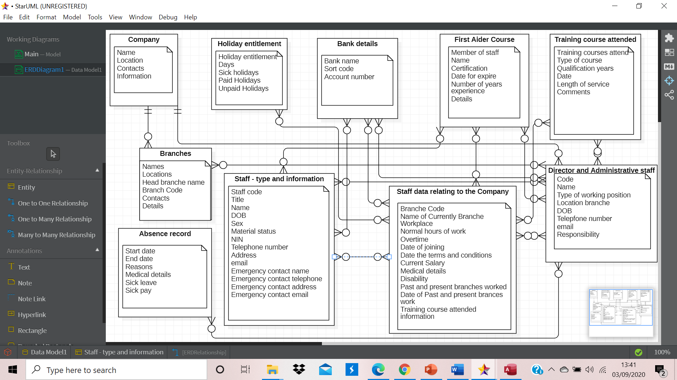
Entity relationship diagram: According to the Scenario I have created 10 entities. I decided to put that 3 types of staff which have given as an one entity, then I reduce some entities as I selected two three like one, and In the same time there isn’t missing information. There is 3 types of relationship in ER diagram (one to one, one to many, many to many). I have used two of them (one to many and many to many). I will explain and justify my vision of it. I have chosen relationship from Company to Branches one to many, because there is one company with many Branches. And one Company relating to the director and administrative staff (which I generalized as a one entity) that means one to many. If I had added separate director and administrative staff as a one separate entity, then my relationship should be one to one, because one company could relate with one director. In that case one member of administrative staff also will relate with one company. Next one is Staff data relating to the company. About it I have chosen relationship many to many, because there is many holidays for many staff, many staff type (Casual staff, Swimming pool instructor, Fitness instructor) and many data in a relation to the company. First Aider course many courses for many staff, many staff data to many First Aider courses and many Administrative staff, which manage it. Training course attended is in a relationship many to many Staff data and administrative staff. Director and administrative staff are in a relation many to many with Branches, Staff type and information, Bank details, First aider course, staff data relating to the company, Absence record and Training course attended, because they manage and process the given information. Only with company they are in a relation one to many, because many administrative staff, which include director as well and one company. Staff data relating to the company has relation with Holiday entitlement, Bank details, First Aid Course, Training Course, Staff type and information and so on. All data relating to the company are there managed by director and administrative staff, which is in a relation with branches and company.
” One entity may have a lot and different attribute which describe it and give a clear picture of the entity and many information about the entity.”
(book: Sikha Bagui, 27/06/2003)
“ERD are commonly used for the development of relational databases. The entities in the ER scheme become tables, attributes and the database schema has been transformed. Since they can be used to view database tables and their relationships, it is often widely used for troubleshooting databases. ER diagrams in software engineering Entity relationship diagrams are used in software engineering during the planning stages of the software project. They help to identify different system elements and their relationships with each other. It is often used as the basis for data flow diagrams or DFD’s as they are commonly known.
An entity may be a person, location, event or object related to a given system. A school system , for example, may involve students , teachers, major classes, subjects, fees, and other things. Entities are represented by a rectangle in ER diagrams, and called by singular nouns.
An attribute is an object, relation, or other attribute property, quality, or characteristic. For instance the Inventory Item Name attribute is an attribute of the Inventory Item entity. An object can possess as many attributes as required. In the meantime attributes may also have unique attributes of their own. For example, the "customer address" attribute may have the number, street, place, and state attributes. These characteristics are called composite.”
(Mike Chapple, 03/08/2019)

Data Flow Diagram
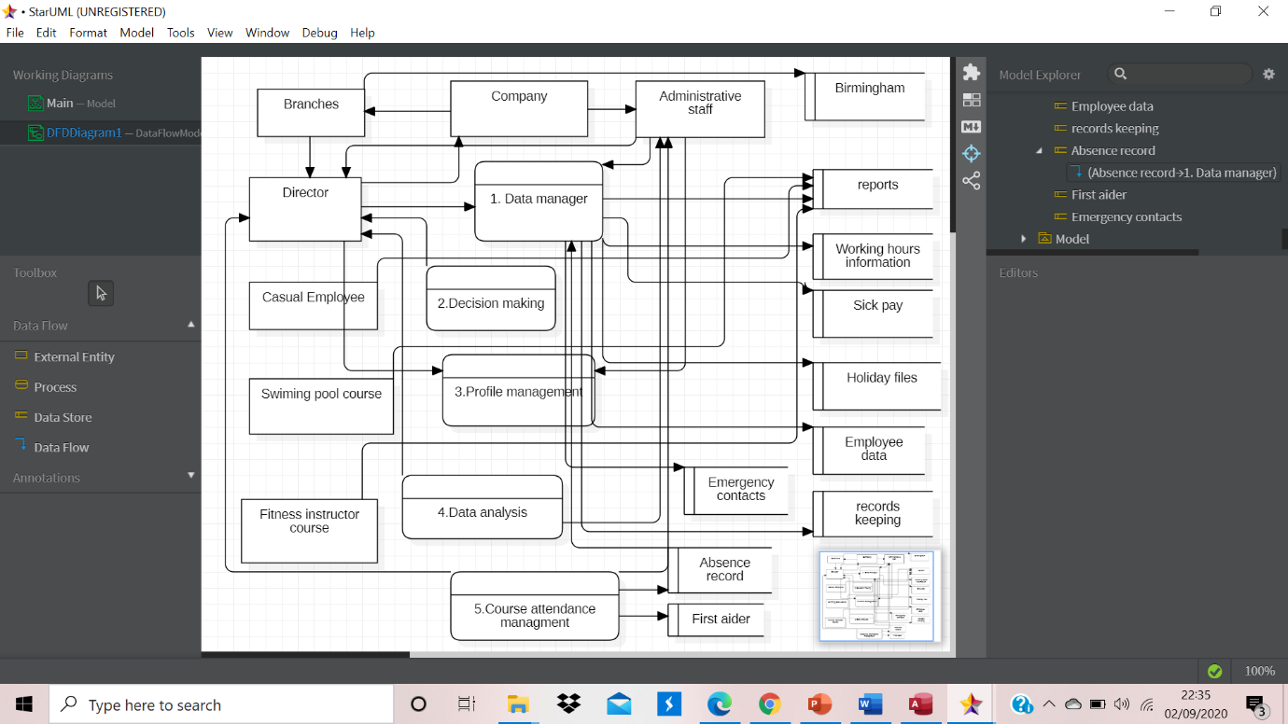
This is my Data Flow Diagram. There is five process inside the system – Data manage, Decision making, Profile management, Data analysis and Course attendance management. I found as an entity – Company, Branches, Administrative staff, Director, Casual Employee, Swimming pool course and Fitness instructor. Data store place – head branch in Birmingham. Other data stores are: Reports, working hours information, Sick pay, Holiday files, Employee data, Records keeping, Emergency contacts, Absence record, First aider.
“The Data Flow Diagram ( DFD) is a tool of organised design and analysis. Traditional visual representation of the flows of information within a system. The Data Flow Diagram(DFD) is commonly used in the analysis and design of software. A tidy and simple DFD will graphically represent a good quantity of the device requirements. The Data Flow Diagram ( DFD) describes the logic models and demonstrates the transformation of data within a system. It includes a data flow modelling method, and supports decomposition to explain the data flows and functions information. The process sequence information can not be provided by a data flow diagram. Therefore it is not a way of modelling the mechanism or procedure.
External Entity - An outside object may represent a human being, a device or a subsystem. It is from where those data start or go. In terms of business procedure it is external to the system we are researching. For this reason people were using the edge of a diagram to identify external entities. Processes - method is an organisational operation or function where data is processed and transformed. To reflect how data is handled within the process, a process can be decomposed to a finer level of detail. Data store - A data store represents the storage required and/or generated by the process for the permanent data. Examples of data stores are given here: membership types, database table, etc. Flow of data - A data flow represents the flow of information, with an arrow head showing at the end of the flow connector indicating its direction.”
(Warren Lynch 03/27/ 2019)

Microsoft Access

Filed and table
I have created four fields and one table. I will show my design view first: Bank details table with type of data store manage. 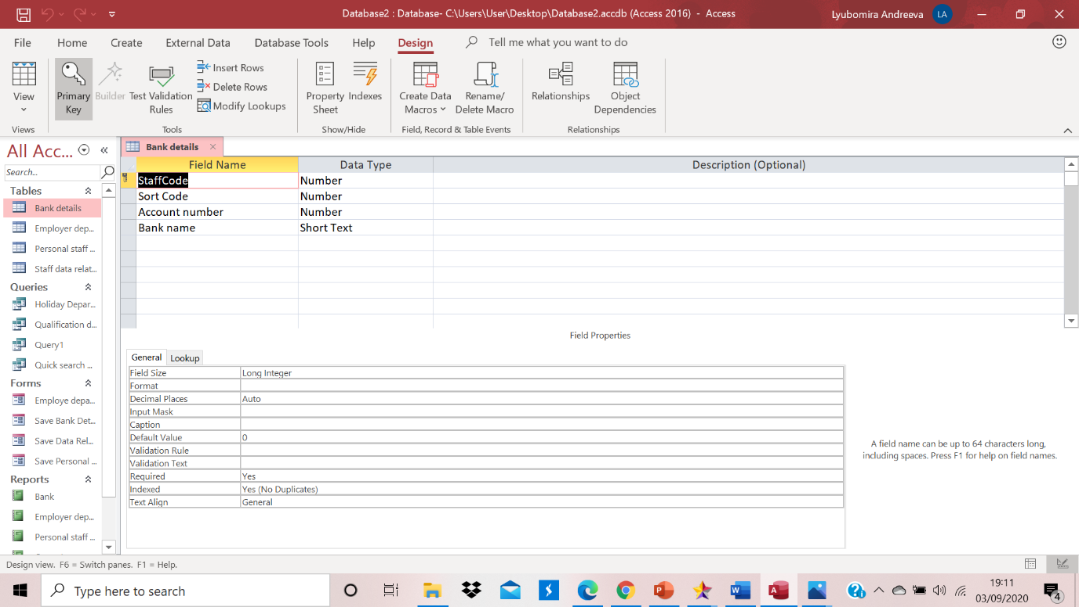
Second table Design view called Employee department
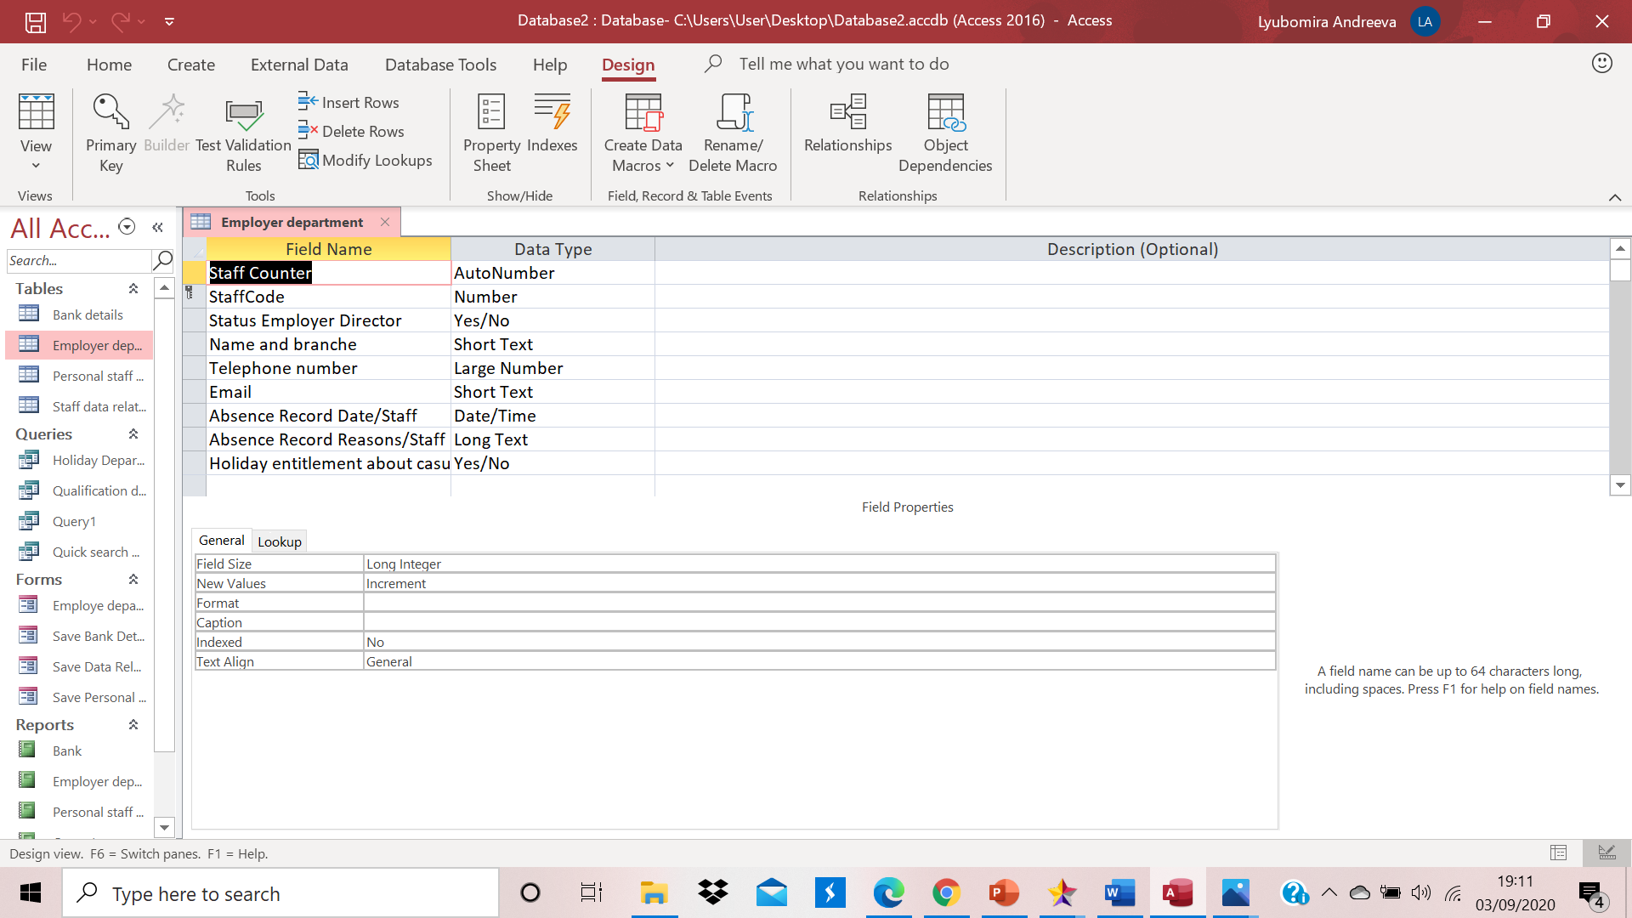

Third table with design view called Personal Staff data.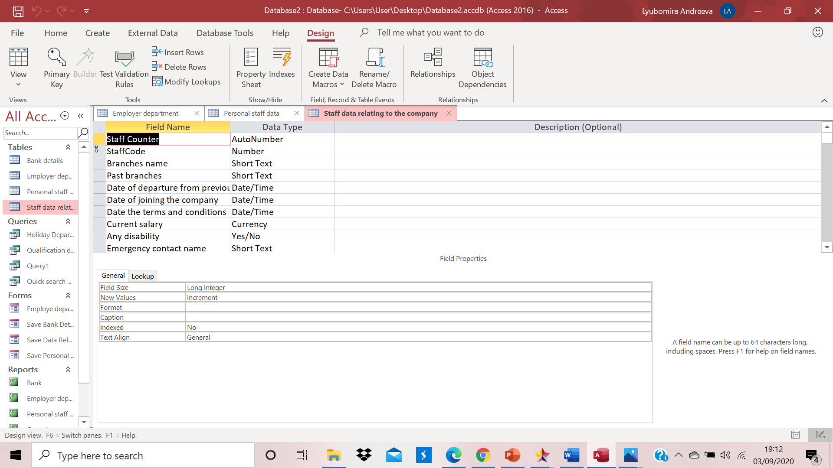

Fourth table design view called Staff relating to the company. I will show it to many pictures, because it is so long and I can’t catch it in one screenshot.
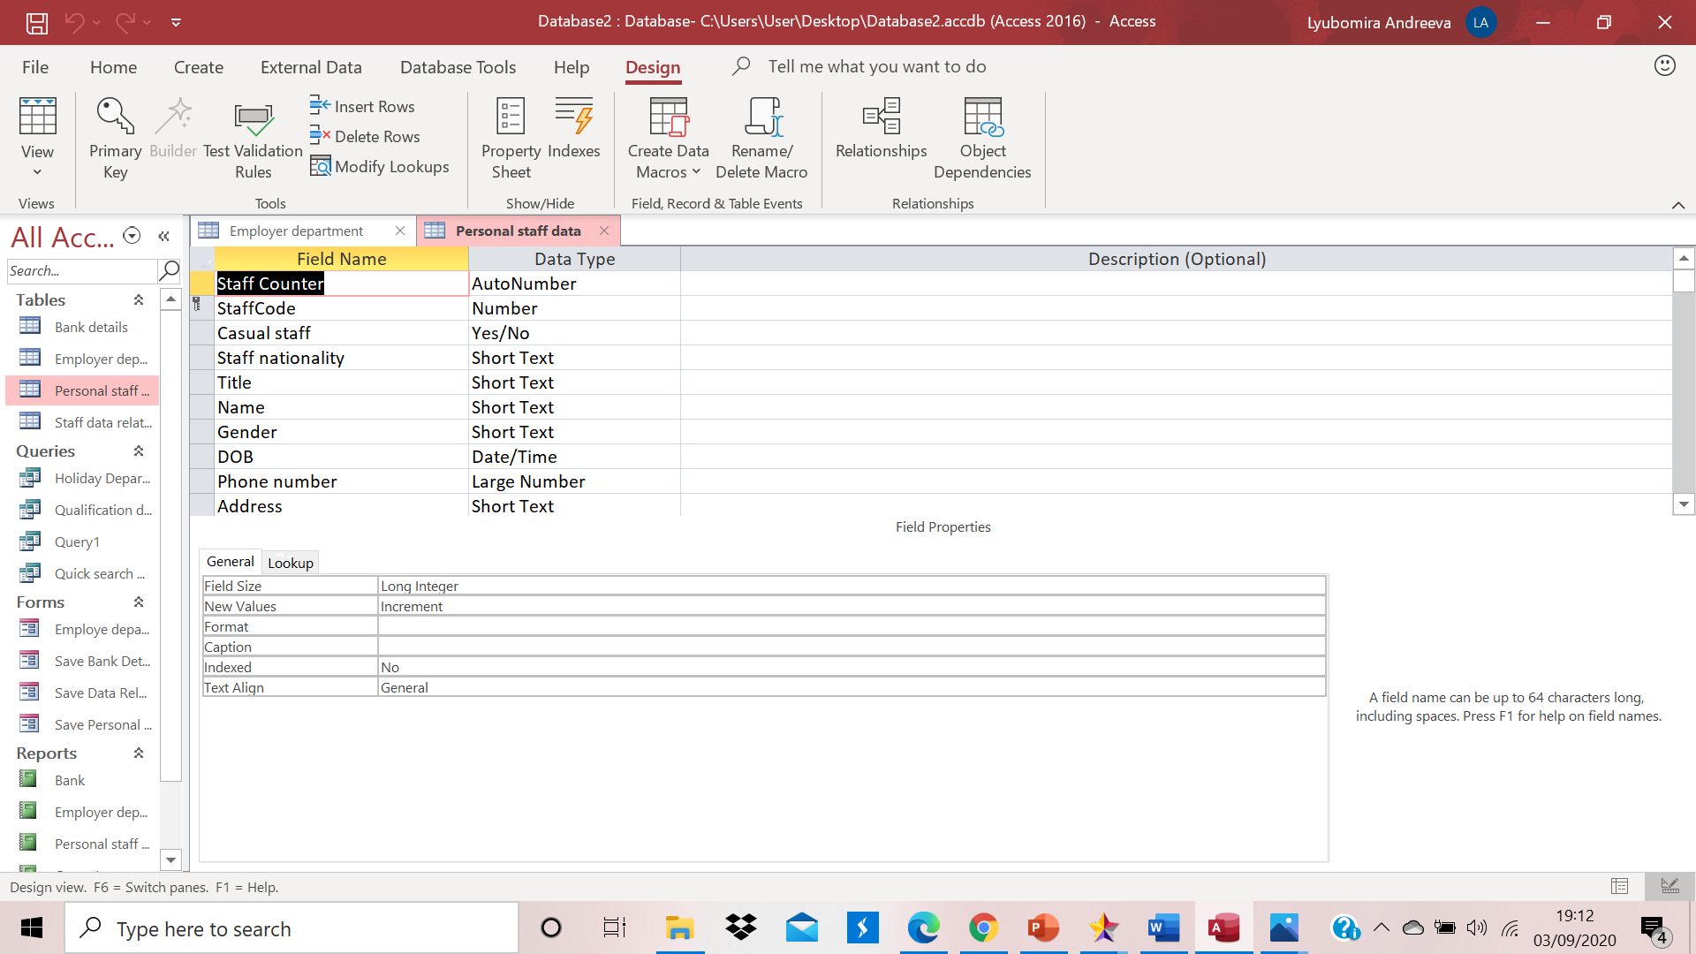

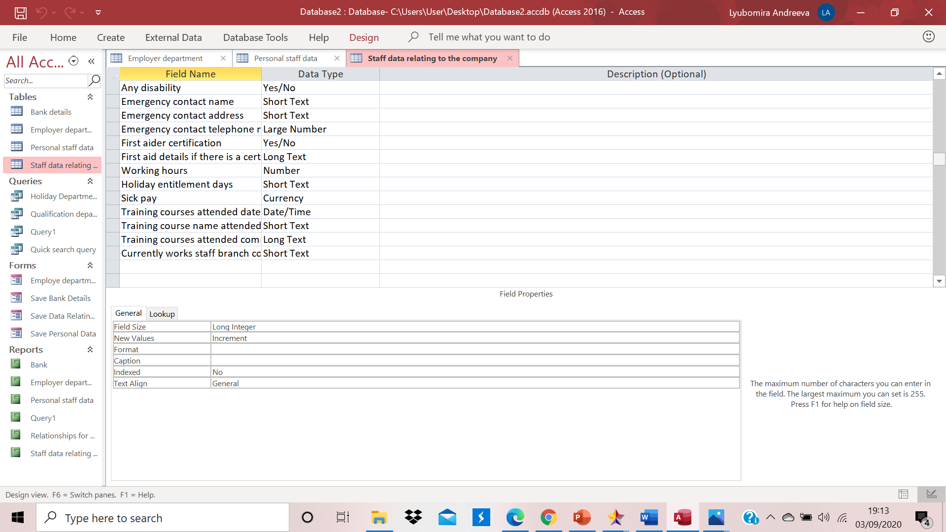
This are my four tables which I have created with different fields, records and query.
Records is all the details for one person. For example all of bank details completed are records for one person. A multiple records create a table. List of records are table. Filed is an attribute. There is relationship between all tables. In this case I have chosen as a relation Primary key Staff Code, which is unique without duplicate I chose as an option. Primary key is your first key in the table, which is in a relation wit other table, but in other tables which is outside of this table is called foreign. The main purpose of the relationship is to write down automatically Primary Key that means it is not necessary to write it in every table, it will pop in automatically because of a relationship which you are establish. Query we use to generate and choose filed which we need for one person database for example we can choose it from SQL code and multiple records for everyone in that filed. This is easy and quick way to find your necessary information. Depend on our criteria we can choose from different tables one or more filed and create a query.
For example: 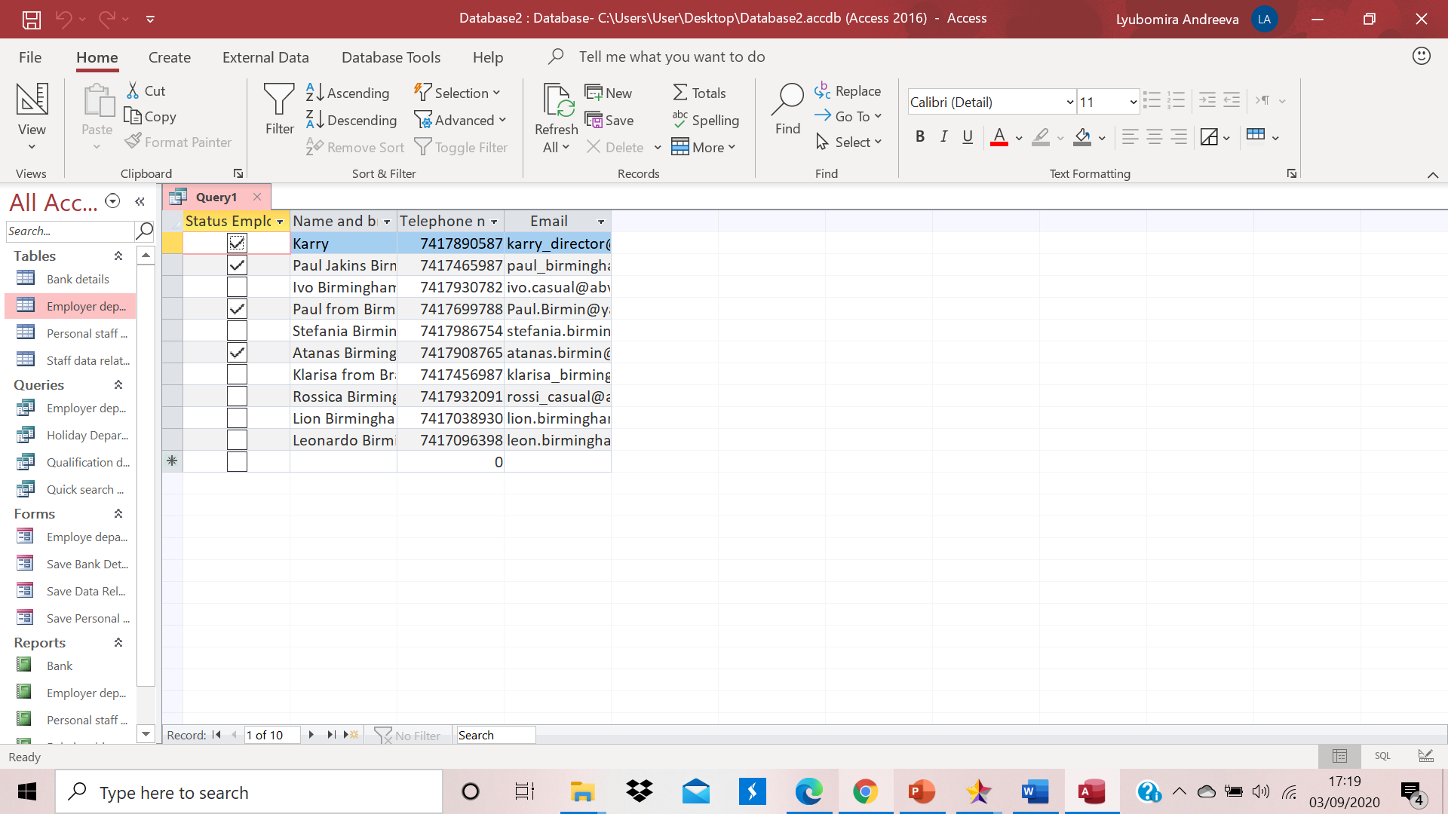

Forms
This is my forms, which are used to enter information in my tables. When we put the information and submit it with button Save record then save it again, open the tables and information is there.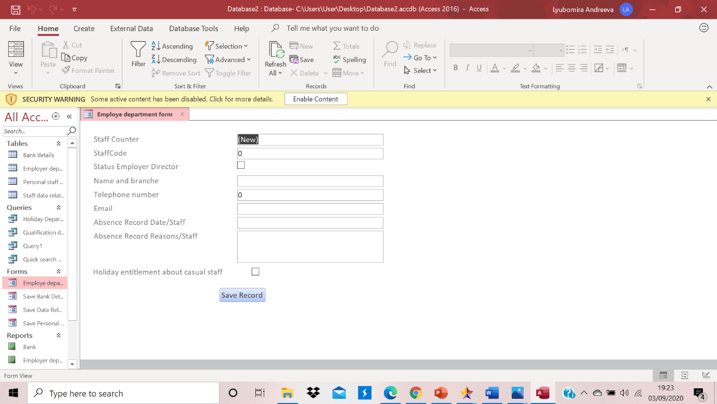
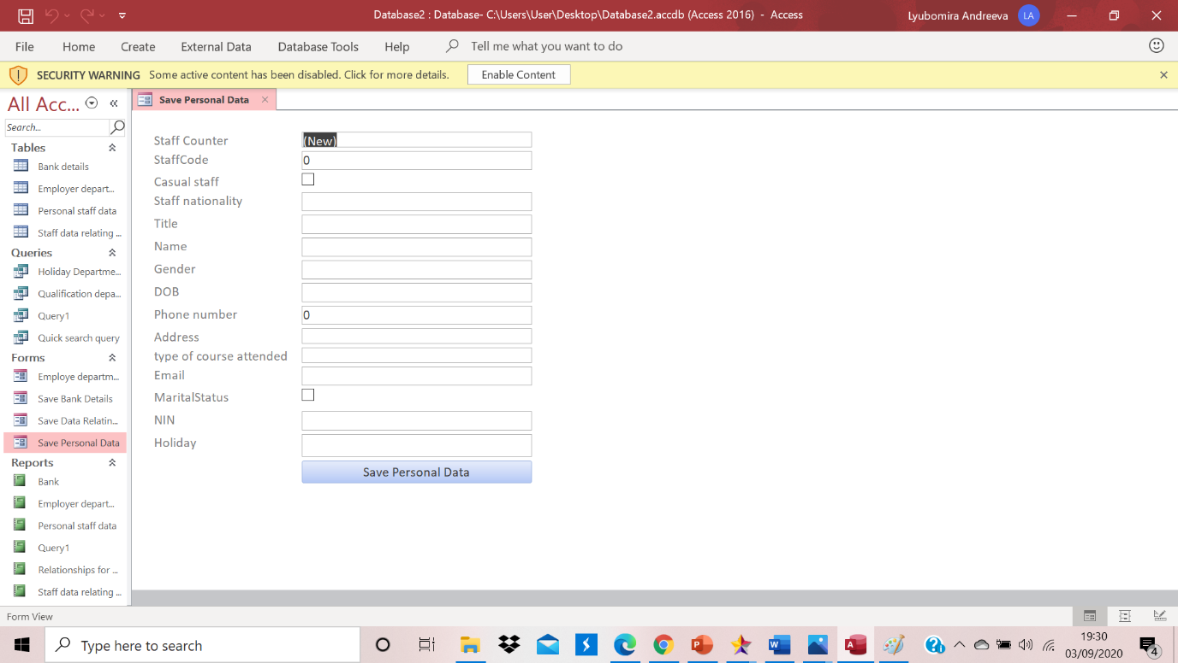
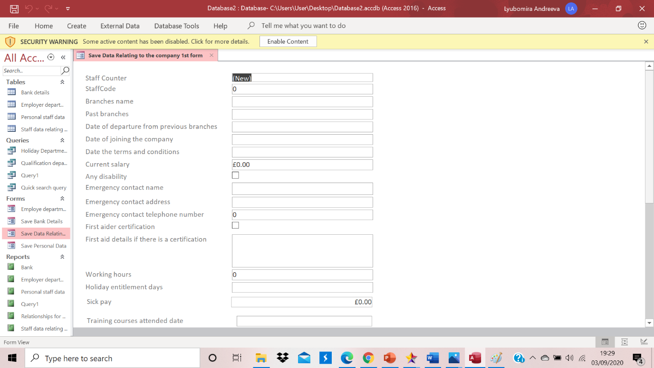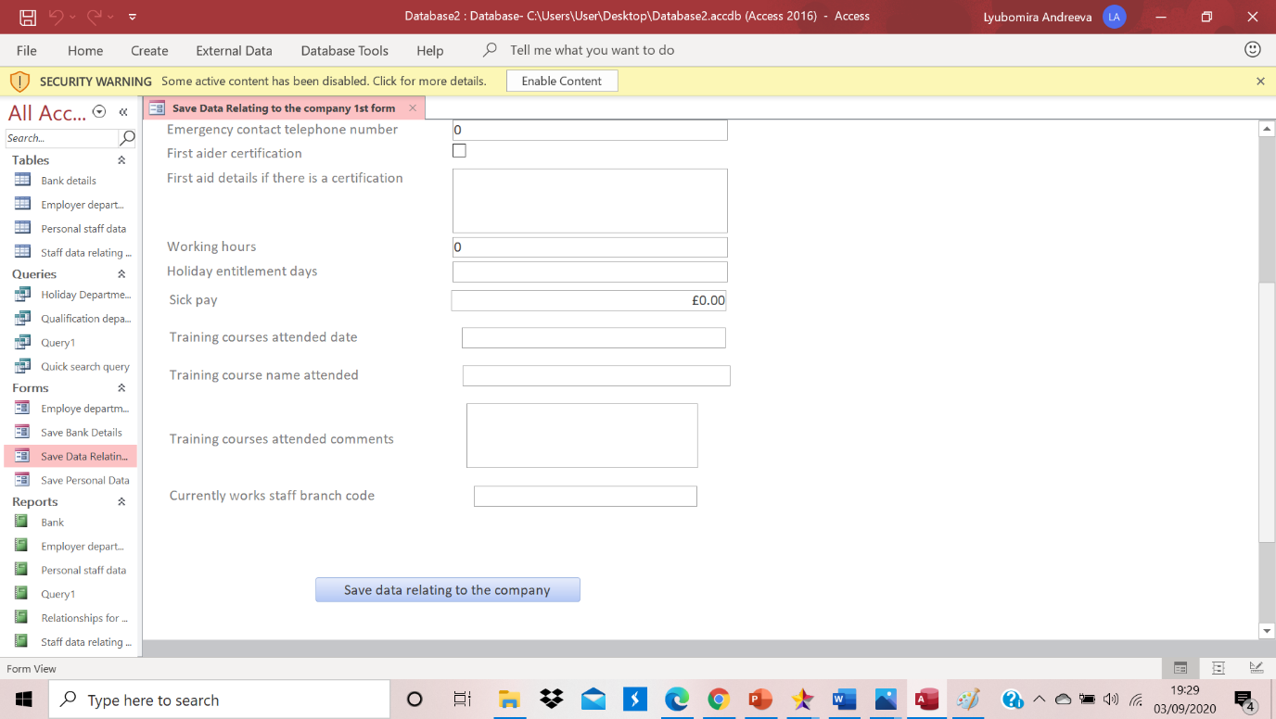
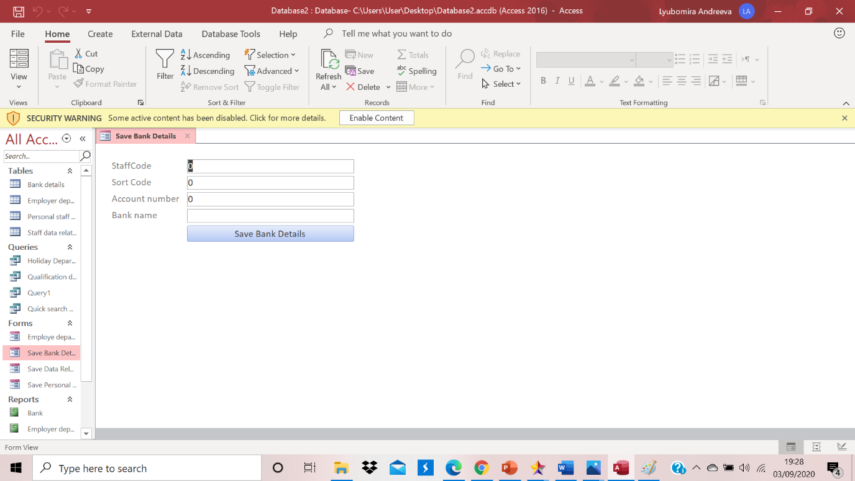

Property Sheet changing

I have done 3 changes in my property sheet for each forms. First format change was Record selector - no, Navigation button - no. And the third one was data entry yes. Because this is our goal to entry the data.
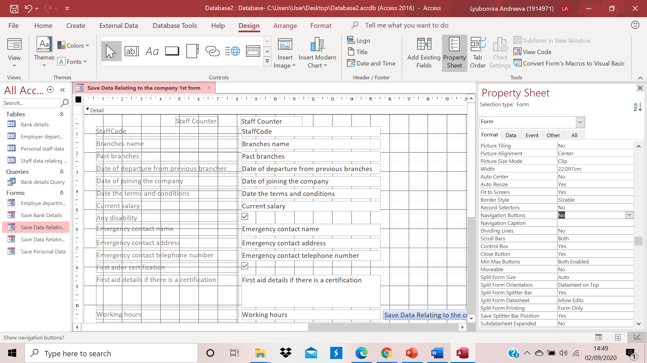

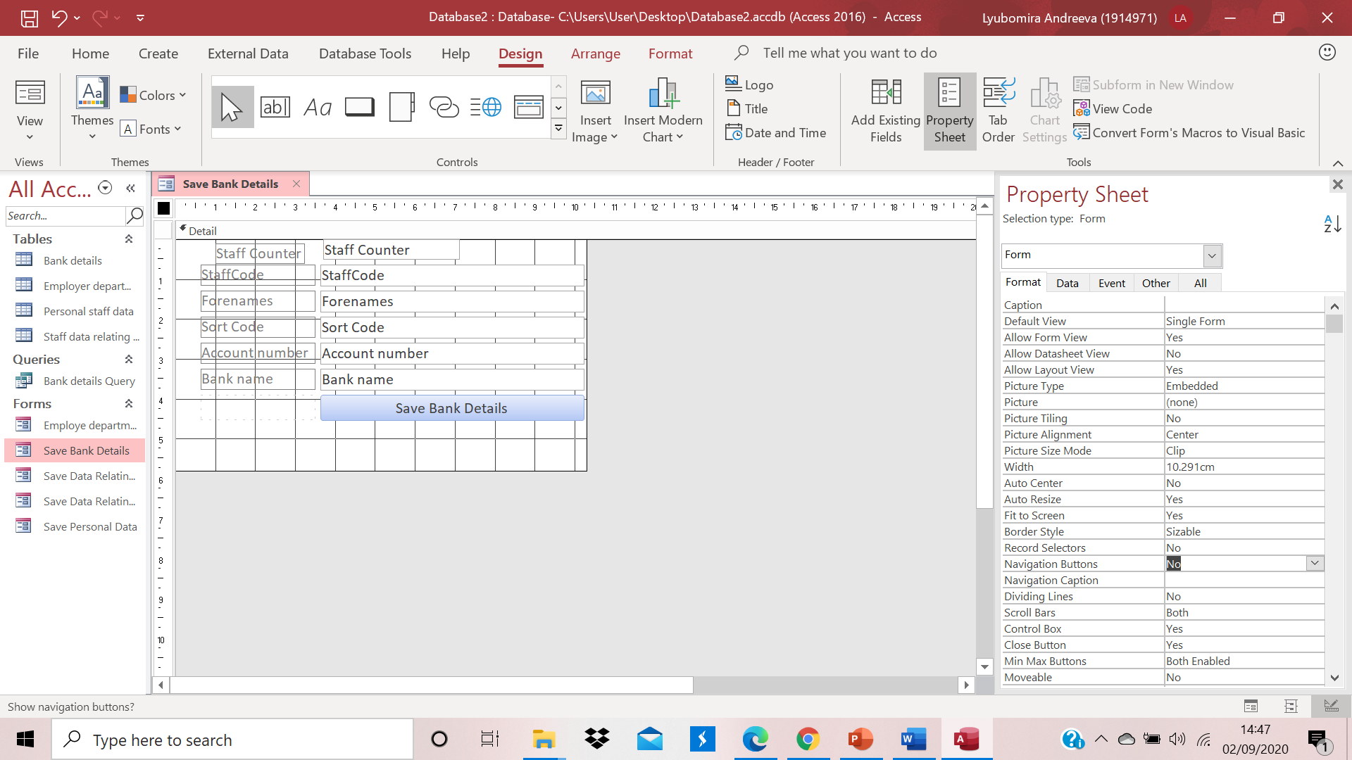

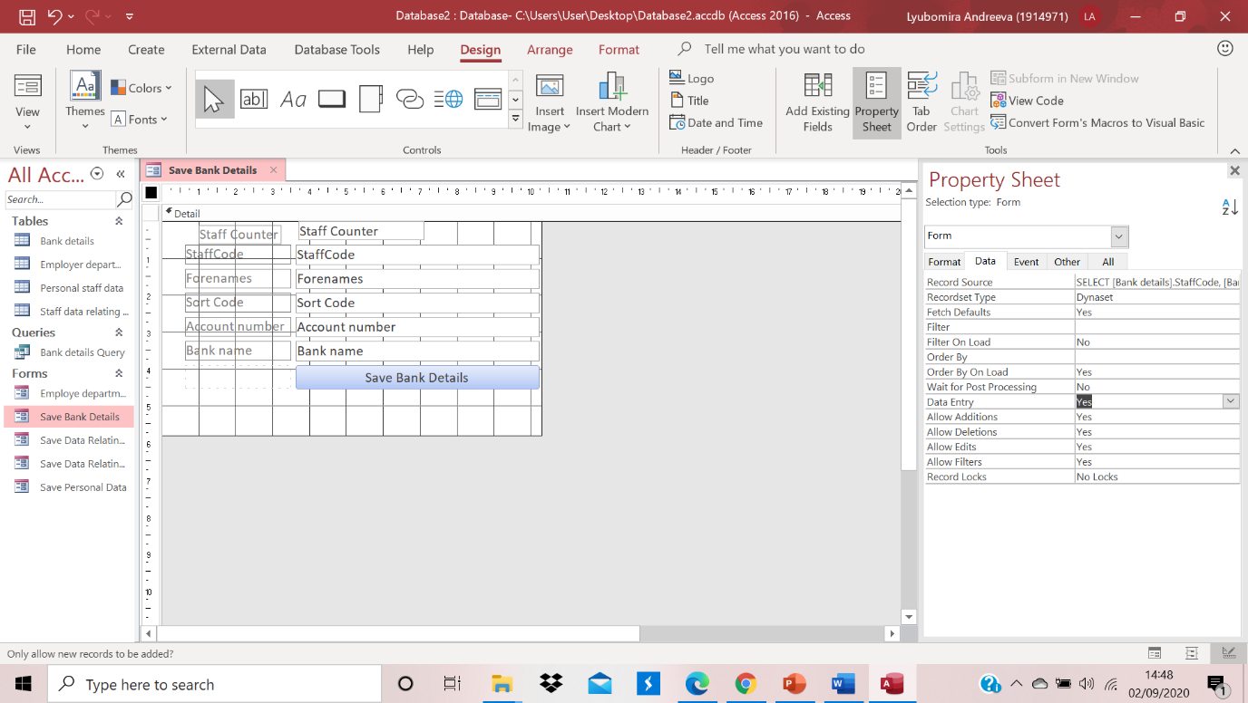
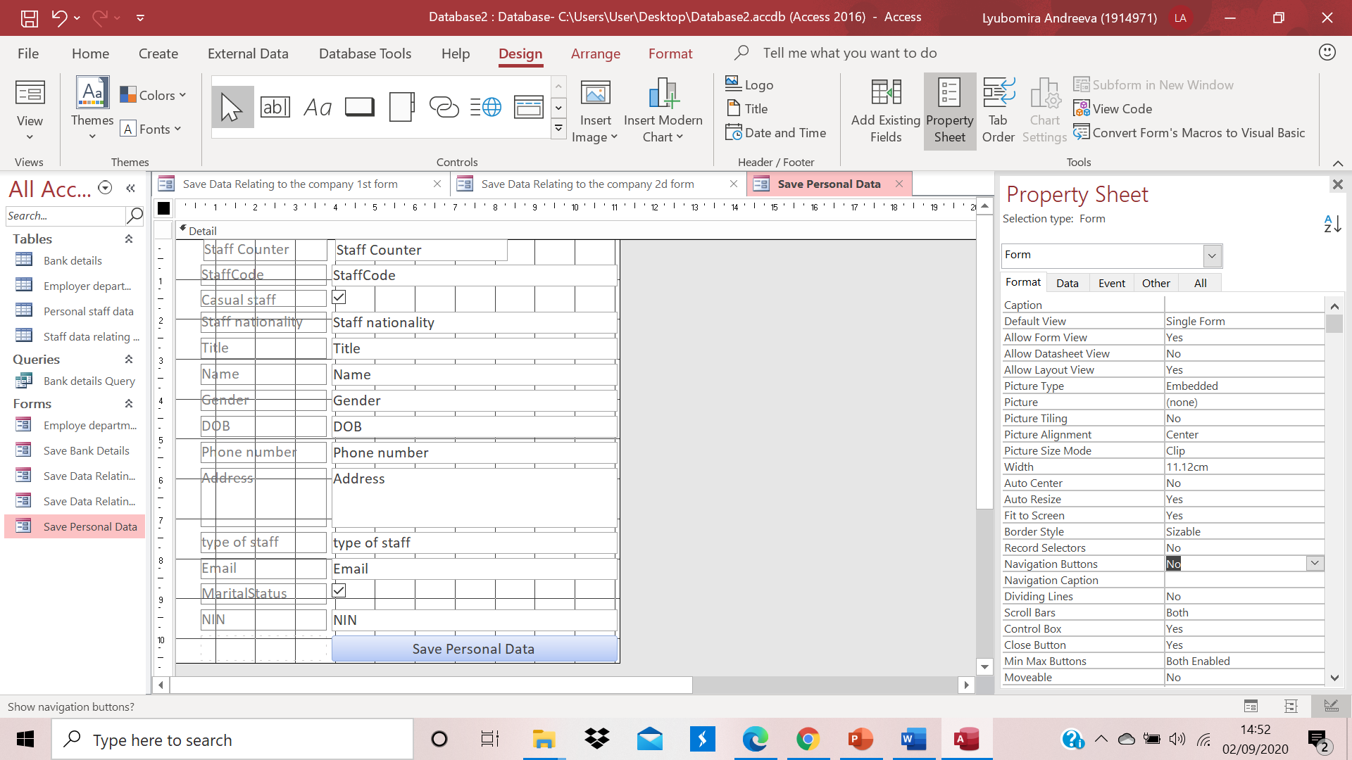

Relationship and Primary Key

This is the relationship and my Primary Key which I mention above.
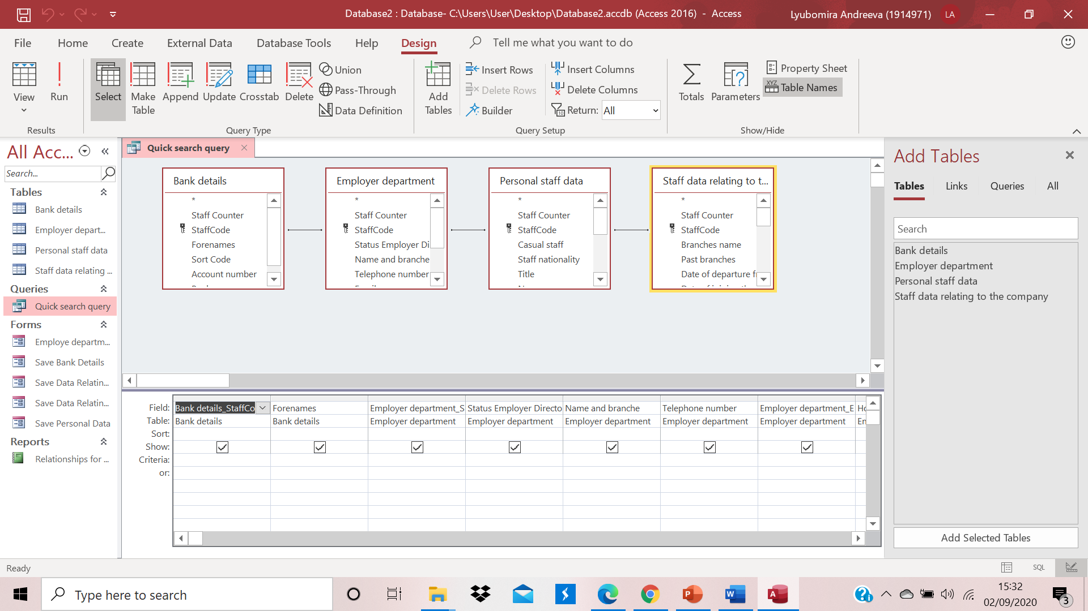

Query as an evidence for relationship
To ensure we have relationship we have to create query: I did from query wizard and design query, where I have chosen which tables and attribute I want to have. The query wizard is automatic and the difference between the query design is, query design allow you for example to choose only one single person which is possible with using a formula. Query wizard automatic show you a tables and from there you can chose fileds, and from query design you are choosing and manage everything from your own design and view. There you have more option as a surching upon a criteria and SQL code and so on.
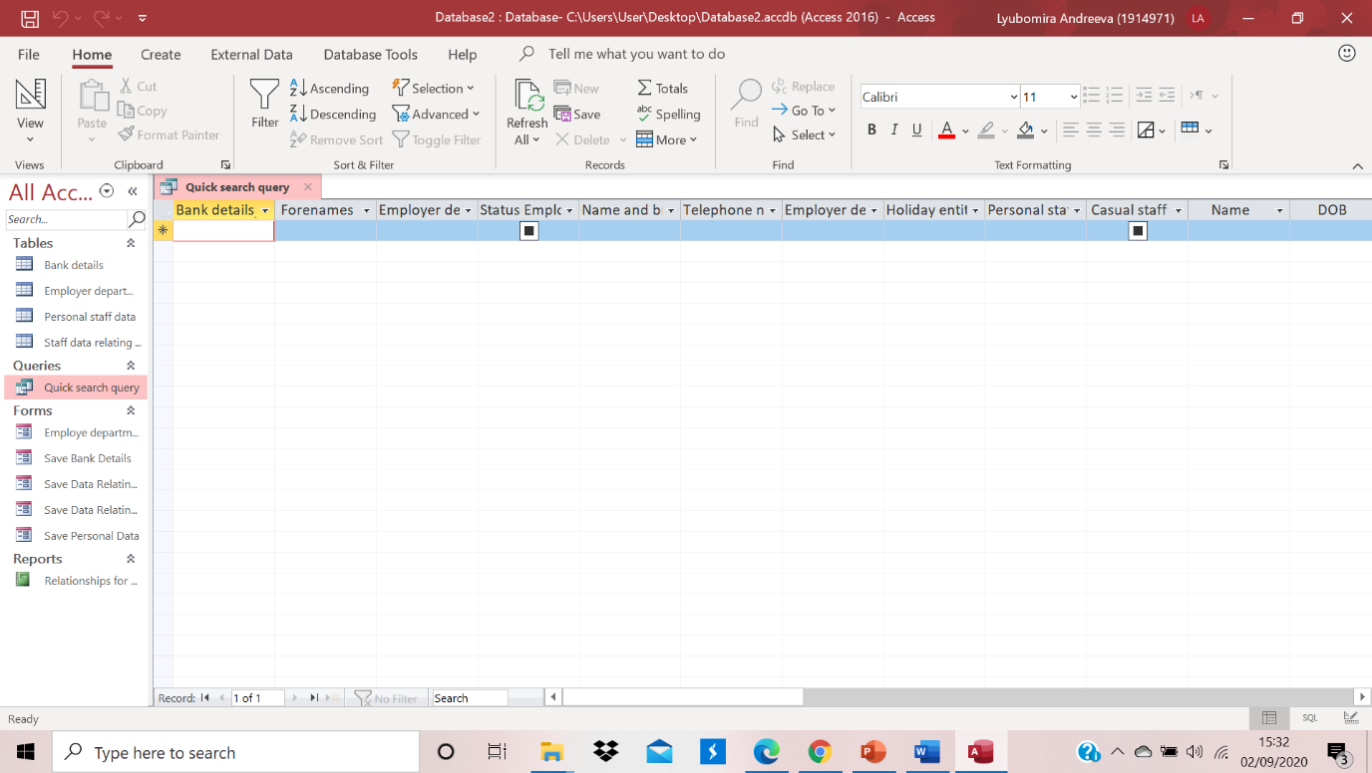

Database input in my table

In the end my database for ten person which working in the company: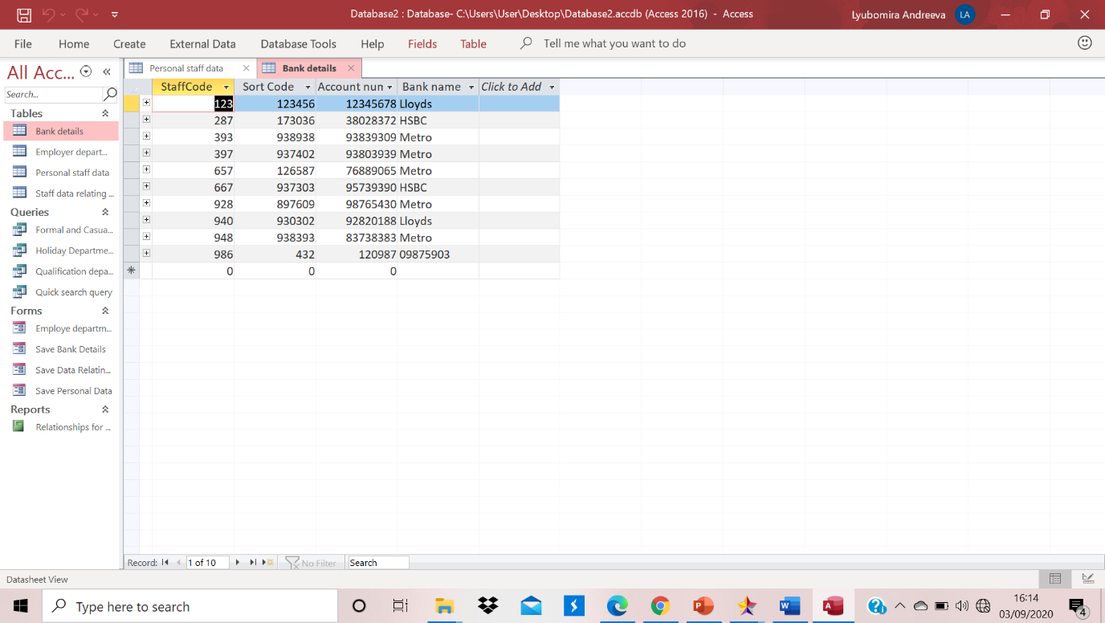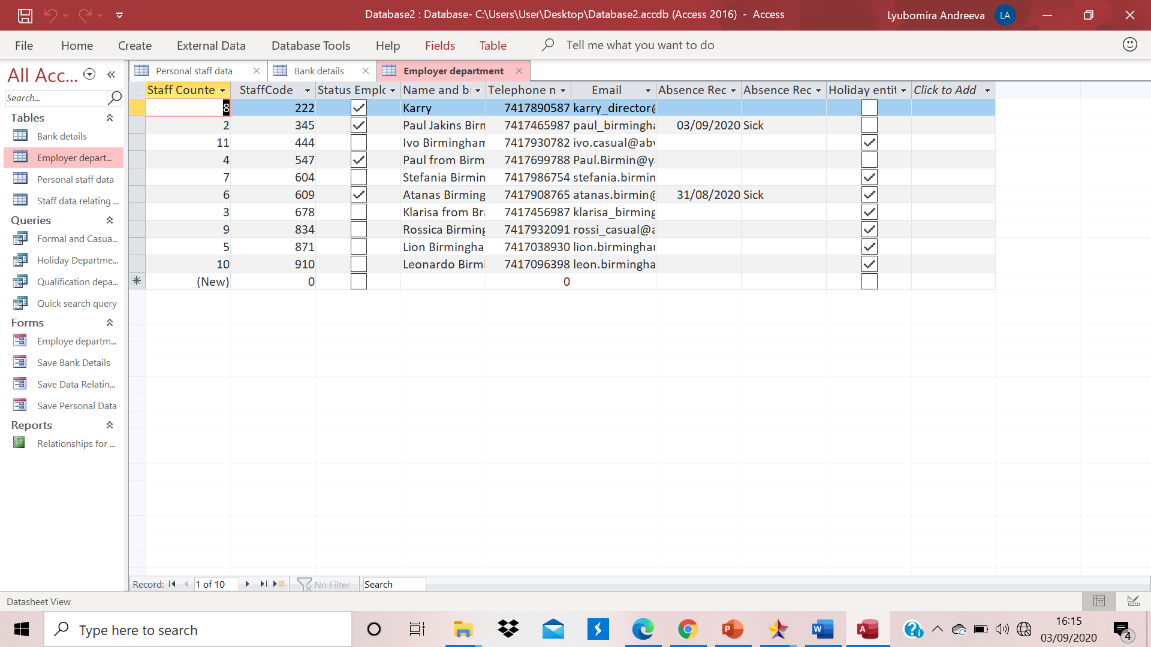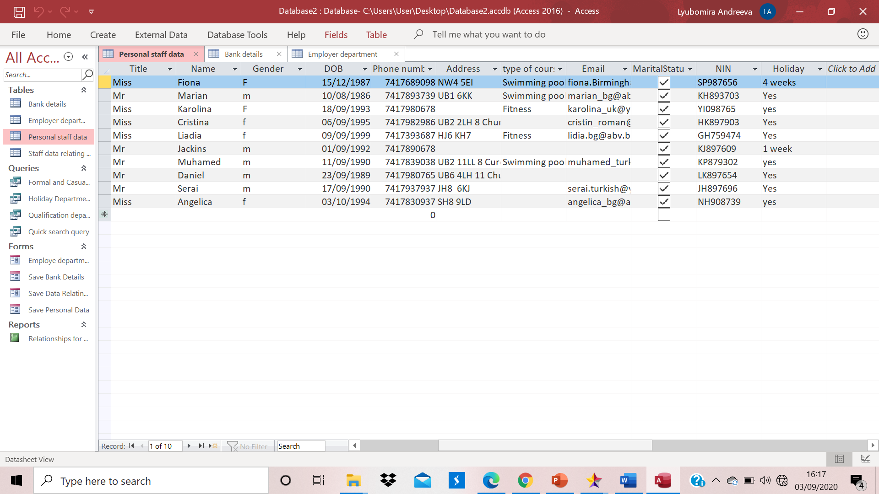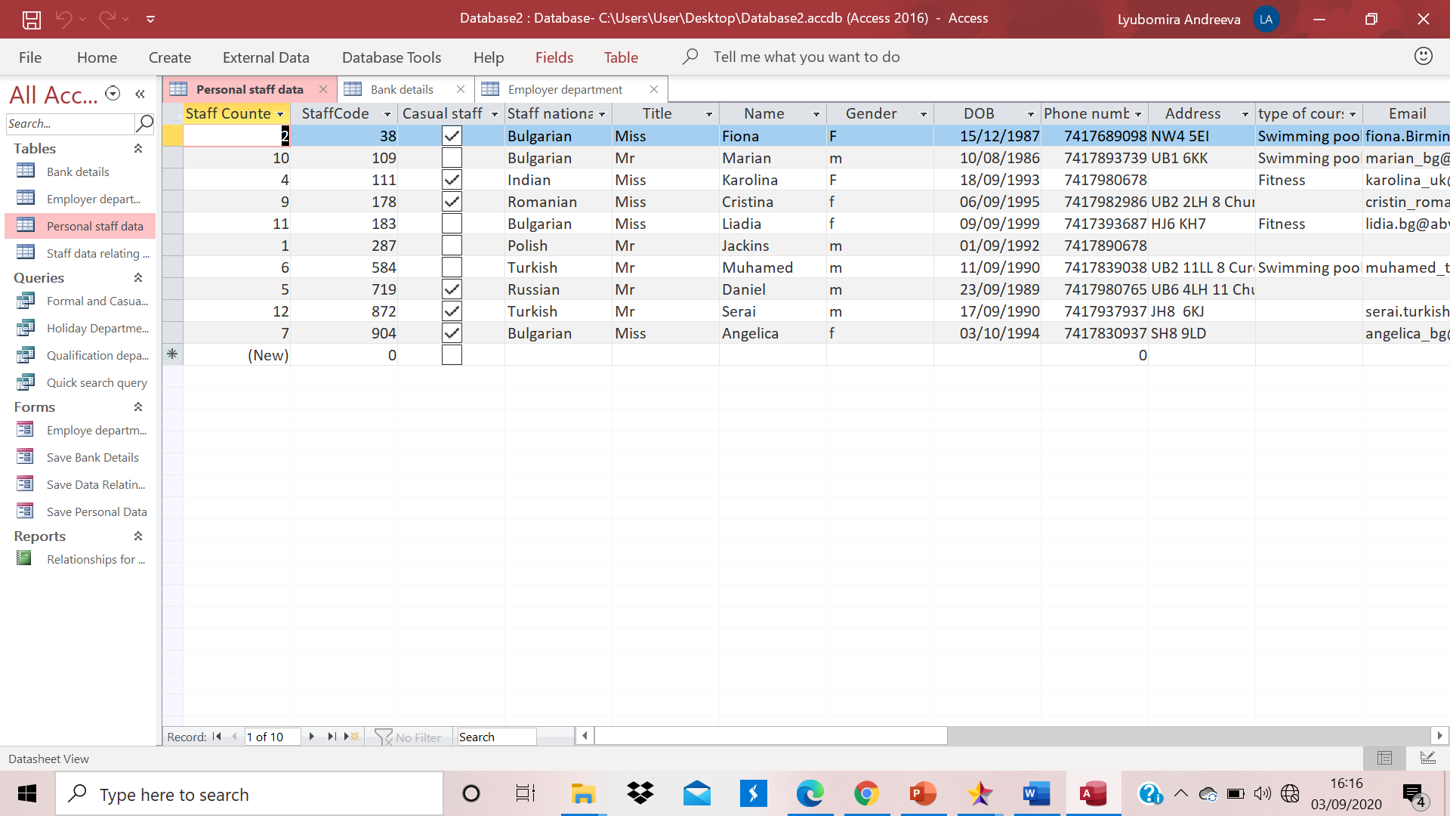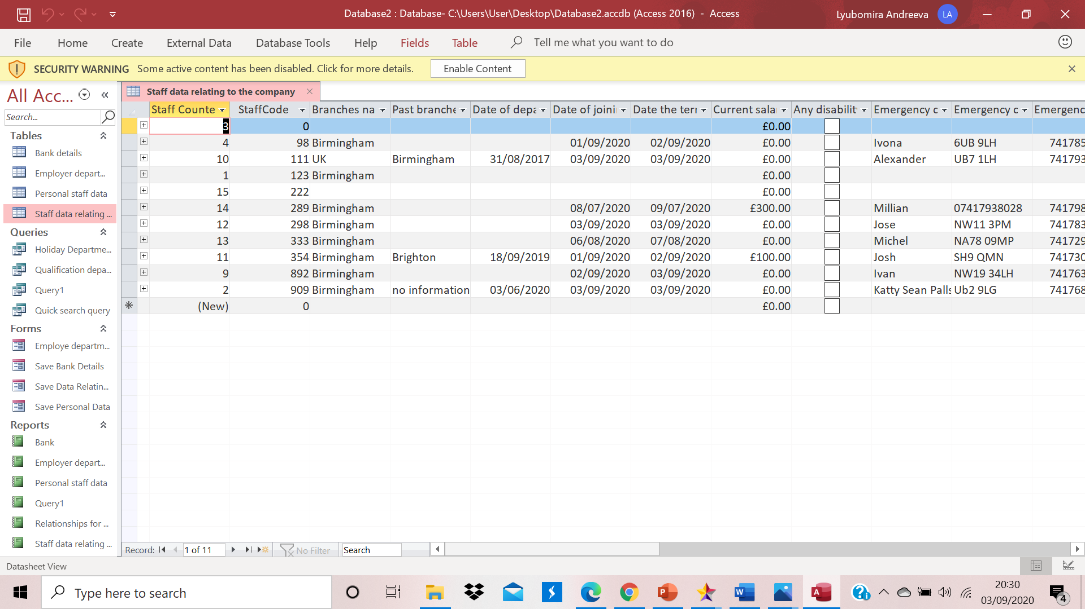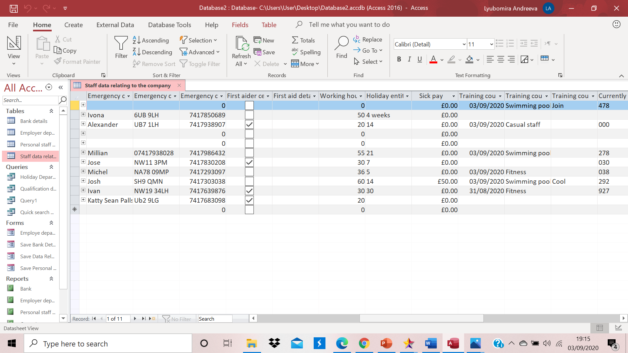
In my table Staff data relating to the company I have created so many fields and I can’t show it as a only one screenshot. There is two screenshots but it is still not enough to show everything, that is why I will count them here: Staff Counter, Staff Code, Branch name, Past Branches, Date of departure from previous branches, Date of joining the company, Date the terms and conditions, Current Salary, Any Disability, Emergency contact name, Emergency contact telephone number, First Aider Certification, First Aider details if there is a Certification, Working hours, Holiday entitlement days, Sick pay, Training course attended date, Training course name attended, Training course attended comments and Currently works staff branch code.

Reports:
This is our proof that every entity has a record that will be kept in the database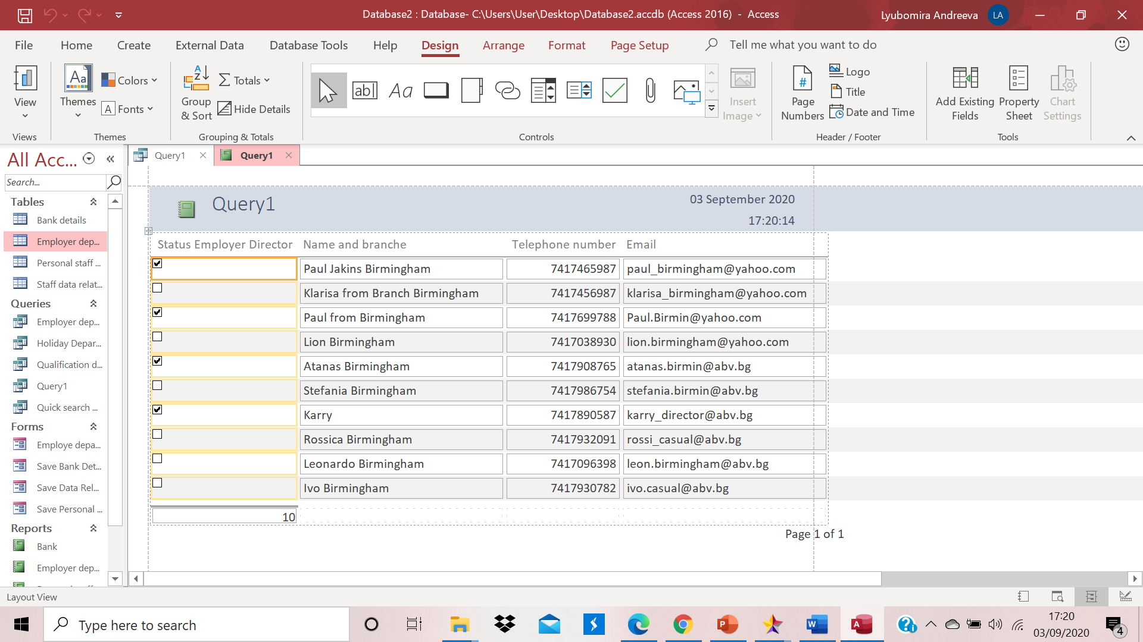
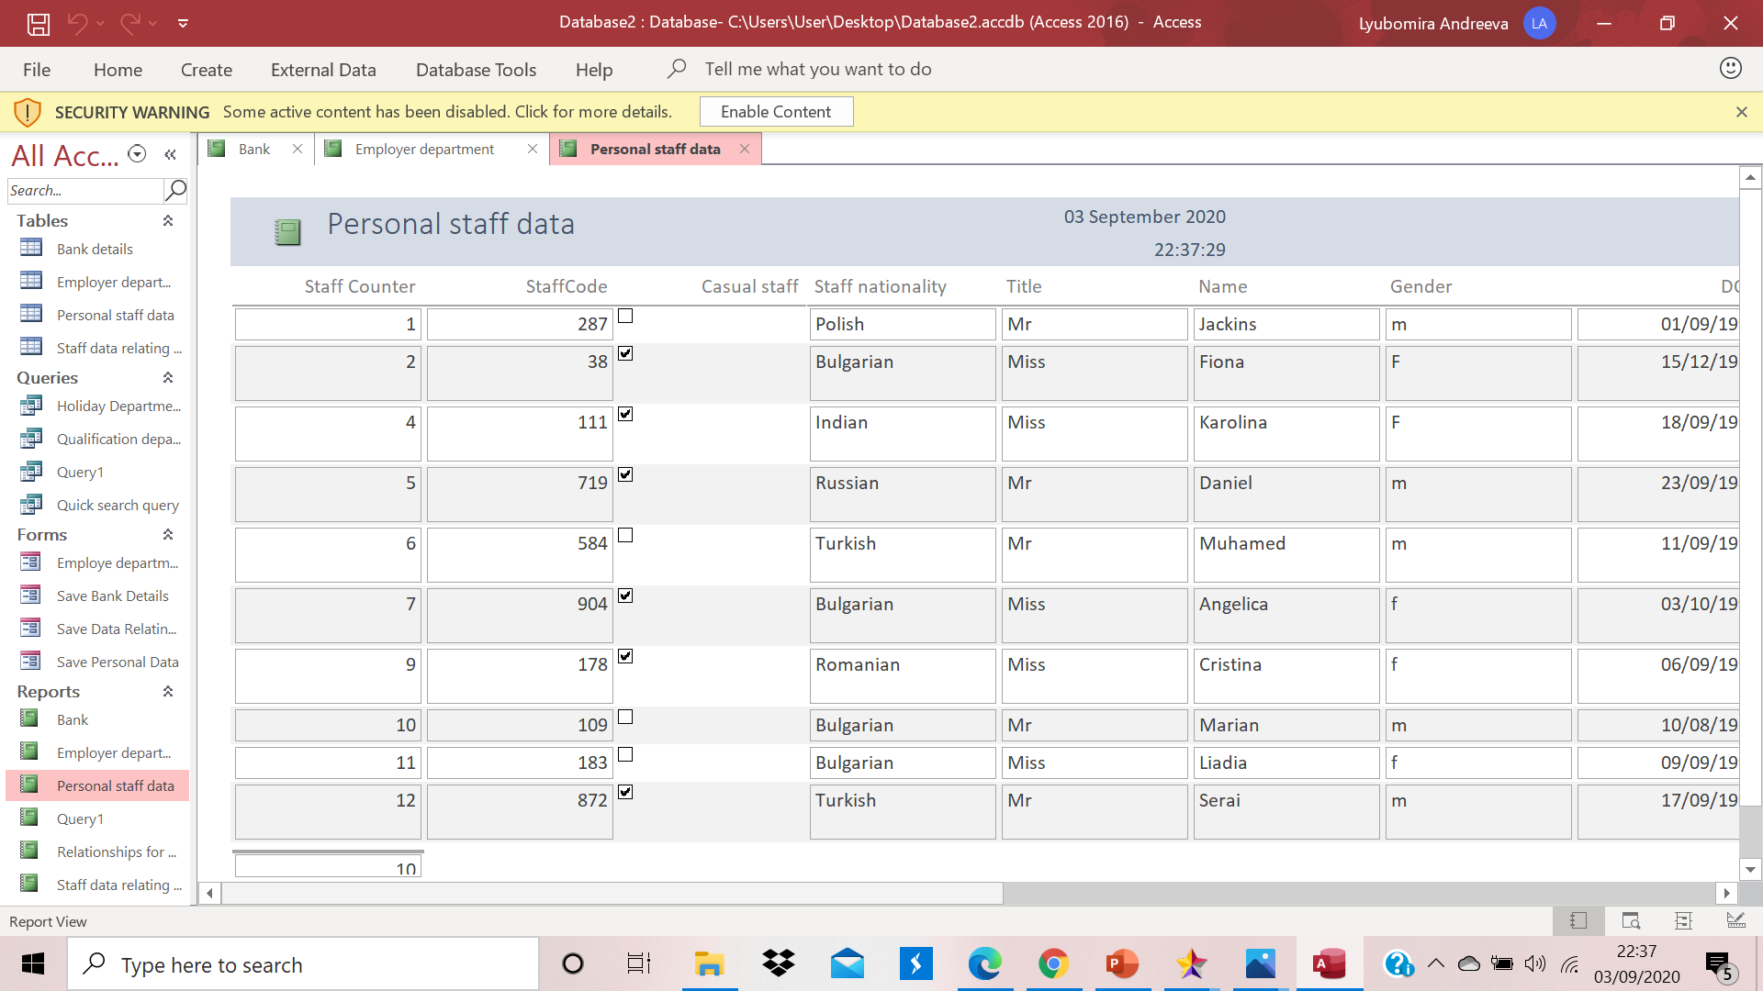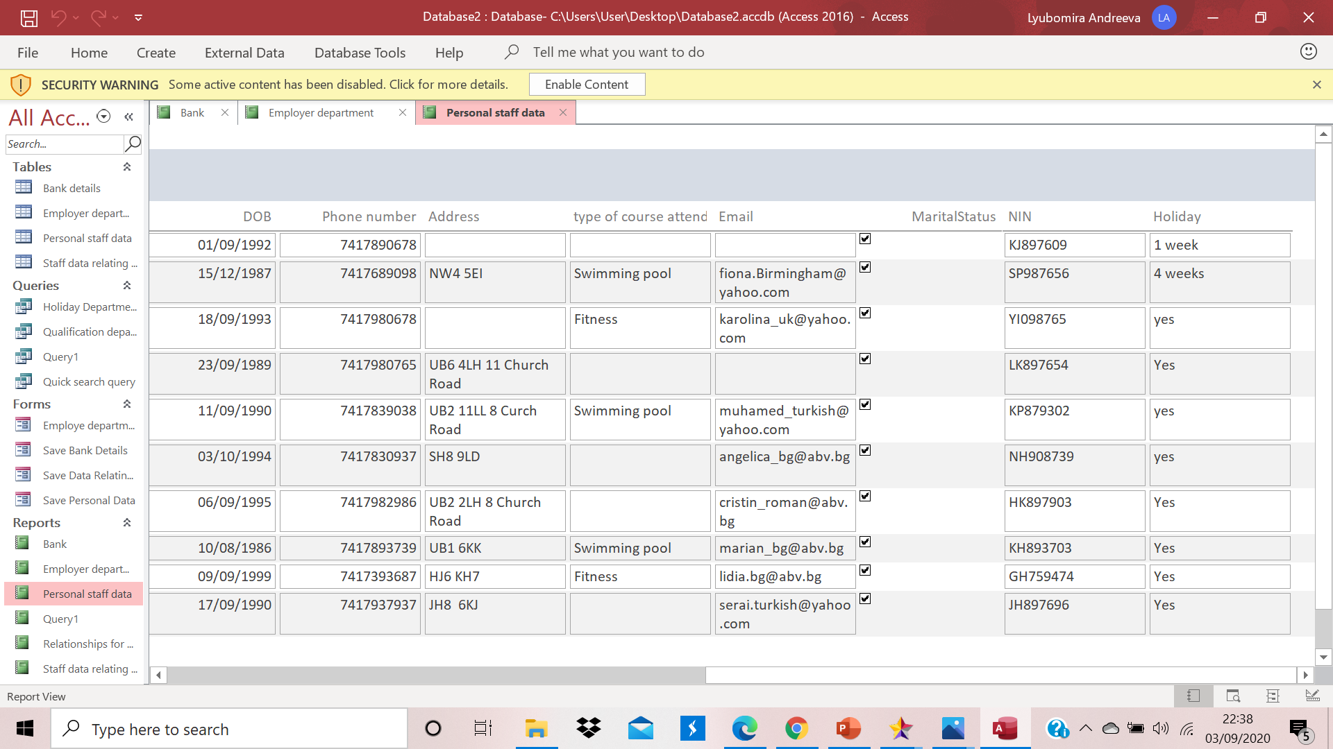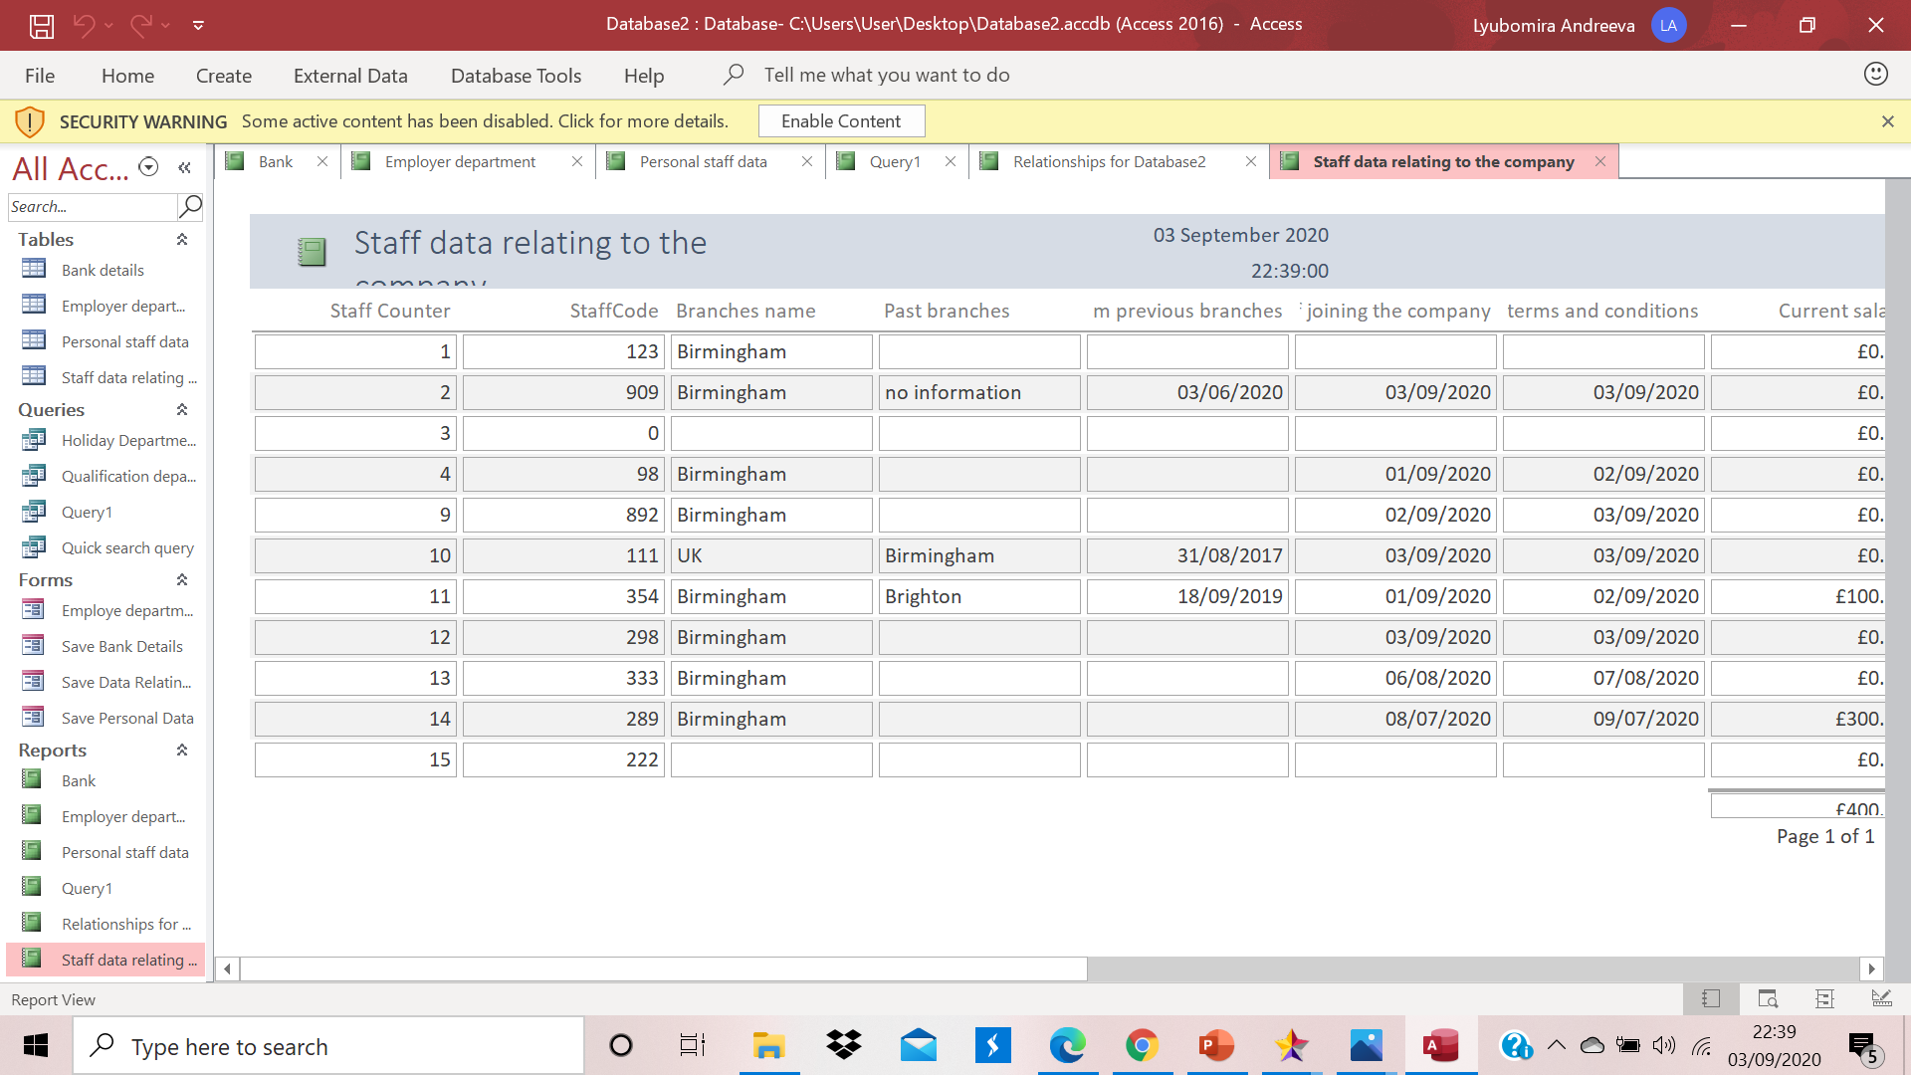
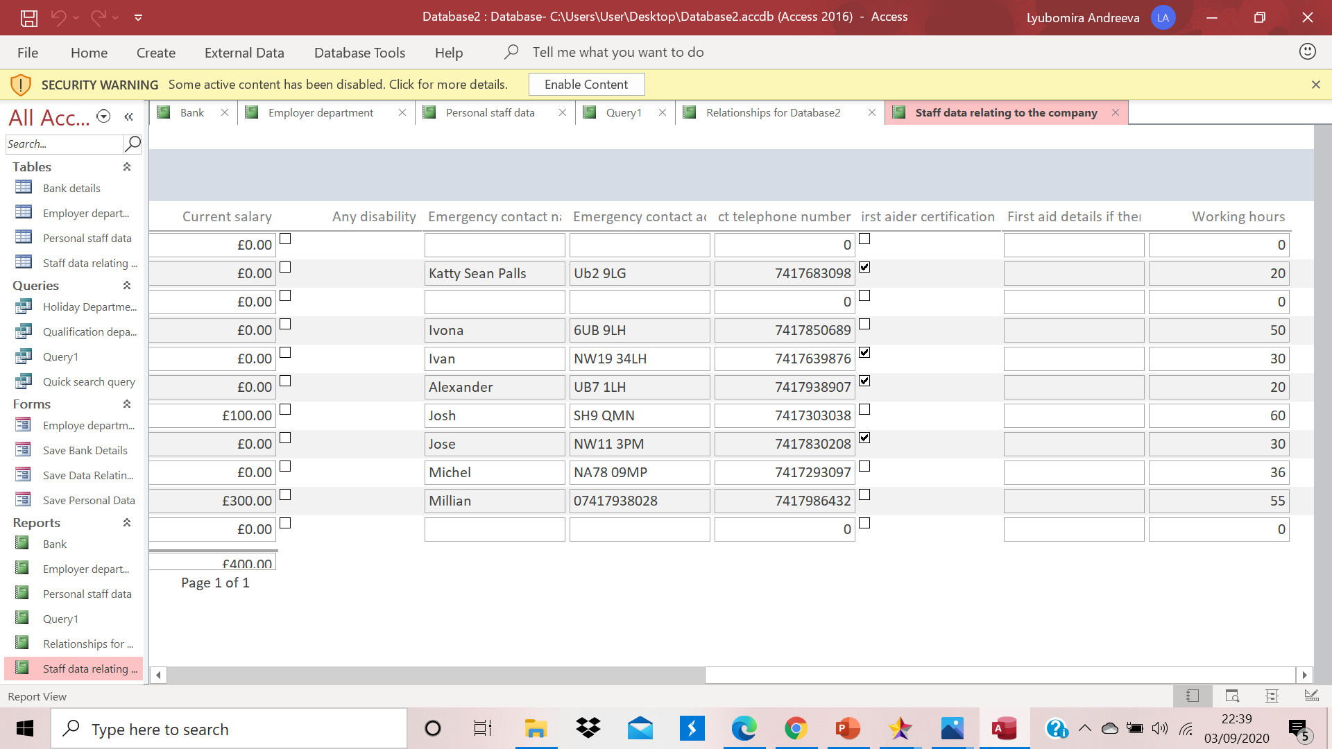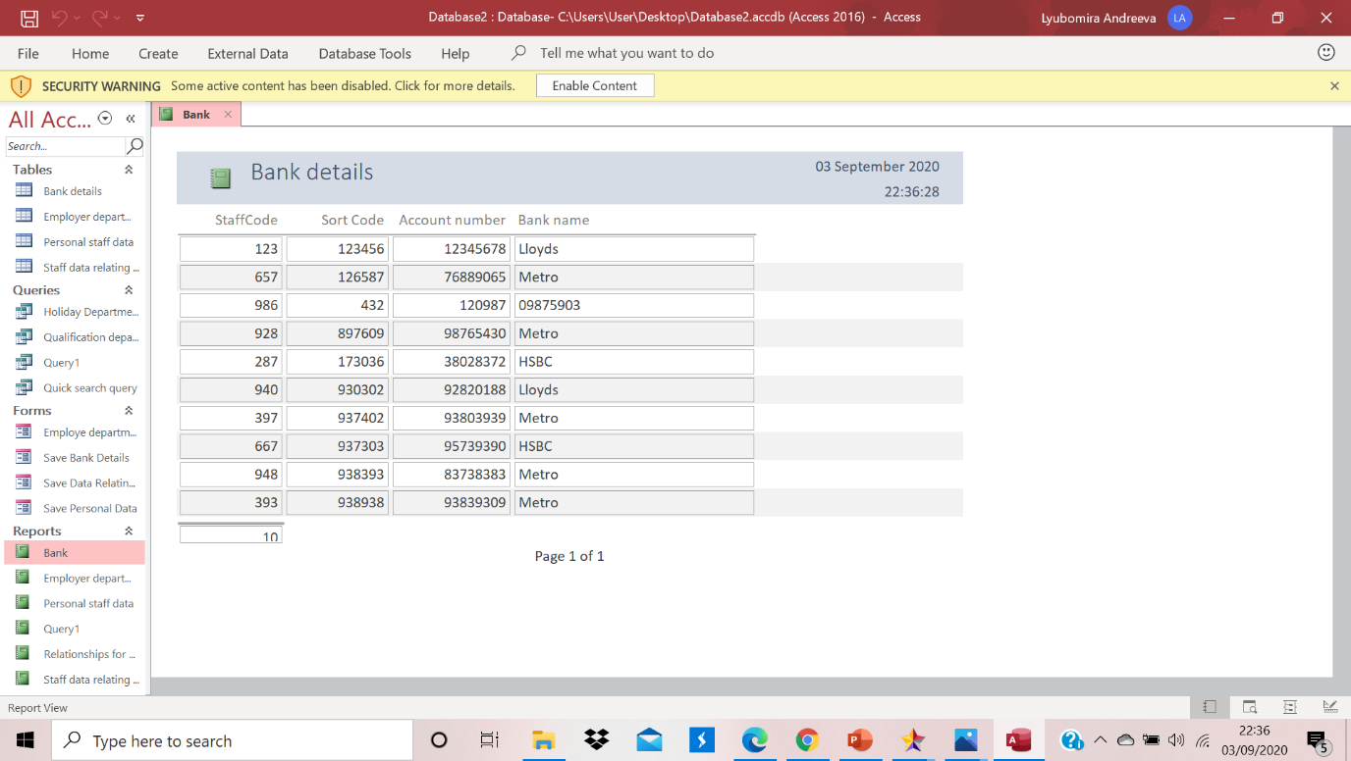

“When we create a query we have to know some basic things. In this example, when I double click on the relationship I can choose some properties. For example from where I want query: Take the records from left table to right or from right to left. We can choose as well criteria of our searching. For example in a criteria filed I can write not in (“Bulgerian”) staff and this command will exclude every records with Bulgarian peoples. When I write the command in the criteria under the phone number filed - Like (“07417”*) I tell to the programme to put each record, which start with this telephone number. With this option I can make my search easy and summarized.”
(Magic Monk,06/03/2016, GCFLearnFree.org, 08/04/2016)
Query multiple tables
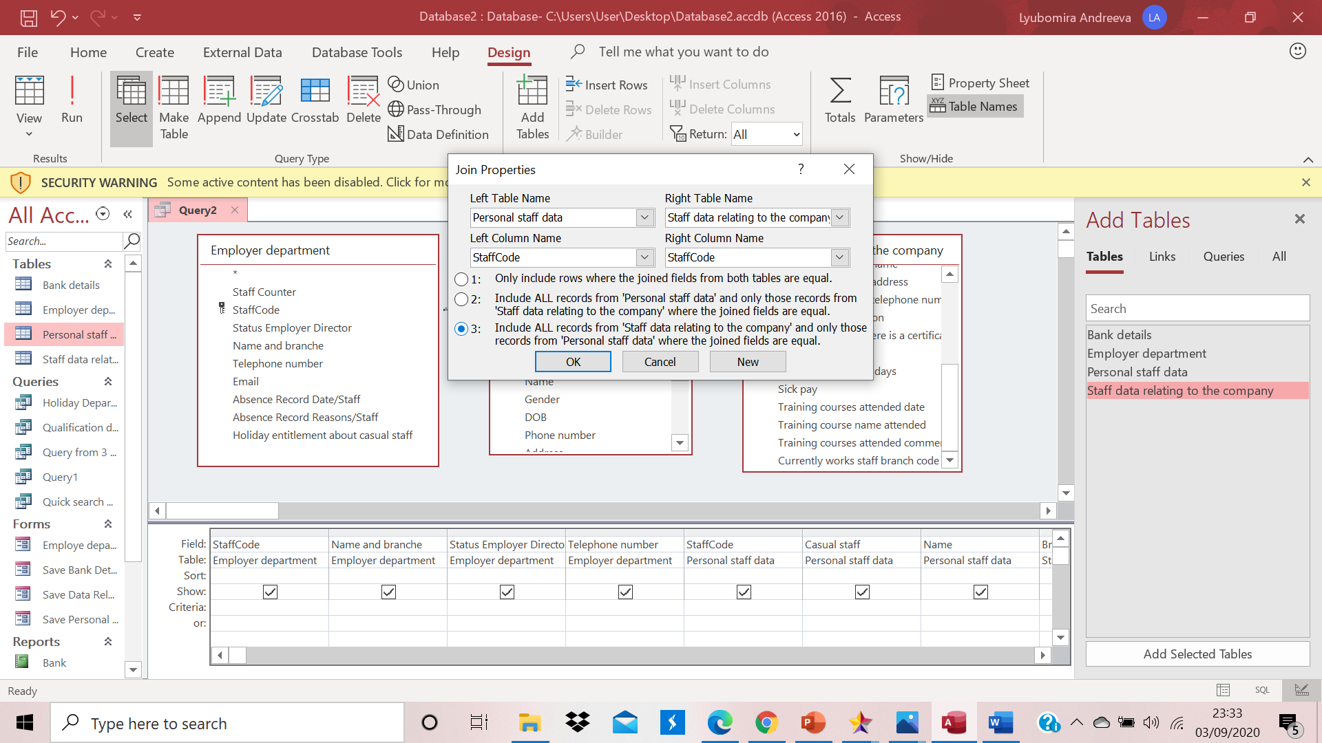

SQL Code
SQL Code to chose only Name and branch and email to show me:
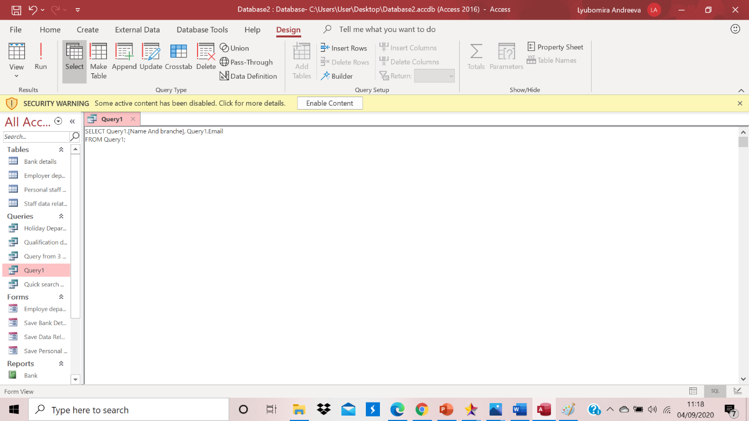
And result:
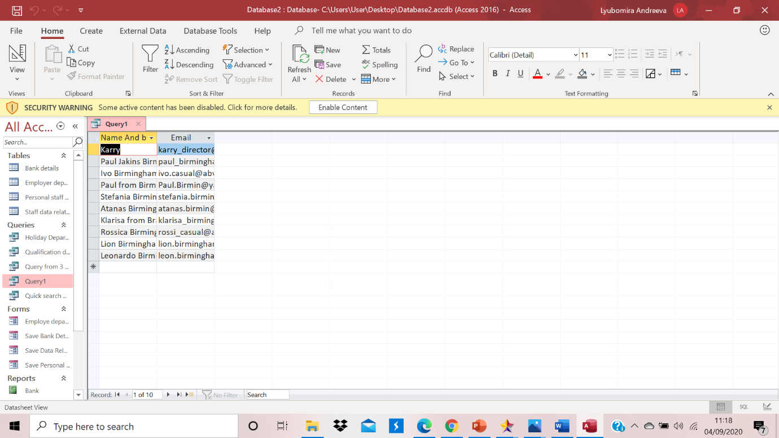
Query created from single table:
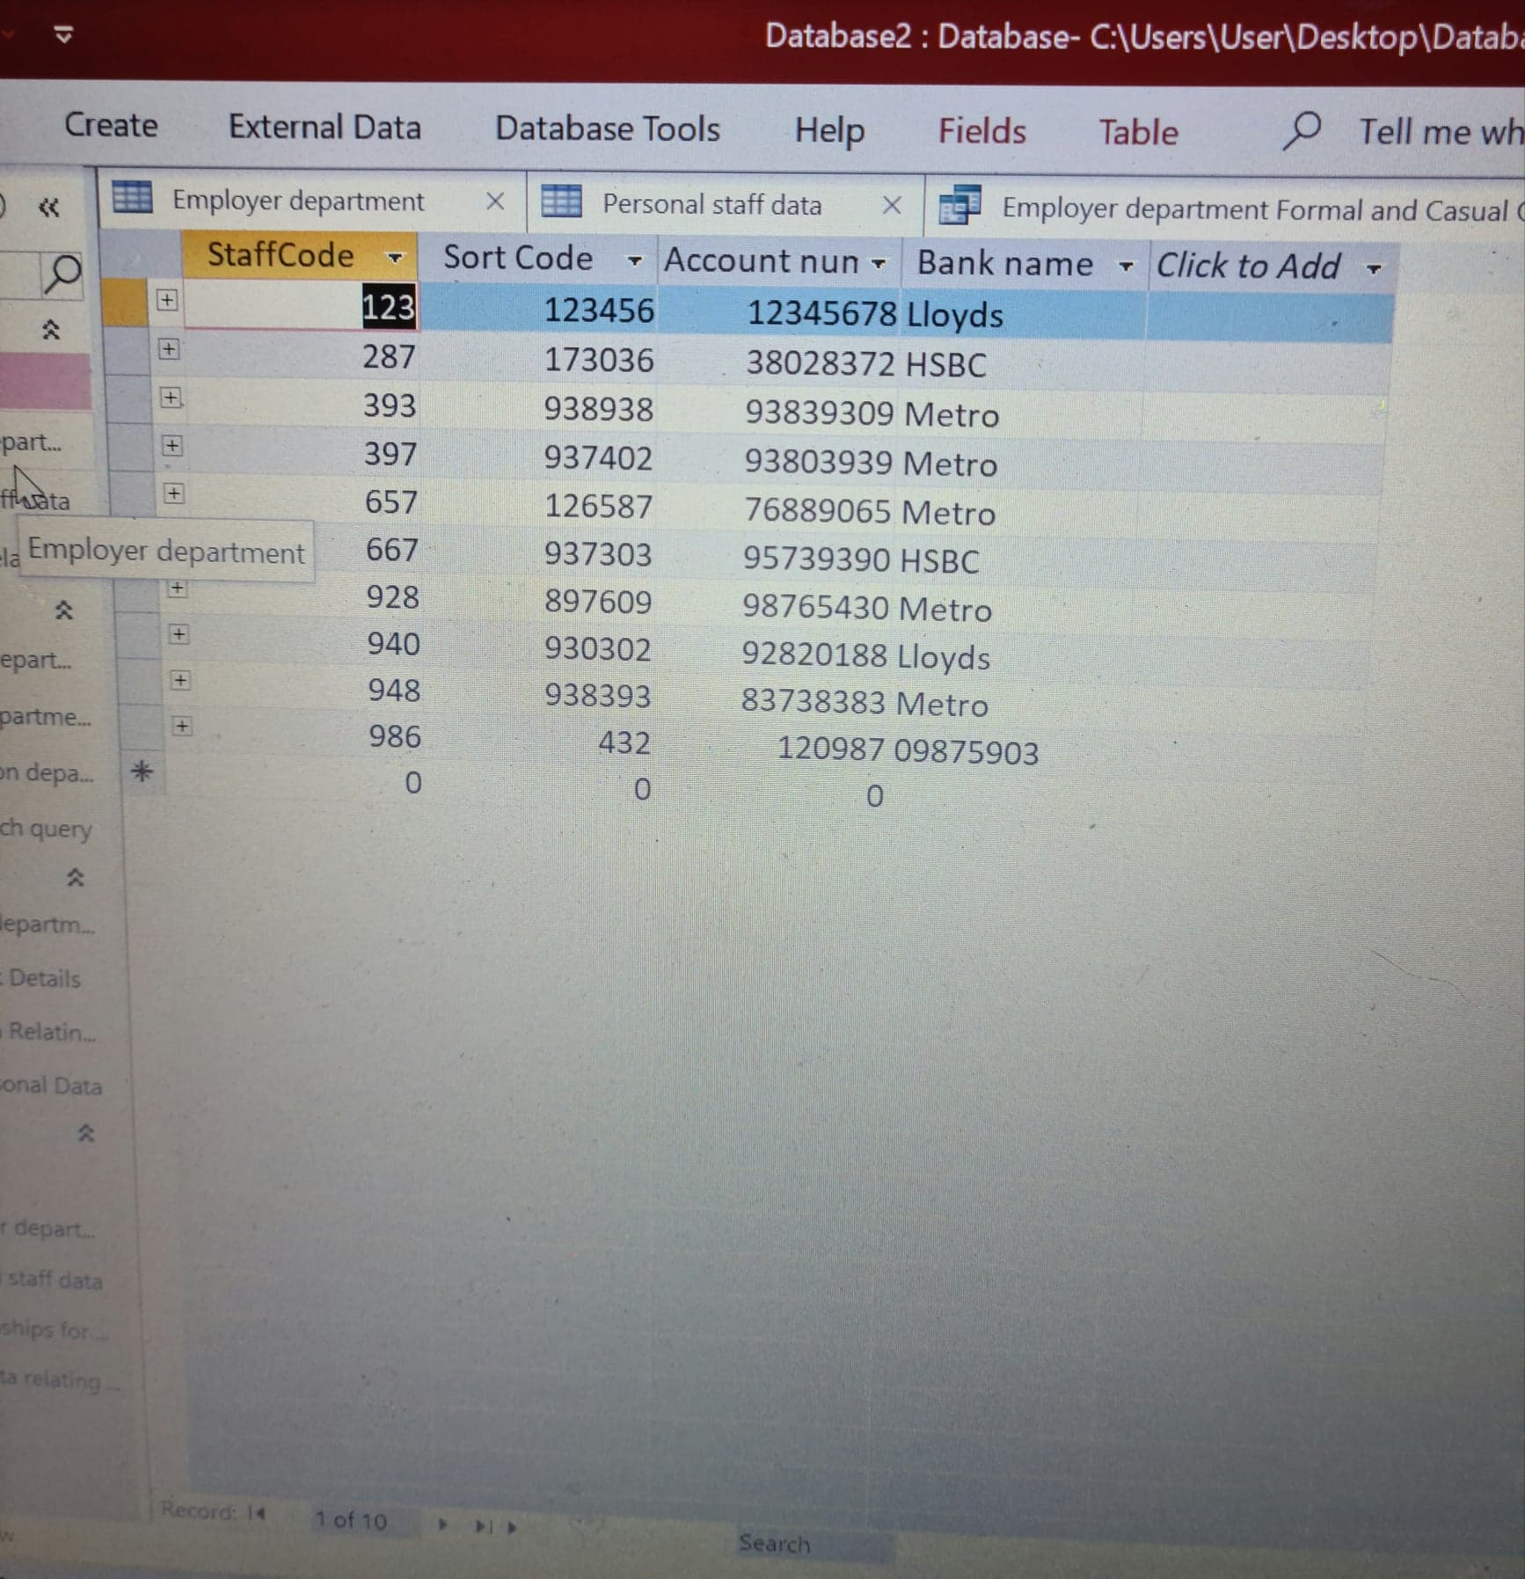

Query design view
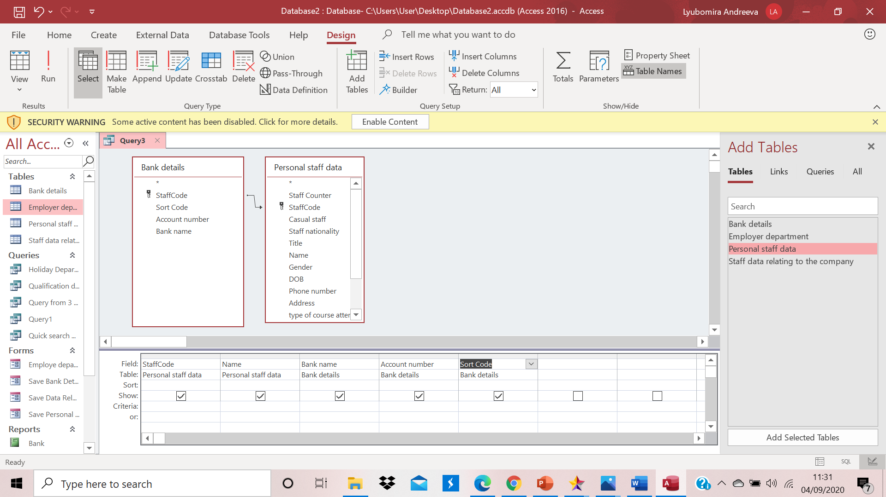
Query database sheet: Display our searching in the query
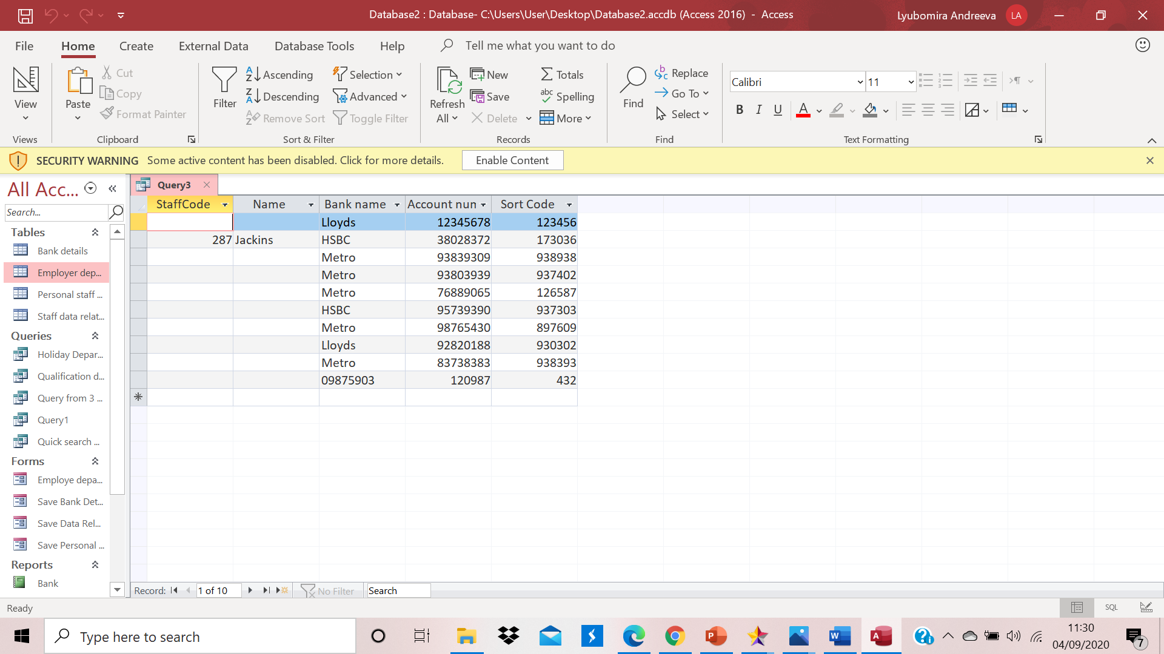

References
Bagui, S., 2003. Database design using entity-relationship diagrams. First ed. s.l.:Auerbach Publications.
Chapple, M., 2019. creately.com. [Online]
Available at: https://creately.com/blog/diagrams/er-diagrams-tutorial/
[Accessed 08 03 2019].
Enterprise, P. S. M., 2012. www.visual-paradigm.com. [Online]
Available at: https://www.visual-paradigm.com/tutorials/data-flow-diagram-dfd.jsp
[Accessed 27 01 2012].
GCFLearnFree.org, 2016. www.youtube.com. [Online]
Available at: https://www.youtube.com/watch?v=vtgwXZMXBTo
[Accessed 08 04 2016].
Hathaway, T. a. A., 2016. Process Modeling Techniques for Requirements Elicitation and Workflow Analysis. First ed. s.l.:BA-EXPERTS; 1st Edition.
IAN, 2016. database.guide. [Online]
Available at: https://database.guide/what-is-microsoft-access/
[Accessed 03 06 2016].
Lynch, W., 2019. medium.com. [Online]
Available at: https://medium.com/@warren2lynch/data-flow-diagram-comprehensive-guide-with-examples-d9858387f25e
[Accessed 27 03 2019].
Monk, M., 2016. www.youtube.com. [Online]
Available at: https://www.youtube.com/watch?v=IFr4jvt_ZZc&t=137s
[Accessed 06 03 2016].

