Student Name: Emily Jones
Student Number: 1900934
BA Course Title: Graphic Design
Module: M4X01560

Tasks in the order I received them:

Task 1 Reflective Writing – Do you know what you think? (Jon’s Task) 541 words
Task 2 Observational Writing – Identify an image and write a semiotic analysis (Ryan’s Task) 498 words
Task 3 Manifesto Writing – ‘What do I believe in?’ (Julia’s Task) 461 words

Task 1 (Jon’s Task)

Learning the effects and consequences of using social media today.

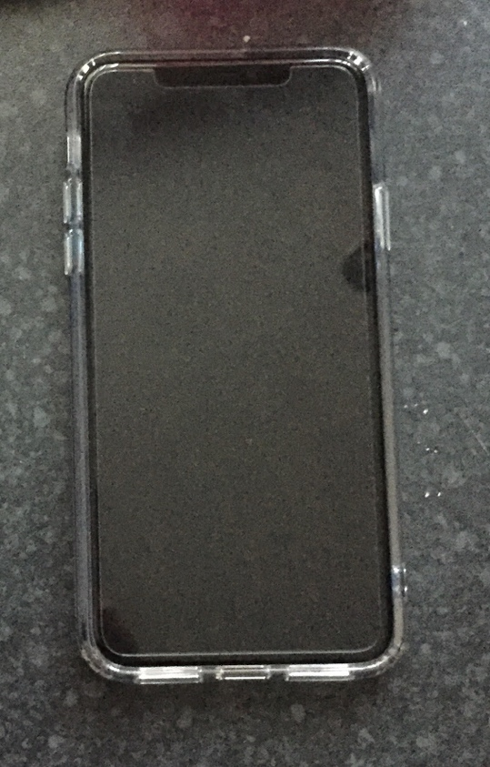

Everyone’s experience using social media is different. I have grown up in a world surrounded by continually advancing technology including phones, tablets, computers, laptops and have never lived in a world where social media such as Facebook, Instagram, Twitter didn’t exist. With the popularity of photo-shopping and using image filters to extenuate the best parts of our bodies or alter our worst features, it makes me truly think, is everything we see on the internet entirely true or are we living in a bubble of lies we may never be able to escape?

Social media first grew in popularity in the early 2010’s with Facebook being one of the first platforms. One of their many aims is to help people connect more by introducing faster ways of communicating with our friends and family. Along the way, it has helped many projects and according to the Social Media Analytics has been “increasingly used as communication channels in business, political, and other contexts.” (Stieglitz, S. et al., 2014.). Social media impacted on a lot of businesses worldwide and has contributed to helping many ways of spreading their messages to their audiences/customers. It helps their company to promote new products and allow customers to review their purchases which then aides many co-operation’s to improve if necessary.

“It seemed like a good idea at the time, then instant instagram regret, but damn, too late, it’s all over What’sApp.” (Fenton, N., 2015). Here Natalie Fenton explains how quick information gets around on social media. It seems to have a ripple effect; the smallest piece of information could spread as quick as a wildfire. Fenton uses some sources of social media to show this. First line in this poem already states the overall effect social media has in society. It also shows what we think ‘looks good’ and what we later regret posting on online.
It stays up to date with information and is a quick and easy way to collect information. However, when reading the poem Social Media Is by Natalie Fenton, she strongly argued that the “Immediate connectedness with “like-minded” people, too awkward to ignore or un-friend.” (Fenton, N., 2015). I believe this is the reason why many people have social media accounts. Whilst social media is a strong source or a quicker and more reliable way of connecting or communicating with people, it also “connects” us to people who we don't normally talk to or aren’t that acquainted with.

Neil Postman states in his book Amusing Ourselves To Death: Public Discourse in the Age of Show Business that “People will come to adore the technologies that undo their capacities to think”. (Postman, N., 2005.). Postman explains when people are constantly online how it can drag them into a different world and makes us lose more of our consciousness every time. I agree with this to some sort of extent, social media can be quite addictive, and we could spend multiple hours scrolling through our feeds on Facebook but I don’t believe it takes away much of our intelligence because some of the most influential people in today’s society including Millie Bobby Brown and Greta Thunberg are trying to make a difference in the world we are living in and they are only 15 and 17 years old.

Bibliography

Fenton, N., 2015. Social Media Is. Social Media Society, 1(1), pp.Social Media Society, 29 April 2015, Vol.1(1).

Postman, N., 2005. Amusing ourselves to death : public discourse in the age of show business 20th Annv., London: Penguin.

Stieglitz, S. et al., 2014. Social Media Analytics. Business & Information Systems Engineering, 6(2), pp.89–96.

Task 2 (Ryan’s Task)

The Mandela Effect – A Semiotic Analysis

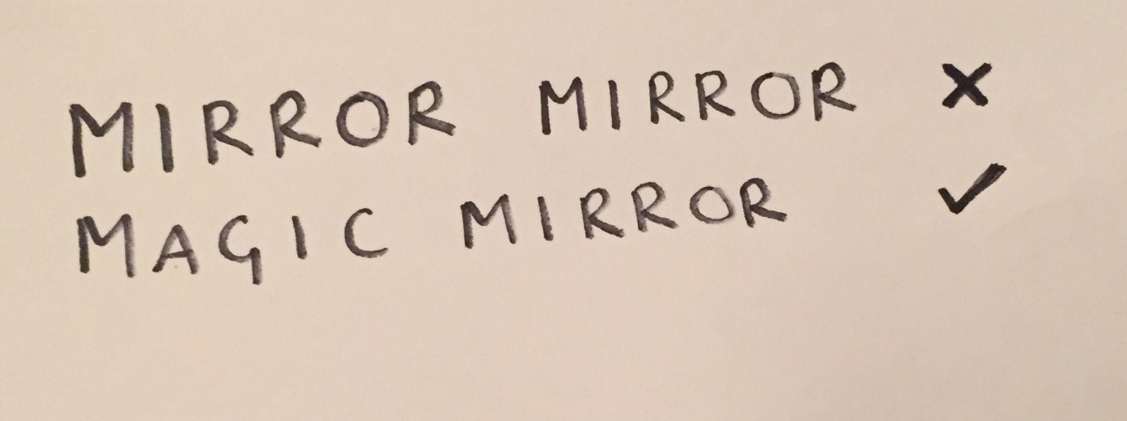

The Mandela Effect originated by the ‘death’ of political leader Nelson Mandela. When Mandela was imprisoned, a lot of people believed he ‘died’ in prison during the 1980’s remembering seeing his ‘death’ on the news when in fact Nelson Mandela was released from prison in 1990 and died recently in 2013. These false memories whether they be “penetrated, invaded, altered” (French, A,. 2018) impacted on the way future generations saw this event and the more we heard the same type of memories from this event, the more we believed that it truly happened.

This changed the way people perceived our society. It made us question who or what do we believe? And whether it is true? According to the article Photographs cause false memories for the news in which they conducted an experiment with students using photographs of real and fictional events, they concluded that “photos make people more likely to say they remembered world events” (Strange, D. et al., 2011.) suggesting that the proof of photos made students believe that because they have physical evidence, the scenario could have happened.

This isn’t the first case in which we have witnessed the Mandela Effect. In the picture above I have shown another example of the use of the Mandela Effect and its impact on pop culture. In the animated classic Snow White and The Seven Dwarves (1937), when the evil queen is talking to her enchanted mirror how does she start?’ Mirror, Mirror on the wall’? Wrong. In fact, if you watch the film again, she says ‘Magic Mirror on the wall’. Like the Mandela’s death conspiracy, people were so positive about their false memories that when the more this message was spread, the more people were thinking that that information is ‘true’. This even got to the point where the ‘mirror, mirror’ was used in pop culture as many people thought and still think it is the correct quote.

In modern society, everyone is surrounding with some type of technology and whilst I was reading Neil Postman’s Amusing Ourselves To Death: Public Discourse in the Age of Show Business he mentioned that “all public understanding of these subjects is shaped by the biases of television.” (Postman, N., 2005.). I believe what Postman is suggesting is that because of the increase in pop culture many of us are believing too much of what we see online and on television and are not questioning whether what we are seeing is actually true or a bunch of lies created by the media to keep us entertained. I do believe that a lot of our understanding has been influenced a lot by pop culture and the media. An example of this could be the way we see colours and how they have different meanings. However, without using these colours to signal or represent something, a lot of our society would be confused and have different reactions to seeing different colours which way lead to disagreement/argument which could create a negative impact in our community.

Bibliography

French, A,. 2018. The Mandela Effect and New Memory. Correspondences, 6(2), pp.201–233.

Postman, N., 2005. Amusing ourselves to death : public discourse in the age of show business 20th Annv., London: Penguin.

Strange, D. et al., 2011. Photographs cause false memories for the news. Acta Psychologica, 136(1), pp.90–94.

Task 3 (Julia’s Task)

Arts in Education – Manifesto

- Allow every child the opportunity to use STEAM (Science, Technology, Engineering, Arts, Maths) in each school subject.
- Have a variety of choices or be shown a range of art subjects to allow the child to show off their inner creativity.
- Allow support to children if they are undecided/not sure about what they want to pursue a career in.
- Have regular visitors to teach children different artistic techniques and arrange frequent school trips to museums and art galleries to show art in the real world.
- Allow children to explore their surroundings, research into today’s society and culture including politics to help them get a better understanding of the world. Help them become inspired.
- Experiment with old and new techniques, hand and digital illustration allowing children to become more confident in using tools and equipment.
- Allow their voices to be heard. Every child has a right to own an opinion and be allowed to freely express themselves throughout their life and through art.
- Spread a positive message across every piece created.

Keywords and Images

Inner Creativity

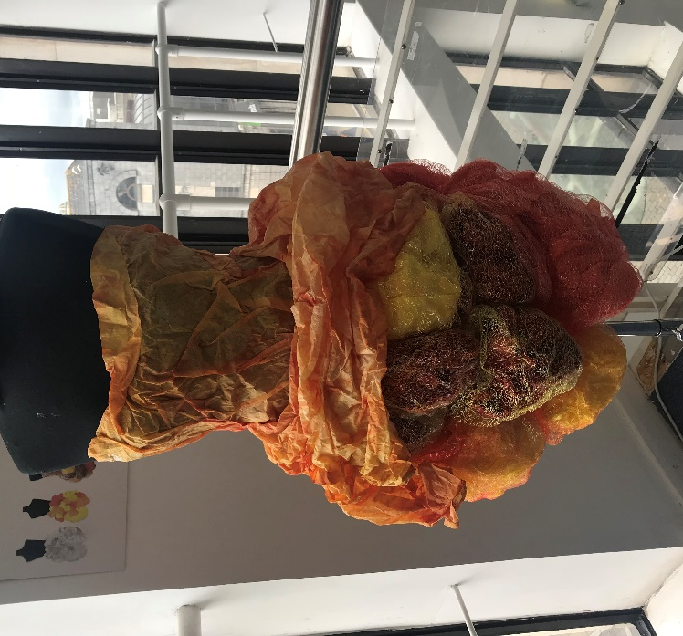

2. Have a variety of choices or be shown a range of art subjects to allow the child to show off their inner creativity

Throughout my education, I have been introduced to a variety of creative subjects and have learnt about various tools and techniques that I have used in many of my own pieces including this piece during textile design in college. In Maxine Greene’s article The Turning of the Leaves: Expanding Our Vision for the Arts in Education, she addresses that “The arts in education should thus recognize possibilities that open new horizons, in both form and substance.” (Greene,M.,2013). This explains that every child in education (and not just in art subjects) should be allowed the opportunity to explore and experiment with every method or technique they can possibly think of to find out what interests them and what they enjoy doing.
Keyword: Become Inspired 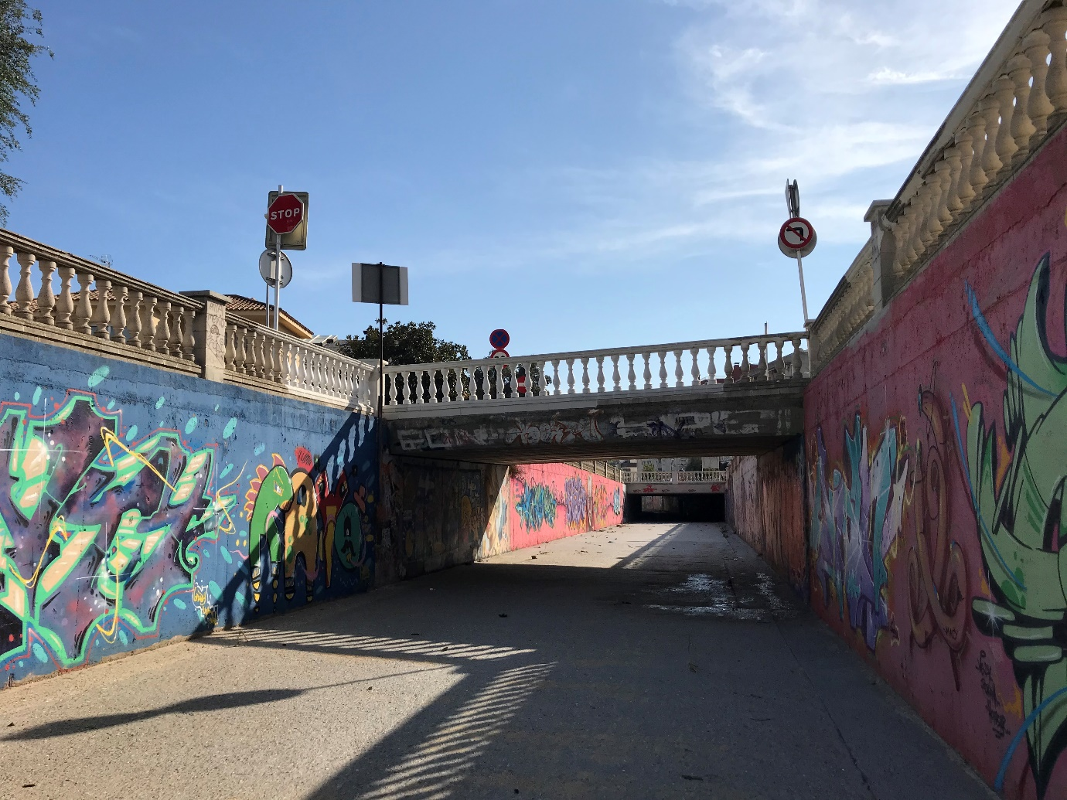

5. Allow children to explore their surroundings, research into today’s society and culture including politics to help them get a better understanding of the world. Help them become inspired.

The picture taken above is of some graffiti I discovered whilst travelling in Spain. I absolutely loved the variety of bright colours, and the shapes and patterns add quirkiness onto the plain walls of this tunnel. These large pieces of art are bold and allowed me to become inspired to create something just as vibrant. In The Oxford Companion to Classical Civilization, it states that before anyone starts to experiment to “distinguish first the areas where experimental investigation is possible from those where it is not.” (Fontenrose, J.E. & Lloyd, S.G., 2014.). This image was taken two minutes away from where I was staying in Spain and goes to show that art is everywhere around us and we can become inspired so easily by nature and our surroundings to create unique pieces of work. In the article Art in Education, it quotes that “Artistic experience, whether in the form of appreciation or expression, is essential to the growth of a full human personality” (Anon,1950). This could indicate that if children are brought up learning and exploring different pieces of art, they are likely to gain a broader imagination and more creativity. I would like to see more educational trips within schools to allow children to get a similar experience as what I got when I was away as I believe it would help broaden their imagination, creativity and most of all get inspired.

Keyword: Experiment

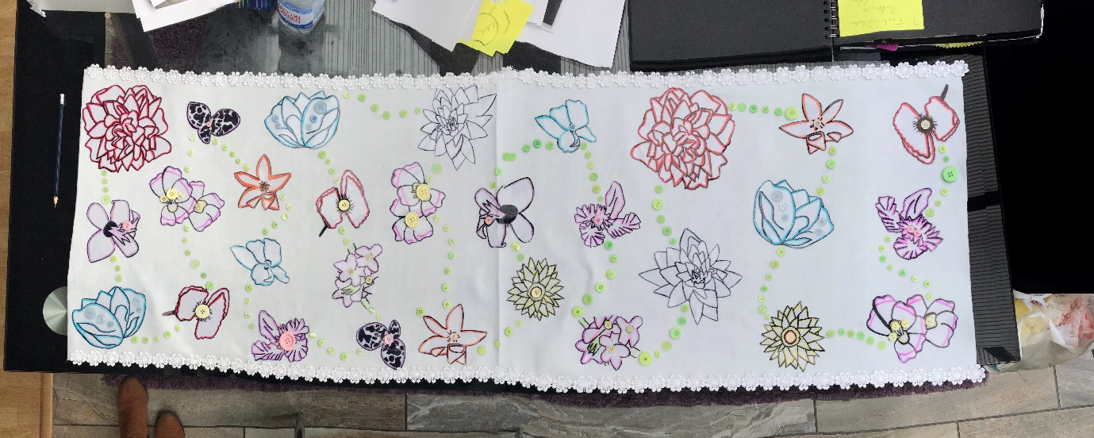

6.Experiment with old and new techniques, hand and digital illustration allowing children to become more confident in using tools and equipment.

This is a photograph I took of another piece I created using various materials I had never used before and experimenting with different shapes and patterns. I believe that lots of experimentation especially in art subjects is very important. It allows you to broaden your techniques and experiences in creating unique work. Without experimentation, a lot of art would be very similar. English painter and printmaker William Blake states that “ The true method of knowledge is experiment” suggesting that if we never explored newer artistic techniques which includes using modern digital software’s such as Photoshop and Illustrator and stuck to the same method to create pieces of art, the world would lack in creativity.

Bibliography

Anon, 1950. Art in Education. Music Educators Journal, 36(3), p.47.

Caponigro, J.P., 2013. 21 Quotes on Experimentation, John Paul Caponigro, viewed 4 January, < https://www.johnpaulcaponigro.com/blog/10466/21-quotes-on-experimentation/>

Fontenrose, J.E. & Lloyd, S.G., 2014. experiment. The Oxford Companion to Classical Civilization, pp.The Oxford Companion to Classical Civilization.

Greene, M., 2013. The Turning of the Leaves: Expanding Our Vision for the Arts in Education. Harvard Educational Review, 83(1), pp.251–252,266.

