

Methods and Search Strategy Academic Poster

Student name: Kamran Khan
Student ID: 2246128

Module name: Independent Report
Module code: BMHP 6020
Lecturer name: Chloe Harries

Comparing Mental Health Outcomes and Academic Success Among Foster Care and Non-Foster Care Graduates
Introduction and Research Aim  A methods chapter explains how evidence was found, selected and analysed so the study is transparent and repeatable. This poster summarises my desk-based (secondary) systematic review method. Aim: to compare mental-health outcomes and academic/post-graduation success between graduates with foster-care histories and non-foster peers, and to identify protective factors and support implications. | Search Strategy  A search strategy is an organised structure of key terms used to search databases by combining the main concepts of a question to retrieve relevant results. I built keyword blocks (foster/care-experienced; mental health; higher-education/graduate), added synonyms, then used OR within blocks and AND between blocks. Pilot searches refined terms; all searches were recorded in a log (database, date, string, results).
Searching for Information  Databases: PubMed/MEDLINE, PsycINFO, Scopus, ERIC and CINAHL, plus targeted grey literature via Google Scholar. Limits: English; 2010–2025; humans; higher education; young adult/adult where available. Screening: remove duplicates → title/abstract screening → full-text screening, recording exclusion reasons. Data extraction captured study design, sample, care-history definition, comparator, outcomes and key findings. | Direct relationship between mental health scores and English scores of college students (Chen and Kim, 2024) 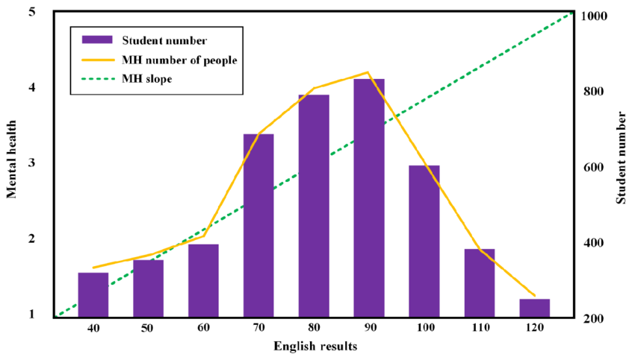
Research Validation and Analysis
Validation in secondary research means ensuring included sources are credible through quality appraisal and an audit trail. Reliability is consistency; validity is accuracy of measurement. I used explicit criteria plus CASP-aligned checks (methods clarity, sampling, bias risks, outcome measurement) and triangulated across studies. Limits: heterogeneity and self-report reduce causal certainty. Analysis used Braun & Clarke’s thematic analysis: familiarisation, coding, building sub-themes, then refining into 3 final themes for Chapter 4.
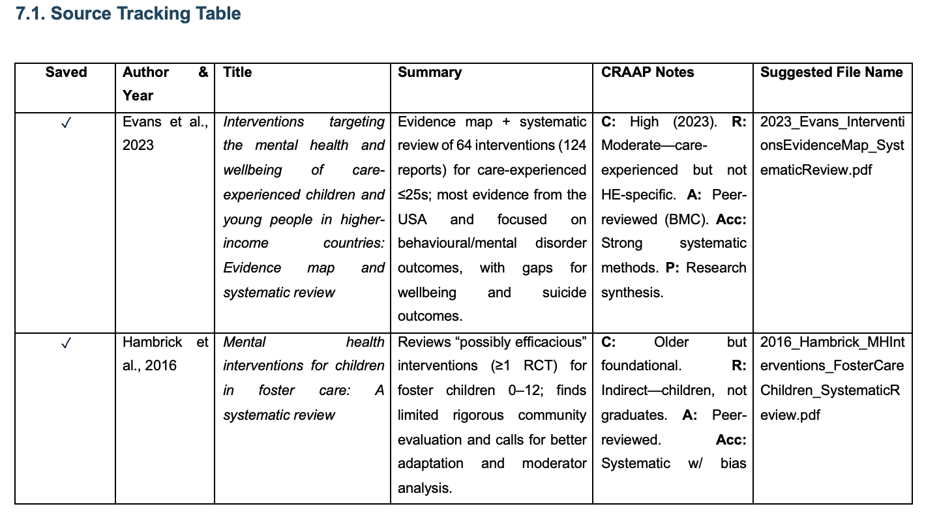

Inclusion Criteria  English (2010–2025); foster-care history pre-18; non-foster comparator; peer-reviewed or high-quality grey sources; reports mental health and/or academic/graduate outcomes; accessible full text. | Exclusion Criteria  No clear foster-care measure; not HE/graduate-relevant; opinion/low-credibility sources; non-English; duplicates/inaccessible texts.
Ethical Considerations
Ethics in secondary research focuses on integrity: accurate citation and paraphrasing, avoiding plagiarism, using reputable sources, and respecting privacy/confidentiality where sensitive data are reported (GDPR awareness).

References
Braun, V. and Clarke, V. (2006) ‘Using Thematic Analysis in Psychology’, Qualitative Research in Psychology, 3(2), pp. 77–101. Available at: https://doi.org/10.1191/1478088706qp063oa.
Chen, X. and Kim, H.K. (2024) ‘The relationship between emotional intelligence, mental health, and the English achievement of college students based on big data statistical analysis’, International Journal of Web-Based Learning and Teaching Technologies (IJWLTT), 19(1), pp.1-16.
Gusenbauer, M. and Haddaway, N.R. (2020) ‘Which Academic Search Systems Are Suitable for Systematic Reviews or meta‐analyses? Evaluating Retrieval Qualities of Google Scholar, PubMed, and 26 Other Resources’, Research Synthesis Methods, 11(2), pp. 181–217. Available at: https://doi.org/10.1002/jrsm.1378.
Muis, K.R., Denton, C. and Dubé, A. (2022) ‘Identifying CRAAP on the Internet: a Source Evaluation Intervention’, Advances in Social Sciences Research Journal, 9(7), pp. 239–265.
Saunders, M.N., Lewis, P. and Thornhill, A. (2019) ‘Understanding research philosophy and approaches to theory development’, in Research Methods for Business Students. Pearson Education, Limited, pp. 128–171.
Vaismoradi, M., Turunen, H. and Bondas, T. (2013) ‘Content analysis and thematic analysis: Implications for conducting a qualitative descriptive study’, Nursing & Health Sciences, 15(3), pp. 398–405. Available at: https://doi.org/10.1111/nhs.12048.

