Name: Nosheen Rashid
Student ID: 2409358
Module 4003
Poster about mental health



Introduction
Community Mental Health Services (CMHS) in England are essential in assisting adults and older individuals with significant mental health challenges, aiming to do so as close to their homes as possible. They are structured to deliver comprehensive, easily accessible, and coordinated care within local communities, which decreases the need for inpatient facilities and enhances long-term well-being. The NHS Long Term Plan highlights the need to update community mental health services, broaden access, and enhance quality through innovative integrated care models. Community Mental Health Teams (CMHTs) are vital parts of Community Mental Health Services (CMHS). These teams comprise various professionals, including social workers, psychiatrists, psychologists, nurses, occupational therapists, and support staff, who are responsible for evaluating, treating, and providing ongoing support for adults with severe mental illnesses (SMI).

CMHTs provide:
• Therapeutic sessions for mental well-being
• Medication management
• Physical health monitoring
• Crisis intervention
• Support with employment, housing, and social needs
• Coordination with primary healthcare and voluntary organisations

The newly proposed community mental health model in the NHS Long Term Plan and Community Mental Health Framework aims to create a more individualised, trauma-informed, and comprehensive approach to care. This includes access to talking therapies, physical health evaluations, Individual Placement and Support (IPS) to facilitate employment, as well as assistance for co-occurring issues like substance use and self-harm.(NHS England, 2024).

History of Community Mental Health Services in England
Historically, mental health treatment in England primarily occurred in large institutional facilities. Beginning in the 1980s, a national policy shift toward deinstitutionalisation aimed to help individuals with mental health challenges reintegrate into their local communities. By the early 2000s, Community Mental Health Teams (CMHTs) had become the norm for community-oriented services.

In the last twenty years, there has been an increased variety of community services available, including Early Intervention in Psychosis (EIP), crisis response teams, personality disorder services, and rehabilitation programs. While this growth has enhanced access, it has also resulted in fragmentation and varying care pathways. In 2019, NHS England launched the Community Mental Health Framework, which set in motion a major transformation initiative to consolidate these disparate services and improve collaboration among different sectors. This framework continues to shape present-day policies and practices.(RC PSYCH ROYAL COLLEGE OF PSYCHIATRISTS,n.d.)

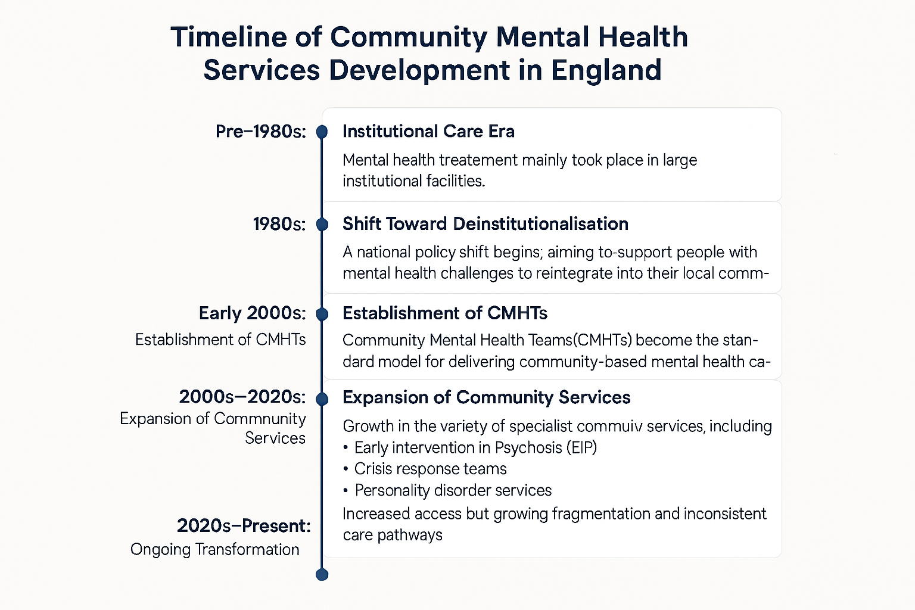
Current Functioning of Community Mental Health Services
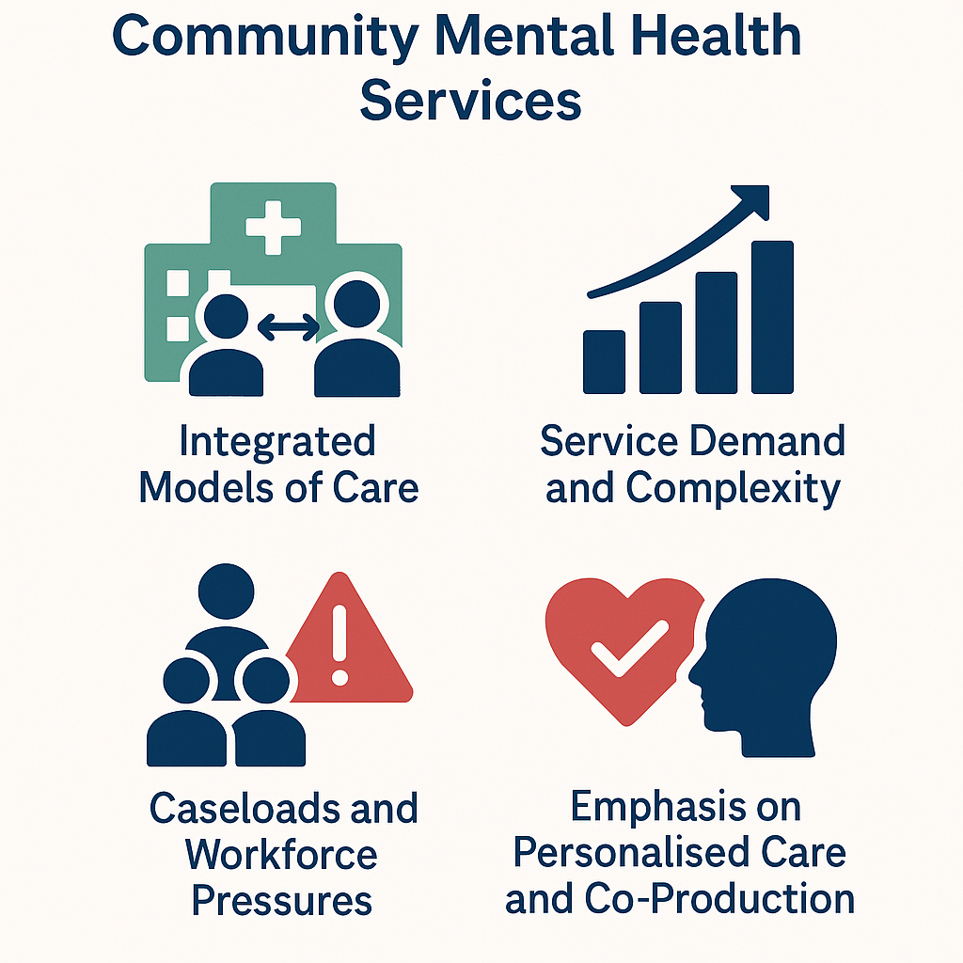

Current Functioning of Community Mental Health Services
1. Integrated Models of Care
Since 2019, Integrated Care Systems (ICSs) have been funded to develop new models of primary and community care. These models are built around Primary Care Networks (PCNs), embedding mental health practitioners in GP practices and enabling smoother transitions across the care system. By 2023/24, these models were expected to expand access to psychological therapies, improve physical health checks, and increase provision of specialist services.(NHS England, 2024).
2. Service Demand and Complexity
The demand for mental health services is steadily increasing, with an average of 453,930 new referrals to secondary mental health services each month in 2024/25, a 15% rise compared to 2022/23. Additionally, individuals are experiencing more complex needs due to issues such as the rising cost of living, housing instability, and social inequalities. (RC PSYCH ROYAL COLLEGE OF PSYCHIATRISTS, n.d.)
3. Caseloads and Workforce Pressures
The 2025 NHS Benchmarking survey revealed that adult community mental health teams are now supporting an average of 1,028 individuals per 100,000 of the population, indicating a notable increase compared to previous years. This rise suggests a growing recognition of the need for mental health services within communities. However, the survey also highlighted ongoing challenges with workforce shortages, as these continue to be a critical issue not only within community mental health teams but also in inpatient services. The persistent vacancy rates hinder the ability to provide adequate support and resources for individuals in need, further exacerbating the pressures on the mental health care system. (Collins, 2025).
4. Emphasis on Personalised Care and Co-Production
Services increasingly prioritise personalised, trauma-informed support and involve people with lived experience in service design. Evidence highlights that high-quality care includes addressing wider needs such as housing, employment, and physical health, aligning with holistic community-based support goals (Community Mental Health Services, 2025).

Challenges Faced by Community Mental Health Services
Challenge 1: Increasing Demand, Long Waiting Times, and Resource Pressures
CMHS face rising demand, longer waiting lists, and limited capacity. For example:
- More than 450,000 new referrals per month (2024/25). (Cqc.org.uk, 2024)
- Children and young people face long delays, with 27% waiting over 18 weeks for treatment as of 2025. (Collins, 2025).
Factors worsening demand include:
- COVID-19 aftereffects
- Austerity and funding constraints
- Social determinants such as unemployment and housing challenges
- These pressures lead to care delays, which can worsen mental health conditions and push people into crisis. [(Cqc.org.uk, 2024)

Challenge 2: Workforce Shortages and Variability in Care Quality
- The Care Quality Commission highlights persistent recruitment and retention issues, leading to burnout, skill gaps, and reduced capacity for high-quality care(Cqc.org.uk, 2024)
Workforce data from 2025 show:
- 14% vacancy rates in community services for young people, and
- 21% in adolescent inpatient care. (Collins, 2025).
- National reports emphasise that variability in commissioning results in uneven service quality across England, meaning a person’s access to care depends heavily on where they live(Cqc.org.uk, 2024)

These challenges hinder the goals of the Community Mental Health Framework, which relies on a well-resourced, skilled workforce and consistent system-wide collaboration.

Conclusion
Community Mental Health Services in England are undergoing a major transformation aimed at creating more integrated, holistic, and person-centred models of care. While progress has been significant—particularly in expanding access and developing new community-based models—demand pressures, workforce shortages, and inequalities continue to constrain service effectiveness. Sustained investment, long-term workforce planning, and system-wide reform remain essential to delivering high-quality, accessible mental health care.

References:
Cqc.org.uk. (2024). Mental health - Care Quality Commission. [online] Available at: https://www.cqc.org.uk/publications/major-report/state-care/2024-2025/access/mh.
Collins, M. (2025). Mental health services in the UK in 2025: what the latest NHS Benchmarking survey tells us - Centre for Mental Health. [online] Centre for Mental Health. Available at: https://www.centreformentalhealth.org.uk/mental-health-services-in-the-uk-in-2025-what-the-latest-nhs-benchmarking-survey-tells-us/.
Community Mental Health Services. (2025). Available at: https://www.nhsconfed.org/system/files/2025-03/nhs_confederation_submission_to_hscsc_inquiry_on_community_mental_health_services.pdf.

Garratt, K. (2021). Mental health policy in England. [online] Parliament.uk. Available at: https://researchbriefings.files.parliament.uk/documents/CBP-7547/CBP-7547.pdf.

NHS England (2024). NHS England Community Mental Health Services. [online] England.nhs.uk. Available at: https://www.england.nhs.uk/mental-health/adults/cmhs/.
CQC (2022). Care Quality Commission. [online] https://www.cqc.org.uk/. Available at: https://www.cqc.org.uk/.

RC PSYCH ROYAL COLLEGE OF PSYCHIATRISTS. The Community Mental Health Framework for Adults and Older Adults | Royal College of Psychiatrists. [online] Available at: https://www.rcpsych.ac.uk/improving-care/nccmh/service-design-and-development/community-framework (Accessed on 15/01/2026).

Name: Nosheen Rashid
Student ID: 2409358
Module 4003
Essay on ambulance services

Ambulance services in England: origins, evolution, current function, and impact
Ambulance care in England has its roots in historical practices predating the National Health Service (NHS). The Knights of St John, who provided care for sick and injured pilgrims, influenced later Victorian first-aid efforts, ultimately leading to the establishment of St John Ambulance in the 1880s. These community and volunteer efforts transformed the transportation of the ill, evolving from hand-drawn litters to horse-drawn carriages and, by the early 20th century, to motorised vehicles. Significant changes to the system occurred during the interwar years: the introduction of the 999 emergency number in London in 1937 established the first dedicated emergency call service globally, fundamentally altering access to immediate assistance. (liverpoolmedicalinst). (Bbc.co.uk, 2026).
The evolution of the modern ambulance service was influenced by a backdrop of warfare, public health legislation, and a trend towards increased centralisation. The First and Second World Wars spurred advancements in ambulance technology and organisation, while the National Health Service Act of 1946 established legal requirements for local authorities to supply ambulances “when necessary.” Following this, restructuring efforts shifted fragmented local services into the NHS in 1974, and by the mid-2000s, many services were merged into regional ambulance trusts, ultimately creating the current 11 ambulance service trusts in England.(liverpoolmedicalinst).
Today’s service is characterised by clinical prioritisation, adherence to time-sensitive standards, and a scope that extends beyond just transportation. These changes were designed to eliminate “hidden waits,” ensure that the type of vehicle dispatched corresponds to clinical requirements (for instance, sending a paramedic crew for stroke cases), and to strike a balance between speed and delivering the appropriate care on the first attempt. Adherence to the ARP is evaluated through monthly Ambulance Quality Indicators (AQI).( London Ambulance Service NHS Trust).
Reviews of evidence and policies emphasise paramedics’ growing role in urgent, primary, and community care, although the research regarding outcomes and ideal models remains inconsistent and indicates a need for more rigorous trials. (Care at the Scene Research for ambulance services NIHR research on urgent and emergency care outside hospital NIHR Dissemination Centre THEMED REVIEW, 2016).
System strain, characterised by demand growth, hospital flow bottlenecks, and workforce challenges, hinders timely responses in urgent and emergency care. The Care Quality Commission’s State of Care 2024/25 highlights long wait times and delayed discharges, which strain hospital capacity and impact ambulance handovers. A parliamentary analysis in early 2025 noted under-performance against ARP standards, renewing the focus on urgent care improvements. Cultural issues, such as bullying and low morale within some trusts, have been identified by NHS England’s culture review, emphasising the connection between staff experience and patient safety (Baker, Garratt and Wilson, 2025).
Despite these pressures, the service’s significance for quality of life is profound. Faster recognition and transport to specialist centres for conditions like stroke or major trauma improve survival and functional outcomes, while expanded out-of-hospital care reduces avoidable emergency department attendances. NIHR’s themed review shows how research in prehospital assessment, decision-making, and targeted interventions has changed practice at the scene, recognising the ambulance service as both a safety-net and a front door to integrated care. (Care at the Scene Research for ambulance services NIHR research on urgent and emergency care outside hospital, NIHR Dissemination Centre THEMED REVIEW, 2016
In sum, England’s ambulance services evolved from voluntary, transport-led beginnings into a complex, clinically-led component of urgent and emergency care. While contemporary performance is constrained by whole-system pressures and workforce culture challenges, outcome-oriented metrics, and expanded paramedic roles, it supports a model that not only saves lives in time-critical emergencies but also enhances day-to-day quality of life by delivering the right care, in the right place, at the right time. (NHS England, 2017).

References:
Bbc.co.uk. (2026). BBC - London - Why 999 for an emergency? [online] Available at: http://news.bbc.co.uk/local/london/low/people_and_places/history/newsid_8675000/8675199.stm Accessed 20 /02/ 2026.
Baker, C., Garratt, K. and Wilson, S. (2025). Ambulance service response times. [online] House of Commons Library. Available at: https://commonslibrary.parliament.uk/research-briefings/cdp-2025-0042/.
Care at the Scene Research for ambulance services NIHR research on urgent and emergency care outside hospital NIHR Dissemination Centre THEMED REVIEW. (2016). Available at: https://evidence.nihr.ac.uk/wp-content/uploads/2020/03/Care-at-the-scene-final-for-web.pdf.
Cqc.org.uk. (2024). The state of health care and adult social care in England 2024/25 - Care Quality Commission. [online] Available at: https://www.cqc.org.uk/publications/major-report/state-care/2024-2025.
liverpoolmedicalinst. (n.d.). History of the Ambulance. [online] Available at: https://www.lmi.org.uk/history-of-the-ambulance.
London Ambulance Service NHS Trust. (n.d.). Home. [online] Available at: https://www.londonambulance.nhs.uk/. Accessed on 17/02/2026.
London Ambulance service. https://www.bbc.co.uk/news/topics/cx1m7zg01mwt accessed on 18/02/2026.
NHS England (2017). NHS England Ambulance Response Programme. [online] England.nhs.uk. Available at: https://www.england.nhs.uk/urgent-emergency-care/improving-ambulance-services/arp/.
Bbc.co.uk. (2026). BBC - London - Why 999 for an emergency? [online] Available at: http://news.bbc.co.uk/local/london/low/people_and_places/history/newsid_8675000/8675199.stm Accessed 20 /02/ 2026.

