

BSc (Hons) Professional Police Practice

LEVEL 5 - 40 Credits

Workbook title: Competency Based Workbook 2 (PCDA)

(SOUTH WALES POLICE, GWENT POLICE AND UWTSD)

Learner name: Aled Nicholas

Learner’s University Registration Number:
2117855

FACULTY OF BUSINESS AND MANAGEMENT
PUBLIC SERVICE PROGRAMME

Module title: Professional Police Practice 2 (PCDA) BMPP5000D

Workbook Guidance

Please read these notes carefully; they provide essential information.

What is the workbook for?

The purpose of this workbook is to enable learners to demonstrate and provide evidence of how they meet the learning outcomes set by the College of Policing, for the BSc programme. Essentially, you are being asked to outline your experiential learning based upon your theoretical understanding in a range of operational situations.

- Wellbeing and Resilience
- Decision-making and Discretion
- Vulnerability and Risk
- Public Protection
- Maintaining Professional Standards
- Leadership and Team-working
- Policing the roads
- Information and intelligence
- Conducting Investigations

You may wish to use the same incidents as you’ve outlined in the Occupational Competence Portfolio.

How should the workbook be presented?

Blank electronic copies can be found on Moodle of this workbook. You must submit this document electronically therefore it is important that you save your work regularly and upload the final typed version through Turnitin on Moodle.

Word count policy can be found in chapter 7 of the Academic Quality under section 7.7 (this applies to presenting work above and under the specified word count).
(https://www.uwtsd.ac.uk/media/uwtsd-website/content-assets/documents/academic-office/aqh-chapters/chapters---en/Chapter_07_Assessment_Taught_Programmes_Pages_72-79-UPDATED-05-11-2019.pdf)

Reflective practice is a core aspect for your workbooks and although there is a variety of useful resources on Moodle, there is one particular book, that is specifically based on reflective practice in policing, here is a link to one chapter from Selina Copley’s Reflective Practice for Policing Students:
https://moodle.uwtsd.ac.uk/pluginfile.php/298870/mod_resource/content/1/Reflective%20Practice%20for%20Policing%20Students%20-%20Selina%20Copley%20Chapter5.pdf

How is the workbook assessed?

Advice and support about the completion of this workbook will be provided by university staff as part of your initial training day. Your tutor constable and in-force training staff will not be involved in assessing or marking your workbook after it has been submitted.

Dates of workbook submission will be made available during the initial training day and posted on Moodle.

Once submitted your workbook will be assessed and marked independently.

Confidentiality

It is important that no individual can be identified either directly or indirectly from the information in the workbook. Therefore, you must:

- adhere to guidance in the Student Handbook about unfair practice and plagiarism.
- not identify individuals including witnesses, victims or offenders by name.
- not write information that enables any individual to be identified indirectly through the description you provide. This includes references to names, colleagues, places (including hospitals, schools, town, villages, streets) specific incidents which were high profile and could be identified due to past publicity, other professionals or any other personal information including medical or other conditions.
- take personal responsibility for adhering to confidentiality rules.
- not include any dates of any incidents or anything that specifically identifies an actual incident.

Please be aware that any content that is deemed to be inappropriate, disrespectful, or abusive will not be tolerated. Following review of any content of this nature the information will be shared with the employer of the student responsible.

Should any health and wellbeing concerns be raised because of disclosures made by the student within this workbook, the employer of the student will be informed.

NOTE

Your workbook will be submitted electronically via Turnitin on Moodle. Guidance on this is in the Student Handbook.

Remember that the workbook is YOUR responsibility you must not rely on the assessor or anyone else to pick up any confidentiality breaches as this is your work and you must accept full responsibility for confidentiality. Meeting all the confidentiality requirements is very important.

Dyslexia and other special circumstances

If you have any condition that you feel may affect your ability to deal with any part of the programme, please see the Student Handbook for further guidance. The University has a Student Services Unit that may be able to help but it is the learner’s individual responsibility to contact them.

Guidance:

- Your workbook must contain the items specified in the table below (clearly identified and in the order given);
- You should use this particular document to insert your text / answer within each section of this workbook;
- You should upload your completed document as a saved pdf file of this workbook; if this is not possible then a Worddoc file is acceptable. Do not send a scanned file from a photocopier, an apple.dot file or a Microsoft publisher file as Turnitin will not be able to assess them, despite you being able to upload them.

Contents

Workbook | Area of Professional Practice | Word count
Task 1 | Wellbeing and Resilience | 1250
Task 2 | Decision-making and Discretion  Vulnerability and Risk  Public Protection | 1750
Task 3 | Maintaining Professional Standards  Leadership and Team-working | 1750
Task 4 | Policing the roads  Information and intelligence  Conducting investigations | 1750
Task 5 | Individual Learning Plan | 1500 equivalent
 | Total | 8000
 | Bibliography

Task 1

Relevant areas of the National Policing Curriculum:
Wellbeing and Resilience

Having achieved Independent Patrol Status, reflect on the impact of organisation culture within policing on your wellbeing and resilience (organisation change, retaining personal values in a wider organisational culture).

Consider the risks of conforming to organisational culture.

Illustrate your strategies for maintaining wellbeing and resilience.

1250 words (+/- 10%: include your actual word count at the end of each section)

ANSWER:

Achieving independent patrol status was a very important step in my policing journey and one that I was very eager to take. It afforded me a new level of responsibility as well as confidence in my role as a police constable. During this time I was fortunate to be supported by an experienced tutor as well as surrounded by a very supportive team. Research has shown that due to the ever expanding role of the police constable, the supervision of a skilled and experienced leader is invaluable in ensuring organisational and individual successes (White and Robinson, 2014). Further to this, Vanebo et al. (2015) outlined the importance of a well functioning team on both group and individual performances amongst police officers. Personally, I feel that I have fitted in very well with both of my teams so far and have been able to build strong relationships with my peers as well as my superiors. This in turn has meant that I am confident in my decisions and able to ask for help where needed.

During my time with South Wales Police I have found the organisational culture to be wholly positive. It is clear that the job is exceptionally demanding but the camaraderie amongst my colleagues goes a long way in making it manageable. In line with this, Zulkafaly et al. (2017) outlined that police officers rely upon both social and emotional support from their teammates in managing and coping with work related stress. In addition Anshel (2000) highlighted the importance of these coping mechanisms and strategies in preventing burnout, management of chronic stress and ultimately quitting of the policing profession. I would personally agree that my colleagues and I rely upon each other for support particularly when dealing with intensely complicated and highly pressured incidents.

According to the College of Policing Code of Ethics (2014), the college as a professional body has a responsibility to all officers to support their decision making under exceptionally difficult circumstances. It also provides a framework by which these decisions must be guided and influenced. Overall, I personally feel very supported by sergeant regarding my decisions. If I am on scene at an incident I am always able to contact him via point to point and rather than make decisions on my behalf he will encourage the correct line of thinking to enable me to make the effective and proper decision independently. I am also very fortunate that I have several very experienced officers on my team who I am able to learn from and hone these skills for myself. Britz (1997) highlighted that level of police experience had no effect on occupational solidarity and therefore informal hierarchy amongst the constable rank can only be a positive influence amongst teams. The ability to feel supported and more importantly trusted by my colleagues makes a huge difference to my well-being and resilience when dealing with challenges at work.

Demou et al. (2019) conducted a thematic analysis of mental health amongst officers and concluded that there were disproportionately increased levels of stress, anxiety, PTSD and depression when compared to other professions. The main contributors to these were outlined as being workload and unsociable working hours. I would personally say that currently, the level of occurrences on my workload are manageable, however, this is not normally the case. In order to manage this and in turn attempt to keep check on my personal well-being, I try to let my sergeant know if I need time to complete workload related enquiries and this allows him to make allowances resource wise if he can. I would say that this is not always possible due to the heavy demand that my sector is always under and the lack of deployable units. I personally feel that I have adjusted well to the shift pattern that a set requires. Unusually, I fare better at the night shift than most as I consider myself to be fairly nocturnal. If it was possible I would opt to work nights only. The only thing I occasionally struggle with is getting back into a normal routine after the end of the set. In addition, looking at the proportion of cancelled rest days I have had, it averages out at around one cancelled rest day every 10 days which is a significant amount.

Velazquez and Hernandez (2019) investigated the effects of exposure to traumatic incidents on the mental health and well-being of officers. It was concluded that there is a certain level of stigma amongst officers in seeking mental health related support. This in turn has a knock on effect on occupational stress and becomes somewhat of a vicious circle. I am fortunate as yet to have not been to many excessively traumatic incidents however I am very mindful of the impact that even smaller ‘less traumatic’ interactions may have on my own well-being. Subsequently, I am very careful not to take my work stress home with me at end of shift. I personally would agree that on the face of it there seems to be a stigma attached to reaching out for help but I would not let this affect my decision to seek professional help should I need it. There is a huge risk attached to allowing this perceived stigma to prevent officers from reaching out for support. I personally am fortunate to be part of quite a small close-knit team who would always encourage each other to ask for help.

According to Purba and Demou (2019), there is a strong relationship between organisational stressors and mental well-being. This is another important consideration when looking at the risk of conforming to organisational culture.They specifically highlight the issue of job related pressure and discuss the implications for officer well-being and performance. They attribute this pressure to public scrutiny, social and political expectations and the expectation to manage their feelings or emotions in a different manner to those in other less emotionally taxing professions. Personally, I have felt on numerous occasion that the expectation of the public is unrealistic in terms of what I am able to deliver. For example, if the member of the public is unaware of the laws surrounding a particular incident then they often expect outcomes which are not legally or lawfully realistic. Managing their expectations can be challenging at times. In order to deal with this I have sought advice from my colleagues and adapted my communication methods in order to prevent these encounters from escalating into disagreements. I consider myself to be exceptionally calm and rational and I believe this demeanour massively helps in my dealings with the public. Something else that I have recently struggled with is public expectation that there are unlimited resources to deal with incidents. We are very often significantly under-crewed and this results in difficulties in dealing with incidents thoroughly and effectively, this is further exacerbated by a lack of time following the incidents to complete necessary paperwork. It is very often the case that I am attached to another incident before I am able to update the previous incident, this will then happen multiple times during the shift resulting and a backlog of admin related tasks. This can be challenging but I consider myself to be a very resilient individual and I am able to ‘bounce back’ very quickly.

In conclusion, I am aware of the risks of conforming to organisational culture as discussed above. I am careful to consider these risks when protecting my own personal well-being and developing resilience however thus far my experiences have been largely positive and I very much enjoy my role. The ethics and values adopted by the policing profession align closely with my own. Whilst policing is a far from easy job I consider myself well equipped to deal with its demands and lucky to be surrounded by peers and superiors who are willing to help me out along my way.

(1,313 Words)

Task 2

Relevant areas of the National Policing Curriculum:
Decision-making and Discretion, Vulnerability and Risk, Public Protection.

You must choose an incident, for example a domestic related incident, and reflect on how you made decisions in complex and unpredictable circumstances using dynamic risk assessment.

Give a brief description of the problem including social and legislative contexts and any relevant cultural, ethnicity and language issues.

Evaluate decisions made during the incident and your use (or otherwise) of the National Decision Model. Explain the rationale behind your decisions and your considerations when recording details of the incident. Consider your ethical approach to the decision. Outline the consequences of your decision making.

1750 words (+/- 10%: include your actual word count at the end of each section)

ANSWER:

The National Decision Model (NDM) is outlined by the College of Policing (2014) and is the decision making strategy adopted across the entire force in both England and Wales. The model itself (as seen below in Fig 1.) is cyclical in that it allows for dynamic adjustment and reassessment due to the often fast changing incidents we are dealing with. In this essay I will discuss a policing incident that I personally attended and explain my decision making and rationale whilst referring to the NDM.

Fig 1.
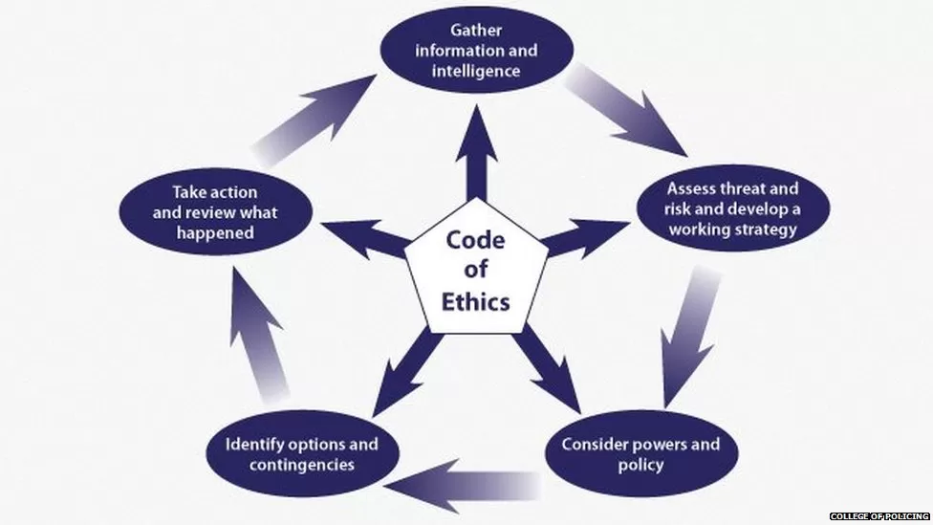

The incident came through as a ‘Concern for safety’ call. The initial stage of decision making commences immediately by assessing what is happening, what we know so far, what don’t we know so far and what further intelligence is required at present. The reporting person said that there had been a large disturbance inside her property between herself and her ex partner. The call operator relayed the information as a call from an erratic female who was stating that she was unable to obtain mental health related assistance from her case worker and or mental health team. She is also alleging that her television has been smashed by her ex partner. So far, we don’t know much else. My considerations at this time are obviously that the individual is in some level of mental distress, it is also important to consider that there may be some level of domestic violence involved. The further information we require at this time is obtained by the call handler who will link known parties to the address. As we are travelling to the incident, we enquire as to whether there are previous markers for domestic violence at the address and whether the individuals involved have any warning makers, including the reporting person. This changing information will feed into any decision making upon arrival at the scene.

Immediately upon arrival, I always stand for a moment outside the address to see if I can hear anything that may indicate what we are about to walk in to. This helps me to decide if I need to take immediate action or whether I need to obtain further information. At this stage I was unable to hear anything so we entered the address. The warning markers at this point came back as drugs, previous arrest for assault (under Section 47 of Offences Against a Person Act, 1861) and violence. I also briefly looked at the previous occurrence which was an incident where she was arrested for Assaulting a Police Officer. It is important at this point to keep all of this information in mind as it may affect any immediate decision making. However, it is important not to allow unconscious bias to cloud your judgement. Upon entry, it became immediately obvious that the reporting person was significantly under the influence of either drugs and/or alcohol. According to Johnson (2004) the relationship between drug use and subsequent criminal or drug related crimes is positively correlated. It is always important to consider the significant impact substance can have on an individuals behaviour and take account of the risk this may pose. Her demeanour was increasingly erratic and It was clear that the risk to our own safety was about to escalate. We were attempting to obtain further information at this point by asking questions relating the initial call but we were unable to get her to comply. It was at this point I noticed remnants of white powder resembling cocaine on the side counter. This information led to consideration of how this specific substance affects people. Paine and Olmstead (2004) concluded significantly increased behavioural disinhibition in those under the influence of cocaine. From my own personal experience and anecdotally, it is clear that people are negatively disinhibited by cocaine use and this results in violent and erratic behaviour.

Following the reporting persons refusal to answer any of our questions as well as her evidently increasing levels of distress, she walked from the living room into the kitchen and myself and my colleague followed. In terms of dynamic risk assessment the kitchen is one of the most dangerous rooms in the house for us as officers and this informed our decision making at this point. The female lunged towards a kitchen knife and it was at this moment I elected to restrain her under Section 3 of the Criminal Law Act (1967). This powers for use of reasonable force in order to prevent crime. This decision was also covered by the common law that an officer may use reasonable force to protect themselves and others. I considered deploying my PAVA as per Association of Chief Police Officers of England (ACPO, 2009) guidelines but did not do this due to the close proximity of both myself and my colleague. I was able to stop her from actually grabbing the knife and immediately eliminated the potential for her to harm both herself and ourselves. My colleague called over the radio for further units to assist whilst I cuffed the individual. If the female had managed to grab the knife I would have used my baton under Section 117 of PACE (Police and Crime Evidence Act, 1984). This power as well as the common law allows the use of a pre-emptive strike, however, fortunately that was not required in this instance.

Once the female was restrained I considered my tone of voice and use of tactical communications to attempt to de-escalate the situation. I also took into account acute behavioural disturbance (ABD) at this point as she was on her front and I was conscious of the risk involved to the individual. I ensured her breathing was not inhibited by her position and tried to sit her up to both protect her airway and for ease of communication with her. According to Humphries and Walker (2023) ABD is more likely to result in a healthcare focussed outcome rather than one of arrest. It was important at this point to ensure that she came to no harm. The Human Rights Act (1998), specifically article 5, refers to an individuals right to freedom and liberty. The act of handcuffing takes away said right to liberty and freedom. As a result, all actions from this point must be justified, proportional, lawful, accountable, necessary and ethical in line with our duty of care to the detained individual. In order to inform tactical decision making this must always be employed.

I arrested the female for affray under Section 3 of the Public Order Act (1986). This act refers to use of or threats to use unlawful violence towards another and that conduct is such that it may cause a person of reasonable firmness to fear for their safety. This can be used in both a private or public setting. In this case it was used within a dwelling for the safety of myself and my colleague. Following the arrest, the individual started screaming and thrashing around. She repeatedly screamed ‘I DON’T DESERVE THIS’ to which I attempted to calmly explain that we were detaining her for her own and our own safety. I considered my own behaviour and how it may come across to her at this point as per the College of Policing (2014) conflict management skills. This states ‘My attitude impacts my behaviour which in turn will affect your attitude and your behaviour’. With this in mind I remained completely calm in my verbal communication with her as well as bearing in mind that she was under the significant influence of drugs and that her own behaviour was under extraneous influence. I treated the female with the respect and dignity with which I would hope to be treated myself regardless of the offence she had committed.

It was at this point when the backup that my colleague requested actually arrived on scene. Despite our best efforts to verbally de-escalate the female we were unable to do so. In hindsight I acted as I did with the options available to me at the time and owing to the immediacy of the threat with the knife. Had the female not attempted to assault myself and/or my colleague, in which instance we would have arrested under the Assault on Emergency Workers Act (2018), we would have more than likely looked to detain her under Section 136 of the Mental Health Act (2003). This outcome would have obtained her the immediate mental health related assistance which she claimed she was trying to access on the original call. However, her actions that unfolded during the course of the call left me with no choice but to arrest for the offence that I did. It is important to consider that when she arrived at custody she would be offered mental health services and be evaluated by a mental health nurse anyway. I also completed a Public Protection Notification post incident detailing her needs and my concerns and this is shared with partner agencies so that she may be referred to the help she requires. This ensured that I as an arresting officer carried out my safeguarding duties to the individual.

In conclusion, paying consideration to the NDM, I am happy with the decisions I made throughout and believe that I acted in a manner that was wholly professional and appropriate. I was careful to take into consideration the ever changing nature of the incident and allow this to inform my decisions at every stage. If I were to attend the same incident again I would act in the exact same way in order to protect the safety of myself and my colleague. I was able to safely detain the individual and ultimately refer her to the mental health related services that she very clearly needed. In all of my actions the well being of the individual was at the forefront and I was diligent in my duty of care towards her.

(1,646 Words)

Task 3

Relevant areas of the National Policing Curriculum:
Maintaining Professional Standards, Leadership and Team-working

Evaluate theories of team dynamics as a means of developing team cohesion (reasons why some teams cannot function, theories and models relating to team dynamics, ways to improve team cohesion).

Consider why inter-personal conflict can occur within a team and outline what strategies can be adopted to enhance individual and team performance.

Consider how team dynamics within the police service can result in failing to comply with professional standards requirements (Code of Ethics, policies, procedures, protocols or legislation).

1750 words (+/- 10%: include your actual word count at the end of each section)

ANSWER:
Central to policing and team cohesion are theories of team dynamics. In this essay I will look to discuss two key models and discuss how they apply to policing and consider their shortcomings. I will also discuss the impact of interpersonal conflict and lack of team cohesion on both individual and overall team performance and their wider implications. Firstly I will discuss Tuckman’s 5 Stage Theory of Group Development (Tuckman, 1965). This theory is centred around 5 clearly defined stages; forming, storming, norming, performing and adjourning. These are briefly outlined in Figure 2. As seen below.

Fig. 2
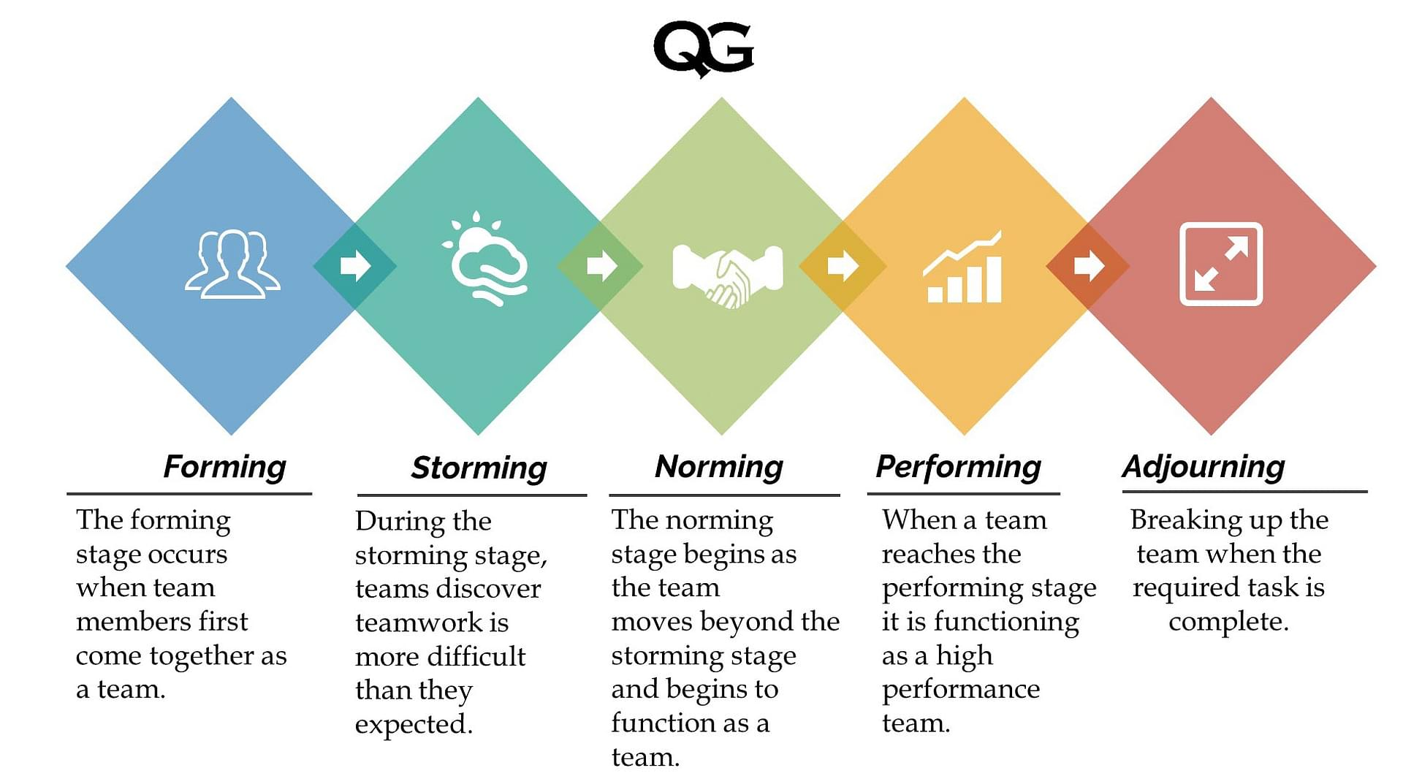

I will discuss these stages in terms of my own personal experiences thus far within my policing journey. Firstly forming, I have been through this experience twice both in my initial experience joining a team during my probation before gaining independent patrol status and then again when joining my current team more recently. At this point I required the most support from my peers and superiors as I was very new to the job. It is widely accepted that newer officers significantly benefit from the vast experience of more seasoned officers and that they are helped enormously by the structure and support that they bring to the team dynamic and working environment (Willams and Sondhi, 2022). Tucker highlights that at this stage in team development individual roles are unclear and the process is not particularly well established. I would agree that when I joined both of my teams it took some time to develop an understanding of where I fitted in and what my role was.. The drawbacks at this stage are that any small errors made by individuals who are not integrated with the team can potentially impact the team as a whole, i.e. making more work for peers or using up their valuable time asking for help or explanation.

Secondly, within the storming stage teams discover that teamwork is more difficult than expected. It also involves development of understanding as to how team decisions are made but the relationships remain blurry (Carter, 2014). I would definitely agree that whilst I was more comfortable in my decision making and slowly becoming more confident in my role at this stage, I still had some way to go. The importance of further developing these relationships at this stage is invaluable. According to Brough and Frame (2004) peer and senior support at this early stage is a strong predictor of both job satisfaction and subsequently retention rates of new officers. At this point in my policing journey I still needed (albeit less) support and would refrain from making autonomous decisions.

Thirdly, the norming stage. This is where the team begins to act cohesively and strong interpersonal bonds form. I would personally say that it took me about 6 months of being on my current team for me to get to this point. I was more confident in my role and comfortable in my individual decision making abilities. I was able to recognise my value as part of the overall team. It was at this stage I felt able to contribute my ideas towards the overall team goals and objectives and finally felt like I had something to offer the team as a whole. I had built strong intrapersonal relationships with my peers as well as comfortable associations with my superiors. According to Power (2018) these strong intrapersonal relationships and intrateam relationships are of critical importance, particularly when dealing with high risk and/ or extreme events. They also highlight the benefit of these intrateam relationships on interteam relationships in these circumstances, i.e. a cohesive team is more effectively able to work with other services such as ambulance or fire services in the resolution of critical incidents. I would personally agree that the benefits of being able to work as a cohesive team especially under intensely pressured situations are insurmountable.

Next is the performing stage. This is referred to as the stage where a team reaches high levels of performance. The entire team runs well and is committed to overall excellent performance. I would say that within my team we are on the precipice of this stage as we are still quite a young team. We have come a long way together but there is always room for improvement and it is important to consider the impacts of comings and goings of officers, for example intake of probationers or members of the team being deferred on hub attachments on the overall cohesion of the group. Our sergeant was sent to work on another team a few months ago and I would say the impact of his departure cannot be understated. We are currently learning to function and operate under a newer sergeant and he runs the team in a totally different way. It will take us some time to get to the ‘performing’ stage as a result of this upheaval. Cohen et al (2018) recognise the importance of strong and most importantly consistent leadership in overall team efficacy and job satisfaction. The implications on the health and wellbeing of the team are also discussed. Although I am some way from being an experienced officer I am getting to the point where I am developing my understanding of my decision making processes and their consequences.

Lastly, the adjourning stage. This was added in subsequent literature by Tuckman and Jensen (1977). This stage refers to the final stage in team development, this is whereby the first four stages are complete and the team looks to review the achievements of the whole. This could be in the form of period performance reviews, Personal Development Planning (PDP), reward incentives or job progression such as completion of sergeant boards or opportunities to ‘act up’ for invaluable ‘on the job’ experience. Personally, I feel that I am some way off looking for opportunities to professionally progress. I am enjoying my role and honing my policing skills to increase my value to the team. As I am in probation I am yet to receive my first yearly personal review but I look forward to this as the feedback I receive will allow me to progress as an officer who is still early in my role.

In addition to Tuckman’s model there are several theories of team dynamics that can be equally applied to policing. The next model I will discuss is the GRPI Model, this refers to Goals, Role, Processes and Interpersonal Relationships (Beckhard, 1972). The stages of which are briefly outlined below in Figure 3.

Fig 3.
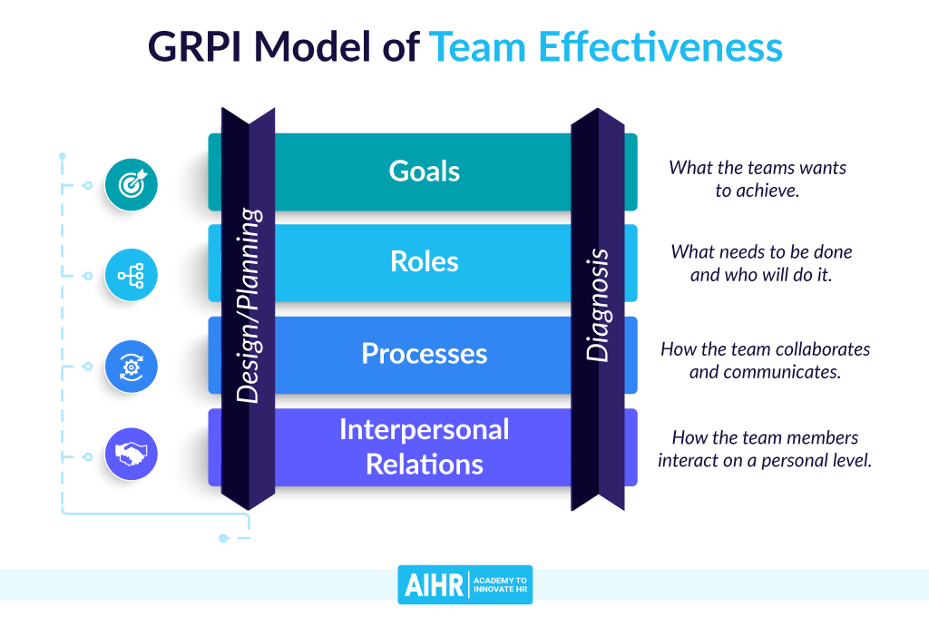

This is a multi directional model which allows for both a top down and a bottom up approach to evaluating and explaining team cohesion. It is important to consider that if a team is new it may be beneficial to start with goals as it is more simplistic and work your way towards specific team objectives such as interpersonal relationships. Equally, with a team that is well established but experiencing challenges it may be more effective to start with interpersonal relationships and work that way. It may be the case that one or two people are affecting the whole.

In order to evaluate this model in terms of policing I will apply it to PSU attendance at an international rugby match. In terms of goals, these must be clearly identified in order to provide a direction and common objective. In this instance this would refer to specifics such as establishing operational parameters and timings and boundaries as well as prioritising both officer and public safety. In terms of roles, this would refer to setting of crystal clear responsibilities for each and every officer and explanation of command structures both on scene and over the radio. Processes in this instance would refer to correct procedures being in place specific to the nature of the event and clear cut scenario planning based on impact assessments and any intelligence gathered pre-event, for example, awareness of planned gathering in known areas. Lastly, relationships are important in this context as they allow for clear and effective communications between colleagues who are used to each other as well as boosts camaraderie amongst working officers who may have never met until this occasion. It is clear that shortcomings in each of these areas will have a significant knock on effect in the overall efficacy of an operation. This could have enormous consequences at a large scale event such as this which could have serious security and health and safety risks. It is paramount that the safety of both the public and officers is maintained and each of these stages ensures that every effort to eradicate these risks is watertight.

Leading on from this, it is important to discuss what happens when these team dynamics do not work or form correctly and the consequences of inter team conflict. According to Espevik et al (2021), In order to work effectively as a team, each member must know their roles, have an awareness of the resources available, must be aware of the strengths and weaknesses of their peers and also be able to communicate clearly and freely. Subsequently, failure to establish these can result in conflict and unresolved conflict can disrupt the harmony of the whole team. According to the current College of Policing (2014) guidelines regarding conflict management, one approach that can be adopted is the CUDSA Model. This refers to Confrontation of the conflict, i.e. acknowledgement that there is an issue. Next is Understanding of the other’s position, i.e. attempting to understand the perspective of the other person in order to mitigate disagreement. The next stage is to Define the problem, i.e. to clearly understand the issues to resolve or deescalate. Searching for and evaluating solutions i.e. rationally discussing how you might come to an agreement either way or to respectfully agree to disagree and lastly Agree upon the best solution which satisfies both parties. Inter personal conflict can occur within any team environment but is especially likely in a high pressured role such as policing.

In addition to this are the impact on compliance with professional standards requirements. According to Ortmeier and Meese (2010) each individual member is responsible for the ethics of the team as a whole. That is to say, one persons failure to behave in an ethically appropriate manner affects badly on the whole team as well as the whole of policing. Talarico and Swanson (1980), discuss the limits of team policing and the potential for whole team attitudes towards change and innovation to hold policing back from much needed advances in protocol and policy. This is effectively saying that in group bias can negatively affect policing. Goldsmith (1989), however, outlined the need for an alignment of ethos when it comes to creating rules and regulations within the force and argued against the negative associations of police cultures created by close knit teams. It is also important to consider the effects of public perception on the police and the knock on impact damage to this can ensue. According to Tankebe (2012) legitimacy (i.e. respect of the police officers right to exercise power) is directly related to willingness to obey the law and cognate concepts of trust amongst the general public.

Ultimately, the benefits of cohesive team dynamics in policing cannot be overstated. In terms of maintaining a positive and enjoyable work environment as well as a well run force which serves the public in a safe and professional manner. With this being said it is important to consider potential drawbacks and address these in order to better the force.

(1,920 Words)

Task 4
Relevant areas of the National Policing Curriculum:
Policing the roads, information and intelligence and conducting investigations.

Explain how information and intelligence can be used in the disruption of the more prevalent criminal activity (e.g. drug smuggling, human trafficking, child sexual exploitation, counterfeit goods, organised crime groups and ‘county lines’) by effective policing of the roads.

Outline how ANPR can be used as investigative resource when disrupting criminal activity.

1750 words (+/- 10%: include your actual word count at the end of each section)

ANSWER:
According to the National Roads Policing Strategy (2022) there are four key pillars of activity, these include prevention of harm and saving lives, tackling crime, driving technology and innovation and lastly changing minds. The strategy looks to achieve the above whilst remaining ethically and procedurally sound, environmentally and ethically informed, based on evidential approach and using the 5 E’s - Engagement, Explanation, Encouragement, Education and Enforcement. Central to roads policing is the obtainment of information and intelligence regarding nationwide criminal activity. This has a plethora of advantages to the force as it allows for pro-active policing to take place up and down the strategic road networks of the UK. The Strategic Roads Network (SRN) in the UK is comprised of motorways and ‘trunk roads’ and it covers around 25000 miles. This allows for roads policing to cover and police an enormous part of the UK. According to Corbett (2008) roads policing is perceived by the public as being the face of policing in the UK and that the service it provides is crucial.

The role of roads policing teams is to react to traffic incidents as well as receive intelligence and information which allows them to track or intercept more widely scaled crime. It is widely acknowledged that due to the level of road safety incidents and deaths each year that more enhanced intelligence and recruitment of more officers is desperately required in order to increase the efficacy of roads policing. According to the UK Government Statistics (2022) there were 1760 road related fatalities across the nation. Additionally, advancements in technology in order to aid roads policing are required if these statistics are to be lowered.

This essay will discuss the usefulness of intelligence and information in targeting and eradicating criminal activity. I will discuss relevant technologies used such as ANPR and discuss their benefits and pitfalls.

Central to police intelligence resources in the UK is the National Intelligence Model (NIM) (College of Policing, 2014). This is a framework used to gather and collate intelligence around criminal activity, the basic details of which are outlined below in Figure 4.
Fig 4.
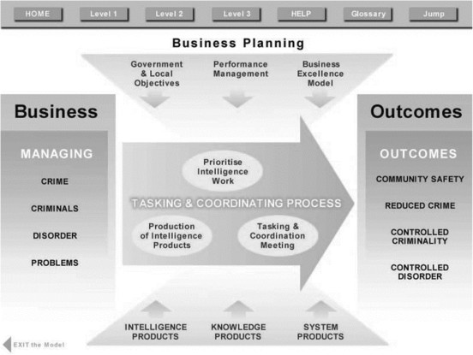

The tasking and co-ordinating process refers to 3 different levels of crime (Bryant and Bryant, 2021). Level one is at a local level (BCU) and managed by local resources. Level two refers to force and regional level which is criminality that usually requires additional resources. Lastly, level three is crime on a national scale which is serious and organised. This categorisation is crucial in allocation of specific resources. For example, burglary across a specific force area would require a force level (level two) response. Another example would be international drugs smuggling which would require national and potentially international counterpart involvement (level three).

Feeding into the tasking and co-ordinating process are intelligence products themselves. These include but are not limited to police forces, specialist closed sources, existing intelligence, information from partner agencies such as the HMRC and local community safety partnerships such as neighbourhood watch. Output from the tasking and co-ordinating process are usually that a control strategy specific to the requirements of the policing of the crime will be implemented. This ensures that operational decisions can be made tailored to the management of each level of crime. In practice, the NIM can be used from start to finish in tracking crime.

In order to apply this to roads policing I will explain a hypothetical scenario where the NIM can be employed throughout. If the local force receives several reports of low level drug dealing. The reports form the source of information which are input into the system and any immediate patterns are established i.e. if the offender is known or not. Next, the task and co ordinating group will task police staff to gather further intelligence to find out if there are other people involved or if there is a specific kind of individual involved. Force databases will be checked and partner agencies may be involved such as the National Crime Database. It may be the case that the crimes are all taking place in a specific area for example. Roads policing may come in useful here as specific cars and/or plates may be linked to certain individuals or known in certain areas and this provides not only another level of intelligence but an opportunity for surveillance. This may result in further intelligence that these individuals are actually transporting drugs across county lines which would result in involvement of national level agencies and resources. It is in these instances where ANPR can be especially useful.

ANPR or Automatic Number Plate Recognition has been widely used as an effective tool for acquiring information about vehicle movements nationwide (Tang et al, 2022). ANPR is run via a network of approximately 11,000 cameras across the Strategic Roads Network across the UK. The technology employed allows almost instant access to vehicle registration marks and allows police to see if there are any existing ‘markers’ attached to the vehicle, i.e. whether the vehicle or any linked persons is known to the police for any reason. Any suspicious or previously marked vehicles will be immediately ‘pinged’ to local resource and this intelligence feeds into the NIM as previously discussed. The ANPR algorithms used are vehicle image capture, number plate detection, character segmentation and character recognition (Patel et al, 2013). This allows for the accurate detection of specific vehicles and plates. This is also useful in identifying quickly whether plates belong to the vehicle they are being displayed as a tactic being deployed more widely amongst criminals is cloned plates. Whether this be to attempt to evade detection through ANPR or due to the vehicles being stolen. In other countries such as Malaysia, more modern technologies have attempted to develop portable ANPR systems and installed them directly into patrol cars (Fakhar, 2019). These systems were not without their limitations though and are some way off being employed in the UK. According to Watson and Walsh (2008), in 2002, the UK police forces trialled the use of ANPR intercept teams, these stopped a total of 180,543 vehicles as a result of using the technology. Across these stop and searches, 13,499 arrests were made for a range of offences including but not limited to burglary, driving offences, drug related offences and auto crime. Additionally, Cameron et al. (2008) highlight that the presence of the ANPR system in itself deters illegal road use including driving of unlicensed or uninsured vehicles. As such, another of the benefits of ANPR is that it seems to promote an element of road safety. Jones (2008) Concluded that ANPR resulted in 90% efficacy in detection and prohibition of overloaded vehicles, which is a significant crackdown on dangerous road use.

It is important to consider the drawbacks of ANPR use, as with everything it has its pitfalls. Whilst it is an effective tool if it successfully identifies an individual who has committed a crime or is in the process of committing a crime and allows for officers to stop and search under Section 163 of the Road Traffic Act (1988), there are ways that people are getting around this. For example, certain fonts of numberplate or a reflective finish on the plate can result in the camera being unable to successfully read the plate and identify the vehicle (Rhead et al, 2012). The issue is that certain individuals particularly those who are involved with organised crime are aware of these pitfalls in ANPR technologies and will routinely exploit them. Another issue is that it has been argued that there are data protection issues surrounding use of ANPR. Parsons et al. (2012) discuss this in terms of how mass surveillance practises arguably invade the personal privacy and security of the general public. Clarke (2015) argues that ANPR impinges on personal freedom and is an invasion of privacy. In addition, Evans-Pugh (2006) states that a system that relies upon multiple external government databases are far more likely to result in errors being made. As such, public confidence in ANPR will be limited as it undermines their belief in its efficacy.

Ultimately, ANPR is a cheap and reasonably effective method of both detecting and deterring crime up and down the UK. Whether this be its ability to detect movements of vehicles allowing officers to detect the specific whereabouts of individuals enabling a stop and search or to effectively enforce safe driving behaviour in general road users nationwide. The efficacy of ANPR can only be improved by advancement in recognition software as well as an increase in resources available to police in accordance with the intelligence it provides. Currently, whilst ANPR is a useful tool, there is an enormous human element required in roads policing which has some way to go in successfully tackling nationwide crime. Road policing plays a serious role in disrupting multiple levels of crime, whether this be on a local, force wide or national level. It is underpinned by the gathering of intelligence and information through resources such as ANPR and requires a multi agency approach.

(1,501 Words)

Task 5
Individual Learning Plan

The second learning outcome identified in the accompanying module descriptor (BMPP 5000D) asks that you create an individual learning plan to meet your identified needs through reflection upon your continuing practice. This shows confidence in your ability to manage your own learning in response to evolving circumstances in the workplace.

This task differs from the PDPs that you have completed in your previous workbooks in that this learning plan allows you to assess what level you believe you are in key knowledge, skills and experience against where you believe you (and the force) consider you should be – now and in the coming 6 to 12 months of your placement. This should then be used to target future development need.

1500 words equivalent. Please note that this is not the actual number of words used in completing the table, the count reflects the thought and research behind it.

It will count towards the overall equivalent word count of 8000 words expected from this module.

ANSWER:

Knowledge, Skills and Experience Assessment

 | REQUIRED |  |  | RATING |  |  | DEVELOPMENT NEED
KNOWLEDGE  Case file building  Even though I’ve completed my Hub attachment, I found that it wasn’t long enough so that case file building skills were developed thoroughly. I’ve found I returned to shift with added knowledge and skills but these have “faded” over the last few months as I haven’t dealt with any files. | Low  1-4 | Med  5-7 | High  8-10 | Low  1-4 | Med  5-7 | High  8-10 | To date I’ve completed 2 case files, as It’s very few and far between that we have the opportunity to fully progress occurrences from initial attendance to court.  I’m aware of my shortcomings regarding case file building and I’m in the process of collating “how to” guides and putting them into a folder in order to aid not only myself but the shift. I also plan on re visiting some of the arrests I’ve made that have gone to court in order to get a better understanding of what exactly is needed.  I find the area challenging as It’s continually evolving with new forms and new ways of doing things, that’s certainly been my experience of the case file build system since I’ve joined.
SKILLS  Taser course  PNC course  Other opportunities | Low  1-4 | Med  5-7 | High  8-10 | Low  4 |  | High  8-10 | Taser course is already booked for the start of next month  I believe having taser to be a massive advantage going forward as it adds another tool to my conflict management toolbox.  Opportunities to complete the PNC training course seem to be very rare, I’ve enquired about future courses but so far have had no reply. When building packages having a PNC trained officer is invaluable because it means that the investigation hub are far more likely to progress the investigation if the package built by response is good.  I’ve also made efforts to speak to my sarge 1 on 1 in order to obtain information on certain pathways and what skills are needed for different roles within the force.
EXPERIENCE  Traffic offences | Low  1-4 | Med  5 | High  8-10 | Low  1-4 | Med  5-7 | High  8-10 | Opportunities to deal with Traffic offences have been fairly rare.  I dealt with a drink driver for the first time a few weeks ago, I found myself relying heavily on my colleague of 20 years+ in the job.  Due to response policing being so busy we don’t have much exposure to traffic offences. I’m hoping to organise a few shifts joining the roads policing team in order to gain this invaluable experience and to also tick a few things off my OCP

Bibliography
The bibliography should only include sources referenced within the workbook using the Harvard referencing system. Information about referencing in written assignments and how to avoid plagiarism can be found on Moodle. It is important that you are aware of the importance of ensuring that the work submitted is your original work.

Association of Chief Police Officers of England, Wales and Northern Ireland.
Guidance on the use of incapacitant spray. ACPO (2009) www.acpo.police.uk <https://gbr01.safelinks.protection.outlook.com/?url=http%3A%2F%2Fwww.acpo.police.uk%2F&data=05%7C01%7Caled.nicholas%40south-wales.police.uk%7C39db3a5c8eb34231c49308db39f101ff%7C270c2f4dfd0c4f0892a9e5bdd8a87e09%7C0%7C0%7C638167479679153206%7CUnknown%7CTWFpbGZsb3d8eyJWIjoiMC4wLjAwMDAiLCJQIjoiV2luMzIiLCJBTiI6Ik1haWwiLCJXVCI6Mn0%3D%7C3000%7C%7C%7C&sdata=4H9GUlTn2hP9iCYhBo0gs2XhwxPrY95UkJUoPxbqFK8%3D&reserved=0>
(Accessed March, 2023)

Code of Policing Ethics (2014)
Available at:
https://www.college.police.uk/ethics/code-of-ethics <https://gbr01.safelinks.protection.outlook.com/?url=https%3A%2F%2Fwww.college.police.uk%2Fethics%2Fcode-of-ethics&data=05%7C01%7Caled.nicholas%40south-wales.police.uk%7C39db3a5c8eb34231c49308db39f101ff%7C270c2f4dfd0c4f0892a9e5bdd8a87e09%7C0%7C0%7C638167479679153206%7CUnknown%7CTWFpbGZsb3d8eyJWIjoiMC4wLjAwMDAiLCJQIjoiV2luMzIiLCJBTiI6Ik1haWwiLCJXVCI6Mn0%3D%7C3000%7C%7C%7C&sdata=Sok9TeTD4%2FasufKm%2FEJLhybMK4IpkU8yEf9cEyg2Wao%3D&reserved=0>
(Accessed March, 2023)

Conflict Management Skills (2014)
Available at:
https://www.college.police.uk/guidance/conflict-management/conflict-management-skills <https://gbr01.safelinks.protection.outlook.com/?url=https%3A%2F%2Fwww.college.police.uk%2Fguidance%2Fconflict-management%2Fconflict-management-skills&data=05%7C01%7Caled.nicholas%40south-wales.police.uk%7C39db3a5c8eb34231c49308db39f101ff%7C270c2f4dfd0c4f0892a9e5bdd8a87e09%7C0%7C0%7C638167479679153206%7CUnknown%7CTWFpbGZsb3d8eyJWIjoiMC4wLjAwMDAiLCJQIjoiV2luMzIiLCJBTiI6Ik1haWwiLCJXVCI6Mn0%3D%7C3000%7C%7C%7C&sdata=FuIRkX4RX2yEizCxPWVH4%2FK%2F0zbF%2F6Vl514QRP%2FSUk8%3D&reserved=0>
(Accessed April, 2023)

National Decision Model - Code of Policing Ethics (2014) Available at:
https://www.college.police.uk/app/national-decision-model/national-decision-model <https://gbr01.safelinks.protection.outlook.com/?url=https%3A%2F%2Fwww.college.police.uk%2Fapp%2Fnational-decision-model%2Fnational-decision-model&data=05%7C01%7Caled.nicholas%40south-wales.police.uk%7C39db3a5c8eb34231c49308db39f101ff%7C270c2f4dfd0c4f0892a9e5bdd8a87e09%7C0%7C0%7C638167479679153206%7CUnknown%7CTWFpbGZsb3d8eyJWIjoiMC4wLjAwMDAiLCJQIjoiV2luMzIiLCJBTiI6Ik1haWwiLCJXVCI6Mn0%3D%7C3000%7C%7C%7C&sdata=Zfq%2BywoiRPPjPecpAOkSFFMUrTRvS87sWRvFzjwEpbA%3D&reserved=0>
(Accessed March, 2023)

National Intelligence Model - Code of Policing Ethics (2014) Available at:
https://library.college.police.uk/docs/npia/NIM-Code-of-Practice.pdf <https://gbr01.safelinks.protection.outlook.com/?url=https%3A%2F%2Flibrary.college.police.uk%2Fdocs%2Fnpia%2FNIM-Code-of-Practice.pdf&data=05%7C01%7Caled.nicholas%40south-wales.police.uk%7C39db3a5c8eb34231c49308db39f101ff%7C270c2f4dfd0c4f0892a9e5bdd8a87e09%7C0%7C0%7C638167479679153206%7CUnknown%7CTWFpbGZsb3d8eyJWIjoiMC4wLjAwMDAiLCJQIjoiV2luMzIiLCJBTiI6Ik1haWwiLCJXVCI6Mn0%3D%7C3000%7C%7C%7C&sdata=6TLvU0n%2BapOCMDM1w1O%2FEucyIRiutDUO6ro6X6VhhIY%3D&reserved=0>
(Accessed April, 2023)

National Roads Policing Strategy (2022)
Available at:
https://library.college.police.uk/docs/NPCC/Roads_Policing_Strategy_2022.25.pdf <https://gbr01.safelinks.protection.outlook.com/?url=https%3A%2F%2Flibrary.college.police.uk%2Fdocs%2FNPCC%2FRoads_Policing_Strategy_2022.25.pdf&data=05%7C01%7Caled.nicholas%40south-wales.police.uk%7C39db3a5c8eb34231c49308db39f101ff%7C270c2f4dfd0c4f0892a9e5bdd8a87e09%7C0%7C0%7C638167479679153206%7CUnknown%7CTWFpbGZsb3d8eyJWIjoiMC4wLjAwMDAiLCJQIjoiV2luMzIiLCJBTiI6Ik1haWwiLCJXVCI6Mn0%3D%7C3000%7C%7C%7C&sdata=J3xLPn8ysQ9rOwuKXIw6jLxTp0xJw9kdqn8c%2BVtMm%2Bk%3D&reserved=0>
(Accessed April, 2023)

Beckhard, R., 1972. Organizational issues in the team delivery of comprehensive health care. The Milbank Memorial Fund Quarterly, 50(3), pp.287-316.

Britz, M.T., 1997. The police subculture and occupational socialization: Exploring individual and demographic characteristics. American Journal of Criminal Justice, 21, pp.127-146.

Brough, P. and Frame, R., 2004. Predicting police job satisfaction and turnover intentions: The role of social support and police organisational variables. New Zealand journal of psychology, 33(1), pp.8-18.

Bryant, R and Bryant, S., 2021, Blackstone’s Handbook for Policing Students, Oxford University Press, Oxford.

Cameron, P., Little, M., Mitra, B. and Deasy, C., 2008. The road safety implications of Automatic Number Plate Recognition Technology (ANPR).

Clarke, R., 2015, May. Freedom and Privacy: Positive and Negative Effects of Mobile and Internet Applications. In Interdisciplinary Conference on ‘Privacy and Freedom', Bielefeld University (pp. 4-5).
Cohen, I.M., McCormick, A.V. and Rich, B., 2019. Creating a culture of police officer wellness. Policing: A Journal of Policy and Practice, 13(2), pp.213-229.

Corbett, C., 2008. Roads policing: current context and imminent dangers. Policing: A Journal of Policy and Practice, 2(1), pp.131-142.

Demou, E., Hale, H. and Hunt, K., 2020. Understanding the mental health and wellbeing needs of police officers and staff in Scotland. Police Practice and research, 21(6), pp.702-716.

Espevik, R., Johnsen, B.H., Saus, E.R., Sanden, S. and Olsen, O.K., 2021. Teamwork on patrol: Investigating teamwork processes and underlaying coordinating mechanisms in a police training program. Frontiers in psychology, 12, p.702347.

Evans-Pughe, C., 2006. Road watch [automatic number plate recognition system]. Engineering & Technology, 1(4), pp.36-39.

Fakhar, S., 2019. Development of portable automatic number plate recognition (ANPR) system on Raspberry Pi. International Journal of Electrical and Computer Engineering, 9(3), p.1805.

Goldsmith, A., 1990. Taking police culture seriously: Police discretion and the limits of law. Policing and Society: An International Journal, 1(2), pp.91-114.

Humphries, C. and Walker, A., 2023. Retrospective cohort study of acute behavioural disturbance in police use of force reports. Journal of Forensic and Legal Medicine, 93, p.102465.

Johnson, H., 2004. Drugs and crime: a study of incarcerated female offenders (Vol. 63). Canberra: Australian Institute of Criminology.

Jones, M., 2008. Targeted roadside enforcement using WIM and ANPR. In International Conference on Heavy Vehicles.

Ortmeier, P.J. and Meese, E., 2010. Leadership, ethics, and policing: Challenges for the 21st century. New York, NY: Prentice Hall.
Parsons, C.A., Savirimuthu, J., Wipond, R. and McArthur, K., 2012. Anpr: Code and rhetorics of compliance.

Patel, C., Shah, D. and Patel, A., 2013. Automatic number plate recognition system (anpr): A survey. International Journal of Computer Applications, 69(9).

Paine, T.A. and Olmstead, M.C., 2004. Cocaine disrupts both behavioural inhibition and conditional discrimination in rats. Psychopharmacology, 175, pp.443-450.

Power, N., 2018. Extreme teams: Toward a greater understanding of multiagency teamwork during major emergencies and disasters. American Psychologist, 73(4), p.478.

Purba, A. and Demou, E., 2019. The relationship between organisational stressors and mental wellbeing within police officers: a systematic review. BMC public health, 19, pp.1-21.

Rhead, M., Gurney, R., Ramalingam, S. and Cohen, N., 2012, October. Accuracy of automatic number plate recognition (ANPR) and real world UK number plate problems. In 2012 IEEE international carnahan conference on security technology (ICCST) (pp. 286-291). IEEE.

Tang, J., Wan, L., Schooling, J., Zhao, P., Chen, J. and Wei, S., 2022. Automatic number plate recognition (ANPR) in smart cities: A systematic review on technological advancements and application cases. Cities, 129, p.103833.

Talarico, S.M. and Swanson Jr, C.R., 1980. The limits of team policing. Police Stud.: Int'l Rev. Police Dev., 3, p.21.

Tankebe, J., 2013. Viewing things differently: The dimensions of public perceptions of police legitimacy. Criminology, 51(1), pp.103-135.

Tuckman, B.W., 1965. Developmental sequence in small groups. Psychological bulletin, 63(6), p.384.

Tuckman, B.W. and Jensen, M.A.C., 1977. Stages of small-group development revisited. Group & organization studies, 2(4), pp.419-427.

Vanebo, J.O., Bjorkelo, B. and Aaserud, T., 2015. Police leadership development: Intentions and critical success-factors. Int'l Pub. Admin. Rev., 13, p.11.

Velazquez, E. and Hernandez, M., 2019. Effects of police officer exposure to traumatic experiences and recognizing the stigma associated with police officer mental health: A state-of-the-art review. Policing: An International Journal.

Watson, B. and Walsh, K., 2008. The road safety implications of Automatic Number Plate Recognition technology (ANPR). The Centre for Accident Research and Road Safety, Queensland,[Online] Available at: http://eprints <http://eprints/> . qut. edu. au/13222/1/13222. pdf (accessed 16 January 2012).

Williams, E. and Sondhi, A., 2022. A Narrative Review of the Literature on the Recruitment of Younger Police Officers in Age and in Service: What Are the Implications for the Police in England and Wales?. Policing: A Journal of Policy and Practice.

White, V. and Robinson, S., 2014. Leading change in policing: police culture and the psychological contract. The Police Journal, 87(4), pp.258-269.

Zulkafaly, F., Kamaruddin, K. and Hassan, N.H.M., 2017. Coping strategies and job stress in policing: A literature review. International Journal of Academic Research in Business and Social Sciences, 7(3), pp.458-467.

