
DEVELOPING INNOVATION AND CREATIVITY FOR BUSINESS

ADVANTAGE

(BMSW6102_SWAN)


SAMSUNG SMARTTHING FRIDGE

Angela Dolphin

1905288

25 MARCH 2022



Executive summary

This study is about Samsung Electronics and how they employ creativity and innovation to come up with new concepts. When it comes to developing new ideas, innovation and creativity go hand in hand. The Samsung Fridge/Laptop Meal Planner is a new product from Samsung. The dangers and problems of creating the product, as well as Samsung's leadership and management style, will be discussed. One of its most recent developments is the newest version of their SmartThings refrigerator, which can provide recipes based on what is in the fridge. The kitchen device claims to help with meal planning by considering personal preferences including gourmet tastes, dietary limitations, and even product expiry dates.
The ability to connect food storage with meal preparation services, such as recipe suggestions, has been regarded as one of Samsung's new model's more attractive characteristics. Similarly, the inclusion of Amazon's voice assistant Alexa was a fur.
Samsung's success and ability to propel goods ahead depends on assessing the efficacy of their inventions, and this would have played a vital role in the creation and success of the SmartThings Fridge.
Samsung promises to go to great lengths to assure outstanding and consistent product quality, as well as timely delivery to ensure customer happiness. Samsung advocates the notion of continually improving productivity by regulating fluctuations in numerous processes in a consistent manner to attain this aim. Samsung uses both open and closed innovation, each with its own set of advantages. Samsung employed a closed innovation process, which offers several benefits, including being the first to introduce the best refrigerator on the market. maintaining the company's leadership position.
I discovered whilst investigating the SmartThing Fridge that both innovation and creativity, were critical in making this fridge the very best on the market.

Contents page

- Introduction…………………………………………………………….3

2.0 Main finding…………………………………………………………….4

2.1 Overview of chosen innovation………………………………….4

2.2 What type of innovation is it?...................................................5

2.3 The creative thinking process..................................................5-6

2.4 Models of innovation……………………………………………..6

2.4.1 Open and closed innovation.................................................6-7

2.4.2 The innovation process........................................................7

2.4.3 The 4 Ps of innovation………………………………………...8

2.5.0 Assessment of the effectiveness…………………………….8

2.5.1 Risk and challenges……………………………………………8

2.6 Leadership and management of Samsung…………………….9
3.0 Conclusion………………………………………………………...10

Appendices...........................................................................................11-12-13

References ….......................................................................................14-15

Reflection on innovation........................................................................16

Reflection on lecture..............................................................................17

Reflection References………………………………………………………18

Introduction

Creativity is thinking up new things and innovation is doing new things. This observation by Levitt in 1974 highlights the connection between creativity and innovation. Both are important in the world of business as they play an essential part in developing new products and methods of working. This report will examine the meaning behind the use of the term's creativity and innovation and the similarities and differences between them. As a case study on creativity and innovation, the report will focus on the company Samsung, its new product called the Fridge/laptop meal planner.
The report will also look at how the creative process would be applied by Samsung when developing the fridge/laptop meal planner and how they will have evaluated its success. The risks and challenges of producing the product, and the leadership and management style used by Samsung will also be included. (Levitt 1974).
The electronics company, Samsung was founded in South Korea in 1938 by Lee Byung-Chull and it first traded as a grocery store. In 1969 the company started selling electronics with the first product being a black and white TV. Samsung is now one of the leading companies in all manufactures of electronic products all over the world. Since 2006 Samsung has been the largest manufacturer of televisions, but they also moved into mobile telephone production with their Smart Phone being introduced in 2011. In 2017 Samsung became the world's largest manufacturer of Samsung semiconductor chips (Life wire, 2020).
One of their most recent innovations, is the latest version of its SmartThings fridge which promises to assist with meal planning by considering personal details such as gourmet tastes, dietary restrictions, and even food expiration dates. For 2018, Samsung's SmartThings fridge was developed to incorporate new smart capabilities (McGarry, 2017).
As Rowlands suggested (2018), innovative ideas can be an expression or finding a solution to ongoing ideas. People can be innately creative, which mean that everyone can be creative daily with all situations.4+1+1. (Rowlands 2018).
Theodore Levitt puts it best: “What is often lacking is not creativity in the idea-creating sense but innovation in the action-producing sense, i.e., putting ideas to work.”
Creativity and innovation can get confused; innovation has always been assumed that it cannot be forced within an organisation. It can be there, or it cannot be there. This is commonly called design thinking and allows companies to effectively evaluate the success of their new product to (Idea value 2016).

2.0 Main Findings

2.1 Overview of the chosen innovation

One of Samsung’s most recent innovations is part of their SmartThings range. Their SmartThings Fridge allows the consumer to keep track of grocery items so that the consumer is kept informed about items they need to purchase because they are running low, or the item is nearing its use by date. This feature is known as The Family Hub Panel's View Inside. This feature is promoted as being perfect for those times when the consumer is travelling home but does not remember if they have the necessary grocery items to produce a meal. It also helps track the expiration dates on food items in and outside of the refrigerator. Once the consumer has used the feature to inform a shopping list for groceries, it then allows for an expiration date to be set. In addition, the consumer can also use the system to send stored or removed items to their shopping list for the next time they shop for groceries. To supplement this, a Meal Planner feature will also suggest recipes using what is already present in the consumer’s fridge (Samsung 2020).
The new model is an evolution of the first Family Hub refrigerator, which debuted in 2016. It has a double-door American-style design, a touchscreen display, and interior cameras that allow the consumer to check on their refrigerator using their smartphone.
One of the features which has been identified as more positive, in Samsung's new model is the ability to integrate food storage with meal preparation services, such as recipe ideas. Similarly, another positive feature is the integration of Amazon's voice assistant Alexa, however, consumers may still opt to have the Samsung voice assistant, Bixby, if they wish which is another advantage of this innovation. Also, The SmartThings Cooking service is the other addition to the SmartThings platform. Many of the cooking service's meal-planning features were available in previous versions of the Family Hub, but the company announced an expanded set of capabilities including guided cooking and the ability to send cooking instructions to synced cooking appliances like the company's Slide-In range.
The innovation has not been without its critics however, as it was described by some as the Franken Fridge, but the company has stayed true to its objective of creating a smart fridge platform that would be updated every year. Also, at over £2,000, the fridge is beyond the means of many consumers (Tuohy 2021).

2.2 What type of innovation is it?

In creating the SmartThings Fridge, it could be suggested the sustaining innovation model was used by Samsung. Incremental innovation is another term for sustaining innovation. Most the innovation is carried out because a product, such as the Samsung SmartThings Fridge, needs to function more effectively than it did originally. The objective is to enhance and expand existing options, any problems will be well defined. Maintaining innovation entails producing successively improved versions for coping with competition, boosting perceived value, exploiting externality effects, and lowering environmental footprints.
Innovators, such as Samsung, aim to provide more advanced products, such as the fridge, for the consumer so they can sell them for a greater profit. (Tool hero 2020).

2.3 The Creative Thinking Process – how creative thinking has been applied at an individual, team, organisational, and industry level
Creative thinking is something that has developed across many industries and sectors, and the electronics industry is no exception, particularly when devising such products as the Samsung SmartThings Fridge.
Samsung repeatedly state that innovation is central to their work as an electronics producer, and this would be their focus when producing products such as the SmartThings Fridge
Samsung has effectively transitioned from a low-cost local producer to a prestigious and fashionable consumer electronics brand. Samsung's performance during the last decade has demonstrated that the company is heading in the right direction. Samsung has developed an experimental tool to identify the key individuals, such as project leaders, promoters, or gatekeepers, so that they can seamlessly blend separate roles creating innovations (mbaknol 2019).
Assessing effectiveness of their innovations is key to Samsung’s success and ability to drive products forward and this would have played an important part in the development and success of the SmartThings Fridge.
Samsung claims to make every effort to achieve excellent and consistent product quality, and at the right time to ensure customer satisfaction. To achieve this goal, Samsung promotes the idea that they continuously improve productivity by controlling variations in various processes in a stable way (Samsung 2020).
The Reliability Test Group works within Samsung as a team and starts working as soon as decisions are made concerning a new device such as the SmartThings Fridge. The test group participates in the manufacturing process throughout development, analysing comments on it even after it has been launched and released. Thousands of the fridges would be tested before they were released, make sure that the fridge would work well in real life situations (News Samsung 2020).

2.4 Models of Innovation

2.4.1 Open and Closed Innovation
The open and closed models of innovation can be distinguished from one another. Whereas closed innovation is developed in a self-contained firm setting, open innovation absorbs external knowledge. It gives a business a distinct identity and a competitive advantage over its competitors. There are several advantages to the closed innovation model, as used by Samsung in producing products such as the fridge. For example, management will have full control of all innovations. With such a unique and unusual product such as the fridge, it is highly likely that Samsung would want to maintain the closed innovation model to ensure that no competitor was able to take their innovation and adapt it to produce themselves. Also, innovation developments will not be seen by the outside world which can create advantages in creating technology unlike any other development on the market, which is something Samsung would wish for.
However, there are also disadvantages. It can be hard for the team to repeatedly produce innovative ideas with limited corporate resources. When this happens, it leads to the company not having any outside expertise to call on to help look at products before the innovation is ready to be sent to market. However, in a company the size of Samsung, it is not likely that this would be a problem when they were devising their SmartThings Fridge.

Similarly, there are also advantages and disadvantages to the open innovation model. This is a quicker method, as the cost of innovation will be less through not having to employ and pay a department on a permanent basis. Also, by using the open model, there is an opportunity to consult an outside expert and work with many different small and new projects.
Yet the disadvantages of the open innovation model are also significant. For example, rivals will be able to see the innovations which will give them an advantage over the original company. In addition, there can be a risk that talented employees could be head hunted by another company see diagram in appendices. (Go tech innovation 2019). (See appendices).

2.4.2 The Innovation Process

Without question, innovation plays a significant role in tackling global development issues. The use or introduction of an innovative technology or way for accomplishing something that helps a business stay competitive and satisfy consumer needs is known as process innovation. (Tech target 2021) (See appendices)
In the culture of improvement and innovation chart, you can see the typical workflow of an innovation process. Although innovation processes within companies are different, they often follow a similar logic. The chart shows the steps of the process as follows:
• At first, the quest for solutions that others have created elsewhere takes precedence. The "fuzzy front-end of invention" is the term for this stage.
•This is followed by the concept generating phase. Employees produce innovative ideas, thoughts, and solutions. Companies frequently rely on innovation challenges and the so-called "swarm intelligence" of a crowd in this setting. An innovation committee, or employees and management in an innovation network, review and prioritise ideas.
• The most inventive innovations are generated from the best ideas in the form of an innovation roadmap, where projects are launched and listed.
• During the implementation phase, innovation teams effectively apply their ideas.
Continuous innovation measurement guarantees that key performance metrics are met (Allen 2020). However, the innovation process does have its disadvantages as it can be both expensive and time-consuming. For example, if companies invest too much and do not get things to market soon enough, they may run out of money. In addition, the company can end up squandering resources by creating something that will not sell. (Tech target 2021).

2.4.3 The 4P’s to Innovation

The 4Ps model was created and developed by John Bessant and Joe Tidd to provide a powerful tool for analysis. It covers elements of innovation such as product development or innovation, positioning ingenuity, process improvement, and paradigm innovation
Product innovation refers to everything that a firm, such as Samsung offers in terms of products and services, such as the SmartThings Fridge.
Positioning ingenuity regards changes in how a process or product is regarded, as well as how the products such as the fridge are used,
Process innovation refers to the ways in which products and services are provided or generated, as well as the changes that are made. It is an integral aspect of every company's structure, including Samsung’s (Flixabout 2020).
Paradigm innovation is a shift in the fundamental mental models that Samsung would use regarding innovations such as their SmartThings Fridge (innovation management 2020). (See appendices)

2.5 Assessment of the Effectiveness

2.5.1 Risks and Challenges
Samsung may apply Lewin’s Field Force theory. For example, at stage one of the process of creating the SmartThings Fridge, if the leaders found a problem this is when they need to make a difference to solve the problem. (Bing 2020) Then, at stage two the leaders could then plan for the change and update the design of the SmartThings fridge by gathering all stakeholders to show how the update would benefit the company. Stage Three would then involve the adjustments to the fridge being applied with all employees agreeing to participate. This stage is important about how well the company is doing and will be monitored on a regular basis (mbkand 2021) (See appendices).
Although innovation is central in the manufacturing business, including Samsung, it is not without its risks and challenges. Financial risks include the cost of innovation being more than expected, not reaching the expected return on investment (ROI). and deviating from the company's core capabilities. Process failures or disruptions to routine business operations are examples of operational risk. When an invention backfires, such as when customers are displeased with a change in their routine or experience, reputational repercussions can be severe (Sc .com 2020).

2.6 Leadership and Management of Samsung
The style of leadership and management used by Samsung to drive their innovation is important and has been studied by many over the years. Changes which took place in the 1990’s have been seen to be of interest. This development of leadership and management structures and strategies would have had an impact on how products such as the SmartThings Fridge could develop successfully.
Chairman Lee encouraged Samsung to spend in research and development, brand marketing, and design capabilities for developing digital products ahead of schedule.
The new management programme yielded incredible results; Samsung Electronics has consistently outperformed the sum of the annual operating earnings, of Japan's five main electronics businesses including Sony and Panasonic, since 2004.
Currently, the company is led by Dr. Oh-Hyun Kwon who is Chief Executive Officer and Vice Chairman, of Samsung Electronics, and Head of Device Solutions. The independent directors provide corporate credibility to the company, and they meet up separately from the board, exchanging free ideas on management (research-methodology 2019).
To foster a free exchange of views on all elements of the company's management, the independent directors meet separately from the executive directors of the Board of Directors. These leaders will supply all the team requires to be effective in creating and manufacturing all technical items, such as the SmartThings fridge, by inspiring the team (Cherry 2020).
The style of leadership identified as being used by Samsung, is the transformational style. This style promotes an upbeat atmosphere and because all employees want to work in a light and healthy environment, they are more focused. As a result, in an organisation with this type of climate, there are fewer chances of making mistakes. Further advantages to this leadership style are that employees have a better grasp of the company's current state. People are motivated to take the organisation to the next level by this leadership style, which is centred on the vision of the leader or management.
There are, however, some disadvantages to this style of leadership. Transformational leadership entails sharing a vision with people to motivate them to work harder and achieve the desired outcome, but it is ineffective in an organisational setting. This is because it provides motivation for staff who may not stay with the company on a long-term basis, they simply enjoy their work (Seelig 2012). (See appendices).

3.0 Conclusion

While investigating the Samsung SmartThing Fridge, I discovered that all businesses require creativity and innovation, and both were critical in guaranteeing that this product would be the finest on the market.
Samsung electronics have a transformational leadership style, which contributed to the success of their SmartThings Fridge. This style fosters a positive environment where employees are engrossed in their job and encourages them to be both innovative and creative. This also allows them to relax, making them more willing to work and, as a result, more productive for the organisation.
Samsung employs both open and closed innovation, each of which is distinct from the other. Samsung used the closed innovation model, which has several advantages, such as being the first to release the finest refrigerator on the market. keeping the company on top.

APPENDICES



(Bing 2020).

Lewins Force Field Theory

Culture of improvement and innovation
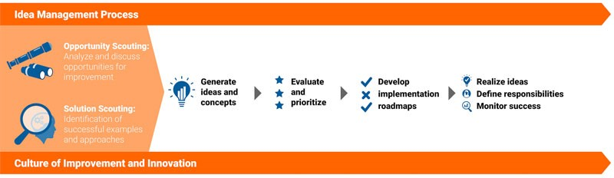
(Allen 2020)
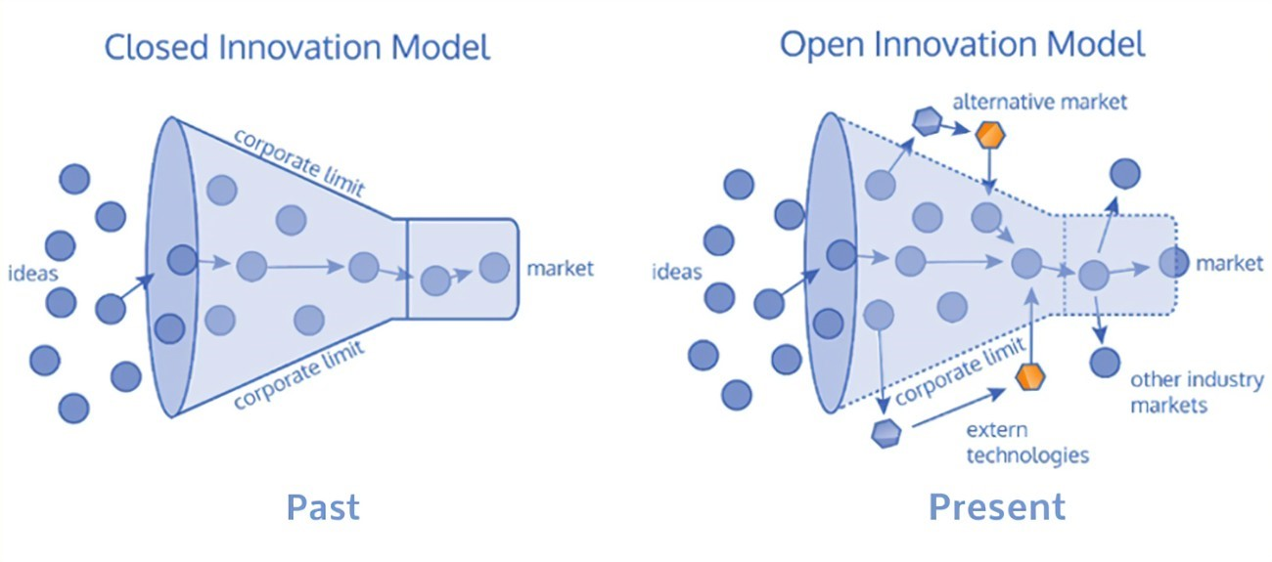

closed and open innovation (vapulas 2020 2020)
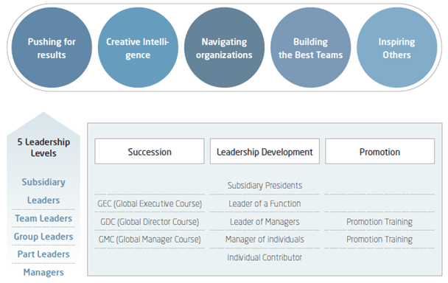 (Samsung 2020) Samsung Leadership Development Program
4 Ps of Marketing 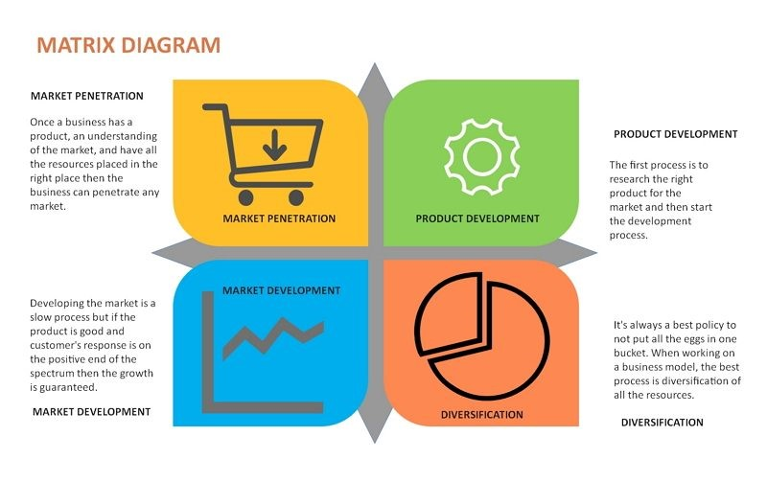
(Edrawmax 2021)

References
Allen, G (2020). Do not do innovation be innovation. Available at: https://a-ecoach.com/dont-do-innovation-be-innovation. (Accessed 20 February 2022).
Bing (2020). Lewins force field theory. Available at:https://www.bing.com/search?q=Lewins+force+field+theory&form=WSBEDG&qs=SW&cvid=20b24de03a4644ac978eb056d70186d6&pq=Lewins+force+field+theory&cc=GB&setlang=en-GB&nclid=1. (Accessed 11 March 2022).
Cherry, K (2020). What is transformational leadership? Available at: https://www.verywellminded.com/bhat-is-transformational-leadership-2795313. (Accessed 15 2022).
Edrawmax (2021). 4Ps of innovation. Available at: https://www.bing.com/search?q=Edravax&form=WSBEDG&qs=SW&cvid=20b24de03a4644ac978eb056d70186d6&pq=Edravax&cc=GB&setlang=en-GB&nclid=118C349F0D8ED83CBCDE90144F11B667. (Accessed 12 March 2022).
Flixabout (2020). 4ps of innovation. Available at: https://fliabout.com/4-ps-innovation. (Accessed 24 February 2022)
Got tech innovation (2019). Open vs closed innovation. Available at: https://gotechinnovation.com/closed-innovations-vs-open-innovations/ (Accessed 19 February 2022)
Idea to value (2016). 15 experts share innovation definition. Available at: https://www.ideatovalue.com/inno/nickskillicorn/2016/03/innovation-15-experts-share-innovation-definition/ (Accessed 6 February 2022).
Innovation management (2020). Innovation space 4ps what s innovation https://innovationmanagement4.wordpress.com/innovation-space-4ps/what-is-innovation-space4ps/#:~:text=1%20Innovation%20space%204Ps.%20The%204Ps%20model%2Fmethod%20was,4%20Position%20innovation.%20 (Accessed 10 February 2022)
Lead innovation (2020). Open innovation vs closed innovation. Available at: https://www.lead-innovation.com/.../open-innovation-vs.-closed-innovation. (Accessed 12 February 2022)
Life wire (2020). History of Samsung. Available at: https://www.lifewire.com/history-of-samsung-818809. (Accessed 1 February 2022).
Levitt, T, (1974) Marketing for Business Growth, publisher – Mcgraw Hill, New York
Mbaknol (2019). Business Analyses. Available at: https://www.mbaknol.com/business-analysis/case-study-samsungs-innovation-strategy/ (Accessed 7 February 2022).
Mbaknol (2021). Modern management. Available at: https://www.mbakno.com/modern-managment-concepts/kurl-lewins-force-field-theory-of-change. (Accessed 12 February 2022).
McGarry, C, (2017). Samsung turns up the heat. Available at: https://www.techhive.com/article/582644/samsung-turns-up-the-heat-on-home-appliances. (Accessed 5 February).
News Samsung (2020). Tour how Samsung s ensuring reliability. Available at: https://news.samsung.com/global/lab-tour-how-samsung-is-ensuring-the-reliability-of-galaxy-devices. (Accessed 12 February 2022).
Research-methodology (2019). Samsung leadership chance. Available at: https://research-methodology.net/samsung-leadership-chance-new-era/ (Accessed 14 February 2022).
Rowlands, D, (2018). The difference between creativity and innovation. Available at: https://www.weareive.org/what-is-the-difference-between-creati.vity-and-innovation. (Accessed 22 January 2022).
Samsung (2020). Support and answers. Available at: https://www.samsung.com/us/support/answer/ANS00049761/ (Accessed 6 February 2022).
Samsung (2020). Semiconductors support Available at: https://www.samsung.com/semiconductor/support/quality-management/ (Accessed 7 February 2022).
SC .com (2020). Benefits-and-risks-of-innovation. Available at: https://cs.com/benefits-and-risks-of-innovation/ (Accessed 15 February 2022).
Seelig, T, (2012). Ingenious: a crash course in creativity. Publisher. Harper Collins. New York
Tech target (2021). Definition process innovation. Available at: https://www.techtarget.com/searchcio/definition/process-innovation. (Accessed 12 February 2022).
Tool hero (2020). Matrix sustaining innovation. Available at: https://www.toolhero.com/innovation. (Accessed 12 February 2022).
Tuohy, J, P, (2021). Samsung’s family hub smart fridge. Available at: https://www.theverge.com/2021/12/28/22856937/samsung-family-hub-smart-fridge-bespoke-ces-2022. (Accessed 14 February 2022).
Vapulus, (2020). Open innovation vs closed innovation. Available at: https://www.vapulus.com/en/open-innovation-vs-closed-innovation. (Accessed 15 February 2022).

Reflection

Innovation is an essential element of business and has several important benefits.
For example, productivity gains can occur when staff have access to the newest innovation and new technology. One benefit is that overall costs decrease in industries where innovation leads to less waste and costs are cut dramatically.
In addition, reduced costs will result from improved productivity. Employees can accomplish more with their work hours if they spend more time on innovation, and less on work that does not require them to use their creative skills.
These benefits will enhance a company’s performance particularly if they investigate the various innovation models available to them (Ni business 2020).

INNOVATION

Innovation and creativity begins with the process of bringing something new to a company, whether it is a new product, a new market strategy, a new approach, or something else entirely, to revive the firm and encourage new value and growth. Company executives must come up with (or listen to) innovative ideas, and then use strategic planning and decision-making to effectively execute the new business concepts (Green 2020).
Revenue-model innovation entails business owners examining their revenue model for opportunities to improve the products and services they provide, as well as the pricing they charge and the clients they target. Organisations that embrace revenue-model innovation may manufacture unique goods, cease selling specific items, alter their supply chain, sell to new consumers, or adjust the prices of their offers, among other things. (Schultz 2020).
Revenue-model innovation comprises a review of a company's revenue model to look for ways to enhance the products and services it offers, as well as the price it charges and the customers it caters to. Organizations that embrace revenue-model innovation may, among other things, develop unique goods, discontinue the sale of certain commodities, change their supply chain, sell to new customers, or revise the prices of their offerings.
Business-model innovation: This entails looking at overarching company models for locations to adopt new solutions, such as the business processes, strategy, mission statement, technology which is utilised, and the firms that the company collaborate with. Organisations that select business-model innovation may, for example, form a strategic alliance with another company, update their software, take venture capital funding, or go from selling in a physical shop to selling online (Ward 2020).
To be successful with innovation, a business must foster a culture that is open to new ideas and unafraid of failure. Employees must be encouraged to attempt new things, and organisations must equip them with the appropriate resources.
Experimentation, coaching, and feedback are required for organisations to be effective in generating innovation.
A culture that supports risk-taking should also be present in organisations. Employees will be more willing to attempt new things if the company is receptive to new ideas and does not penalise those who fail.
Therefore, despite the associated risks, challenges, and other issues, it is clear to see that innovation is a significant aspect of any business (Masterclass 2021).

“Where do ideas come from?” Lecture given by Davina Evans term 2

Davina's lectures are a little different from others in that she displays YouTube videos and then will give us a questionnaire to fill out to determine what kind of thinkers we are.
The lecture being reflected upon was intriguing since it included a video of Steve Johnson talking about where ideas originate from (Johnson 2010). He was engaging because he had a few one-liners that made me chuckle. He claims that ideas emerge from a group of people having a talk and a cup of coffee; when everyone has a voice and is able to contribute thoughts freely, this can lead to wonderful ideas, and when all these things are combined, the eureka moment can be reached. This is what Johnson refers to as the "liquid network" (Johnson 2010).

The second section of the lecture included an image of Edward de Bono’s six hats of thinking (MindTools 2020).This consists of the six distinct coloured hats which can be used in meetings or individually. It has the advantage the same issue. The connotations of each hat are varied, with each one being a different colour to identify a different role within the team. For example, the blue hat s the ‘Conductors Hat’ signifying the person in the group who is to lead the final decision making (Bono group 2018). Similarly, the green hat denotes the ‘creative’ member of the group, and the red hat ‘Hat of the hart’ whose wearer uses sentiment and instinct when thinking up ideas. The role of the optimist n the group is identified by wearing of the yellow hat and team member responsible for listening and identifying gaps in knowledge wears the white ‘Factual Hat’ (Southampton 2017).

Both the Steven Johnson film clip, and the Edward de Bono image were very useful. When any visual materials are given a context in lectures, I find they I learn more efficiently. Although I enjoy both the film clip and the image in this lecture, I think some further explanation would have helped me have a better understanding of concepts underlying them. When have used visual resources in the part, I have found that if the facilitator has highlighted topics within the film or image to focus on, I may then concentrate on the most important sections of the film or image therefor gaining even more knowledge. Also, t s beneficial f am told whether or not taking notes on the film clip content is a good idea.

`

References
Bono Group (2018). Six thinking hats. Available at: hhtps://www.debonogroup.com/services/core-programs-six-thinking-hat. (Accessed 12 March 2022).

Green, N (2020) Ideas professional development. Available at: https://www.wework.com/en-gb/ideas/professioal-develoment/what-is-business-innovation. (Accessed 11 March 2022).
Johnson S, (2010). Front Cover. Available at: https://books.google.co.uk/book?id=KsZV19dFIns&printsecfront-cover&dgsteven+johnson+where. (Accessed 11 March 2022).

Johnson S, (2010). Where do ideas come from. Published Penguin group. London.

Ni business (2020). Advantages Innovation. Available at: https://www.nibusinessinfo.co.uk/content/advantages-innovation. (Accessed 11 March 2022).
Masterclass, (2021). Innovation is essential-for-business-success. Available at: https://www.masterclass.com/articles/why-innovation--is-essential-for-business-success. (Accessed 11 March 2022).
Schultz, H (2020). Why innovation is essential to a business. Available at: https://www.masterclass.com/artical/why-innovation-for-a-business-succses. (Accessed 4 March 2022).
Mindtool group (2020). Six thinking hats. Available at: https://www.mindtools.com/pages/artical/new-ted-07htm. (Accessed 12 March 20220.
Southampton (2017). Six thinking hats. Available at: https://www.southampton.ac.uk/assets/doc/hr/six%20thinking%20hats.pdf. (Accessed 10March 2022).

Ward, S (2020). Business innovation. Available at: https://www.thebalancemb.com/business-innovation-2948310. (Accessed 11 March 2022).

